
MATHEMATICAL MODELING & CONTROL STRATEGIES FOR HYBRID HYDROGEN SYSTEMS
AHMET YEŞİL
090220359
June 14, 2026
MAT 4901E
PROF. DR. SEMRA AHMETOLAN
Prepared by :
Student No :
Submission Date :
Course :
Supervisor :
Table of Contents
Table of Figures 2
Table of Tables 2
1. Definition and Purpose of Design 3
2. Scope of Design and Areas of Usage 3
3. Conducted Studies 4
3.1. Literature Review 4
3.1.1. Energy Management Strategies for Fuel Cell Hybrid Vehicles 4
3.1.2. PEMFC Modelling Approaches 4
3.1.3. Lithium-ion Battery Modelling Approaches 5
3.2. System Architecture, Reference Vehicle and Drive Cycle 5
The natural decision variable of the EMS is consequently the power delivered by the DC/DC converter to the bus, 6
3.3. Mathematical Modelling of the Powertrain Components 8
3.3.1. Longitudinal vehicle dynamics 8
3.3.2. PEMFC stack model: Mann–Amphlett GSSEM 8
3.3.3. Battery model: 1-RC equivalent circuit with hysteresis 10
3.4. Power Flow Model 10
3.5. Derivation of the Cost Function 10
3.6. EMS Methods 10
3.7. Current Status of the Study 10
4. References 10

Table of Figures
Figure 1 OCV-SOC Relations [11] 5
Figure 2 Some Topologies. (a) Topology T1 (b) Topology T2 (c) Topology T3 (d) Topology T4 (e) Topology T5 [1] 6
Figure 3 WLTC Class 3b Low, Medium, High cycles [21] 7

Table of Tables
Table 1 Architectural selections of the study. 6

1. Definition and Purpose of Design
The purpose of this study is modelling a plug-in hydrogen fuel cell hybrid electrical vehicle (FCHEV) and find optimal energy management strategy (EMS) for this FCHEV.

Hydrogen fuel cell vehicles one of the most eco-friendly vehicles since the only exhaust emission of a proton exchange membrane fuel cell (PEMFC) is water. A fuel cell alone is not fully suited for daily driving due to its dynamic response to acceleration is slow, it cannot absorb the energy from regenerative breaking and frequent load cycling accelerates membrane degradation.[1] For these reasons, the fuel cell is hybridized with a lithium-ion battery pack and result of this the architecture of the vehicle contains two independent energy sources. In the plug-in hybrid configuration considered in this study, the lithium-ion battery is additionally charged from the electrical grid. Aim of this plug-in hybrid approach is accelerate charging of the battery and gaining range.

Whenever the driver demands a traction power $P_{load}(t)$ controller must decide the load at every instant, what fraction of this demand is supplied by the fuel cell and what fraction is supplied by the battery. This demand decision rule is the energy management strategy, and is success directly affects hydrogen and electric consumption and in the end real life cost. The problem naturally acts like optimal control problem in which cumulative cost functional is minimized subject to the power balance of the DC bus, the state-of-charge (SoC) dynamics of the battery and the physical limits of the components.

In this project aim is to model a FCHEV alongside with a fuel cell stack and a battery derive cost function, and formulation of four solution strategies.

2. Scope of Design and Areas of Usage
This study mainly divided six steps. First, a literature review is carried out on energy management strategies for fuel cell hybrid vehicles, zero-dimensional PEMFC modelling and on lumped-parameter equivalent circuit models of lithium-ion batteries. Second the system architecture is selected: the T4 topology, in which the PEMFC is connected to the DC Bus through a unidirectional DC/DC converter while the battery is connected directly, is selected, the second-generation Toyota Mirai is selected as the reference vehicle, and two consecutive Worldwide Harmonized Light Vehicles Test Procedure (WLTP) Class 3b cycles are selected as the reference trip. Third, the mathematical models of the PEMFC and lithium-ion battery are constructed: the longitudinal vehicle dynamics, the Mann–Amphlett Generalized Steady-State Electrochemical Model (GSSEM) of the fuel cell stack, and the first-order resistor–capacitor equivalent circuit model with hysteresis (1-RC + Hysteresis) of the battery. Fourth, the system’s power flow model is constructed and the conversion chains from the control decision to the hydrogen mass flow rate and to the battery state of charge are derived. Fifth, the operational cost function combining the grid electricity cost and the hydrogen cost is derived for the charge-depleting plug-in hybrid scenario and prices are adopted from Germany 2026 price scenarios. Finally, the complete optimal control problem is stated and the four EMS strategies selected and formulated.

The outputs of the study can be used in several areas. The formulation provides a directly transferable basis for the supervisory control software of plug-in fuel cell passenger cars, and, with modified parameter sets, of fuel cell city buses, light commercial vehicles. Since the cost function is parametrized with European hydrogen and electricity prices can be used for feasibility analysis of fuel cell vehicles in European market.

3. Conducted Studies

3.1. Literature Review

3.1.1. Energy Management Strategies for Fuel Cell Hybrid Vehicles

Energy management strategies are commonly grouped into three classes [1]. Rule based strategies, comparing predetermined rules and use fuzzy logic thus they carry no optimality guarantee. Optimization-based strategies, formulate the power split as an optimal control problem. Dynamic programming computes the global optimum by backward recursion over the whole drive cycle and is therefore usable only offline, as a benchmark [15], [16]. Equivalent Consumption Minimization Strategy (ECMS) uses Pontryagin’s Minimum Principle (PMP) converts the constrained problem into the pointwise minimization of a Hamiltonian and can be interpreted as a real-time realization of PMP in which the co-state is replaced by an equivalence factor [2], [3]. Xu et al. applied PMP to a plug-in fuel cell city bus and demonstrated that the PMP solution remains within approximately 1.4 % of the DP optimum while being realizable in real time; the same study proved that a classical ECMS with a constant equivalence factor might degenerate into a charge-depleting/charge-sustaining (CDCS) strategy in the plug-in case [4]. Adaptive versions of ECMS for this reason update the equivalence factor online, typically by a proportional–integral feedback on the SoC tracking error [5]. Model predictive control (MPC) solves a finite-horizon optimization at every sampling instant and applies only the first element of the resulting control sequence [1].

3.1.2. PEMFC Modelling Approaches

Fuel cell models are classified by spatial resolution into zero- to three-dimensional models, and by modelling philosophy into mechanistic, semi-empirical and data-driven models [6], [7]. For EMS-oriented studies, zero-dimensional semi-empirical models are the established choice, since the controller requires only the static input–output map between stack power, efficiency and hydrogen consumption. The Generalized Steady-State Electrochemical Model of Mann and Amphlett [6] indicates the cell voltage as the Nernst potential reduced by activation, ohmic and concentration losses, extending the earlier polarization models of Springer et al. [8] and Kim et al. [9]. Compared with dynamic zero-dimensional models such as that of Ziogou et al. [10], a static formulation requires only algebraic evaluations; an operation-count analysis carried out within the present study indicates that this reduces the computational load of a DP optimization by more than two orders of magnitude at the expense of a steady-state error of only a few per cent, which is the decisive argument for its adoption here.

3.1.3. Lithium-ion Battery Modelling Approaches

Battery models suitable for real-time state estimation are classified as electrochemical, data-driven and equivalent-circuit. Nejad et al. compared ten lumped-parameter equivalent circuit models systematically on LiFePO₄ (LFP) and LiNMC cells and reported that the first-order RC model extend with a hysteresis state (1-RC + Hysteresis) achieves the lowest SoC estimation error for LFP chemistry (1.39 % mean error), together with marked robustness against erroneous SoC initialization [11]. The hysteresis description follows Huria et al. [12], and the underlying state and parameter estimation framework is that of Plett [13]. Because the LFP open-circuit-voltage curve is almost flat between 20 % and 80 % SoC, the hysteresis state is indispensable for this chemistry [11], [12]. The flat open-circuit-voltage characteristic and the associated hysteresis of the LFP chemistry are illustrated in Figure 1. This study adopts the two-level modeling approach proposed by Onori et al. [14]. Specifically, a high-fidelity plant model is used for the physical system, while a simplified model is run inside the optimizer.

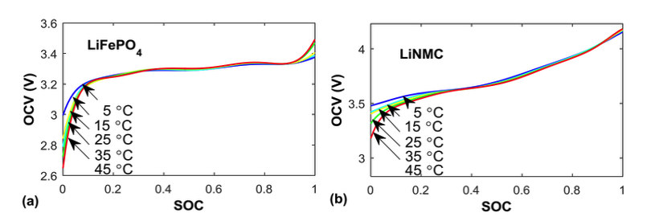
Figure 1 OCV-SOC Relations [11]

3.2. System Architecture, Reference Vehicle and Drive Cycle

The architectural selections of the study are summarized in Table 1, where each choice is explained in the section indicated.

Architectural component | Selection | Section
Topology | T4: PEMFC + unidirectional DC/DC + DC bus + battery | 3.2
Reference vehicle | Toyota Mirai | 3.2
Drive cycle | 2 × WLTP Class 3b (1 h, 46.5 km) | 3.2
PEMFC model | Mann–Amphlett 0-D semi-empirical (GSSEM) | 3.3.2
Battery cell / pack | A123 ANR26650M1B (LiFePO₄), 96s10p, ≈ 7.92 kWh | 3.3.4
Battery model | 1-RC + Hysteresis [11] | 3.3.4
Cost scenario | Germany 2026: € 11/kg H₂, € 0.35/kWh | 3.5
EMS strategies | DP, A-ECMS, MPC, BLFS | 3.6
Table 1 Architectural selections of the study.

In the T4 topology the fuel cell stack feeds the DC bus through a unidirectional DC/DC converter, whereas the battery is connected to the bus directly and exchanges power bidirectionally. Common FCHEV topologies, including the adopted T4 structure, are compared in Figure 2.
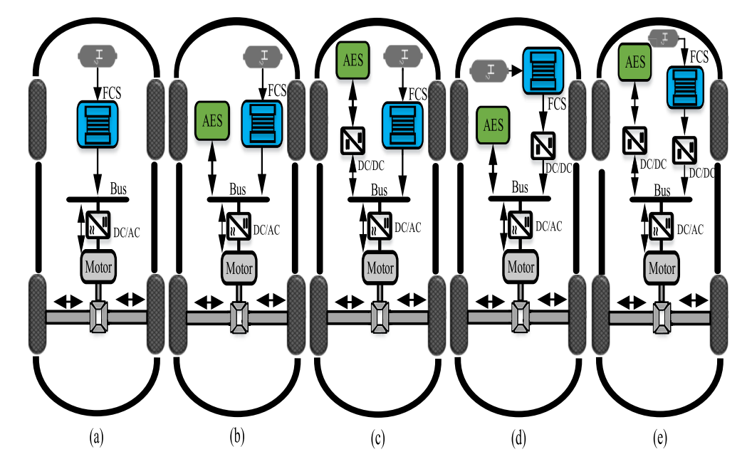
Figure 2 Some Topologies. (a) Topology T1 (b) Topology T2 (c) Topology T3 (d) Topology T4 (e) Topology T5 [1]

The natural decision variable of the EMS is consequently the power delivered by the DC/DC converter to the bus,

 | $$u(t)≡P_{dc}(t),$$ | (1)

and, once Eq. (1) is fixed, the battery power follows directly from the power balance of the DC bus,
 | $$P_{bat}(t)=P_{load}(t)-P_{dc}(t),$$ | (2)

so that a single decision variable completely determines the power split. The sign convention adopted in Eq. (2) is that $P_{bat}>0$ indicates battery discharge and $P_{bat}<0$ indicates battery charging, either by regenerative braking or by extra fuel cell power. The unidirectional converter enforces $P_{dc}≥0$. The only memory of the system is the battery state of charge, which is taken as the state variable, $x(t)≡SoC(t)$. The hydrogen tank level is a state, because the hydrogen cost enters the running cost directly and no terminal constraint is imposed on the tank; the same simplification is adopted in [4], [5].

The second-generation Toyota Mirai (2020+) is selected as the reference vehicle, since it is the most selling production fuel cell passenger car for which a complete and recent experimental energy balance is available in the literature [17]. The Toyota Mirai is not a plug-in vehicle; in this study its battery is rescaled to approximately 7.92 kWh to provide the plug-in functionality, while all remaining vehicle parameters are kept at their published values. The vehicle parameters used in the dynamic model are listed in Table 2.

Parameter | Symbol | Value
Total mass (incl. driver) | $$m_{v}$$ | 1925 kg
Frontal area | $$A_{f}$$ | 2.547 m²
Aerodynamic drag coefficient | $$C_{d}$$ | 0.29
Rolling resistance coefficient | $$C_{r}$$ | 0.012
Air density (20 °C) | $$ρ_{air}$$ | 1.18 kg/m³
Drivetrain efficiency | $$η_{dt}$$ | 0.92
Maximum motor power | $$P_{m,max}$$ | 134 kW
Stack net peak power | $$P_{fc}^{max}$$ | 128 kW (system net 110 kW)
DC/DC converter efficiency | $$η_{dc}$$ | 0.95
Table 2 Second generation Toyota Mirai parameters [17] and Toyota official technical specifications [22].
The reference trip consists of two consecutive WLTP Class 3b cycles, giving a total duration of $T=3600$ s and a distance of 46.5 km; the speed profile of the constituent WLTC Class 3b phases is shown in Figure 3.

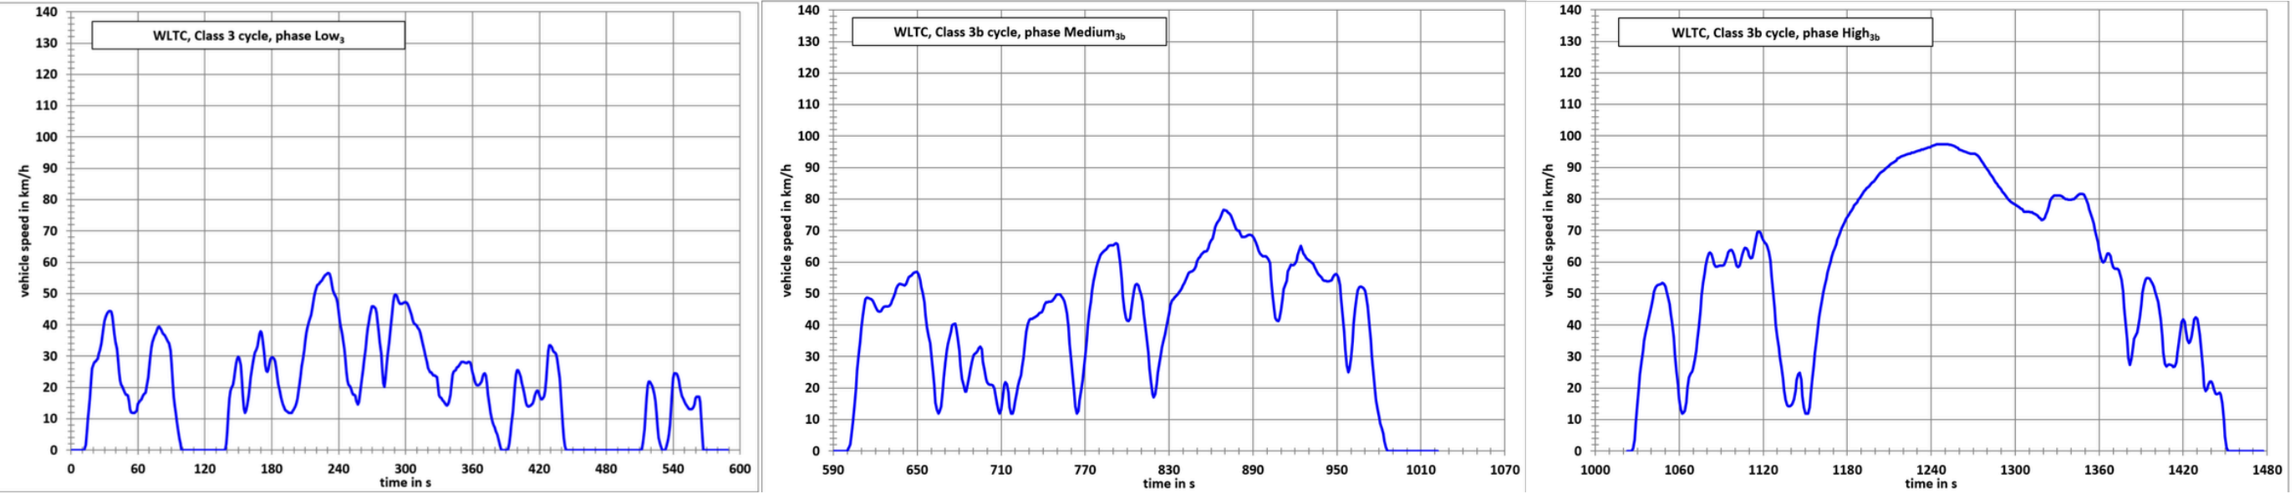
Figure 3 WLTC Class 3b Low, Medium, High cycles [21]
Two cycles are required so that the 7.92 kWh pack can be depleted by a meaningful amount within the trip. Two cycles are required so that the 7.92 kWh pack can be depleted by a meaningful amount within the trip. Because the driving cycle is known, the required load power $P_{load}(t)$can be calculated in advance, which is exactly what the DP benchmark requires. Furthermore, the simulation is discretized with a time step of $Δt=1$, resulting in $N=3600$decision points.

3.3. Mathematical Modelling of the Powertrain Components

3.3.1. Longitudinal vehicle dynamics

The power that must be transmitted to the wheels at vehicle speed $v(t)$ and acceleration $a(t)=dv/dt$ on a road of grade angle $α$ is obtained from the classical longitudinal dynamics balance,

 | $$P_{wheel}=[m_{v}a+m_{v}gC_{r}cosα+\frac{1}{2}ρ_{air}C_{d}A_{f}v^{2}+m_{v}gsinα] v,$$ | (3)

in which the four terms represent the inertial force, the rolling resistance, the aerodynamic drag and the grade force, respectively; for the WLTP cycle a level road, $α=0$, is assumed. The power demanded on the DC bus is then obtained from Eq. (3) through the drivetrain efficiency in a direction-dependent manner,

 | $$P_{load}(t)=\{P_{wheel}(t)/η_{dt}, P_{wheel}(t)≥0 (traction), P_{wheel}(t) η_{dt}, P_{wheel}(t)<0 (regenerative braking),$$ | (4)

since the drivetrain losses increase the during electrical demand and reduce the recoverable power during braking. Eq. (4) is evaluated over the entire cycle to produce the load trajectory used by all strategies.

3.3.2. PEMFC stack model: Mann–Amphlett GSSEM
In the GSSEM, the voltage of a single cell is written as the thermodynamic potential reduced by three loss terms [6], whose effect on the cell voltage is illustrated by the typical polarisation curve in Figure 4,

 | $$V_{FC}=E_{Nernst}-V_{act}-V_{ohm}-V_{con}.$$ | (5)

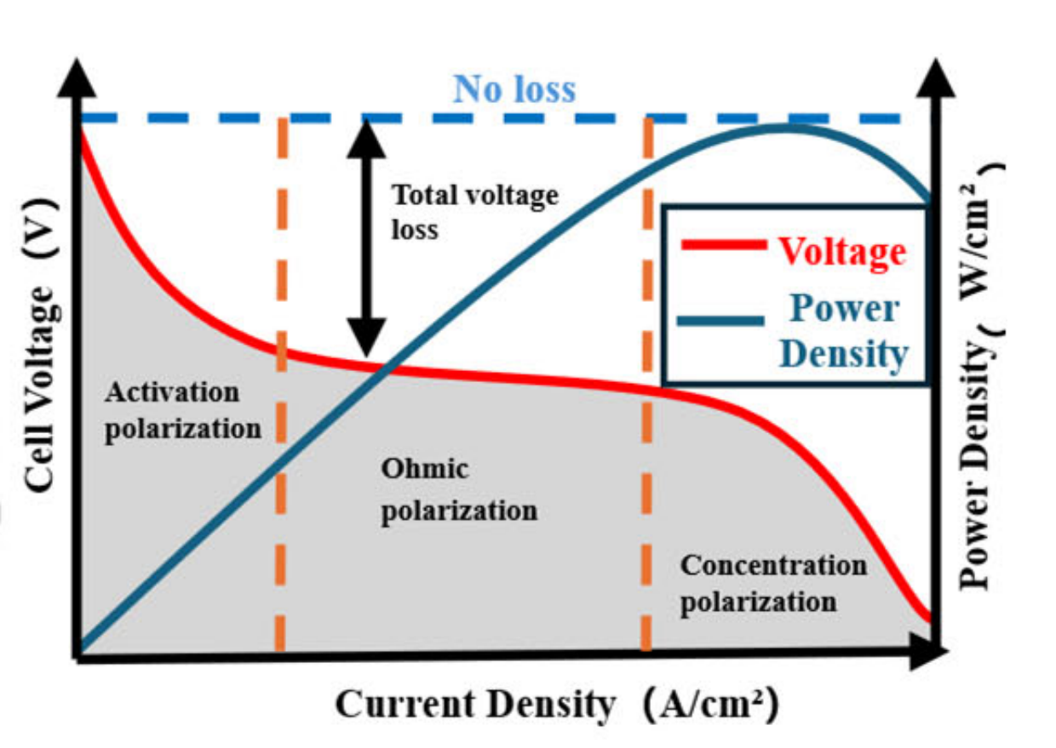
Figure 4 Typical polarisation curve (adapted from [7]).

The Nernst potential in Eq. (5) is evaluated as

 | $$E_{Nernst}=1.229-8.5×{10}^{-4} (T-298.15)+4.308×{10}^{-5} T(lnp_{H_{2}}^{*}+\frac{1}{2}lnp_{O_{2}}^{*}),$$ | (6)
where $T$ is the stack temperature in kelvin and $p_{H_{2}}^{*}$, $p_{O_{2}}^{*}$ are the partial pressures of the reactants at the catalyst interfaces. The activation overvoltage represents as the semi-empirical Tafel-type expression

 | $$V_{act}=-[ξ_{1}+ξ_{2}T+ξ_{3}TlnC_{O_{2}}^{*}+ξ_{4}Tlni],$$ | (7)

in which $ξ_{1},ξ_{2},ξ_{3},ξ_{4}$ are the stack-specific semi-empirical coefficients and $C_{O_{2}}^{*}$ is the dissolved oxygen concentration. The ohmic loss is expressed over the membrane and contact resistances as
 | $$V_{ohm}=i (R_{M}+R_{C}), R_{M}=ρ_{M}\frac{l}{A},$$ | (8)

where the membrane specific resistivity $ρ_{M}$ depends on the effective water content $λ$, the current density and the temperature according to the correlation of Mann et al. [6]. The concentration loss caused by reactant depletion at high current densities is modelled as

 | $$V_{con}=-βln(1-\frac{J}{J_{max}}),$$ | (9)

with $J=i/A$ the current density and $β$ an empirical coefficient, following the form adopted
in [7]. The stack voltage and the gross stack power follow from Eq. (5) as

 | $$V_{stack}=N_{cell} V_{FC}, P_{fc,gross}=V_{stack} I,$$ | (10)

with $N_{cell}=330$ cells and an active area of $A=300 cm^{2}$ for the Mirai II FCB130 stack [17]. The model is used under an isothermal assumption ($T=343$ K), since the stack temperature evolves on a time scale of minutes and is regulated by a dedicated cooling controller, whereas the EMS acts on a time scale of seconds; the influence of thermal management and ageing on EMS performance is investigated in [20] and is left outside the present scope. The coefficient set selected from the values characterized by Mann et al. [6]; within Graduation Project II (MAT 4902E), the coefficients will be re-identified for the Toyota Mirai stack from the published polarization data [17] by metaheuristic optimization, following the methodology given by Fang et al. in [7].
For the EMS, the internal electrochemical variables are way more detailed; what the controller requires is the hydrogen mass flow rate associated with a gross stack power. The efficiency-map form
 | $${\dot{m}}_{H_{2}}=\frac{P_{fc,gross}}{η_{fc}(P_{fc,gross}) {LHV}_{H_{2}}}$$ | (11)

is therefore adopted, where ${LHV}_{H_{2}}=120 MJ/kg$ is the lower heating value of hydrogen and the stack efficiency map $η_{fc}(⋅)$ is derived offline from Eqs. (5)–(10) and going to be stored as a one-dimensional look-up table at MAT 4902E. The indicative values for the Toyota Mirai stack are a peak efficiency of approximately 0.70 near 12 kW gross power and approximately 0.54 at maximum power [17]; because efficiency changes considerably at different power levels, finding the optimal power split becomes a challenging problem.

3.3.3. Battery model: 1-RC equivalent circuit with hysteresis
The battery pack consists of 960 A123 ANR26650M1B LiFePO₄ cells in a 96s10p configuration, providing a nominal voltage of 316.8 V, a capacity of $Q_{pack}=25$ Ah and a nominal energy of 7.92 kWh. From comparison made by Nejad et al. [11], the 1-RC + Hysteresis equivalent circuit model is adopted. The corresponding equivalent-circuit structures are depicted in Figure 5. The relaxation voltage of the single RC branch obeys the discrete state equation

 | $$V_{RC1}(k+1)=a V_{RC1}(k)+b i_{k}, a=e^{-Δt/τ_{1}}, b=R_{1}(1-a),$$ | (12)

with the time constant $τ_{1}=R_{1}C_{1}≈180$ s. The state of charge evolves by Coulomb counting,

 | $$SoC(k+1)=SoC(k)-\frac{η_{i} Δt}{Q_{pack}} i_{k},$$ | (13)

where $η_{i}=0.995$ is the coulombic efficiency and the current is positive in discharge. The terminal voltage is assembled from the open-circuit voltage, the ohmic drop and the relaxation state of Eq. (12) as

 | $$V_{k}=V_{OC}({SoC}_{k},{direction}_{k})-i_{k}R_{s}-V_{RC1}(k).$$ | (14)

Because the open-circuit-voltage curve of the LFP chemistry is nearly flat over the operating window, the open-circuit voltage in Eq. (14) is treated as a dynamic state that relaxes towards direction-dependent charge and discharge reference curves according to the hysteresis law of Huria et al. [12],

 | $$\frac{dV_{OC}}{dSoC}=\frac{dV_{OC}^{ref}}{dSoC}+m_{hyst}(V_{OC}^{ref}-V_{OC}),$$ | (15)

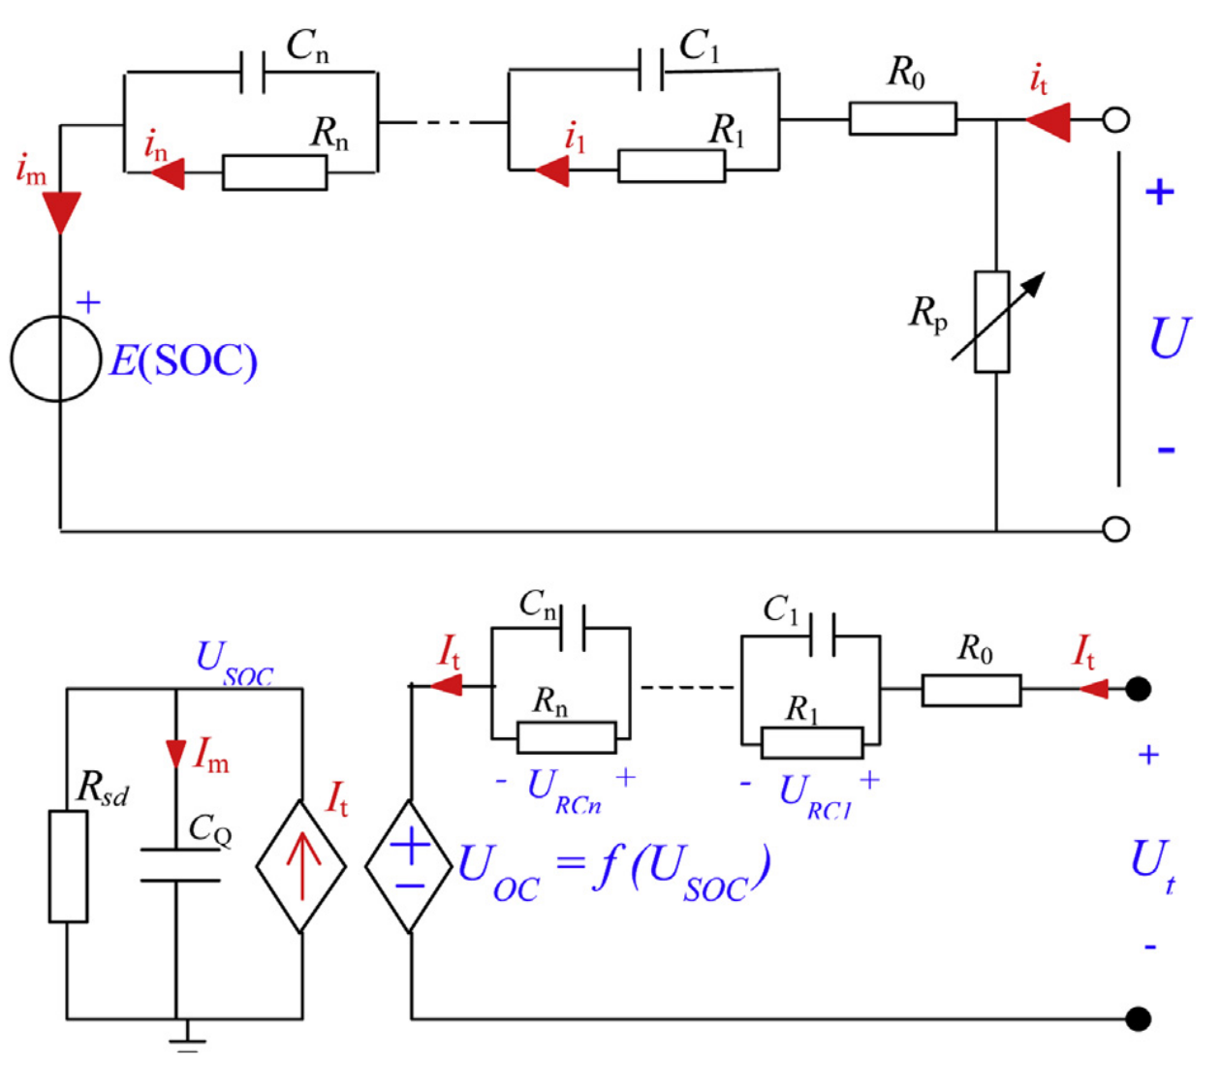
Figure 5 Equivalent circuit models adopted for electrochemical cells [12].

where the reference curve $V_{OC}^{ref}$ is the charge branch when the SoC increases and the discharge branch otherwise, each branch being fitted by an eighth-order polynomial in SoC [11], and $m_{hyst}=150$ governs the transition rate. The cell parameters $R_{s}=8 mΩ$, $R_{1}=6 mΩ$ and $C_{1}=30 000$ F are taken from [11] and scaled to pack level by the series/parallel arrangement; the RC time constant is invariant under this scaling. The SoC operating window is constrained to $[0.20, 0.95]$ to limit degradation, the trip starts from the fully charged plug-in condition ${SoC}_{0}=0.90$, and the charge-depleting target at the end of the trip is ${SoC}_{target}=0.25$.
Following the two-level approach in [14], the detailed model (Eqs. 12–15) is used for the physical simulation. Meantime, the EMS optimization layer uses the simpler Rint model, tracking only the SoC state.

3.4. Power Flow Model
The two conversion chains that connect the decision variable to the physical consumption quantities are indicted like. On the fuel cell side, the bus power is referred back to the gross stack power through the converter efficiency and the auxiliary (compressor, cooling, pumping) consumption,
 | $$P_{fc,net}=\frac{P_{dc}}{η_{dc}}, P_{fc,gross}=P_{fc,net}+P_{aux},$$ | (16)

with $η_{dc}=0.95$ and $P_{aux}/P_{fc,gross}≈0.10$–$0.13$ [17]; the gross power of Eq. (16) is converted to the hydrogen mass flow rate by Eq. (11). On the battery side, the terminal power $P_{bat}=V_{bat}I_{bat}$ is combined with the terminal voltage equation, Eq. (14), results in a quadratic equation for the current. The valid physical solution is:

 | $$I_{bat}=\frac{(V_{OC}-V_{RC1})-\sqrt{(V_{OC}-V_{RC1})^{2}-4R_{s}P_{bat}}}{2R_{s}},$$ | (17)

and the requirement that the discriminant in Eq. (17) remain non-negative naturally encodes the power capability limit of the pack. Replacing Eq. (17) into the Coulomb counting law gives the complete state dynamics of the optimal control problem,

 | $${SoC}_{k+1}={SoC}_{k}-\frac{η_{i} I_{bat}(P_{bat,k},{SoC}_{k}) Δt}{Q_{pack}},$$ | (18)

so that the causal chain of the model reads $P_{dc}→P_{bat}$ by Eq. (2), $P_{bat}→I_{bat}$ by Eq. (17) and $I_{bat}→SoC$ by Eq. (18).
Particularly, the grid-to-wheel efficiency of the battery path (≈ 0.87) significantly exceeds the peak tank-to-wheel efficiency of the fuel cell (≈ 0.61). Thus, energetically battery usage is always preferable, but the optimal decision is taken on a monetary rather than an energetic basis, which motivates the cost function derived next.

3.5. Derivation of the Cost Function

3.5.1. Hydrogen consumption cost

Given the hydrogen price $M_{H_{2}}$in €/kg, the hydrogen cost for one sampling interval is calculated using Eqs. (11) and (16) as a direct function of the decision variable:

 | $$C_{fc,k}=M_{H_{2}}⋅\frac{P_{dc,k}/η_{dc}+P_{aux,k}}{η_{fc}(⋅) {LHV}_{H_{2}}}⋅Δt,$$ | (19)

which is non-negative for every meaningful decision and independent of the battery state.

3.5.2. Electricity consumption cost

In the plug-in charge-depleting scenario, the energy drawn from the lithium-ion battery originates from the grid, not from fuel cell; the classical equivalence-factor interpretation of ECMS is therefore replaced by the direct monetary valuation of grid electricity, following Xu et al. [4] and the plug-in literature [18], [19]. Since energy is lost during both charging and discharging, the optimization algorithm must apply different weights to these two power flows. This is captured by the direction-dependent round-trip efficiency

 | $$η_{eff}(P_{bat})=(η_{dis} η_{chg})^{sgn(P_{bat})},$$ | (20)

so that during discharge ($P_{bat}>0$) the grid energy originally invested per unit of bus energy exceeds unity, while during charging ($P_{bat}<0$) only the recoverable fraction of the absorbed energy is credited. With the electricity price $M_{ele}$ converted to SI units, the per-step electricity cost reads

 | $$C_{bat,k}=M_{ele}'⋅\frac{P_{bat,k}}{η_{eff}(P_{bat,k},{SoC}_{k})}⋅Δt,$$ | (21)

which, unlike Eq. (19), depends on both the decision and the state and becomes negative whenever the battery is being charged, thus crediting recuperated energy at its grid-equivalent value. The efficiencies $η_{dis}$ and $η_{chg}$are not constants but rely on the terminal-to-open-circuit voltage ratio. To optimize the simulator, they are pre-calculated offline and stored as lookup tables based on SoC and power. The initial plug-in charge itself does not enter the cost functional; it is represented by the boundary conditions ${SoC}_{0}=0.90$ and ${SoC}_{target}=0.25$. Representative charge-depleting SoC trajectories obtained with different strategy classes are shown in Figure 6.
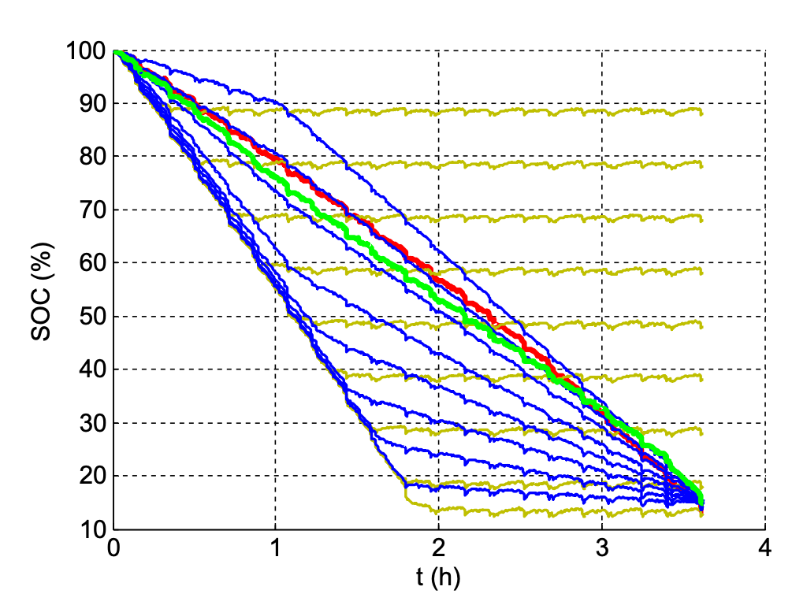
Figure 6 Comparison of SOC trajectories of different strategies, red: DP, green: PMP, yellow: CDCS, blue: Blended (adapted from [4]).

The price parameters are fixed by Germany 2026 market scenarios [23], [24], summarized in Table 3; The main results are based on the default scenario, while the remaining scenarios are reserved for the sensitivity analysis in MAT 4902E. Since grid electricity is cheaper than hydrogen on a lower-heating-value basis in this default setting, the optimal strategy is theoretically expected to maximize battery usage within its constraints.
Scenario | $M_{H_{2}}$ (€/kg) | $M_{ele}$ (€/kWh)
High | 13.85 | 0.40
Default | 11.00 | 0.35
Low | 8.00 | 0.32
Table 3 Germany 2026 price scenarios for hydrogen (700 bar) [23] and residential electricity [24].

3.5.3. Total cost functional
The running cost of one step combines Eqs. (19) and (21),

 | $$L_{k}(x_{k},u_{k})=C_{fc,k}(u_{k})+C_{bat,k}(x_{k},u_{k}).$$ | (22)
Imposing the terminal SoC target as a hard constraint may render the problem infeasible; it is therefore imposed as a soft quadratic penalty,

 | $$Φ({SoC}_{N})=γ ({SoC}_{N}-{SoC}_{target})^{2},$$ | (23)

with the tuning weight initialized at $γ=1000 \text{€}$, a value chosen by dimensional reasoning so that a unit SoC deviation is penalized at a magnitude far exceeding the expected trip cost of 5–15 €. The total cost function is the sum of the running cost in Eq. (22) over the horizon and the terminal penalty:

 | $$J(\{u_{k}\}_{k=0}^{N-1})=\sum_{k=0}^{N-1}{L_{k}}(x_{k},u_{k})+Φ({SoC}_{N}),$$ | (24)

and Eq. (24) constitutes the principal mathematical result of this study. Component degradation costs of the fuel cell and the battery are intentionally excluded from Eq. (24). The load-ramp limitation in the BLFS layer (Section 3.6.5) smooths out power demands, which indirectly protects fuel cell durability.

3.6. EMS Methods

3.6.1. Complete problem statement

Collecting the cost functional, the state dynamics and the physical limits, the complete optimal control problem is stated as
 | $$\underset{\{P_{dc,k}\}_{k=0}^{N-1}}{\text{min}}J=\sum_{k=0}^{N-1}{L_{k}}({SoC}_{k},P_{dc,k})+γ({SoC}_{N}-{SoC}_{target})^{2},$$ | (25)

subject to the state dynamics of Eq. (18), the power balance of Eq. (2), the initial condition ${SoC}_{0}=0.90$, and the operating limits

 | $$0≤P_{dc,k}≤P_{dc}^{\text{max}}, P_{bat}^{\text{min}}≤P_{bat,k}≤P_{bat}^{\text{max}}, {SoC}_{\text{min}}≤{SoC}_{k}≤{SoC}_{\text{max}},$$ | (26)

in which the battery power bounds are SoC-dependent as encoded by the discriminant of Eq. (17). The problem in Eqs. (25)–(26) involves $N=3600$ scalar decisions and a one-dimensional state, a size that is tractable offline by DP and in real time by the remaining strategies. The four solution strategies formulated below will be implemented and compared in MAT 4902E.

3.6.2. Dynamic Programming

Dynamic programming computes the global optimum of Eqs. (25)-(26) by the Bellman backward recursion over the cost-to-go function,

 | $$V_{k}({SoC}_{k})=\underset{P_{dc,k}}{\text{min}}\{L_{k}({SoC}_{k},P_{dc,k})+V_{k+1}({SoC}_{k+1})\}, V_{N}=Φ({SoC}_{N}),$$ | (27)

evaluated on a discretized state decision grid ($ΔSoC=0.005$, $ΔP_{dc}=1$ kW), following the implementation structure of Sundström and Guzzella [15] and the theoretical framework of Bertsekas [16]. Because DP requires knowing the entire power demand in advance, it cannot be implemented in a real vehicle. Instead, it serves purely as a theoretical benchmark to evaluate real-time strategies.

3.6.3. Adaptive ECMS

The real-time counterpart of the optimal solution is constructed from Pontryagin’s Minimum Principle, according to which the optimal decision minimizes, at every instant, the Hamiltonian

 | $$H(SoC,P_{dc},λ,t)=L(SoC,P_{dc})+λ \dot{SoC},$$ | (28)

where $λ$ is the co-state [2], [4]. In the adaptive ECMS implementation, the role of the co-state is taken by an equivalence factor $s(t)$ which is updated online by a proportional–integral law on the SoC tracking error, following Gao et al. [5],

 | $$s(t)=s_{0}+m e_{SoC}(t)+n\int_{0}^{t}{e_{SoC}}(τ) dτ, e_{SoC}={SoC}_{ref}(t)-SoC(t),$$ | (29)

where the reference trajectory ${SoC}_{ref}(t)$ decreases linearly from 0.90 to 0.25 over the trip, in accordance with the charge-depleting character of the plug-in operation [4]. For the plug-in case, adapting the equivalence factor (Eq. 29) is important. As shown by Xu et al. [4], a constant factor can push the strategy to extreme physical limits. To prevent this, a feedback law continuously guides the SoC toward its reference. At each time step, the Hamiltonian (Eq. 28) is evaluated across a discrete grid, and the power $P_{dc}$ that minimizes the cost is applied.

3.6.4. Model Predictive Control

MPC solves, at every instant $k$, the finite-horizon restriction of Eqs. (25)–(26),
 | $$\underset{\{P_{dc,j}\}_{j=k}^{k+N_{p}-1}}{\text{min}}\sum_{j=k}^{k+N_{p}-1}{L_{j}}({SoC}_{j},P_{dc,j})+γ_{MPC}({SoC}_{k+N_{p}}-{SoC}_{ref}(t_{k+N_{p}}))^{2},$$ | (30)

Subject to the dynamics of Eq. (18) and the limits of Eq. (26), the algorithm uses a receding horizon approach. It assumes a constant future load over a prediction horizon of $N_{p}=15$applies only the first step of the optimal sequence and repeats the optimization at the next instant.

3.6.5. Boundary Layer Surface Following

BLFS is not an independent EMS but a lightweight lower-level protection layer operating under A-ECMS or MPC. It defines a hysteresis band of half-width 0.05 around the SoC reference trajectory: above the band the fuel cell is held at minimum power so that the battery is depleted, below the band the fuel cell is held at its peak-efficiency operating point so that the battery is recharged, and inside the band the command of the upper-level strategy is passed through. An example of such a layered energy management structure is given in Figure 7. In addition, the fuel cell load ramp is limited to

 | $$\left|\frac{dP_{fc}}{dt}\right|≤5 kW/s,$$ | (31)

which prevents gas starvation and membrane exhaustion caused by rapid transients; the constraint in Eq. (31) thereby protects fuel cell durability without entering the cost functional explicitly. The qualitative comparison of the four strategies is summarized in Table 4.

Property | DP | A-ECMS | MPC | BLFS
Information required | Full cycle | Instantaneous + SoC ref. | Finite horizon | Instantaneous SoC
Optimality | Global | Near-optimal (PMP) | Local | None (rule-based)
Real-time capable | No | Yes | Yes | Yes
Computational load | High (offline) | Low | Medium | Very low
Role | Benchmark | Production candidate | Production candidate | Protection layer
Table 4 Qualitative comparison of the four EMS strategies.

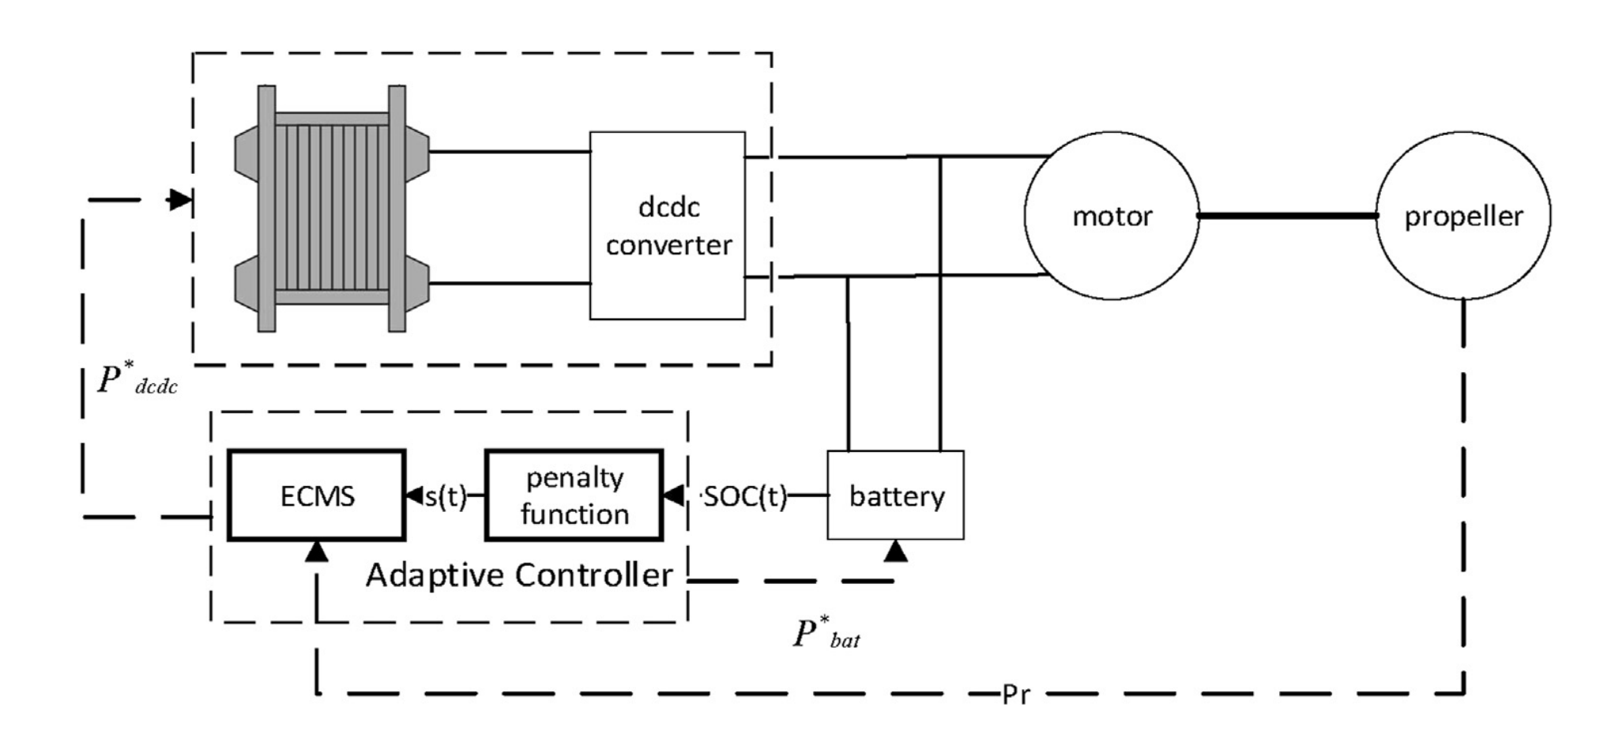
Figure 7 Example of structure of the energy management strategy [5].

3.7 Current Status of the Study and Outline of Graduation Project II

Within the present term, the literature survey has been completed, all architectural selections have been fixed based on primary sources, the component models have been formulated, the plug-in operational cost function has been derived, and the complete optimal control problem, Eqs. (25)-(26), has been stated together with the formulation of the four solution strategies, Eqs. (27)-(31).

Graduation Project II will be devoted to the numerical solution of this formulation. First, a two-layer simulation environment will be implemented in Python: a high-fidelity plant layer, combining the Mann–Amphlett stack model with the full 1-RC + Hysteresis battery model, and a simplified controller layer based on the efficiency look-up table and the Rint model. Second, the semi-empirical stack coefficients will be identified for the Mirai II from the published polarization data [17] by metaheuristic optimization (PSO/GA), and the efficiency map of Eq. (11) will be generated. Third, the four strategies will be implemented in sequence: the DP benchmark by backward recursion, A-ECMS with the PI-adapted equivalence factor, MPC transcribed to a quadratic program and solved, and the BLFS protection layer integrated beneath the real-time strategies. Finally, the strategies will be compared over the reference trip in terms of total operating cost (€/100 km), hydrogen and electricity consumption, terminal SoC accuracy, fuel cell quasi-stability and per-step computation time, and a sensitivity analysis will be performed over the price scenarios of Table 3 and the penalty weight of Eq. (23).

4. References
[1] Khalatbarisoltani, A., Kandidayeni, M., Boulon, L., & Hu, X. (2024). Energy management strategies for fuel cell vehicles: A comprehensive review. IEEE Transactions on Intelligent Transportation Systems, 25(1), 14–32. https://ieeexplore.ieee.org/abstract/document/10247150
[2] Sciarretta, A., & Guzzella, L. (2007). Control of hybrid electric vehicles. IEEE Control Systems Magazine, 27(2), 60–70.
https://ieeexplore.ieee.org/abstract/document/4140747

[3] Paganelli, G., Delprat, S., Guerra, T. M., Rimaux, J., & Santin, J. J. (2002). Equivalent consumption minimization strategy for parallel hybrid powertrains. IEEE Vehicular Technology Conference, 2076–2081.
https://www.academia.edu/download/48212250/Equivalent_consumption_minimization_stra20160820-12660-d4l1g0.pdf

[4] Xu, L., Ouyang, M., Li, J., Yang, F., Lu, L., & Hua, J. (2013). Application of Pontryagin’s Minimal Principle to the energy management strategy of plugin fuel cell electric vehicles. International Journal of Hydrogen Energy, 38(24), 10104–10115.
https://www.sciencedirect.com/science/article/abs/pii/S0360319913013578

[5] Gao, J., Li, Y., Liu, Y., & Li, X. (2021). Adaptive real-time optimal energy management strategy based on equivalent factors optimization for hybrid fuel cell system. International Journal of Hydrogen Energy, 46, 4329–4338.
https://www.sciencedirect.com/science/article/abs/pii/S0360319920340830

[6] Mann, R. F., Amphlett, J. C., Hooper, M. A. I., Jensen, H. M., Peppley, B. A., & Roberge, P. R. (2000). Development and application of a generalised steady-state electrochemical model for a PEM fuel cell. Journal of Power Sources, 86(1–2), 173–180.
https://www.sciencedirect.com/science/article/abs/pii/S037877539900484X

[7] Fang, Y., Yang, F., Xing, Y., Zhang, X., Wang, W., & Lin, S. (2026). A comparative review of modeling and metaheuristic parameter identification strategies for zero-dimensional PEMFC polarization models. Energies, 19, 1438.
https://www.mdpi.com/1996-1073/19/6/1438

[8] Springer, T. E., Zawodzinski, T. A., & Gottesfeld, S. (1991). Polymer electrolyte fuel cell model. Journal of the Electrochemical Society, 138, 2334–2342.
https://iopscience.iop.org/article/10.1149/1.2085971/meta

[9] Kim, J., Lee, S., Srinivasan, S., & Chamberlin, C. E. (1995). Modeling of proton-exchange membrane fuel-cell performance with an empirical equation. Journal of the Electrochemical Society, 142, 2670–2674.
https://iopscience.iop.org/article/10.1149/1.2050072/meta

[10] Ziogou, C., Voutetakis, S., Papadopoulou, S., & Georgiadis, M. C. (2011). Modeling, simulation and experimental validation of a PEM fuel cell system. Computers & Chemical Engineering, 35, 1886–1900.
https://www.sciencedirect.com/science/article/abs/pii/S0098135411001037

[11] Nejad, S., Gladwin, D. T., & Stone, D. A. (2016). A systematic review of lumped-parameter equivalent circuit models for real-time estimation of lithium-ion battery states. Journal of Power Sources, 316, 183–196.
https://www.sciencedirect.com/science/article/abs/pii/S0378775316302427

[12] Huria, T., Ludovici, G., & Lutzemberger, G. (2014). State of charge estimation of high power lithium iron phosphate cells. Journal of Power Sources, 249, 92–102.
https://www.sciencedirect.com/science/article/abs/pii/S037877531301745X

[13] Plett, G. L. (2004). Extended Kalman filtering for battery management systems of LiPB-based HEV battery packs — Part 3: State and parameter estimation. Journal of Power Sources, 134, 277–292.
https://www.sciencedirect.com/science/article/abs/pii/S0378775304003611

[14] Onori, S., Serrao, L., & Rizzoni, G. (2016). Hybrid electric vehicles: Energy management strategies. Springer.
https://link.springer.com/content/pdf/10.1007/978-1-4471-6781-5.pdf

[15] Sundström, O., & Guzzella, L. (2009). A generic dynamic programming Matlab function. IEEE Control Applications & Intelligent Control, 1625–1630.
https://ieeexplore.ieee.org/abstract/document/5281131

[16] Bertsekas, D. P. (2005). Dynamic programming and optimal control (3rd ed.). Athena Scientific.
https://web.mit.edu/dimitrib/www/DP1_Short_View.pdf

[17] Energy balance and hydrogen exhaust emissions of the second-generation Toyota Mirai. (2025). International Journal of Hydrogen Energy.
https://www.sciencedirect.com/science/article/pii/S0360319925034093

[18] Hu, X., Murgovski, N., Johannesson, L. M., & Egardt, B. (2013). Energy efficiency analysis of a series plug-in hybrid electric bus with different energy management strategies and battery sizes. Applied Energy, 111, 1001–1009.
https://www.sciencedirect.com/science/article/pii/S0306261913005631

[19] Tribioli, L., Cozzolino, R., Chiappini, D., & Iora, P. (2016). Energy management of a plug-in fuel cell/battery hybrid vehicle with on-board fuel processing. Applied Energy, 184, 140–154.
https://www.sciencedirect.com/science/article/pii/S0306261916314398

[20] Kandidayeni, M., Macias, A., Boulon, L., & Kelouwani, S. (2020). Investigating the impact of ageing and thermal management of a fuel cell system on energy management strategies. Applied Energy, 274, 115293.
https://www.sciencedirect.com/science/article/pii/S0306261920308059

[21] United Nations Economic Commission for Europe. (2022). UN Global Technical Regulation No. 15: Worldwide harmonized Light vehicles Test Procedure (WLTP) (ECE/TRANS/WP.29/2022/42/Rev.1). https://unece.org/sites/default/files/2022-04/ECE_TRANS_WP.29_2022_42_Rev.1E.pdf

[22] Toyota Motor Corporation. (2022). Toyota Mirai technical specifications. Toyota (GB) Media Site. https://media.toyota.co.uk/wp-content/uploads/sites/5/pdf/220203M-Mirai-Tech-Spec.pdf

[23] H2 MOBILITY Deutschland GmbH. (2026). H2.LIVE: Hydrogen stations in Germany and Europe — fuel pricing.
https://h2.live/en/

[24] BDEW Bundesverband der Energie- und Wasserwirtschaft. (2026). BDEWStrompreisanalyse Januar 2026. https://www.bdew.de/media/documents/BDEW_Strompreisanalyse_012026_1.pdf

