**Tugas Pertemuan Ke – 4**

**Bab 4 : Recycle View**

|  |  |
| --- | --- |
| **Nama** | Ali |
| **Nim** | 1918118 |
| **Kelas** | C |
| **Pemberi Tugas** |  |

1. Recycle View
2. Langkah langkah percobaan
3. Buat project baru

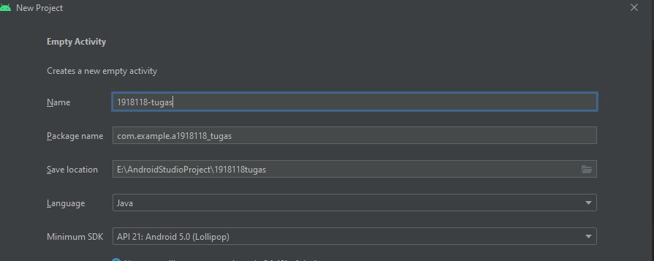

1. Buat layout baru, dengan cara klik kanan pada res>layout new>Layout Resource File. Lalu beri nama seperti gambar berikut

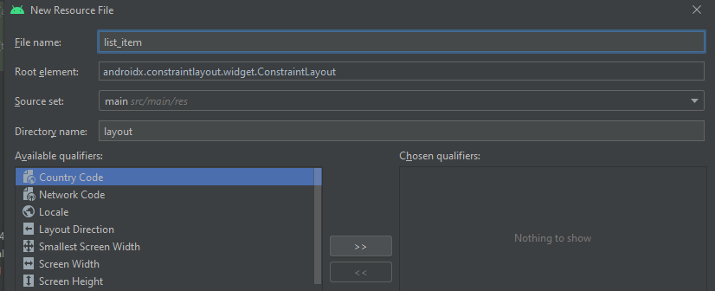

1. Desain list_item seperti dibawah

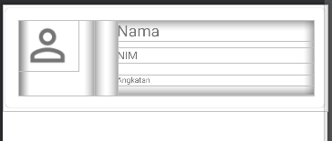

Source Code list_item

|  |
| --- |
| <?xml version="1.0" encoding="utf-8"?>  <androidx.cardview.widget.CardView  xmlns:android="http://schemas.android.com/apk/res/android"  xmlns:app="http://schemas.android.com/apk/res-auto"  android:layout_width="match_parent"  android:layout_height="wrap_content"  android:elevation="3dp"  app:cardCornerRadius="5dp"  app:cardUseCompatPadding="true">  <LinearLayout  android:layout_width="match_parent"  android:layout_height="96dp"  android:orientation="horizontal"  android:layout_margin="15dp"  >  <LinearLayout  android:layout_width="96dp"  android:layout_height="match_parent"  android:orientation="horizontal"  >  <de.hdodenhof.circleimageview.CircleImageView  android:id="@+id/image"  android:layout_width="76dp"  android:layout_height="65dp"  android:src="@drawable/ic_baseline_perm_identity_24" />  </LinearLayout>  <LinearLayout  android:layout_width="30dp"  android:layout_height="match_parent"/>  <LinearLayout  android:layout_width="match_parent"  android:layout_height="wrap_content"  android:orientation="vertical"  >  <TextView  android:id="@+id/txt_nama"  android:layout_width="match_parent"  android:layout_height="wrap_content"  android:layout_marginBottom="8dp"  android:text="Nama"  android:textSize="20sp" />  <TextView  android:id="@+id/txt_nim"  android:layout_width="match_parent"  android:layout_height="wrap_content"  android:layout_marginBottom="15dp"  android:text="NIM" />  <TextView  android:id="@+id/txt_angkatan"  android:layout_width="match_parent"  android:layout_height="wrap_content"  android:layout_marginBottom="12dp"  android:text="Angkatan"  android:textSize="10sp" />  </LinearLayout>  </LinearLayout>  </androidx.cardview.widget.CardView> |

Disource code diatas, dibuat sebuah layout resource dengan nama list_item. Yang akan menampung data yang nanti akan diinputkan

1. Buka activity_main.xml lalu masukkan source code seperti dibawah

Jika belum, maka masukkan source code dibawah ini

Source Code activity_main

|  |
| --- |
| <?xml version="1.0" encoding="utf-8"?>  <LinearLayout xmlns:android="http://schemas.android.com/apk/res/android"  xmlns:app="http://schemas.android.com/apk/res-auto"  xmlns:tools="http://schemas.android.com/tools"  android:layout_width="match_parent"  android:layout_height="match_parent"  tools:context="com.example.recycle_1918118.MainActivity">  <androidx.recyclerview.widget.RecyclerView  android:id="@+id/recycleview"  android:layout_width="match_parent"  android:layout_height="match_parent"/>  </LinearLayout> |

1. Buat class baru dengan nama Mhs, dan MhsList

Source Code class Mhs

|  |
| --- |
| package com.example.recycle_1918118;  public class Mhs {  private String nama,nim,angkatan;  private int img;  public Mhs(String nama, String nim, String angkatan, int img){  this.nama = nama;  this.nim = nim;  this.angkatan = angkatan;  this.img=img;  }  public String getNama(){  return nama;  }  public void setNama(String nama){  this.nama = nama;  }  public String getNim(){  return nim;  }  public void setNim(String nim){  this.nim = nim;  }  public String getAngkatan(){  return angkatan;  }  public void setAngkatan(String angkatan){  this.angkatan = angkatan;  }  public void setImg(){  this.img=img;  }  public int getImg(){  return img;  }  } |

Source Code class MhsList

|  |
| --- |
| package com.example.recycle_1918118;  import android.view.LayoutInflater;  import android.view.View;  import android.view.ViewGroup;  import android.widget.ImageView;  import android.widget.TextView;  import androidx.annotation.NonNull;  import androidx.recyclerview.widget.RecyclerView;  import java.util.ArrayList;  public class MhsList extends  RecyclerView.Adapter<MhsList.ContentViewHolder> {  private ArrayList<Mhs> dataList;  public MhsList(ArrayList<Mhs> dataList) {  this.dataList = dataList;  }  @NonNull  @Override  public MhsList.ContentViewHolder  onCreateViewHolder(@NonNull ViewGroup parent, int viewType) {  LayoutInflater layoutInflater =  LayoutInflater.from(parent.getContext());  View view =  layoutInflater.inflate(R.layout.list_item, parent, false);  return new ContentViewHolder(view);  }  public void onBindViewHolder(ContentViewHolder holder, int  position) {  holder.txtNama.setText(dataList.get(position).getNama());  holder.txtNim.setText(dataList.get(position).getNim());  holder.txtAngkatan.setText(dataList.get(position).getAngkatan());  holder.images_profile.setImageResource(dataList.get(position).getImg());  }  @Override  public int getItemCount() {  return (dataList != null) ? dataList.size() : 0;  }  public class ContentViewHolder extends  RecyclerView.ViewHolder {  private TextView txtNama, txtNim, txtAngkatan;  private ImageView images_profile;  public ContentViewHolder(View itemView) {  super(itemView);  txtNama = (TextView)  itemView.findViewById(R.id.txt_nama);  txtNim = (TextView)  itemView.findViewById(R.id.txt_nim);  txtAngkatan = (TextView)  itemView.findViewById(R.id.txt_angkatan);  images_profile=(ImageView)  itemView.findViewById(R.id.image);  }  }  } |

Source code class MainActivity

|  |
| --- |
| package com.example.recycle_1918118;  import androidx.appcompat.app.AppCompatActivity;  import androidx.recyclerview.widget.LinearLayoutManager;  import androidx.recyclerview.widget.RecyclerView;  import android.os.Bundle;  import com.example.recycle_1918118.R;  import java.util.ArrayList;  public class MainActivity extends AppCompatActivity {  private RecyclerView recyclerView;  private MhsList adapter;  private ArrayList<Mhs> ctnArrayList;  private ArrayList<Mhs> ctArrayList;  @Override  protected void onCreate(Bundle savedInstanceState) {  super.onCreate(savedInstanceState);  setContentView(R.layout.activity_main);  addData();  recyclerView =  (RecyclerView) findViewById(R.id.recycleview);  adapter = new MhsList(ctnArrayList);  RecyclerView.LayoutManager layoutManager = new  LinearLayoutManager(MainActivity.this);  recyclerView.setLayoutManager(layoutManager);  recyclerView.setAdapter(adapter);  }  private void addData() {  ctnArrayList = new ArrayList<>();  ctnArrayList.add(new Mhs("Naruto", "1918466",  "1999",R.drawable.naruto));  ctnArrayList.add(new Mhs("Luffy", "1918212",  "1997",R.drawable.luffy));  ctnArrayList.add(new Mhs("Goku", "1918721",  "1989",R.drawable.goku));  ctnArrayList.add(new Mhs("Erza", "191787",  "2009",R.drawable.erza));  }  } |

1. 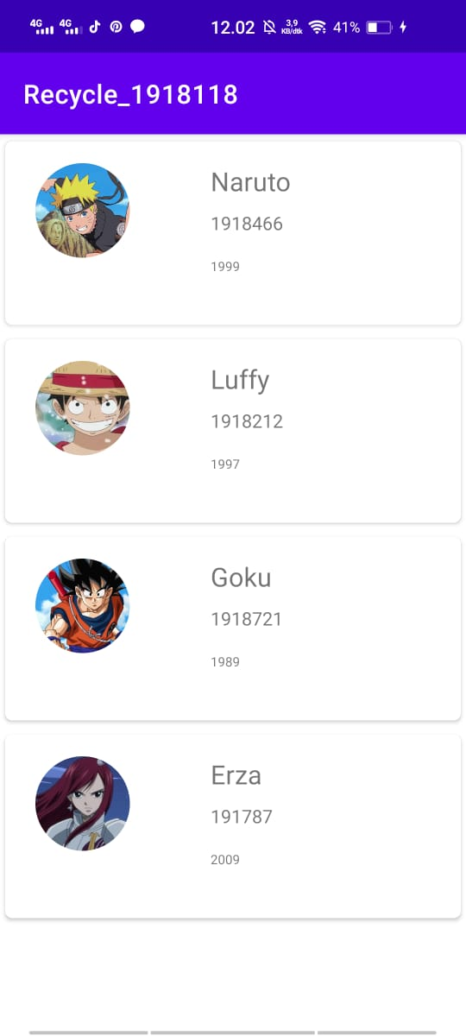Hasil akhir

1. Link Repository Github