**Evaluation Only. Created with Aspose.Words. Copyright 2003-2015 Aspose Pty Ltd.**

请求右边公式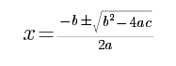的解？

答案为：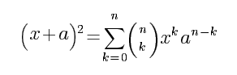

不存在