Instruction using HuaweiLogAnalyser

REQUIRED .NET 8.0 WIN X64 TO BUILD
To build, test and publish program read README.MD

To start program use HuaweiLogAnalyzer.exe (\HEK\publish\win-x64)
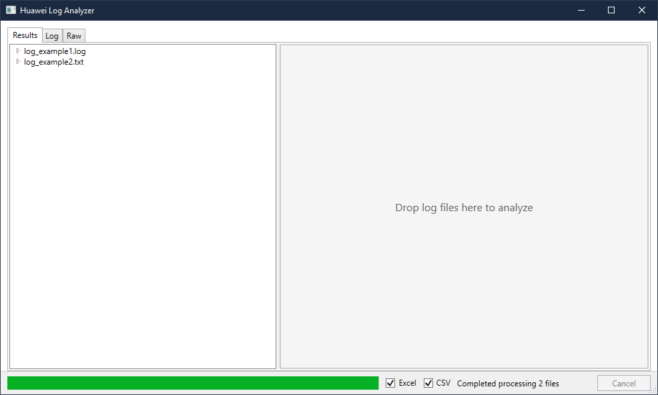
Picture 1 – Main Screen HuaweiLogAnalyser

Here you drop files just dragging from Explorer, you can drag more than 1 file.Before that you should choose in which format to export: Excel, CSV or both. You should choose minimum 1 format.
If process taking too long you able cancel analyzing.
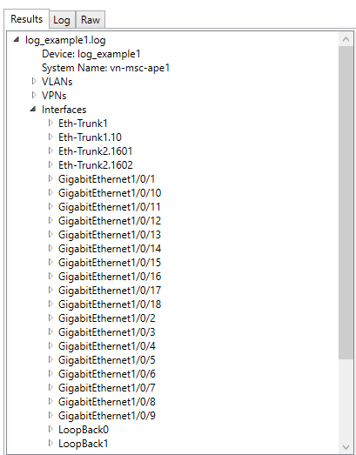
Picture 2 -Parsed in tab Results

Here you can open tree and check needed result.
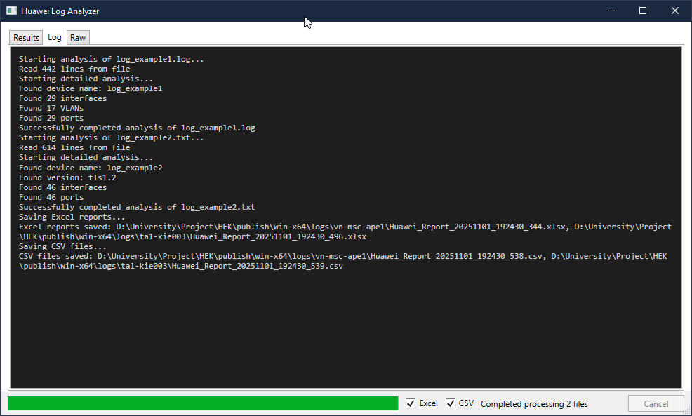
Picture 3 – tab Logs
There you can check stages and processes analyzed files.

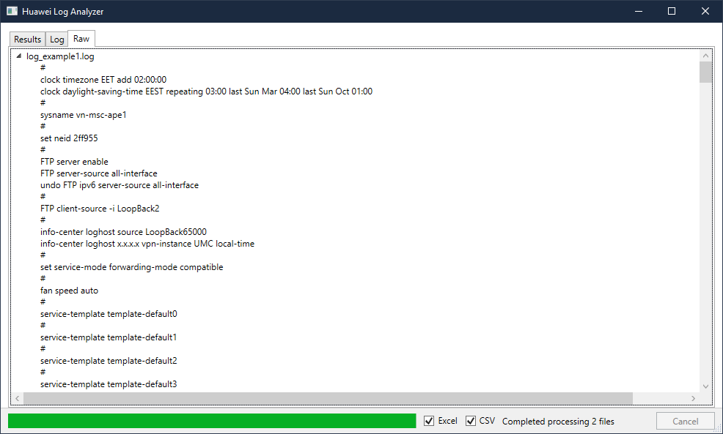
Picture 3 - tab Raw
In tab Raw can check original data from files. Without needed opening them.

