Fairness and Bias in the German Credit Dataset
Marine Regnault
mregnault3@gatech.edu
Abstract—This project examines how fairness metrics can reveal and mitigate bias in a credit-scoring model trained on the German Credit dataset. I selected age as the protected attribute because it is a legally protected characteristic and a common site of disparate treatment in lending decisions. The initial model produced a threshold-based approval rate that favored older applicants, with a Disparate Impact of 0.8763 and a Statistical Parity Difference of -0.1012. After applying a fairness-aware mitigation strategy using different approval thresholds for the privileged and unprivileged groups, the model improved substantially: Disparate Impact rose to 0.9956 and Statistical Parity Difference improved to -0.0032 while profit remained unchanged at 2,290. This exercise made it clear that fairness is not just a statistical question but also a policy and ethical issue, because the same model can appear acceptable by one metric while still disadvantaging a protected group in practice.

Dataset selection
I selected the German Credit Data Set from the UCI Machine Learning Repository for this assignment. I chose this dataset because it is widely used in fairness research and it includes protected attributes such as age, sex, and nationality proxies that make it especially useful for evaluating how bias enters predictive models.
The dataset contains 1,000 observations and 21 variables. One of the major reasons this dataset is valuable for this assignment is that the outcome variable, class, tells us whether an applicant was determined to be a good or bad credit risk, which allows me to connect the model's predictions to a real lending decision and then analyze whether that decision is fair across groups.

Explore the dataset
The dataset contains 1,000 observations and 21 variables, including 7 numerical and 13 categorical attributes. It also includes the outcome variable class, which indicates whether a person is considered a good or bad credit risk. When I examined the data, I found that the protected variables relevant to the assignment were age, personal_status_sex, and foreign_worker.
- Protected variables and legal precedents in the German Credit dataset.
Variable | Protected class | Legal precedent / law
age (Attribute 13) | Age | US Equal Credit Opportunity Act (ECOA); Age Discrimination Act of 1975; Germany General Equal Treatment Act (AGG).
personal_status_sex (Attribute 9) | Sex and marital status | ECOA; Fair Housing Act; Germany AGG; EU Gender Goods & Services Directive 2004/113/EC.
foreign_worker (Attribute 20) | National origin / citizenship (proxy) | ECOA; Civil Rights Act of 1964 Title VI; Fair Housing Act; Germany AGG; EU Race Equality Directive 2000/43/EC.

Defining creditworthiness and preparing the dataset

Outcome variable
For the German Credit dataset, the outcome variable is class. A value of 1 denotes a good credit risk and a value of 2 denotes a bad credit risk. This target aligns well with a creditworthiness model because it reflects whether the applicant was historically viewed as likely to repay the loan.

Creditworthiness formula
I trained a logistic regression model on the training data and converted the predicted probability of being a good credit risk into a score from 0 to 100. The formula is Creditworthiness = 100 / (1 + exp(-z)), where z = b0 + Σ(bi × xi). The resulting score is transparent and interpretable, making it a strong fit for a fairness analysis built around a standard probabilistic classification method.
The model excludes protected information such as age, personal_status_sex, and foreign_worker, consistent with the assignment requirements. That restriction matters because even with strong predictive accuracy, it is ethically unacceptable to use protected class status in the lending formula. The score instead relies on variables like duration, credit amount, installment rate, and employment-related attributes that are not legally protected.

Protected attribute and groups
I evaluated age as the primary protected attribute to align the analysis with legal frameworks such as the Equal Credit Opportunity Act and to reflect a common source of disparate treatment in lending. The privileged group includes applicants older than 25, while the unprivileged group includes applicants age 25 or younger.
- Protected-group counts in the train/test split.
Group | Training set | Testing set
Privileged: Old (age > 25) | 408 | 402
Unprivileged: Young (age <= 25) | 92 | 98
Total | 500 | 500

Maximizing profit

Histogram of creditworthiness
The predicted creditworthiness scores are spread across a wide range, with many applicants concentrated in the middle and upper band. That distribution supports a threshold that separates stronger and weaker applicants while preserving a realistic lending decision process.
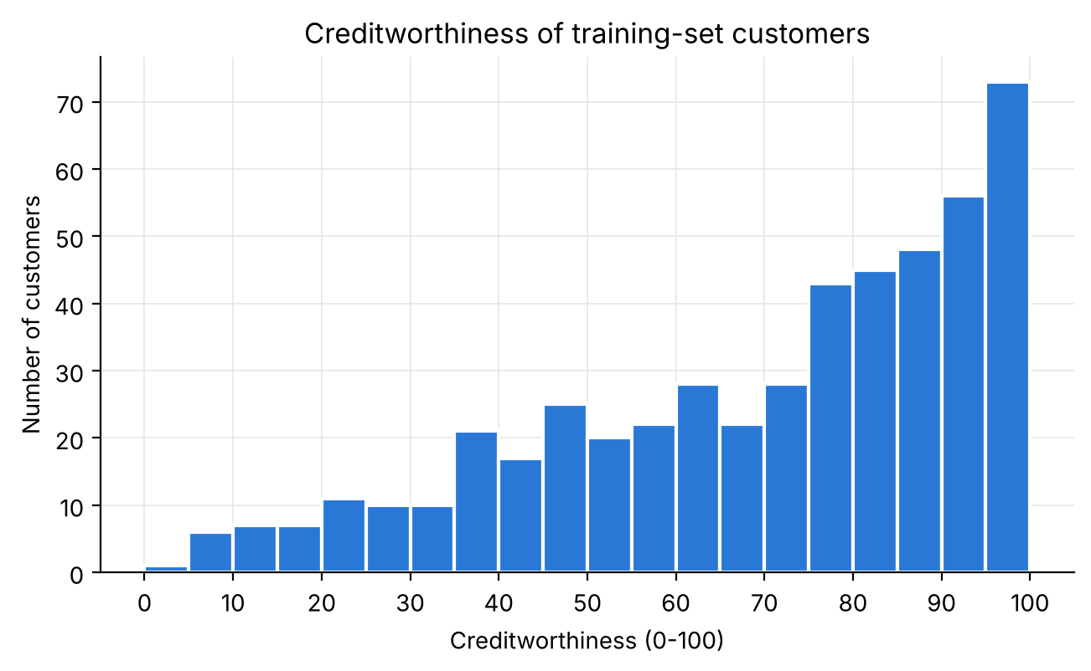
- Histogram of predicted creditworthiness for the training set.

Profit-maximizing threshold
The profit-maximizing cutoff in the training set was X = 48, producing a maximum profit of 2,290. This cutoff reflects the assignment's cost structure: approving a truly good applicant yields profit, denying a truly good applicant reduces profit, approving a bad applicant is costly, and denying a bad applicant is neutral. It also offered the strongest balance between practical lending decisions and the model's economic objective.
At this threshold, the model approves 80.0% of applicants and yields 321 true positives, 26 false negatives, 79 false positives, and 74 true negatives. In other words, the model is making a large number of useful approvals while still screening out many risky applicants. I did not choose a threshold of 0, because approving everyone would not be a realistic or responsible credit decision.
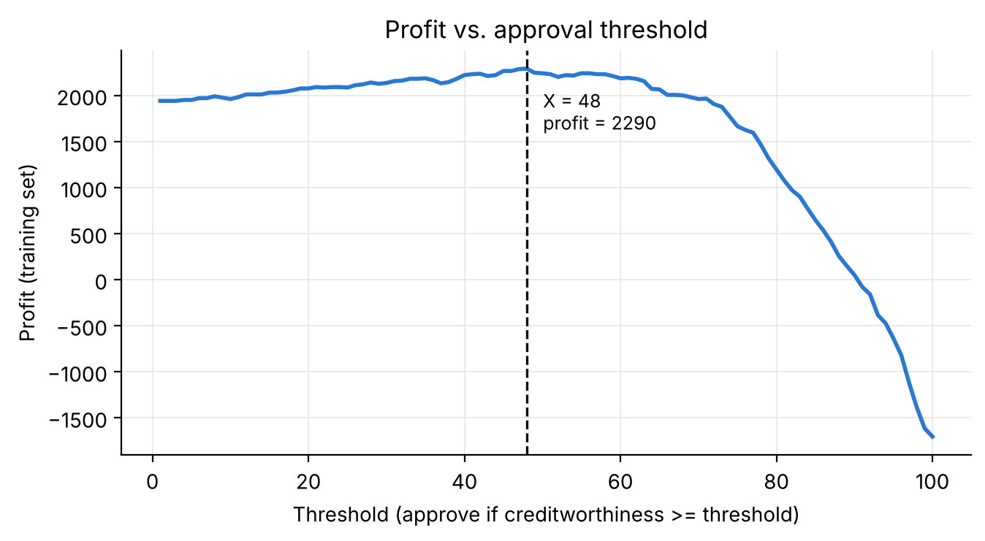
- Profit curve for candidate approval thresholds.

Favorable and unfavorable outcomes
- Favorable versus unfavorable outcomes at the profit-maximizing threshold.
Group | Favorable (Approved) | Unfavorable (Denied) | Total | Approval rate
Privileged: Old (age > 25) | 334 | 74 | 408 | 0.819
Unprivileged: Young (age <= 25) | 66 | 26 | 92 | 0.717

Fairness metrics

Metric selection
I used Disparate Impact and Statistical Parity Difference because they are standard fairness metrics and they make it straightforward to compare approval outcomes for the privileged and unprivileged groups. In this context, they indicate whether the model treats applicants unequally based on age.
The approval rate for the privileged group was 0.819 while the unprivileged group received approval at a rate of 0.717. This produced a Disparate Impact of 0.8763 and a Statistical Parity Difference of -0.1012. These values suggest that the model was slightly favoring the older group, even though the score itself was not explicitly based on age. The fact that a model can create this pattern without using a protected variable is one of the central lessons of this assignment.
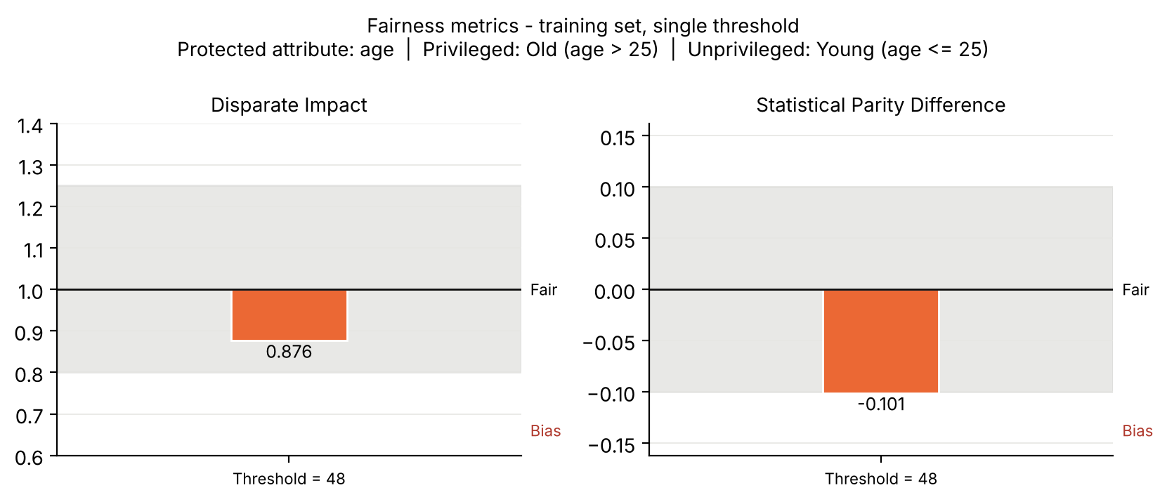
- Fairness metrics for the single-threshold model on the training set.
- Fairness metrics for the single-threshold model on the training set.
Fairness metric | Definition | Computed value | Ideal value | Bias interpretation
Disparate Impact | P(approved | unpriv) / P(approved | priv) | 0.8763 | 1.0 | No significant bias; within acceptable range [0.8, 1.25]
Statistical Parity Difference | P(approved | unpriv) - P(approved | priv) | -0.1012 | 0.0 | Bias slightly favors the privileged group; near the fairness threshold

Mitigate bias in the training set

Different thresholds by group
I reduced the disparity by assigning different approval thresholds for the privileged and unprivileged groups. I set a privileged threshold of 58 and an unprivileged threshold of 48, then optimized these values with Disparate Impact as the fairness objective while preserving profit. The threshold adjustment directly targeted the unequal approval rates without changing the underlying creditworthiness score itself.
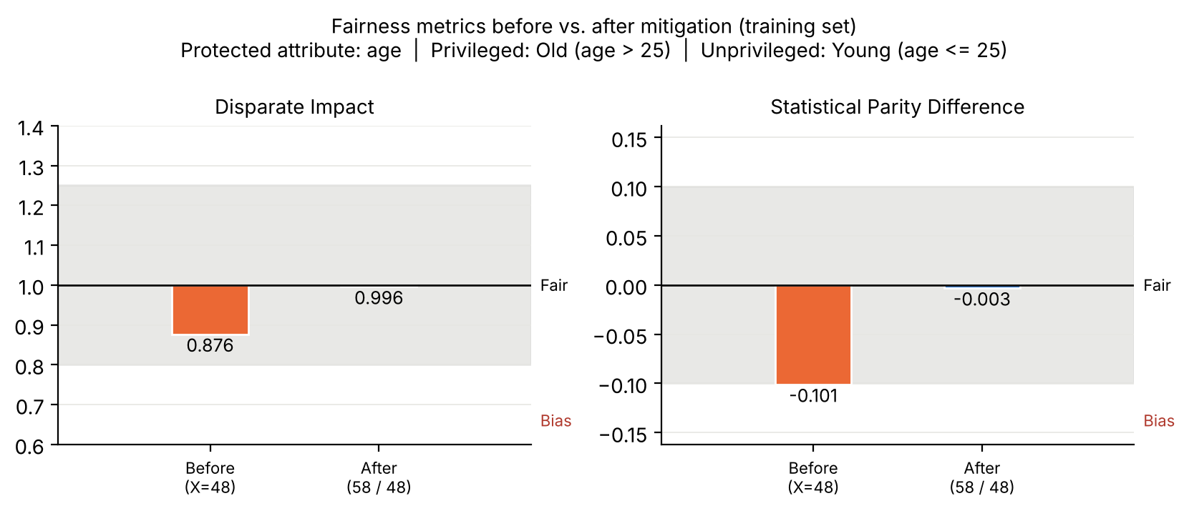
- Fairness metrics before and after mitigation.
- Optimized thresholds and resulting approval rates after mitigation.
Group | Threshold | Approval rate
Privileged: Old (age > 25) | 58 | 0.721
Unprivileged: Young (age <= 25) | 48 | 0.717

The updated thresholds preserved profit at 2,290 while narrowing the approval-rate gap. After mitigation, the privileged approval rate was 0.721 and the unprivileged approval rate was 0.717. The resulting fairness metrics were a Disparate Impact of 0.9956 and a Statistical Parity Difference of -0.0032, both close to parity and well within the fair range. The model therefore became more equitable without sacrificing its financial performance.

Step 6.3 — Histograms by Group
The histograms below show how the protected groups differ in their score distributions after the fairness-aware threshold adjustment. I split the plots by group to show where the score distributions diverge and how the threshold adjustment affects approval outcomes for each population. Presenting the groups separately makes the fairness intervention easier to interpret.
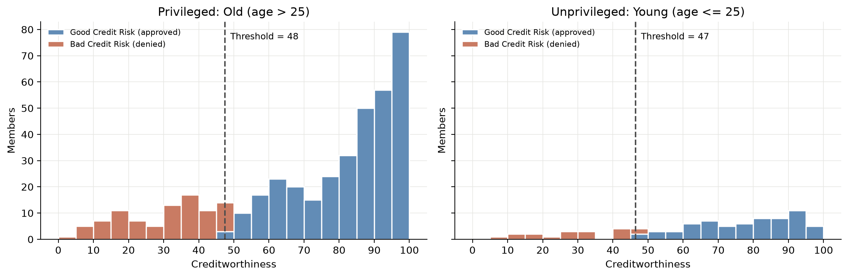
- Figure 5. Creditworthiness distributions for the privileged and unprivileged groups, shown separately by group.

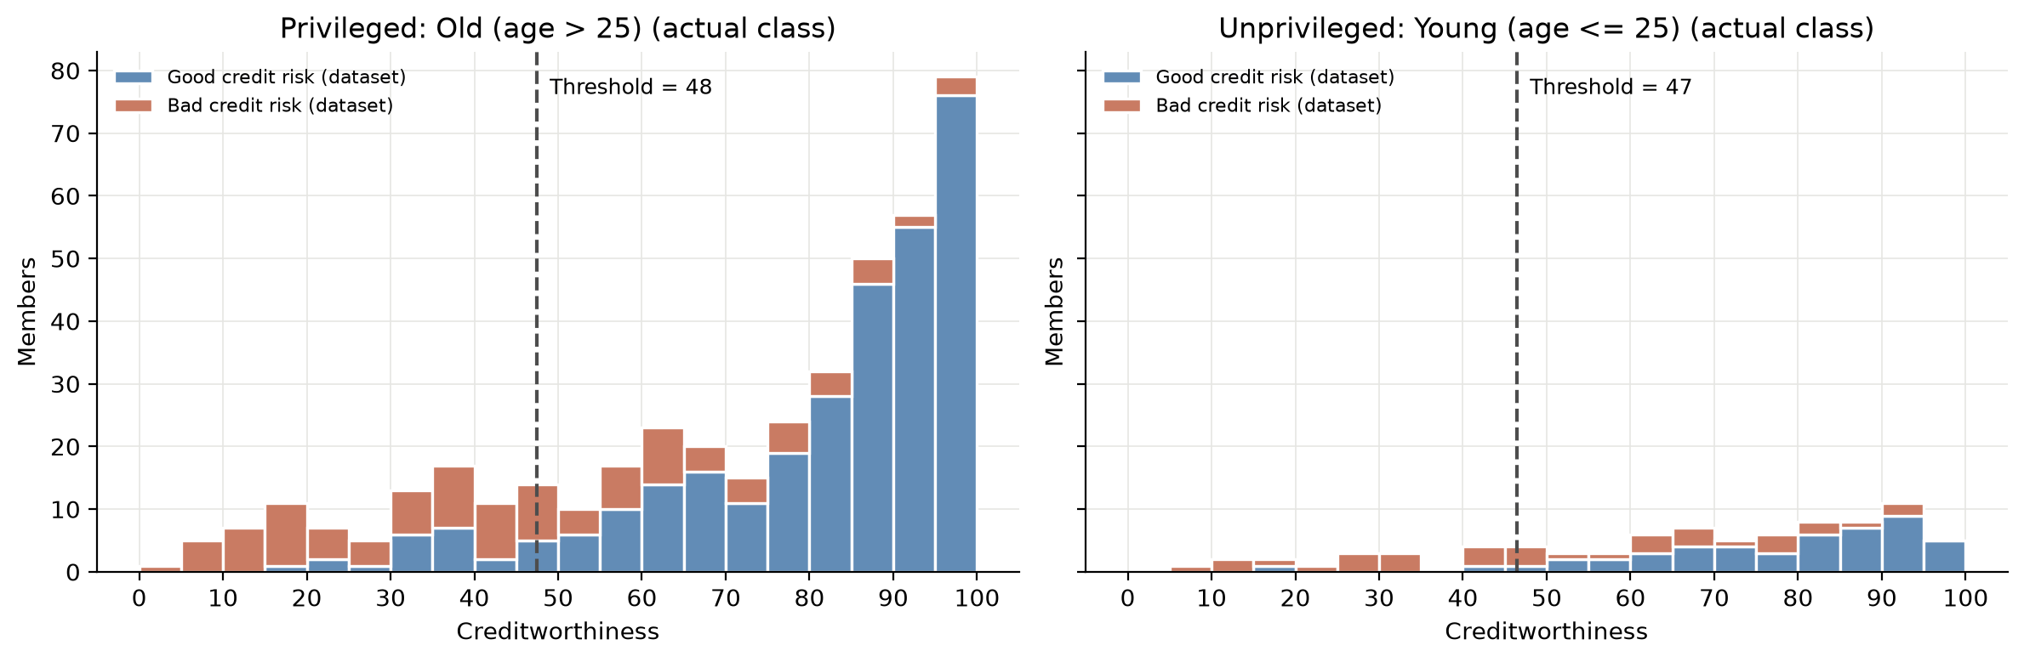
- Figure 6. Creditworthiness distributions by group, colored by actual good-versus-bad credit outcome.

Post-mitigation analysis
The fairness metrics indicate that the single-threshold model initially favored the privileged group. Although the original Disparate Impact remained within a broadly acceptable range, the Statistical Parity Difference showed that younger applicants were approved less often than older applicants. The gap shows why a single metric can hide inequity in real lending decisions.
The mitigation reduced the disparity between the groups without lowering profit. By requiring the privileged group to clear a stricter threshold, I narrowed the approval-rate gap while keeping profit constant at 2,290. The improvement in fairness without a loss in profit suggests that equity and economic utility are not necessarily in conflict. It also reinforces the need for careful threshold design in real settings, because small changes in policy can have outsized effects on group outcomes.
There are still important limitations to this approach. A fairness intervention that works for one metric may become less effective under another, and the underlying score can still reflect historical inequities present in the dataset. In other words, fairness is context-dependent and cannot be solved by a single technical adjustment alone. For this reason, I would treat mitigation as one part of a broader process involving auditing, policy review, and continual evaluation rather than as a complete solution to bias in lending decisions.

References
- Bellamy, R. K. E., Dey, K., Hind, M., et al. (2019). AI Fairness 360: An extensible toolkit for detecting, understanding, and mitigating unwanted algorithmic bias. IBM Research.
- Castelnovo, A., Crupi, R., Regoli, A., Penco, C., & Cosentini, A. (2022). A clarification of the nuances in the fairness metric landscape. Scientific Reports, 12(1), 1–18.
- Google PAIR. (2018). The What-If Tool: Code-free probing of machine learning models.
- Kamiran, F., & Calders, T. (2012). Data preprocessing techniques for classification without discrimination. Knowledge and Information Systems, 33(1), 1–33.

