UR Territory Optimization Solution
- Home Page for URC:
Each Block represent a territory while color represents its performance based on the currently selected HeatMap (Currently: Market Share)

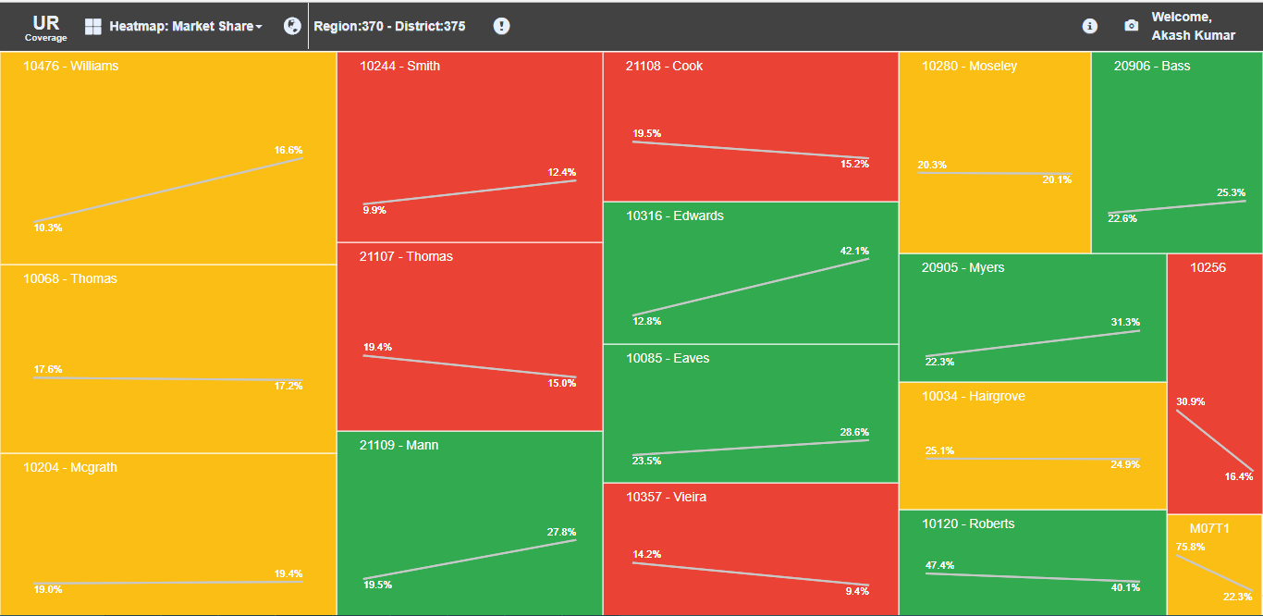
Size of the box represents Forecast (Market Potential) for the territory.
Larger the size larger the potential of the territory, which is also the HeatMap selection right now.

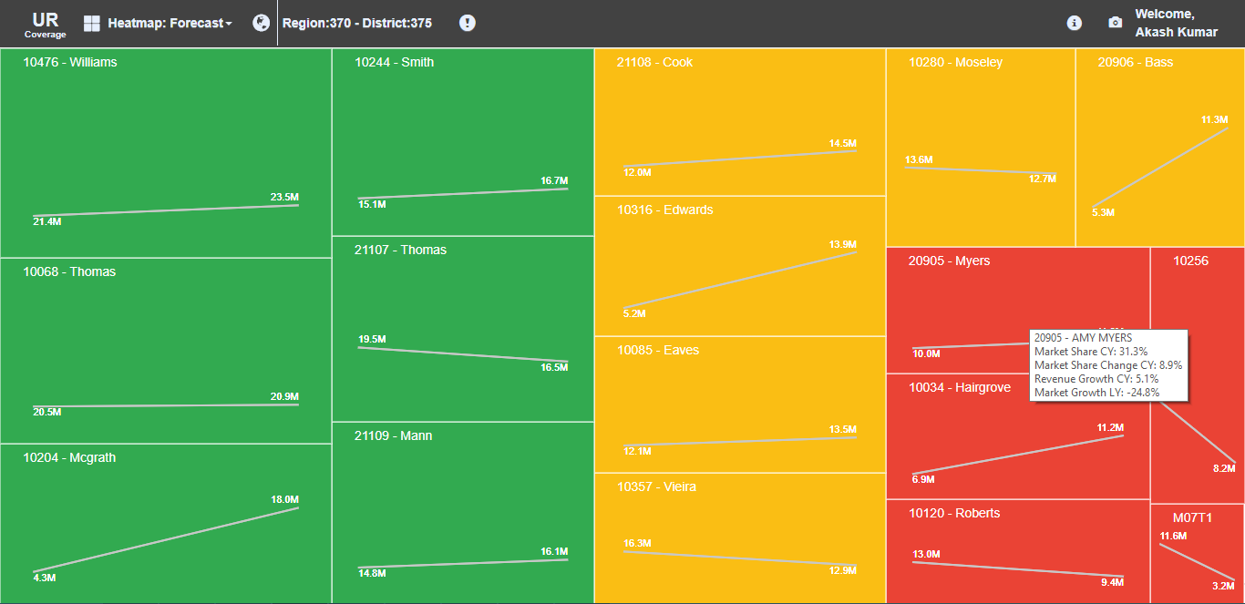
- Map view of the application:
Navigating to Map where user can see whole district in a view. For UR main users are District Managers.

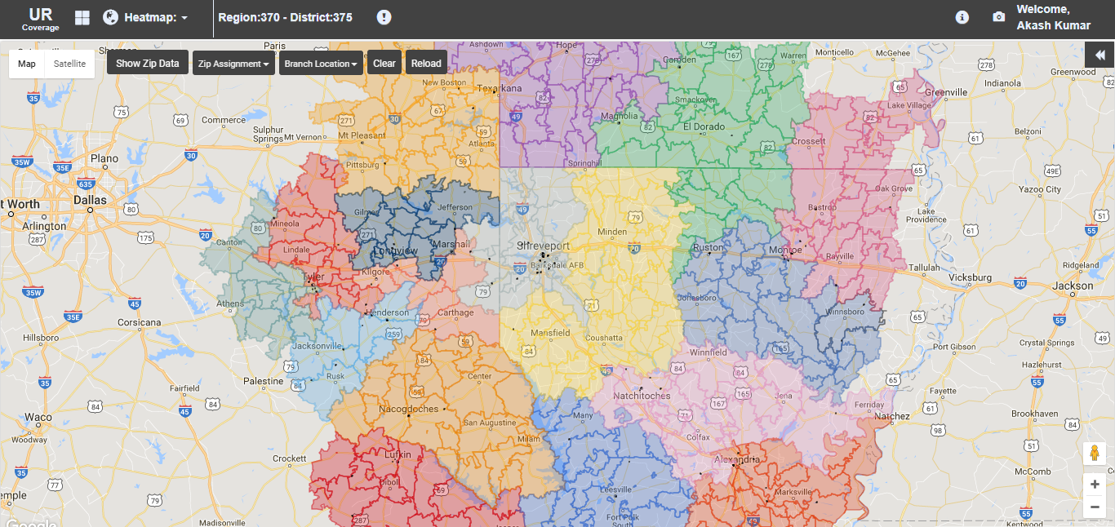

Table on the right-hand side shows the territory details:
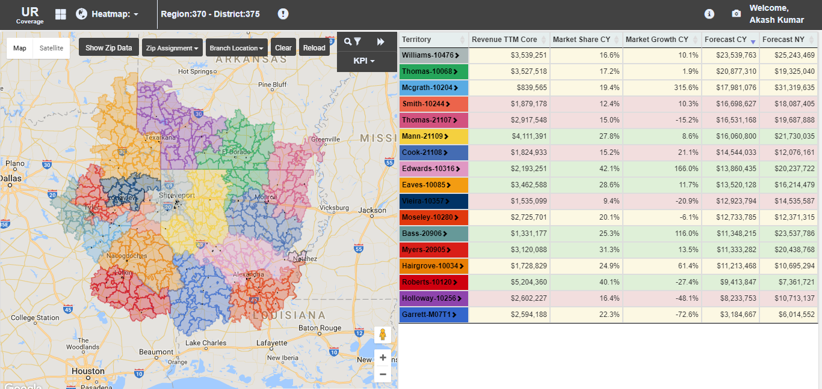

- Comparison view:
Comparing performances of two territories:
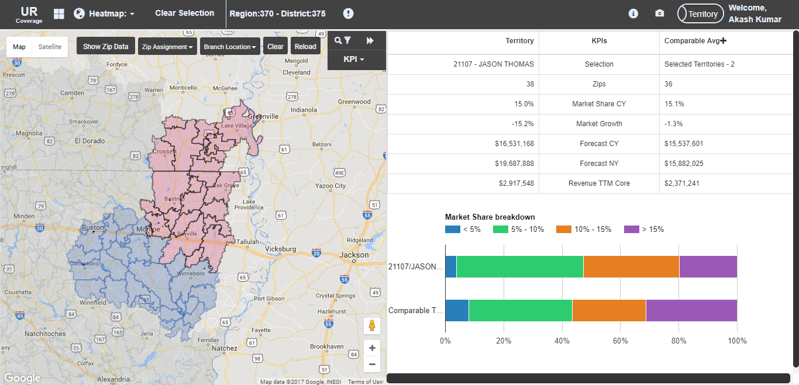

- Realignment view:
Realigning zips from one territory to another
