Issues/glitches with the portal:

- Clients are completing their forms and not moving from screened to forms completed! This means that we have had calls from parents saying we haven’t replied to their completed forms but we cannot see them as completed and therefore can’t find them.
The only current way to rectify this is to move them from ‘screened’ into ‘matched’ manually which then allows me to click on the 3 dots and ‘view responses’.
However we have no way of checking who on the screened column has completed the forms unless we do this step manually!
Also we can’t move the clients from screened to ‘completed forms’ manually, the system won’t let us complete this step. So they either have to stay in ‘screened’ or move to ‘matched’
This is what it comes up with when I try:
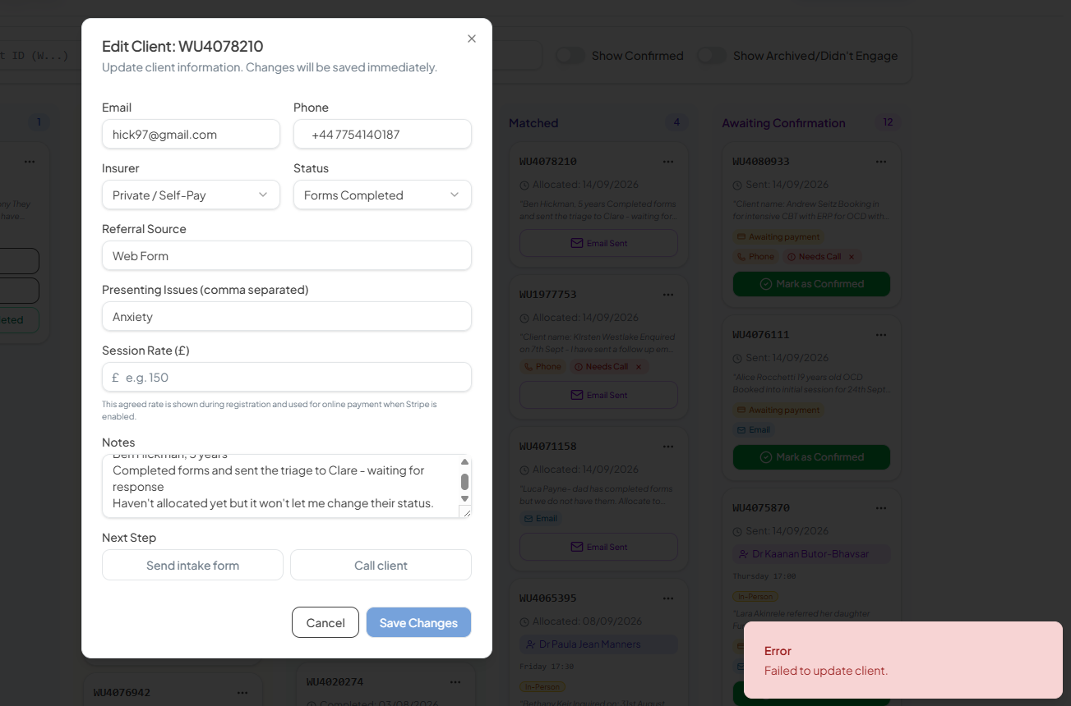
- Clinicians/admin can’t delete slots from the availability calendar (even after refreshing the website)
Some slots are working and some slots aren’t (i.e., Wednesday at 12pm)
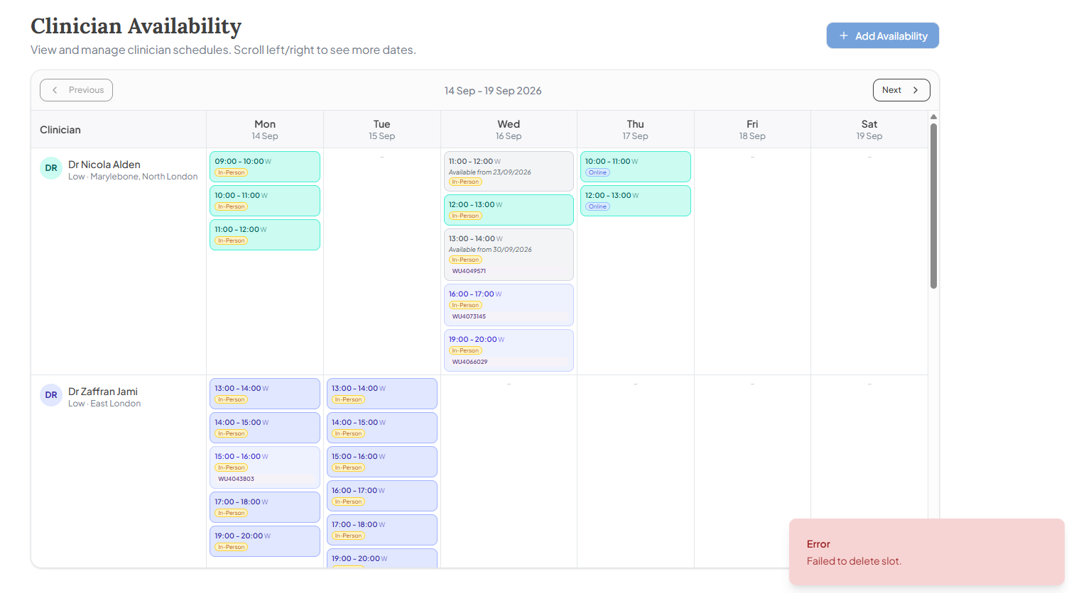

There is also the following availability for Dr Alden but I then can’t select half of the available slots when I go to allocate them to the chosen slot (this includes the slots that don’t have WU numbers allocated to them)
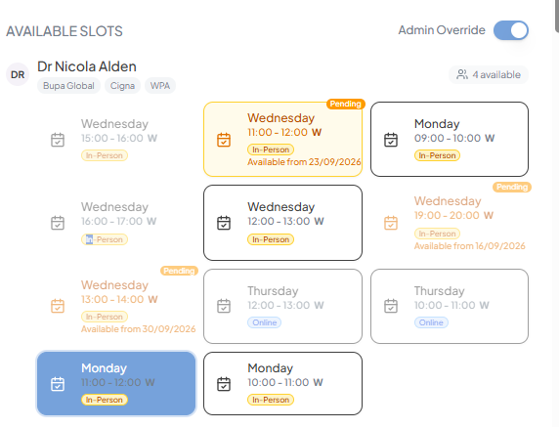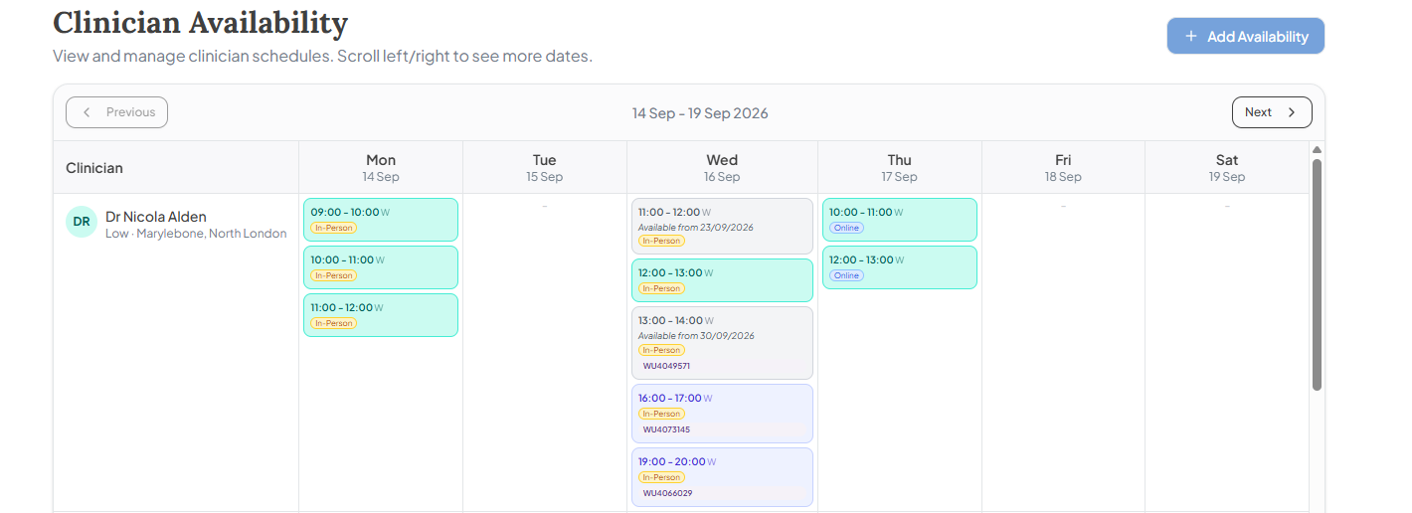

- Website need to be refreshed every 30 minutes - is there a way to delay the need for this
- Once we have allocated a client to ‘options sent’ (i.e., we have sent the clinician availability through the system) the client information disappears and all we can see is their WU number which makes it really hard to keep easy track of the individuals
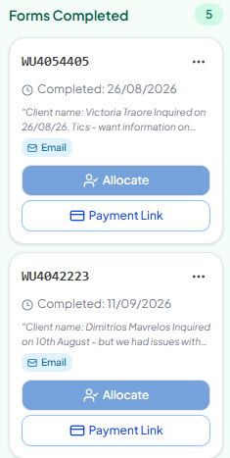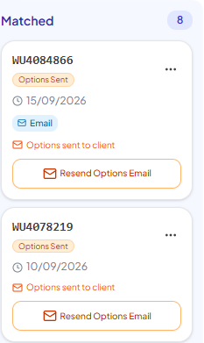

- I also cannot select when a clinicians appointment time has been confirmed:
- 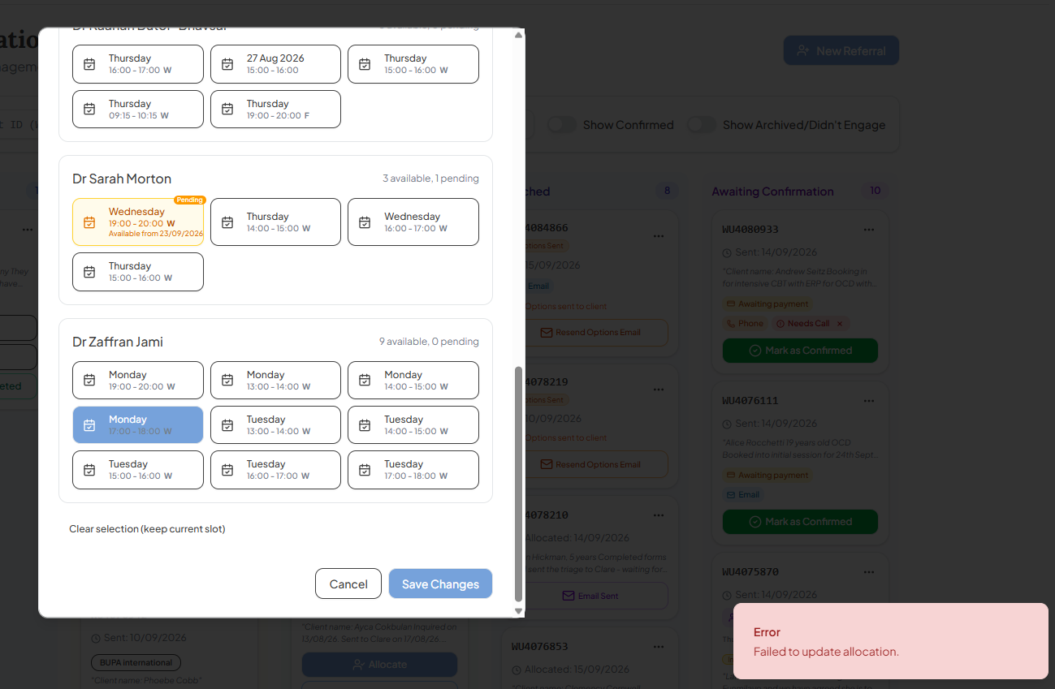
This means that I can’t book it in through the portal and need to manually move them to ‘awaiting confirmation’ and then delete the available slot off the calendar manually.

- Once someone is in matched I can no longer view their responses to the inquiry form:
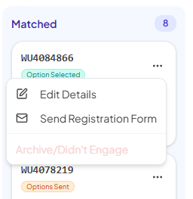
I also can’t access their payment link in this stage either. This means I have to manually move them to waiting confirmation before I can do this.

- We cannot see when the registration forms have been sent through the portal and have no indication of when they have been completed and sent back.
Could there be a button that indicates that the registration form has been sent
And then a button that indicates the registration forms have been received?

