What is Latency?

To sending data to Point A to Point B. It will take some time . That time is called Latency. If you have more distance . we have more latency . This is very obvious network terminology.

Now we should understand what is connection between latency and Region.

What is a Region?
AWS has data centers all over the world. These locations are called Regions.
Example:
First User case: To Avoid Latency
If your business is in India but your application is hosted in a US data center, when a user in India accesses the application, the data has to travel a very long distance. Because of this long distance, the response will be slower. This delay is called latency.
Instead of hosting the application in the US, we can host application in an India region.
When the application is hosted closer to the users(example India user), the data travels a shorter distance, and the application responds faster.
So, choosing the nearest AWS Region helps to reduce latency and improve performance.
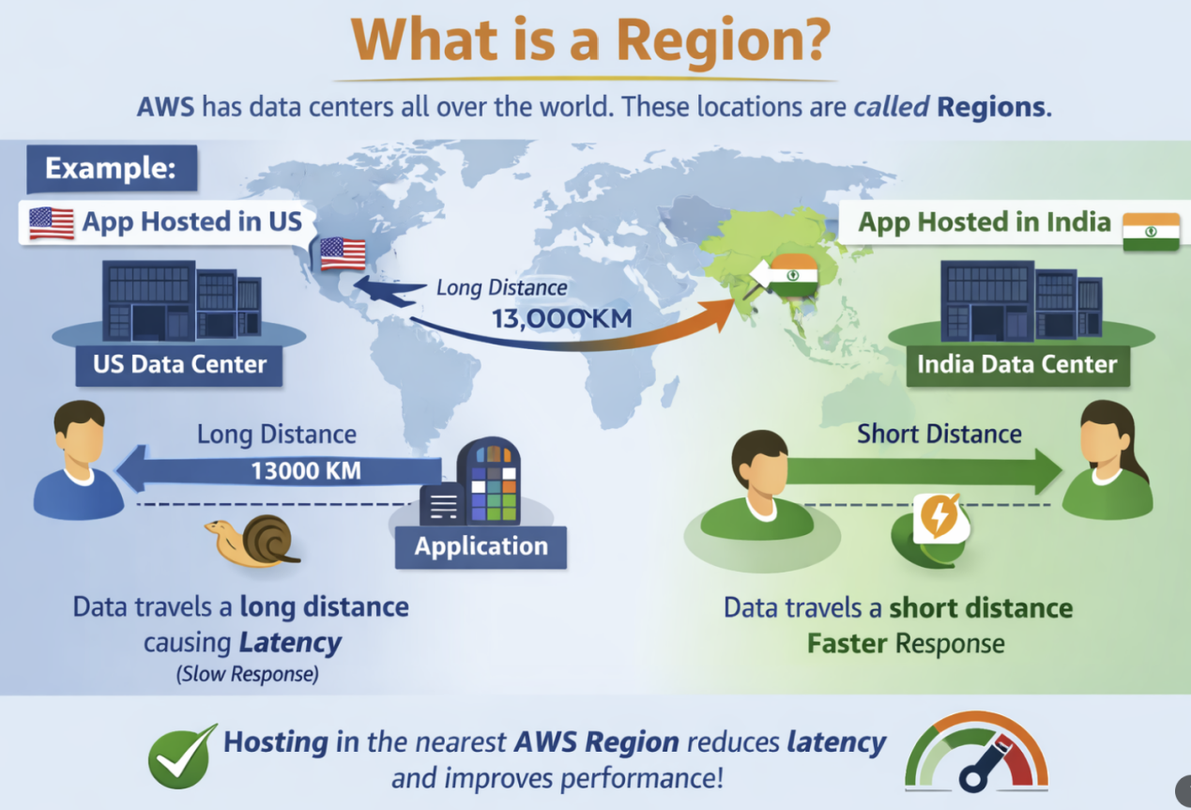

Second Use case: Follow the Indian Digital Data Act.
India Government having a Digital Data Act.
According to the Digital Data Act, the government has announced that data must be localized.
Data localization means:
If you are doing business in India and you collect personal data of Indian users, that data must be stored inside India.
If you want to transfer the data outside India, you must first get permission from the Indian Government.
When you host your application in the India AWS Region, Amazon will not store or copy your data to any other region by default. Your data stays within India unless you configure it otherwise.
- If you host your data in the AWS India Region
- AWS will not move or copy your data to another region by default
- Data stays within that region
Note: Only if YOU configure replication (backup, DR, cross-region copy), then data moves.
So, by hosting data in the India region, we can follow government rules and ensure compliance with the Digital Data Act.
Avaliabiltiy zone:
Inside the Region we have Availability Zone(AZ)
AZ means it is actual data center or collection of data center.
Region is just Geo-Graphical Boundary, but inside the Region we have Availability zone.
For example:
In India AWS has ap-south-1 Region - mumbai region. In this region they have three Data center facilities . Both Data center having high speed connectivity.We can called it low latency high speed connectivity.
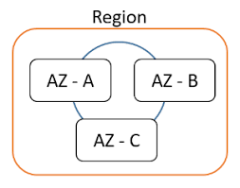

In mumbai three data centers placed in different location
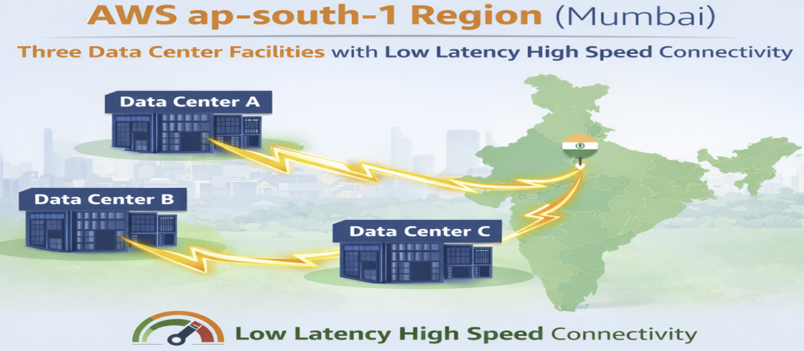
So three different data center , we call it availability zone . Each of this three AZ having different source of Electricity, different source of water supply so if any one of AZ down , another AZ will support . Those AZ connected together low latency with high speed fiber optic Cable. Those AZ build together 100KM distance.
So if it critical application, This case hosted the application in multi AZ , if one AZ has failed , Application is running in another AZ . So we can maintain the high availability.
Local Zone:
It is also data center facility , but is developed out of the region., but it is related to parent region.
AZ with in the region , Local zone out of the Region
Main use of AZ it provide the high availability.
Main use case Local Zone to Provider Low latenency access to the user.
Feature | Availability Zone | Local Zone
Location | Inside Region | Outside Region
Purpose | High availability | Low latency
Used for | Fault tolerance | Fast response
Example use | Banking app | Gaming / Video

Real-time example (VERY EASY)

Without Local Zone ❌
- User: Chennai
- App Region: Mumbai
- Data travels far

- Response is slower

With Local Zone ✅
- User: Chennai
- App runs in Chennai Local Zone
- Data travels very short distance
- Response is very fast

Important point to remember
AZ = High Availability
Local Zone = Low Latency
AZ is inside Region
Local Zone is outside Region but connected to it

What does “connected to a parent Region” mean?
Parent Region = Main AWS Region
Local Zone = Extension of that Region

Simple meaning:
A Local Zone does NOT work alone.It depends on the main (parent) Region.

Step-by-step explanation

Example:
Parent Region: Mumbai (ap-south-1)
Local Zone: Chennai (example)
Chennai Local Zone is linked to Mumbai Region using AWS private high-speed network.

What happens because of this connection?

1, Control stays in the Region
- VPC
- IAM
- Route tables
- Security groups
- Monitoring
All these are managed from the parent Region, not from Local Zone.

2. Data & services come from Region
- Databases (RDS)
- S3
- DynamoDB
- CloudWatch
These services usually run in the parent Region
Local Zone uses them through the connection.

3.Compute runs closer to users
- EC2
- EBS
- Load Balancer (some types)
These can run in Local Zone for low latency

Very simple analogy :

Think like this:
Head Office = Parent Region
Branch Office = Local Zone
Branch cannot work alone
All rules & data come from Head Office
Branch is close to customers → faster service

One-line meaning (Easy)
“Connected to parent Region” means Local Zone works as part of the main Region and depends on it for services, control, and data.

Super simple analogy :
Main house = Region
Nearby shop = Local Zone
- Shop is outside the house
- But electricity, rules, control come from the house
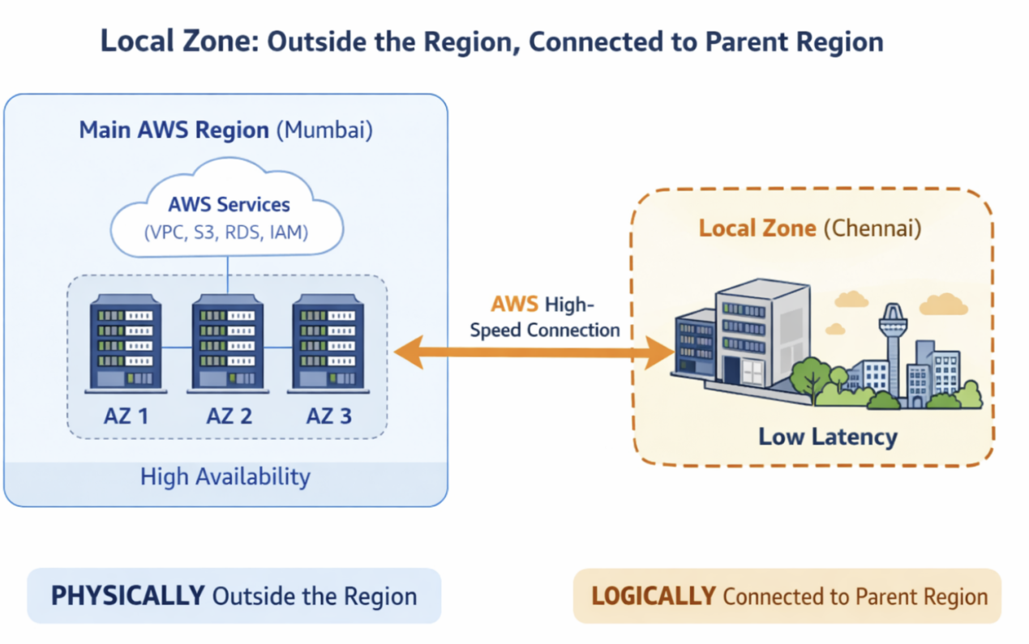
AWS - WaveLength:
Now a days users using mobiles instead of using laptop or desktop.
There are many application and companies building the application specifically Mobile.
Mostly all the data center connect with Wired network. But if you have application particularly for mobile users . if you want to host this application on 5G network only.
So this case Application hosted on the 5G network, So this kind of scenario we can host the application in AWS wave length.

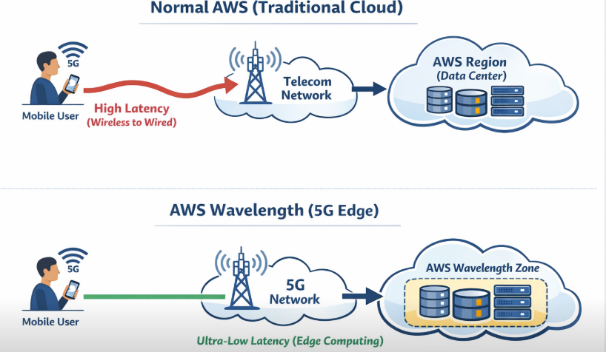

What is an AWS Region?
An AWS Region (like us-east-1, ap-south-1) has big AWS data centers.
These are far from mobile users.
Good for normal web apps, but not ideal for ultra-low latency mobile apps.

What is a Wavelength Zone?
A Wavelength Zone is NOT inside the AWS Region data center.
It is located inside the telecom provider’s 5G network (like Verizon, Airtel, Jio, etc.).
It is physically closer to mobile users.
So yes, it is outside the traditional AWS Region, but t is logically connected to the AWS Region.
Component | Location
Application (EC2 / EKS / ECS) | ✅ Wavelength Zone (5G network)
Database / S3 / DynamoDB | ✅ AWS Region
Monitoring / IAM | ✅ AWS Region

Without Wavelength
Mobile → 5G → Internet → AWS Region → App

With Wavelength
Mobile → 5G → Wavelength Zone → App (Very Fast)
↓
AWS Region (DB, S3)
Note:“Applications run in AWS Wavelength Zones, which are outside the normal AWS Region data centers and located inside the 5G network, but they are still connected to the parent AWS Region.”
AWS Outposts:
- Today, many companies use a Hybrid Cloud, which means a mix of private cloud (on-premises) and public cloud (AWS).
- The main challenge in hybrid cloud is infrastructure management.
- Private cloud and public cloud usually use different tools and different management systems.
- Because of this, companies may need different experts for each environment, which makes management complex and costly.
- To solve this problem, AWS provides a service called AWS Outposts.
- With AWS Outposts, AWS installs its own hardware in your on-premises data center.
- This hardware runs AWS services locally, inside your private cloud.
- The best part is, both on-premises and AWS cloud resources are managed using the same AWS Console.
- This allows companies to use hybrid cloud without using different tools.
- We can manage public cloud and private cloud together from one AWS Console.
Conculsion:
“AWS Outposts brings AWS infrastructure to on-premises environments, allowing us to manage both private and public cloud using a single AWS Console.”
Outposts = AWS hardware in on-premises, managed like AWS cloud
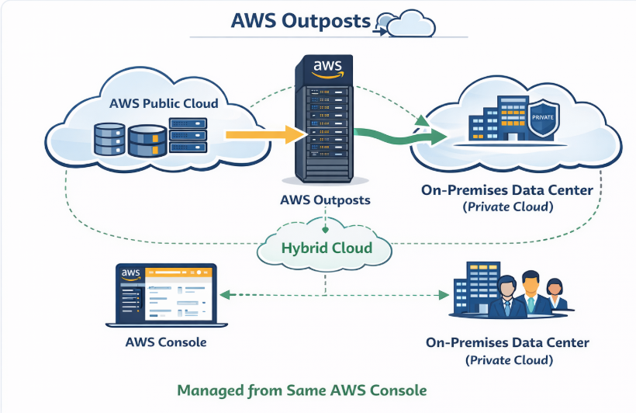
Edge Location:

Edge Location – Simple Explanation
To understand Edge Location, first we need to understand CDN (Content Delivery Network).

What is CDN?
CDN (Content Delivery Network) is a network of servers distributed across multiple geographical locations.
Its main purpose is to deliver content to users with low latency and high speed.

Real-Time Example: OTT Platforms (Netflix, Prime Video, Hotstar)
Today, when we watch movies on OTT platforms, we often get 4K quality videos without buffering.
Is this happening automatically?
No. This is possible because OTT platforms use CDN technology.

Why CDN is Needed
Movies and videos are static content:
They do not change frequently
Once uploaded, the content remains the same
Instead of serving this content from one central location every time, CDN caches the content closer to users.

Example Scenario
User location: Gujarat
Netflix origin server (main data center): Mumbai
If every request goes directly from Gujarat to Mumbai:
- Network latency increases
- Video buffering may occur
- High-quality streaming becomes difficult

How CDN Solves This Problem
Netflix copies (caches) movie content from the origin server (Mumbai) to CDN locations near users
Many CDN servers are placed inside or close to ISP networks. Which means physically place CDN servers inside or next to ISP data centers.
When the user plays a movie:
The request is served from the nearest CDN location
The request does not go to the origin server
Result:
- Very low latency
- High-speed delivery
- Smooth 4K streaming experience

ISP-Level Caching
Large OTT platforms often:
Partner directly with Internet Service Providers (ISPs)
Cache content inside ISP infrastructure
This provides extraordinary speed and quality.
However:
Small companies cannot easily negotiate with ISPs
It requires huge scale and cost.

AWS Edge Location
AWS provides its own global CDN network called Edge Locations.

What is an Edge Location?
Edge Locations are AWS CDN data centers
Used only for caching and content delivery
Located very close to end users across the globe

How Small Companies Use Edge Locations
Small businesses don’t need to work with ISPs directly.
Instead, they can:
Upload content to AWS (S3 / ALB / EC2)
Use AWS CloudFront
CloudFront automatically caches content at Edge Locations
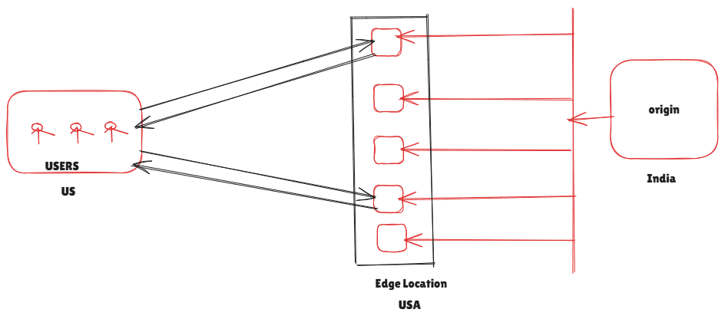
Conculsation: AWS Edge Location is part of CloudFront CDN. It caches static content near users to reduce latency and deliver fast performance without depending on ISP tie-ups.
Regional edge Caches:
Edge location are having low capacity of storage. Regional edge caches , it huge than edge location. Regional edge can able to handle many edge location.
AWS having 350 + edge location, 13+ Region edge cache is there , Because one regional edge cache can able to mange multiple edge location. The role of regional edge cache to get maximum data from origin. Whenever user send request it will not directly go to origin, the request will regional edge cache. So we can save our origin to get more request

Real-Time Example (OTT / Website)
- First user watches a movie
- Data comes from Origin → Regional Edge Cache
- Next 1,000 users:
- Served from Edge / Regional cache
- Origin is protected from traffic spikes
Note: Edge locations alone are not enough because they have small storage. Regional edge caches are used to reduce origin load and support many edge locations.
We can use edge locations directly, but regional edge caches are needed because edge locations have limited storage and regional caches reduce origin traffic and support multiple edge locations.
Edge locations are small and fast; regional edge caches are bigger and protect the origin by serving many edge locations.
Edge locations have low storage capacity, so they cannot store large or less-frequently accessed data. In this case, the request does NOT go directly to the origin first — it goes to the Regional Edge Cache. Only if the data is not found there, then it goes to the origin.
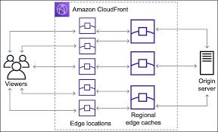

User
↓
Edge Location (cache miss)
↓
Regional Edge Cache
↓ (only if cache miss)
Origin

