EC2 : Elastic Compute Cloud ( Terminology is E one time and c two time (c2))

Ec2 is platform , Using this Platform we can create and manage Virtual machines

If you looking below picture: AWS categorizes with them name

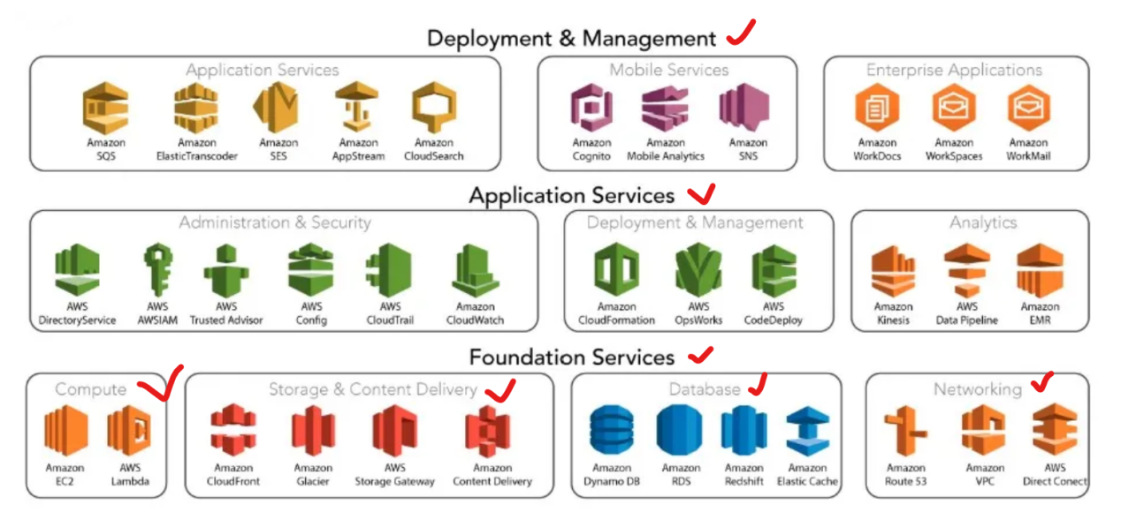

Ec2 is one of the most important Compute Service:

Here we can create and manage Virtual machines. Virtual machines management is most important points here.

Before jump to EC2 dashboard

We should know how ec2 work ? what is virtual machine ?

In Real world scenario there is physical Servers

Physical servers are mainly Tower, Rack, Blade, Micro, Mainframe, GPU, and Bare-Metal servers, used based on size, performance, and workload.

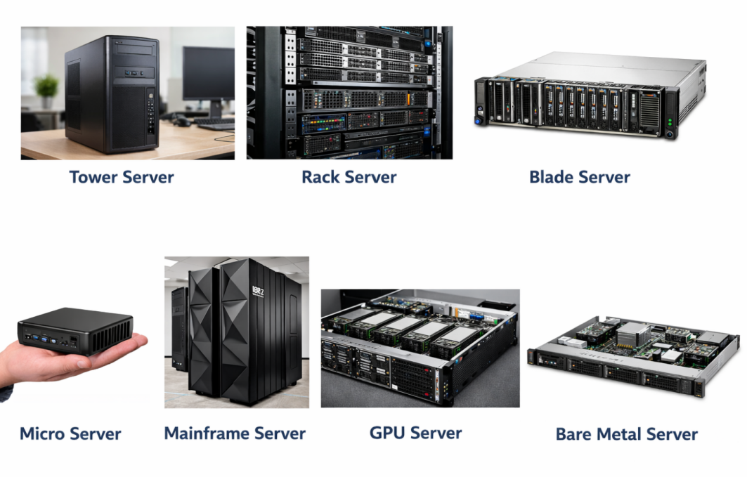
Tower server: if your are requirement is very high. If you need 50 or 60 servers . Managing this servers is physically it is actually hard.

Rack Server: This kind of server we can easily fitting to rack

Blad server: Suppose if you requirement of 1000 of servers. It would be good go with blad server.

Now Those severs capacity is actually too high. If you purchase this type of servers

Spec would be

16 core Cpu

128 GB RAM

Capacity of servers is very high , if you have high capacity how we can use it

If you need to use those servers , first thing we need to install the OS inside the server

Before 2000 it was problematic because , if you have this type of server we able to install only one OS in the server.
If you have high operating server, if you install only one OS in the server. We are not able to utilize whole server, there will be lot of resource wastage and cost.

To solve this problem the company called VM ware introducing the concept of virtualization. For normal system for enterprise system VM ware introduced the concept of virtualization. Using this concept of virtualization. We can create or install multiple OS inside the single server box.

Note: Using this concept we can install and Running simultaneously at a time Linux, Windows OS in single server box.

How it is possible ?

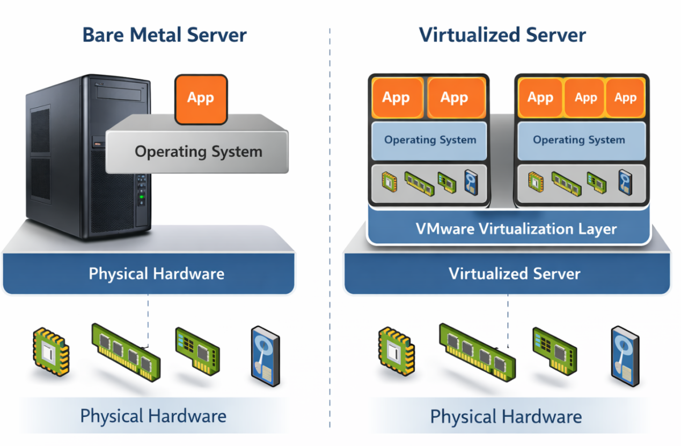

The Name of the VM Ware hypervisor is es-xi , same way Microsoft also develop hypervisor hyper V

Hypervisor having capability to share physical hardware Among Multiple system , We have to create virtual system in one physical box, so here we have virtual system , that’s why we called as VM.

So if you look at the picture it mean using one hardware , we can run multiple OS at a time simultaneously.

Now Physical machine hosting Virtual Machines. Now we don’t need to setup separate physical machine for each OS like windows and Linux. We can run both OS simultaneously using single physical Machine.

Now When we are creating Any ec2 instance . We are actually creating VM . EC2 is platform to provide , facility to create Virtual Machine.

Note: In AWS EC2 we don’t need take care about virtualization , Hypervisor virtualization, hardware will take care by AWS. Hardware are underline infrastructure, So all the visualization , Hardware will be take care by AWS.

We are responsible for Create VM , OS , Install Application that you want add inside VM.

We can Create VM without worrying about underline infrastructure.

Physical machine we called it Host , VM machine we called Guest

Conculsion:

- EC2 is an AWS compute platform used to create and manage virtual machines (VMs).

- In real world, applications run on physical servers like Tower, Rack, Blade, etc., which have very high capacity.

- Virtualization (VMware, Hyper-V) allows multiple operating systems to run on a single physical server.

- An EC2 instance is a virtual machine, created using this virtualization concept.

- In AWS, AWS manages hardware and hypervisor, and we manage VM, OS, and applications.

Creation Of Windows EC2 instance

Step1: Name: Mentioned Name

Step2: Choose AMI : Windows

Note: choose free tier eligiable

Step3: Choose Instance Type (Based on requirement we can choose)

Note: choose free tier eligiable

Step4: Key pair (used to Authenticate your server)

Step5: Network settings

Create security group -> add the security group on the ec2 instance

Step6:Configure Storage

Note: If you login windows ec2 instance , each time we need decrypt password by using pem key , to avoid this we can set up the permanent password inside the windows server. Follow below steps

Server Manger -> Tools -> Computer Management -> Local users and Group -> Users -> Administrator user (right Click) -> set password -> Proceed -> ok

Type of instance Status

AWS EC2 has two main status checks:

System Status Check – handled by AWS

Checks AWS hardware and network

If it fails, it is AWS problem

Instance Status Check – handled by customer (us)

Checks OS health, disk, CPU, memory, and network reach-ability

If it fails, it is our problem

Network reach check – handled by AWS.

Server can be reached

Internet / VPC network is working

Main things AWS checks from network side :

1.Elastic Network Interface (ENI)

- Network card of the EC2

- Attached correctly or not

- Working or not

2.AWS internal network connectivity

- Can AWS reach the instance inside the VPC

- No AWS backbone issue

3.Routing inside AWS

- Traffic can move inside AWS network

- No AWS routing failure

4.Physical host networking

- Network on the AWS physical server is healthy

5.Hypervisor connectivity

- AWS virtualization layer can talk to your EC2

❌ What AWS does NOT check in network reach

- Security Group rules

- NACL rules

- Internet Gateway

- NAT Gateway

- Application ports (22, 80, 443)

These are customer responsibility.

Note: Network reach check is handled by AWS because it checks AWS network connectivity to the instance.

When both checks pass, AWS shows 2/2 or 3/3, which means

-> EC2 instance is healthy and working fine.

Creation Of Linux EC2 instance

Step1: Name: Mentioned Name

Step2: Choose AMI : Amazon-Linux

Note: choose free tier eligiable

Step3: Choose Instance Type (Based on requirement we can choose)

Note: choose free tier eligiable

Step4: Key pair (used to Authenticate your server)

Step5: Network settings

Create security group -> add the security group on the ec2 instance

Step6:Configure Storage

Note: if you are using above window 10 OS in your laptop. We can directly login Linux server by using command line interface in windows machine , it support. , but if your using below windows 10 CMD will not support login Linux server.

$ ssh -i linux.pem ec2-user@13.60.188.15

Session -> New Session -> SSH -> Remote host(server Public IP address) -> username (ec2-user) -> Advance SSH Setting ->click (use private key) ->select your key on your laptop -> ok

AMI: Amazon Machine Image
It is pr-configured template of a virtual machines environment in AWS.

It includes the operation system, application server,application and other configuration needed to deploy virtual machine.

In traditional way:

After setting up the server , we need to install OS either Linux or windows, for this case we need to install IOS image , then it will boot the process and installed on the server.It will take more time to install.

Note:ISO image = a file that contains the full Operating System setup files.

Simple example (real life)
Earlier, we used CD / DVD to install Windows or Linux
That CD contained the OS installation files
Now instead of CD, we use one file
That file is called an ISO image
ISO = digital copy of an OS CD/DVD

But in AWS instead of going IOS, we can use AMI , Based on the OS we can choose the AMI, not only this we some additional features

But there are many case by using AMI

- Rapid instance Deployment of EC2 instance. If we use traditional way it take more to setup, but here by chose AMI we can setup quickly.

- Load balancing and scaling . when we use auto scaling we need application and OS for scale , for this case it will automatically create the instance by identically custom AMI.

- When we use Auto Scaling, AWS automatically creates new EC2 instances using a custom AMI.
That AMI already has OS + application + required software, so every new instance is identical.

- Environment Cloning: we can multiple instance using custom AMI

- Disaster Recovery: By using AMI we can use active AMI to standby AMI.

Demo AMI:

We need to create 10 ec2 instance , we have to configure web server and DHP server all 10 windows system

Now can do two ways:

Use Case-1

One is normal way, I have create 10 windows ec2 instance , I will configure web server and DHCP all the 10 instance individually. But defintaly it will take time,
Use Case-2

Another way I have create a one ec2 instance. In this particular ec2 instance I will configure the web server and DHCP server.

Once I create everything, then I will create a new customize AMI from this ec2 instance.

Then remaining 9 ec2 instance I will create by using customize AMI. Now remaining instance get ready with web and DHCP server.

Since using costume AMI we create 10 ec2 instance with proper requirement and also if any ec2 instance e failed if we want to create new ec2 instance, we can easily create use this costume AMI , we will save the time

Demo:

Step-1 create instance (choose Window AMI 2019)

Note: enable port number 80 on SGW

Step-2 ServerManger -> Add roles and features -> Next -> Role base features -> Next -> select DHCP server -> Add features -> Select Web server -> Add features -> Next -> Next -> Next -> Next -> Install

Step-3

Tools -> computer management -> Local user and computers ->users -> administrator -> set password-> mention the password.

Step-4

After installing IIS service , we can view IIS default page by using Instance public IP address.

Step-5 Create Custome AMI

Click ec2 instance ->Action -> Image and Template -> Create Image -> Name (custom AMI) -> description (web AMi) -> create AMI

To Verify

Go to AMI -> check AMI Image

Step-6

We can create subsequent AMI two ways by using Custom AMI.

Case-1

Directly create click custom AMI and Launch Template AMI

Note: AMI’s are region based. It will placed only which region we have created .

If you want to copy AMI one region to anther region we have copy option, by using copy option we can copy ami from one region to another region.

Case-2

Create Instance -> Name -> Choose AMI -> My AMI -> owned by me -> select the custom AMI -> create Key pair -> choose sgw -> Number instance (2)

Now it will create two ec2 instance.

Step-7

Now those EC2 instance have web server ready

To verify

Use Public ip address of newly created ec2 instance , you will able to web server page.

Step-8
Login the New EC2 instance by using password . Already created administration password while creating Custom AMI.

And also login the windows ec2 instance we can verify in the Tools option DHCP and Web server should be install

Server Manger -> Tools

Step-9

Clean up all the instance and AMI

To Delete the AMI

AMI -> Action -> First D-register the AMI

To Permanently delete the AMI

Snapshot -> Delete AMI snapshot

EC2 Instance Type:

When we are going to create EC2 instance we need to select the instance type as well

Use cases of instance type based on the workload , we can choose the instance type, each instance types have different specification.

Example :

If you are hosting application RAM and CPU must be strong

If you are databases storage must be strong

You can refer the compare instance type -> we can view multiple instance type in AWS console in ec2 instance option

T2 is old generation and t3 is newer generation

Refer this page , To identify Instance type starting letter details

Big data usage -> we can use type D

A - ARM based processer

I - IOPS -> for database , if you need speed of the data storage is high

T -Cheap and general purpose (balance of cpu , storage , memory) , it is cheaper one

M -> Main choice it is also balanced of everything , it is higher then T.
C - Compute Application of requirement CPU is very high.

G - Graphics Graphical related

F - Field programming gate Arrays Real time video processing ( live cricket or foot ball match)

P - General purpose for Machine learning

B - Bare Metal you will not getting OS over there,

X - xterme memory

Z factor Extreme memory and CPU

Nitro System based instance

When we are using instance , Instance is virtual machine

How we create virtual machine , hardware , hyper visor layer , it provides virtulizatoin. Then we create Virtual machine(EC2)

Hypervisor will share the hardware into virtual machine.

Note: When we are create Normal ec2 instance , ec2 instance will get hardware form hyper visor. Hyper visor will get full control hardware, then hypervisor will share the hardware into the ec2 instance.

VM -> Request to Hypervisor -> Then hypervisor will provide the hardware

When we are creating Nitro based instance . it is one kind of same ec2 instance but nitro based instance will access directly hardware. It will bypass hypervisor layer. So it will provide extreme level of performance.

If you want to high level performance. Bypassing the hypervisor layer then we can use nitro based instance.

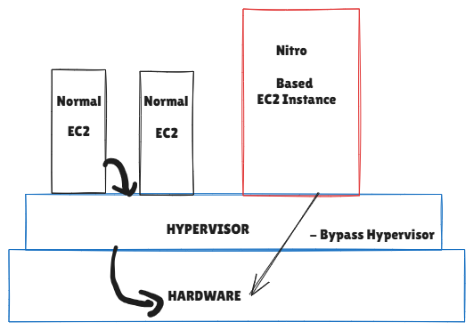

Multi-AZ:

If you are having to create ec2 instance , we need to choose the availability zone , if you are not select the availability zone . AWS will choose the availability zone.

If your application is critical (you don’t required down time and also for uninterrupted service) better deploy the application in to multi AZ

If is it non critical , if you are able to tolerant , we can create the ec2 instance any one of the AZ.

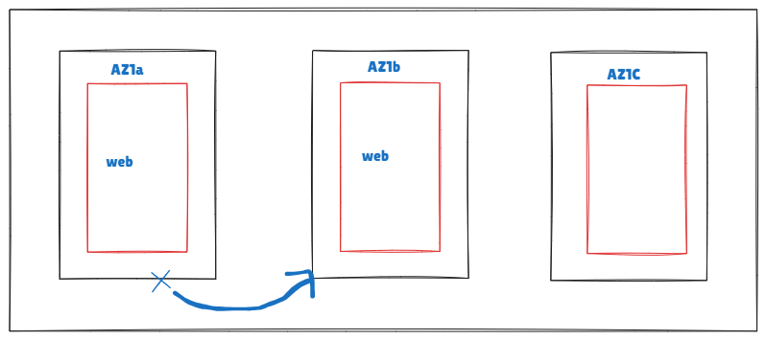

Public and Private IP address:

Whenever launch ec2 instance we have option Auto assign Public IP

This option we can enable or disable. To understand this option we have to understand what is public and private ip address.

When ever we create ec2 instance we able to see public and private ip Address.

Public IP -> we cant use Any IP, will get public up address from ISP. ISP will provide the Public IP address, We will get it ISP.

When we create the ec2 instance Public IP will provide from AWS. So we can AWS as ISP.

Public IP address Rout-able on internet. When we accessing any website over the internet like google ,Facebook , you tube. It is having public IP. Without Public IP will not able to access any website.

Suppose if your hosting web server on your ec2 instance we have to provide public ip address on your ec2 instance.

If your hosting any kind live streaming video on your ec2 instance we have to enable the public IP.

When we are create the EC2 instance in AWS environment. Example ec2 instance created in Mumbai if you want to access that particular instance on your laptop in your location, we can access over the internet. So internet must be enable on the ec2 instance and also enable public ip. So we can access the ec2 instance over an internet using Public IP.

Note: Providing Public IP address on your ec2 instance is not mandatory. We can enable or disable the public IP address. It is Optional.

But whenever create the ec2 instance it must have private IP as well.

Private IP address is address it not rout-able over the internet. We can assign any private IP address. If you assign the private IP on your EC2 instance we don’t need any permission. It is not like public ip address.

And also Private IP , Internet Corporation decided range

In IP there is three Class

Class A 10.0.0.0 - 10.255.255.55

Class B 172.16.0.0 - 172.31.255.255

Class C 192.168.0.0 - 192.168.255.255

If you want to use private ip we can use any ip withing this range. If you want to use public IP AWS will give. Some case Public IP is Chargable.

What is the Use case we can use Public and Private IP.

Public IP is rout-able over the internet. We can access the EC2 instance over the internet

Private IP is not rout-able over the internet. But we can use this internal communication.

Suppose if I have two ec2 instance

Ec2 instance one have public IP and private IP

Ec2 instance two have only private IP

Example: Case-1
If you are hosting any web server or video streaming application we can assign Public IP and Private IP also

But if you want to hosting the EC2 instance more securely like back-end or database. Don’t use Public IP address on that EC2 instance. This case use only Private IP address

If you want to access web server we can access over the internet , but if you want to access web server to database. this case we can use Private IP.

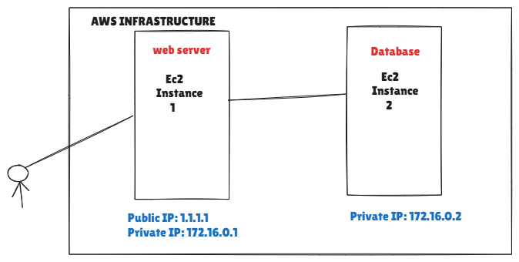

Example: Case-2

If you have three Ec2 instance those having only private IP address, In this case how we can access the private ec2 instance on your laptop. This case Bastion host comes into the picture, By using bastion host we can access the private ec2 instance.

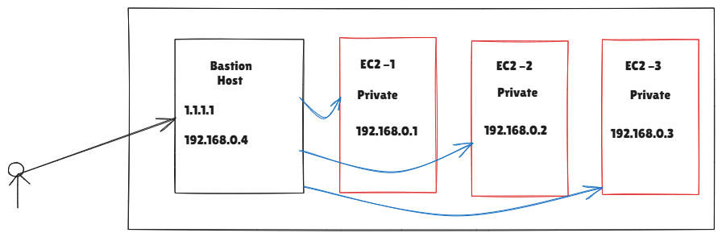

Note: This is actual AWS Best Practice. If it is compulsory to assign public IP that cases only consider. Otherwise don’t assign. If your not assign public IP , your server will be very safe and secure.

Demo:

Step1:

Create two windows ec2 instanc

Create one ec2 instance using Public IP address

Create another EC2 instance using only private IP address

Step2:

Server 1 one have public and private IP.

Server2 only have private IP.

Login server1 using RDP -> username and password (get password Upload file) -> Using the decrypt the password.

Now if you want to login server2 . We can login server2 by using server1. It is like nested.

Note: Here Server 1 act as bastion host.

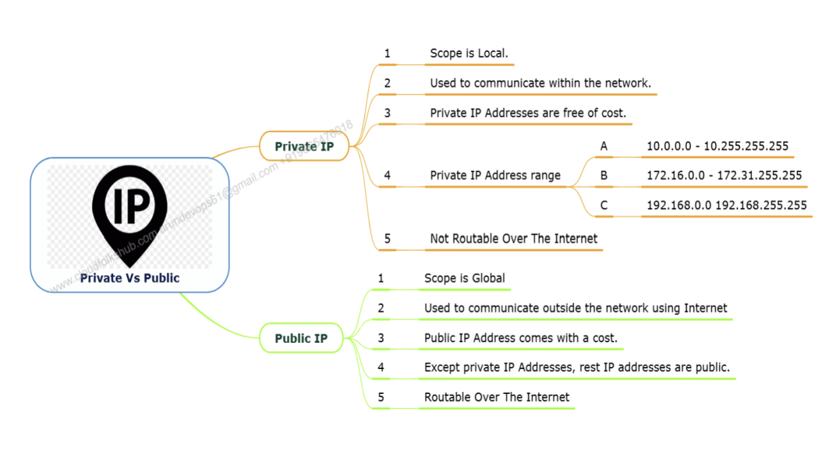

Conclusion:
- Public IP allows EC2 instances to be accessed over the internet and is mainly used for web servers or public-facing applications.
- Private IP is used for internal communication inside AWS and is not reachable from the internet.
- For security best practice, back-end and database servers should use only private IPs.
- To access private EC2 instances, use a Bastion Host that has a public IP.

Elastic IP:
Elastic IP is exactly like Public IP.

Main differen between Public ip and elastic IP.

When you use public IP, if you shutdown or start Ec2 instance the IP may Change

If you want static Public IP, in this Case we can Elastic IP and attache with EC2 instance.

When we use Elastic IP . if you stop or start ec2 instance it maintains the same elastic IP, it never change. But we have to pay extra charges when we use elastic IP, because it is chargeable.

Chargeable Condition:

If an Elastic IP (EIP) is attached to a running EC2 instance → AWS does NOT charge you.

Elastic IP is attached to a running EC2 instance.One Elastic IP per running instance

When Elastic IP is CHARGEABLE

Elastic IP is NOT attached to any instance
Example: You allocated an EIP but didn’t attach it

Elastic IP is attached to a STOPPED instance
Instance stopped = EIP idle = charge

More than one Elastic IP attached to the same instance
First one is free, extra ones are charged

Elastic IP attached to resources other than EC2
Like unused or mis configured setups

User Data:

It is one kind of Automation.

if you want to configure the server as web server.

There are two ways

One Manual way

Another way is user data script

When we create the instance we have user data script where we past the all the commands. Once Ec2 instance is ready it will execute all the commands automatically and I will get my web server ready. So here we are using concept of shell scripting.

In the Linux we are using shell scripting it is one of kind of automation. We can mentioned the multiple command at a script. System will execute one by one and windows also we can use same concept we called as power shell scripting.

In user data we can use power of shell scripting or power shell scripting based on the OS, We are not going to run command manually , it will execute automatically.

So Once Ec2 instance ready , system will be execute the scripting Automatically.So we will get out web server ready.

User data is mainly used in advanced EC2 scenarios like Auto Scaling.
In Auto Scaling, EC2 instances are automatically launched or terminated based on CPU utilization or load. Because instances are created dynamically, we cannot manually install a web server on each instance.

In this case, we use user data in the EC2 launch template. The user data script runs automatically when a new instance starts and installs the required web server and other dependencies. This ensures every auto-scaled instance is configured correctly without manual effort.

Conclusion: User data is used in Auto Scaling to automatically install software like a web server when new EC2 instances are launched, since manual installation is not possible.

Demo:

Without user data:

Step-1

Launch the Ec2 instance

Step-2

Login the ec2 instance

Install httpd
$ sudo su -
$ yum update -y
$ yum install httpd -y
$ systemctl start httpd
$ systemctl enable httpd
$ echo “ hi welcome to aws and devops class” > /var/www/html/index.html

With user data:

Step-1

Launch the Ec2 instance -> Adavance details -> user data

#!/bin/bash
$ yum update -y
$ yum install httpd -y
$ systemctl start httpd
$ systemctl enable httpd
$ echo “ hi welcome to aws and devops class” > /var/www/html/index.html

Note: if your using windows instance you have to use power shell.

Step-2
Instance will be create Automatically with web server then take public Address , hit will get output.

Termination Protection:

It is used to prevent accidentally delete the ec2 instance.

There are two ways we can enable this option

Enable after instance Creation

Enable during instance Creation

Step-1 Enable after instance Creation

Create ec2 instance

Select the EC2 instance -> Action -> Instance Setting -> change Termination Protection -> Enable -> Save

Now if your delete this instance -> it will show may not be terminated.

Note: It is extra layer of security

Step-2 Enable during instance Creation

Sometime we may forget to enable termination protection. So this case we can enable the termination protection while creating the EC2 instance.

Launch ec2 instance -> Advance details -> termination protection -> Enable

Note: Add also we can enable stop protection also.

Placement Group:

Ec2 -> Launch Ec2 instance -> Advance Details -> Placement Group ->

Create new placement Group ->

-> Name

-> Placment Startegy

- Cluster

- Spread

- Partition

Meaning of the Strategy and what is the use of placement Group

What is Placement Group:

It is enable you to influence how your instance are placed on the underlying hardware.

As we now we are not responsible to manage AWS underlying infrastructure.

We select the AZ , In that AZ AWS How place the EC2 instance it is totally depan on AWS , But using Placment group we can influence particular decision of AWS according to your requirement . Now how all things are working . We are going to discuss about this , To understand we need to know , three types of placement group.

- Clustered
- Spread
- Partition

Cluster:

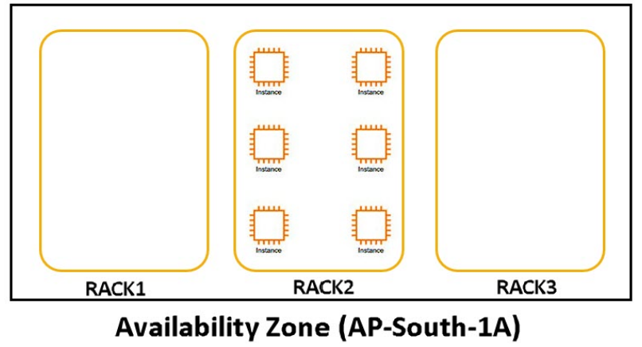

As we now AZ is a Data Center and there have rack. Inside the Rack Placing the Server.

In Cluster All the ec2 instance placed in the particular Rack. As shown in diagram all EC2 instance placed in Rack 2

When we using Clustered All the EC2 instance is availability in only One AZ, So we cannot use multi AZ.

Advantages:

High Speed Connectivity. Because of all ec2 instance placed in common network device,So if you want to communicate one server to multi server with low latency and high speed. We can use clustered Placement Group. Because all the ec2 instance placed in same rack.

Disadvatanges:

If that particular Rack Goes down , everything will down. Because all your ec2 instance placed in the same rack. So no high availability when we your are using clustered.

Spread:

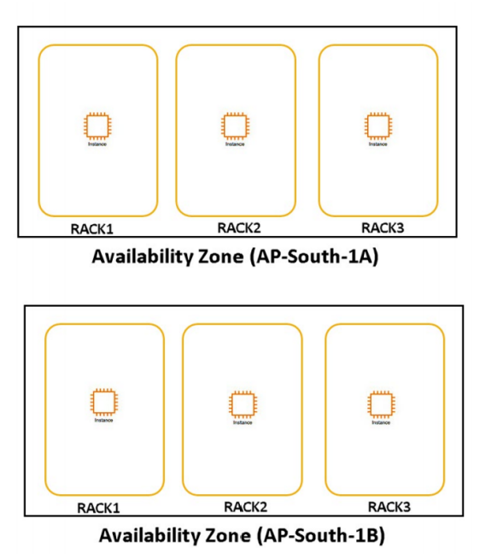

It is completely opposite to clustered.

When we are using Spread all EC2 instance placed in Multiple rack. Refer the diagram above.

Advantages:

We have high availability. If one Rack is down , no issue another rack will work , because we spread the EC2 instance into multiple rack.

Disadvantages:

To communicate one server to another server we have to compromise the Latency because when we communicate one rack to another there is differenet network devices in between this , so latency will be high.

Conclusion: Cluster it gives high speed without latency , but there is High availability, Spread gives high availability with little latency.

Limitation in Spread: we able to run 7 instance in one AZ. Which means instance will placed in 7 different rack.

Suppose if your ap-south-1 , there we have 3 AZ . so totally 7*3 we can run 21 ec2 instance in that particular region. So one placement group we able to run 21 ec2 instance.

Note: if you want to create EC2 instance more that 21, then we need to create another placement group.

Partition:

Here we are getting advantage combined Cluster and Spread.

Here Creating Partition.

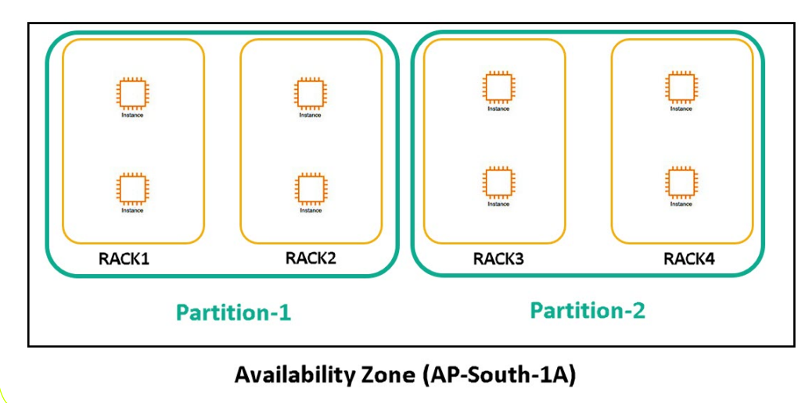
As per diagram:

One partition we have two racks. So this Rack having common Hardware, So every partition we have common hardware.

So we can place the ec2 instance in multiple rack

Advantage:1

Suppose two servers placed in same partitions , speed will be high because partition using common hardware's

Advantage:2

If one partition down, another partition will support

So if you want high availability with low latency we can use partition, So any mission critical Applications. We can use this partitions strategy.

Limitation of partition Placement Group:
- We can do 7 partiation per az , some region we can upto 15 partition
- It works one single AZ

Limitations of Placement Group:

Placement group name must be unique within your AWS account for the region.

We cant merge placement group.

One instance will be able to place one placement group

We cannot launch dedicated host in placement group.

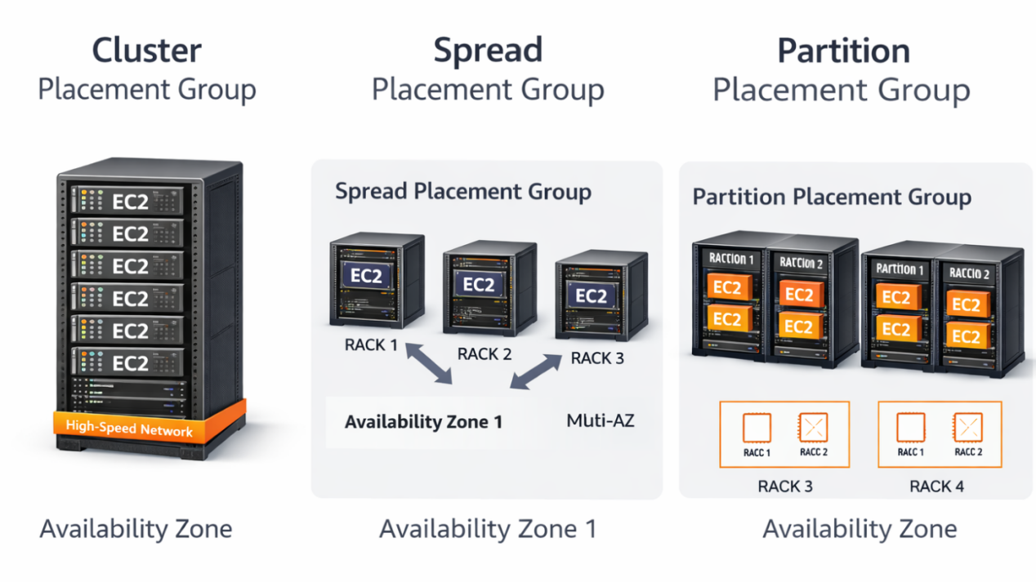

AWS Tenancy:

- Shared

- Dedicated

- Dedicated Host

Tenancy: Determine how the physical hardware on which your instance run is shared with other AWS account.

As we know that AWS is Public Cloud,You can create the AWS account and create ec2 instance , also others will also create the AWS account and ec2 instance. It is possible others ec2 instance and others ec2 instance both are placed in same Particular hardware (same host) Machine.

Some Organization for security purpose or compliance they are not allowing launch the ec2 instance in the same hardware were others customers. So they want to isolated their ec2 instance with other AWS customers. So in this case AWS introduced Tenancy.

Shared

It is default one. Suppose if you are creating ec2 instance without touching any tenancy. That ec2 instance by default it will create in shared tenancy.

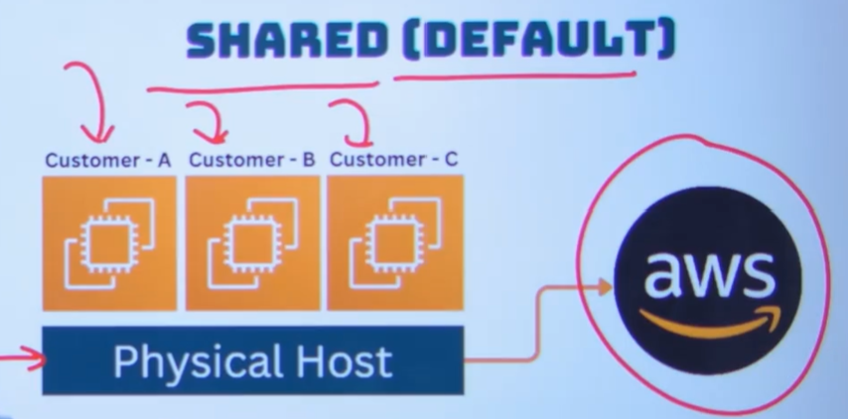

Note: Here multiple customer hosting their ec2 instance machine in the same physical host. Here it is less secure . It is cheaper , we don’t need to pay any extra payment

Dedicated Instance:

But if you want more secure as government compliance , no bodies will host the ec2 instance in your physical hosts. In this case AWS introduced Dedicated instance is there.

Dedicated Instance means , AWS assigned particular host to you. Now we are not going to mange the physical host, AWS will manage the host, but other customer can’t placed their ec2 instance on this physical host

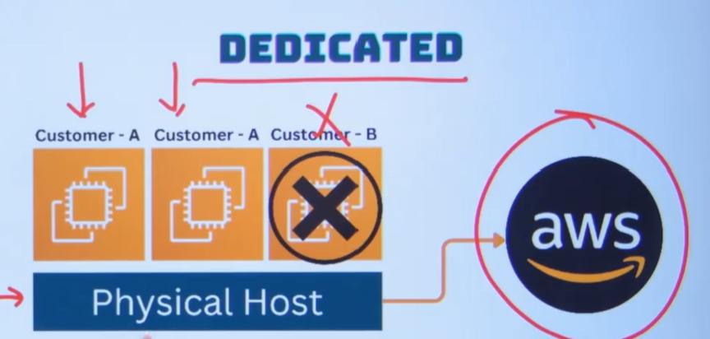
Note: if you are not allowing other host ec2 instance. In this case we can use.but we have to pay extra money to AWS. It is more secure and great level of isolation.
Dedicated Instance.

Dedicated Host:

The physical host managed by us. Here we have full control of cpu , socket and also we can setup own license here. If you are using the dedicated host.It will provide direct hard ware access on your physical host. It will provide the great flexibility. We can bring our own license. We have complete control of everything. But it is very expensive. If you want to create the physical host how can we create.
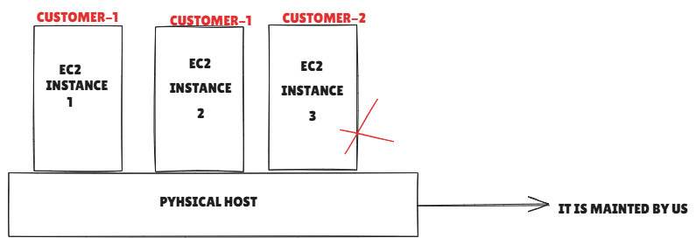

Ec2 dashboard -> Dedicated Hosts -> allocated dedicated host-> here we can create all dedicated physical host

Once create the physical host , we can create the EC2 instance over this dedicated Physical host

EC2 Parahcase Option Part-1

- On-Demand

- Spot Instance

- Reserved (standard)

- Reserved(Convertible)

- Reserved(scheduled)

- Savings plans (ec2)

- Savings Plans(Compute)

If you understand right purchase option we can save money. We can save up to 80 percentage money for your company.

On-Demand: It means Pay as you go pricing model . here there is no commitment . So here if your using ec2 instance one hour we have to pay one hour. Here per second and per minutes pricing.here we have no commitment you can use it and delete and also pricing is the highest one. Because here great flexibility any time we can create or delete.

Spot instance: it is Bidding model. Instead of AWS deciding price , we can deciding the price as well.
If AWS data center capacity available, they will provide particular ec2 instance according to our bidding price. But if the data center capacity will be full, they may be delete our instance as well.

Note: if your using spot instance we can save 90% cost saving.

Reserved Instance(standard&Convertible):

Here we need to give the commitment 1 or 3 years . When you are using this we can save 72% money. And also they are giving pricing option also.

- ALL Upfront of money(All money in advance)
- Partial (50 percantage every month)
- No Upfornt of money( will make payment every month)

Note: Based on the commitment discount percentage will be vary

Reserved instance Scheduled:

When we use Reserved standard and convertible we are giving commitment 24 hours use. So here we have to pay for 24 hrs .

But if you want to use some certain hours per days Example 8 hours , that case we can use reserved scheduled instance for one year only. This will give great flexibility. When we using this one we can save 70% money.

Note: We can book it only one one year

Savings Plans:

When we use this we can use any of the compute service from AWS.

Note: It may be got confusion , Next part will able to understand.

EC2 Purchase Option Part-2

If we have comparing both all purchasing model we can understand easily.

On - Demand:

Pricing is pay as you go

NO cost savings

We cannot do change size with in family t3 to t2

Spot:

Bidding we are paying according to our bidding price.

They can terminate the instance any time

90 percantage const savings

Note: AWS will terminate your instance any time, if they don’t have data center capacity available.
We cannot do change size with in family t3 to t2

Reserved , saving Plans

No upfront -> we have to pay every month

Partial -> we have to pay 50 percentage advance amount

All upfront -> we have to pay all money in advance

Note: On demand or spot instance here we are not giving any commitments, reserved and savings we have to commitments either Min 1 or Max 3 years, scheduled reserved instance we have only one year options.

We can do change size with in family t3 to t2

Change size with same family t3 to t2

We can do All reserved and savings plan

Change family t2 to c5

We can do only

Reserved Convertible and saving plan compute

If you have predictable you can go reserved standard or saving plan , otherwise go and user reserved convertible and saving plan compute.

Change compute ec2 to lambda

By using saving plan compute , we can change the compute ec2 , lambda , far gate. Great flexibility there in saving plan.

Change the OS:

Example: Linux to windows

Reserved instance convertible , savings plan ec2 and savings plan compute

Change region

Savings plan compute

Change tenancy ( shared to dedicated)

Saving plan compute we can do

EC2 Purchase Option Part-3

By default it will create on-demand instance

EC2 instance -> Advanced details: spot instance -> customization

We can set maximum price

If there is availability , AWS will provide , it will create automatically in AWS console

Interruption behaviour we can set

Hibernate

Stop

Termination

Go to reserver instance ->

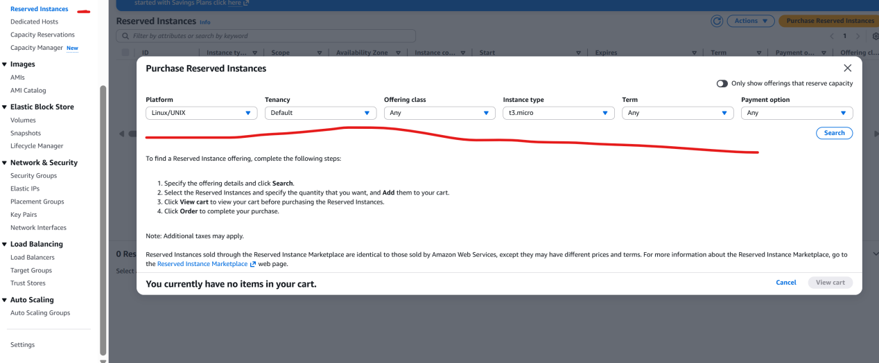

Note: if you reserved the ec2 instance 3 year, suppose if you don’t want this instance after one year, AWS will not provide money , this case we can sale the ec2 instance in reserved instance market place.

We can go the AWS market place, we can sale to the third party. We can do only reserved standard instance only we can sale. In convertible instance we don’t have that facility.

Reserved standard and convertible , it will be best if your running ec2 24 hours. It will be great money savings, Suppose if you are going to pay 8 hours better reserved scheduled

Note: Reserved scheduled it is will be there only one certain region, mumbai it is not there ,but in NV it is there.

But now:

Scheduled Reserved Instances were available earlier for EC2.
Now AWS mostly recommends Savings Plans instead of Scheduled RI.
Savings Plans work across regions (depending on type).

AWS Pricing Calculator:

https://calculator.aws/#/createCalculator/ec2-enhancement

By using that we can find out the cost

Introduction of storage:
Storage:

We have mainly three storage
- DAS - Direct attach storage or Block level storage

- File storage

- Object Storage ( it is only available in the cloud)

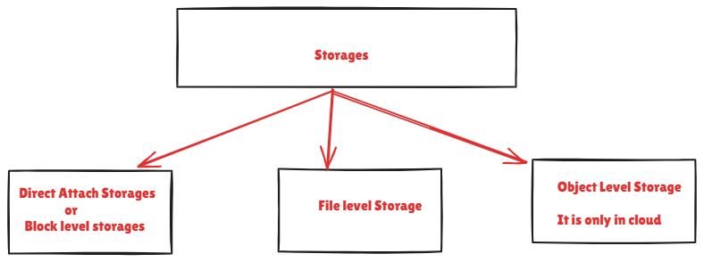

Note: if you are having on-premises we don’t have option for object level storage

DAS ->

Example for DAS Storage:

Storage directly connect with your computer know as DAS Storge. Let say Hard disk and SSD Directly connect with your computer or laptop is a example of DAS storage. Pen drive Is the example of DAS storage. It is the fastest storage all of this three storage.

One of the biggest disadvantageous .

It is having not share.

We cannot use simultaneously with multiple computers. DAS is kind of storage which directly connect to the server. We cannot share with another computer.

It Is storage that need to format. When we connect the system we have to format. Because manufacture doesn’t know about which is your operating system.

If we are purchasing hard disk , we may use Linux or windows system. It is always in RAW format. Then we need to format it with various OS.

If it is windows we have to do NTFS format . if Linux we have to ext format.

So Rule is when we are using DAS , we need to attach to the particular one system and then we need to format it . when we formatting the disk we are create the block storage over there in the hard disk. that’s why we called it block storage.

In our normal on-premise infra we are purchasing hard disk,ssd, pendrive we are attaching the particular storage with computer and we are formatting it. So we called it DAS.

But when we are in AWS, when we are talking about ec2 instance block storage options here we have two DAS storage options available.

- Instance store

- EBS ( Elastic block storage)

Biggest disadvantage it is not shareable.

Then what if I want to share the storage into multiple device

For example:

If you have 100 instance , if you want to do storage. You have to use100 hdd or ssd.

In this case just create one storage server. If you have 100 computers your are not storing data into100 computers instead of this setting up one particular device or computer using at shared storage. Now your are going to store the data into particular device . the advantages is we don’t take care about 100 instance and 100 hard disk. All the data your storing in shared storage and your are just take care one particular shared storage device. So one of the shared storage device we called as file storage

For linux -> NFS storage

For Windows -> CIFS (SMB) Common internet file system,

Advantage of this kind of storage is shared storage. Here we can do multiple storage simultaneously.

Now AWS shared storage file Linux we have EFS service and windows we have FSx

Advantages is we don’t need to configure server it is kind of server-less storage is available in the AWS environment.

Same way if we have big data requirement you have huge massive amount of data then we need to store specifically which static data , your not editing and changing frequently in this case we can use object storage

In AWS we know as s3

Two Kinds of Block storage available in AWS EC2 instance:

We can connect those ec2 instance directly into the EC2 instance.

- Instance Store
- EBS (Elastic block Storage)

All though they are block storage we are attaching to the ec2 instance , then go and store data inside but they are many difference between two this. Before learn both , first we should know the normal behaviour of the EC2 instance.

As We know ec2 is a kind of virtual machine , we have to have physical host in order to run the virtual machine, there are multiple VM running inside the host.

In AWS they may have 50 t0 10 thousand Host machine in single AZ

For example , consider two host machine

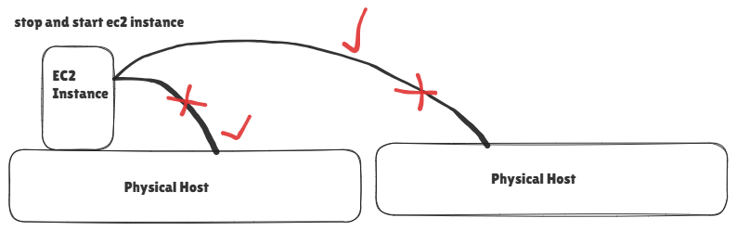
EC2 instance hosted any one of the physical host we don’t know.
So EC2 (VM) can be start any one of the Host machine at very first. Then if you stop ec2 instance and start the ec2 instance, this particular ec2 instance will be recreate any one of the Host. Because AWS algorithm will deiced create any of the ec2 instance based on the free resource , so AWS algorithm will consider which one is prefer, So every time if you stop and start ec2 instance AWS algorithm will decided which one is perfect based on free space. This applicable when stop and start the ec2 instance.

Instance Store: it is block level storage

We are attaching this with our ec2 instance to store data inside the instance in the instance store.

Instance store is directly attached to the particular physical host . it will always residing always inside the particular host. So now if I having one ec2 instance, this attached the any one of the physical host with using storage of instance store.
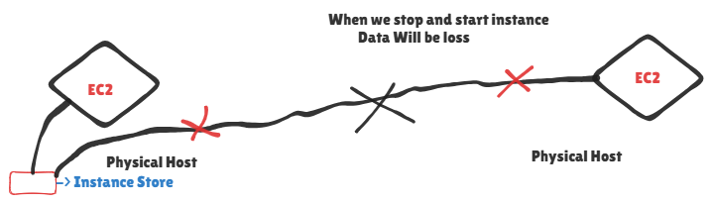
If you stop and start ec2 instance it may create another ec2 instance. So that particular ec2 instance cannot able to access the particular instance store. Because instance store there only the particular physical host. Now condition instance store there in particular physical host and ec2 instance there in some different particular physical host.

When we use instance store we cannot power of the ec2 instance. If we power off the ec2 instance , the data of ec2 instance instance store will be deleted. It means instance store will be delete automatically.

Instance store which is actually act as temporary storage.

Reason usage of instance store: For high performance we can use instance store. Ec2 instance and instance store both are hosted in same physical host , so will get low latency and high level performance. Problem it is temporay storage. If you stop the instance the data will be lost.

How can solve the problem in the instance store. We have one another option we called it elastic storage (EBS)

EBS:

EBS it is kind of external storage, which is actually connected with multiple physical host. We can accessible from multiple physical host as well. When we are going to ebs volume volume for ec2 instance. Big advantages is we can power off the ec2 instance, if it start from another physical host, we can access the EBS volume same way if it is start from first physical host . we don’t worry we can access ebs volume as well.

EBS volume is permanent storage solutions, Even if you delete the ec2 instance your EBS volume will be there, so we can attached same EBS volume with another EC2 instance, so we are not getting same performance like instance store

So we are not getting some performance like instance store , but can store the data permanently.

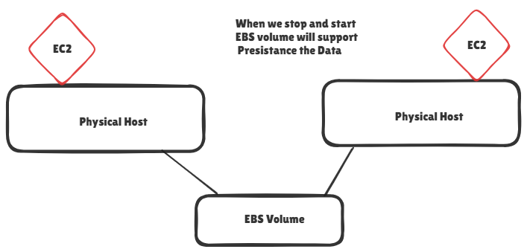

Conculsion:
- In Amazon Web Services, an EC2 instance is a virtual machine that runs on an unknown physical host (normal behavior).
- When an EC2 instance is launched, AWS automatically selects a physical host based on available resources.
- If you stop and start the EC2 instance, AWS may place it on a different physical host.
- This happens because AWS scheduling algorithms choose the best host based on capacity and availability.
- Due to this normal behavior, storage tied only to a specific host may not be accessible after instance restart.
Diff between Instance Store and EBS Volume:
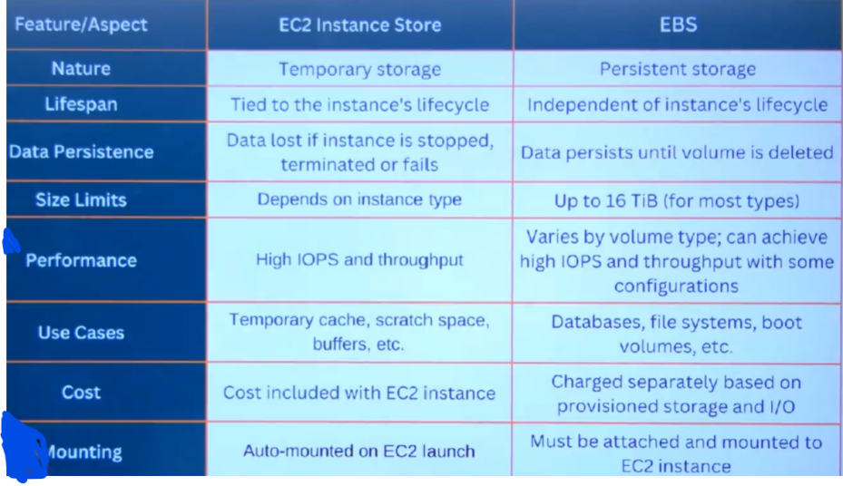

Size Limits: If you want use instance store . we cannot use instance store with any type of instance. For example: t2.micro not supporting instance store, there are specific type of instance we have to create and with this we will getting the instance store.

EBS Volume we can create 16 tb of Volume, It is available any type of instance.

Along With this for instance store size always depends on the instance type. It is always fixed with the instance type.

Performance:

Instance Store: It is directly connect to the storage , so we get greater performance with low latency.

EBS : we have types of volume types , based on that performance will be differenet.

Cost:

Instance Store: we are not going to give extra money for this, it is specifically coming with instance type, size also fixed and price also included with the instance pricing.

EBS: here we are paying separate money for the EBS, if you are 100GB ebs volume, we have to pay for 100 gb.
Suppose if am going to stop my ec2 instance. Do I need to pay anything ?

Situation | EC2 Charge | EBS Charge
Instance Running | ✅ Yes | ✅ Yes
Instance Stopped | ❌ No | ✅ Yes
Instance Terminated + EBS Deleted | ❌ No | ❌ No
Instance Terminated but EBS Kept | ❌ No | ✅ Yes

Mounting:

Instance store: Instance is automatically mounting into the ec2 instance

EBS: We have to create EBS volume , attaching to ec2 instance and we need to mount it.so we have to manually mounting from ec2 instance

Six Scenario of Local Storage Configuration:
So finally we have two Local Storage:

- Instance Store

- EBS

Six Scenario of Local Storage Configuration:

- Instance Store as Root Volume
- EBS as Root Volume
- Instance Store as data volume
- EBS as data volume
- Instance Store as Root Volume , EBS as Data volume
- EBS as root volume,Instance store as data Volume

What is root volume and data volume

If you we consider in our windows laptop we have 3 drives

C drive, E drive, D drive

Here C drive (windows ICON) because it is root volume , and others drivers are are data volume.

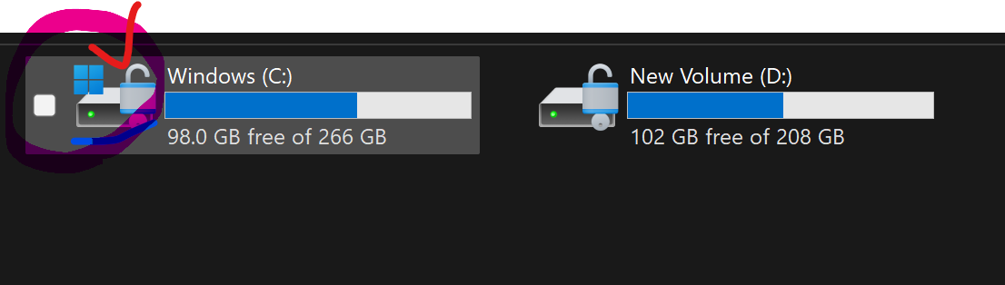

- Instance Store as Root Volume

We can configure Instance store as root volume.

For better understanding open two parallel AWS console.

When we go to create instance store as root volume we have to Choose AMI with supporting Instance store volume
AWS console -> Launch Ec2 instance -> Browse More AMI’s -> Community AMI
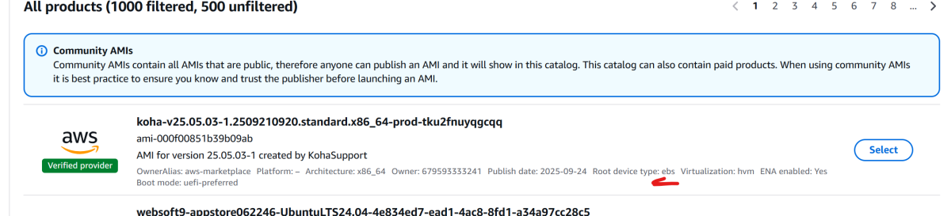

Look this : root device type is EBS, but we need root device is instance store.

We have to filter the root device as instance store:

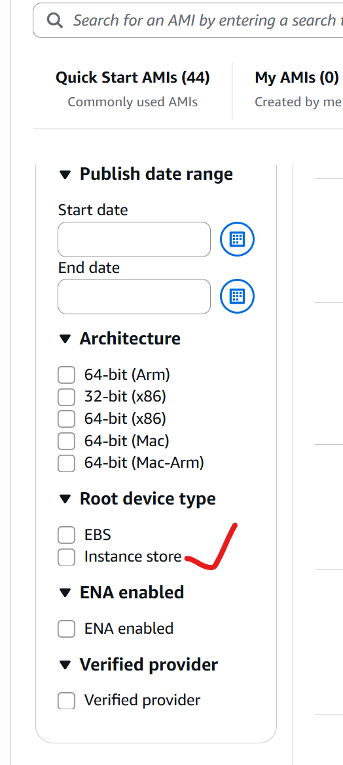
Note: Better choose north virgena region for filter the instance store option as root volume
Note: if your choose windows OS it will not show, because Instance store will not be there in windows OS. Windows AMI not supporting instance Store.

-> Select

Parallel create another launch instance choosing EBS volume

First Note:

If you select root device as instance store , we have to notice instance type, all instance type not support instance store as a root device ,

Suppose if you want to create instance store root using t2.micro we cannot do that.

Root device as instance store will support only specific instance type.

But in the case EBS it support all the ec2 instance types.

Second Note:

The size of the instance store is dependent on the instance type,

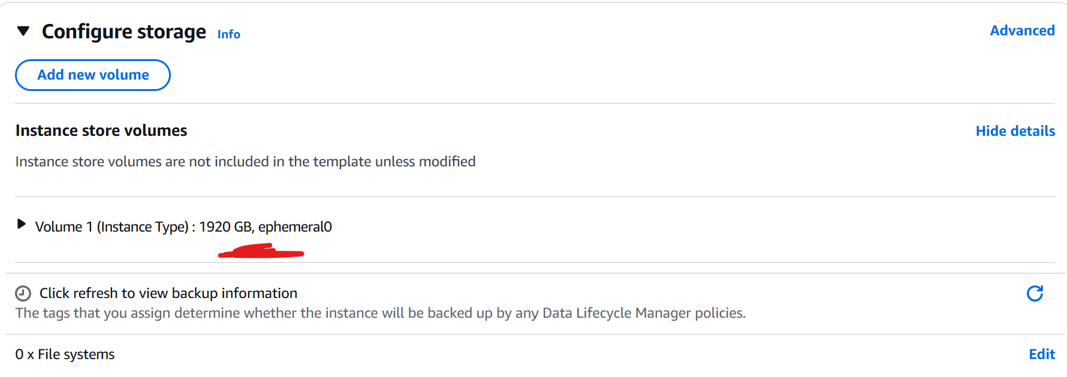

Third Note:

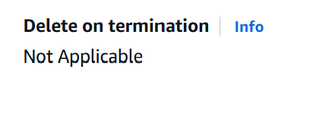
Delete on termination is not applicable , when we delete the ec2 instance , instance store is ephemeral , it will also delete

But when we use EBS volume:

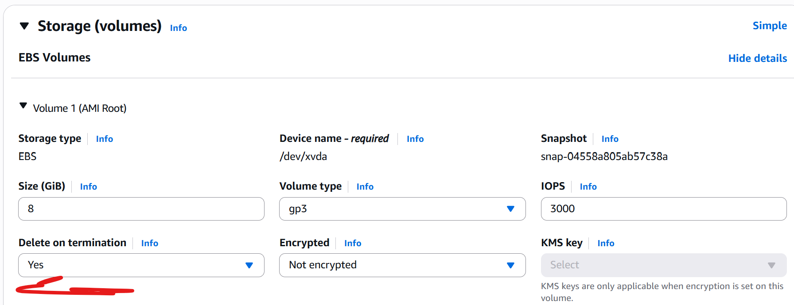
It is have, it means if we delete my ec2 instance, it will delete as well, suppose if you are going to select no, what will happened we can delete our ec2 instance, but root volume will be there as it is , and also we can attach another ec2 instance as well, we can attach it.

Instance store as Data volume:

Suppose if we want to add another data volume using instance store we cannot do all the instance types, but EBS volume we can add, all the instance

Instance store , we need to choose the specific instance type. For this case we need to x1.32xlarge

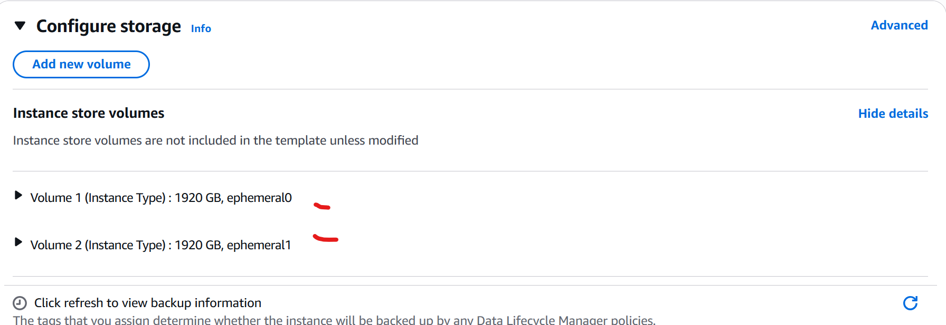

Now we can two volumes based on the instance type , it will be differ.

If in case EBS volume , we can add directly.This not depend on the instance type.

Instance store as root volume and ebs as data volume.

We can add by using add volume option in instance store:
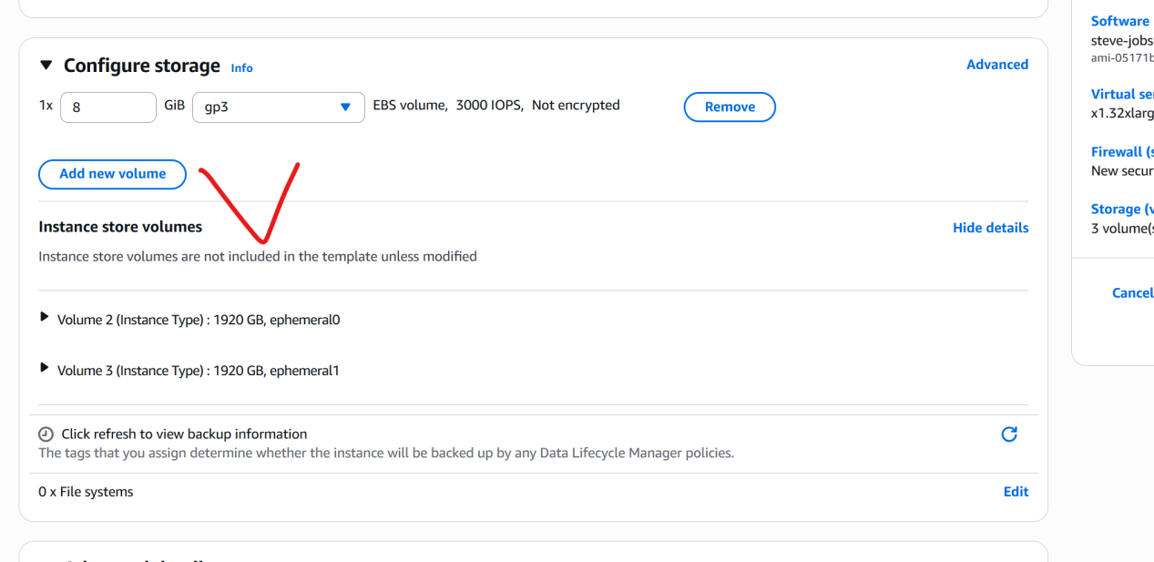

EBS as Root volume and instance store as data volume:

If you want to instance store as data volume we have choose the specific instance type.
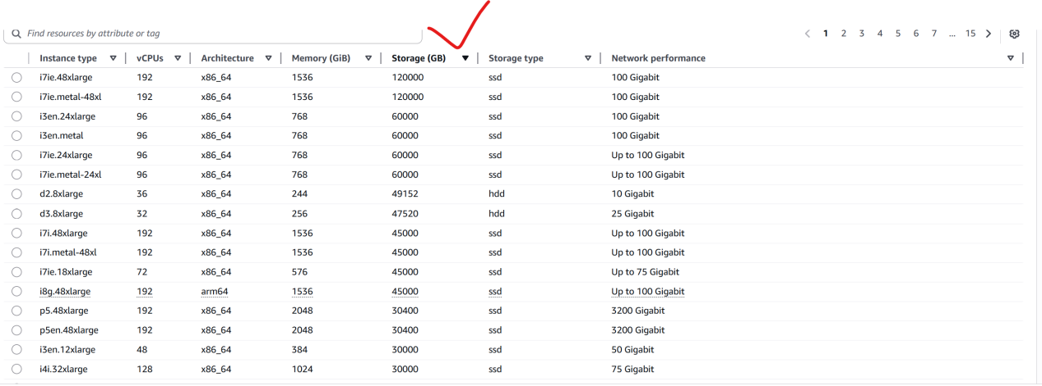

We have click storage option. For getting instance store as data volume.

-> Instance store it is dependent of the instance type and AMI
-> Instance store cost will be depends on the instance type, we don’t need to pay extra payment
for instance store
-> Instance store we cannot choose the storage manually, it will be as it is based on the instance type storage.
-> EBS we have to money for storage (above 30 GB we have to pay)
-> EBS volume will be support for any instance type and AMI
->EBS We can customize the storage size based on requirement

Types of EBS:

EBS is DAS (Directly attach storage), when we are creating ec2 instance, if you want to store data inside this, we have to create EBS volume,

When we are creating EBS Volume , We have many options: There 7 Types of volume that we create

When we chose the EBS volume, we have to choose correct , because based on that you will get charge.

If you are going to select wrong volume we have to pay more money and also your getting less performance.

We have types of storage (HDD, SSD) SSD is new one, HDD is older one

SSD we have four types, HDD we have two types, Magnetic one type

- SSD EBS => 4

- HDD EBS => 2

- Magnetic => 1

SSD Types:

If you are selecting write of volume , we can save money for our company.

- General purpose (GP2, GP3)

- Provisioned IOPS (i01, i02)

Use Cases:

GP2 is older version, better we canuse gp3 than gp2

General purpose we can use normal and mid level performance

Provisioned IOPS we can use high level performance , I/o- intensive work load

Compare to IO1 to IO2 is better

Volume Size:

When we create the EBS volume we have to choose the Size of the volume

Gp2,Gp3 -> 1GB - 16Tib (Tebibits)

1000KB -> I mega bytes

1024KB -> 1 mebiits

Same as here

· Tb (Terabits) → Decimal unit (1 Tb = 1000 Gb)
· Tib (Tebibits) → Binary unit (1 Tib = 1024 Gib)

Base Performance:

How we can count performance of the SSD

There are two measurement for the performance.(IOPS and Throughput)

First Options

IOPS - it means input output per seconds

Example:

If I am having 1000IOPS in ssd

It means My ssd can handle 1000 input and output request will handle

If is 2000iops it can handle 2000 input and output request will handle per seconds

Based on the IOPS we can count the ssd Performance.

Better number of iops , better performance.

Second Option

Throughput : it is all about data,

Example

My ssd will handle request of 1000 input and output,

Here how much data it handle at a time

For Example:

If we have 250 mib/s it will 250mibs data will handle per second.

GP2 we have 3IOP per gb , here IOPS is consider based on the storage Size
Example:

If you are choosing 100gb, the iops will calculate 100*3 => 300IOPS will get

Note: Minimum is 100IOPS (if you are using 10gb => 10*3 => 30iops , No , it will consider minimum 100IOPS in any case)

But we have problem:

If we want 900IOPS, only 50GB data required

50 * 3 = 150 IOPS , but requirement we need 900 iops, in this case

300*3 = 900 IOPS

Note: here we have to create 300GB volume size, but requirement is only 50GB , so we are paying for another 250 GB,

After some time amazon upgrading:

GB3 -> we will get 300IOPS flat,

If you are creating 50 GB volume we will get 3000IOPs, even 10GB will get 3000IOPS.

If you want more than 3000IOPS , we can do upto 16000 IOPS , but we have to pay.

Provisioned we have to choose based on the requirement we can use up-to 6400, but we have to pay extra money as per requirement.

Maximum IOPS:

GP2, GP3-> upto 16000 IOPS

Proivisoned io1,io2 -> 64000 IOPS.

Note: IO2 we have block express (256000 IOPS will support), Block express will support only available for the specific instance type.

Throughput: (How much data shared)

GP1 -> 250 Mibs

GP2 -> 125 - 1000 Mibs

IO1 -> 1000 MIb

IO2 -> 1000Mib , 4000Mib (for Block Express instance Type)

Cost:

GP2 => 1TB => $102 per month

GP3 => 1TB => $81+ IOPS cost

Better GP3 is best

IOPs1 and IOPs2 will get same $128 for one TB

Then what is major difference between IOP1 and IOP2 is durability.

IO1 -> 99.9 %

IO2 -> 99.999 %

Note: EBS failed chance is very less in IO2

Multi Attach ( Attaching into multiple ec2 instance)

GP2 and GP3 we cannot do

Io1 and io2 we can do , but it should be with Nitro instances.

Configurable IOPS & Throughput (According to the requirement

GP2 -> it is fixed 3iops

GP3, io1, io2 -> we can do , but we have to pay extra money.

Block Express:

It only support in IO2 .

It give sub-milisecond latency

Block express we cannot use all the type, only particular ec2 instance types only able to create.

Note: Block express is there in extra payment

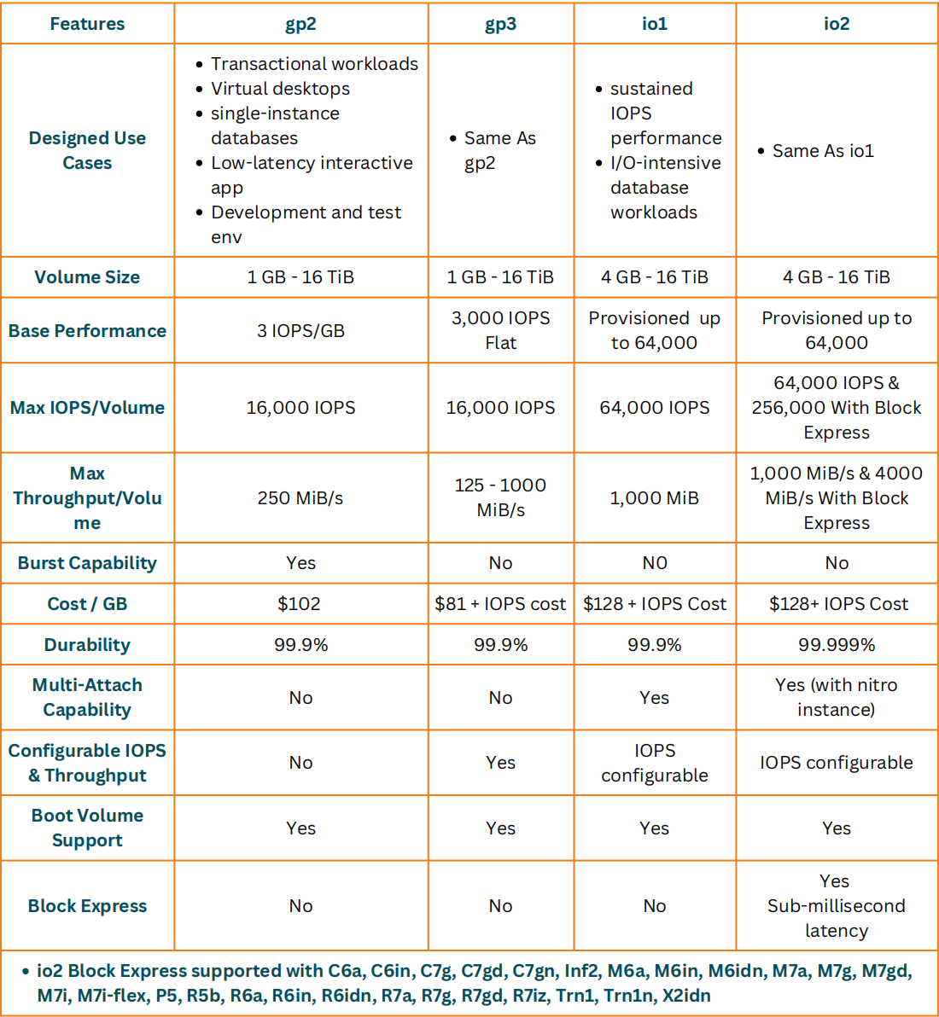

EBS Volume TYPE HDD:

The problem with SSD is high if we have huge amount of data , when we using SSD , it will get more cost , to save money we can use HDD.

Through put Optimize HDD

Cold HDD

Magnetic (old One)
- it is sequential kind of storage, it is old one , it may be deprecated, there is one indication also.

Indication is cost:

Magnetic cost is higher than throughput optimized HDD, refer the below table will get understand.

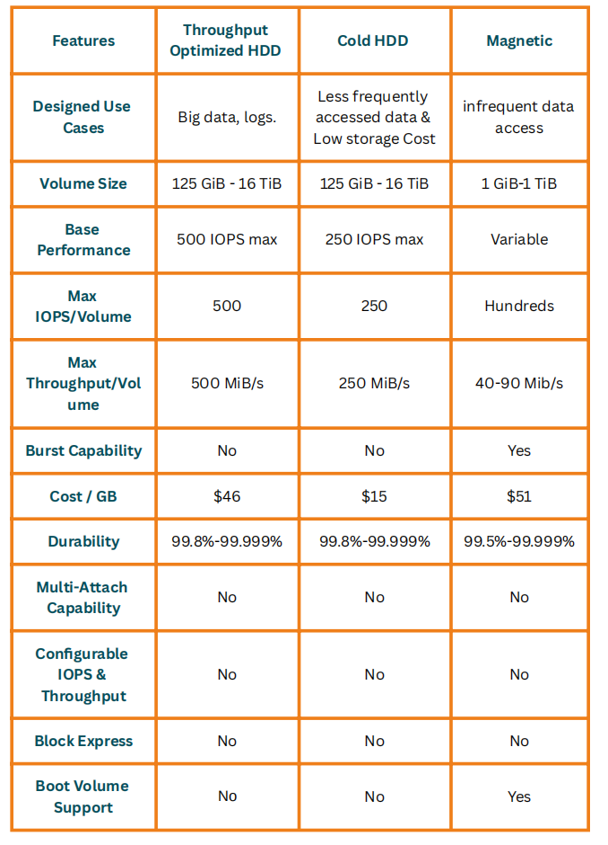

EBS Partical:

How we can attache the EBS volume in EC2 instance.

Step-1

Create the window EC2 instance(windows 2019 instance)

Note: why we use windows for attaching EBS we can easily visible the drive on GUI in windows machine for easy to understand

Note: We can directly add new EBS volume while creating EC2 instance itself.

Step-2

Login into ec2 instance and verity the Root Volume

-> Go to the -> server manager (utility configure windows server)-> tools -> Computer management -> Disk management
Here we can verify the root volume

Or

Windows + r -> type diskmgmt.msc (it will same window)

Step-3 (Creating Additional Volume)

Volumes -> Create EBS Volume -> Choose the volume types -> size 15 -> Select availability zone -> create volume

Note: EC2 instance and EBS volume must be same availability zone.

Note: Encryption, if you are working with secure environment, to secure data we have to encrypt the volume, using KMS service we can encrypt. If you forget to encrypt the volume while creating, we cannot encrypt the volume after creating EBS volume, there is way we can use snap shot , will see in snap shot.

Step-4 (Attaching the EBS volume)

Select the EBS volume -> Action -> Attach volume -> select the ec2 instance

Step-5 (Formating Raw drive)

Login to the ec2 instance -> Disk management -> right click the drive (click online) -> again right click (initialize disk) -> right click - > Simple volume -> next (3) -> finish

How to increase the EBS volume:

Step-1

Select the EBS Volume -> Action -> modify -> increase size 15 to 30 gb -> modify

Step-2

Login into the EC2 instance -> disk management (refresh ) -> right click d-drive -> Extend volume -> next(2)

If you don’t want to use

Select EBS Volume -> Detach ->

Now we can attach the another EBS volume.

Note: We cannot copy EBS volume from one AZ to another AZ, Also we cannot copy one region to another region as well.

Note: we can attach volume same AZ EC2 instance.

Note: We don’t need to power off the ec2 instance when we modify the ec2 instance.

Note: EBS volume can attach only one EC2 instance . Only possible to attache multiple ec2 instance using nitro instance.

Note: if you forget to encrypt the ebs volume, we cannot to modify the encrypt , but only we can do encrypt by using snap shot.

Snap shot:

Step-1:
Create windows machine and while creating add the new EBS volume 15 GB Volume.

Step-2

Login to the ec2 instance and add the EBS volume

Go to Disk Management -> right click 15GB drive -> online -> Right Click -> Simple volume -> Next(4)

Open this volume and store the new files and writing something in this file and also creating multiple files also.

Step-3 Taking Backup using snapshot

Select the EBS Volume -> create snapshot

Or

Go to snapshot option -> create volume and select the instance.

Take second option and do.

Step-3

Go to the d drive and delete all the files inside the drive.

Note: Now we can get it back up by using snap shot.

Step-4

Go to ec2 instance console -> snapshot -> select the snapshot -> create volume from snapshot -> Create volume

Step-5 (In order to get the data)

Select the EBS volume (which we create by using snap shot) -> attache EBS volume -> select the ec2 instance

Inside ec2 instance -> disk management -> E drive -> right click -> online

Then when we open this all the data will be available which we have delete.

Once practice delete the all the resource which we have created.

Use Cases of Snap shot:

Step-1:

First create the volume for sample

If you want to copy volume one AZ to another AZ we cannot copy directly

For more clarification we can check in EBS Action and also we are not able to encrypt the volume also, if you forget encrypt the EBS volume.

If you want to do encrypt the after creation of volume and copy into some AZ this case we can use snap shot.

Use_case -1 ( Creating volume into another AZ and encryption)

Step-2:

- Create a snap shot from the EBS volume
- Select Particular snapshot -> Action -> Create volume from the snapshot -> Select AZ (another zone az1b)-> Encrypt now -> Create Volume

Note: This is way we can change the AZ zone and enable encryption, We cannot encryption directly if your forget encryption.

Use_case -2 (change the region of the EBS Volume)

Step-3:

- Create a snapshot ( we can existing snapshot for demo)
- Select this particular snapshot -> Action -> copy snapshot -> Destination Region (we can choose) -> copy snapshot
- We will get this same snapshot to another region.
- Now we create the volume from this snapshot and attached the EBS volume into anyother ec2 instance.

Fast Snapshot Restore:

Idea of snapshot creating new volume and backup of volume:

When we are creating Volume from our snapshot, for us it very straight forward process , it is very fast. Be-causing we having small size of backup.

In real world scenario EBS volume is Terra bytes, In this case if you are taking volume from this large snapshot , it will take more time.

Now if you want to speed up the restoration process. We can use fast restore option of the snap shot. If you have small snapshot , this feature not required. If you have big volume of the snapshot , we can enable this option, this is paid features.

Demo:
Step1: Create snap ( You can use exsiting snap shot for demo)

Step-2: select this snapshot -> Action -> Manage fast restore snapshot -> select the AZ and Enable

Note: we have to pay for this options

Data Life cycle Manager (DLM):

It is Automation of Volume snapshot.

If you have critical data inside the volume, It is always good idea to take snap shot of the volume and you can restore the data anytime but if you are taking the backup manually.there is chance you may forget to take the snapshot.

Now in this case we can create automation for taking snapshot .

How we can do this?

AWS Console ->

-> Create volume (taking 10 GB Sample) and Ensure that add the tags while creating volume.

-> Life cycle Manager -> EBS Snapshot Policy -> Next ->

-> Target Resource types:(take volume or instance)

Note: Instance: it will take all the volume connected to the instances.

-> Choose -> Volume

Note: if you are not mentioned the tags , it will take all our EBS volumes.

Note: if you want to take automated backup of particular volume. We have to mentioned tags of the particular volume.

-> IAM role (as it is)

-> Policy status ( enable)

-> Next

-> Schedule name (Metioned name)

-> Frequency (daily)

-> Every (24 Hours)

-> Starting time (9:00am UTC)

Note: Now this back process start every day 9:00 AM

-> Retention type ( it will keep data for the particular time and

-> Count or age

Note: we can setup another scheduled also.

-> Review

-> create policy.

Note: if you want to disable and enable the policy we can do this.

EFS:

It is most important part of AWS services and also most important part of storage as well.

EBS -> Directly attached storage, but EFS is different

Example:

I need to host this website with AWS. This case we can host the application in EC2. To maintain the high availability setup the application in two ec2 instance with different AZ. User can able to access any one of the EC2 instances.

Use with EBS:

This case if we are using EBS. EBS is direct storage , we cannot the storage into the multiple EC2 instance. So this case we have to create separate EBS volume in each ec2 instance. Two identical website loaded into two ec2 instance. If two ec2 instance OK , but if you have 10 ec2 instance, we have to create the 10 EBS volume.

Now Problem when we are going to upgrade the website, we have to update the 10 EBS volume.This is problematic over here.
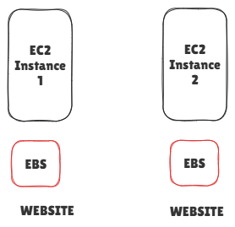
Use with EFS:

Instead of EBS we can use EFS , Main advantage of EFS is , it is shared storage. So this EFS will be accessible with both EC2 instance.

Main Benefits , by using single EFS volume we can access any number of the ec2 instance. We can put our website into single EFS volume.

So here if have 100 ec2 instance, if we want to upgrade , we just upgrade in EFS , it will automatically updated into all the Ec2 instances.

Using Shared Storage device having many advantages.

The disadvantages of EFS is actually Linux based storage. It works Linux NFS. Suppose if you want to use Linux we have to have Linux based Ec2 instance. It supports only Linux not windows.

If windows we can use Fsx.

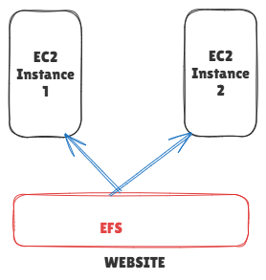

Another use-cases

If you have 10 workstation in on-premises , if we want to data locally, then this case we can use EFS for that, How we can connect on-premises with cloud storage for this we have setup VPN or direct connect.

Use case of EFS

- We can website multipe server using single EFS, we can easily upgrade
- EFS we can use shared file server
- We can EFS for on-premises server to maintain storage in Cloud storage of EFS.

EFS LAB:

Step-1 Creat Security Group

Security Group for EC2

EC2 -> Security Group -> Create Security Group -> name (web-sg) -> VPC (default VPC) -> Inbound Rule (ssh 22) -> Create Security Group.

Security Group for EFS

EC2-> Create Security Group -> name (EFS-sg) -> VPC(default VPC) -> Inbound Rule(2049) -> Source (allow Web-sg) -> Create Security Group)

Note: Only Security Group of WEB-SG only allowed

Step-2 Create two EC2 instance two different AZ.

For getting High Availability we are create two ec2 instance at different AZ.

One EC2 instance Create availability zone A and another one is Availability zone B

Ensure that Security Group Should Choose Web-SG(ssh 22)

Step-2 Create EFS

EFS -> Create File -> Name(mentioned name) -> default VPC -> Customize -> Disable Encryption -> Disable Automatic Backup -> Rest as it is -> Next

Security Group -> Enable EFS SG Group (which we created) in all AZ

Note: while Creating Security Group , Better Create all the AZ , by feature if are creating ec2 instance in some other AZ , EFS will support otherwise EFS will not be mount that EC2 instance. So we have to mount EFS in that particular AZ by future.

Step-3 Launch Two EC2 instance:

- Launch two EC2 instance in mob-Extreme

- Install packages in both ec2 instance
$yum install amazon-efs-utils

- Create a folder efs both ec2 instance
$ mkdir efs

- Go to EFS -> Select EFS -> Attach -> copy first mount option (sudo mount -t efs -o tls fs-08c63edb7056cf7b3:/ efs) and past it both ec2 instance.

Go to first ec2 instance

$ cd efs

$ touch file{1..10)

Now we can able to this files in ec2-2 also,

Note: Because EFS will shared the Storage

For Hosting the Application by using EFS concept
Step-1 Install Httpd for all the instance

$ sudo yum update -y
$ sudo yum install httpd -y
$ sudo systemctl start httpd
$ sudo systemctl enable httpd

Step-2
$ sudo yum install amazon-efs-utils -y

Step-3
$ sudo mount -t efs fs-xxxx:/ /var/www/html

Note: Replace fx-xxxx with your EFS ID

Step-4
Ensure In Security Group Should enable the Port number 80

Step-5
$ echo "Hello from EFS - Server 1" | sudo tee /var/www/html/index.html

Now open:

http://EC2-1-Public-IP
http://EC2-2-Public-IP

You will see SAME content.

If you edit from EC2-2 → It reflects in EC2-1.

Because both are reading from same EFS storage

EFS Options and Real Use Cases:
How we can host website using EFS high available in EC2.

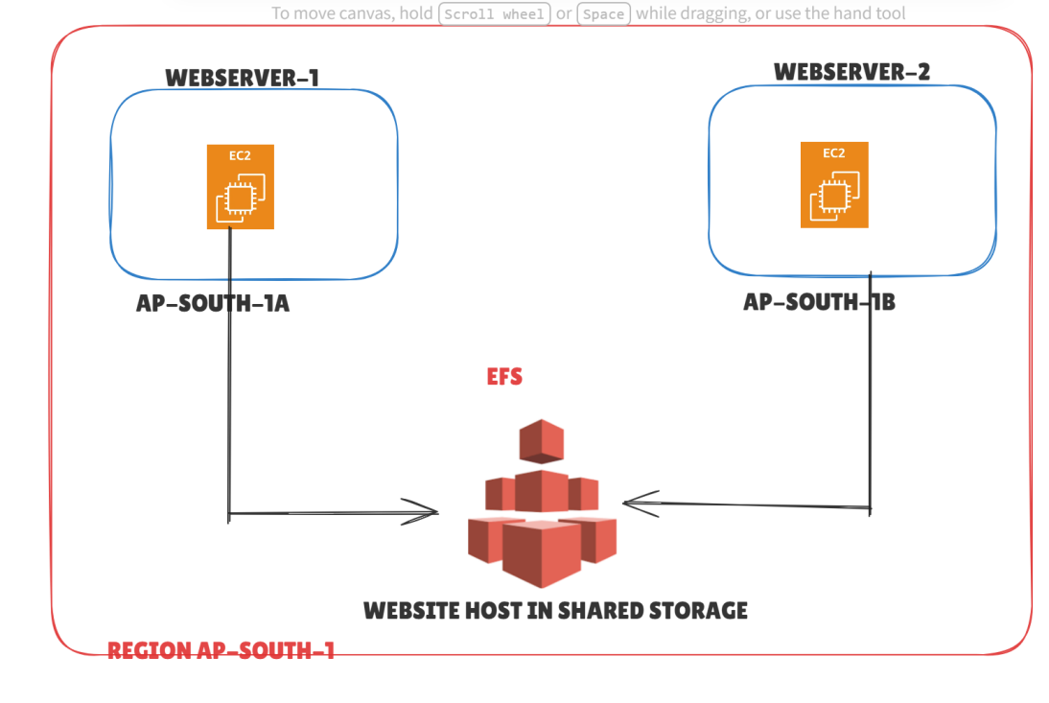

When look at the picture two Web servers different AZ, because of high availability, if anything goes down, another one will give back up.

The mentioned EFS volume will be access both of the EC2 instances, if we updated website in efs storage it will be updated both of the EC2 instances.

If we have 50 ec2 instance also, it is better.

Go to the AWS Console :

EFS -> Mentioned (Name) -> Customize

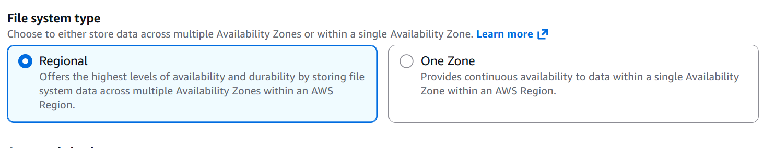

Regional -> AWS maintain data multiple AZ, they will replicate data Multi AZ automatically, best for Very critical data

One-Zone -> it is maintain single AZ ,It is stored in particular AZ
Ex: if u already data in on-premises, if you want to data in cloud this case we can use this.

Automatic Backups ( we can select automatic backups based on critical or non-critical data)

Inside EFS, there are 3 storage classes
- Standard – Normal, fastest, highest cost
- Infrequent Access (IA) – Cheaper, for rarely used files
- Archive – Cheapest, for very rarely used files
Note: frequently access data hot , infrequently access data cold
Transition to IA
- It moves from Standard → IA
- Storage cost reduces
- Small retrieval charge applies
- Access is still immediate
- Slightly higher latency than Standard
- No manual restore needed
Transition to Archive
- It moves from Standard → Archive
- Very low storage cost
- Higher latency than IA
- Retrieval charge applies
- Still no manual restore needed
- File remains accessible

Retrieval Time Difference

Standard → Fastest
IA → Slightly slower
Archive → More latency, but still immediate access
Transition into Standard
Enable -> Encryption (if you want)

Customize encryption settings: We can use Key management service also.

Performance Settings:

- Throughput mode

- Performance mode

Throughput mode :How much data process at a time in your storage Is throughput mode

Enhanced Mode:(two options)

-> Elastic (recommended)
-> provisioned

Bursting Mode: it is based how much storage data inside the EFS Volume, based on the storage it will handle the thorough put data per seconds. Based on the user storage it will double the speed.

If it is critical , if you need more throughput u can go enhanced mode
If it is not critical , if you need moderate , we can use burst mode.

Performance Mode: How many request can handle (it is input out per second)

General purpose ( it is general input and output per seconds)

Max I/O (it gives higher)

