VPC:

One of the Most Important Service in AWS.

As we know AWS is public cloud , anybody can create the resource over there.

User A also create the resources and User B also Create the resources , then How AWS will be Isolated resources both of them.

Example:

Selecting Region and Three AZ
Suppose

If we are going to create EC2 instance ap-south-1b , Ultimately AWS placed the EC2 instance into the physical host.

I have two user Ramu and somu , this two users they don’t know each other. But both are AWS User's

Ramu decided Create the EC2 instances and same-way some also decided create a EC2 instances

Are they able to communicate each other ? because they are placing them in the same physical host.

If yes no baddies will use AWS , Because there is no Security at all, if they can able to communicate each other , it is not security. So no one well yes.

If No, Then how Isolated Resources ?

We can isolated , because we follow the Technology which is VPC.
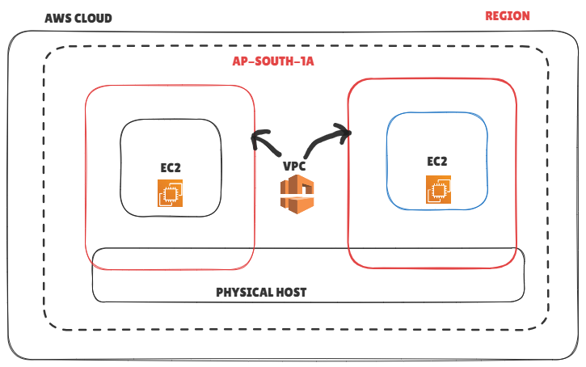

They may share same physical host , but they are using Separate VPC, because of this resources isolated, they cannot to access ec2 instance together.

When we create the AWS account, AWS will provide one default VPC in each and every region. Whenever create the ec2 instance that will be create inside the default vpc only.because of this it is isolated from other users.

Default VPC is more limitation , if you are creating small application we can use this. But corporate requirement it cannot full fill your requirement , now this case we have decided Our VPC

How to create VPC:

Setting up VPC , It required below mentioned five steps:

- Create a VPC
- IP Address
- Subnet
- Internet Gatway
- Rout table

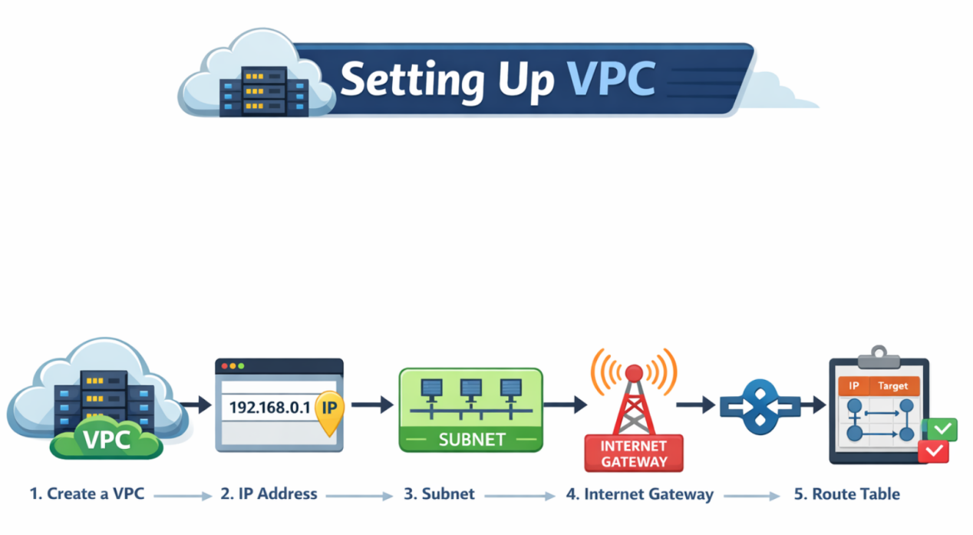

By default we have default VPC in AWS , We can delete that VPC, We can create the default VPC also if we delete the default VPC.

When we are create VPC , We have to give IP address Range. We have to decided the IP address Range

IP address , We have public and Private IP address , When we are going to create Network we have to setup the private IP range.

Private IP Range

Class A 10.0.0.0 - 10.255.255.255 / CIRD 8
Class B 172.16.0.0 - 172.31.255.255 / CIDR 16
Class C 192.168.0.0 - 192.168.255.255 / CIDR 24

Based on IP requirement for your machine on project , we choose CIDR size (like /16, /20, /24)

Because now days we use CIDR to calculate the IP address especially in AWS VPC

CIDR (Classless Inter-Domain Routing)

How to calculate IP range by using CIDR , Simple formula

CIDR Value - Total Bit

= 24 - 32
= 8
= 2 to the power 8

Answer 256 IP address we can use when we are choosing CIDR Value is 24.

Step-1

Go to AWS console

Create VPC -> VPC name -> cidr Value 192.16.0.0/24

Step-2

Subnet:

Sub net will be create inside the any one of AZ, if you are not creating sub net we are not able to use AZ.

Create subent -> Subnet name -> Choose AZ-A-> 192.16.0.0/24

Note: Here we have use sub net IP same series of IP address which we using in VPC CIDR Serious.

Note: One sub net cannot use all the AZ, In AWS always create sub net inside AZ. But in AZURE cloud it possible, We can use one sub net across all the AZ.

Step-3

For high Availability. Create one more subnet

Create subnet -> subnet -> choose different AZ -> 192.16.0.0/24 (use IP range)

Note: Here we are not able to create sub-net, Because all VPC IP we used first sub-net.

How can we resolve this problem?

Step-4

Since we are using all the VPC IP series in one sub net , we cannot modify the existing VPC CIDR Range, but we can create another series of VPC

192.168.1.0/24

Go the VPC -> select VPC -> Add new ipv4 CIDR value 192.168.1.0/24

Go to the sub net -> create sub net name (sub net-2) -> choose AZ-b -> choose vpc and subnet cidr 192.168.1.0/24

But now issue solve , the main problem is if your go to check edit cidr we can add only up to 5 CIDR

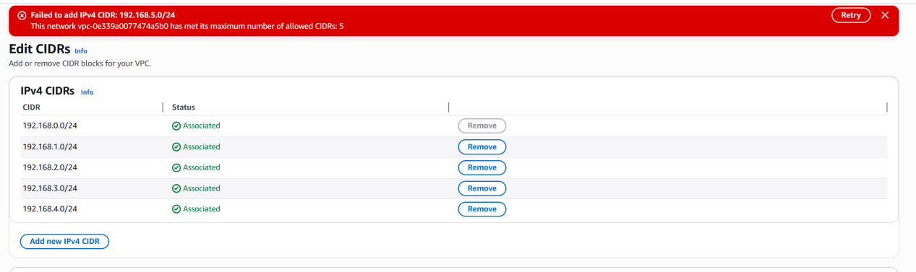

The solution is we have to sub divided the IP address using sub net.

Step-5

We can subdivided the IP address by using CIDR calculator. So here we can sub-net divided the sub-net using same series

https://www.solarwinds.com/free-tools/advanced-subnet-calculator
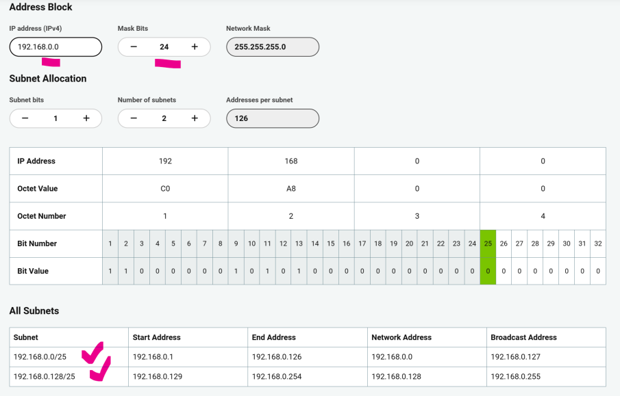

Always AWS will use reserved five IP for each sub-net

- 0 → Network address
- 1 → VPC Router
- 2 → DNS
- 3 → Reserved for future use
- 127 → Broadcast address
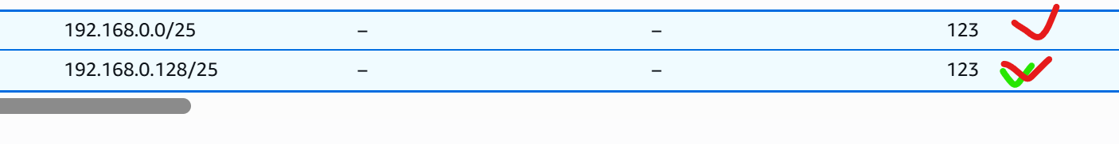
Total 126 -> each sub net AWS will allocated to use 123

Step-6

Create two EC2 instance using custom vpc along with two different availability zone,

Ensure that enable auto-assign public Yes

After creating EC2 instance , if you try to access the EC2 we are not able access because it doesn’t have internet supply , to enable internet sub-net we need attache the internet gateway on the VPC.

Final Conclusion

- Always plan VPC CIDR properly before creating subnets to avoid IP exhaustion.
- Divide VPC CIDR into smaller subnet ranges instead of using full CIDR in one subnet.
- Each subnet is created inside only one Availability Zone in AWS.
- AWS reserves 5 IP addresses in every subnet.
- To access the internet, attach an Internet Gateway and update the Route Table with 0.0.0.0/0 route.

Internet Gateway:

How to Setup the Internet in VPC?

- Public IP address is option

- Private IP address mandatory ,it will be create based on your sub-net range.

If you want internet get connectivity we have to use Internet gateway , IGW is should be attached to VPC.

Step-1

Create -> internet Gateway -> create

Once Create IGW , we have to attache into the VPC.

Route table:

if you want to get internet to your VPC , we have to route the internet using internet gateway into your Rout table

Once create the VPC , it will automatically create the default rout table which we called as main route table.

When ever we create the sub net it will automatically associate into Main rout table, but main rout table don’t have access of internet, if we want we can route internet into the main route table.

Note: sub-net A ec2 instance will be connect sub-net B ec2 instance, because all sub-net associate into main rout table.

Note: Without Using public IP address , we cannot able to access the internet in your EC2 instance.

Two Tier Application:

When we are deploy app in real time we have to do more secure

How we can secure , It is everything based on the design on VPC.
How web app design in Real time env.

First web server , it is point of contact of users. User Access the Website using Web Server.

That why web server always hosted in public IP, User can access the web-server using Public IP. Web server can expose the internet, Any bodies can access the web server

What about customer data, it is always stored into the database server. So we have two tier one is web server tier and another one is database tier.

Database is very important , we don’t want any bodies access database server over the internet.

The process is user will access the web server and web server will store the data inside the database server.

We don’t want inbound connectivity for the data base server . User will access the web server and web server will access the database server.

How we can deploy same kind of Scenario in the AWS Infra structure.

We have to create this kind of setup as mentioned below.

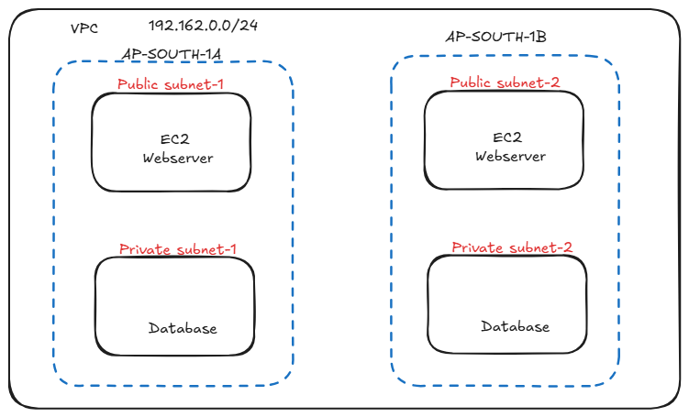

Public sub-net placed the internet connectivity, Reason for two public sub-net and private sub-net to maintain the high availability.

Public sub net have internet connectivity

Private sub net don’t have internet connectivity.

And also we should understand how to give out band traffic for your database.

How to create the VPC Part-5

We understood the basics.

How to create the VPC

How to create the sub net

How to create the Internet gateway and purpose

How to create Rout table and purpose.

But this is not enough, We have to setup the VPC According to AWS best practices. So we have to setup public and private sub net.

Always web server use the public sub-net, hence publicly accessible

Database should be run as Private sub net, it should not have internet access. So any server running database it totally safe.



We have to setup four sub net , two is public and another two is private, to maintain high availability we have to maintain the multi sub-net for each web app and database.

Demo: AWS Console

Step -1 CREATE VPC

Going to VPC

Create Vpc -> VPC only -> Name (my vpc) -> Ip address range 192.168.0.0/24 -> create VPC.

Step-2 CREATE SUBNET

We Need to create four sub-net.
Go to subnet -> Create Subnet -> select VPC ->

Subnet-1

Name: public-subent-1
AZ: ap-south-1a

Subnet CIDR Block: 192.168.0.0/26

Add subent

Subnet-2

Name: public-subent-2
AZ: ap-south-1b

Subnet CIDR Block: 192.168.0.64/26

Subnet-3

Name: private-subent-1
AZ: ap-south-1a

Subnet CIDR Block: 192.168.0.128/26

Subnet-4

Name: private-subent-2
AZ: ap-south-1b

Subnet CIDR Block: 192.168.0.192/26

-> Create Subnet (it will create four subnets)

Once create all the sub-net , we are not confirmed those public and private sub-net , we just naming the sub-net , Right now all this are private sub-net

Note: if you want to create the internet connectivity for public sub-nets we need to attached the internet gateway.

Step-3 CREATE INTERNET GATWAY

Create Internet gateway -> Name (IGW) -> Create internet gateway

Attach to VPC -> Select the VPC -> Attach internet gateway

Step-4 ENTRY INTO ROUTE- TABLE

By default main route table will be created , once create sub net , By default all the sub nets will be associated to the main route table.

We can verify in AWS console

-> (VPC -> Routable -> check routable Main (yes))
-> Sub-net Associated -> we able to see all the sub-net will associates to main route table (Sub-nets without explicit associations.)

Note: Now if you connect Internet gateway into main Rout table , all the the sub-net will get access internet connectivity.So all the subnet should be public.

How will resolve the problem?

We will create another rout able .

Step-5 Create Route table:

Route table -> Create Route table -> Name(RT-Pub)

VPC -> Select the vpc -> Create Route table.

Step-6 Associate the publi-subnet - RT-Pub Route table:

Go to RT-Pub -> Sub net Associations -> Edit sub net Associations -> Selecting the two pub sub nets -> Save associations.

Note: Once Associated the pub sub nets into pubic RT , it will automatically DE-associated from the main route table.

Step-7 ( IGW to Routes)

-> public RT -> Routes -> Add routes -> 0.0.0.0/0 , Internet gateway(select the igw) -> save changes

Pub sub-nets are associated into the pub rout table and pub rout table having connectivity to the internet gateway that’s why it public.

Note: In private sub net server , how we can install the database, without internet(outgoing Traffic).
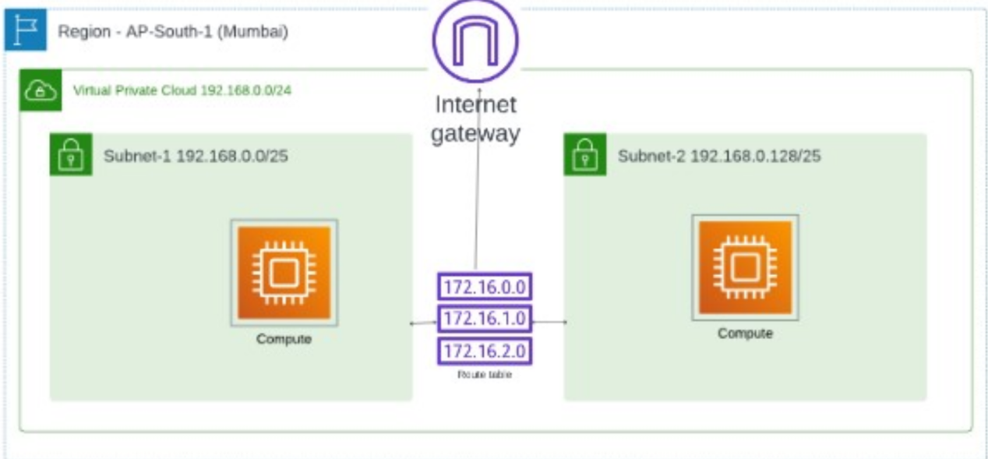

Create VPC Part 5 (public and private subnet)

Step-1

Using public sub-net login the ec2 instance

Step-2

Using private sub-net login the ec2 instance, We are not able to do

To access this private sub net EC2 instance we have two ways:

EC2 instance connect endpoint. (new features)

VPC -> endpoints -> create endpoint ->

Name -> (mentioned name)

Select -> Ec2 instance connect endpoint

Select -> particular vpc

Select Security Group -> default security group

Select sub net -> Select the private subnet-1

-> Create end point

Note: it will take some time to create.

Note: Ec2 instance connect endpoint having one issues, It is using AWS API call, if you access this particular endpoint, If you want to this endpoint to access this ec2 instance, we must have AWS username and password. It means we have to login into AWS Account.

In this case, I can access the database server using my username and password.
If someone else wants to access my database server, I need to give them access. But giving my AWS username and password to connect to the EC2 instance is not a good and secure method.
So what should we do instead? How can we give access without sharing our username and password?

Click EC2 instance -> connect -> EC2 instance connect -> Connect using EC2 instance connect endpoint -> Select the endpoint (which we have created) -> Connect

Note: When u try it root account , it will not ask username and password, Because already your are serving in root account.

Second Option: Connect through bastion host.

WE have to create Special Ec2 instance in the public IP , Then they have access the private sub-net using this public EC2 instance, They called it bastion host.

Demo:

- Login the bastion host using Public IP.
- Login private sub net database server form this bastion host , Refer the below command
$ ssh -I <pem.key>

Note: for copy the pem file use scp command

$ scp -i <pem.key> pemkeyfilename ec2-user@<bastion host public ip> :/home/ec2-user

$ ls

$ ssh -I <pem.key> ec2-user@<database private IP address>

Will get permission error , reason for this ?

As per rule pem file it should be read permission.

$ chmod 400 <pemfile>

$ ssh -I <pem.key> ec2-user@<database private IP address>

Step-3

In the private ec2 instance, try give ping command

$ ping google.com

$ yum install httpd -y

Note: we are not able to access and download , because we don’t have internet connection in this private sub net particular ec2 instance.

Now if we want to upgrade Linux box , install database we need internet ,

Note: We need internet , I need only outbound internet, but I don’t want inbound internet for no bodies access this server.

Then how can we provide outbound internet in this particular EC2 instance ?

Use case of Nat gateway

If you want to setup the outbound traffic for private sub-net , we can use Nat gateway.

Nat gateway it is kind of components , which will get internet from the internet gateway and it will provide internet connectivity to private sub net EC2 instance.

Why we are not able to access internet in this Private EC2 instance. Two problem.

- Private sub net Route table we are not routing to the Internet gateway. So we are not able to send request to the internet gateway
- Internet gateway cannot with communicate if you have only private IP. Internet gateway can communicate with any AWS resources those having public IP.In order to communicate with internet gateway, We must have public I, but we don’t provide Public IP into the private sub net.

How we can solve this problem?

We must have agent , This particular agent we have public IP, Using this Public IP will communicate to the internet gateway, Internet gate way doesn’t have any issues with agent , because agent have public IP address.It will communicate to the internet gateway, it will bring internet for us and then it will send the internet to Private sub-net Ec2 instance.

Now this agent is know as Nat gateway

Demo:

Go to vpc -> Nat gateway ->

Name: name of the nat gateway

Sub net -> select the Any one of the public sub net -> Create Nat gatway.

Note: IGW Cannot communicate if don’t have public ip, Now nat gateway using the this public ip, it will communicate to the internet gateway, it will bring the internet connectivity to our private subnet.

Go to main route table -> Routes -> Add route -> 0.0.0.0/0 -> Selecte NGW -> save changes.

Note: Nat gateway . it provides the outbound traffic for the private sub net , it is chargeable don’t forget to delete and also release the elastic ip also.

Summary for all the VPC Components:

VPC: A virtual private Cloud is a virtual network dedicate to our AWS account with in AWS cloud
It provides logical isolated environment for our AWS account.

- VPC are created with a specific range of IP address using CIDR Block notation
- AWS supports IPV4 CIDR blocks between /16 and /28 net mask
- We can add up to 5 CIDR Range withing single VPC
- Soft limt of vpc per region 5 VPC , but this can be increased upon request.

Sub net: A sub net is a segmented portion of a VPC’s IP address range, allowing for organization allocation of IP address.

- Configuration: Subnets are created within AZ.
- Limitation: Upto 200 sub-nets

Public Sub net:
- Role:Sub net that accessible from the internet
- Usage : it used of load balancer and web server.
- Point to consider: But it required internet Gateway, So it will get inbound and outbound.

Private Sub net:
- Role:it is not accessible from the internet
- Usage: it is used for sensitive application like database.
- Point to consider: Requires a NAT gateway for outbound internet access.

Internet Gateway:
Role: it use connect AWS VPC to the internet.
Configuration: Attache internet gate way with our VPC.
Point to consider: public IP is needed for the access the internet using internet gateway

Nat Gateway:
- Role: it is used access the outgoing traffic in the private sub net for updates and downloading.
- Configuration: Placed in public sub net with an Elastic IP address
- Point to consider: it will not provide Inbound internet.
- Each Natgateway supports upto 55000 simultanesous connections.
- Bandwidth: One nat gateway supports Upto 45 GBPs depending on instance types.

Rout tables:
- Role: control where network traffic is directed
- Configuration: Main Rout able it is automatically created, it managed difficult routing for all the subnets
- Custom route table: Create manually for specific routing needs.
- Limitaion: upto 200 route table create per VPC
- Routes per route table: 50

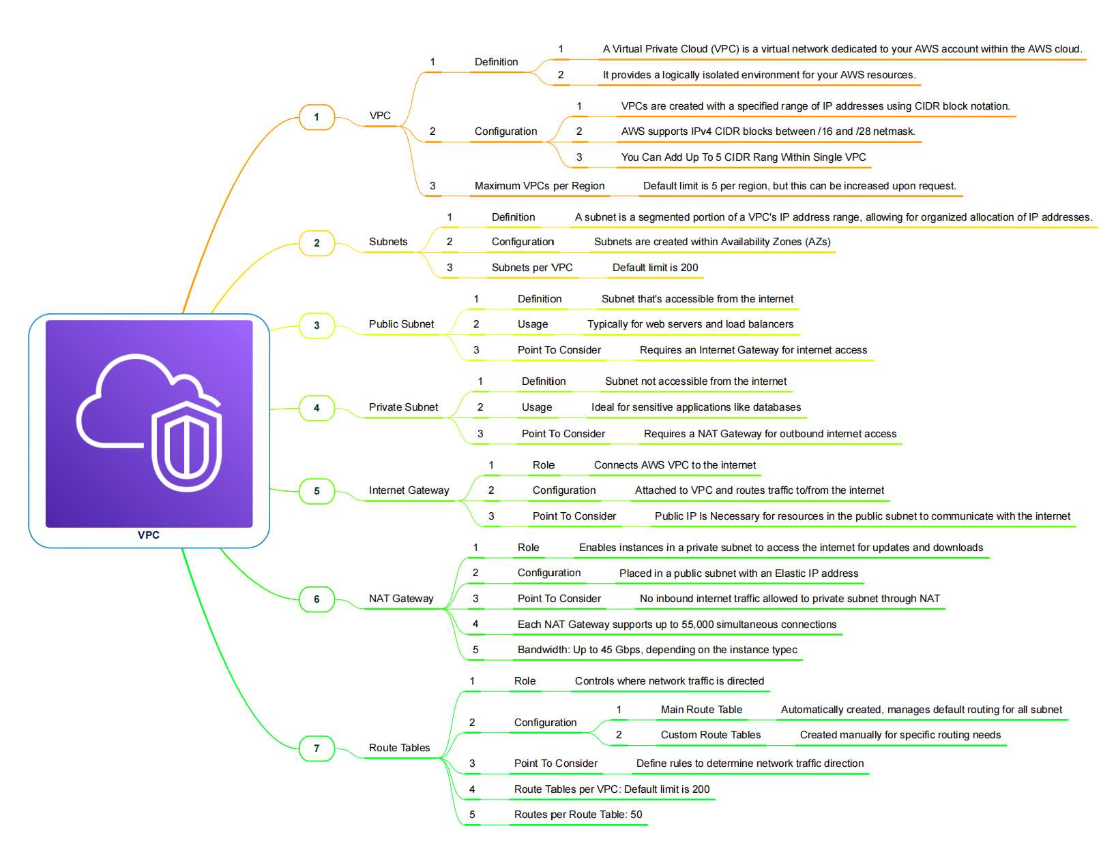

VPC Peering:

If we have two different VPC Account inside this I have two VPC

Are they able to communicate to each other ?

No, We cannot

Same way I have two VPC in my same account , Are we communicate each other ?

Answer is no.

Be default two VPC cannot talk each other , even if two different AWS account or same AWS account.

If we want to able to communicate each other is there any way , yes we have, we called it VPC peering connection.

By using VPC peering , we can connect two different VPC , evern if same account or same region

If both parties are agree they can communicate each other.

Demo:

Step-1

Create two VPC with different region

Go to mumbai region create a VPC CIDR Value: 192.168.0.0/24

Create a private subnet Subnet id 192.168.0.0/24

Create Ec2 instance -> choose the VPC id and sub-net

Step-2

Go to North virgin region create a VPC CIDR Value: 192.168.1.0/24

Create a private subnet Subnet id 192.168.1.0/24

Create Ec2 instance -> choose the VPC id and sub-net

Note: don’t use same cidr value as two differen VPC , VPC Peering will not allow same series.

Step-3

How we can access private sub-net EC2 instance by using endpoint service we can do that

Create Endpoint in Mumbai region.

Step-4

Connect India ec2 instance using ec2 instance connect.

Ping US instance Private IP address, using command

$ ping <ip_address>

It will not work , communication will not happened each other…….

Step-5

If you want to communicate one VPC to another VPC we have to create the VPC region…..

Go to Mumbai region

Peering connection -> create Peer connection -> Requester details (Mumbai region VPC ) -> Account -> My account -> Another region (select another region VPC) -> VPC Id (update USA VPC ID)

Go to US VPC -> Peering connection -> Action Accept request

Step-6

Update the route table in each VPC

India vpc routa table update USVPC cidr block

US VPC route table update Inida VPC Cidr block

NACL:

Setup: Create EC2 instance and host the application and enable the security group (all traffic allow)

Note: This scenario for this particular ec2 instance there is no security, because all traffic allow in the security Group. But in the AWS we have two layer to protect our ec2 instance

First layer is NACL, it is used to protect the entire sub-net , Security Group which is used to protect the specific resources.

If we are access the ec2 instance , we need pass the two protecting layer security group and nacl.

But Right now In our setup all traffic enable both security group and nacl. So now we can able to open the website.

Example : NACL is security for Enter office Campus(DLF), Security group is security for individual that particular office

Default setting of NACL:

When we create VPC , example default VPC.

We can see that Network ACL’s, -> default ACL which is associated with all of the three sub-nets

In the ACL We have inbound and out-band traffic allow

Demo:

Step-1

Create one network ACL -> Name -> Select VPC -> Create NACL

Step-2

Sub-net association -> select the sub-net (AP-south -1a)

Note: So now by default it will deny all inbound and outbound traffic deny when we create custom NACL

Note: Now we are not able access everything. Verify the website.

Note: Now we cannot login the ec2 instance, website and pinging server from another

Step-3

Edit both inbound and outbound rule

In bound rule : Rule - 100 , Type : All ICMP - ipv4 , Source: 0.0.0.0/0

Outbound Rule : Rule - 100 Type: All traffic , Source: 0.0.0.0/0

Note: Why need to give outbound rule because NACL is stateless

Now we can ping the ip address , able to connect

$ ping <public_ip> on Window CLI

To allow SSH , we need enable the ssh port number in inbound traffic
Inbound: Rule-200 , Type: ssh(22) , Source: 0.0.0.0/0

To allow http, we need enable the ssh port number in inbound traffic

Inbound: Rule-300, Type: http(80), Source: 0.0.0.0/0

Now we can open website also

Note: In network ACL we can add the Deny rule, But security we don’t have.

Deny my IP;
Rule: 400 , traffic HTTP, source: myip address, Deny

Even if you add the deny rule, website will be working when you access In your laptop , Why?

Because in 300 rule ( we allow all traffic http), that why it will not consider the 400 rule.

Note: NAC always Lower number gives higher the priority.

But if you want this, Change the rule number

Give rule number 250 instead of 400 -> save changes

This case it will check 250 rule it deny <my ip> , so we are not able to access the website in our own my ip in laptop and it will check 300 it allow the all traffic, this case expect my ip it will allow all the traffic.

Note: Lower number gives higher the priority.

Conculastion:
- Network ACL (NACL) protects the entire sub-net, while Security Group protects the individual EC2 instance.
- NACL is stateless, so we must allow both inbound and outbound traffic.
- Lower rule number has higher priority, and NACL supports both Allow and Deny rules.
One-line summary: NACL = Sub-net level security | Security Group = Instance level security.

Difference between NACL and Security Group:
Security Group:

Assigned to Instance
- we can attache security group in Network Interface, Like EC2 have network interface and load balance r, EFS also have network interface.

NACL:

Assigned to Sub-net level

Example
Use cases For NACL:

Requirement is we don’t want traffic from port number 80 entire ec2 instance, So we need to block 80 port number for entire sub-net. No one access 80 port number traffic all the EC2 instance under particular sub-net level. This case we can use NACL ,

Use case for Security Group:

If you want to block traffic 80 only particular ec2 instance over the sub net, this case we can use security group.

Security Group → Instance level security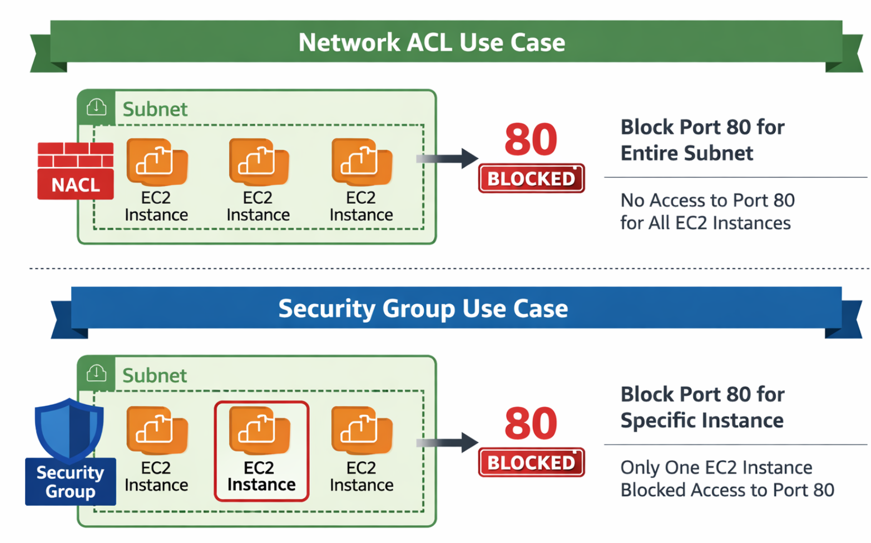

NACL (Network ACL)
- It is used to control traffic at the sub-net level, so the rule will apply to all EC2 instances inside that sub-net. Example: Blocking port 80 for the entire sub-net.

- NACL → Subnet level security

Security Group
- It is used to control traffic at the instance level, so the rule will apply to only a specific EC2 instance. Example: Blocking port 80 for one EC2 server only.

- Security Group → Instance level security

Security Group: Simultaneously Apply all rule

If you are enable the traffic like httpd , nfs etc …… All the traffic allow automatically, there is no Sequence Manner.

Access Control List: Rules Applies in Squence

Here we need to provide Rule number, Lower the rule number higher the priority. It will restrict the traffic based on Rule where we assigned in NACL.

Security group

Only Allow Rule

NACL

we can setup allow or deny Rule.

Security Group

It is state full

NACL

It is stateless

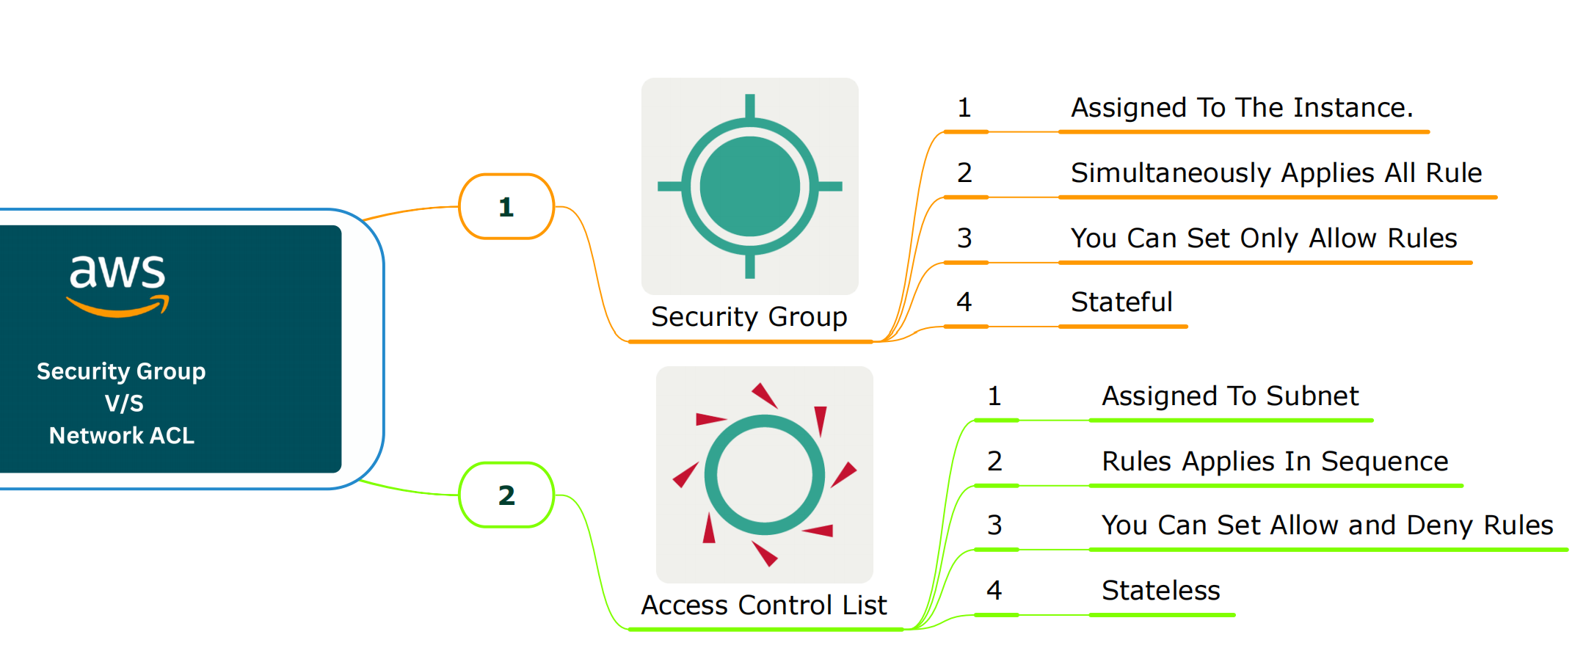

Difference Between State full and Stateless:

If you are sending traffic external we have to allow inbound traffic traffic both stateless and state full.

Stateless: When access the internet from ec2 to instance , we need to setup the rule.

State full: When access the internet from ec2 to instance, we don’t need to setup the rule, it will automatically allow.

