Autoscaling:
Auto Scaling in AWS means automatically increasing or decreasing the number of servers (instances) based on traffic or load. It helps your application handle more users and also reduce cost when traffic is low.
Simple Example
Imagine your website runs on 2 EC2 servers.
- If traffic increases, AWS will automatically add more servers (like 4 or 6).
- If traffic decreases, AWS will remove extra servers and keep only the required ones.
This process is called Auto Scaling.
To implement the Autoscaling:
Create Auto scaling Group:
- It allows to manage a collection of EC2 instance as single unit
- Making it easier to automatically scale the number of instances in response to changing demand
Create Launch template
- Defines how new EC2 instances should be created (AMI, instance type, security group).
- It is used to simplifying the launching new ec2 instance.
Scaling Policies
- Rules that decide when to add or remove instances.

Types of scaling polices
- Manual Scaling
- Schedule Scaling
- Dynamic scaling
Create launch template
- Name of the template
- Version – 1
- Browse Ami – select linux ami
- Instancy type – t2.micro
- Key pair – select the key pair
- Security group – Select security group
- Advance -> user data

-> Create Launch template

Create Auto scaling group
Name -> mentioned name
Lauch Template -> choose the template -> Next
VPC -> select default VCP
Subnet -> Select all the availability zone
Load balancing -> No load balancer -> next
Desired capacity – 0 (how many instances right now)
Minimum – 1
Maximum – 5
Next (4)
Create Autoscaling group

Now go and check the ec2 instance console, no instance will come, because desired and minimum capacity is defined zero
Scenireo-1
Edit do changes
Minimum -1
Desired capacity -1
Now we able to see one ec2 instance
Scenireo-2
Better tolerance of Autoscaling:
Now try to terminate the instance, if you terminate the ec2 instance, it will create new ec2 instance
Scenireo-3 (Scale out)
Edit do changes
Desired capacity -2
Now will get two ec2 instance

Now if you open any ec2 instance, web site will open same in all the instance.
Scenireo-4 Above maximum
Desired capacity -6
It will not work
Desired capacity it should be in between minimum and maximum
Scenireo-5 Scale in
Desired capacity 1
Decreases the instance

Scheduled Scaling:
Means that scaling action are performed automatically as a function of time and date
This is useful when you know exactly when to increases or decreases the number of instances in your group
Use case: we can setup increasing the instance particular date.
Steps
Scale Out
Click Auto scaling -> Automatic scaling, Below steps follow:
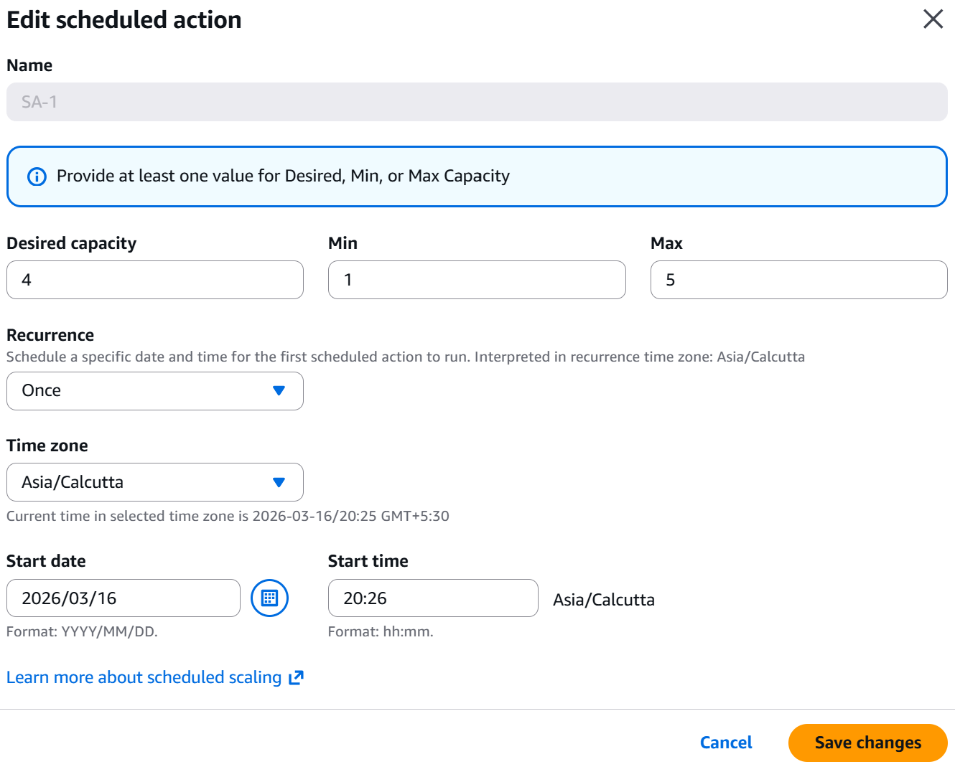

We can see once scheduled time reached.

Scale in :
We can create another scheduled for scale in
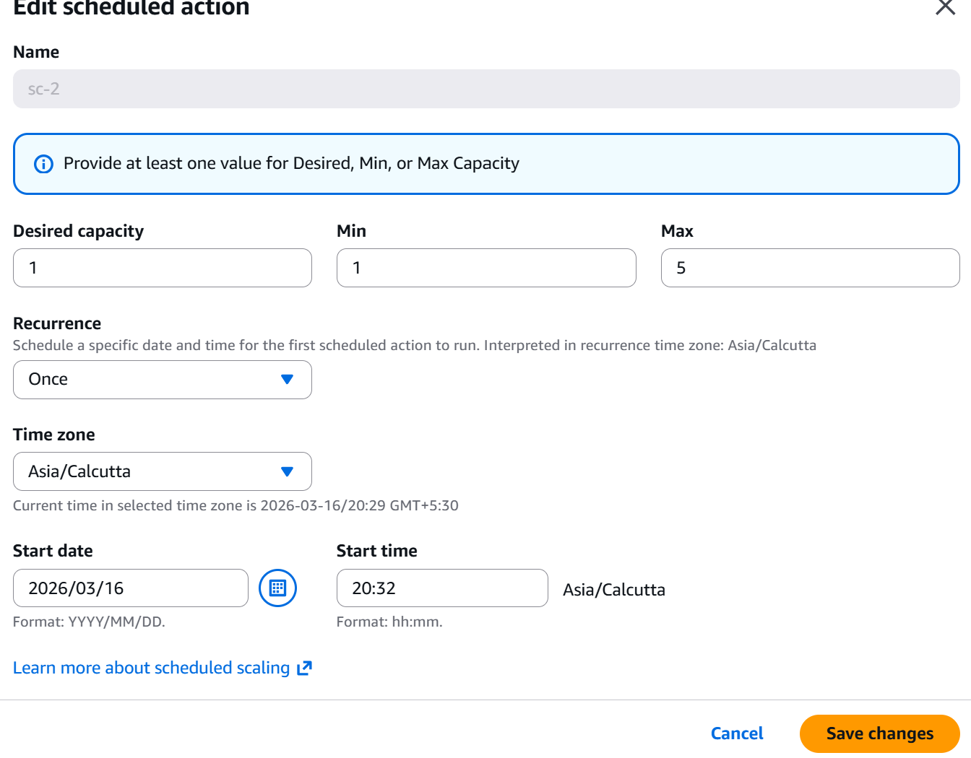

Dynamic Scaling
Simple Scaling
Step Scaling
Target Tracking scaling

