What is Operating System (OS) ?

- Operating system is a software which is used to interact with computer

- OS will act as mediator between user and computer hardware Components

- Hardware Componentes: Ram , Hard diks , Keyboard , Mouse etc ..

- OS is mandatory to use any Computer. Without using OS we cannot interact with computer.

- OS provides environment to run other Applications.
- Ex: Notepad, Browser , Calculator , Paint …. etc …

- If you want use the Application in computer , we need environment , that environment is OS will provide.
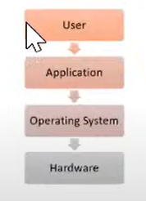
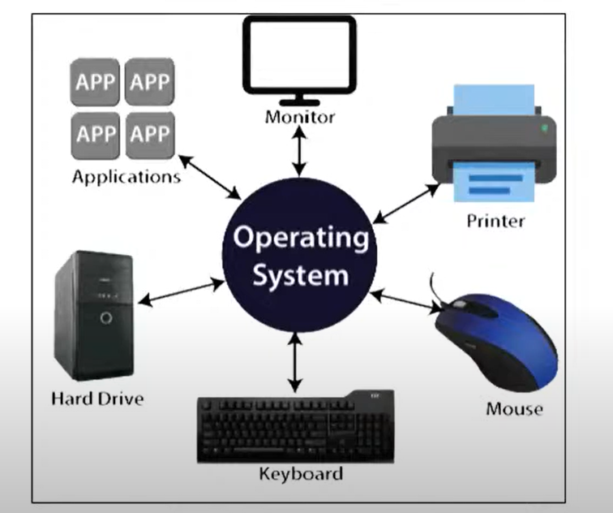

Windows Operating System:

- Developed by Micro System
- It is having GUI (Graphical user Interface) . Anyone can easily use the Windows Operating System.

- It is commerical (Paid) .

- It is single user based Operating System . Only one person can use at a time.

- Less Security features . Easily Virus can attack our software which are running on the OS because everything will be executed as a .exe file and .bat file

- If you want install the any software will download as .exe file and .bat file

- If you run .exe file and .bat file virus can easily attack in our computer

- Security system is very less that why install Anti Virus in our device. To protect our system.

- It is re-commanded for Personal purpose use.

Linux Operating System:

- Most famous Operating system use in IT Linux as a Devops eng we are going to Use Linux only.

- Linux is free and Open source OS

- Linux is multi user Based OS at a time.

- Security features are very high.

- As a devops and developer should know Linux OS.

- It is Recommended for application, servers , database etc ….

- In IT Application , database everything will run in Linux Machine only.

- Linux is community based OS , It is not belongs to another company.

- Linux is recommended for Project.

- Everything it belongs to CLI (Command line interface).

Linux OS History:

- In 1991 , a student ‘Linus Trovalds’ developed this Linux OS.

- Before Linux Unix OS used.

- Trovalds identify some drawbacks in unix Operating system.

- Linus trovalds identified some challenges in UNIX OS.

- He suggested to UNIX team about what are the challenges in UNIX OS , but the UNIX team rejected his Opinion.

- Then Linus trovalds used to develop the Minux OS

- After he used Minux OS to develop the Linux

- Linus + Minux => Linux

- Linus Torvalds released Linux OS with Source Code into Market.

- He release the OS into market , So anyone can use the OS Freely. That’s why we called Linux free and open source software.

Linux OS Distributions:

As Linux OS is Open Source, so many people and companies taken that Linux OS and modified according to their requirements and released into market with different name those are called as Linux Distribution or Linux flavored OS.

Example: In Windows we use windows 7, windows 11 , windows 10 in different version in Windows OS like that . In Linux there is no version , here we are having distributions.

RED HAT

Ubuntu OS

Cent OS

Fedaro

Open SUSE

Kali Linux

Debian

Amazon Linux

Those are all Linux distribution OS.

Here some of the distribution are commercial and some of the free
Example: Red hat commerical

What is Linux Distributions:

Linux is open source software , So may People download the source code of OS and they modified some code in Linux Operating System they Release into market in different name that is called Linux Distribution.

What is the Purpose of Linux:

Application Infrasturcture:

Below Snap mentioned All this software installed only Linux Machine only.
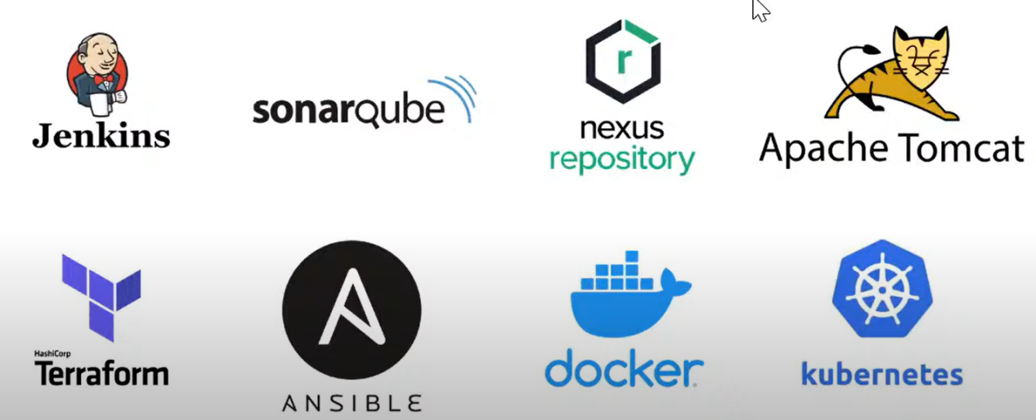

To setup Infrastructure we are using Linux Machine only.

Note: Devops Tool Chain all the software installed in Linux Machine only .

Linux Environment Setup:
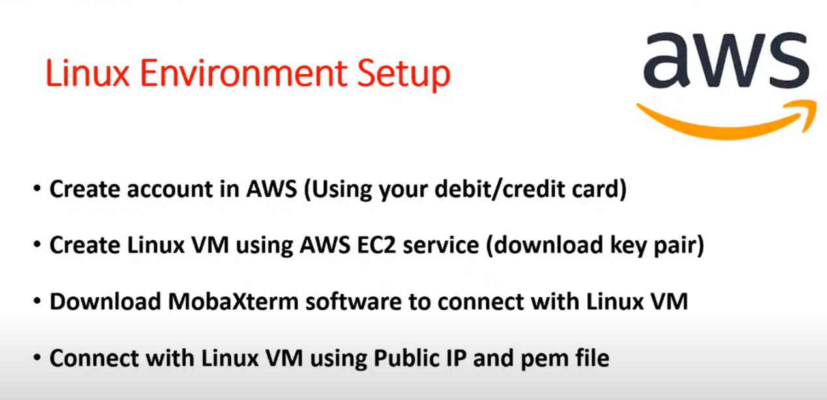

We no need to install the Linux in you local Machine. We are going to use Linux Machine in AWS.

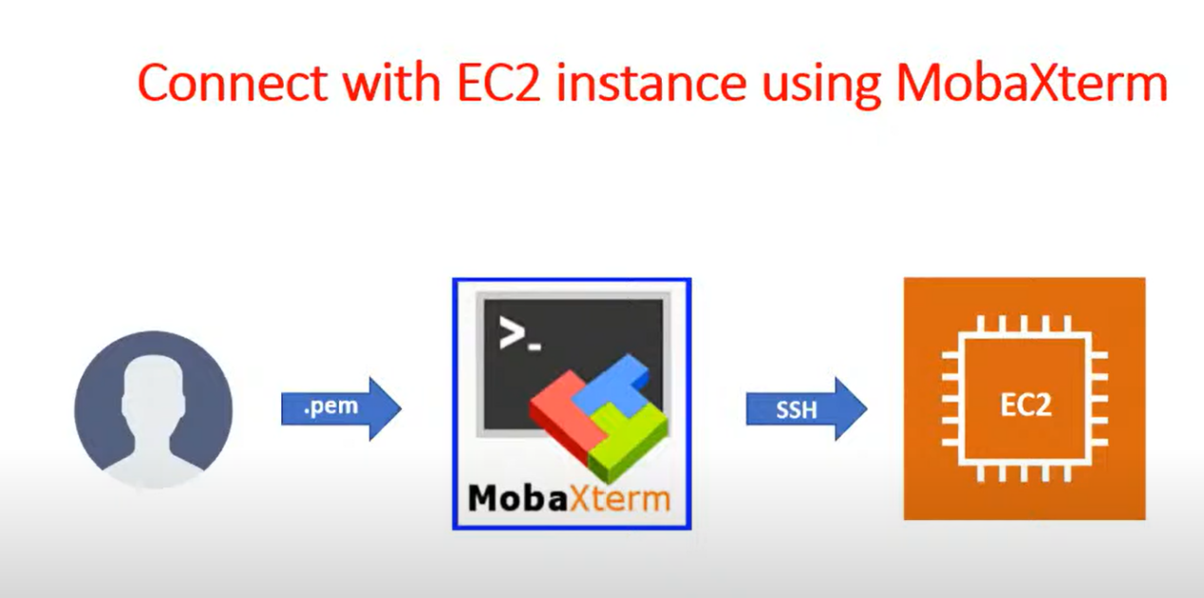

We can use connect with Linux machine by using the mediator tool of MobaXterm, putty , Git bash.

Linux Commands:

$ sudo su -

Linux we will Operate with commands CLI

In a Linux Everything is represent as a file

Normal file (text files)

Directory file (folder)

Create a directory:

# Make the directory

$ mkdir

# create the sub directroy

$ mkdir -p arun/kumar

# Remove the directory

$ rmdir

# List the files and directory

$ ls -l

# if you want to change the Directory

$ cd

# Want to come back the directory

$ cd ..

# Present working directroy

$ pwd

# two steps back

$ cd ../..

# Two forward

$ cd /arun/kumar

# Directly go to the Home Directory

$ cd ~

Create the files

To create empty file

$ touch <filename>

Note we can create multiple file also

If you want to create the multiple empty file with different name

$ touch arun{1..4}.txt

If want to create the file with content

$ cat > filename

Note: After Writing data press ‘CTRL+d’ to save and close that file
Note: if your using the command for existing file OLD data will remove

Print the file data:

$ cat filename

It wil print with line number without considering space

$ cat -b <filename>
It will print the Line number with considering the Space

$ cat -n <filename>

If we want to append data to existing file

$ cat >> filename

To delete the file

$ rm <filename>
To delete the empty directory

$ rmdir <dirname>

To delete the non-empty directory

$ rm -r <dirname>

Note: -r recursive (to delete content first and delete the directory)

Rename the files or directory

$ mv <present name> <new name>

Copy the data one file into another file

$ cat f1.txt > f2.txt

copy More than one file data into single file or we can re-direct multi file into single file

$ cat f1.txt f2.txt > arun

Another command for copy one file to another file

$ cp arun kumar

Note: to Copy one file we can use cat or copy.
If you want to copy the directory

$ cp -r dir1 dir2

If you want to show where it will store while copy file

$ cp -v arun.txt dir1
If you want to copy the source file to destination same file permission, owner,group, time stamp.

$ cp -p <source file> <destination file>

If you want print the content reverse (bottom to top)

$ tac <filename>

Print the data from top to bottom (by default first 10 lines)

$ head <filename>

$ head -n25 <filename>

$ head -n50 <filename>

$ head -n4 <filename>

Print the data bottom to top (by default last 10 lines)

$ tail <filename>

$ tail -n25 <filename>
$ tail -n4 <filename>

Note: if you want to latest logs , we can use tail.

# To check the no of lines , words , character

$ wc filename

Search the word in the file

To list the file:

$ ls -l

$ ls -a

$ ls -lS

$ ls -lh

$ ls -lt

$ ls -ltr

$ ls -lt /var/app

$ ls -lt /var/app/*.log/
$ ls -lt /var/app/*.gz/

Grep:
Grep is used to select the lines/rows based on requirement search string from a give files / command output

Grep syntax:

$ grep <option> ‘search string’ files
$ commond output | grep [option] ‘search string’
Grep stands for GLOBAL REGULARE EXPRESSION PRINT

It is used to find the data in line (like Ctrl+F)

Grep cmd will process the text line by line it prints the line which are matched with given pattern.

$ grep text-string-to-search filename.txt

$ grep Linux <filename>

To ignore Case Senstive

$ grep -i Linux <filename>

Real time we can use the pattern inside the logs
Example:
$ grep -i nullpointerexecuteion sbi.log

If you want to search the pattern for all the files in present working directory

$ grep -i linux *

If you want to search word present working directory with sub directory we can use R

$ grep -R Linux

If you want to find the line with count

$ grep -n arun <filename>

If you want to count the word

$ grep -c arun <filename>

If you want to print execpt the particular name

$ grep -v arun <Filename>

Text Editors:

In windows will use Notepad as text editor

In Linux we will use VI text editor (it is default in Linux)

$ vi arun.txt

Press “i” in key board to enter into insert mode
Write the data in file

Press esc the press wq to save that file.

I need to close the file without saving data esc q!

Note: ! -> not symbol

SED

SED stands for strem Editor

Using SED stand command we can replace the text without opening the file

$ sed 's/Linux/arun/' arun

Note: by default it will not replace the change

If you want to save the original file also

$ sed -i 's/Linux/arun/' arun

To delete the line without opening the file

$ sed '2d' arun

$ sed -i '2d' arun

To delete the last line file

$ sed $d arun

To delete the line from second line to last line

$ sed -i '2,$d' arun

If u want to check the history of the command

$ history

If you want to check the particular command history

$ history | grep sed

If you want to particular command on the history result

$ ! <countnumber?

System Information:

To collect OS details , Kerenel Details , Process details

$ uname --help

To collect the all the details by using single command

$ uname -a

Hostname details

$ uname -n

OS details

$ uname -s

Kerenel release details

$ uname -r

Uptime:

By using this command we can check how long system has been running after rebooting , number of user with running session, and system CPU load average past 1,5,15 minutes

$ uptime

# Only minutes

$ uptime -p

Need to know which time we boot the machine

$ uptime -s

Hostnamectl:

By using this command we can check the hostname details and edit the hostname of the linux machine through terinmnal

# if you want to check architecture and OS flavoured details
$ hostanamectl

To edit the hostname detils

$ hostnamectl set-hostname arun

Timedatectl

It is allows to review and change the configuration of the system clock and we can change the current data , time and time zone

To view the timezone details

$ timedatectl

To list the all the timezone

$ timedatectl list-timezones

To fileter out particular timezone

$ timedatectl list-timezone | grep Asia

To set the time zone

$ timedatectl set-timezone Asia/Calcutta

NTP: Network time protocol

It will fetch the internet time and set the date and time

To active the ntp

$ timedatectl set-ntp 1

To disable

$ timedatectl set-ntp 0

Note: if your ntp is active , we cannot change the time in local, if you want to change the local time , we have to disable the ntp

To change the time

$ timedatectl set-time 12:30:00
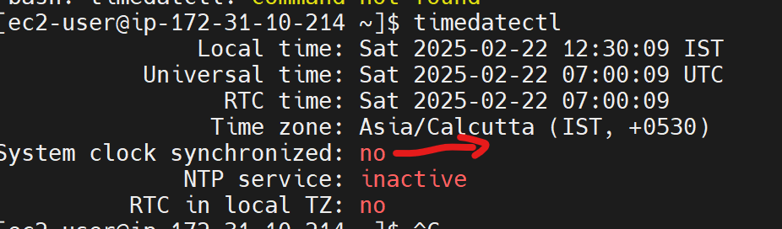

Note: system Clock synchronized : no (because system bios and this time is different)

# if want to change the date

$ sudo timedatectl set-time "2025-03-25"

# if you want to change the date and time both

$ sudo timedatectl set-time "2025-03-25 09:25:00"

If you want to revert again, we need to enable the ntp

$ timedatectl set-ntp 1

Date:

Data command is used to display system date and time , by usin this also we can set date and time

# To check the date and time

$ date

# if you want to check future and past days

date -d last+saturday
date -d next+saturday

date -d next+year

To change the timedate

Ensure that disable ntp

$ sudo date -s "01-may-2026 12:30:00"

But it is not re-commanded way

# if you want to view customize date and time format

$ date +"%Y-%m-%d:%H-%M"

We can create the file with date and time stamp

$ touch arun$(date +%y-%m-%d:%H-%M)

Note:
Small y - 25

Capital y -2025

Cal

To view the calendar

$ cal

If you want to check the particular month

$ cal 2 2025

W
How many users login , it will show which user login and which process they are running

$ w

To know currently which user login
$ whoami

File editor:

Two types vi and vim

- Vi ( old one)

- VIM (latest one)

There are two major mode in vi and vim editor

- Command mode (normal mode)

- Insert mode

Entering into insert mode : i

Escaping into insert mode: esc

Saving file : w

Quite from file : q

Save + qutie : esc :wq

- : set number

- Copy -> yy

- Past above -> shift + p

- Past below -> p

- To delete the line -> dd

- Cut and pass -> dd and p

- To search the word -> /arun + enter , and type n to go next and next line

- To undo changes -> u

Service Mangment:

/etc/apache/ports.conf

-------------------------------------------------------------------------------------------------------------

File archeive:

To storing multiple files to single file for backuping purpose

File Compress in Linux:

Compression is a reduction in the number of bits needed to represent data. Compressing data can save storage capacity , speed up file transfer and decreases cost of storage hardware and network bandwidth.

For example: if we compress 20MB files with 2:1 ratio the compressed file with be 10MB approximately.

File archiving and compressing using commands tar

Compressing method;
gzip and bzip

Command | Explanation
tar -c | Create archeive without compression
tar -v | Display the details of the files that have been archived
tar -f | Creating an archive with given file name
tar -z | Archive & compress using gzip Compress (.gz)
tar -j | Archive & compress using gzip Compress (.bz2)
tar -x | Extract the archive
tar -t | view the files of an archive without extracting

tar (tap archive)
$ tar -cvf <newfilename.tar> <filenames>

$ tar -cvf test.tar file1 file2 file3 file4

C -> create without compression

V -> if u need command output

F -> to mentioned the file name

Filname ended with .tar

# if you want to view file inside the tar files
$ tar -tvf test.tar

T -> view the file
V -> verbose output
F -> file

# To extract tar file

$ tar -xvf <tar file name>

X -> extract
V -> verbose
F -> file

Archiving the file with compression

$ tar -czvf arun.tar.gz file*

C -> create

Z -> gzip compression

V -> verbose

F -> files

If u want to view the compression files

$ tar -tvf arunt.tar.gz

How to extract the Compression file

$ tar -xzvf test.tar.gz

How to do bzip format

$ tar -cjvf arun.tar.bz2 file*

J -> bz2 format

To view the files

$ tar -tvf arun.tar.bz2

How to extract

$ tar -xjvf arun.tar.bz2

How to compres the directory

Create directory and create inside some files

Then compress the directory
$ tar -czvf test.tar.gz <directoryname>

To extract the directory

$ tar -xzvf test.tar.gz

How to extract the one single if we have multiple files inside archiving

$ tar -xvf test.tar arun

_____________________________________________________________________

SCP: Secure Copy Protocol

It use the ssh protocol
SCP is program for copying files between Computers.

$ scp option <source file> <destination file>

Internet must , remote server username and password is must

How to check server to server communication by using ping command we can check

From server 1 to ping server 2
$ ping <remote server IP address>

Form server 2 to ping server 1

Prerequisite before do scp:
Create user
$useradd raja
$passwd raja
$ vi /etc/ssh/sshd_config
==> Password authentciation: yes
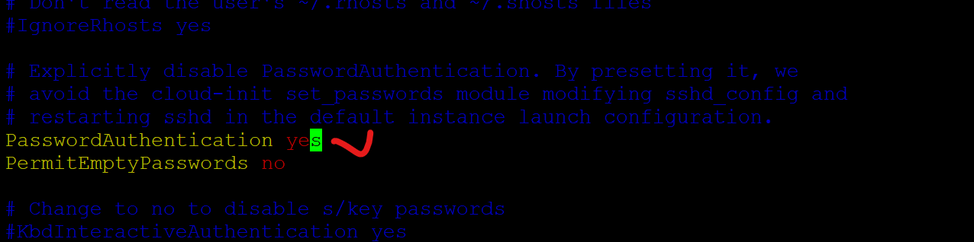
$ sudo systemctl restart sshd

Options
$ scp <source filename> username@ip_address:<destination path>

Example
$ scp /home/ec2-user/demo.txt raja@3.133.154.255:/home/raja

How to copy the direcotry
$ scp -r /home/ec2-user/arun raja@3.133.154.255:/home/raja

Copy the file from landing remote server to destination

$ scp somu@3.145.112.55:/home/somu/raja .

Same time stamp should copy from source file to destination file

$ scp -p somu@3.145.112.55:/home/somu/raja .

If remote server ssh port is customized , for this case need to use Captial P while copy scp command

$ scp -P 443 somu@3.145.112.55:/home/somu/raja .

Before doing that we need to change port number and restart the sshd

$ vi /etc/ssh/sshd_config
==> change the portnumber 8080

$ systemctl restart sshd

$ scp -P 8080 ./demo.txt raja@3.133.154.255:/home/raja

Rsync:

By using rsync we can copy within the server

We can copy network drives

We can copy one server to another server

Mainly it is used for database backup.

SCP :
For example: if copy 10 files
First time It will copy 10 files one server to another server, then same 10 files if we copy one server to another same server again each time it will copy all the 10 files.

Rsync:
But when comes to rsync , when copy the files second time , it will copy only which one modifed that files only it will copy the another server .because it will notice time stamp, file modification time all those things it will match and identify , then after that only it will do copy to destination server.
Main features : We will transfer the incremental files , which files is modified that files only we can modified

Syntax:
$ rsync [option] (source directoy) (destination directoy)

Case-1
Create two folder and create a one file inside source folder. Then using below command
$ mkdir local

$ mkdir remote

Inside local directory

$ touch File{1..20}

$ rsync -av /root/test/* /root/remote

v -> verbose

a -> multiple option combined

Case-2

Inside the local folder edit some files and some content again this command

$ $ rsync -av /root/test/* /root/remote

Note: here Rsync only copy the increment backup, which files is modified that file only send to destination path

To copy the directory from one server to another

$ rsync -av /root/test/ raja@18.117.77.202:/home/raja

To view the file transfer details with human readable format use h
$ rsync -avh /root/test/ raja@18.117.77.202:/home/raja

If you want to copy the file one server to another with compress we can use “z”

$ rsync -avzh /root/test/ raja@18.117.77.202:/home/raja

For example

First send the will without using z , will able to see the size of the file
$ rsync -avh /root/test/ raja@18.117.77.202:/home/raja

After that delete that file on remote server

Than again use the same file with using z command we able to understand , how file will reduce while copy the file one server to another server.

$ rsync -avzh /root/test/ raja@18.117.77.202:/home/raja

If you do want to incremental copy from one server to another server use this command

$ rsync --ignore-existing -avh /root/test/ raja@18.117.77.202:/home/raja/

Example :

Before executing this command.

Create one new file , then edit one file source file , also same file should edit in destinatin side

In source server

$ touch new

$ cat >> file 7 (edited from local end)

Destination server

$ cat > file7 (edited from remote end)

Then use the r sync command will able to understand.

Conclusion: it will not copy the modified file source to detestation.

# If you want to delete unwanted files in destination server. We can use the command

$ rsync --delete -avh /root/test/ raja@18.117.77.202:/home/raja/

Before execute this command, add some files in destination server.

Once execute this command it will delete the unwanted in destination server. It will maintain the same files and folder both source and destination servers.

-----------------------------------------------------------------------------------------------------------------
Linux Performance Monitoring:

Memory , Process Monitoring and disk size

Free:

To check the RAM size .

$ free (it is shows bytes)

$ free -h (human read able format)

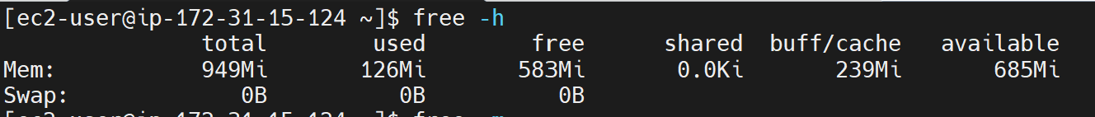

Swap Memory: it is used to if ram memory full, swap memory will support temporary process of kernel

Df : disk free

To check the overall file system.

$ df -h

$ df -hT

$ df -htx tmps

By using df -h we can check overall file system

du

$ du -h (it will show each file inside the folder)

$ du -h /home

$ du -s (it will show overall file system size)

$ du -sh /home

$ du -sh * (it will show all files and directory on the folder)

Top:
Zomibe: Child process of the main process

PID -> it is unique ID for every Process

User -> which user running this process

PR -> priority

NI -> Manual priority

SHR -> shared memory

S -> process status ( R -> running , S - sleep , Z -> zomibe)

Cpu -> cpu utilizatin

Mem -> memory utilization

Time -> duration of process running

Command -> Which command

If you want to check the particualar user process we can use -u
$ top u username

Q - for quiet

Process and kill the process

Command | Explanation
ps aux | Display Every Process on BSD Format
ps -ef | Display Every Process on standard format ( commanly used)

Command | Explanation
Kill | kill the process of mentioned process id
pkill | kill the process of mentioned process name
kill -9 | Forcefully kill the process of mentioned process id

For example

Run this command
$ top

Run this command
$ tail -f /var/log/new.txt

$ ps -ef | grep tail

$ ps -ef | grep top

Then open the duplicat server then use the command

$ kill <process id>

$ kill - <process id>

$ pkill <process name>

File Permission in Linux

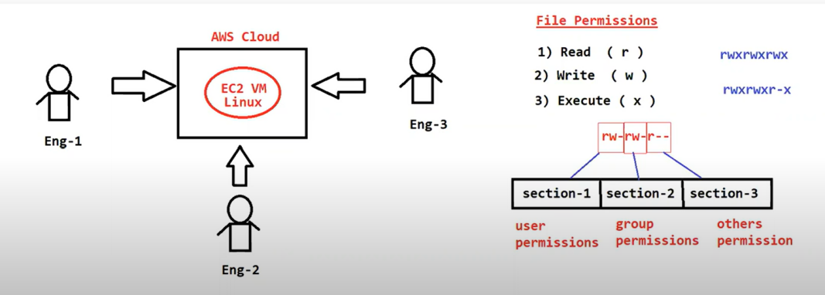

Multiple User can Access the single Linux server in a real time project

A File can have 3 Permission

1 Read (r)

2 write (w)

3 execute (3)

File permission are divided into 3 Section

Section 1 : User Permission ( first 3 chrachter represents user permissions)

Section 2: Group Permission (from 4th to 6th represents Group Permissions)

Section 3: Other Permission ( from 6th to 8th represents Others Permissions)

Sample Patterns

Sample - 1
-rwxrwxrwx -> all are full permisssion

Sample-2

-r-x--xr--

User -> read and execute

Group -> execute

Others -> read
Note: first hyper represent file

Sample-3

d--xr--xr--

User --> execute

Group --> read and execute

Other --> read

Note: first d represent the directory

Modifying the file permissions:

Using chmod command we can change file permission in linux OS

Using chmod we can add and remove permission

Note: ‘+’ represents adding and ‘-’ represent removing

Add execute the permission for the user

$ chmod u+x filename

Add the read permission for the user

$ chmod u+r filenanme

Remove the read permission for the user

$ chomod u-r filename

Add the read permission for the group

$ chmod g+r filename

Add the read permission for the other user

$ chmod o+r filename

Add the write permission for the user

$ chmod g+w filename

Remove read and write permission for the group at a time

$ chome g-rw filename

File Permissions with Numeric

R - 4 , W -2 , X -1

0 -> no Permission

1 -> only execute

2 -> only read

3 -> read and execute

4 -> only read

5 -> read and execute

6 -> read and write

7 -> read , write and execute

We can setup both method using alphametic or numeric

Working with User account in Linux

Linux is multi user Operating System

With in one Linux machine we can create multiple user accounts

Multiple user can access only Linux at a time and they can perform multitasking

Note: Every Linux machine have Route account ( Super user)

When we launch a linux machine in amazon linux AMI we get ec2-user as default user account

If you want to switch root user

$ sudo su -

Note: If you want to install any software and any admin related work we need to switch into root user

How can logout from the user

$ exit

How to know which are we login >

$ whoami

Create user in Linux

# create user

$ sudo useradd arun

If you want to verify the user in Linux machine

$ id <username>

How to create the group:

$ sudo groupadd <groupname>

To verify all the user

$ cat /etc/passwd

How to add the user to the group

$ sudo usermod -aG <groupname> <username>

To verify the user add on the group

$ id username

How to remove the user into the group

$ sudo gpasswd -d <username> <groupname>

How to delete the group

$ sudo groupdel <groupname>

How to delete the user

$ sudo userdel <username>

To display the all the group

$ cat /etc/group

To Print user who are belongs to particular grop

$ sudo lid -g <groupname>

Chown:

Chown it is used change the ownership of the file

We can see owner of the file using ls -l command

# change the owner of the file

$ sudo chown <username> filename

# change the owner of the file by using userid also

$ sudo chown <uid> filename

Linux user and Group Management:

There are three types of Account:
- Root Account
- User Account
- System Account

Root Account: Default Administrator Account
By using the account we can do delete the OS. But very careful while using this account.

User Account: Normal User. We can create multiple user account , We can give Privileges also based on the requirement.

System Accounts: Created only for Specific Purpose of software, For example
Mail, Apache accounts.
Don’t use interrupt this account normal. This will run belong to them process

Important path to check information about user and group details:

- /etc/passwd

- /etc/shadow

- /etc/group

How do identify the user details.

$ cat /etc/passwd

0 -> root Account (full permission Account)

1-999 -> systems Account

Above 1000 -> User Account.

Brife explain about user details

jenkins:x:1003:1005::/home/jenkins:/bin/bash

Jenkins -> username

X -> Password Encyrpted

1003 -> UID (user ID)

1005 -> GID (Group ID)

:: -> here we can give comments ( like descrition)

/home/jenkins -> home directory

/bin/bash -> which types of shell

Note: by default shell type is BASH we can check $ echo $SHELL
More Types of shell there : sh shell, z shell , bash shell

$ cat /etc/shadow -> Password will be store here with encrypted format

Whenever we give the password that time Linux will check decrypt-ed password and verify the password in this file.

This is by default securities mechanism.

$ cat /etc/group -> it is related to check the group information,

User Management:

Commands | Explaination
useradd -m | Create a new user with home directory in /home
useradd -d | Create new user with custom home directory
useradd -g | Create a new user and mentioned group name or ID as Primary group
useradd -s | Specify the custom shell
useradd -e | the data (format YYY-MM--DD) on which the user account will be disabled

$ useradd [options] (New userid)

$ useradd -m arun

Note: if red hut , amazon linux not required , it will automatically created in /home directory

$useradd -s <shell type> <username> We can give shell type

Example:

$ useradd -s "/bin/sh" arun

Before setting up password just check the shadow file weather it encrypted or not.

Case-1
Before setting up the password, ! ! (it represent not password set), we cannot login the user also

Add the password for the user
$ passwd arun

Case-2
After setting up the password:

If you want to check and login the new username and password

Go to root user

$ vi /etc/ssh/sshd_config

To enable password authentication, change the value of PasswordAuthentication to yes:

PasswordAuthentication yes

$ sudo systemctl restart sshd

Then we can login the another terminal by using New username and password.

For practice:

$ useradd -d /three -s "/bin/sh" user3

Using -g

Create group

$ groupadd devtem

To add the user into the group

$ useradd -g devteam user5

Check user group and group details by using below commands

$ id user5

$ cat /etc/group

We can check by using groups command which user comes form which group

$ groups <username>

For this user5 primary group is devteam.

Note: By default if you are not mentioning the group while creating the user, it will create primary group as same as username.

Using -e

If you want to create the tempaory user name , we can setup the expiry date.

$ useradd -s "/bin/bash" -e 2025-02-17 user6

$ chage -l user6

Check out by using chag -l (with expire and without setting up expire)

Using -c it is used for description

$ useradd -c "ITteam" -s "/bin/sh" arunIT

UserMod:
It is used to modify existing Linux users settings & Parameters. Most of the user mod Commands options are available with same functionality in usermod. command.

Command | Explanation
usermod -c | ADD/Modify user description
usermod -d | New home directory for user account
usermod -e | set expire date for the user account
usermod -g | modify primary group
usermod -aG | Append the user to the additional group with removing form other groups
usermod -l | Modify the login name
usermode -m | move user home directory to other location
usermod -L | Lock user
usermod -u | Unlock user
usermod -s | Change use default shell

To change the description

$ usermod -c "Devloping" test1

To change the Directory for the user

# create one user

$ useradd kj
Note: This user will create normal home directory

# login separate terminal for the new user add some file and exit the terminal

# Ensure that before the change home director , no other process should not be run on the user.

# Then use the command

$ usermod -d /hom/test_kj -m kj

# Then again the check the terminal will able to use the file

Note: -m it is used for move the file old path user to new path user.

Setup the expire date

Check the status of expire details for user

$ chage -l <username>

Change the expire date

$ usermod -e 2025-10-25 kj

Change the primary group for user

$ usermod -g <groupname> <username>

To check

$ groups username

$ grep <groupname> /etc/group

Add secondary group

$ usermod -aG <groupname> <username>

-a Append the new group name
-G Add the secondary group (only one secondary able to add)

We can add multiple group to user at a time

$ usermod -aG new1,new2,new3 <username>

Note: Small g (add primary group) G (add secondary Group)

Note: Per user add only one primary group, but we can add multiple secondary Group

Need to change the login name for user/ modify the username

$ usermod -l <newname> <old username>

After that login the new username, then verify it

How to Lock and Unlock the user

$ usermod -L <username>

How to verify user is lock or not

$ passwd -S <username>

Note: S -> should Capital S

If u want to unlock

$ usermod -U <username>

Modify the shell

$ usermod -s “/bin/bash” <username>

How to delete the user

Delete without Directory

$ userdel <username>

Delete with Directory of the username

$ userdel -r <username>

Note: Best Practice delete the user without using -r

Chage:
The change command is used to view and change the user password expiry information. This command is used when the login is to be provided for user for a limited amount of time or when it is necessary to change the login password from time to time.

Commands | Explanation
chage -l | Used to view the account aging information
chage -E | used to set the account expiry
chage -m | used to set the minimum number of days between password changes
chage -M | use to set the maximum days for password validity. (password Expiry date)
chage -I | used to set account inactive after password expiry
chage -W | Give prior warning before the password expiry

To check the account user details

$ chage -l username

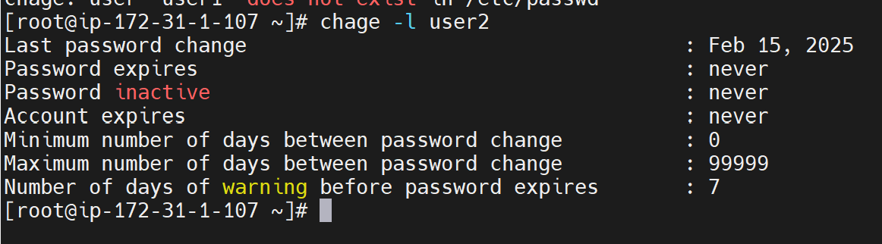

Password expire : set the password expire date

Password inactive: after the password , we can change within this duration

Account Expires: temparoy account

Minimum number of days between password change: user can change the password after setting password

Maximum number of days between password change: Set the time of password expire date.

Number of days of warning: it will display the warning message before expire the password

Set the account expiry

$ chage -E 2025-02-16 <username>

To set password change duriation

$ chage -m 1 username

Note: root account any time can change, but that particular cant change once set the time.

Set the password expiry time

$ chage -M 30 username

Grace period user should change the password

$ chage -I 4 username

Note: if the user missed to change the password within duration , that is user go to inactive, only root user can active the user.

To set the warning notification.

$ chage -W 2 username

Note: Capital W

To create the Group

$ group add [group name]

Add the group with unique id

$ groupadd -g 2025 arun

To add the user on the group

$ usermod -aG <groupname> <username>

To delete the group

$ groupdel <groupname>

To change the group name

$groupmod -n <newname> <oldname>

To verify to list group

$ tail /etc/group

How to check user there in number of secondary group
$ groups <username>
How to delete the user into the particular group:
$ sudo gpasswd -d <username> <groupname>

Sudo & Visudo Command in Linux:

Sudo Command:

What is the need for sudo?

Giving root user password to all admins is dangerous for many reasons.

Working as root means that you have the power to:

- Remove any or all files

- Change the permission for any files

- Change the run level of the system

- Alter user account

- Mount or unmount file systems

- Remove or uninstall software

- Create , remove and alter file system

In real time , no one get root user permission , everyone create the user , that user will give the sudo permission, to adding the sudo permission for that user we need to some changes in /etc/sudoers file

Note: ensure that this file is very important, make sure changes should be valid.
Very carefully edit the file, if you want to edit , be carefully modify the visudo.

root ALL=(ALL:ALL) ALL

First all -> which host previlage go to allocated.

(ALL:ALL) -> by default root it will consider , if in case want to do some other user and group we can give

ALL : what are the command that user able to run

For practice:

For this can create one user and login the terminal separately

Then try to install package using this command

$ sudo yum install httpd -y

It wont be accepted

After adding the user in visudo

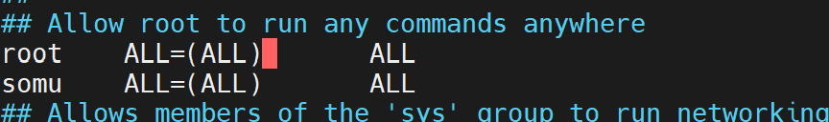

We can able to install the package.
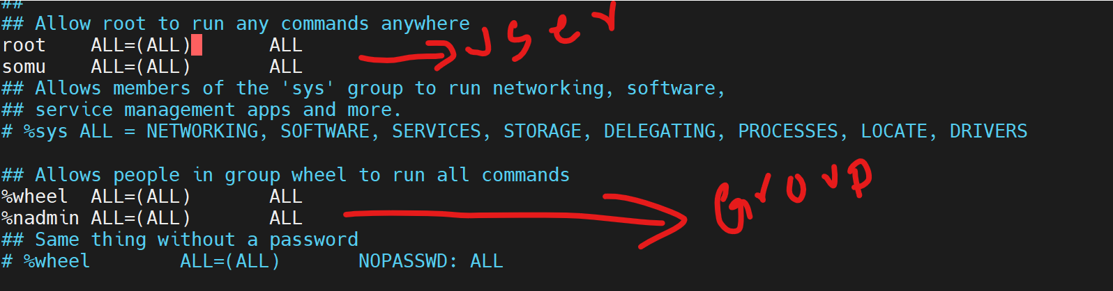
Adding Group in sudors file:

And also we can give sudo permission for group also , Instead of updating the users one by one , we can add the all the user in one group , that group we can add into visudo file as same as user

Why we use visudo:

It wont allow the edit multiple user visudo file at a time simultaneously.

If your are adding any unwanted line in visudo it will show error refer below two snap

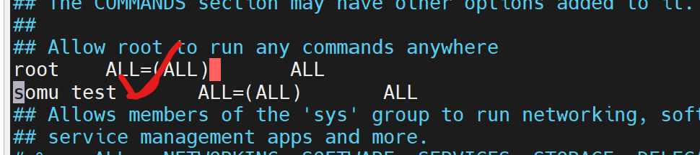

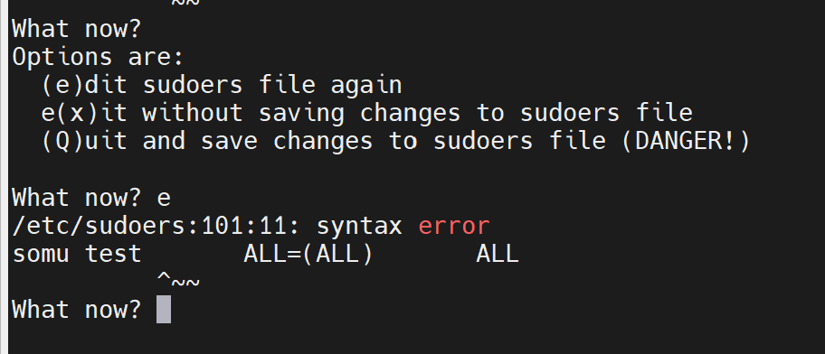

How to give particular command execution access to a user account

For best practice and easy to understand create three user like below

$ useradd useradmin
$ useradd sysadmin
$ useradd netadmin

We are going to give access the particular command for particular user

$ useradd, userdel, groupadd,usermod , groupmod, groupdel

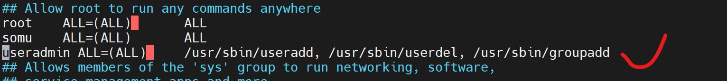

Then log in the particular user in one terminal

We able to run useradd command ,

but if run sudo yum install httpd command it will show error.

Commandalias:

We create a commands a group and then we can call the command by using commandalias.

Instead giving the multiple commands for multiple user , we can create commandalias inside the visudo file

Then we can refer the command alias on the user , example below.

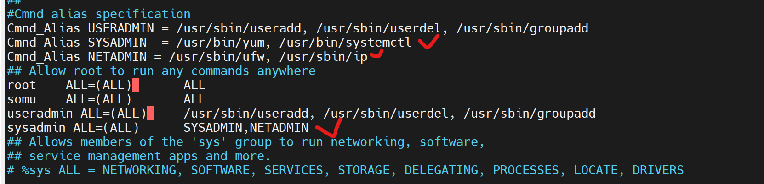

Note: alias name should be CAPITAL , otherwise will get error.

If you want to check the what are the commands will able to access for particular user. Use this command

$ sudo -l

Linux Permission Mangment:

There are three classes of permission for any file , directory in Linux

- User

- Group

- Other

There are three types of permission also.

R - can Read the File

W - Can write the file
X - Can Execute the file

Each class we can apply this three Permissions.

All files three permission it will automatically assign , we can check by using the command
$ ls -l

We can modify the permission by using the Command , chmod , Chown by using Linux command.

How to identify the file and directory

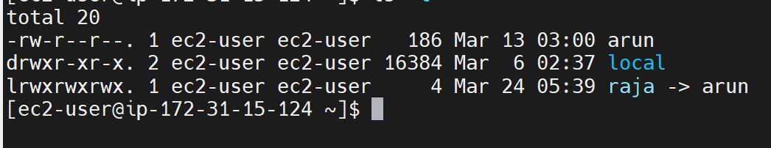

- it is file

d it is directory

l it is linked file

rwx | rwx | rwx | arun.txt
user | Group | Others

User -> owner the file

Group > Groups

Others -> Apart owner of the us and groups, remaining are others.

If you want to change the permission and owner, we can use command chmod and Chown

Chmod:

By using chmod we can change the permission for files and directory, by using two types we can do that

- Symbolic mode

- Numeric / absolute mode
Syntax:

$ chmod options permission filename

Symbolic mode:

If you want to change the permission by using symbolic mode, we have to use three letters

For Example:

For user -> U letter

For Group -> G letter

For Others -> O letter

All -> a letter

Symbolic mode permission:

+ Adds a permission to a file and directory

- Remove the permissions

= sets the permissions and override the permission set earlier.

Create one script file

$ vi hello.sh

#!/bin/bash
echo "hello world"

Execute this command

$ ./hello.sh

If it is not execute, then we have to give the execute permissions by using this command.

$ chmod u+x hello.sh

$ ./hello.sh (it will execute now)

If want to remove the permission

$ chmod u-rx hello.sh

Creating Common folder for all the user:

Step 1: Install Samba
sudo yum install samba -y # RHEL/CentOS

Step 2: Create a Shared Directory
sudo mkdir /samba/shared
sudo chmod 777 /samba/shared
Step 3: Configure Samba
sudo nano /etc/samba/smb.conf
Add this at the bottom:
[Shared]
path = /samba/shared
browseable = yes
writable = yes
guest ok = yes
force user = nobody

Or

We can use /var folder

First create user

Three users

$ useradd user1

$ useradd user2

$ useradd user3

Set the password also for all the user

Go to root user:

$ cd /var

Add the file

$ cat > dummy

Case-1 (checking the others)

Then login user1

Go to /var/

Try to modified the files in dummy u can’t do that

Then use this command

$ chmod o+w dummy

Now try u can do that

Case-2 (group permission)

$ login user2

U can modify that, then u can add that user into root group

$ usermod -aG root user2

Logout and login into the user

Then you can able to access the dummy file, because of adding the root grop

We can give multiple permsission at single time while using chmod command

$ chmod u+rw,g-wx,o-wx dummy

For all full permission

$ chmod a=rwx dummy

To remove the all permission

$ chmod a= dummy

For directory change permission

Go and do the changes the permission in /var
$ chmod o-x /var

Go login any other user example new3

$ ls -l /var

Output: you will be facing this error.
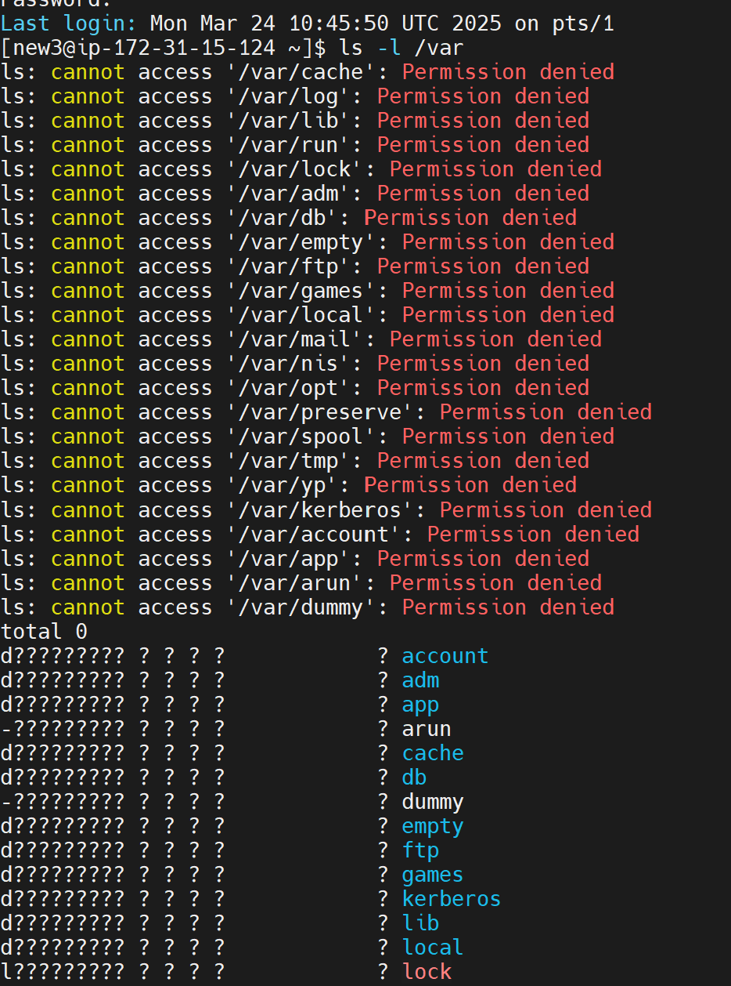

For directory, if we are not giving read and execute permission, we are not able to see inside the files.

If you want to view, we have to change the permission again

$ chmod o+x /var

If you want to apply the permission inside the folder

$ chmod -R o+x /var

How to change the absolute mode, Numeric Mode:

Read -4

Write -2

Execute -1

If you want to give full permission, we need to 7

We have to mentioned the three digit number, which means we need to give permission for three types

If you want to give full permission

$ chmod 777 filename

$ chmod 700 filename

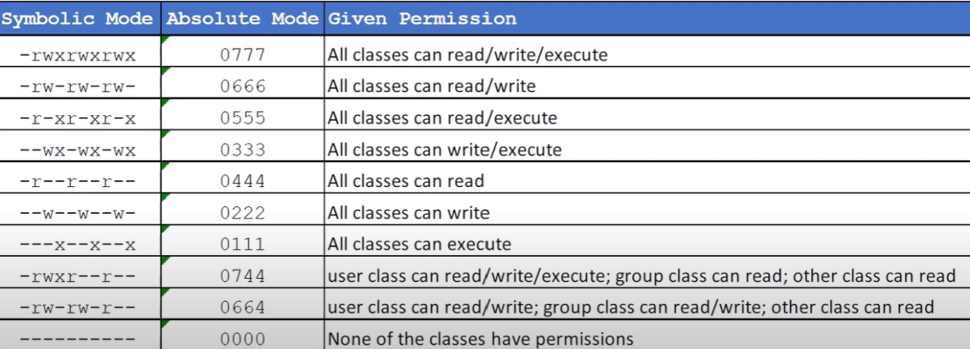

Chown:

It is used to change the owner ship of user and group of a file or directory

Change the user ownership

$ chown new1 filename

Change the group ownership

$ chown :sysadmin filename

If you want to change both

$ chown new1:sysadmin filename

If you want to change the user permission inside the directory file too
$ chown -R new1:new1 demo
For best example:

Login into the root user

Create three user

Username : demo1 , demo2 , demo3

Create the file

$ cat > dummy

Try to login any other user demo1

Go to /var

Try to the edit the dummy file, we can’t do,

To access this, we need to other permission
$ chmod o+w dummy

Now all other user can write the file , but we need to give access only demo1, demo2 and demo3 should not be write the file .

For this case, we need to create one group ex: sysadmin ,

then we need to add the demo1 and demo2 in the new group,

Then we give the

$ chmod g+x,o-x dummy

Then change the group on dummy file

$ chown :sysadmin dummy

Then now demo1 and demo2 we able to the write, then demo3 will not able to write.

ACL: By using ACL , we can give permission file and directory separately without changing/using owner and group permission.

It is second level of permission.

Use cases of ACL, if you want to give permission for particular user , we can use ACL.

If you want to check acl details for particular file, we can use command

$ getfacl filename

If you want to set the permission for particular user

$ setfacl -m u:demo3:r-x hello.sh

Note: without using user and group , we can setup the permission.

If you want to give permission for directory with inside the file we can give recursively.

$ setfacl -R -m u:demo3:r-x arun

If you want to set permission for creating future files and directory by default.

$ setfacl -d -R -m u:demo3:r-x /var/arun
If you want to remove the acl for particular files all users

$ setfacl -b /var/hello.sh

If you want to remove the acl permission one by one user for files

$ setfacl -x u:demo3 hello.sh

How to remove acl for directory

setfacl -b -R /var/arun

find:

It is used to find the directory and file inside the directory

Find <dir> -name “filename” or “folder”
To find the file mentioned the directory path

$ find /var/log -name *log

To find the file mentioned the current working directory

$ find ./ -name "*.log"

For practice:

Create file :

$ touch test{1..10}.log

$ find ./ -name "*.log"

$ touch test{1..10}.csv

$ find ./ -name "*.csv"

If you want to count the number of file

$ find ./ -name "*.csv" | wc -l

Create a directory same name as test and find the command it will find both file and directory of the test name

$ find ./ -name "test*"

If you want to search only file or only directory.

For directory

$ find ./ -type d -name "test*"

For file

$ find ./ -type f -name "test*"

If you want to check the sub folder of the directory

$ find /home -type d -name "*"

I want to check 10 days or 20 days before older file

$ find /var/log -type f -mtime +20 -name "*"
$ find /var/log -type f -mtime +20 -name "*.log"

If you want to check the file size of the particular command

$ find /var/log -type f -mtime +20 -name "*.log" -exec du -sh {} +

If you want to delete before 10 days files

$ find /var/log -type f -mtime +10 -name "*" -exec rm -rf {} +

If you want to delete the all the log file in root folder

$ find /root -type f -name "*.log" -exec rm -rf {} +

If you want to check the file based on the file size

$ find /var/log/chrony -type f -size +23k -name "*.log*" (+above)

$ find /var/log/chrony -type f -size -23k -name "*.log*" (-below)

if you want to check the all the path of the linux server

$ find / -type f -name "arun"

$ find / -type d -name "arun"

Note: + above , - below

Disk Partition Management:

Why use Disk partition: it is used to efficiently manage the hard disk storage.

For example:
Case:1
In one server they might be using APP team and DBA team. So that will sub-divided space for APP team some space and DBA team some space. If we maintain partition like this ,by future disk space issue can be we avoid for each team.

For example: If database team accumulate the 100% space, App team will not occupied the server. That’s why have to partition.

Case-2
If may be multiple application can single server .so for this case Each Application we will maintain the separate partition in the same server.

Disk partition important things

- Types of partition tables
- File system types
- LVM

What is partition types:

If I have 100 GB hard disk either Linux or windows ,Hard disk should know which types of data method to store.

There are two types

MBR (Master Boot Record)

GPT (GUID Parition Tables)

MBR is oldest types. Advance method is GPT.

We can see this in Laptop mother board in BIOS we can see

Legacy UUFI (GPT Partition)

Legacy (MBR partition)

Latest OS computers it supports both MBR and GPT

Important things: Before partition. We should know which type partition should be support for the server.When we do partition , We should partition based on the Partition types.

Even we can check in windows machine :

Disk management -> Disk 0 -> Right click -> volumes
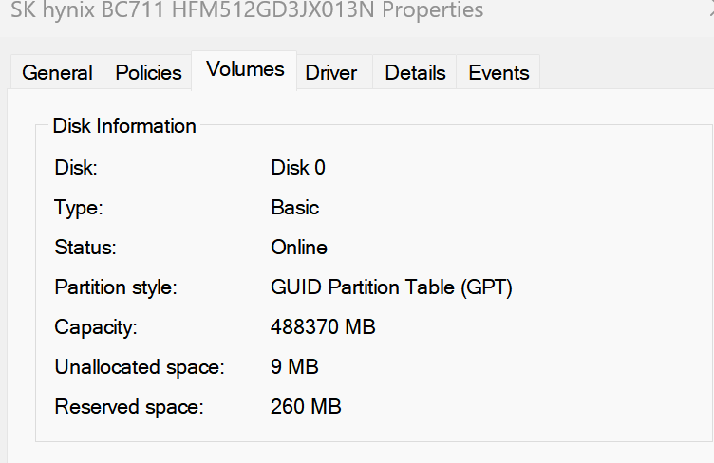

To checking the partition types we can use command in Linux

$ parted -l

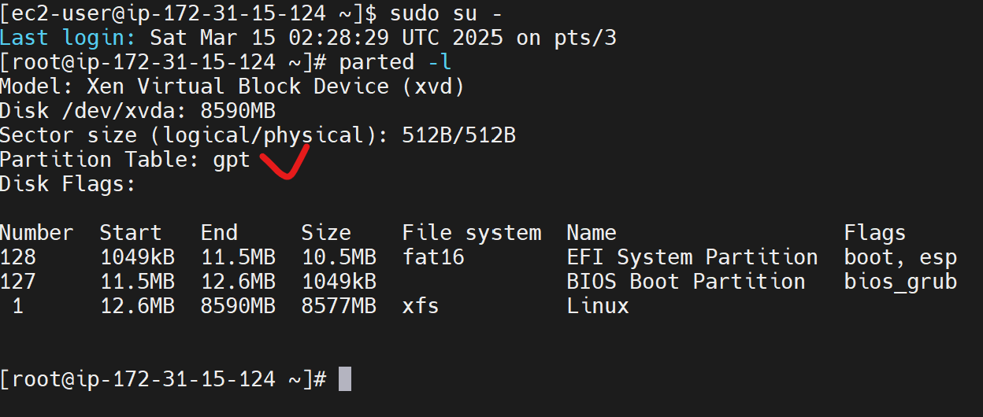

Note: Before partition we should check which partition that hard disk will work. Based on that we should do partition as much as same type.

If it is reflected msdos when we check using this command parted -l -> it would be MBR type.

Step1:

We need to add the hard disk on our server

In AWS we can use EBS volume

Create EBS Volume and attache the EBS volume on EC2 instance.

By using this Command we can find out the hard disk attached or not

$ lsblk

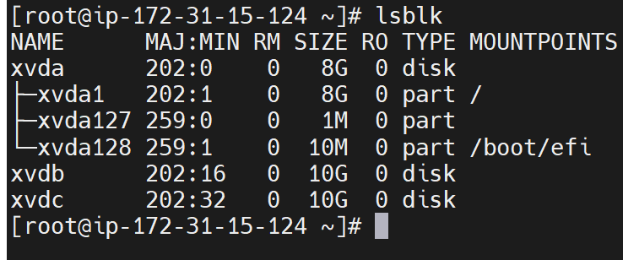

Note: By using this command we can check what are hard disk connected in the device.

How to create the partition and mount to the folder

By using fdisk we can it is traditional way , we can also do some other tool also like parted,gdisk by using this tool also we can do that.

Step 2 -> we need to do partition

$ fdisk -l (it will give clear details as similar of lsblk command)

Note: Before do to the fdisk, check properly if there is existing data’s are there or not , once we give fdisk command , old data will be deleted.

RAW disk we cant mount directly, that why we mount it partition.

Now we need to do the format the hard disk by using fdisk command

Before do that we need confirm weather data is there or not.

$ fdisk /dev/xvdb (partition details)

$ m (it will give the help and details)

$ n (to add a new partition)

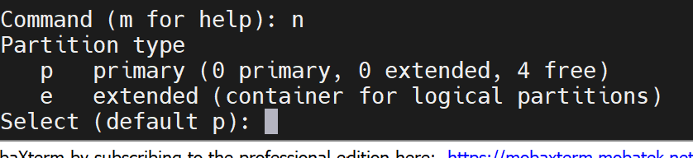

P -> means primary partition (we will be do primary partition 4 only), if in case , if you want to do more , we can create 3 primary partition and one extended partition.

If it mbr partition type we can do only 4 primary , Single disk we can do only 4 drive paritiation.

If GPT we can do like this below, create three primary partition and then we can create extended partition.

Example if you have 10 GB hard disk:

3 Primay Partition -> 2gb, 2gb, 2gb
2 Extended partition -> 2gb , 2gb

$ p

$ enter

1 -2047 (by defualt it will take details of partition table )

$ enter

$ +1G

Before write It will give the details:
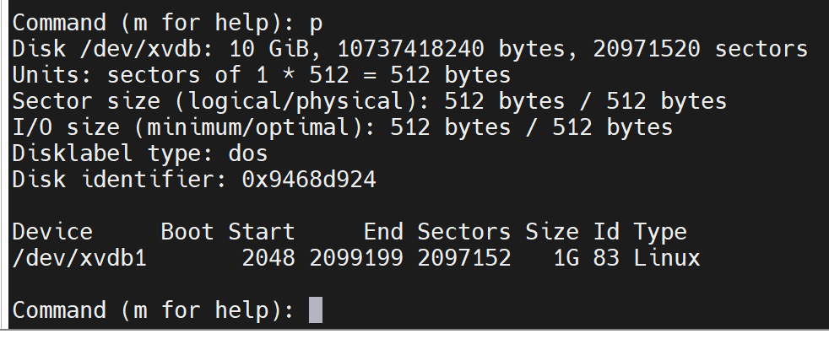

$ w (it will sync)

Note: if incase not need we can q (quite)

Output:
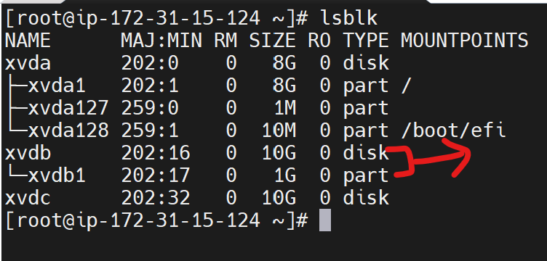

We can use this command also, we can check the details of particular hard disk

$ fdisk -l /dev/xvdb (to verify)

We can do another partition also like above:

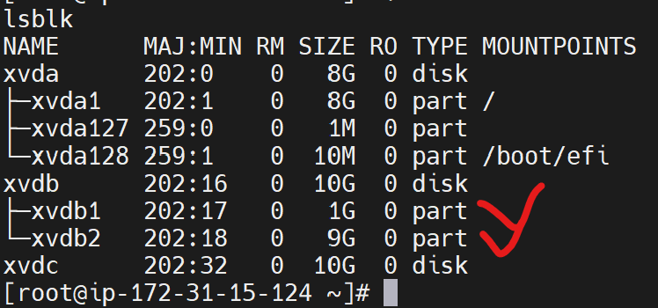

After that we need to mount:

Create two directory:

$ mkdir data1

$ mkdir app

Next we need to create the file system:

Note: if any disk we add , we should format and add the file system.

In Linux there are multiple file system, ext3 , ext4 , xfs , btrfs

Each file system has own data structure.

-> ext4 - ubuntu os default
-> xfs - red hut os default
-> btrfs -> susi linux

$ mkfs.xfs /dev/xvdb1

Note: If some time showing busy use this process:

$ fuser -v /dev/xvdb

$ kill -9 6643

Then try it will work.

Output:
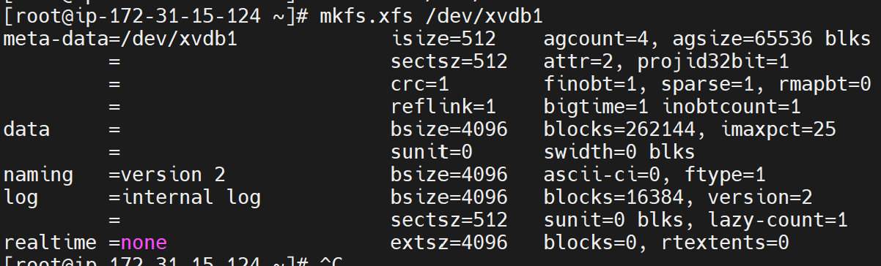

$ lsblk -f (to verify the output)
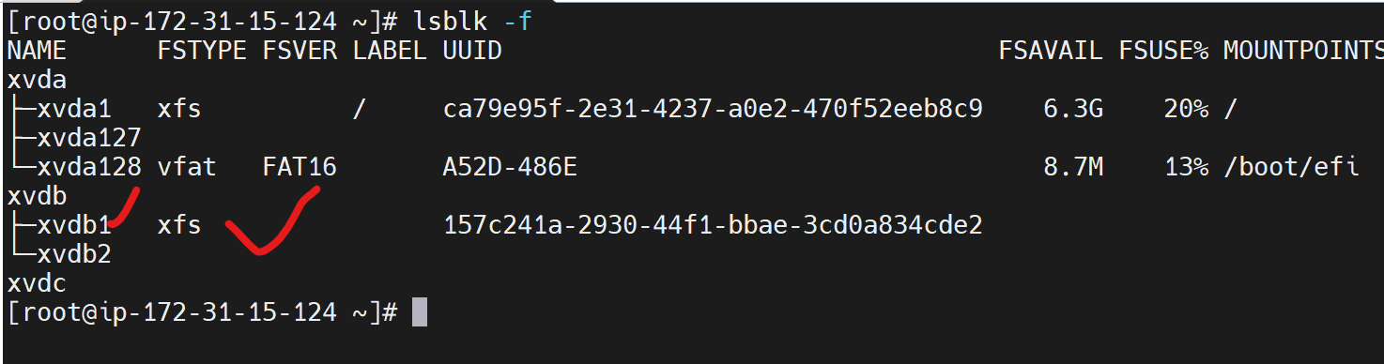

$ mount /dev/xvda1 /data1

Output:
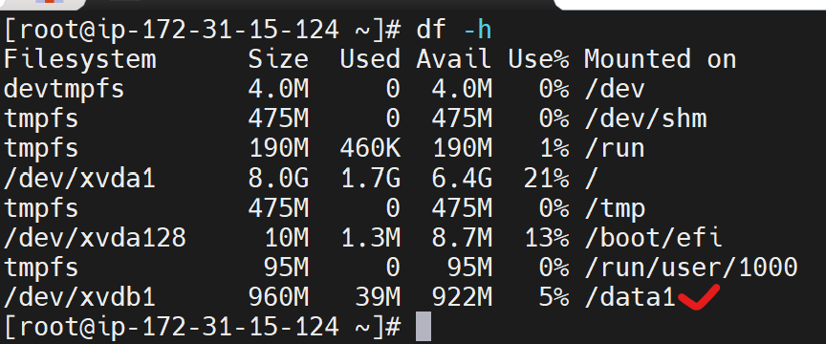

By using df -h we can check the mounting details

$ df -h

Note: if we are mounting the partition without using file system will be facing this kind of error.

Then again try to create another partition:

$ mkfs.xfs /dev/xvdb2

$ mount /dev/xvdb2 /app

Output:
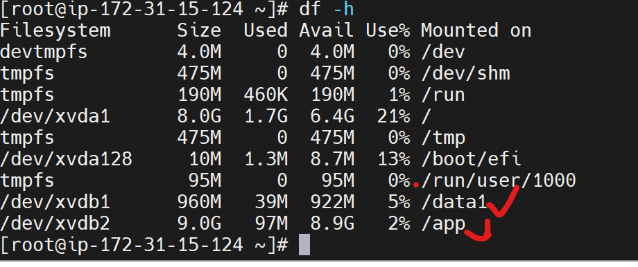

Then reboot the server.

$reboot now

Once Reboot , Mount point will be deleted. To verify use this command
$ lsblk

$ df -h

If you want to mount paremantly , We need to update is fstab

Note:We need to carefully edit the fstab. If you are mis-configure the root or boot , machine will not be rebooted.before do that do carefully.if its corrupted os will not be rebooted.

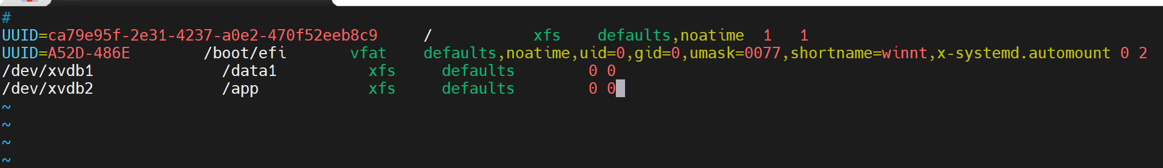

After that we need save the file

Give the command

$ mount -a (it will automatically the check the fstab entry and properly mounted on the server)

$ df -h

Then it will mount permanently.

Note: if you want disable the particular mount point, we need to follow the below steps

Go to fstab and do it #

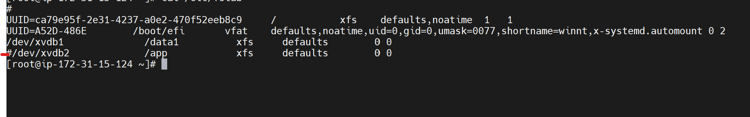

$ mount -a

$ umount /dev/xvdb2

$ df -h

Conculsation:

Once add the hard disk on the server.

First select the partition types:

$ fdisk

$ n

$ enter (default 1)

$ enter

$ +1G

$ p

$ w

Create the mkfs file system:

$ mkfs.xfs /dev/xvdc1

Note: file system should in partiton path, don’t give hard disk

$ mkdir /mnt

$ mount /dev/xvdc1 /mnt

Note: Give Partiation path

$ df -h

Permant mount

$ vi /etc/fstab

Update the entry

$ mount -a

$ df -h

How to delete the partition in RHEL:

Step-1:

$lsblk
First unmount the file system

$umount /app

Note: Some we cant umount due to target is busy. This case we need to kill the process. We can use this command

$ lsof /app

$ kill -9 <process id>

$ df -h

Step-2

Remove the entry inside the fstab file

$ vi /etc/fstab

We can remove or we can # symbol

$ lsblk

Step-3

$ fdisk /dev/svdb

$ m

$ d

$ p (if any partition it will show , other wise it wont show anything)

$ w

We can check confirm by using lsblk command

$ lsblk

Note: if we are not remove the entry inside the fstab, whenever OS reboot , it will try it mount that disk partition,

Logical Volume Manger (LVM):

LVM Basically is didactically used to manage the disk partition in Linux machine.

We can do disk partition in two ways one is traditional method and LVM

But LVM is Advanced method.

If you want to add the additional space in traditional method , We need to add the additional disk and then we need to stop the database service and copy the data from old disk to new Hard disk.

But when we use LVM for this case, we can easily the increases without stop the service and without reboot the system also.

Important Three Core components in LVM:

- Physical Volume

- Volume Group

- Logical Volume

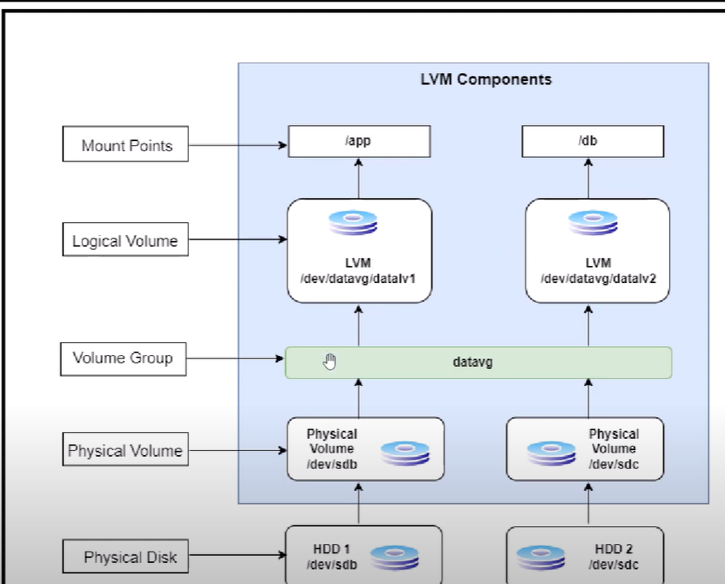

Create two EBS Volume

Attach those EBS volume into a EC2 instance.

Install the LVM tool on the server

$ sudo yum install -y lvm2

To Create the Physical Volume

$ pvcreate /dev/xvdb

To check the physical volume list on the server.

Note: We can create multiple pvc at single time.

$ pvs

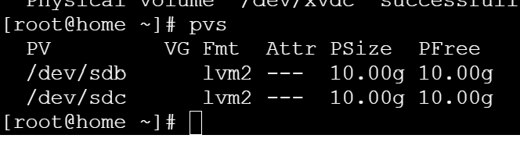

And also if you want to check the clear view we can use the command

$pvdisplay

Step-2

Create the volume Group

$ vgcreate app-vg /dev/xvdb /dev/xvdc

Note: We can give the volume group based on our requirement for easy understandable. For example we add the root partition we can give root-app

To view the VGS we can use the command

$ vgs

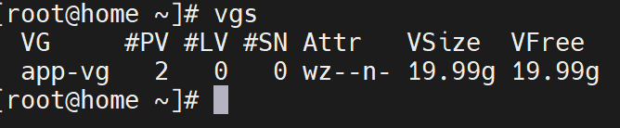

Step-3

To create the Logical Volume:

$ lvcreate -n app-lv -L 5G app-vg

Explain the command

# lvcreate -> command , -n name (new name) , -L (mentioned the size) , volume group name

To verify

$ lvs

And also give this command

$ vgs

We can confirm volume group details.

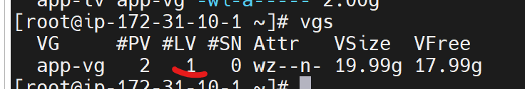

$ mkfs.xfs /dev/app-vg/app-lv

$ mkdir /app

$ mount /dev/app-vg/app-lv /app/

Next Partition:

$ lvcreate -n app-lv1 -l 100%FREE app-vg

$ mkfs.xfs /dev/app-vg/app-lv1

$ mount /dev/app-vg/app-lv1 /data

To Verify:

$ df -h

Note: If you want to do logical volume remaining space, that cases we can do below command

$ lvcreate -n app-lv1 -l 100%FREE app-vg

Now create next lvm

Mount into the fstab for permante mount.

How to extend the LVM:

Step-1

First extend the lv without increases the vg extend

$ lvextend -L +5G /dev/app-vg/app-lv

$ df -h

$ xfx_growfs /dev/app-vg/app-lv

Note: if ext4 , resizing command will be different

Step-2
Extended the vgs

vgextend app-vg /dev/nvme3n1

Extend the lv

lvextend -L +5GB /dev/app-vg/app-lv

xfs_growfs /dev/app-vg/app-lv

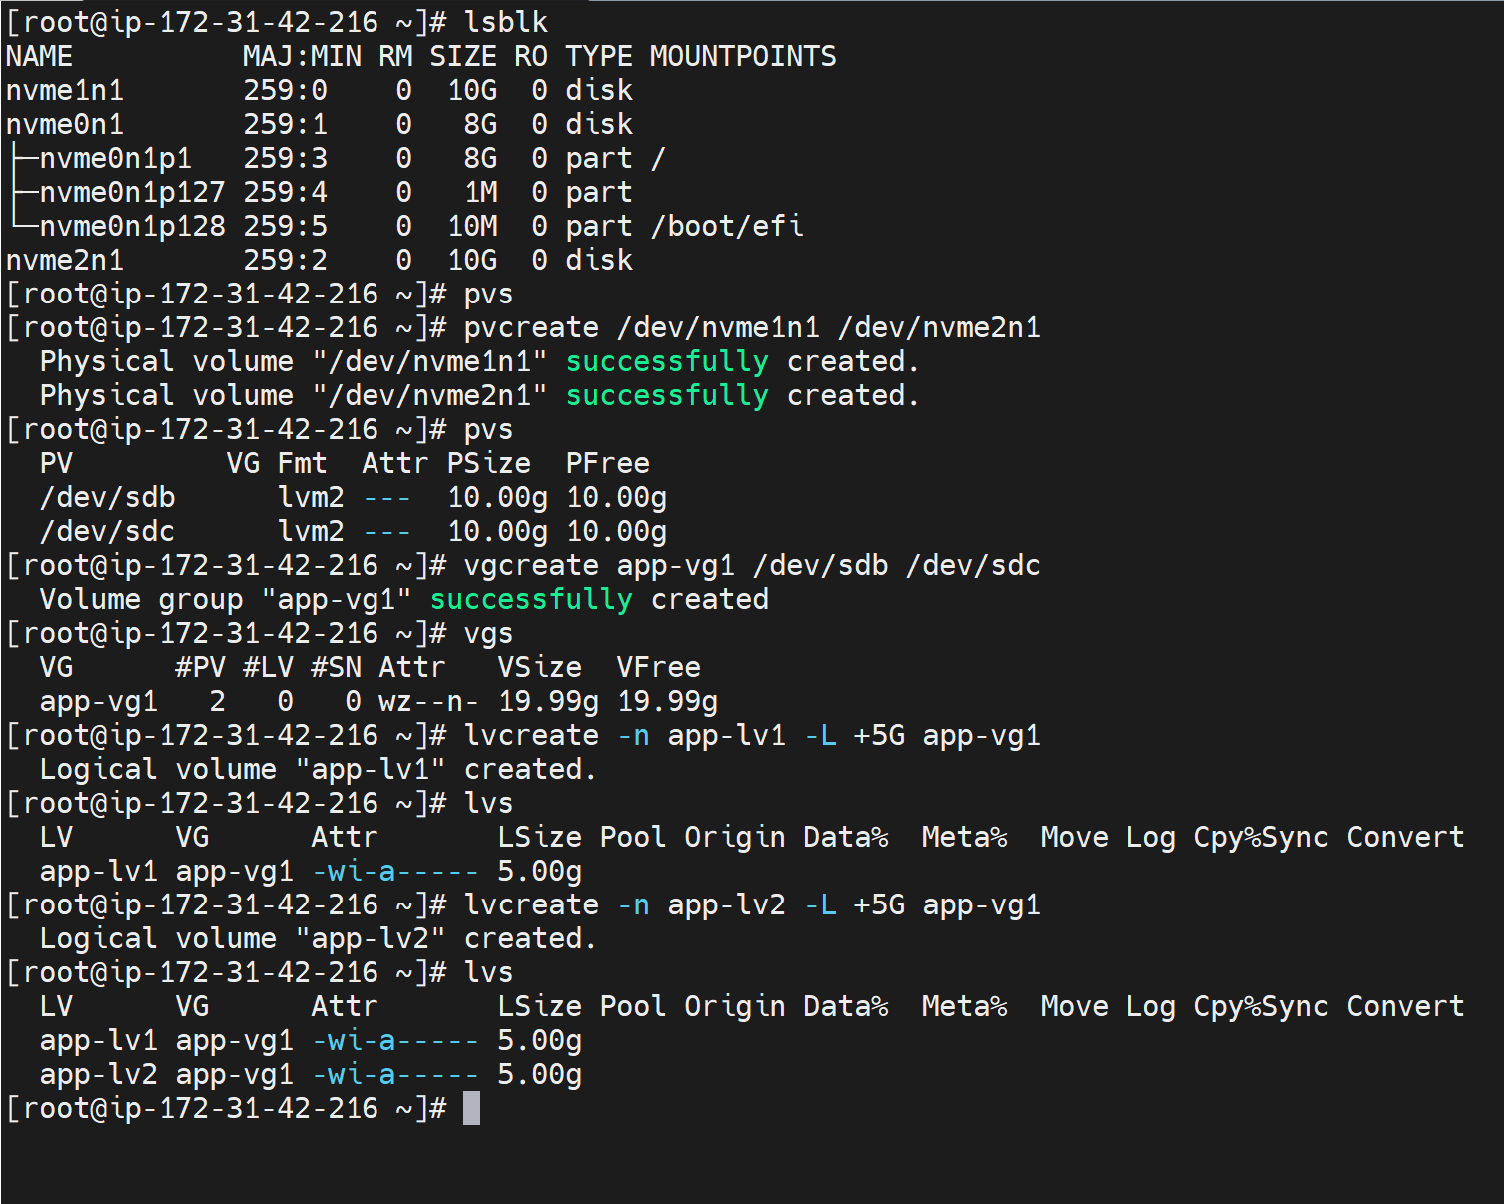

To search the file in the Linux we can use two command

$ locate and $ find

Find and locate commands are used to search files in Linux machine

# search file which contains arun
$ locate arun

# search file and display counts
$ locate -c arun

Example:

I want to check how many txt files are there need to check

#print the count of all text files
$ locate -c *.txt

$ locate java

$ locate index.html

In Linux machine will maintain the DB call Locate db

In Linux all the files and directories locations will be store in local db that is locate db

When we execute the locate command it will search in locate db .

Accurate result we are not getting using locate command. Performance wise locate is faster , because it is not going to search in actual file system. So we are not getting the updated details.

Find command will search for the files and directory actual file system. But performance find command is taking time.

Find command providing advanced searching techniques.

# search find files under home directory
$ find /home -name arun

Find it will search recursive search , it will search home directory and sub-directories also.

To Display only empty file
$ find /home -type f -arun

To display only empty directory
$ find /home -type -d empty

Note: find command will search the entire file systems

Grep is used to search the patterns , but find and locate command it is used to search location of files and directory.

MAN:

To get documentation of any command we can use MAN Command

$ man ls

$ man ping

$ man find

Important Commands:

$ ifconfig : it is used to print ip address of our machine

Note: if note need to install net-tools

$ wget:it is used to download file based on URL
Example:
$wget https://dlcdn.apache.org/tomcat/tomcat-11/v11.0.4/bin/apache-tomcat-11.0.4.tar.gz

$ curl: it is used send a request to URL
It is used to send http request to url

$ ping: it is used check network connectivity

Example:
$ ping google.com

How to deploy the static website

What is webserver?
It is user run web application .

Ex: httpd

To run web applications we need web server

So we need to install web-server on our machine .

So that we can issue httpd web server.

$ sudo yum update

$ sudo yum install httpd

$ service httpd start

Note: Enable httpd Protocol with 80 port in security group of our ec2 instances.

After enabling 80 port in security group , we can access the website using EC2 Public ip address.

To change the content

$ cd /var/www/html

$ vi index.html

How to install required software in Linux

$ sudo yum install httpd

$ sudo yum installl git
$ git --version

$ sudo yum install maven
$ mvn -version

$ sudo yum install java
$ java -version

We can remove httpd server from our machine

$ sudo yum remove httpd

Package Manger:

It is a tool that allows user to install , uninstall , upgrade , update software on operation system.

Types Package manager:

Ex: Yum , apt , rpm , deb , choclate etc ….

Linux Package manager is used to to install , remove , update and upgrade in linux os.

What is packages

Package means it is one application
Ex: httpd, java ,git , docker, jenkins etc…

Based on Linux Distribution Package manager will be different

Which package manger we need to use?

RPM based Linux Distubtions: Amazon Linux, Red hat Linux , Centos etc

Package manager : yum , rpm , dnf

DEB based Linux Distrubtions: Ubuntu Linux, Debian Linux etc …

Package manager : apt , apt-get , debian

Top5 Packag manger:

YUM: Yellowdog updater modified
APT: Advance Packaging Tool

RPM: Red Hat Package Manager

DPKG: Debain Package Management Systme

DNF: Dandified YUM

Do find the files and directory in server

$ find / -type d -name arun

$ find / -type f -name arun

$ find

