1. Form validation

jQuery:

$(document).ready(function () {

$('#myform').validate({ // initialize the plugin

rules: {

field1: {

required: true,

email: true

},

field2: {

required: true,

minlength: 5

}

}

});

});

2.

Comet with iframe technique : server timestamp demo

We need:

* A PHP script that will handle the persistent http request (backend.php)
* A HTML file that will load Javascript code and that will show the data coming from the server (index.html)
* The [prototype](http://www.prototypejs.org/) library that will help us to write simple JS code

To understand how it works this schema should help:   
[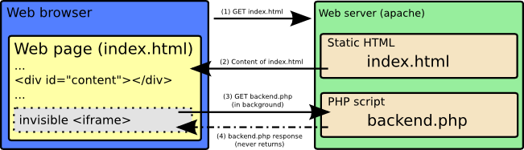](http://www.zeitoun.net/_detail/articles/comet_and_php/comet.png?id=articles%3Acomet_and_php%3Astart)