HELLBURN
COMPETITIVE BURN-TO-EARN PROTOCOL
Built on TitanX | Burns DragonX | Real ETH Yield

WHITEPAPER v2.0
February 2026

Disclaimer
This document is for informational purposes only and does not constitute financial, investment, or legal advice. Cryptocurrency and DeFi investments carry significant risk, including the potential loss of all invested capital. Smart contracts, despite testing and audits, may contain vulnerabilities. Past performance of similar protocols does not guarantee future results. All projections in this document are hypothetical scenarios based on assumptions that may not materialize. Always do your own research (DYOR) before participating.

Table of Contents
1. Executive Summary
2. The Problem — Why Existing Protocols Fall Short
3. The Solution — HellBurn's Three Innovations
4. The Deflation Flywheel — How It All Connects
5. Genesis Phase — Your Entry Point (Detailed Example)
6. Burn Epochs — Competing for ETH (Detailed Example)
7. Staking & Real Yield (Detailed Example)
8. Tokenomics Deep Dive
9. Day 888 Strategy — The Catalyst Event
10. Anti-Dump Mechanisms
11. 12-Month Projections (Best / Base / Worst Case)
12. Roadmap
13. Risks & Disclaimers

1. Executive Summary
HellBurn is the first Competitive Burn-to-Earn Protocol in the TitanX ecosystem. It combines gamified, competitive burning with real ETH yield and creates perpetual deflationary pressure on both TitanX and DragonX.
While existing TitanX ecosystem protocols (DragonX, Helios, Hydra, B88) rely on a one-time minting phase followed by passive staking, HellBurn introduces a fundamentally new concept: Burn Epochs — competitive 8-day cycles where participants burn TitanX and DragonX to earn a proportional share of ETH rewards. A streak system rewards consistent participation with up to 3x multiplier and punishes inactivity with a full reset.
The result: A self-reinforcing deflationary flywheel that does not end after the minting phase but runs in perpetuity. HellBurn strategically leverages the historic TitanX Day-888 payout (~727 ETH, ~$2.39M) as the ignition event.
Key Facts at a Glance:
Parameter | Value
Token | HBURN (ERC-20, Ethereum)
Core Mechanic | Competitive Burn Epochs + Payout Capture
Burn Targets | TitanX + DragonX (dual burn)
Yield | Real ETH from TitanX staking payouts
Supply | Fixed — mint only during 28-day Genesis, then permanently disabled
Admin Keys | None — fully decentralized after deployment
Launch Event | Before TitanX Day 888 (~April 2026)

2. The Problem — Why Existing Protocols Fall Short

2.1 One-Time Deflationary Pressure
Every TitanX ecosystem project follows the same pattern: A minting phase where users deposit TitanX to receive new tokens, a portion gets burned, and then... nothing. The burn pressure stops completely after minting ends. Deflation is a one-time event, not a sustainable force.
Example: Protocol X had a 14-day minting phase that burned 500B TitanX. Impressive — but on Day 15, burn activity dropped to zero. The protocol generated no further deflationary pressure for the remaining lifetime of the project.

2.2 Passive Staking Without Engagement
After minting, users stake their tokens and wait passively. There is no incentive to actively participate in the ecosystem. This leads to declining engagement, reduced community activity, and a classic "mint → stake → forget → dump when price drops" cycle.

2.3 Missing Gamification
DeFi protocols compete for attention in an oversaturated market. Without competitive and game-theoretic elements, there is no reason to return daily. The most successful DeFi protocols — Curve Wars, Convex, GMX, and Pendle — have proven that competitive mechanics are the strongest retention drivers in crypto.

3. The Solution — HellBurn's Three Innovations

3.1 Burn Epochs: Perpetual Deflationary Pressure
Every 8 days (synchronized with TitanX's payout cycle), a new Burn Epoch begins. During each epoch, users can burn TitanX and/or DragonX into the Epoch Pool. At epoch end, accumulated ETH rewards are distributed proportionally to each participant's weighted burn.
The key insight: Burning never stops. As long as ETH rewards flow (and they do, as long as the treasury has staked TitanX), there is always an incentive to burn. Deflation is not time-limited but permanent.

3.2 Streak System: Game Theory as Retention
Participating in consecutive epochs builds a streak. Each consecutive epoch increases the personal multiplier by +0.2x, up to a maximum of 3.0x after 11 consecutive epochs (~88 days). Missing a single epoch resets the entire streak to 1.0x.
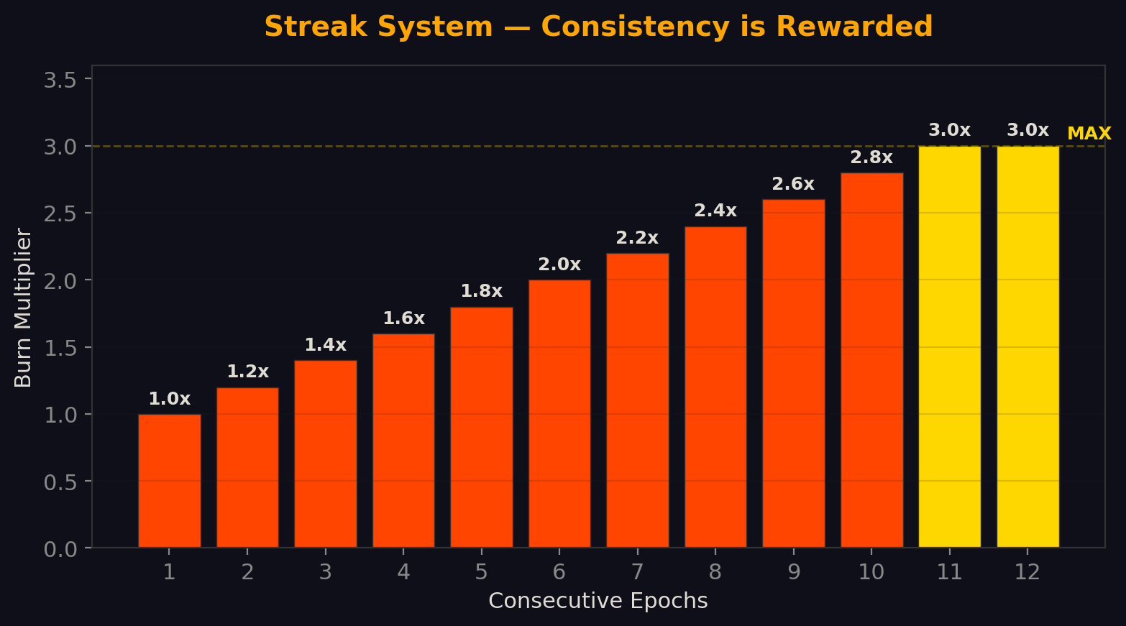
Why this works: The psychological lock-in effect is powerful. A user at 2.4x streak (8 consecutive epochs) would need 8 more epochs to rebuild if they miss one. The fear of losing the streak keeps participants active — exactly what drives perpetual burn pressure.

3.3 Burn-to-Boost Staking ("Fuel")
Stakers can actively increase their shares by burning additional TitanX or DragonX during an active stake ("Fuel" mechanic). DragonX gives 2x fuel compared to TitanX. Maximum fuel boost: +50% shares. This creates burn pressure not only at minting, not only at epochs, but also within the staking system — triple deflationary pressure.

4. The Deflation Flywheel
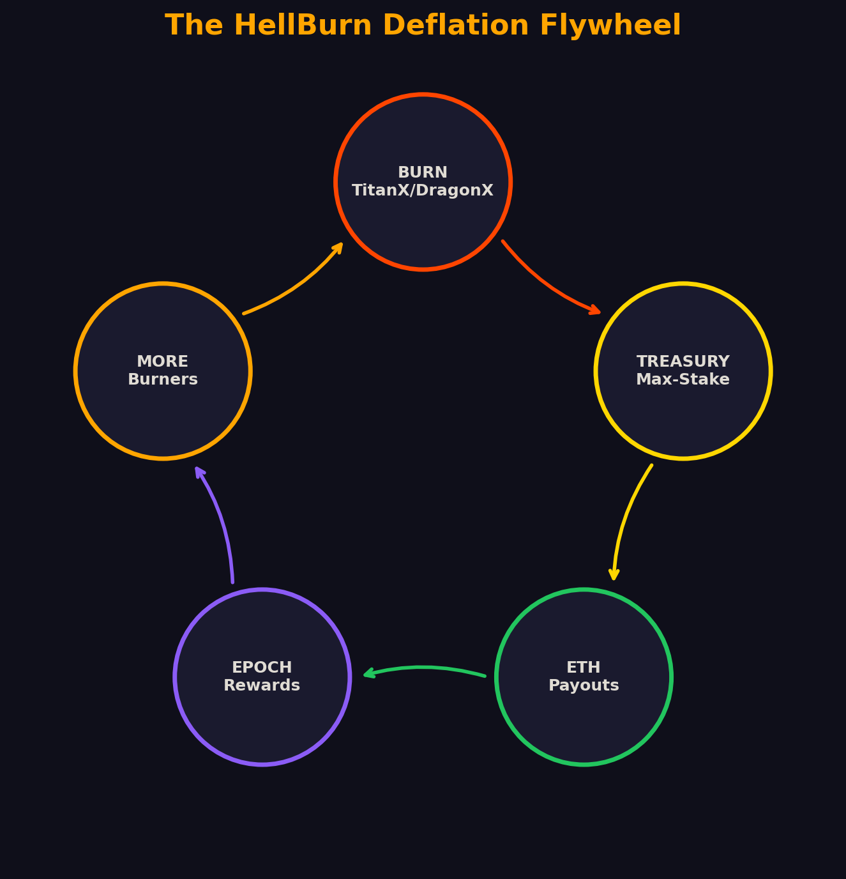
The HellBurn Flywheel is a self-reinforcing cycle:
Step 1: Users burn TitanX/DragonX (via Genesis, Epochs, or Fuel). Step 2: 35% is permanently burned, 35% goes to DragonX Vault, 22% is max-staked in treasury (3,500 days), 8% to Genesis fund. Step 3: Staked TitanX generates ETH at every payout cycle (8/28/90/369/888 days). Step 4: 80% of ETH flows to Epoch burners, 20% to HBURN stakers. Step 5: More burns create more stakes, which generate more ETH, which attract more burners.
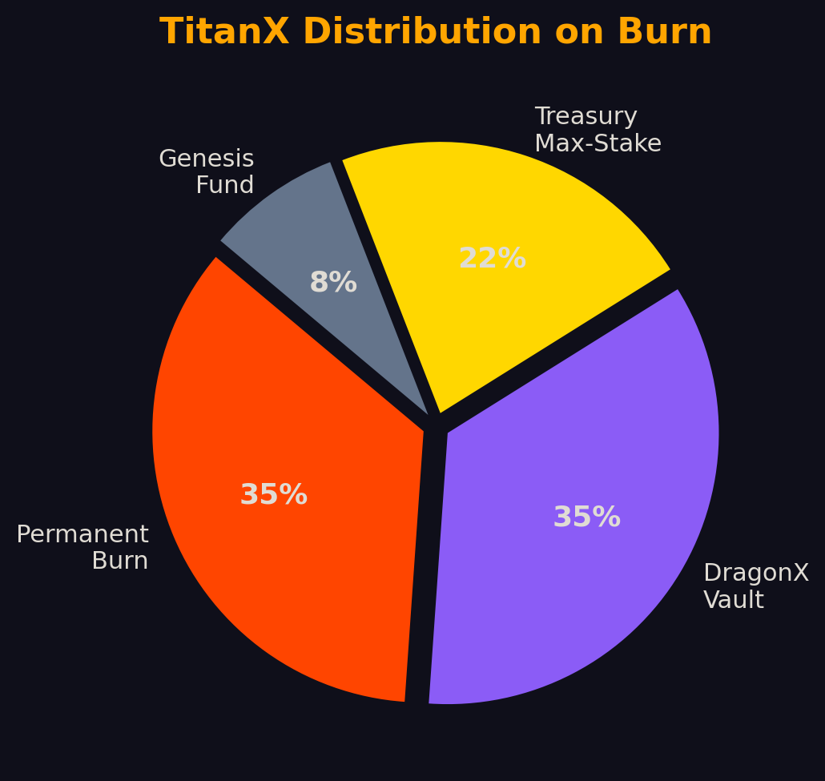

5. Genesis Phase — Your Entry Point
The Genesis Burn Phase (28 days) is the only opportunity to mint HBURN. Users burn TitanX and receive HBURN tokens at a decreasing ratio that rewards early participants:
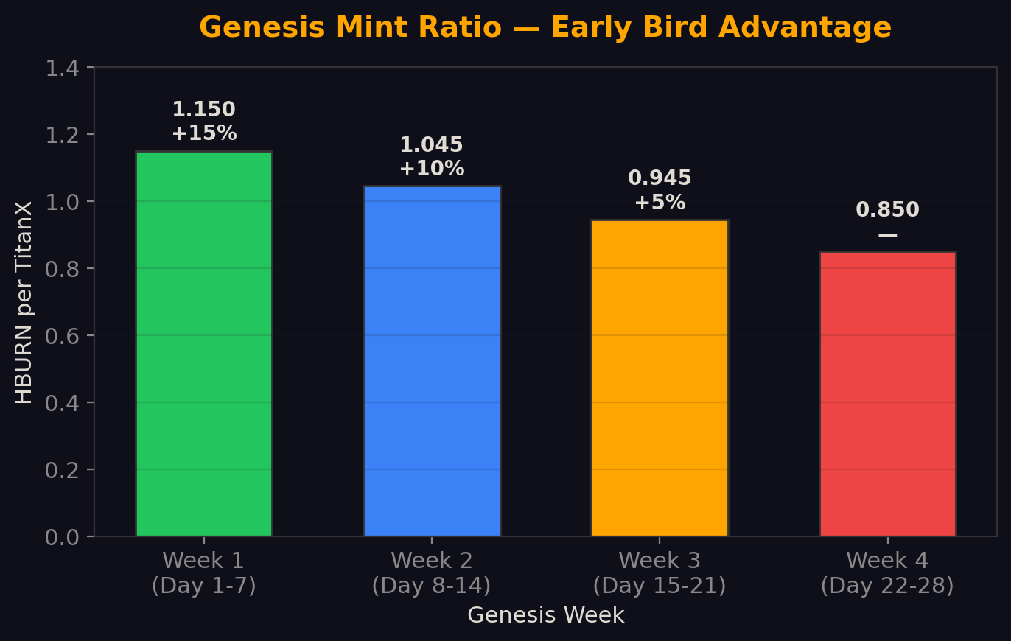
Week | Base Ratio | Early Bonus | Effective Rate | HBURN per 1B TitanX
Week 1 (Day 1-7) | 1:1.00 | +15% | 1:1.15 | 1,150,000,000 HBURN
Week 2 (Day 8-14) | 1:0.95 | +10% | 1:1.045 | 1,045,000,000 HBURN
Week 3 (Day 15-21) | 1:0.90 | +5% | 1:0.945 | 945,000,000 HBURN
Week 4 (Day 22-28) | 1:0.85 | None | 1:0.85 | 850,000,000 HBURN

Practical Example: Alice Burns 5B TitanX in Week 1
Alice decides to participate in Genesis on Day 3 (Week 1) with 5,000,000,000 TitanX.
Calculation:
- Effective rate: 1.15 HBURN per TitanX
- Total HBURN minted: 5,000,000,000 x 1.15 = 5,750,000,000 HBURN
- Instantly available (25%): 1,437,500,000 HBURN
- Vesting over 28 days (75%): 4,312,500,000 HBURN (~154,017,857 HBURN per day)

Her 5B TitanX is distributed as follows: 1,750,000,000 permanently burned (35%), 1,750,000,000 to DragonX Vault (35%), 1,100,000,000 max-staked in treasury for 3,500 days (22%), 400,000,000 to Genesis fund (8%).
Compare: If Alice had waited until Week 4, the same 5B TitanX would only yield 4,250,000,000 HBURN — that is 1,500,000,000 HBURN less (26% fewer tokens). Early participation is significantly rewarded.

6. Burn Epochs — Competing for ETH
After Genesis ends, the competitive phase begins. Every 8 days, a new epoch starts. Users burn TitanX (1x weight) or DragonX (2x weight) into the epoch pool. At epoch end, ETH rewards are distributed proportionally to weighted burns.
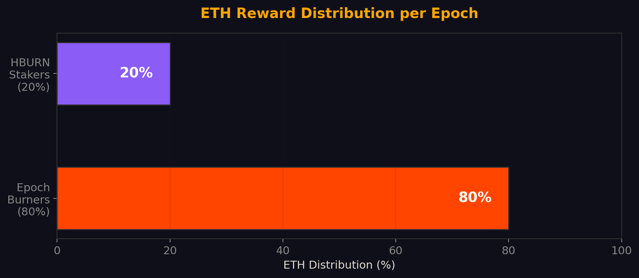

Practical Example: Bob Competes in Epoch 5
The epoch pool contains 10 ETH. Bob has been participating since Epoch 1, building a 5-epoch streak (2.0x multiplier). He burns 100,000 DragonX.
Bob's weighted burn:
- DragonX weight: 2x
- Streak multiplier: 2.0x
- Weighted burn: 100,000 x 2 x 2.0 = 400,000 weighted units

If the total weighted burns in the epoch are 2,000,000, Bob's share is 400,000 / 2,000,000 = 20%. He receives 20% of the 80% burner pool = 1.6 ETH.
Without streak: If Bob had no streak (1.0x), his weighted burn would be only 200,000 — half the share, only 0.8 ETH. The streak literally doubles his rewards in this scenario.

Streak Growth Over Time
Consecutive Epochs | Multiplier | Timeframe | Reward vs. 1.0x
1 | 1.0x | 8 days | Baseline
3 | 1.4x | 24 days | +40%
5 | 1.8x | 40 days | +80%
8 | 2.4x | 64 days | +140%
11+ | 3.0x (MAX) | 88+ days | +200%

7. Staking & Real Yield
HBURN staking offers real ETH yield — not inflationary token rewards, but actual ETH from TitanX staking payouts and the 20% epoch allocation.
Share Calculation: Shares = Amount x Time Bonus x Fuel Bonus x Loyalty Bonus
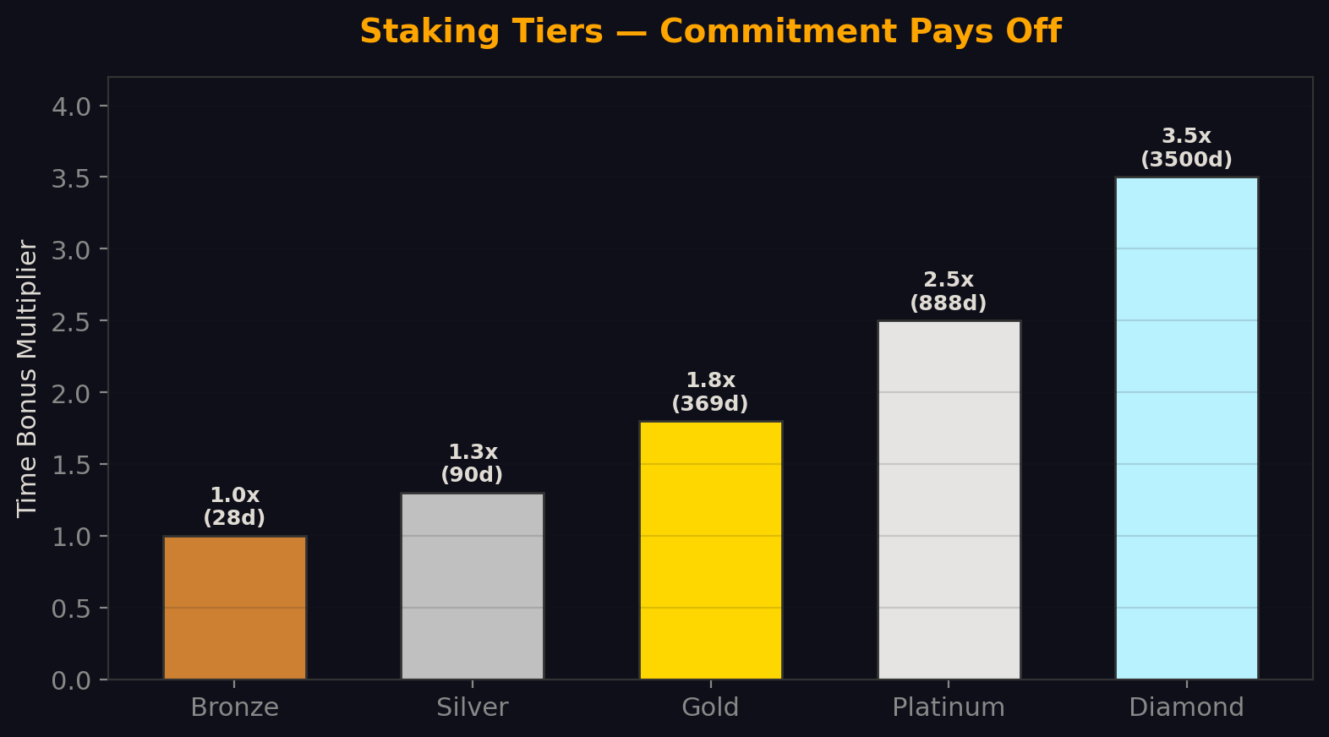

Practical Example: Carol Stakes for Gold Tier
Carol has 500,000 HBURN and stakes for 369 days (Gold tier). She also adds fuel by burning 200,000 TitanX. She has completed 1 previous stake (loyalty bonus: 1.1x).
Carol's shares:
- Amount: 500,000 HBURN
- Time bonus: 1.8x (Gold, 369 days)
- Fuel bonus: 1.25x (partial fuel from 200K TitanX)
- Loyalty bonus: 1.1x (1 completed restake)
- Total shares: 500,000 x 1.8 x 1.25 x 1.1 = 1,237,500

Without optimization: A Bronze stake (28 days) without fuel or loyalty would yield only 500,000 x 1.0 x 1.0 x 1.0 = 500,000 shares. Carol's optimized strategy gives her 2.475x more ETH rewards from the same initial HBURN investment.

Penalty System
Maturity | Status | Penalty | What Happens
0-49% | Locked | Cannot unstake | Must wait
50% | Earliest exit | ~100% | Nearly all HBURN lost
75% | Mid-maturity | ~50% | Half returned, half penalized
100% | Mature | 0% | Full HBURN + ETH rewards
100%+7d | Grace period | 0% | Optimal exit window
Penalty distribution: 50% of penalized HBURN is permanently burned (deflation), 50% stays in the staking contract (rewards remaining stakers).

8. Tokenomics Deep Dive
Parameter | Value
Name | HellBurn
Ticker | HBURN
Standard | ERC-20 (Ethereum)
Total Supply | Determined by Genesis Burn Phase (then permanently fixed)
Inflation Rate | 0% — no further minting possible after Genesis
Admin Keys | None — fully decentralized, no owner functions
Deflationary Forces | Buy & Burn (20% of epoch ETH), early unstake penalties, fuel burns

Supply Projection
HBURN is purely deflationary after Genesis. The supply can only decrease through three mechanisms:
1. Buy & Burn: 20% of all epoch ETH is used to buy HBURN on Uniswap and burn it permanently.
2. Early unstake penalties: 50% of penalty is burned.
3. Fuel mechanism: TitanX/DragonX burned for fuel removes tokens from circulation permanently.

9. Day 888 Strategy — The Catalyst Event
TitanX Day 888 is the single largest payout event in the protocol's history. Currently, approximately 727 ETH (~$2.39M) sits in the 888-Day Payout Pool, representing 50.6% of the total cycle reward pool.
HellBurn's Strategy: Launch Genesis before Day 888. All collected TitanX is immediately max-staked to build the largest possible share allocation. When the 888 payout triggers, the HellBurn treasury receives its proportional ETH share. This ETH flows into the first Burn Epochs, creating an extremely attractive reward pool — a powerful marketing event.

Timeline
Timeframe | Event | Action
~Day 852 | Contract Deployment | Deploy, audit, create LP
~Day 855 | Genesis Start | 28-day minting, TitanX immediately staked
Day 888 | MEGA PAYOUT | Treasury receives share of 727 ETH pool
Day 888+ | Burn Cascade | ETH buys & burns TitanX, DragonX, HBURN
~Day 896 | Epoch 1 | First Burn Epoch with massive ETH pool

Why This Matters — Example
Assume HellBurn accumulates 50B TitanX during Genesis, all max-staked. If TitanX has 10T total staked, HellBurn's treasury represents 0.5% of total staking power. The Day-888 payout of 727 ETH would allocate approximately 3.6 ETH directly to HellBurn's first epoch reward pool. Combined with the 8-day cycle payout (~15 ETH from a typical cycle), the first epoch could start with 18+ ETH — an extraordinary reward pool for early participants.

10. Anti-Dump Mechanisms
HellBurn implements a four-layer anti-dump system that prevents the classic post-minting sell-off:
Layer | Mechanism | Effect
1. Vesting | 25% instant, 75% vested over 28 days | No Day-1 massive dump possible
2. Penalties | Locked until 50% maturity, sliding penalty | Early exits are costly (50% burned)
3. Loyalty | 1.1x bonus on restake, Phoenix at 3 restakes | Incentivizes holding & restaking
4. Buy & Burn | 20% of all epoch ETH buys & burns HBURN | Constant buying pressure on market

11. 12-Month Projections
IMPORTANT: The following projections are hypothetical scenarios for illustration only. They are NOT financial advice or guarantees. Actual results will depend on market conditions, adoption, and many unpredictable factors.
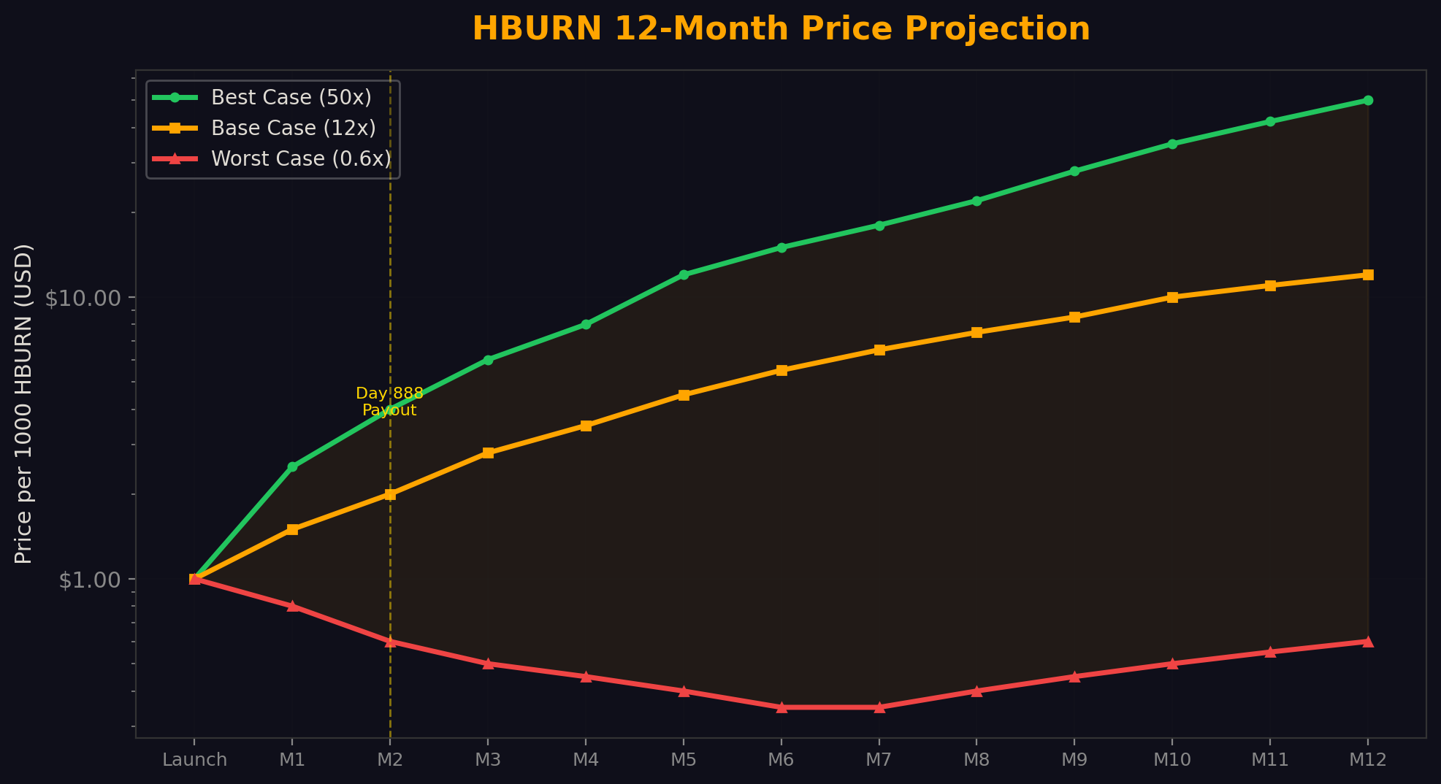

Assumptions
Factor | Best Case | Base Case | Worst Case
Genesis Participation | 200B+ TitanX burned | 50-100B TitanX | <20B TitanX
Epoch Participation | 500+ unique burners/epoch | 100-300 burners | <50 burners
Market Conditions | Bull market, ETH >$5K | Sideways, ETH $2-4K | Bear market, ETH <$2K
Day 888 Impact | Major catalyst, viral | Moderate attention | Overshadowed by market
Streak Adoption | >60% maintain streaks | 30-50% maintain | <20% maintain
TitanX Ecosystem | Growing, new protocols | Stable | Declining interest

Best Case Scenario (50x in 12 months)
In the best case, HellBurn launches during a bull market with strong TitanX community support. The Day 888 payout creates viral attention, Genesis fills rapidly, and the first epoch rewards are substantial enough to attract new users from outside the TitanX ecosystem. High streak adoption creates persistent burn pressure, reducing circulating supply dramatically. The Buy & Burn mechanism creates consistent buying pressure on Uniswap, supporting price.

Base Case Scenario (12x in 12 months)
In the base case, HellBurn attracts a solid core community from the TitanX ecosystem. Genesis reaches 50-100B TitanX, creating a meaningful treasury. Epoch participation is steady but not explosive. The protocol proves its mechanics work, builds trust, and gradually attracts more participants. Growth is organic rather than viral.

Worst Case Scenario (0.6x after 12 months)
In the worst case, a bear market reduces interest in DeFi broadly. Genesis participation is low, resulting in a small treasury and modest ETH rewards. Some early participants dump their vested tokens. However, the deflationary mechanics (Buy & Burn, penalties) provide a floor — the supply keeps shrinking even with low activity. The protocol survives but requires time to build momentum.

Month-by-Month Projection Table
Month | Best Case | Base Case | Worst Case | Key Event
Launch | $1.00 | $1.00 | $1.00 | Genesis opens
Month 1 | $2.50 | $1.50 | $0.80 | Genesis ends, Day 888 approaching
Month 2 | $4.00 | $2.00 | $0.60 | Day 888 payout, Epoch 1-3
Month 3 | $6.00 | $2.80 | $0.50 | First streaks hit max (3.0x)
Month 4 | $8.00 | $3.50 | $0.45 | Stable epoch participation
Month 5 | $12.00 | $4.50 | $0.40 | Cross-ecosystem attention
Month 6 | $15.00 | $5.50 | $0.35 | Major supply reduction visible
Month 7 | $18.00 | $6.50 | $0.35 | Potential partnership announcements
Month 8 | $22.00 | $7.50 | $0.40 | Second wave of adoptions
Month 9 | $28.00 | $8.50 | $0.45 | Phoenix stakers emerge
Month 10 | $35.00 | $10.00 | $0.50 | Supply shock from burns
Month 11 | $42.00 | $11.00 | $0.55 | Growing external interest
Month 12 | $50.00 | $12.00 | $0.60 | Mature protocol, steady state
Note: Values shown are relative (normalized to $1.00 at launch). Actual price will depend on initial market cap and liquidity depth.

12. Roadmap
Phase | Timeframe | Milestones
Phase 0 | March 2026 | Smart Contract Development, Internal Testing, Community Building
Phase 1 | Before Day 888 | Deployment, Audit, Genesis Burn Phase Launch
Phase 2 | Day 888 | Payout Capture, Burn Cascade, Marketing Push
Phase 3 | Day 888+ | Epoch 1, UI Launch, Community Growth
Phase 4 | Q3 2026 | Cross-Ecosystem Integrations, Partnerships, Governance
Phase 5 | Q4 2026+ | Multi-Chain Expansion, Advanced Gamification

13. Risks & Disclaimers
Risk Category | Description | Mitigation
Smart Contract | Despite testing and audits, contracts may have bugs | Extensive testing (91 tests), Slither audit, guardian pause mechanism
Market Risk | Crypto is extremely volatile, prices can drop | Deflationary mechanics provide structural support
Dependency | HellBurn depends on TitanX protocol | Diversified burns (TitanX + DragonX)
Liquidity | Low liquidity can amplify price movements | Initial LP provided, Buy & Burn adds buying pressure
Regulatory | DeFi regulation is evolving globally | No admin keys, fully decentralized
Adoption | Protocol needs active participants to thrive | Streak system incentivizes retention

HELLBURN — Burn to Earn. Compete to Win.

