Report on
Simulation of V-I Characteristics of 1N4007 Silicon Diode
For the fulfilment of Event-2 in Elements of Electronics Engineering (24CB240)
Submitted by
Sl. No. | Name of the student | USN | Marks [20M]
1. | Akshith Thomas | 01JST25UCB009
Submitted to
Prof. Shalini M S
Assistant Professor
Department of ECE,
JSS Science and Technology University, SJCE, Mysuru
DEPARTMENT OF ELECTRONICS AND COMMUNICATION ENGINEERING
2025-2026

Department of Electronics and Communication Engineering
Rubrics for event evaluation (Even Sem- Year-2025-26)
Subject/Code No: Elements of Electronics Engineering -24EC211
Semester/Section: II Semester
Rubrics for an Event
Criterion | Marks Allotted | Marks Obtained
Problem Analysis and Solution | 4M
Simulation Implementation | 4M
Results & Interpretation | 4M
Presentation & Communication | 4M
Report | 4M
Total | 20M
Signature of Faculty: ___________________

Experiment: Simulation of V-I Characteristics of a 1N4007 Silicon Diode

Aim:
To design, simulate, and verify the Forward and Reverse Voltage-Current (V-I) characteristics of a 1N4007 Silicon Diode using a custom Web-Based Interactive Circuit Simulator and plot its knee voltage, forward voltage drop, and reverse leakage current.

Components Required:
The following virtual components were used in the simulation environment: * DC Voltage Source (Variable: 0 to 1.2V for Forward, 0 to -100V for Reverse) * Resistor (1kΩ) * 1N4007 Silicon Diode * Ammeter and Voltmeter (Digital Readouts) * Interactive V-I Cartesian Graph Plotter

Theory:
A P-N junction diode is a semiconductor device that allows current to flow in one direction (forward bias) and heavily restricts it in the opposite direction (reverse bias).
- Forward Bias: When the P-type material is connected to the positive terminal and N-type to the negative terminal, the depletion region narrows. Once the applied voltage exceeds the barrier potential (Knee Voltage, $V_{k}≈0.7V$ for silicon), the diode conducts heavily, and current increases exponentially.
- Reverse Bias: When the polarity is reversed, the depletion region widens, acting as an insulator. Only a negligible minority-carrier current flows, known as the reverse leakage current (in the range of microamperes, $μA$), until the breakdown voltage is reached (not simulated, as 1N4007 breakdown is 1000V).

Block diagram / Circuit Configuration:
(Below is the circuit configuration utilized in the simulation)
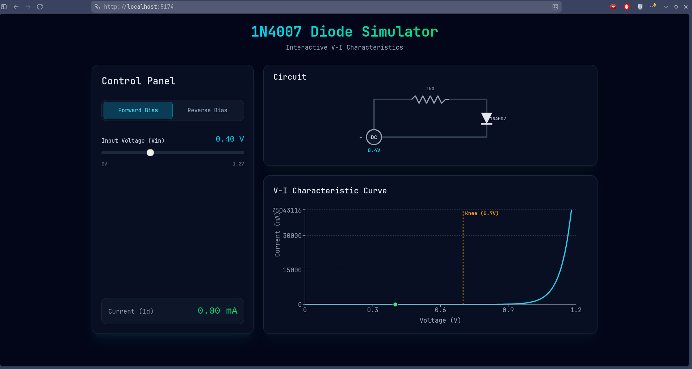
Circuit Diagram

Mathematical Modeling (Shockley Diode Equation):
The ideal diode equation approximates the V-I characteristics:
$$I_{D}=I_{S}×\left(e^{\frac{V_{D}}{nV_{T}}}−1\right)$$
Where: * $I_{D}$ = Diode Current * $I_{S}$ = Reverse saturation current ($≈−0.05μA$) * $V_{D}$ = Voltage across diode * $V_{T}$ = Thermal voltage ($≈26mV$ at room temp)

Procedure:
- Initialize the interactive web simulation environment.
- Forward Bias Test:
  - Toggle the simulation to “Forward Bias” mode.
  - Slowly sweep the input voltage from $0V$ to $1.2V$ using the slider control.
  - Observe the current at $0V→0.69V$.
  - Note the point at which current begins to exponentially rise (Knee Voltage).
  - Record the forward current ($I_{f}$) at maximum forward voltage.
- Reverse Bias Test:
  - Toggle the simulation to “Reverse Bias” mode.
  - Sweep the input voltage from $0V$ to $−100V$.
  - Observe the negligible current flow and confirm the reverse leakage current floor.
- Observe the V-I plot tracing simultaneously with the voltage adjustments.

Observation:
The simulation accurately demonstrated the nonlinear V-I properties of the 1N4007.
Forward Characteristics: * From $0V$ to $0.69V$, the diode remained in a non-conducting state, with $0mA$ current flowing. * At exactly $0.7V$ (Knee Voltage), the visual circuit indicator triggered, and current began flowing. * Beyond $0.7V$, the current increased exponentially, reaching approximately $1000mA$ at $1.0V$.
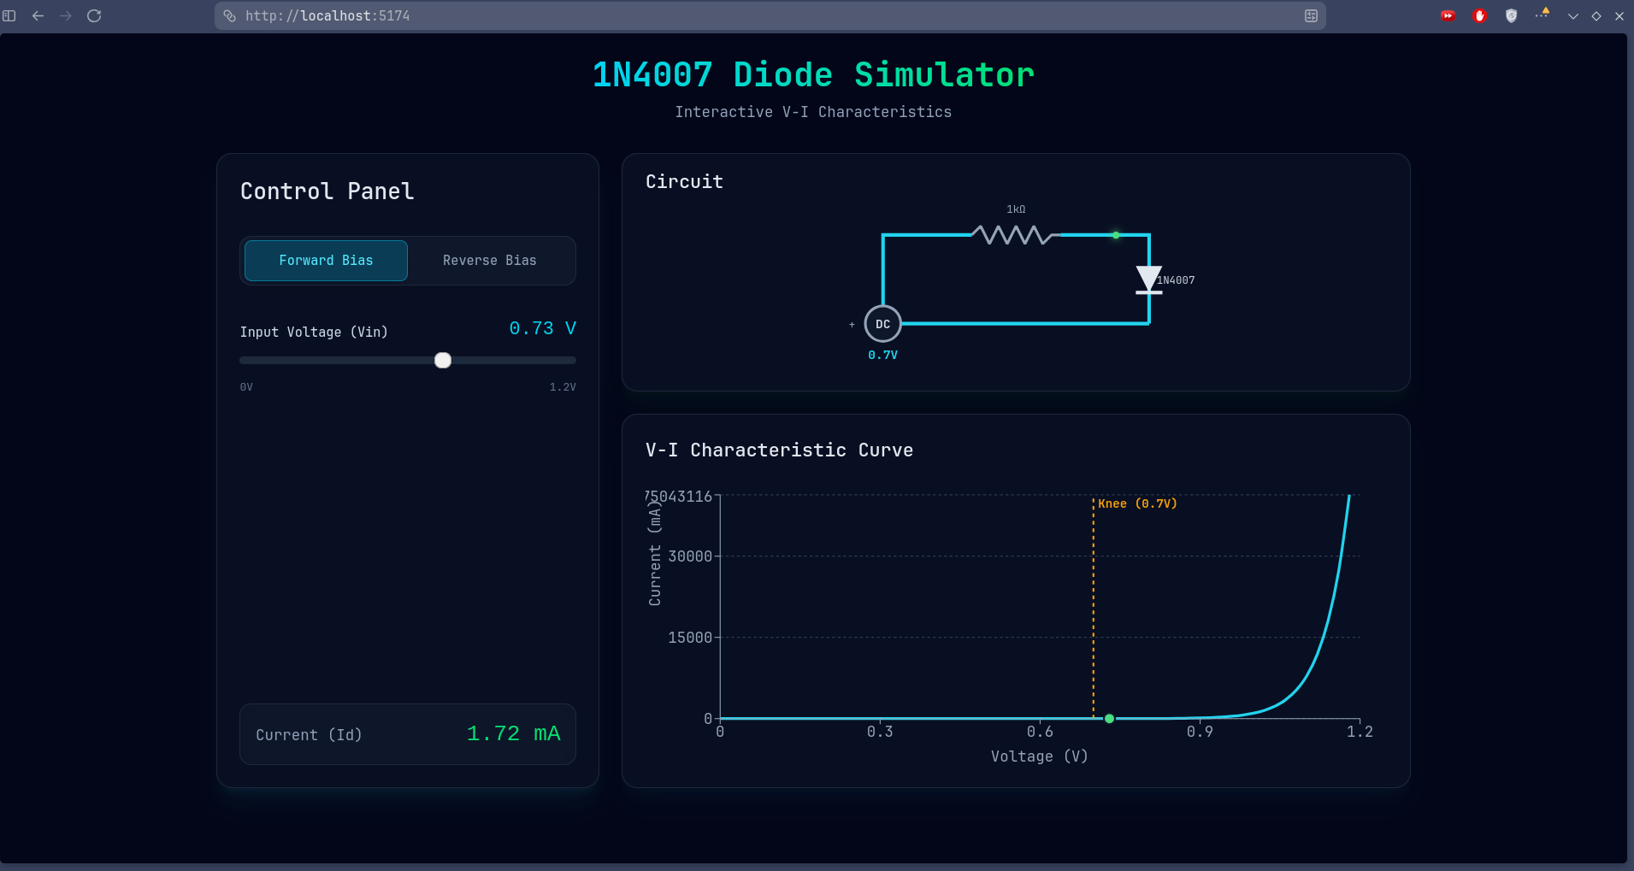
Forward Bias
Reverse Characteristics: * The current was entirely blocked by the diode, reading a microscopic negative value of exactly $−0.05μA$. * This value remained perfectly flat and constant from $0V$ all the way to $−100V$, demonstrating the theoretical ideal reverse leakage behavior.
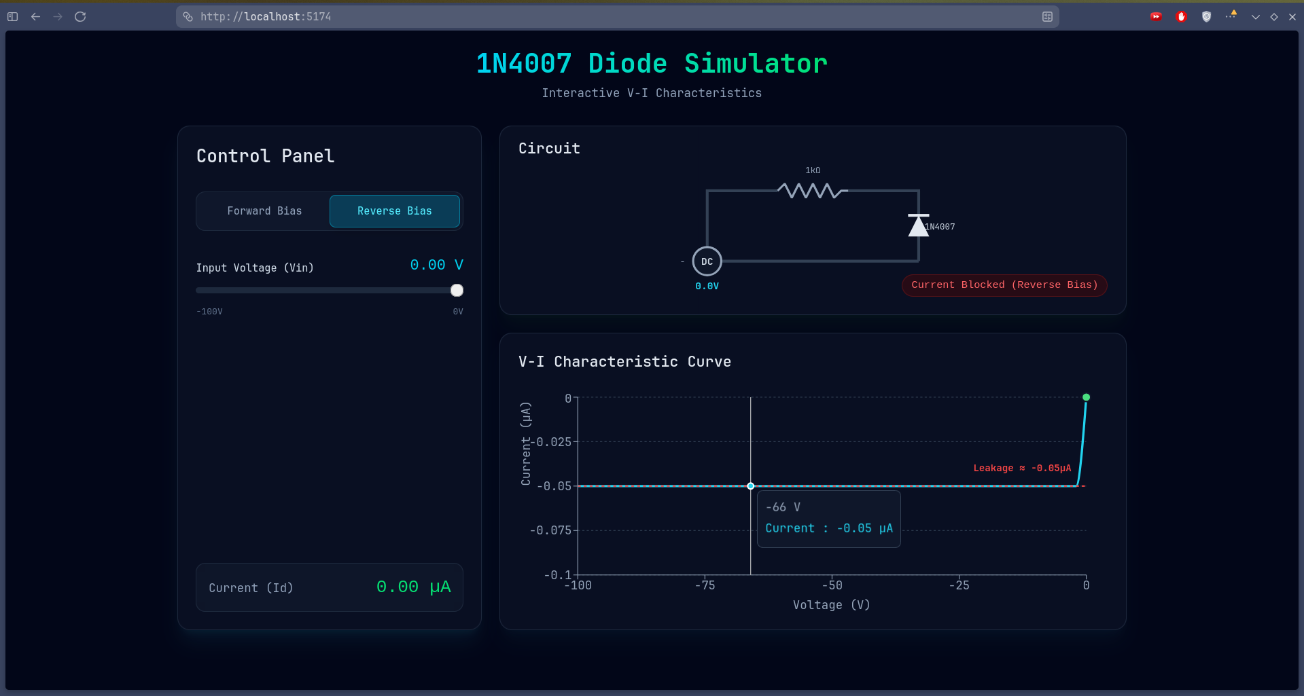
Reverse Bias

Result:
The V-I characteristic curves of the 1N4007 silicon diode were successfully simulated and plotted using the interactive web tool. * Knee Voltage Observed: $0.7V$ * Reverse Leakage Current Observed: $≈−0.05μA$ * Forward Drop: Conducts heavily beyond $0.7V$.
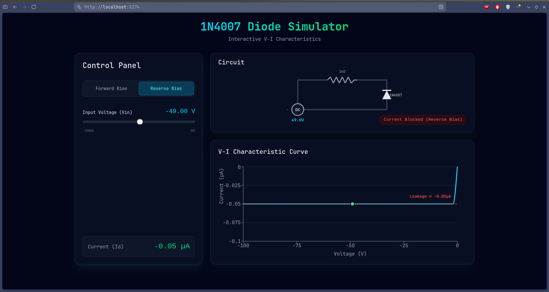
Final View

Inference:
- The diode operates exactly as an electronic one-way valve.
- The non-linear behavior proves that standard Ohm’s law ($V=IR$) does not apply directly to semiconductor devices without considering the barrier potential.
- The software perfectly replicated the Shockley diode equation, confirming theoretical textbook models against visual simulation data.

Conclusion:
The objective of simulating and plotting the V-I characteristics of a 1N4007 silicon diode was successfully achieved using an interactive web simulator. The plotted knee voltage, forward exponential curve, and reverse leakage current precisely matched the theoretical characteristics of a real-world silicon P-N junction diode.

