|  |
| --- |
| **meLink**  System Architecture  Company Name : _____ CoordSafe Pte Ltd_____________ |
| **ALL INFORMATION PROVIDED WILL BE**  **HELD IN STRICTEST CONFIDENCE** |

Part I: meLink System Concept



Part II: meLink System Architecture



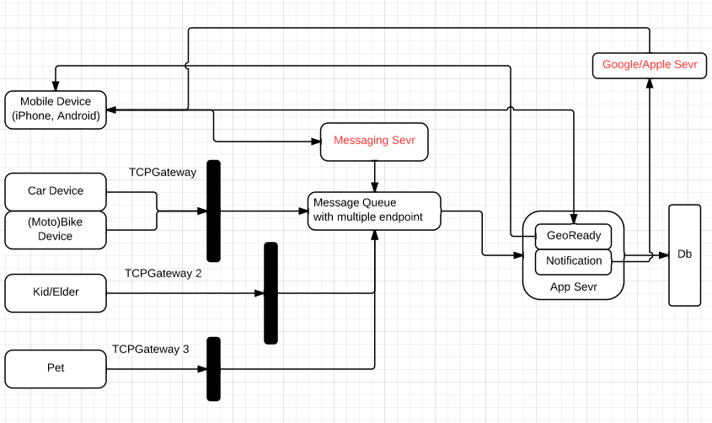

There are 3 type of users of meLink:

1. meLink Web Portal: A registered meLink user is able to access meLink services through meLink Web Portal. Refer to “meLinkWebSpecs” for details. (Hongbin)
2. meLink Mobile App. A registered meLink user is able to access meLink services through meLink Mobile Portal. Refer to “meLinkMobileSepcs” (Lihui & Yangwei) and “meLinkMobileAppInterfaceSpecs” (Yangwei) for details.
3. meTag: meTag is able to access meLink service by predefined logic and wearer activities. Refer to “meTagSpecs” for details. (Hongbin)