|  |  |  |  |
| --- | --- | --- | --- |
| Version | Author | Date |  |
| * 1.0 | * Wang HongBin | * 2013-10-21 |  |
|  |  |  |  |

PROCESS CHART

|  |  |  |
| --- | --- | --- |
|  |  |  |
| Register | Normal RegistrationSocial Registration |  |
|  |  |  |
| Login | Normal loginForget password |  |
|  |  |  |
| Show Member | Layout/DesignGoogle map (adding more functions and presentation)Map marker etc. presentation |  |
|  |  |  |
| WARD | Upload imagine of wardTo be chosen into circle |  |
|  |  |  |
| CIRCLE | Adding circle function |  |
|  |  |  |
| GeoFence | Adding out and in functionAdding new notification info |  |
|  |  |  |
| POINT | Each user can add point with 100feet (a circle fence) |  |
|  |  |  |
| History | Showstatistics |  |
|  |  |  |
| Alarm | Adding new notification |  |
|  |  |  |
| Message | Using SMS / Email / App message |  |
|  |  |  |

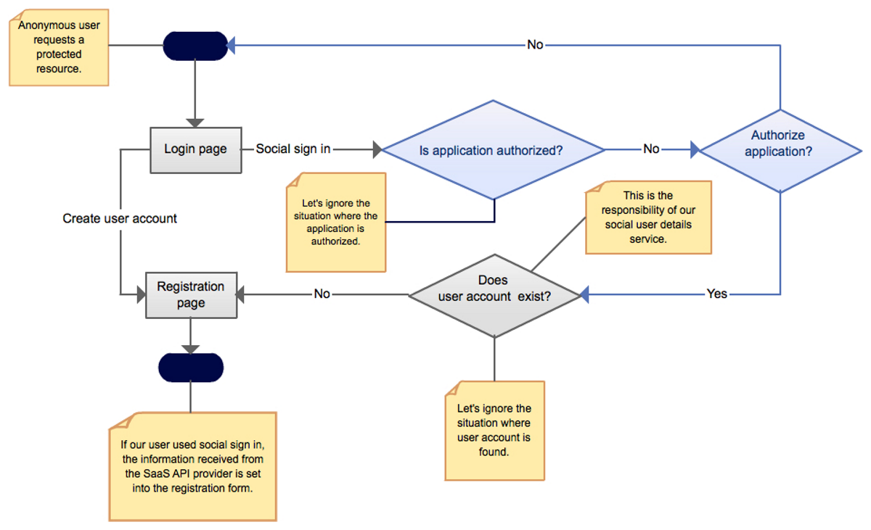

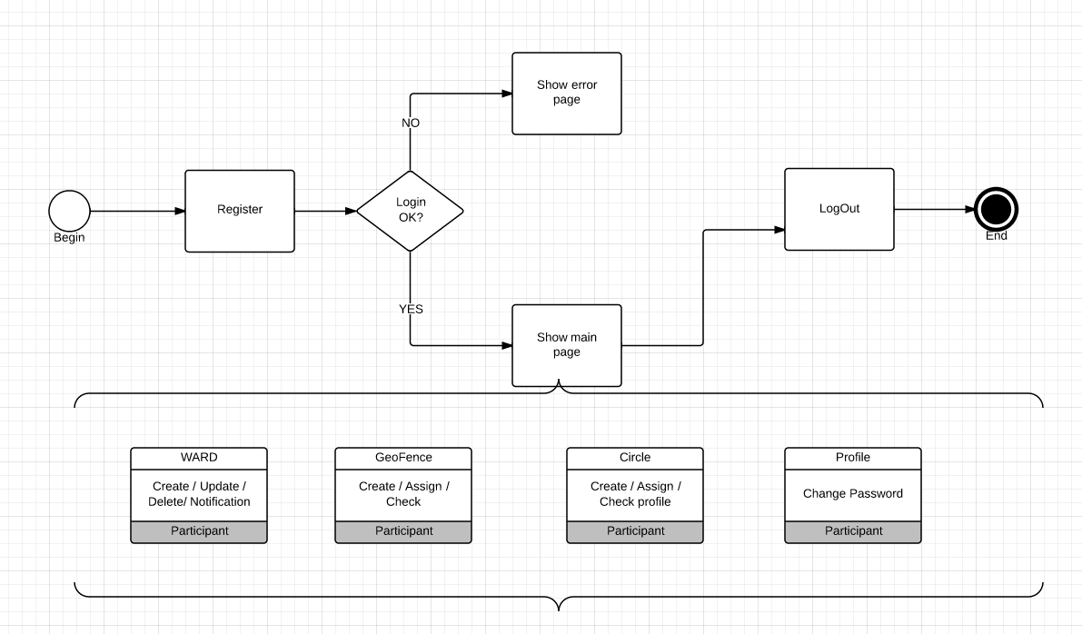

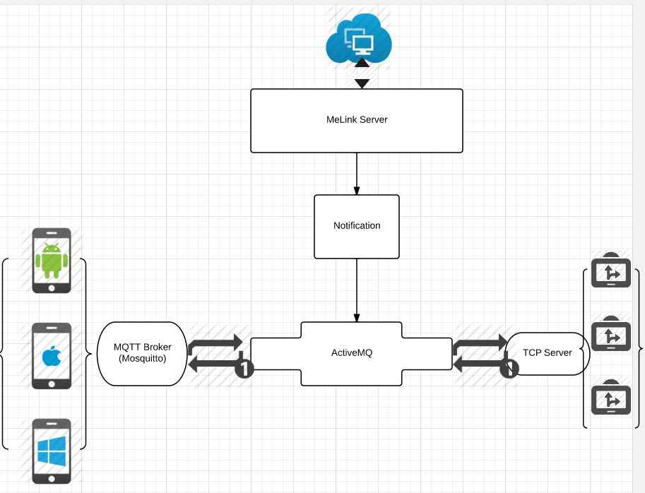

Registration:

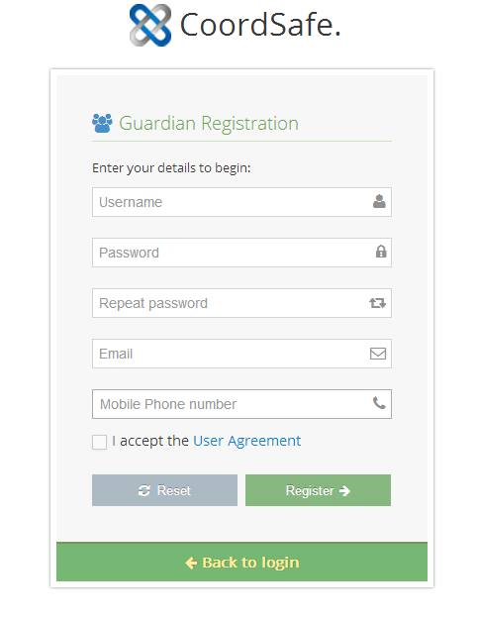

Login:

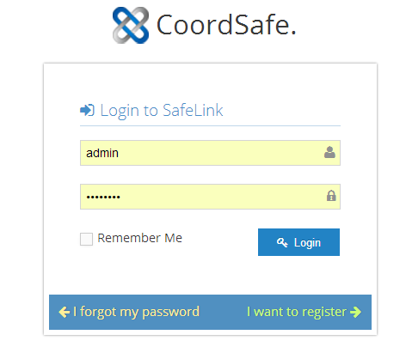

|  |  |  |
| --- | --- | --- |
| Social login | Including Google, Facebook, Twitter, LinkedIn and QQ; |  |
|  |  |  |
| Notices: | | |
| There are five type users |  |  |
|  | Guardian | Register using the web; |
|  | Ward | The ones who use coordsafe device; |
|  | Social | Login with social account; |
|  | Retailer | Sales who help sell the coordsafe device; |
|  | Administrator | Have all the above rights; |
|  |  |  |
|  |  |  |

Forget password:

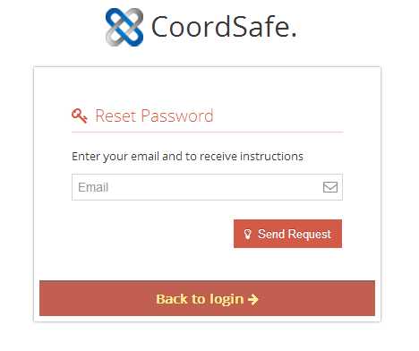

Show circle’s members:

* The default index page after login

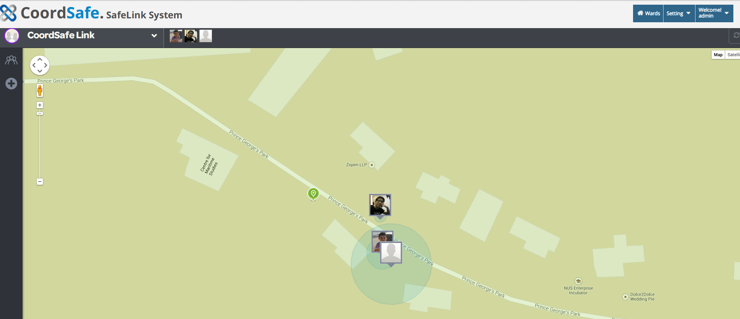

* After click the circle;

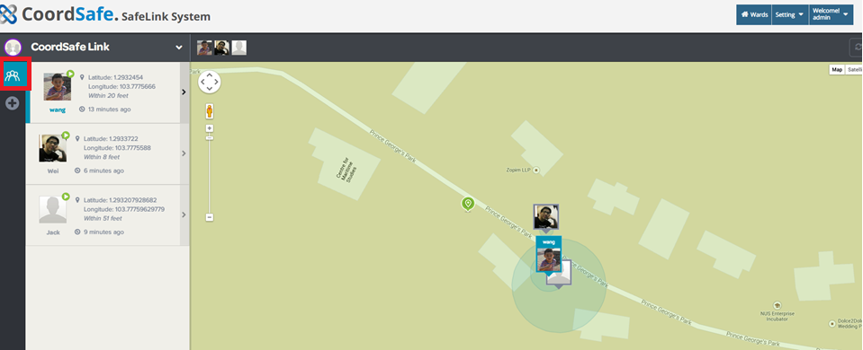

Show circle member’s profile:

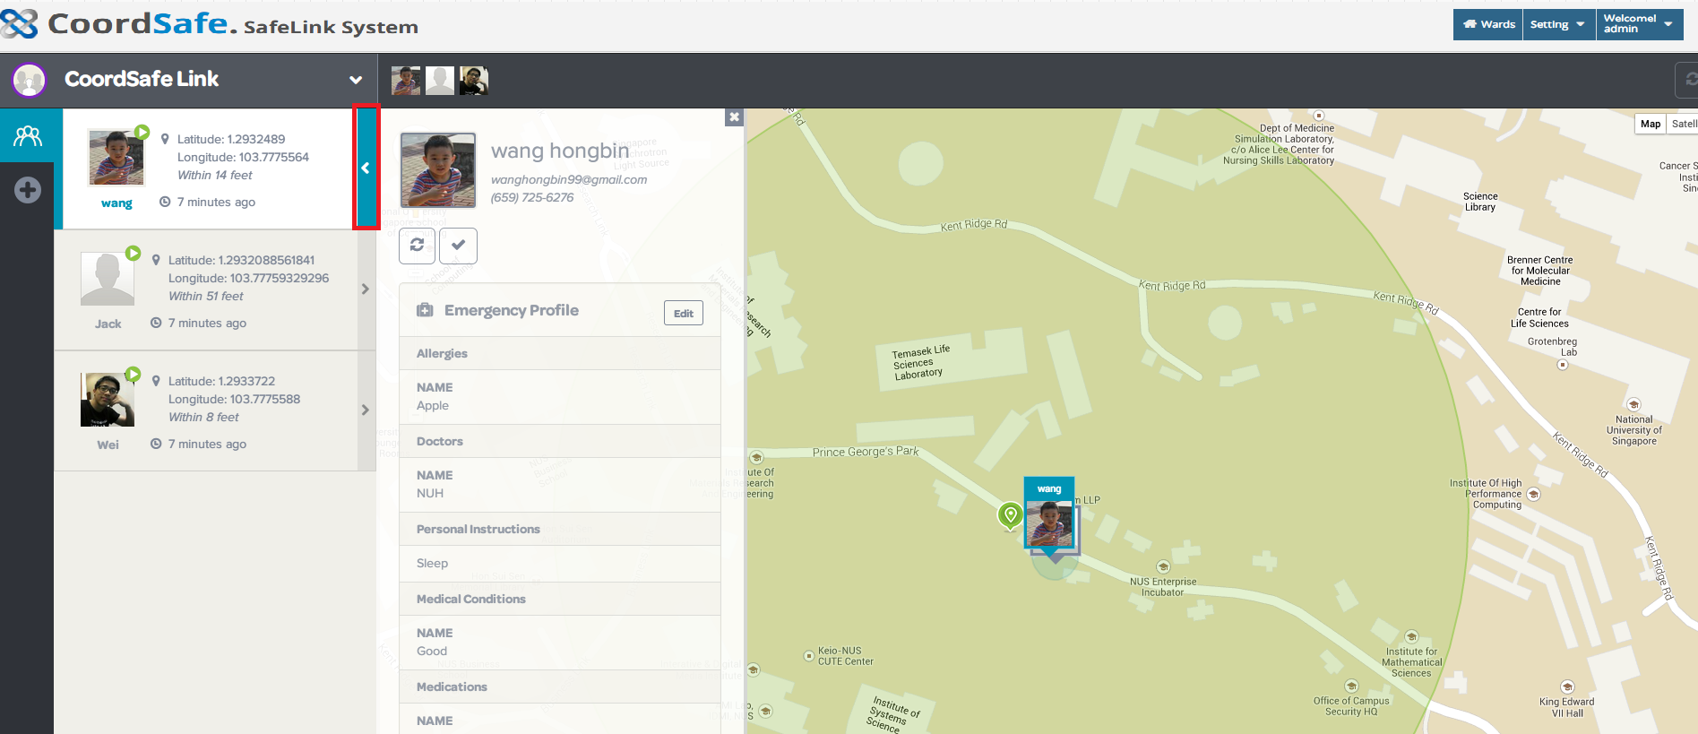

After click + to add a new member,

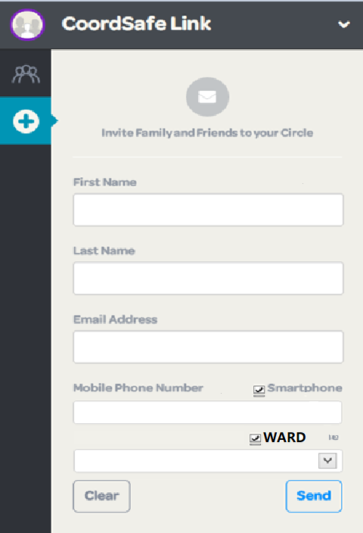

Create Circle:

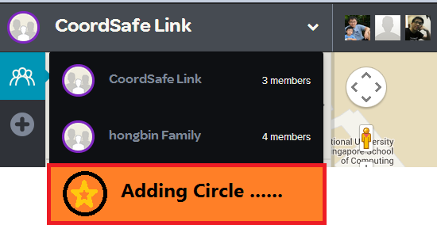

|  |  |  |
| --- | --- | --- |
| Circle Table | | |
| ID | Long |  |
| Name | Char | Circle’s name, it is not unique; |
| Description | VarChar |  |
| Admin | Char | The administration of the circle is the one who create the circle; |
| CreatedTime | Time |  |
| CreatedBy | Char |  |
| IsPaid | Boolean | If paid is true, it means that the circle’s member number is 20 maximum; otherwise, the number of member is only 5; |

Circle concept:

A circle is a collection of devices, the maximum number is 8 currently. Either Guardian or Ward, the owner of circle can invite them into the circle.

|  |  |
| --- | --- |
| Circle Functions | |
| * Sending Message | The same circle’s member can communicate using EMAIL / SMS / App Message; |
| * Checking others’ history | The circle’s members can check other member’s route history and current place |
| * Sending request check in | Any member can sent **Request Check In** to other members; |
| * Invite other guardian/ward(only admin) |  |

Message Server

Notification Server

Invite member into the circle: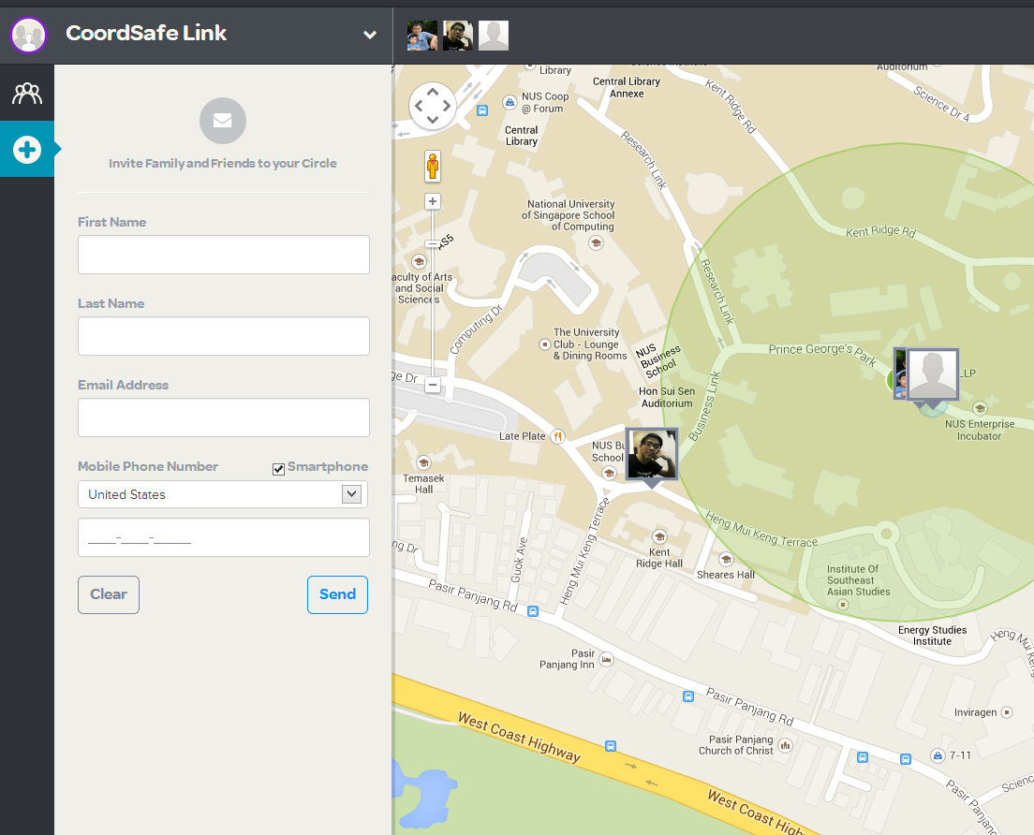

|  |  |  |
| --- | --- | --- |
| User invited Type | Registered | None-registered |
|  | * Send an email and app message to that user, the user can add the circle after checking the message; | * Only send an email to the user to ask the user to download the app; |
|  |  |  |

Create Ward：

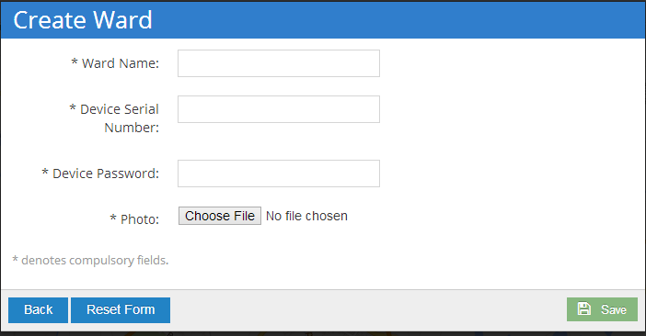

* Please provide a tip for the photo that the size of photo should not exceed 5M;

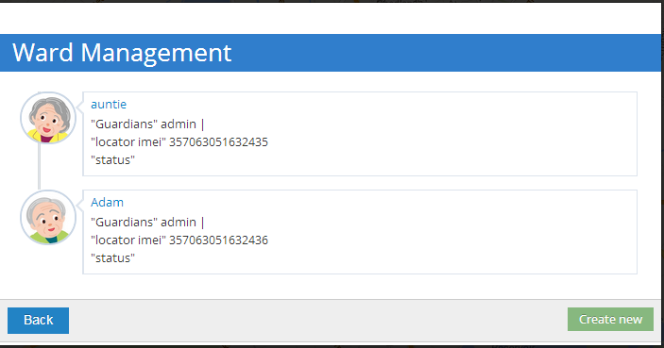

* Each ward can be edited / deleted or add notifications
* It is better to add a function that when click the icon that link to the map location;

Create Zone/ place

* Places is a great way to know when your loved ones have arrived at a destination or are leaving a set location. For instance, you can be notified once Sally arrives at the library or when Billy is leaving school. To receive these automatic alerts, you can use the Places feature to define a location inside the Life360 app. It is very easy to do and best of all, you do not have to be at the location in order to make it a Place!
* Zone is an area that user create on map, which is bigger that place. You can think that place is a point, and zone is a polygon. Normally, the zone type is safe zone or dangerous zone, but place is neutral, for example a home is a place or an office is a place. Of course, a home is a safe zone too;

A circle or a ward can be assigned to a place or a zone;