105590040 hw2 楊信致

1.

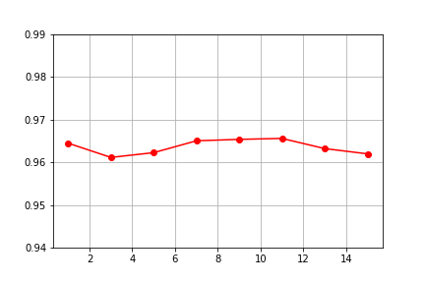

2.

|  |  |
| --- | --- |
| Sample mean | Sample covariance |
|  |  |

|  |  |  |
| --- | --- | --- |
| KNN | Naive Bayes | Bayes optimal classifier |
|  |  |  |

3.

|  |  |  |
| --- | --- | --- |
|  | KNeighborsRegressor | LinearRegression |
| Class 0: | C:\Users\YEE\Documents\MechineLearningHW\HW2\2-1.png |  |
| Class 1: | C:\Users\YEE\Documents\MechineLearningHW\HW2\2-2.png |  |
| Class 2: | C:\Users\YEE\Documents\MechineLearningHW\HW2\2-3.png |  |

Q: Is k-NN regression better than linear regression (in HW #1)?

A:如果k-nn 的k控制的很好，兩者的預測結果是差不多的。但是如果k-nn的k沒有控制好，則預測結果會比linear還糟糕。

4.

|  |  |
| --- | --- |
| Histograms | p(x) |
| C:\Users\YEE\Documents\MechineLearningHW\HW2\4-1.png | C:\Users\YEE\Documents\MechineLearningHW\HW2\4-2.png |

Yes, I see three peaks in the second plot.

5.

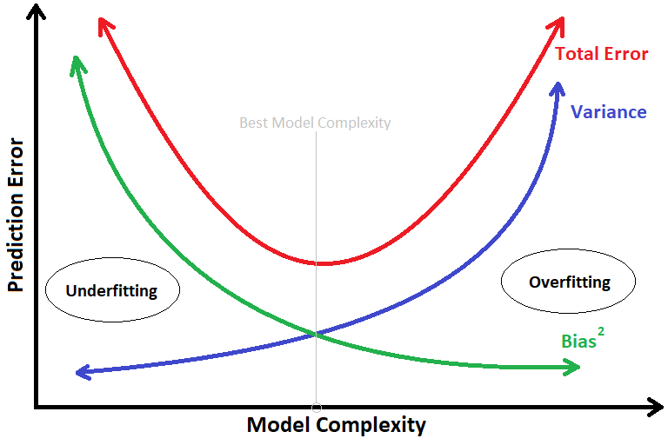

A1: βj 不取極值，目的是使訓練出來的model，比較不會發生overfitting的狀況

A2:後者的bias會比前者的還來的低，前者的variance會比後者還來的低