1.

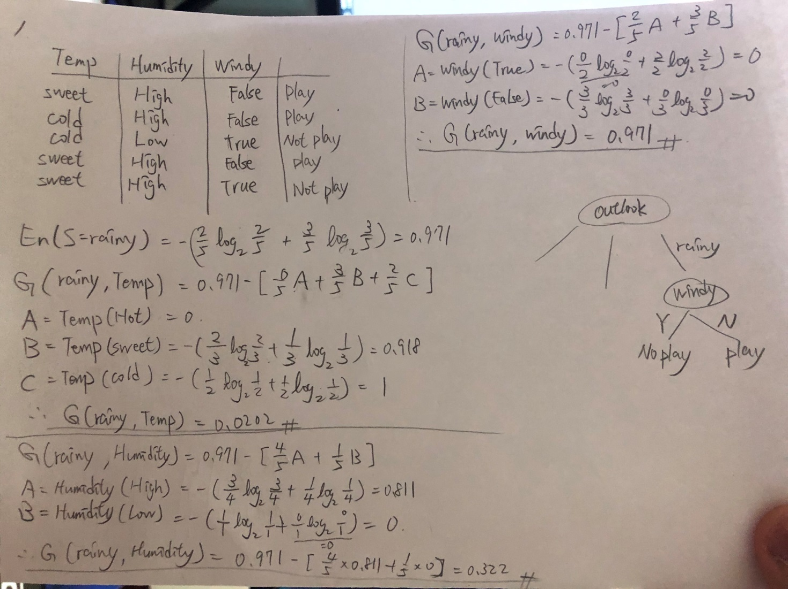

2.

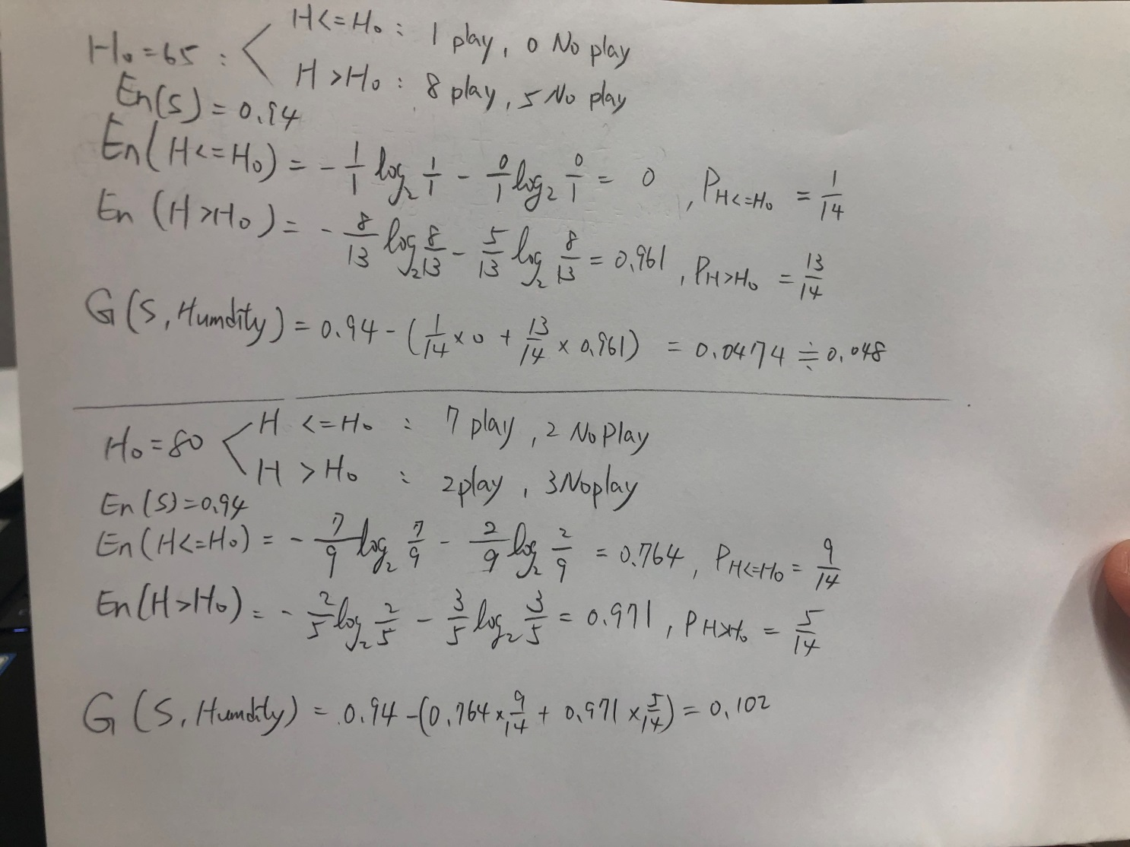

3.

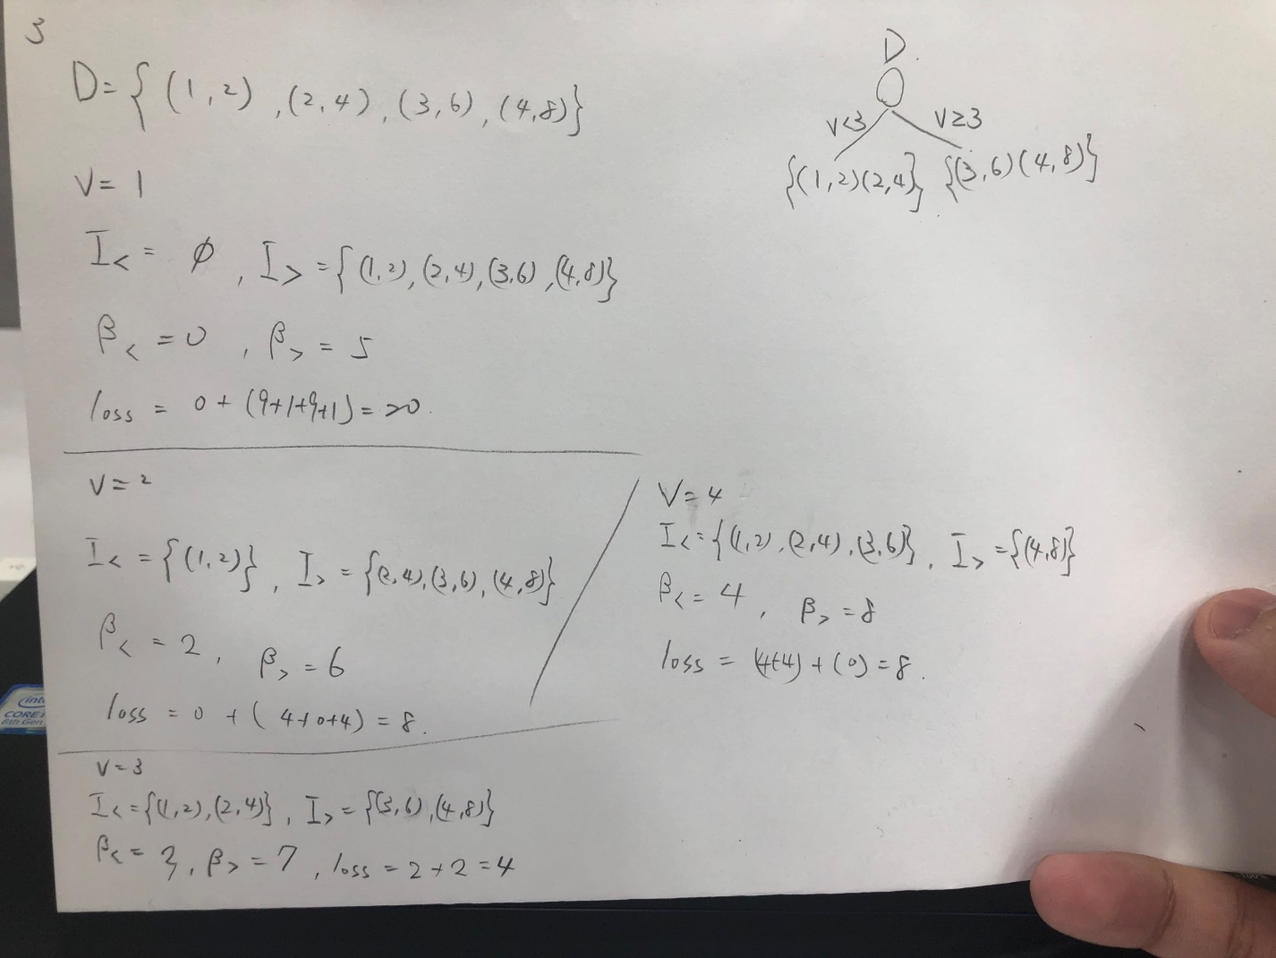

4.

|  |  |
| --- | --- |
| a.  藍線為PoV(K)的曲線,紅線是y = 0.9  C:\Users\YEE\Documents\MechineLearningHW\HW3\4.png | b.  k0差不多大於等於5 , PoV(k0) > 0.9  C:\Users\YEE\Documents\MechineLearningHW\HW3\4.png |

5.

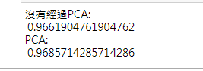

兩種方法的差別不大