1.

No, 不能確定有沒有non-Gaussian distributions

2.



|  |  |
| --- | --- |
| 3. | 4. |
| https://cdn.discordapp.com/attachments/568427949875789845/704890421796667422/image0.jpg | https://cdn.discordapp.com/attachments/568427949875789845/704904041481764946/image0.jpg |

5.

a. map radius = 39√2

b. 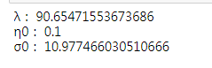

c.

