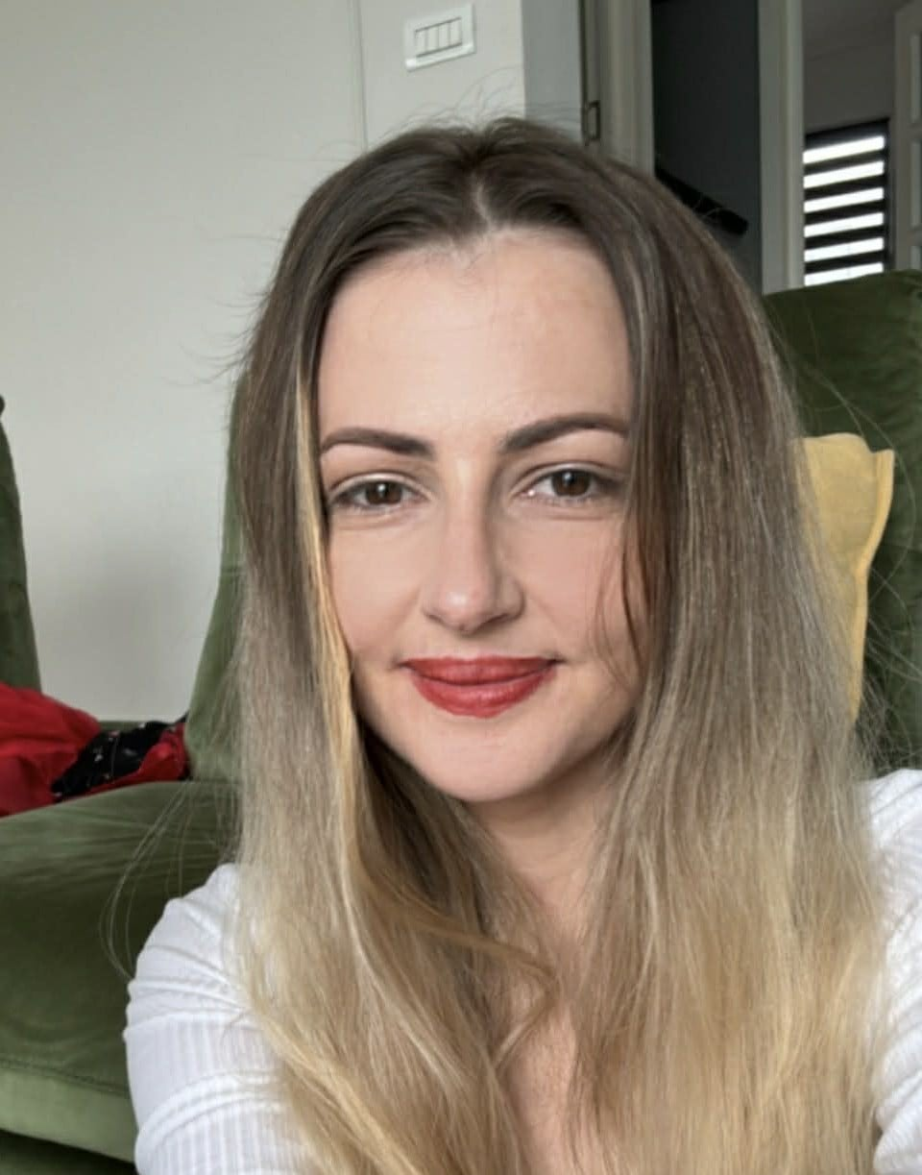 | Elena Soroceanu  Software Test Engineer | QA Specialist  📧 elena.soroceanu29@email.com  📞 0742557316  🔗 linkedin.com/in/Elena Soroceanu  💻 github.com/hellensoro  📍 Iași, Romania

PROFESSIONAL SUMMARY
ISTQB certified Software Test Engineer with 6+ years of experience in manual and automated testing in the automotive industry. Proven expertise in quality assurance for safety-critical systems compliant with ASIL standards, using industry-specific tools such as CANoe, Vector HIL, vTESTstudio and CarMaker. Experienced Scrum Master with a passion for continuous improvement, mentoring junior testers, and delivering high-quality embedded software.

WORK EXPERIENCE
Software Test Engineer @ Continental Automotive
March 2018 – May 2026 | Iași, Romania
- Executed manual and automated test cases for embedded automotive software systems compliant with ASIL standards
- Performed HIL (Hardware-in-the-Loop) testing using Vector HIL and dryHIL environments to validate ECU behaviour
- Used vTESTstudio and DAXIL for test scripting and execution in automotive test environments
- Conducted vehicle dynamics and ADAS simulation testing using CarMaker
- Managed CI/CD pipelines and version control using Jenkins and GitHub
- Acted as Scrum Master for a cross-functional team: led sprint planning, reviews, and retrospectives
- Mentored junior QA engineers and students; created training materials and hands-on labs for ISTQB preparation
- Participated in requirements reviews and assisted the development team in defect localization and analysis

Web Developer intern @ Dispatch-IT
February 2022 – August 2022 | Iași, Romania
- Implemented new functionalities on existing products using JavaScript and Node.js
- Worked with React, PostgreSQL, and Postman for frontend development and API integration
- Collaborated with team members to identify and remove software bugs; performed unit testing

Catalog Associate @ Amazon
2016 – 2018 | Iași, Romania
- Coordinated with vendors and manufacturers to ensure smooth dataflow and timely catalog updates
- Utilized SQL and internal database tools to streamline the cataloging process
- Demonstrated strong analytical and problem-solving skills in a fast-paced, data-driven environment

Customer Service Adviser @ Unicredit Bank
February 2015 – February 2016 | Iași, Romania

- Provided first-level customer support via phone and email.
- Investigated customer inquiries and resolved account-related issues.
- Maintained accurate records of customer interactions.

Key Account Representative @ Masterprint
February 2013 – February 2015 | Iași, Romania
• Managed a portfolio of key customer accounts and maintained long-term business relationships.
• Prepared offers, processed orders, and ensured timely customer support.
• Collaborated with internal teams to deliver solutions that met client requirements.

TECHNICAL SKILLS
Testing: | Manual Testing, UI Testing, Test Automation, Regression, Integration, API Testing
Automotive Tools: | vTESTstudio, Vector HIL, dryHIL, CarMaker, DAXIL, CANoe
Dev & Tools: | Jenkins, GitHub, Git, Postman, SQL, PostgreSQL, JavaScript, Node.js, React, HTML, CSS
Methodologies: | Agile, Scrum, Kanban, ASIL Standards
Other: | ISTQB, Scrum Master, Mentoring, Requirements Review

CERTIFICATIONS & COURSES
- ISTQB Certified Tester – Foundation Level (CTFL)
- Web Development Bootcamp
- JavaScript, HTML, CSS

EDUCATION
Master's Degree – Supervision and Social Planning
Faculty of Philosophy and Social-Political Sciences, Alexandru Ioan Cuza University | 2011 – 2013 | Iași, Romania

LANGUAGES
Romanian: Native
English: Fluent
Italian: Basic

