**How to use the game engine**

The client and the server will get the item and upgrade data from App_Data\tofu-universe-items.js and App_Data\tofu-universe-upgrades.js

Inside tofu-universe-items.js:

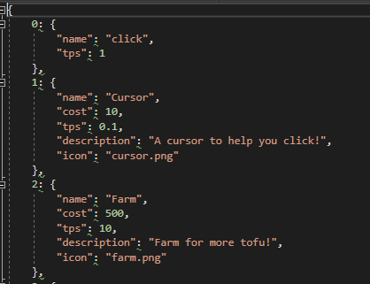

To add a new item, just add another index (the index is the item’s id), and specify the properties “name”, “cost”, “tps”, “description”, and “icon”. The icon itself is stored in Content\Images\Items\

Item id 0 is a dummy item for the player clicking on the tofu. Only change the “tps” value if you want

Inside tofu-universe-upgrades.js:

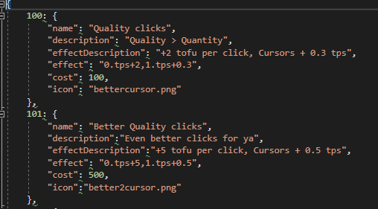

To add a new item just add an index and the properties as shown above.  
Upgrade icons are located at Content\Images\Upgrades\



Effect syntax:



1.tps+0.5



One upgrade can have multiple effects, separated by commas  
Allowed operators: ‘+’, ‘-‘, ‘*’, ‘/’, ‘=’  
All add effects are applied first before multiplication.  
EQUALS OPERATOR OVERRIDES EVERYTHING