October 25, 2019

Johns Hopkins University

Facilities & Real Estate

3910 Keswick Rd. Suite N3100

Baltimore, MD 21211

Dear Facilities Manager,

On my daily walk to the Johns Hopkins Homewood campus, I must cross University Parkway. The location of my apartment building makes it easiest and quickest to cross University Parkway directly in front of the North Gate without using a crosswalk. According to Google Maps, the length of this path is approximately 285 feet, as shown in the attached Figure 1. It would be much safer to walk to the nearest pedestrian crosswalk at Charles Street, but the length of this path is approximately 988 feet, as shown in Figure 2. This means that I would have to walk over 700 additional feet to safely and lawfully cross University Parkway. Given that the average person in their 20s can comfortably walk at 4.56 feet/second,[1] it would take the average college student almost three minutes to walk the extra 700 feet required to cross University Parkway in a safe manner. For a college student, who may be running late to class and is generally short on time, it incredibly tempting to save three minutes of walking time by crossing University Parkway without using a marked crosswalk.

I am studying ways to prevent and control traffic injuries through public health interventions at the Johns Hopkins Bloomberg School of Public Health. I have taken courses from leading injury prevention experts who have taught that it is essential to "make the safest way the easiest way." In the case of University Parkway, the safest way for many students is too difficult to reach, which is why I consistently observe students crossing this street in an unsafe way.

One way to make it safe and easy to cross University Parkway is to install a pedestrian crosswalk directly in front of the North Gate, with clear signage to communicate the crossing to drivers. This crosswalk will help alert drivers of pedestrians crossing the road, and will help encourage drivers to slow down and drive more cautiously. In a behavioral study, Knoblauch et al. described how, after a marked crosswalk was introduced, drivers tended to approach the crosswalk at a lower speed.[2] Another behavioral study by Katz et al. found that drivers were more likely to slow down or stop for pedestrians when the pedestrian was crossing within a marked crosswalk.[3] Adding a marked crosswalk will also help encourage pedestrians to cross University Parkway in a more predictable way, as the Knoblauch study also found an increase in crosswalk usage after crosswalk installation.[4]

To further increase the visibility of this crosswalk to motorists, the crosswalk signage should be comprised of permanent pedestrian road signs which face both directions of traffic. Pedestrians should have the option of pressing a button at the beginning of the crossing which would trigger lights to flash on the pedestrian signage, further alerting drivers of the pedestrian's presence. An example of such a system is shown in Figure 3. The street lighting on University Parkway should also be improved so that pedestrians are more visible to drivers at night. Finally, rumble strips should be installed on both lanes of traffic on University Parkway before vehicles cross this crosswalk, which will further help alert drivers of the upcoming crosswalk. These would be similar to the rumble strips present on San Martin Drive near the crosswalk in front of Olin Hall, and similar to the rumble strips in Figure 4.

Pedestrians are one of the most at-risk groups of people who use our roadways, as demonstrated by the high and rising rate of pedestrian traffic fatalities in Maryland. In 2018, 133 pedestrians were killed on Maryland roadways, up 14% from 117 in 2017.[5] Johns Hopkins University has the responsibility to protect the safety of all members of its community, including its pedestrians. The University has the resources required to work with Baltimore City to implement a solution to this safety hazard, a solution which may save lives and prevent serious injury to students and liability for the University.

Thank you for considering this issue. Please feel free to respond with any questions or comments.

Sincerely,

Andrew Hellinger

Attachments

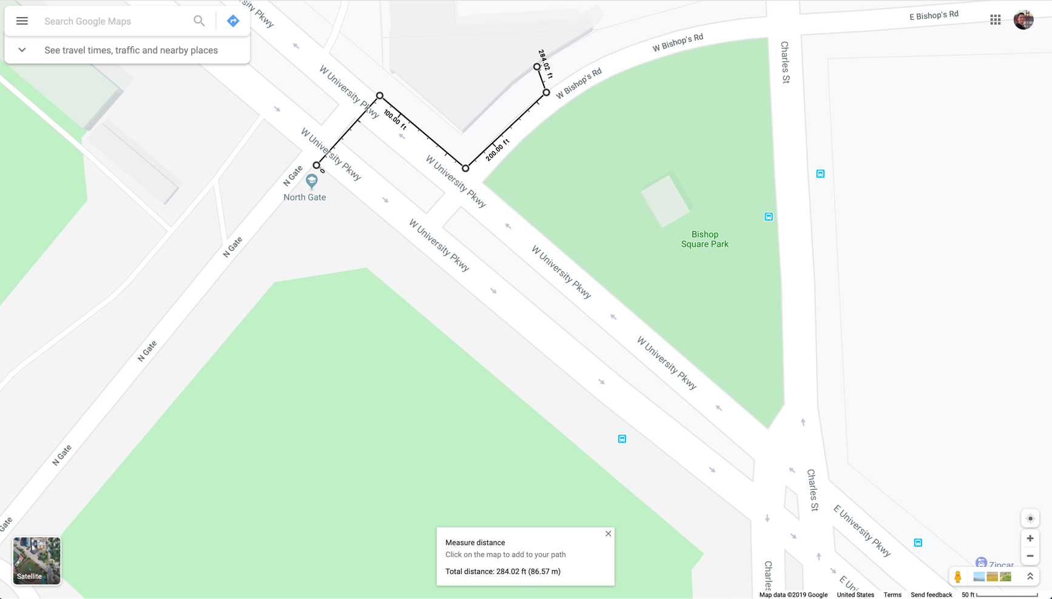

Figure – Total distance to cross University Parkway without using a marked crosswalk.

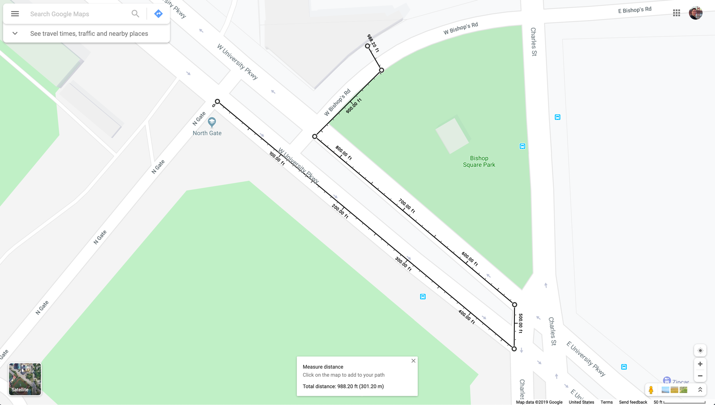

Figure – Total distance to cross University Parkway using a marked crosswalk.

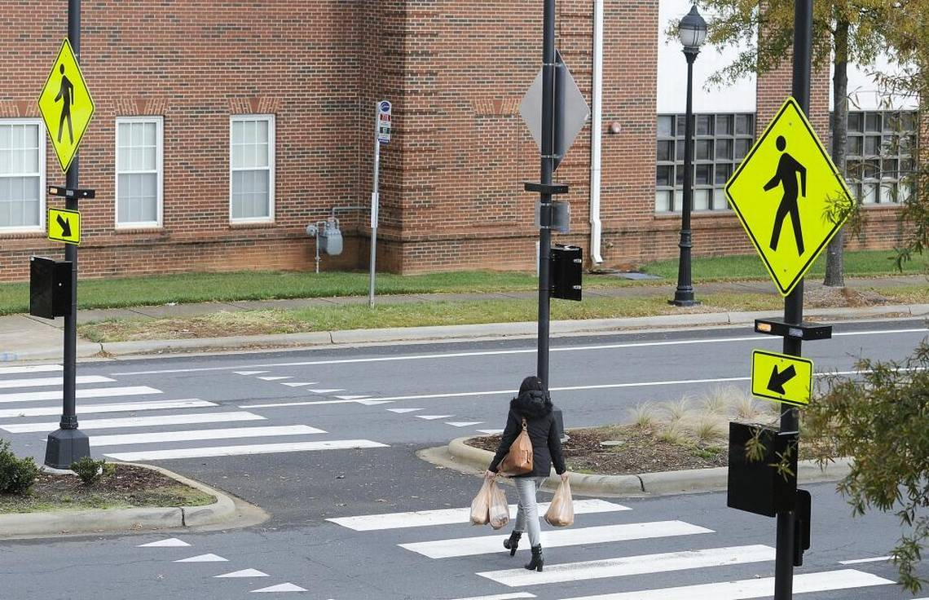

Figure – An example of pedestrian signage with alert lights for drivers.

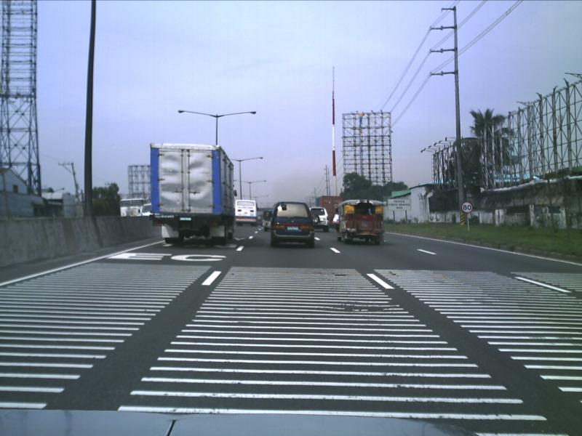

Figure – An example of rumble strips on a highway.

1. Bohannon 1997, doi: https://doi.org/10.1093/ageing/26.1.15
2. Knoblauch 2001, https://rosap.ntl.bts.gov/view/dot/14632
3. Katz 1975, doi: https://doi.org/10.1177/001872087501700510
4. Knoblauch
5. https://www.baltimoresun.com/maryland/bs-md-traffic-fatalities-20190417-story.html