湖 北 大 学

24 —— 25 学年度
第 一 学期

学 生 实 验 报 告 册

学 院： 网络空间安全学院
学生姓名： 蒋凤培
班 级： 2022级密科2班
学 号： 202231104021013
课程名称： 密码算法的软件实现
任课老师： 陈思维

学生实验守则

1、学生在规定的时间内进行实验，不得无故缺席或迟到。
2、学生在每次实验前对排定要做的实验应进行预习，并按要求作好预习报告。
3、每次实验前，必须交上次实验报告和本次实验预习报告，并经指导教师提问、检查同意后，才可进行本次实验。
4、学生进入实验室指定位置后，首先根据仪器清单核对自己使用的仪器是否有缺少或损坏，发现问题及时向指导教师报告，严禁擅自动用别组仪器。
5、实验时必须有实事求是、严肃认真的科学态度，严格遵守仪器操作规程和注意事项。
6、实验完毕应将实验数据交给指导教师检查，合格后，整理复原好仪器设备，方可离开实验室。
7、保持实验室肃静和整洁，不得大声喧哗，乱丢垃圾和吃东西。
8、学生在实验过程中，由于不遵守操作规程或未经许可，擅自进行实验而造成事故、损坏仪器设备，应及时报告，并填写损坏清单，按院有关规定进行赔偿。
实 验 报 告 单

实验名称： DES密码算法的软件实现

实验室 双创大楼701 时间 2024/10/30

实验目标和实验内容：实现算法加解密并验证其正确性
(包含实验目的、实验器材、实验原理、实验性质、实验步骤、数据记录与处理及结果讨论等内容)
- 基础实现
- 代码截图
- des.h //头文件

#ifndef DES_H
#define DES_H
//声明全局变量
extern int PC1[]; //密钥扩展选择置换表1,56bit
extern int PC2[]; //密钥扩展选择置换表2,48bit
extern int IP[]; //加密初始置换表,64bit
extern int ext[]; //扩展层E的扩展表,48bit
extern int S[][4][16]; //替换层S的8个S盒
extern int P[]; //置换层P的置换表,32bit
extern int IIP[]; //加密逆初始置换表,64bit
//声明函数
void des_key_schedule(int* key, int (*rke)[48]);
void f(int* s, int* R, int (*rke)[48], int r);
void des_encrypt(int* pt, int (*rke)[48], int* ct);
#endif
- globals.c//全局变量
#include"des.h"
//定义全局变量
int PC1[56] = { //密钥扩展选择置换表1
57,49,41,33,25,17,9,1,
58,50,42,34,26,18,10,2,
59,51,43,35,27,19,11,3,
60,52,44,36,63,55,47,39,
31,23,15,7,62,54,46,38,
30,22,14,6,61,53,45,37,
29,21,13,5,28,20,12,4 };
int PC2[48] = { //密钥扩展选择置换表2
14,17,11,24,1,5,
3,28,15,6,21,10,
23,19,12,4,26,8,
16,7,27,20,13,2,
41,52,31,37,47,55,
30,40,51,45,33,48,
44,49,39,56,34,53,
46,42,50,36,29,32 };
int IP[64] = { //加密初始置换表
58,50,42,34,26,18,10,2,
60,52,44,36,28,20,12,4,
62,54,46,38,30,22,14,6,
64,56,48,40,32,24,16,8,
57,49,41,33,25,17,9,1,
59,51,43,35,27,19,11,3,
61,53,45,37,29,21,13,5,
63,55,47,39,31,23,15,7 };
int ext[48] = {//扩展层E的扩展表
32,1,2,3,4,5,
4,5,6,7,8,9,
8,9,10,11,12,13,
12,13,14,15,16,17,
16,17,18,19,20,21,
20,21,22,23,24,25,
24,25,26,27,28,29,
28,29,30,31,32,1
};
int S[8][4][16] = {//替换层S的8个S盒
{
{ 0xe,0x4,0xd,0x1,0x2,0xf,0xb,0x8,0x3,0xa,0x6,0xc,0x5,0x9,0x0,0x7 },
{ 0x0,0xf,0x7,0x4,0xe,0x2,0xd,0x1,0xa,0x6,0xc,0xb,0x9,0x5,0x3,0x8 },
{ 0x4,0x1,0xe,0x8,0xd,0x6,0x2,0xb,0xf,0xc,0x9,0x7,0x3,0xa,0x5,0x0 },
{ 0xf,0xc,0x8,0x2,0x4,0x9,0x1,0x7,0x5,0xb,0x3,0xe,0xa,0x0,0x6,0xd }
},

{
{ 0xf,0x1,0x8,0xe,0x6,0xb,0x3,0x4,0x9,0x7,0x2,0xd,0xc,0x0,0x5,0xa },
{ 0x3,0xd,0x4,0x7,0xf,0x2,0x8,0xe,0xc,0x0,0x1,0xa,0x6,0x9,0xb,0x5 },
{ 0x0,0xe,0x7,0xb,0xa,0x4,0xd,0x1,0x5,0x8,0xc,0x6,0x9,0x3,0x2,0xf },
{ 0xd,0x8,0xa,0x1,0x3,0xf,0x4,0x2,0xb,0x6,0x7,0xc,0x0,0x5,0xe,0x9 }
},

{
{ 0xa,0x0,0x9,0xe,0x6,0x3,0xf,0x5,0x1,0xd,0xc,0x7,0xb,0x4,0x2,0x8 },
{ 0xd,0x7,0x0,0x9,0x3,0x4,0x6,0xa,0x2,0x8,0x5,0xe,0xc,0xb,0xf,0x1 },
{ 0xd,0x6,0x4,0x9,0x8,0xf,0x3,0x0,0xb,0x1,0x2,0xc,0x5,0xa,0xe,0x7 },
{ 0x1,0xa,0xd,0x0,0x6,0x9,0x8,0x7,0x4,0xf,0xe,0x3,0xb,0x5,0x2,0xc }
},

{
{ 0x7,0xd,0xe,0x3,0x0,0x6,0x9,0xa,0x1,0x2,0x8,0x5,0xb,0xc,0x4,0xf },
{ 0xd,0x8,0xb,0x5,0x6,0xf,0x0,0x3,0x4,0x7,0x2,0xc,0x1,0xa,0xe,0x9 },
{ 0xa,0x6,0x9,0x0,0xc,0xb,0x7,0xd,0xf,0x1,0x3,0xe,0x5,0x2,0x8,0x4 },
{ 0x3,0xf,0x0,0x6,0xa,0x1,0xd,0x8,0x9,0x4,0x5,0xb,0xc,0x7,0x2,0xe }
},

{
{ 0x2,0xc,0x4,0x1,0x7,0xa,0xb,0x6,0x8,0x5,0x3,0xf,0xd,0x0,0xe,0x9 },
{ 0xe,0xb,0x2,0xc,0x4,0x7,0xd,0x1,0x5,0x0,0xf,0xa,0x3,0x9,0x8,0x6 },
{ 0x4,0x2,0x1,0xb,0xa,0xd,0x7,0x8,0xf,0x9,0xc,0x5,0x6,0x3,0x0,0xe },
{ 0xb,0x8,0xc,0x7,0x1,0xe,0x2,0xd,0x6,0xf,0x0,0x9,0xa,0x4,0x5,0x3 }
},

{
{ 0xc,0x1,0xa,0xf,0x9,0x2,0x6,0x8,0x0,0xd,0x3,0x4,0xe,0x7,0x5,0xb },
{ 0xa,0xf,0x4,0x2,0x7,0xc,0x9,0x5,0x6,0x1,0xd,0xe,0x0,0xb,0x3,0x8 },
{ 0x9,0xe,0xf,0x5,0x2,0x8,0xc,0x3,0x7,0x0,0x4,0xa,0x1,0xd,0xb,0x6 },
{ 0x4,0x3,0x2,0xc,0x9,0x5,0xf,0xa,0xb,0xe,0x1,0x7,0x6,0x0,0x8,0xd }
},

{
{ 0x4,0xb,0x2,0xe,0xf,0x0,0x8,0xd,0x3,0xc,0x9,0x7,0x5,0xa,0x6,0x1 },
{ 0xd,0x0,0xb,0x7,0x4,0x9,0x1,0xa,0xe,0x3,0x5,0xc,0x2,0xf,0x8,0x6 },
{ 0x1,0x4,0xb,0xd,0xc,0x3,0x7,0xe,0xa,0xf,0x6,0x8,0x0,0x5,0x9,0x2 },
{ 0x6,0xb,0xd,0x8,0x1,0x4,0xa,0x7,0x9,0x5,0x0,0xf,0xe,0x2,0x3,0xc }
},

{
{ 0xd,0x2,0x8,0x4,0x6,0xf,0xb,0x1,0xa,0x9,0x3,0xe,0x5,0x0,0xc,0x7 },
{ 0x1,0xf,0xd,0x8,0xa,0x3,0x7,0x4,0xc,0x5,0x6,0xb,0x0,0xe,0x9,0x2 },
{ 0x7,0xb,0x4,0x1,0x9,0xc,0xe,0x2,0x0,0x6,0xa,0xd,0xf,0x3,0x5,0x8 },
{ 0x2,0x1,0xe,0x7,0x4,0xa,0x8,0xd,0xf,0xc,0x9,0x0,0x3,0x5,0x6,0xb }
}
};
int P[32] = {//置换层P的置换表
16,7,20,21,
29,12,28,17,
1,15,23,26,
5,18,31,10,
2,8,24,14,
32,27,3,9,
19,13,30,6,
22,11,4,25
};
int IIP[64] = {//加密逆初始置换表
40,8,48,16,56,24,64,32,
39,7,47,15,55,23,63,31,
38,6,46,14,54,22,62,30,
37,5,45,13,53,21,61,29,
36,4,44,12,52,20,60,28,
35,3,43,11,51,19,59,27,
34,2,42,10,50,18,58,26,
33,1,41,9,49,17,57,25
};
- des_key_schedule.c//密钥扩展
#include"des.h"
#include <string.h>
#include<stdio.h>
void des_key_schedule(int *key, int (*rke)[48])
{
int tmp[56];
for (int i = 0; i < 56; i++)//选择置换PC-1
{
tmp[i] = key[PC1[i]-1];//注意置换表中的数值是从1开始，而数组的下标是从0开始，因此要减1
}
int C[28], D[28];//存储状态分割的结果
for (int r = 1; r <= 16; r++)//16轮
{
memcpy(C, tmp, 28*sizeof(int));
memcpy(D, tmp + 28, 28 * sizeof(int));//状态分割
if (r == 1 || r == 2 || r == 9 || r == 16)//循环移位
{
int tc = C[0];
int td = D[0];
memmove(C, C + 1, 27 * sizeof(int));
memmove(D, D + 1, 27 * sizeof(int));
C[27] = tc;
D[27] = td;
}
else {
int tc1 = C[0];
int tc2 = C[1];
int td1 = D[0];
int td2 = D[1];
memmove(C, C + 2, 26 * sizeof(int));
memmove(D, D + 2, 26 * sizeof(int));
C[26] = tc1;
D[26] = td1;
C[27] = tc2;
D[27] = td2;
}
memmove(tmp, C , 28 * sizeof(int));//状态连接
memmove(tmp+28, D , 28 * sizeof(int));
for (int i = 0; i < 48; i++)//选择置换PC-2
{
rke[r-1][i] = tmp[PC2[i]-1];
}
/*printf("第%d轮的轮密钥为：\n", r);
for (int j = 0; j < 48; j++) printf("%d", rke[r - 1][j]);
printf("\n");*/
}
}
- des_encrypt.c//加密
#include"des.h"
#include<stdio.h>
#include<string.h>
/*
功能：核心轮函数f
传递参数：R-指向32比特右分支数组的首地址，r-处于第r轮
*/
void f(int * s, int* R, int (*rke)[48], int r)//r最小为1
{
int tmp[32];
for (int i = 0; i < 48; i++)//扩展层E
{
s[i] = R[ext[i] - 1];
}
for (int i = 0; i < 48; i++)//异或轮密钥
{
s[i] ^= rke[r-1][i];
}
int row, column,so;
for (int i = 0; i < 8; i++)//替换层S
{
row = s[i*6 + 0]*2 + s[i*6 + 5];//行标(最小为0)
column = s[i * 6 + 1] * 8 + s[i * 6 + 2] * 4 + s[i * 6 + 3] * 2 + s[i * 6 + 4];//列标
so = S[i][row][column];
for (int j = 0; j < 4; j++)
{
tmp[4 * i + j] = (so >> (3 - j)) & 1;//注意顺序
}

}
for (int i = 0; i < 32; i++)//置换层P
{
s[i] = tmp[P[i] - 1];
}
}
void des_encrypt(int *pt, int (*rke)[48], int *ct)
{
int tmp[64],s[48];
for (int i = 0; i < 64; i++)//初始置换
{
tmp[i] = pt[IP[i]-1];
}
int L[32], R[32];
memmove(L, tmp, 32 * sizeof(int));//左右分支
memmove(R, tmp+32, 32 * sizeof(int));
for (int r = 1; r <= 16; r++) //循环16轮
{
f(s, R, rke, r);//f函数
for (int i = 0; i < 32; i++) //异或交换分支
{
tmp[i] = R[i];
R[i] = s[i]^L[i];
L[i] = tmp[i];
}
}
memmove(tmp, R, 32 * sizeof(int));//左右分支交换合并
memmove(tmp+32, L, 32 * sizeof(int));
for (int i = 0; i < 64; i++)//初始逆置换
{
ct[i] = tmp[IIP[i] - 1];
}
//for (int j = 0; j < 64; j++) printf("%d", ct[j]);//输出密文
}
- main.c//主函数
#include<stdio.h>
#include<string.h>
#include"des.h"
#include<time.h>
#include<math.h>

int main()
{
double count = pow(2, 20);
clock_t start, end;
int pt[64];//64bit明文
int ct[64];//64bit密文
int key[64];//64bit种子密钥
int rke[16][48];//加密的16轮的轮密钥
int rkd[16][48];//解密的16轮的轮密钥
char char_pt[] = "0000000000000000000000000000000000000000000000000000000000000000";
char char_key[] = "0000000000000000000000000000000000000000000000000000000000000000";
for (int i = 0; i < 64; i++)
{
pt[i] = char_pt[i] - '0';
key[i] = char_key[i] - '0';
}
start = clock(); // 记录开始时间
//加密
des_key_schedule(key, rke);//密钥扩展算法求加密轮密钥
//printf("待加密的明文为：\n");
//for (int j = 0; j < 64; j++) printf("%d", pt[j]);
while (count--)
{
//printf("\n加密所得密文为：\n");
des_encrypt(pt, rke, ct);
}
//加密
end = clock(); // 记录结束时间
double time = ((double)(end - start)) / CLOCKS_PER_SEC;
printf("加密8MB的明文程序的运行时间为 %.4f 秒\n", time);//CLOCKS_PER_SEC是time.h定义的宏,CPU运行时钟周期数/s。
printf("运行速度为 % .4f Mbps\n", 8*8/time);
//解密
for (int i = 0; i < 16; i++)//获得解密轮密钥
{
memcpy(rkd[i], rke[15 - i], sizeof(rke[15 - i]));//加解密使用轮子密钥顺序相反
}
//printf("\n解密所得明文为：\n");
des_encrypt(ct, rkd, pt);

return 0;
}
- 运行结果
- 实例1
明文：1000000001000000001000000001000000001000000001000000001000000001
密钥：1000000000100000000100000100100000000000000000100000000001000000
密文：0011011101111110011111001011011011101101110000010111001110010001
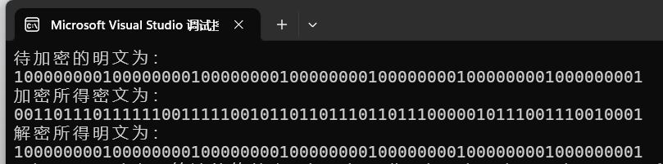
- 实例2
明文：1111111111111111111111111111111111111111111111111111111111111111
密钥：1111111111111111111111111111111111111111111111111111111111111111
密文：0111001101011001101100100001011000111110010011101101110001011000
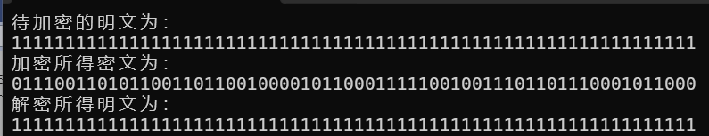
- 实例3
明文：0000000000000000000000000000000000000000000000000000000000000000
密钥：0000000000000000000000000000000000000000000000000000000000000000
密文：1000110010100110010011011110100111000001101100010010001110100111
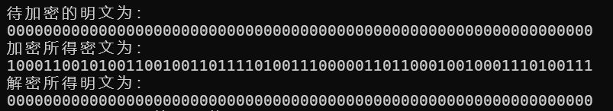
- 速度测试
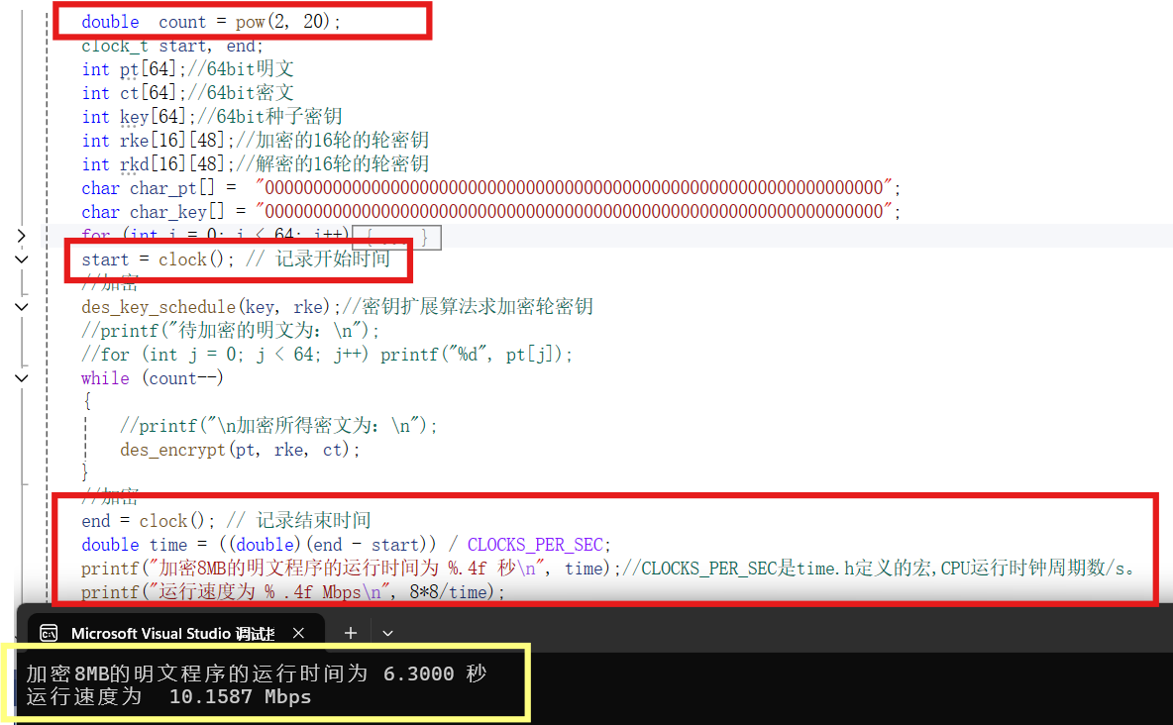
- 比特切片
- 代码截图
- des.h //头文件
#ifndef DES_H
#define DES_H
//声明全局变量
extern int PC1[]; //密钥扩展选择置换表1,56bit
extern int PC2[]; //密钥扩展选择置换表2,48bit
extern int IP[]; //加密初始置换表,64bit
extern int ext[]; //扩展层E的扩展表,48bit
extern int S[][4][16]; //替换层S的8个S盒
extern int P[]; //置换层P的置换表,32bit
extern int IIP[]; //加密逆初始置换表,64bit
//声明函数
void des_key_schedule(int* key, int (*rke)[48]);
void f(int* s, int* R, int (*rke)[48], int r);
void des_encrypt(int pt[64][4], int rke[16][48], int ct[64][4]);
#endif

- globals.c//全局变量
和基础实现相同
- des_key_schedule.c//密钥扩展
和基础实现相同
- des_encrypt.c//加密

#include"des.h"
#include<stdio.h>
#include<string.h>
/*
功能：核心轮函数f
传递参数：R-指向32比特右分支数组的首地址，r-处于第r轮
*/
void f(int* s, int* R, int (*rke)[48], int r)//r最小为1
{
int tmp[32];
for (int i = 0; i < 48; i++)//扩展层E
{
s[i] = R[ext[i] - 1];
}
for (int i = 0; i < 48; i++)//异或轮密钥
{
s[i] ^= rke[r - 1][i];
}
for (int i = 0; i < 8; i++)//替换层S
{
tmp[3+ i * 4] = (s[5 + i * 6] & s[4 + i * 6] & s[3 + i * 6] & s[2 + i * 6] & s[i * 6]) ^ (s[5 + i * 6] & s[4 + i * 6] & s[2 + i * 6] & s[1 + i * 6] & s[i * 6]) ^ (s[5 + i * 6] & s[4 + i * 6] & s[2 + i * 6] & s[1 + i * 6]) ^ (s[5 + i * 6] & s[4 + i * 6] & s[1 + i * 6] & s[i * 6]) ^ (s[5 + i * 6] & s[4 + i * 6] & s[i * 6]) ^ (s[5 + i * 6] & s[4 + i * 6]) ^ (s[5 + i * 6] & s[3 + i * 6] & s[2 + i * 6] & s[1 + i * 6] & s[i * 6]) ^ (s[5 + i * 6] & s[3 + i * 6] & s[2 + i * 6] & s[i * 6]) ^ (s[5 + i * 6] & s[3 + i * 6] & s[1 + i * 6]) ^ (s[5 + i * 6] & s[3 + i * 6] & s[i * 6]) ^ (s[5 + i * 6] & s[2 + i * 6] & s[1 + i * 6]) ^ (s[5 + i * 6] & s[1 + i * 6]) ^ (s[5 + i * 6] & s[i * 6]) ^ (s[4 + i * 6] & s[3 + i * 6] & s[2 + i * 6] & s[i * 6]) ^ (s[4 + i * 6] & s[3 + i * 6] & s[1 + i * 6] & s[i * 6]) ^ (s[4 + i * 6] & s[3 + i * 6] & s[1 + i * 6]) ^ (s[4 + i * 6] & s[3 + i * 6] & s[i * 6]) ^ (s[4 + i * 6] & s[2 + i * 6] & s[i * 6]) ^ (s[4 + i * 6] & s[2 + i * 6]) ^ (s[4 + i * 6] & s[1 + i * 6] & s[i * 6]) ^ (s[4 + i * 6] & s[1 + i * 6]) ^ (s[4 + i * 6] & s[i * 6]) ^ (s[3 + i * 6] & s[2 + i * 6] & s[1 + i * 6] & s[i * 6]) ^ (s[3 + i * 6] & s[2 + i * 6] & s[i * 6]) ^ (s[3 + i * 6] & s[i * 6]) ^ s[3 + i * 6] ^ (s[2 + i * 6] & s[1 + i * 6] & s[i * 6]) ^ (s[2 + i * 6] & s[i * 6]) ^ s[1 + i * 6];
tmp[2 + i * 4] = (s[5 + i * 6] & s[4 + i * 6] & s[3 + i * 6] & s[2 + i * 6] & s[i * 6]) ^ (s[5 + i * 6] & s[4 + i * 6] & s[3 + i * 6] & s[1 + i * 6] & s[i * 6]) ^ (s[5 + i * 6] & s[4 + i * 6] & s[3 + i * 6] & s[1 + i * 6]) ^ (s[5 + i * 6] & s[4 + i * 6] & s[3 + i * 6]) ^ (s[5 + i * 6] & s[4 + i * 6] & s[2 + i * 6] & s[1 + i * 6] & s[i * 6]) ^ (s[5 + i * 6] & s[4 + i * 6] & s[1 + i * 6] & s[i * 6]) ^ (s[5 + i * 6] & s[4 + i * 6] & s[i * 6]) ^ (s[5 + i * 6] & s[3 + i * 6] & s[2 + i * 6] & s[1 + i * 6] & s[i * 6]) ^ (s[5 + i * 6] & s[3 + i * 6] & s[2 + i * 6] & s[1 + i * 6]) ^ (s[5 + i * 6] & s[3 + i * 6] & s[2 + i * 6]) ^ (s[5 + i * 6] & s[3 + i * 6] & s[1 + i * 6] & s[i * 6]) ^ (s[5 + i * 6] & s[3 + i * 6] & s[1 + i * 6]) ^ (s[5 + i * 6] & s[2 + i * 6] & s[1 + i * 6] & s[i * 6]) ^ (s[5 + i * 6] & s[2 + i * 6] & s[1 + i * 6]) ^ (s[5 + i * 6] & s[2 + i * 6]) ^ (s[5 + i * 6] & s[1 + i * 6] & s[i * 6]) ^ (s[5 + i * 6] & s[1 + i * 6]) ^ s[5 + i * 6] ^ (s[4 + i * 6] & s[3 + i * 6] & s[1 + i * 6] & s[i * 6]) ^ (s[4 + i * 6] & s[3 + i * 6]) ^ (s[4 + i * 6] & s[2 + i * 6] & s[1 + i * 6] & s[i * 6]) ^ (s[4 + i * 6] & s[2 + i * 6] & s[1 + i * 6]) ^ (s[4 + i * 6] & s[2 + i * 6]) ^ (s[4 + i * 6] & s[1 + i * 6]) ^ (s[4 + i * 6] & s[i * 6]) ^ s[4 + i * 6] ^ (s[3 + i * 6] & s[2 + i * 6] & s[1 + i * 6] & s[i * 6]) ^ (s[3 + i * 6] & s[2 + i * 6] & s[1 + i * 6]) ^ (s[3 + i * 6] & s[2 + i * 6] & s[i * 6]) ^ (s[3 + i * 6] & s[2 + i * 6]) ^ (s[3 + i * 6] & s[1 + i * 6] & s[i * 6]) ^ (s[3 + i * 6] & s[1 + i * 6]) ^ s[3 + i * 6] ^ (s[2 + i * 6] & s[1 + i * 6] & s[i * 6]) ^ (s[2 + i * 6] & s[1 + i * 6]) ^ (s[1 + i * 6] & s[i * 6]) ^ s[i * 6];
tmp[1 + i * 4] = (s[5 + i * 6] & s[4 + i * 6] & s[3 + i * 6] & s[2 + i * 6] & s[i * 6]) ^ (s[5 + i * 6] & s[4 + i * 6] & s[3 + i * 6] & s[2 + i * 6]) ^ (s[5 + i * 6] & s[4 + i * 6] & s[3 + i * 6] & s[1 + i * 6] & s[i * 6]) ^ (s[5 + i * 6] & s[4 + i * 6] & s[2 + i * 6] & s[1 + i * 6] & s[i * 6]) ^ (s[5 + i * 6] & s[4 + i * 6] & s[2 + i * 6] & s[i * 6]) ^ (s[5 + i * 6] & s[4 + i * 6] & s[2 + i * 6]) ^ (s[5 + i * 6] & s[4 + i * 6]) ^ (s[5 + i * 6] & s[3 + i * 6] & s[2 + i * 6] & s[1 + i * 6] & s[i * 6]) ^ (s[5 + i * 6] & s[3 + i * 6] & s[2 + i * 6]) ^ (s[5 + i * 6] & s[3 + i * 6] & s[1 + i * 6]) ^ (s[5 + i * 6] & s[3 + i * 6]) ^ (s[5 + i * 6] & s[2 + i * 6] & s[1 + i * 6] & s[i * 6]) ^ (s[5 + i * 6] & s[2 + i * 6] & s[1 + i * 6]) ^ (s[5 + i * 6] & s[1 + i * 6] & s[i * 6]) ^ (s[5 + i * 6] & s[1 + i * 6]) ^ (s[5 + i * 6] & s[i * 6]) ^ s[5 + i * 6] ^ (s[4 + i * 6] & s[3 + i * 6] & s[1 + i * 6]) ^ (s[4 + i * 6] & s[3 + i * 6] & s[1 + i * 6]) ^ (s[4 + i * 6] & s[3 + i * 6] & s[i * 6]) ^ (s[4 + i * 6] & s[3 + i * 6]) ^ (s[4 + i * 6] & s[2 + i * 6] & s[1 + i * 6] & s[i * 6]) ^ (s[4 + i * 6] & s[2 + i * 6]) ^ (s[4 + i * 6] & s[1 + i * 6] & s[i * 6]) ^ (s[4 + i * 6] & s[i * 6]) ^ (s[3 + i * 6] & s[2 + i * 6] & s[1 + i * 6] & s[i * 6]) ^ (s[3 + i * 6] & s[2 + i * 6] & s[i * 6]) ^ (s[3 + i * 6] & s[1 + i * 6]) ^ (s[2 + i * 6] & s[1 + i * 6] & s[i * 6]) ^ (s[2 + i * 6] & s[i * 6]) ^ s[2 + i * 6] ^ (s[1 + i * 6] & s[i * 6]) ^ s[1 + i * 6];
tmp[i * 4] = (s[5 + i * 6] & s[4 + i * 6] & s[3 + i * 6]) ^ (s[5 + i * 6] & s[4 + i * 6] & s[2 + i * 6] & s[1 + i * 6] & s[i * 6]) ^ (s[5 + i * 6] & s[4 + i * 6] & s[1 + i * 6] & s[i * 6]) ^ (s[5 + i * 6] & s[3 + i * 6] & s[2 + i * 6] & s[1 + i * 6] & s[i * 6]) ^ (s[5 + i * 6] & s[3 + i * 6] & s[2 + i * 6] & s[i * 6]) ^ (s[5 + i * 6] & s[3 + i * 6] & s[2 + i * 6]) ^ (s[5 + i * 6] & s[3 + i * 6] & s[1 + i * 6] & s[i * 6]) ^ (s[5 + i * 6] & s[3 + i * 6] & s[i * 6]) ^ s[5 + i * 6] ^ (s[4 + i * 6] & s[3 + i * 6] & s[2 + i * 6] & s[i * 6]) ^ (s[4 + i * 6] & s[3 + i * 6] & s[2 + i * 6]) ^ (s[4 + i * 6] & s[3 + i * 6] & s[1 + i * 6] & s[i * 6]) ^ (s[4 + i * 6] & s[2 + i * 6] & s[i * 6]) ^ (s[4 + i * 6] & s[i * 6]) ^ s[4 + i * 6] ^ (s[3 + i * 6] & s[2 + i * 6] & s[1 + i * 6] & s[i * 6]) ^ (s[3 + i * 6] & s[2 + i * 6] & s[1 + i * 6]) ^ (s[3 + i * 6] & s[2 + i * 6] & s[i * 6]) ^ (s[3 + i * 6] & s[2 + i * 6]) ^ (s[3 + i * 6] & s[1 + i * 6] & s[i * 6]) ^ (s[3 + i * 6] & s[i * 6]) ^ (s[2 + i * 6] & s[1 + i * 6] & s[i * 6]) ^ (s[2 + i * 6] & s[1 + i * 6]) ^ s[2 + i * 6] ^ s[1 + i * 6] ^ s[i * 6];
}
/*int row, column, so;
for (int i = 0; i < 8; i++)//替换层S
{

row = s[i * 6 + 0] * 2 + s[i * 6 + 5];//行标(最小为0)
column = s[i * 6 + 1] * 8 + s[i * 6 + 2] * 4 + s[i * 6 + 3] * 2 + s[i * 6 + 4];//列标
so = S[i][row][column];
for (int j = 0; j < 4; j++)
{
tmp[4 * i + j] = (so >> (3 - j)) & 1;//注意顺序
}
}*/
for (int i = 0; i < 32; i++)//置换层P
{
s[i] = tmp[P[i] - 1];
}
}
void des_encrypt(int pt[64][4], int rke[16][48], int ct[64][4])
{
int tmp[64], s[48];
for (int m = 0; m < 4; m++) //4组明文
{
for (int i = 0; i < 64; i++)//初始置换
{
tmp[i] = pt[IP[i] - 1][m];
}
int L[32], R[32];
memmove(L, tmp, 32 * sizeof(int));//左右分支
memmove(R, tmp + 32, 32 * sizeof(int));
for (int r = 1; r <= 16; r++) //循环16轮
{
f(s, R, rke, r);//f函数
for (int i = 0; i < 32; i++) //异或交换分支
{
tmp[i] = R[i];
R[i] = s[i] ^ L[i];
L[i] = tmp[i];
}
}
memmove(tmp, R, 32 * sizeof(int));//左右分支交换合并
memmove(tmp + 32, L, 32 * sizeof(int));
for (int i = 0; i < 64; i++)//初始逆置换
{
ct[i][m] = tmp[IIP[i] - 1];
}
printf("第%d组明文加密所得密文为:\n",m+1);
for (int j = 0; j < 64; j++) printf("%d", ct[j][m]);//输出密文
printf("\n");
}
}
- main.c//主函数
#include<stdio.h>
#include<string.h>
#include"des.h"
int main()
{
int num = 4;//明文组数
int pt[64][4];//4组64bit明文，每一组明文竖着放
int ct[64][4];//4组64bit密文，每一组密文竖着放
int key[64];//64bit种子密钥，加密4组明文使用相同种子密钥
int rke[16][48];//加密的16轮的轮密钥
int rkd[16][48];//解密的16轮的轮密钥
char char_pt0[] = "0000000000000000000000000000000000000000000000000000000000000000";
char char_pt1[] = "1000000000000000000000000000000000000000000000000000000000000001";
char char_pt2[] = "0000000000000001000000000000000000000000000100000000000001000000";
char char_pt3[] = "0000011100000000000000000000000000000111000000000000000000000000";
char char_key[] = "0000000000000000000000000000000000000000000000000000000000000000";
for (int i = 0; i < 64 ; i++)//每一组明文竖着放入数组中
{
pt[i][0] = char_pt3[i] - '0';
pt[i][1] = char_pt2[i] - '0';
pt[i][2] = char_pt1[i] - '0';
pt[i][3] = char_pt0[i] - '0';
key[i] = char_key[i] - '0';
}
//加密
des_key_schedule(key, rke);//密钥扩展算法求加密轮密钥
printf("待加密的明文为：\n");
for (int i = 0; i < num; i++)
{
printf("第%d组明文：\n",i+1);
for (int j = 0; j < 64; j++) printf("%d", pt[j][i]);
printf("\n");
}
printf("\n加密所得密文为：\n");
des_encrypt(pt, rke, ct );
/*
//解密
for (int i = 0; i < 16; i++)//获得解密轮密钥
{
memcpy(rkd[i], rke[15 - i], sizeof(rke[15 - i]));//加解密使用轮子密钥顺序相反
}
printf("\n解密所得明文为：\n");
des_encrypt(ct, rkd, pt);*/
return 0;
}
- 运行结果
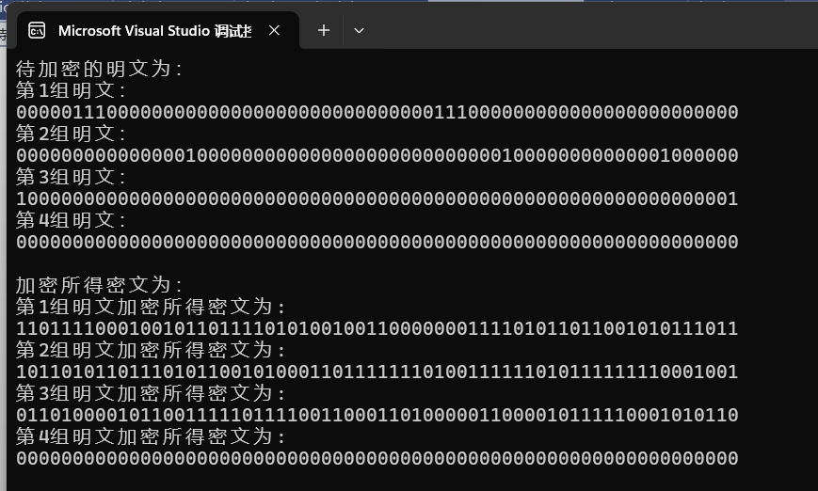
- 速度测试

- 遇到的问题及解决办法
- 语法
- 使用预处理器的包含保护（如#ifndef、#define、#endif）来防止头文件被多次包含;
头文件使用#ifndef、#define和#endif组成的包含保护机制（#ifndef DES_H、#define DES_H、#endif）。当这个头文件第一次被某个源文件包含时，由于DES_H这个宏还没有被定义，所以头文件中的内容（包括全局变量的extern声明和函数声明）会被正常处理。如果这个头文件被另一个源文件再次包含，因为DES_H宏已经在第一次包含时被定义了，所以#ifndef条件为假，头文件内部的内容（除了#ifndef、#define、#endif这三行本身）不会被再次处理，从而避免了重复声明等错误,其他源文件仍然可以使用头文件包含的全局变量和声明的函数。
- 定义全局变量，在多个源文件中共享变量；
可以使用一个专门的源文件（例如globals.c）来定义所有需要在多个源文件中共享的全局变量，并在相应的头文件（例如globals.h）中使用extern关键字声明这些变量。然后，在需要使用这些全局变量的其他源文件中包含相应的头文件即可。 extern是一个存储类说明符，用于告诉编译器这个变量是在其他地方定义的。它主要用于在多个源文件之间共享变量。
- 密码算法
- 每轮经过f函数后，将右分支R经过f变换之后的状态与左分支异或产生下一轮的右分支，原始右分支R（未经过f函数）变成下一轮左分支。过程中要保留原右分支，不可更改。
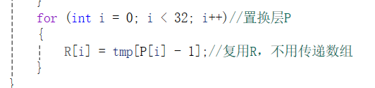
图 1 错误代码，更改右分支
- 实验总结
在本次实验中，我完成了DES密码算法的软件实现，并通过比特切片技术进行了优化。比特切片技术通过并行处理提高了算法的执行效率，减少了加密和解密所需的时间。实验结果表明，相比传统序列实现，比特切片实现在保持算法正确性的同时，显著提升了性能。通过本次实验，我不仅加深了对对称加密原理的理解，还锻炼了算法设计和性能优化的实践能力。

成绩：

批阅教师：————————
日 期：————————

