湖 北 大 学

24 —— 25 学年度
第 一 学期

学 生 实 验 报 告 册

学 院： 网络空间安全学院
学生姓名： 蒋凤培
班 级： 2022级密科2班
学 号： 202231104021013
课程名称： 密码算法的软件实现
任课老师： 陈思维

学生实验守则

1、学生在规定的时间内进行实验，不得无故缺席或迟到。
2、学生在每次实验前对排定要做的实验应进行预习，并按要求作好预习报告。
3、每次实验前，必须交上次实验报告和本次实验预习报告，并经指导教师提问、检查同意后，才可进行本次实验。
4、学生进入实验室指定位置后，首先根据仪器清单核对自己使用的仪器是否有缺少或损坏，发现问题及时向指导教师报告，严禁擅自动用别组仪器。
5、实验时必须有实事求是、严肃认真的科学态度，严格遵守仪器操作规程和注意事项。
6、实验完毕应将实验数据交给指导教师检查，合格后，整理复原好仪器设备，方可离开实验室。
7、保持实验室肃静和整洁，不得大声喧哗，乱丢垃圾和吃东西。
8、学生在实验过程中，由于不遵守操作规程或未经许可，擅自进行实验而造成事故、损坏仪器设备，应及时报告，并填写损坏清单，按院有关规定进行赔偿。
实 验 报 告 单

实验名称： AES密码算法的软件实现

实验室 双创大楼701 时间 2024/10/30

实验目标和实验内容：实现算法加解密并验证其正确性
(包含实验目的、实验器材、实验原理、实验性质、实验步骤、数据记录与处理及结果讨论等内容)
- 基于算法描述的字节实现
- 代码
- aes.h
#ifndef AES_H
#define AES_H
#include <stdint.h>
//声明全局变量
extern uint8_t Sbox[]; //S盒，长度为256
extern uint8_t INV_Sbox[];//逆S盒，长度为256
//声明函数
void aes_key_schedule(uint8_t* key, uint8_t(*rk)[16]);//密钥扩展
void AddRoundKey(uint8_t* s, uint8_t* rk);//轮密钥加
void ShiftRow(uint8_t* s);//行移位
uint8_t xtime(uint8_t a);//02*uint8_t[4]
void MixColumns(uint8_t* s);//列混淆
void SubBytes(uint8_t* s);//字节代换
void aes_encrypt(uint8_t* pt, uint8_t(*rk)[16], uint8_t* ct);//加密
void InvShiftRow(uint8_t* s);//逆行移位,循环右移
uint8_t xtime_0E(uint8_t a);//0E*uint_8[4]
uint8_t xtime_09(uint8_t a);//09*uint_8[4]
uint8_t xtime_0B(uint8_t a);//0B*uint_8[4]
uint8_t xtime_0D(uint8_t a);//0D*uint_8[4]
void InvMixColumns(uint8_t* s);//逆列混淆
void InvSubBytes(uint8_t* s);//逆字节代换
void aes_decrypt(uint8_t* ct, uint8_t(*rk)[16], uint8_t* pt);//解密
#endif
- main.c
#include"aes.h"
#include<stdio.h>
#include <stdint.h>
#include<time.h>
#include<math.h>
int main() {
double count = pow(2, 20);//加密次数，总加密16MB明文
clock_t start, end;
uint8_t pt[16], ct[16], key[16], rk[11][16];
char char_pt[] = " ff ff ff ff ff ff ff ff ff ff ff ff ff ff ff ff";
char char_key[] = "ff ff ff ff ff ff ff ff ff ff ff ff ff ff ff ff";
int i;
for ( i = 0; i < 16; i++) {
// 使用sscanf从字符串中读取明文和种子密钥
sscanf_s(char_pt + i * 3, "%2hhx", pt +i);
sscanf_s(char_key + i * 3, "%2hhx", key + i);
}
printf("待加密的明文为：\n");
for (i = 0; i < 16; i++) printf("%02x ", pt[i]);
printf("\n种子密钥为：\n");
for (i = 0; i < 16; i++) printf("%02x ", key[i]);
start = clock(); // 记录开始时间
//密钥扩展算法
aes_key_schedule(key, rk);
printf("\n轮密钥为：\n");
for (int r = 0; r < 11; r++) {
for (i = 0; i < 16; i++) printf("%02x ", rk[r][i]);
printf("\n");
}
//加密
while (count--)
{
aes_encrypt(pt, rk, ct);
}
end = clock(); // 记录结束时间
printf("加密所获得的密文为：\n");
for (i = 0; i < 16; i++) printf("%02x ", ct[i]);
double time = ((double)(end - start)) / CLOCKS_PER_SEC;
printf("\n加密16MB的明文程序的运行时间为 %.4f 秒\n", time);//CLOCKS_PER_SEC是time.h定义的宏,CPU运行时钟周期数/s。
printf("运行速度为 % .4f Mbps\n", 16 * 8 / time);
//解密
aes_decrypt(ct, rk, pt);
printf("\n解密所获得的明文为：\n");
for (i = 0; i < 16; i++) printf("%02x ", pt[i]);
return 0;
}
- globals.c
#include"aes.h"
#include <stdint.h>
//定义全局变量
//S盒，用于加密和密钥扩展
uint8_t Sbox[256] = {
0x63,0x7c,0x77,0x7b,0xf2,0x6b,0x6f,0xc5,0x30,0x01,0x67,0x2b,0xfe,0xd7,0xab,0x76,
0xca,0x82,0xc9,0x7d,0xfa,0x59,0x47,0xf0,0xad,0xd4,0xa2,0xaf,0x9c,0xa4,0x72,0xc0,
0xb7,0xfd,0x93,0x26,0x36,0x3f,0xf7,0xcc,0x34,0xa5,0xe5,0xf1,0x71,0xd8,0x31,0x15,
0x04,0xc7,0x23,0xc3,0x18,0x96,0x05,0x9a,0x07,0x12,0x80,0xe2,0xeb,0x27,0xb2,0x75,
0x09,0x83,0x2c,0x1a,0x1b,0x6e,0x5a,0xa0,0x52,0x3b,0xd6,0xb3,0x29,0xe3,0x2f,0x84,
0x53,0xd1,0x00,0xed,0x20,0xfc,0xb1,0x5b,0x6a,0xcb,0xbe,0x39,0x4a,0x4c,0x58,0xcf,
0xd0,0xef,0xaa,0xfb,0x43,0x4d,0x33,0x85,0x45,0xf9,0x02,0x7f,0x50,0x3c,0x9f,0xa8,
0x51,0xa3,0x40,0x8f,0x92,0x9d,0x38,0xf5,0xbc,0xb6,0xda,0x21,0x10,0xff,0xf3,0xd2,
0xcd,0x0c,0x13,0xec,0x5f,0x97,0x44,0x17,0xc4,0xa7,0x7e,0x3d,0x64,0x5d,0x19,0x73,
0x60,0x81,0x4f,0xdc,0x22,0x2a,0x90,0x88,0x46,0xee,0xb8,0x14,0xde,0x5e,0x0b,0xdb,
0xe0,0x32,0x3a,0x0a,0x49,0x06,0x24,0x5c,0xc2,0xd3,0xac,0x62,0x91,0x95,0xe4,0x79,
0xe7,0xc8,0x37,0x6d,0x8d,0xd5,0x4e,0xa9,0x6c,0x56,0xf4,0xea,0x65,0x7a,0xae,0x08,
0xba,0x78,0x25,0x2e,0x1c,0xa6,0xb4,0xc6,0xe8,0xdd,0x74,0x1f,0x4b,0xbd,0x8b,0x8a,
0x70,0x3e,0xb5,0x66,0x48,0x03,0xf6,0x0e,0x61,0x35,0x57,0xb9,0x86,0xc1,0x1d,0x9e,
0xe1,0xf8,0x98,0x11,0x69,0xd9,0x8e,0x94,0x9b,0x1e,0x87,0xe9,0xce,0x55,0x28,0xdf,
0x8c,0xa1,0x89,0x0d,0xbf,0xe6,0x42,0x68,0x41,0x99,0x2d,0x0f,0xb0,0x54,0xbb,0x16
};
//逆S盒，用于解密
uint8_t INV_Sbox[256] = {
0x52,0x09,0x6a,0xd5,0x30,0x36,0xa5,0x38,0xbf,0x40,0xa3,0x9e,0x81,0xf3,0xd7,0xfb,
0x7c,0xe3,0x39,0x82,0x9b,0x2f,0xff,0x87,0x34,0x8e,0x43,0x44,0xc4,0xde,0xe9,0xcb,
0x54,0x7b,0x94,0x32,0xa6,0xc2,0x23,0x3d,0xee,0x4c,0x95,0x0b,0x42,0xfa,0xc3,0x4e,
0x08,0x2e,0xa1,0x66,0x28,0xd9,0x24,0xb2,0x76,0x5b,0xa2,0x49,0x6d,0x8b,0xd1,0x25,
0x72,0xf8,0xf6,0x64,0x86,0x68,0x98,0x16,0xd4,0xa4,0x5c,0xcc,0x5d,0x65,0xb6,0x92,
0x6c,0x70,0x48,0x50,0xfd,0xed,0xb9,0xda,0x5e,0x15,0x46,0x57,0xa7,0x8d,0x9d,0x84,
0x90,0xd8,0xab,0x00,0x8c,0xbc,0xd3,0x0a,0xf7,0xe4,0x58,0x05,0xb8,0xb3,0x45,0x06,
0xd0,0x2c,0x1e,0x8f,0xca,0x3f,0x0f,0x02,0xc1,0xaf,0xbd,0x03,0x01,0x13,0x8a,0x6b,
0x3a,0x91,0x11,0x41,0x4f,0x67,0xdc,0xea,0x97,0xf2,0xcf,0xce,0xf0,0xb4,0xe6,0x73,
0x96,0xac,0x74,0x22,0xe7,0xad,0x35,0x85,0xe2,0xf9,0x37,0xe8,0x1c,0x75,0xdf,0x6e,
0x47,0xf1,0x1a,0x71,0x1d,0x29,0xc5,0x89,0x6f,0xb7,0x62,0x0e,0xaa,0x18,0xbe,0x1b,
0xfc,0x56,0x3e,0x4b,0xc6,0xd2,0x79,0x20,0x9a,0xdb,0xc0,0xfe,0x78,0xcd,0x5a,0xf4,
0x1f,0xdd,0xa8,0x33,0x88,0x07,0xc7,0x31,0xb1,0x12,0x10,0x59,0x27,0x80,0xec,0x5f,
0x60,0x51,0x7f,0xa9,0x19,0xb5,0x4a,0x0d,0x2d,0xe5,0x7a,0x9f,0x93,0xc9,0x9c,0xef,
0xa0,0xe0,0x3b,0x4d,0xae,0x2a,0xf5,0xb0,0xc8,0xeb,0xbb,0x3c,0x83,0x53,0x99,0x61,
0x17,0x2b,0x04,0x7e,0xba,0x77,0xd6,0x26,0xe1,0x69,0x14,0x63,0x55,0x21,0x0c,0x7d
};
- aes_key_schedule.c
#include"aes.h"
#include <stdint.h>
#include <string.h>
//void RotWord()
uint8_t Rcon[10] = { 0x01, 0x02, 0x04, 0x08, 0x10,
0x20, 0x40, 0x80, 0x1B, 0x36 }; //轮常数
void aes_key_schedule(uint8_t *key, uint8_t (*rk)[16]) {
memcpy(rk[0], key, 16);//初始密钥复制,注意这里的 key 是一个指针（uint8_t *key），在32位系统上 sizeof(key) 通常为4字节，在64位系统上通常为8字节，而不是16字节（key 所指向的数组的实际大小）。
for (int r = 1; r <= 10; r++) {
//循环上移一个字节
rk[r][0] = rk[r - 1][13];
rk[r][1] = rk[r - 1][14];
rk[r][2] = rk[r - 1][15];
rk[r][3] = rk[r - 1][12];
//S盒变换,异或轮常量,异或前一轮密钥的对应字节
for (int i = 0;i < 4;i++) {
if(i==0)
rk[r][i] = Sbox[rk[r][i]] ^ Rcon[r - 1] ^ rk[r - 1][i];//注意轮常量为1字节，只需每一列最上面的字节异或轮常量
else
rk[r][i] = Sbox[rk[r][i]] ^ rk[r - 1][i];
}
//计算后续密钥
for (int i = 1; i <= 3;i++) {
for (int j = 0;j < 4;j++) rk[r][4*i+j] = rk[r][4*(i-1)+j]^rk[r-1][4*i+j];
}
}
}
- aes_encrypt.c
#include"aes.h"
#include <stdint.h>
#include <string.h>
//异或轮密钥(一轮)
void AddRoundKey(uint8_t* s, uint8_t* rk) {
for (int i = 0; i < 16;i++) {
s[i] ^= rk[i];
}
}
//行移位，循环左移
void ShiftRow(uint8_t* s) {
uint8_t tmp[16];//临时变量
memcpy(tmp, s, 16);
//第二行
s[1] = tmp[5];
s[5] = tmp[9];
s[9] = tmp[13];
s[13] = tmp[1];
//第三行
s[2] = tmp[10];
s[6] = tmp[14];
s[10] = tmp[2];
s[14] = tmp[6];
//第四行
s[3] = tmp[15];
s[7] = tmp[3];
s[11] = tmp[7];
s[15] = tmp[11];
}
//02*uint_8[4]
uint8_t xtime(uint8_t a) {
return (a >> 7) == 1 ? (0xff & (((a) << 1) ^ 0x1B)) : ((a) << 1);
}
//列混淆
void MixColumns(uint8_t* s) {
uint8_t tmp[16];//临时变量
memcpy(tmp, s, 16);
for (int i = 0;i < 4;i++) {
s[0 + 4 * i] = xtime(tmp[4 * i]) ^ xtime(tmp[1+ 4 * i]) ^ tmp[1 + 4 * i] ^ tmp[2 + 4 * i] ^ tmp[3 + 4 * i];//第一行
s[1 + 4 * i] = tmp[4 * i] ^ xtime(tmp[1 + 4 * i]) ^ xtime(tmp[2 + 4 * i]) ^ tmp[2 + 4 * i] ^ tmp[3 + 4 * i];//第二行
s[2 + 4 * i] = tmp[4 * i] ^ tmp[1 + 4 * i] ^ xtime(tmp[2 + 4 * i]) ^ xtime(tmp[3 + 4 * i]) ^ tmp[3 + 4 * i];//第三行
s[3 + 4 * i] = xtime(tmp[4 * i]) ^ tmp[ 4 * i] ^ tmp[1 + 4 * i] ^ tmp[2 + 4 * i] ^ xtime(tmp[3 + 4 * i]);//第四行
}
}
//字节代换
void SubBytes(uint8_t* s) {
for (int i = 0;i < 16;i++) {
s[i] = Sbox[s[i]];
}
}
void aes_encrypt(uint8_t *pt, uint8_t(*rk)[16], uint8_t *ct) {
memcpy(ct, pt, 16);
//异或白化密钥
AddRoundKey(ct, rk[0]);
int r = 1;
//9轮核心轮函数f
for (r; r <= 9;r++) {
SubBytes(ct);
ShiftRow(ct);
MixColumns(ct);
AddRoundKey(ct, rk[r]);
}
SubBytes(ct);
ShiftRow(ct);
AddRoundKey(ct, rk[r]);
}

- aes_decrypt.c
#include"aes.h"
#include <stdint.h>
#include <string.h>
//逆行移位,循环右移
void InvShiftRow(uint8_t* s) {
uint8_t tmp[16];//临时变量
memcpy(tmp, s, 16);
//第二行
s[1] = tmp[13];
s[5] = tmp[1];
s[9] = tmp[5];
s[13] = tmp[9];
//第三行
s[2] = tmp[10];
s[6] = tmp[14];
s[10] = tmp[2];
s[14] = tmp[6];
//第四行
s[3] = tmp[7];
s[7] = tmp[11];
s[11] = tmp[15];
s[15] = tmp[3];
}
//0E*uint_8[4]
uint8_t xtime_0E(uint8_t a) {
return xtime(xtime(xtime(a))) ^ xtime(xtime(a)) ^ xtime(a);//08+04+02
}
//09*uint_8[4]
uint8_t xtime_09(uint8_t a) {
return xtime(xtime(xtime(a))) ^ a;//08+01
}
//0B*uint_8[4]
uint8_t xtime_0B(uint8_t a) {
return xtime_09(a) ^ xtime(a);//09+02
}
//0D*uint_8[4]
uint8_t xtime_0D(uint8_t a) {
return xtime_09(a) ^ xtime(xtime(a));//09+04
}
//逆列混淆
void InvMixColumns(uint8_t* s) {
uint8_t tmp[16];//临时变量
memcpy(tmp, s, 16);
for (int i = 0;i < 4;i++) {
s[0 + 4 * i] = xtime_0E(tmp[4 * i]) ^ xtime_0B(tmp[1 + 4 * i]) ^ xtime_0D(tmp[2 + 4 * i]) ^ xtime_09(tmp[3 + 4 * i]);//第一行
s[1 + 4 * i] = xtime_09(tmp[4 * i]) ^ xtime_0E(tmp[1 + 4 * i]) ^ xtime_0B(tmp[2 + 4 * i]) ^ xtime_0D(tmp[3 + 4 * i]);//第二行
s[2 + 4 * i] = xtime_0D(tmp[4 * i]) ^ xtime_09(tmp[1 + 4 * i]) ^ xtime_0E(tmp[2 + 4 * i]) ^ xtime_0B(tmp[3 + 4 * i]);//第三行
s[3 + 4 * i] = xtime_0B(tmp[4 * i]) ^ xtime_0D(tmp[1 + 4 * i]) ^ xtime_09(tmp[2 + 4 * i]) ^ xtime_0E(tmp[3 + 4 * i]);//第四行
}
}
//逆字节代换
void InvSubBytes(uint8_t* s) {
for (int i = 0;i < 16;i++) {
s[i] = INV_Sbox[s[i]];
}
}
//解密
void aes_decrypt(uint8_t* ct, uint8_t(*rk)[16], uint8_t* pt) {
memcpy(pt, ct, 16);
//异或密钥
AddRoundKey(pt, rk[10]);//注意轮密钥使用顺序与加密相反
int r = 1;
//9轮核心轮函数f
for (r; r <= 9;r++) {
InvShiftRow(pt);
InvSubBytes(pt);
AddRoundKey(pt, rk[10-r]);
InvMixColumns(pt);
}
InvShiftRow(pt);
InvSubBytes(pt);
AddRoundKey(pt, rk[0]);
}
- 运行结果
- 测试数据1
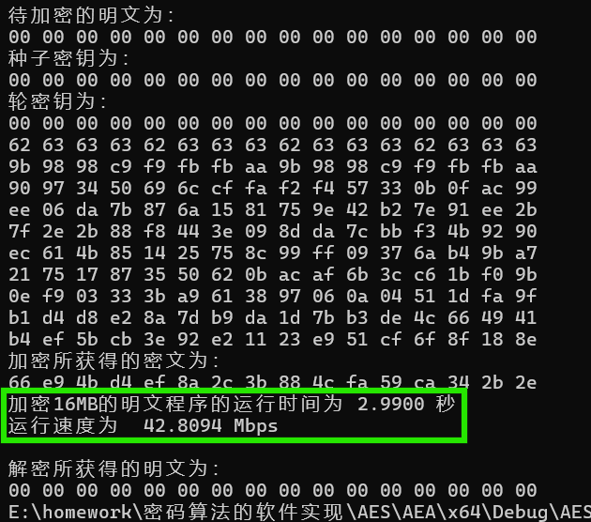
- 测试数据2
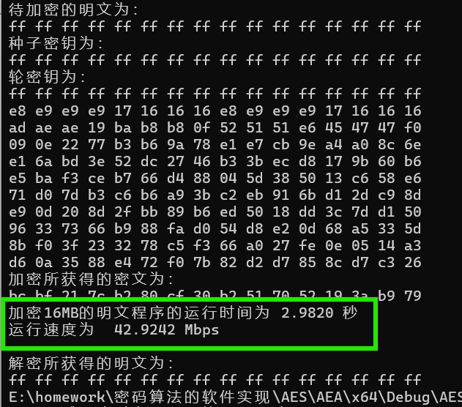
- 查表实现（包括采用指针）
- 代码
- aes_lookup_table.h
#ifndef AES_H
#define AES_H
#include <stdint.h>
//声明全局变量
extern uint8_t Sbox[]; //S盒，长度为256
extern uint8_t INV_Sbox[];//逆S盒，长度为256
//声明函数
void aes_key_schedule(uint8_t* key, uint8_t(*rk)[16]);//密钥扩展
void AddRoundKey(uint8_t* s, uint8_t* rk);//轮密钥加
void ShiftRow(uint8_t* s);//行移位
uint8_t xtime(uint8_t a);//02*uint8_t[4]
void SubBytes(uint8_t* s);//字节代换
uint8_t xtime_03(uint8_t a);//03*uint_8[4]
void MC_build_tabla();//列混淆建表
void SB_MC_build_tabla();//字节代换、列混淆建表
void aes_encrypt(uint8_t* pt, uint8_t(*rk)[16], uint8_t* ct);//加密
void InvShiftRow(uint8_t* s);//逆行移位,循环右移
uint8_t xtime_0E(uint8_t a);//0E*uint_8[4]
uint8_t xtime_09(uint8_t a);//09*uint_8[4]
uint8_t xtime_0B(uint8_t a);//0B*uint_8[4]
uint8_t xtime_0D(uint8_t a);//0D*uint_8[4]
void InvSubBytes(uint8_t* s);//逆字节代换
void Inv_T_build_tabla();//创建逆MC表，4*8bit-->4*32bit
void Inv_TS_build_tabla();//创建逆SB、MC表，4*8bit-->4*32bit
void word4_to_byte16(uint8_t* word, uint32_t* byte);//4*32bit-->16*8bit,4个转换位16个字节
void aes_decrypt(uint8_t* ct, uint8_t(*rk)[16], uint8_t* pt);//解密
#endif

- main.c
#include"aes_lookup_table.h"
#include<stdio.h>
#include <stdint.h>
#include<time.h>
#include<math.h>
int main() {
double count = pow(2, 20);//加密次数，总加密16MB明文
uint8_t pt[16], ct[16], key[16], rk[11][16];
clock_t start, end;
char char_pt[] = " ff ff ff ff ff ff ff ff ff ff ff ff ff ff ff ff";
char char_key[] = "ff ff ff ff ff ff ff ff ff ff ff ff ff ff ff ff";
int i;
for (i = 0; i < 16; i++) {
// 使用sscanf从字符串中读取明文和种子密钥
sscanf_s(char_pt + i * 3, "%2hhx", pt + i);
sscanf_s(char_key + i * 3, "%2hhx", key + i);
}
printf("待加密的明文为：\n");
for (i = 0; i < 16; i++) printf("%02x ", pt[i]);
printf("\n种子密钥为：\n");
for (i = 0; i < 16; i++) printf("%02x ", key[i]);
start = clock(); // 记录开始时间
//密钥扩展算法
aes_key_schedule(key, rk);
printf("\n轮密钥为：\n");
for (int r = 0; r < 11; r++) {
for (i = 0; i < 16; i++) printf("%02x ", rk[r][i]);
printf("\n");
}
//加密
MC_build_tabla();//建表
SB_MC_build_tabla();
while (count--)
{
aes_encrypt(pt, rk, ct);
}
end = clock(); // 记录结束时间
printf("加密所获得的密文为：\n");
for (i = 0; i < 16; i++) printf("%02x ", ct[i]);
double time = ((double)(end - start)) / CLOCKS_PER_SEC;
printf("\n加密16MB的明文程序的运行时间为 %.4f 秒\n", time);//CLOCKS_PER_SEC是time.h定义的宏,CPU运行时钟周期数/s。
printf("运行速度为 % .4f Mbps\n", 16*8 / time);
//解密
Inv_T_build_tabla();//创建逆MC表
Inv_TS_build_tabla();//创建逆SB、MC表
aes_decrypt(ct, rk, pt);
printf("\n解密所获得的明文为：\n");
for (i = 0; i < 16; i++) printf("%02x ", pt[i]);
return 0;
}
- globals.c
#include"aes_lookup_table.h"
#include <stdint.h>
//定义全局变量
//S盒，用于加密和密钥扩展
uint8_t Sbox[256] = {
0x63,0x7c,0x77,0x7b,0xf2,0x6b,0x6f,0xc5,0x30,0x01,0x67,0x2b,0xfe,0xd7,0xab,0x76,
0xca,0x82,0xc9,0x7d,0xfa,0x59,0x47,0xf0,0xad,0xd4,0xa2,0xaf,0x9c,0xa4,0x72,0xc0,
0xb7,0xfd,0x93,0x26,0x36,0x3f,0xf7,0xcc,0x34,0xa5,0xe5,0xf1,0x71,0xd8,0x31,0x15,
0x04,0xc7,0x23,0xc3,0x18,0x96,0x05,0x9a,0x07,0x12,0x80,0xe2,0xeb,0x27,0xb2,0x75,
0x09,0x83,0x2c,0x1a,0x1b,0x6e,0x5a,0xa0,0x52,0x3b,0xd6,0xb3,0x29,0xe3,0x2f,0x84,
0x53,0xd1,0x00,0xed,0x20,0xfc,0xb1,0x5b,0x6a,0xcb,0xbe,0x39,0x4a,0x4c,0x58,0xcf,
0xd0,0xef,0xaa,0xfb,0x43,0x4d,0x33,0x85,0x45,0xf9,0x02,0x7f,0x50,0x3c,0x9f,0xa8,
0x51,0xa3,0x40,0x8f,0x92,0x9d,0x38,0xf5,0xbc,0xb6,0xda,0x21,0x10,0xff,0xf3,0xd2,
0xcd,0x0c,0x13,0xec,0x5f,0x97,0x44,0x17,0xc4,0xa7,0x7e,0x3d,0x64,0x5d,0x19,0x73,
0x60,0x81,0x4f,0xdc,0x22,0x2a,0x90,0x88,0x46,0xee,0xb8,0x14,0xde,0x5e,0x0b,0xdb,
0xe0,0x32,0x3a,0x0a,0x49,0x06,0x24,0x5c,0xc2,0xd3,0xac,0x62,0x91,0x95,0xe4,0x79,
0xe7,0xc8,0x37,0x6d,0x8d,0xd5,0x4e,0xa9,0x6c,0x56,0xf4,0xea,0x65,0x7a,0xae,0x08,
0xba,0x78,0x25,0x2e,0x1c,0xa6,0xb4,0xc6,0xe8,0xdd,0x74,0x1f,0x4b,0xbd,0x8b,0x8a,
0x70,0x3e,0xb5,0x66,0x48,0x03,0xf6,0x0e,0x61,0x35,0x57,0xb9,0x86,0xc1,0x1d,0x9e,
0xe1,0xf8,0x98,0x11,0x69,0xd9,0x8e,0x94,0x9b,0x1e,0x87,0xe9,0xce,0x55,0x28,0xdf,
0x8c,0xa1,0x89,0x0d,0xbf,0xe6,0x42,0x68,0x41,0x99,0x2d,0x0f,0xb0,0x54,0xbb,0x16
};
//逆S盒，用于解密
uint8_t INV_Sbox[256] = {
0x52,0x09,0x6a,0xd5,0x30,0x36,0xa5,0x38,0xbf,0x40,0xa3,0x9e,0x81,0xf3,0xd7,0xfb,
0x7c,0xe3,0x39,0x82,0x9b,0x2f,0xff,0x87,0x34,0x8e,0x43,0x44,0xc4,0xde,0xe9,0xcb,
0x54,0x7b,0x94,0x32,0xa6,0xc2,0x23,0x3d,0xee,0x4c,0x95,0x0b,0x42,0xfa,0xc3,0x4e,
0x08,0x2e,0xa1,0x66,0x28,0xd9,0x24,0xb2,0x76,0x5b,0xa2,0x49,0x6d,0x8b,0xd1,0x25,
0x72,0xf8,0xf6,0x64,0x86,0x68,0x98,0x16,0xd4,0xa4,0x5c,0xcc,0x5d,0x65,0xb6,0x92,
0x6c,0x70,0x48,0x50,0xfd,0xed,0xb9,0xda,0x5e,0x15,0x46,0x57,0xa7,0x8d,0x9d,0x84,
0x90,0xd8,0xab,0x00,0x8c,0xbc,0xd3,0x0a,0xf7,0xe4,0x58,0x05,0xb8,0xb3,0x45,0x06,
0xd0,0x2c,0x1e,0x8f,0xca,0x3f,0x0f,0x02,0xc1,0xaf,0xbd,0x03,0x01,0x13,0x8a,0x6b,
0x3a,0x91,0x11,0x41,0x4f,0x67,0xdc,0xea,0x97,0xf2,0xcf,0xce,0xf0,0xb4,0xe6,0x73,
0x96,0xac,0x74,0x22,0xe7,0xad,0x35,0x85,0xe2,0xf9,0x37,0xe8,0x1c,0x75,0xdf,0x6e,
0x47,0xf1,0x1a,0x71,0x1d,0x29,0xc5,0x89,0x6f,0xb7,0x62,0x0e,0xaa,0x18,0xbe,0x1b,
0xfc,0x56,0x3e,0x4b,0xc6,0xd2,0x79,0x20,0x9a,0xdb,0xc0,0xfe,0x78,0xcd,0x5a,0xf4,
0x1f,0xdd,0xa8,0x33,0x88,0x07,0xc7,0x31,0xb1,0x12,0x10,0x59,0x27,0x80,0xec,0x5f,
0x60,0x51,0x7f,0xa9,0x19,0xb5,0x4a,0x0d,0x2d,0xe5,0x7a,0x9f,0x93,0xc9,0x9c,0xef,
0xa0,0xe0,0x3b,0x4d,0xae,0x2a,0xf5,0xb0,0xc8,0xeb,0xbb,0x3c,0x83,0x53,0x99,0x61,
0x17,0x2b,0x04,0x7e,0xba,0x77,0xd6,0x26,0xe1,0x69,0x14,0x63,0x55,0x21,0x0c,0x7d
};
- aes_key_schedule_lookup_table.c
#include"aes_lookup_table.h"
#include <stdint.h>
#include <string.h>
//void RotWord()
uint8_t Rcon[10] = { 0x01, 0x02, 0x04, 0x08, 0x10,
0x20, 0x40, 0x80, 0x1B, 0x36 }; //轮常数
void aes_key_schedule(uint8_t* key, uint8_t(*rk)[16]) {
memcpy(rk[0], key, 16);//初始密钥复制,注意这里的 key 是一个指针（uint8_t *key），在32位系统上 sizeof(key) 通常为4字节，在64位系统上通常为8字节，而不是16字节（key 所指向的数组的实际大小）。
for (int r = 1; r <= 10; r++) {
//循环上移一个字节
rk[r][0] = rk[r - 1][13];
rk[r][1] = rk[r - 1][14];
rk[r][2] = rk[r - 1][15];
rk[r][3] = rk[r - 1][12];
//S盒变换,异或轮常量,异或前一轮密钥的对应字节
for (int i = 0;i < 4;i++) {
if (i == 0)
rk[r][i] = Sbox[rk[r][i]] ^ Rcon[r - 1] ^ rk[r - 1][i];//注意轮常量为1字节，只需每一列最上面的字节异或轮常量
else
rk[r][i] = Sbox[rk[r][i]] ^ rk[r - 1][i];
}
//计算后续密钥
for (int i = 1; i <= 3;i++) {
for (int j = 0;j < 4;j++) rk[r][4 * i + j] = rk[r][4 * (i - 1) + j] ^ rk[r - 1][4 * i + j];
}
}
}
- aes_encrypt_lookup_table.c
#include"aes_lookup_table.h"
#include <stdint.h>
#include <string.h>
uint32_t T[4][256] = {0};//MC表，4*8bit-->4*32bit
uint32_t TS[4][256] = {0};//SB、MC表，4*8bit-->4*32bit
//异或轮密钥(一轮)
void AddRoundKey(uint8_t* s, uint8_t* rk) {
for (int i = 0; i < 16;i++) {
s[i] ^= rk[i];
}
}
//行移位，循环左移，用于最后一轮
void ShiftRow(uint8_t* s) {
uint8_t tmp[16];//临时变量
memcpy(tmp, s, 16);
//第二行
s[1] = tmp[5];
s[5] = tmp[9];
s[9] = tmp[13];
s[13] = tmp[1];
//第三行
s[2] = tmp[10];
s[6] = tmp[14];
s[10] = tmp[2];
s[14] = tmp[6];
//第四行
s[3] = tmp[15];
s[7] = tmp[3];
s[11] = tmp[7];
s[15] = tmp[11];
}
//02*uint_8[4]
uint8_t xtime(uint8_t a) {
return (a >> 7) == 1 ? (0xff & (((a) << 1) ^ 0x1B)) : ((a) << 1);
}
//03*uint_8[4]
uint8_t xtime_03(uint8_t a) {
return xtime(a) ^ a;//02+01
}
//字节代换，用于最后一轮
void SubBytes(uint8_t* s) {
for (int i = 0;i < 16;i++) {
s[i] = Sbox[s[i]];
}
}
//列混淆建表
void MC_build_tabla() {
for (int i = 0;i < 256;i++) {
T[0][i] = (((uint32_t)xtime_03(i)) << 24) ^ (((uint32_t)i) << 16) ^ (((uint32_t)i) << 8) ^ ((uint32_t)xtime(i));//03x,x,x,02x(矩阵第一列倒序),注意排在列上方的放右边
T[1][i] = (T[0][i] << 8) ^ (T[0][i] >> 24);
T[2][i] = (T[1][i] << 8) ^ (T[1][i] >> 24);
T[3][i] = (T[2][i] << 8) ^ (T[2][i] >> 24);
}
}
//字节代换、列混淆建表
void SB_MC_build_tabla() {
for (int i = 0;i < 256;i++) {
for (int j = 0; j < 4;j++) {//0~3
TS[j][i] = T[j][Sbox[i]];
}
}
}

void aes_encrypt(uint8_t* pt, uint8_t(*rk)[16], uint8_t* ct) {
uint32_t tmp[4] = { 0 };//临时变量，4*32bit
memcpy(ct, pt, 16);
//异或白化密钥
AddRoundKey(ct, rk[0]);
int r = 1;
//9轮核心轮函数f
for (r; r <= 9;r++) {
//实现SR、SB、MC
for (int i = 0;i < 4;i++) {
tmp[i] = TS[0][ct[4*i]] ^ TS[1][ct[(5+4*i)%16]] ^ TS[2][ct[(10 + 4 * i) % 16]] ^ TS[3][ct[(15 + 4 * i) % 16]];//同时实现行移位
}
//4*32bit-->16*8bit
for (int i = 0;i < 4;i++) {
ct[4 * i] = tmp[i] & 0xff;//取最后8位
ct[1 + 4 * i] = (tmp[i] >> 8 ) & 0xff;
ct[2 + 4 * i] = (tmp[i] >> 16) & 0xff;
ct[3 + 4 * i] = tmp[i] >> 24;
}
//轮密钥加
AddRoundKey(ct, rk[r]);
}
SubBytes(ct);
ShiftRow(ct);
AddRoundKey(ct, rk[r]);
}
- aes_decrypt_lookup_table.c
#include"aes_lookup_table.h"
#include <stdint.h>
#include <string.h>
uint32_t Inv_T[4][256] = { 0 };//逆MC表，4*8bit-->4*32bit
uint32_t Inv_TS[4][256] = { 0 };//逆SB、MC表，4*8bit-->4*32bit
//逆行移位,循环右移
void InvShiftRow(uint8_t* s) {
uint8_t tmp[16];//临时变量
memcpy(tmp, s, 16);
//第二行
s[1] = tmp[13];
s[5] = tmp[1];
s[9] = tmp[5];
s[13] = tmp[9];
//第三行
s[2] = tmp[10];
s[6] = tmp[14];
s[10] = tmp[2];
s[14] = tmp[6];
//第四行
s[3] = tmp[7];
s[7] = tmp[11];
s[11] = tmp[15];
s[15] = tmp[3];
}
//0E*uint_8[4]
uint8_t xtime_0E(uint8_t a) {
return xtime(xtime(xtime(a))) ^ xtime(xtime(a)) ^ xtime(a);//08+04+02
}
//09*uint_8[4]
uint8_t xtime_09(uint8_t a) {
return xtime(xtime(xtime(a))) ^ a;//08+01
}
//0B*uint_8[4]
uint8_t xtime_0B(uint8_t a) {
return xtime_09(a) ^ xtime(a);//09+02
}
//0D*uint_8[4]
uint8_t xtime_0D(uint8_t a) {
return xtime_09(a) ^ xtime(xtime(a));//09+04
}
//逆字节代换
void InvSubBytes(uint8_t* s) {
for (int i = 0;i < 16;i++) {
s[i] = INV_Sbox[s[i]];
}
}
//创建逆MC表，4*8bit-->4*32bit
void Inv_T_build_tabla() {
for (int i = 0;i < 256;i++) {
Inv_T[0][i] = (((uint32_t)xtime_0B(i)) << 24) ^ (((uint32_t)xtime_0D(i)) << 16) ^ (((uint32_t)xtime_09(i)) << 8) ^ ((uint32_t)xtime_0E(i));//0Bx,0Dx,09x,0Ex(矩阵第一列倒序),注意排在列上方的放右边
Inv_T[1][i] = (Inv_T[0][i] << 8) ^ (Inv_T[0][i] >> 24);
Inv_T[2][i] = (Inv_T[1][i] << 8) ^ (Inv_T[1][i] >> 24);
Inv_T[3][i] = (Inv_T[2][i] << 8) ^ (Inv_T[2][i] >> 24);
}
}
//创建逆SB、MC表，4*8bit-->4*32bit
void Inv_TS_build_tabla() {
for (int j = 0; j < 4;j++) {
for (int i = 0;i < 256;i++) {
Inv_TS[j][i] = Inv_T[j][INV_Sbox[i]];
}
}
}
//4*32bit-->16*8bit,4个转换位16个字节
void word4_to_byte16(uint8_t* byte, uint32_t* word) {
for (int i = 0;i < 4;i++) {
byte[4 * i] = word[i] & 0xff;//取最后8位
byte[1 + 4 * i] = (word[i] >> 8) & 0xff;
byte[2 + 4 * i] = (word[i] >> 16) & 0xff;
byte[3 + 4 * i] = word[i] >> 24;
}
}
//解密
void aes_decrypt(uint8_t* ct, uint8_t(*rk)[16], uint8_t* pt) {
memcpy(pt, ct, 16);
uint32_t tmp[4] = { 0 };//临时变量，4*32bit
uint8_t rk_tmp[16] = { 0 };//临时变量，16*8bit
//异或密钥
AddRoundKey(pt, rk[10]);//注意轮密钥使用顺序与加密相反
int r = 1;
//9轮核心轮函数f
for (r; r <= 9;r++) {
//实现SR、SB、MC
for (int i = 0;i < 4;i++) {
tmp[i] = Inv_TS[0][pt[(4 * i) % 16]] ^ Inv_TS[1][pt[(13 + 4 * i) % 16]] ^ Inv_TS[2][pt[(10 + 4 * i) % 16]] ^ Inv_TS[3][pt[(7 + 4 * i) % 16]];//同时实现行移位
}
//4*32bit-->16*8bit
word4_to_byte16( pt, tmp);
//轮密钥加
for (int i = 0;i < 4;i++){
tmp[i] = Inv_T[0][rk[10 - r][4*i]] ^ Inv_T[1][rk[10 - r][1+ 4 * i]] ^ Inv_T[2][rk[10 - r][2+ 4 * i]] ^ Inv_T[3][rk[10 - r][3+ 4 * i]];
}
//4*32bit-->16*8bit
word4_to_byte16( rk_tmp, tmp);
AddRoundKey(pt, rk_tmp);
}
InvShiftRow(pt);
InvSubBytes(pt);
AddRoundKey(pt, rk[0]);
}
- 运行结果
- 测试数据1
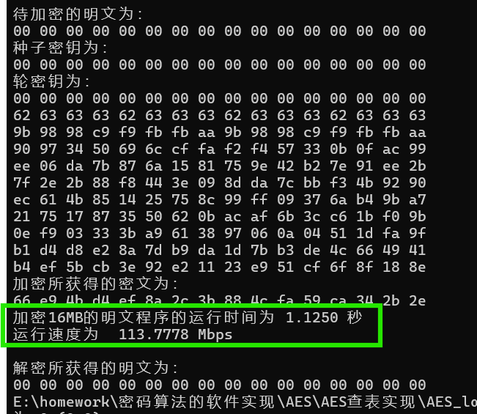

- 测试数据2
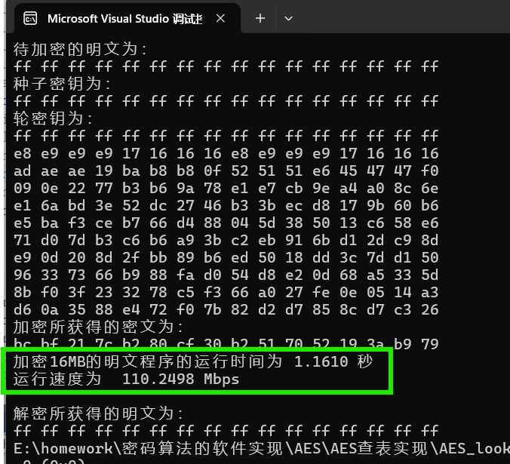

- 遇到的问题及解决办法
- memcpy(rk[0], key, sizeof(key))，没有把16字节key复制给rk[0];
这里的 key 是一个指针（uint8_t *key），在32位系统上 sizeof(key) 通常为4字节，在64位系统上通常为8字节，而不是16字节（key 所指向的数组的实际大小）。正确的做法是将这一行改为 memcpy(rk[0], key, 16);，以确保完整地复制16个字节的初始密钥到 rk[0]。
- 实现密钥扩展算法时，若定义轮常量为1字节，则只有一列的最上面的那个字节需要异或轮常量。
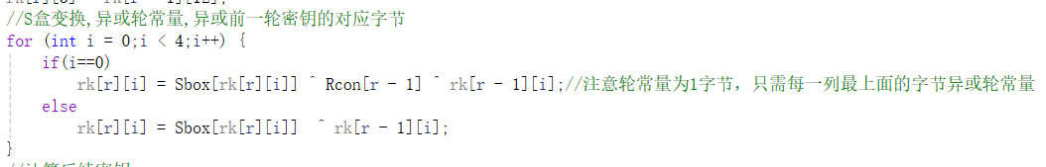
- 查表实现创建列混淆表时，注意每一列到高位放在32bit的低位，03x,x,x,02x为混淆矩阵第一列倒序,注意排在列上方的放右边。
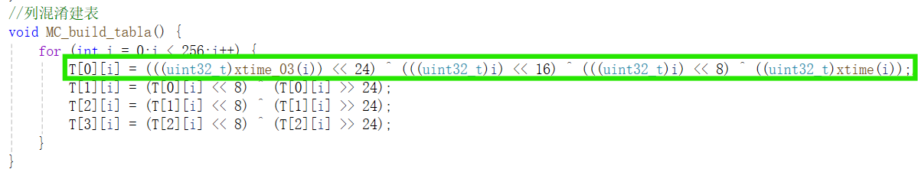

- 实验总结
本次实验我成功实现了AES密码算法，包括基于字节实现的算法和查表实现。实验中，详细编写了AES算法的关键组成部分，包括密钥扩展、轮函数（包括字节代换、行移位、列混淆和轮密钥加）以及解密过程。通过对比测试，验证了算法的正确性，确保了加密和解密操作能够正确执行。
在实验过程中，遇到了内存拷贝的问题，在处理指针和数组时要特别小心，确保正确地复制数据。此外，还通过构建查找表来减少计算复杂度，从而提高了算法的执行效率。
通过本次实验，我不仅加深了对AES算法工作原理的理解，而且提升了编程技能，特别是在处理密码学算法时的细节把握能力。

成绩：

批阅教师：————————
日 期：————————

