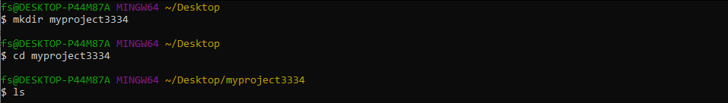

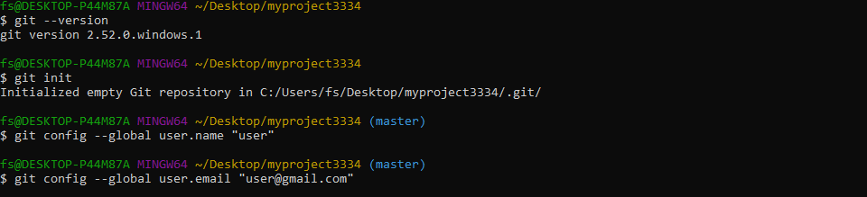

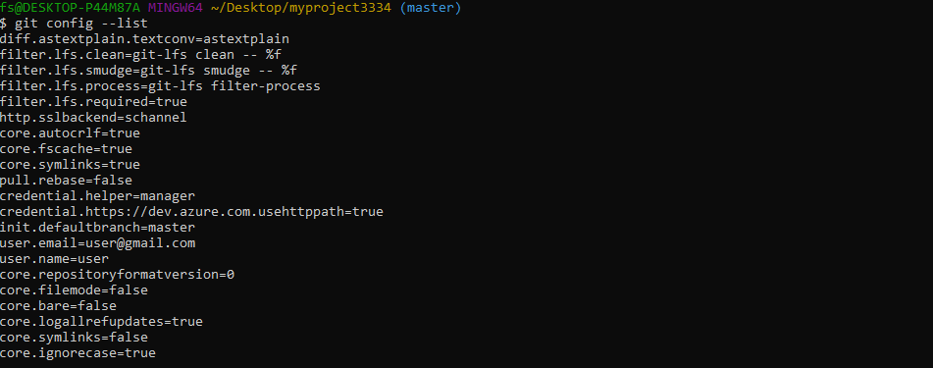

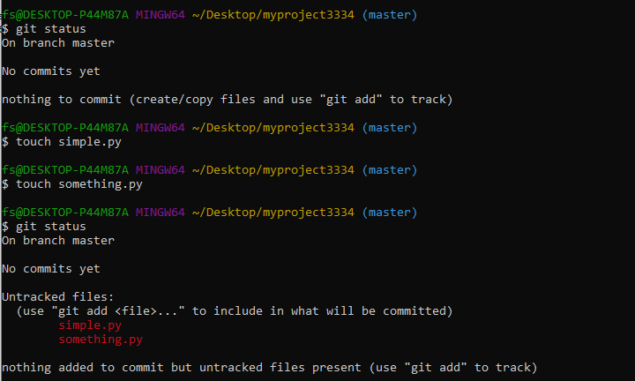

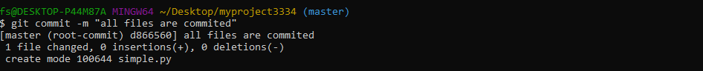

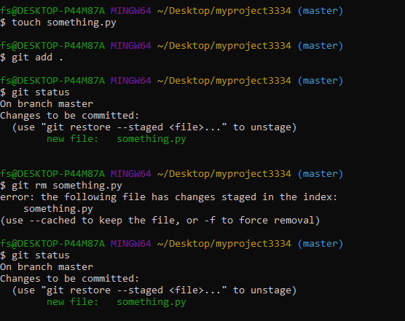

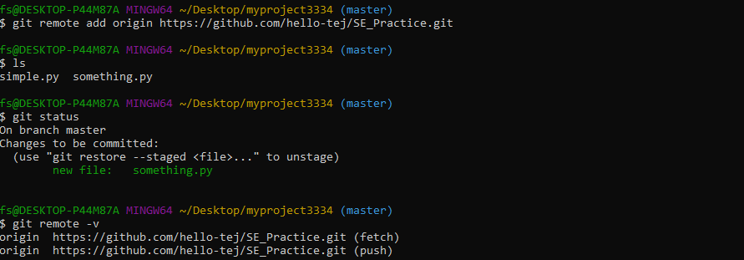
ERROR: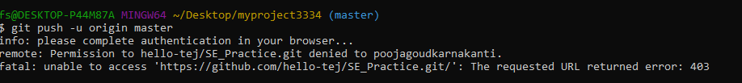
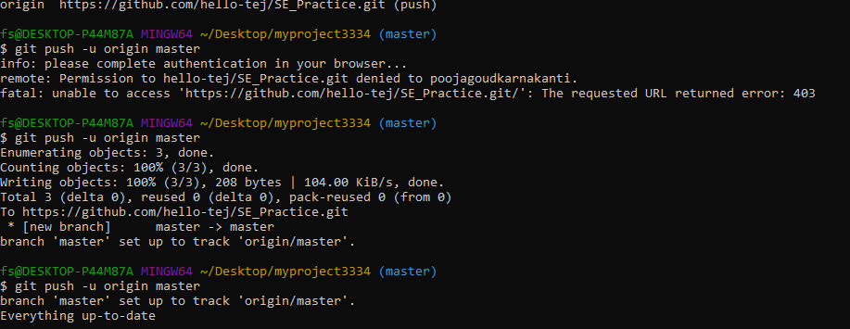

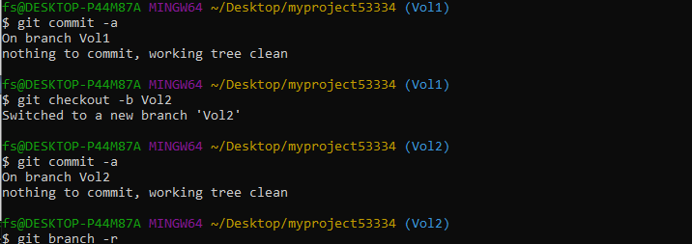

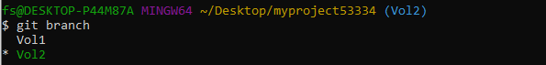

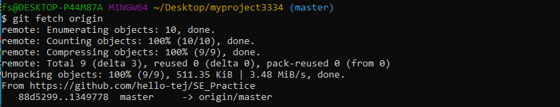
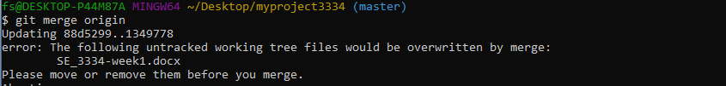

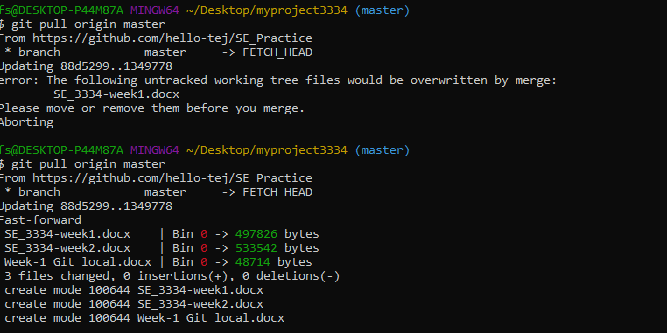

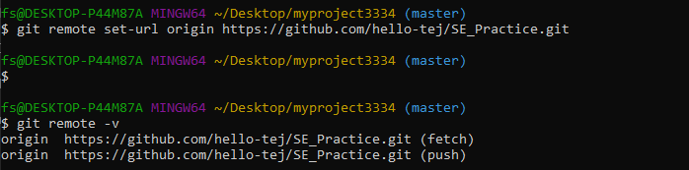

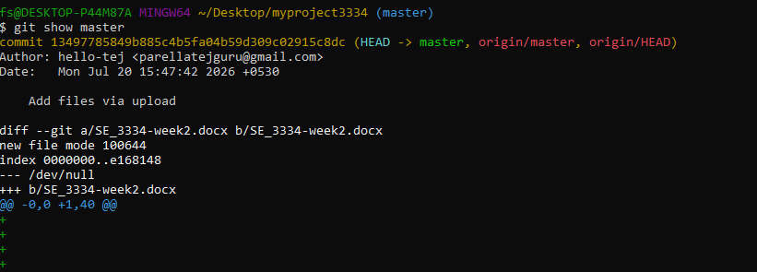

git remote prune origin

When someone deletes a branch on the remote, your local Git doesn’t automatically remove the corresponding remote-tracking branch (like origin/old-feature).
git remote prune origin removes these outdated references.

• Fetching a Specific Remote Branch: To fetch a specific branch from a remote.
git fetch <remote_name><branch_name>

git fetch origin feature-branch

• Setting the Upstream Branch for Pushing : When pushing for the first time and want to set the remote branch you are pushing to:

git push --set-upstream <remote_name><branch_name>

git push --set-upstream origin feature-branch

• git merge: Merges the specified branch into the current branch. This command integrates the changes from the feature branch into the main branch.
git checkout main # Switch to the main branch
git merge branch-name # Merge branch-name into main
• Rebasing a Local Branch onto a Remote Branch: If you want to rebase your local branch onto a remote branch (this can be useful to keep your history linear)
git fetch <remote_name>
git rebase <remote_name>/<branch_name>
Example:
git fetch origin
git rebase origin/main

5. Undoing Changes

• git reset :Removes the specified file from the staging area but leaves the working directory unchanged. git reset --hard can also reset the working directory and staging area to the last commit.
git reset <file>:
• git revert: Creates a new commit that undoes the changes from a specified commit, leaving the history intact.
git revert <commit>:
6. Viewing History

• git log: Shows a history of commits in the repository, including commit hashes, messages, and timestamps. Use git log --oneline for a more concise view.
git log:
• git diff: Displays differences between various commits, the working directory, and the staging area. git diff without arguments shows changes not yet staged.
git diff:
• git show: Shows the details of a specific commit, including the changes made and the commit message.
git show <commit>
7. To undo the changes made to file before staging it.

• git restore filename
8. To correct committed with the wrong message
• git commit --amend -m "Corrected commit message"

9. Recovering deleted branches

• git reflog
• git checkout -b feature-ui<commit_hash>

Give commands one after the other

Give definition and command for each
11. To remove accidentally committed sensitive file from Git history.

- git filter-branch --force --index-filter \
- "git rm --cached --ignore-unmatch secrets.txt" \
- --prune-empty --tag-name-filter cat -- --all

12. To merge changes from another branch
First switch to branch where changes are to appliedand then merge another-branch
- git checkout previous-branch
- git merge another-branch

13. To resolve a merge conflict manually
You tried to merge two branches and Git reported a conflict in x.js. Then for conflict resolution do:
- Open x.js and resolve/remove the conflict markers (<<<<<<<, =======, >>>>>>>)
- After resolving:
- git add app.js
- git commit # If Git didn’t auto-create a merge commit

14. The .gitignore
The .gitignore file is used to tell Git which files or directories to ignore in your project. It's a useful way to avoid committing unnecessary files like log files, build outputs, and IDE configurations.
  - Create a .gitignore File
In the root directory of your Git project, create a file called .gitignore
touch .gitignore
  - Add Rules to .gitignore
Inside the .gitignore file, you add patterns for the files and directories you want Git to ignore. Each pattern should be written on a new line.
Here are some common examples:
- Ignore all .log files:*.log
- Ignore a specific file:secret_file.txt
- Ignore all files in a temp/ directory:temp/
- Ignore all files except important_file.txt inside a folder:
folder/*
!folder/important_file.txt
- Ignore files with a specific extension:*.bak
15. To see who changed a particular line in a file
- git blame script.py

16. Git stash
# You modified files A and B, but not committed them.
git stash # saves changes and reverts to clean state
git switch another-branch
# do something else...
git switch main
git stash apply # brings back your changes
17. To check branch is merge
- git branch –merged

If branch not merged then displays its name

18. To Delete multiple local branches at once

- git branch –d branc1 branch2 branch3

Task 3:Students must explore all git commands on given scenario-based question.(Note student write command in observation book and paste the answer (git command) below each question for uploading).

