KURT FRANCIS O. CARPESO
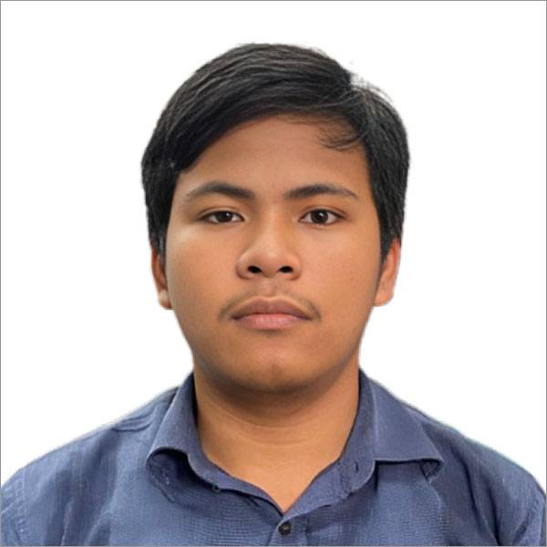
502 Area6-A Sitio Cabuyao Barangay Sauyo
Novaliches, Quezon City
0995 922 8310
franciscarpeso@gmail.com
______________________________________________________________________
PERSONAL INFORMATION
Date of Birth: June 10, 2005
Place of Birth: Quezon City
Citizenship: Filipino
Gender: Male
Civil Status: Single
Interest: Basic Python, Java, C#, MySQL , Oracle, and Cyber Security
______________________________________________________________________
EDUCATIONAL BACKGROUND
Primary: Sauyo Elementary School
Secondary: Sauyo Highschool
Tertiary: Quezon City University
Bachelor: Quezon City University (Information Technology)
______________________________________________________________________
PERSONAL QUALIFICATION
- Eager to build a strong foundation in MySQL and strengthen the security of the data of users.
- Quick to adapt to new tools and creative design.
- Have hands-on experience in MySQL and Oracle.
- Respectful and professional in team environments, and easy to associates to the team.
- Open to feedback and always ready to improve.
- Can work under pressure.

