实验五 单周期MIPS CPU设计

姓名：姜庆彩

学号：PB15051087

* 实验要求

设计CPU，完成以下程序代码的执行，其功能是起始数为3和3的斐波拉契数列的计算。只计算20个数。

.data

fibs: .word 0 : 20 # "array" of 20 words to contain fib values

size: .word 20 # size of "array"

temp: .word 3 3

.text

la $t0, fibs # load address of array

la $t5, size # load address of size variable

lw $t5, 0($t5) # load array size

la $t3, temp # load

lw $t3, 0($t3)

la $t4, temp

lw $t4, 4($t4)

sw $t3, 0($t0) # F[0] = $t3

sw $t4, 4($t0) # F[1] = $t4

addi $t1, $t5, -2 # Counter for loop, will execute (size-2) times

loop: lw $t3, 0($t0) # Get value from array F[n]

lw $t4, 4($t0) # Get value from array F[n+1]

add $t2, $t3, $t4 # $t2 = F[n] + F[n+1]

sw $t2, 8($t0) # Store F[n+2] = F[n] + F[n+1] in array

addi $t0, $t0, 4 # increment address of Fib. number source

addi $t1, $t1, -1 # decrement loop counter

bgtz $t1, loop # repeat if not finished yet.

out:

j out

* 实验结果：

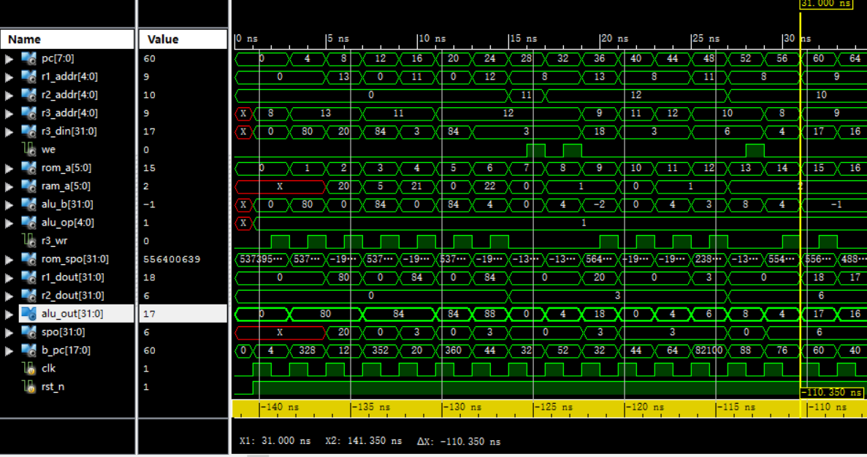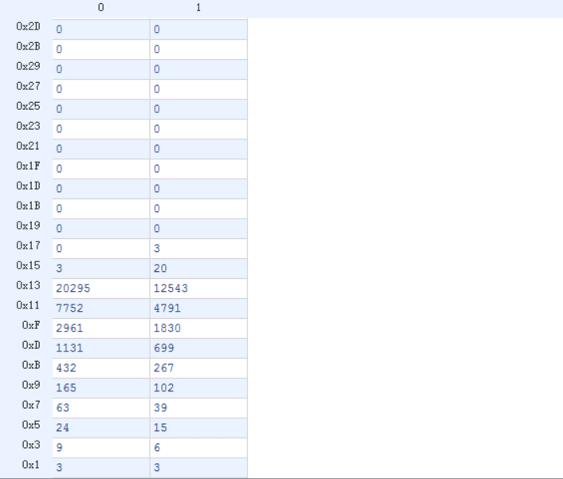

* 实验总结：

这次实验要求的是异步读取，一开始不知道可以使用DRAM实现，而是用了与前几次一样的双端口RAM，然后死活跑不出来，后来看了群里面的dalao发言才知道可以用DRAM，这样就变得比较简单了；由于是异步读取，前面设计的REGFILE模块也需要改成非时钟沿触发而是直接赋值；反而数据通路不是很复杂，简单的逻辑判断就可了。

* 源代码：

module alu(

input signed [31:0] alu_a,

input signed [31:0] alu_b,

input [4:0] alu_op,

output reg [31:0] alu_out

);

always@(*)

begin

case(alu_op)

1: alu_out <= alu_a + alu_b;

2: alu_out <= alu_a - alu_b;

3: alu_out <= alu_a & alu_b;

4: alu_out <= alu_a | alu_b;

5: alu_out <= alu_a ^ alu_b;

6: alu_out <= ~(alu_a | alu_b);

default:alu_out <= alu_out;

endcase

end

endmodule

module REG_FILE(

input clk,

input rst_n,

input [4:0] r1_addr,

input [4:0] r2_addr,

input [4:0] r3_addr,

input [31:0] r3_din,

input r3_wr,

output [31:0] r1_dout,

output [31:0] r2_dout

);

reg [31:0] register[0:31];

assign r1_dout=register[r1_addr];

assign r2_dout=register[r2_addr];

integer k;

always@(posedge clk or negedge rst_n)

begin

if(~rst_n)

begin

for(k=0;k<32;k=k+1)

register[k]=32'b0;

end

else if(r3_wr)

register[r3_addr]=r3_din;

end

endmodule

module control(

input clk,

input rst_n,

input [31:0] instruction,

input [31:0] spo,

input [31:0] r1_dout,

input [31:0] r2_dout,

input [31:0] alu_out,

output reg signed [7:0] pc,

output reg [4:0] r1_addr,

output reg [4:0] r2_addr,

output reg [4:0] r3_addr,

output reg [31:0] r3_din,

output reg we,

output reg [5:0] rom_a,

output reg [5:0] ram_a,

output reg [31:0] alu_b,

output reg [4:0] alu_op,

output reg r3_wr,

output reg signed [17:0] b_pc

);

reg flag;

reg signed [31:0] judge;

reg signed [17:0] offset;

reg signed [17:0] next_pc;

reg [27:0] j_pc;

always@(*)

begin

if(~rst_n) next_pc=0;

else if(flag==1) next_pc=pc+4;

offset=instruction[15:0]<<2;

b_pc=offset+next_pc;//branch

j_pc=instruction[25:0]<<2;//jump

end

always@(posedge clk or negedge rst_n)

begin

if(~rst_n)

begin

pc=7'b0;

flag=0;

end

else if(instruction[31:26]==6'b000010) pc=j_pc[7:0];

else if(instruction[31:26]==6'b000111&&judge>0) pc=b_pc[7:0];//bgzt

else

begin

pc=next_pc[7:0];

flag=1;

end

end

always@(*)

begin

rom_a=pc>>2;

end

always@(*)

begin

if(~rst_n)

begin

r3_wr=0;

we=0;

r1_addr=0;

r2_addr=0;

end

else if(instruction[31:26]==6'b001000) //addi

begin

if(instruction[15]==1)

alu_b={16'b11111_1111_1111_1111,instruction[15:0]};

else alu_b={16'b0000_0000_0000_0000,instruction[15:0]};

r1_addr=instruction[25:21];

r3_addr=instruction[20:16];

r3_din=alu_out;

alu_op=5'h01;

if(~clk) r3_wr=1;

else r3_wr=0;

end

else if(instruction[31:26]==6'b000000) //add

begin

r1_addr=instruction[25:21];

r2_addr=instruction[20:16];

r3_addr=instruction[15:11];

alu_b=r2_dout;

alu_op=5'h01;

r3_din=alu_out;

if(~clk) r3_wr=1;

else r3_wr=0;

end

else if(instruction[31:26]==6'b100011) //lw

begin

r1_addr=instruction[25:21];

alu_b={16'b0000_0000_0000_0000,instruction[15:0]};

alu_op=5'h01;

ram_a=alu_out[7:2];

r3_addr=instruction[20:16];

r3_din=spo;

if(~clk) r3_wr=1;

else r3_wr=0;

end

else if(instruction[31:26]==6'b101011) //sw

begin

r1_addr=instruction[25:21];

r2_addr=instruction[20:16];

alu_b={16'b0000_0000_0000_0000,instruction[15:0]};

ram_a=alu_out[7:2];

alu_op=5'h01;

r3_wr=0;

if(~clk) we=1;

else we=0;

end

else if(instruction[31:26]==6'b000111) //bgtz

begin

r1_addr=instruction[25:21];

judge=r1_dout;

end

end

endmodule

module top(

input clk,

input rst_n,

output signed [7:0] pc,

output [4:0] r1_addr,

output [4:0] r2_addr,

output [4:0] r3_addr,

output [31:0] r3_din,

output we,

output [5:0] rom_a,

output [5:0] ram_a,

output [31:0] alu_b,

output [4:0] alu_op,

output r3_wr,

output [31:0] rom_spo,

output [31:0] r1_dout,

output [31:0] r2_dout,

output [31:0] alu_out,

output [31:0] spo,

output [17:0] b_pc

);

REG_FILE uuu(

.clk(clk),

.rst_n(rst_n),

.r1_addr(r1_addr),

.r2_addr(r2_addr),

.r3_addr(r3_addr),

.r3_din(r3_din),

.r3_wr(r3_wr),

.r1_dout(r1_dout),

.r2_dout(r2_dout)

);

alu ttt(

.alu_a(r1_dout),

.alu_b(alu_b),

.alu_op(alu_op),

.alu_out(alu_out)

);

control uut(

.clk(clk),

.rst_n(rst_n),

.instruction(rom_spo),

.spo(spo),

.r1_dout(r1_dout),

.r2_dout(r2_dout),

.alu_out(alu_out),

.pc(pc),

.r1_addr(r1_addr),

.r2_addr(r2_addr),

.r3_addr(r3_addr),

.r3_din(r3_din),

.we(we),

.rom_a(rom_a),

.ram_a(ram_a),

.alu_b(alu_b),

.alu_op(alu_op),

.r3_wr(r3_wr),

.b_pc(b_pc)

);

myrom utu(

.a(rom_a),

.spo(rom_spo)

);

myram err(

.a(ram_a),

.d(r2_dout),

.clk(clk),

.we(we),

.spo(spo)

);