Digital Literacy Portfolio – Task 2

1. Overview
In today’s digital-first world, building a professional online presence is essential for students. As part of this task, I created profiles on GitHub, LinkedIn, and Kaggle to establish my digital identity and begin my professional journey.

2. Platforms Selected

GitHub
Purpose: Code hosting & project portfolio
Use: Storing projects, showcasing work

Kaggle
Purpose: Data science & ML practice
Use: Working on datasets and learning analytics

LinkedIn
Purpose: Professional networking
Use: Connecting with peers and professionals

3. Profile Highlights

GitHub Profile Snapshot
- Profile Overview
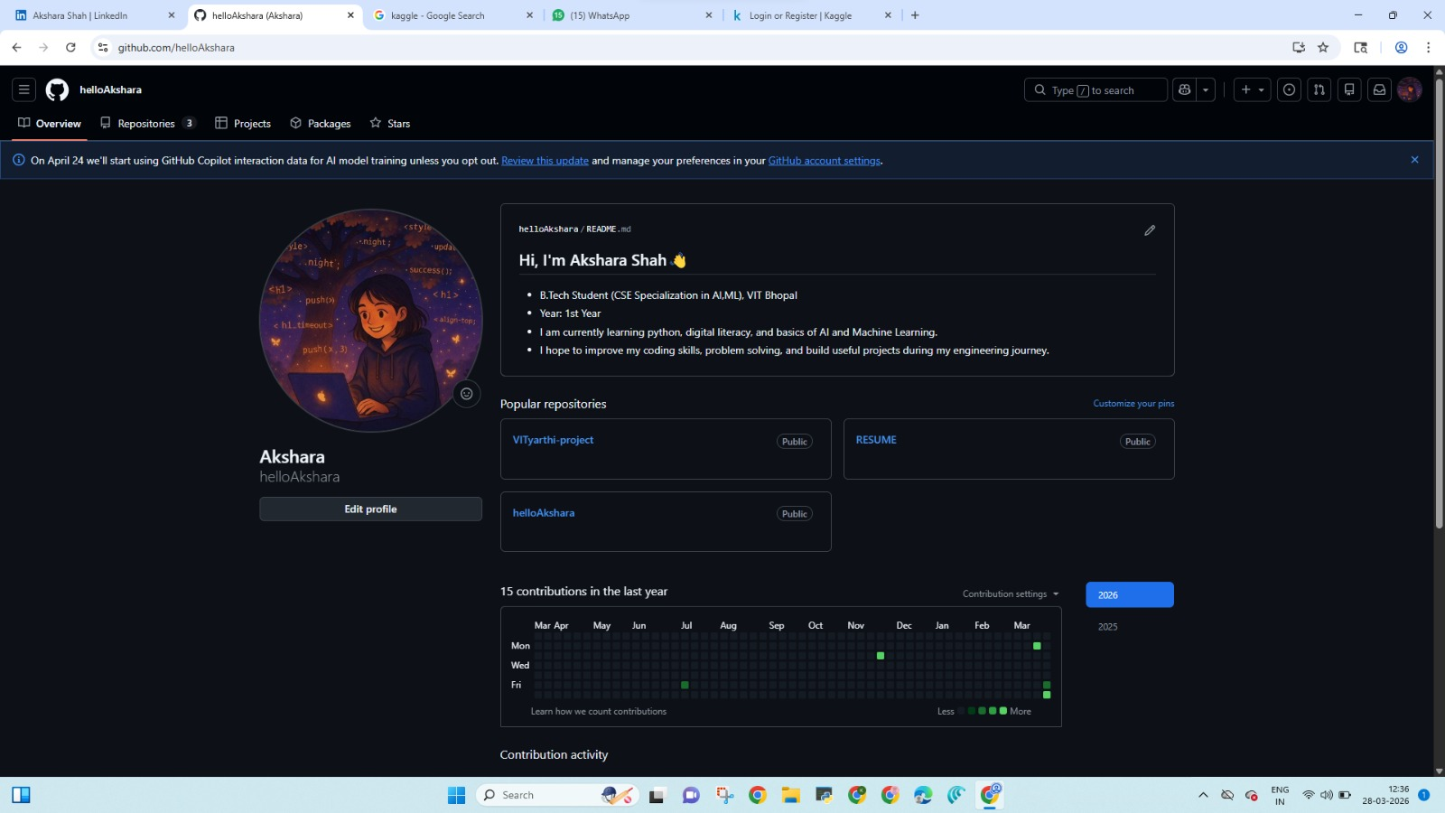

- Key Section Repository
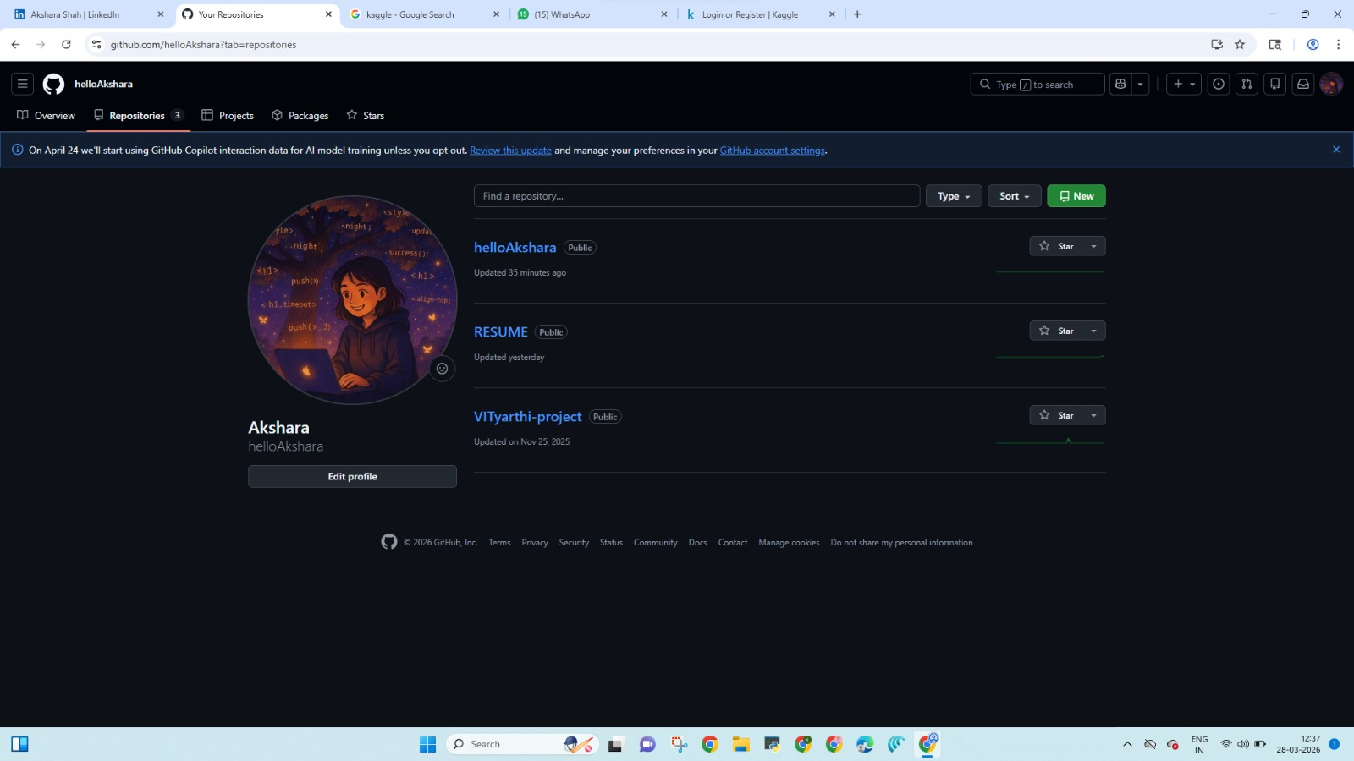
- README
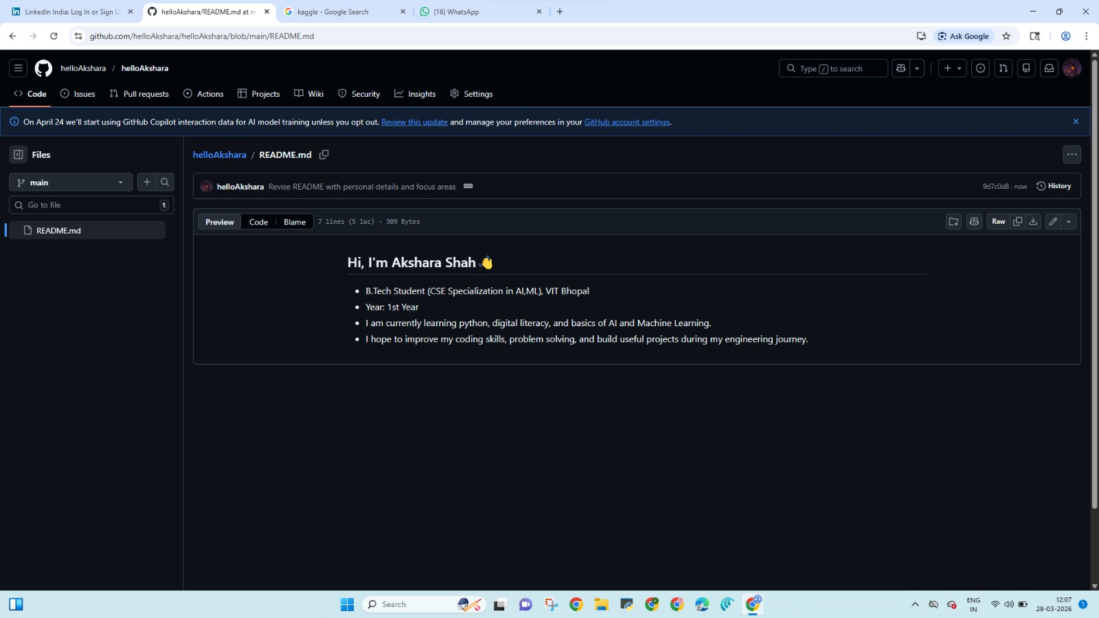

Kaggle Snapshot
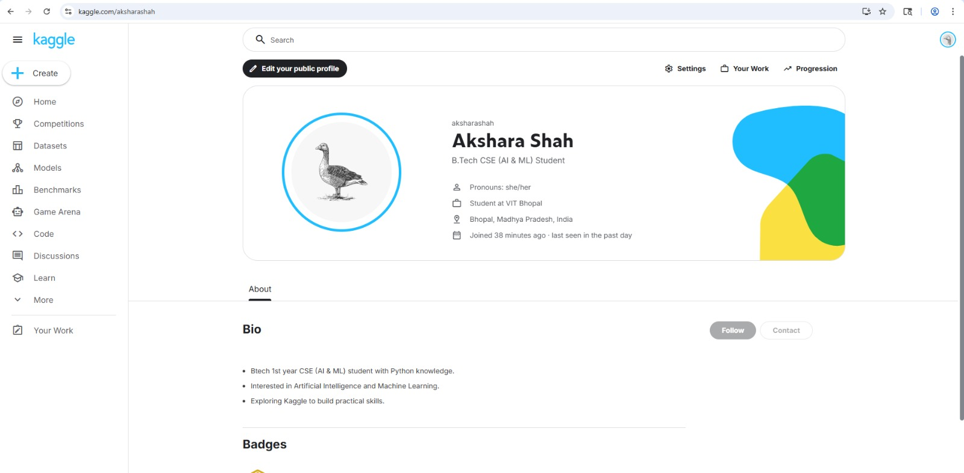

LinkedIn Snapshot
(Profile overview and educational section)
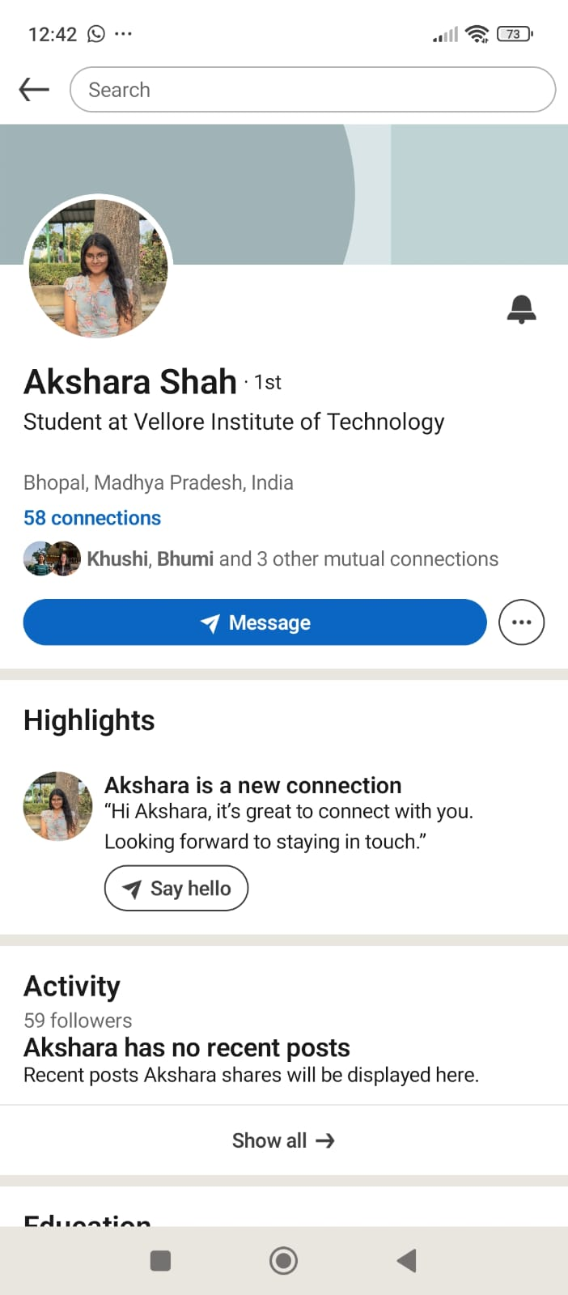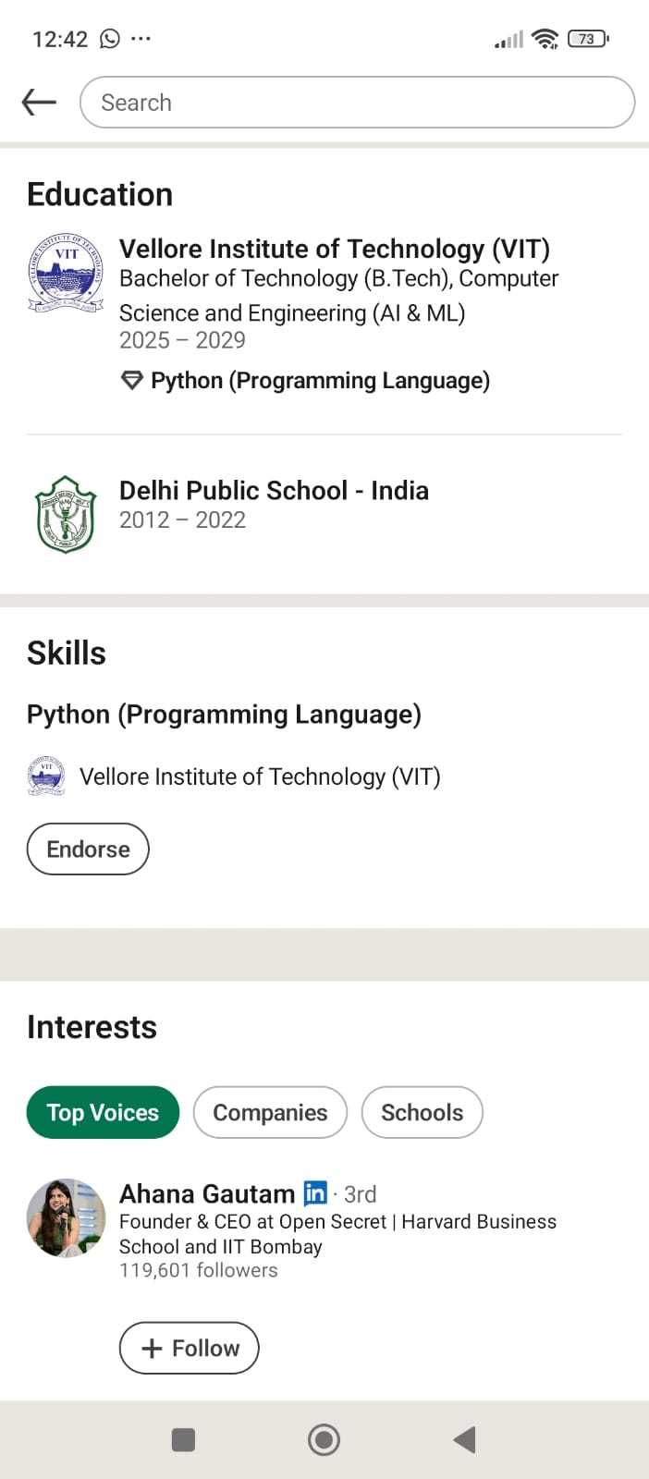

4. Reflection & Learning
For my students digital portfolio, I chose to build my presence on GitHub, LinkedIn, and Kaggle. GitHub is primarily used for storing code, collaborating on projects, and creating a public portfolio. I created a profile README that introduces my background, branch, and learning goals. LinkedIn serves as a professional networking platform where I added my B.Tech program at VIT Bhopal, along with my expected graduation year and a brief headline. This will help me connect with peers, seniors, and industry professionals. Kaggle is a platform for data science and machine learning practice, where I can work on datasets, build models, and improve my analytical skills.
Over the next four years, I plan to use GitHub to regularly upload my academic and personal projects, LinkedIn to expand my professional network and stay updated with industry trends, and Kaggle to practise data analysis and participate in competitions. Together, these platforms will help me build a strong digital presence and prepare for internships and future career opportunities.

5. Future Roadmap
Year | Focus Area | Platform Use
1st Year | Basics (Python, Git) | GitHub uploads
2nd Year | Projects | Kaggle datasets
3rd Year | Internships | LinkedIn networking
4th Year | Placement Prep | All platforms

