1. 安装RabbitMQ

1.erlang安装

wget https://packages.erlang-solutions.com/erlang-solutions-1.0-1.noarch.rpm

sudo rpm -Uvh erlang-solutions-1.0-1.noarch.rpm

sudo yum install erlang

2. RabbitMQ安装

wget http://www.rabbitmq.com/releases/rabbitmq-server/v3.6.6/rabbitmq-server-3.6.6-1.el7.noarch.rpm

yum install rabbitmq-server-3.6.6-1.el7.noarch.rpm

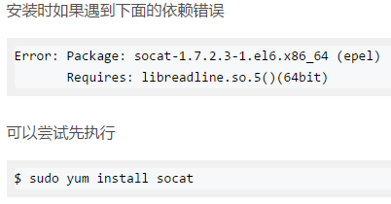

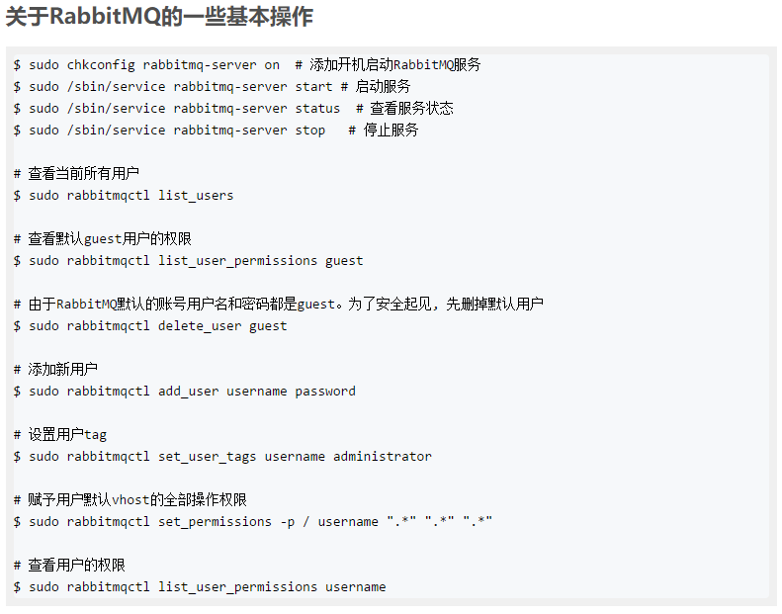

3.开启web管理接口

sudo rabbitmq-plugins enable rabbitmq_management

4.开放端口

1. /sbin/iptables -I INPUT -p tcp --dport 5672 -j ACCEPT
2. /sbin/iptables -I INPUT -p tcp --dport 15672 -j ACCEPT

5启动或关闭

service rabbitmq-server stop

service rabbitmq-server start