AI Health Monitoring System (Audio + RAG + LLM) - Advanced Guide

🧠 High-Level Flow Diagram
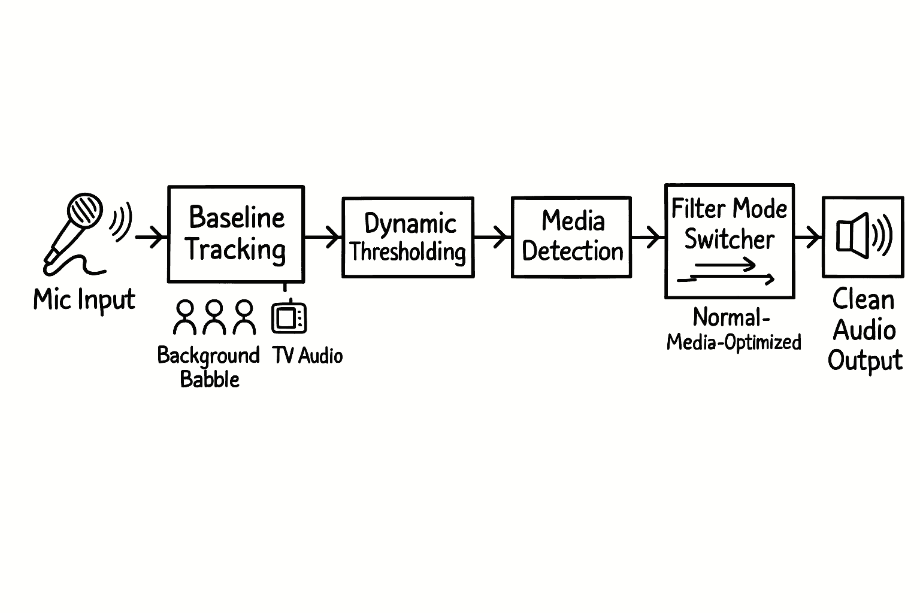



📊 Simple Text Flow (for your doc / presentation)
🎤 User Voice Input (Mic)
↓
🔊 Audio Recording (Streamlit Mic Recorder)
↓
🧠 Whisper Model (Speech → Text)
↓
📝 Transcribed Text
↓
🤖 OpenAI LLM (GPT Model)
↓
💡 AI Generated Answer
↓
🖥️ Display in Streamlit UI

🔁 Detailed Flow (Step-by-Step)
[User]
↓
🎤 Speak into microphone
↓
[Streamlit UI]
↓
🎧 Capture audio (bytes)
↓
[Whisper Model]
↓
🔤 Convert audio → text
↓
[Text Processing]
↓
🤖 Send to OpenAI API
↓
[LLM Reasoning]
↓
📄 Generate response
↓
[Streamlit UI]
↓
🖥️ Show:
- Transcription
- Answer

1. Required Installations
pip install streamlit streamlit-webrtc av openai-whisper faiss-cpu
langchain langchain-community langchain-text-splitters sentence-transformers soundfile

2. Microsoft Visual C++ (MANDATORY)
Download (x64):
https://aka.ms/vs/17/release/vc_redist.x64.exe
Install → Restart system

3. Azure Deployment Steps (Optional if you want to use that way)
1. Create Azure App Service
2. Enable Python runtime
3. Upload project (Git or ZIP)
4. Set environment variable:
OPENAI_API_KEY
5. Run:
streamlit run health_monitor.py --server.port 8000

4. LangGraph Workflow (Advanced)
Nodes:
- Audio Input
- Transcription
- Retrieval
- LLM Analysis
- Output
This enables retries, memory, and better orchestration.

