Registration Form

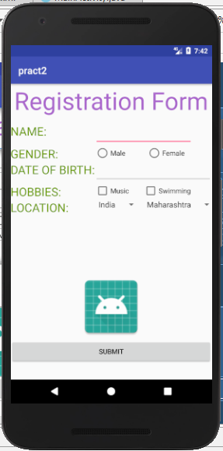 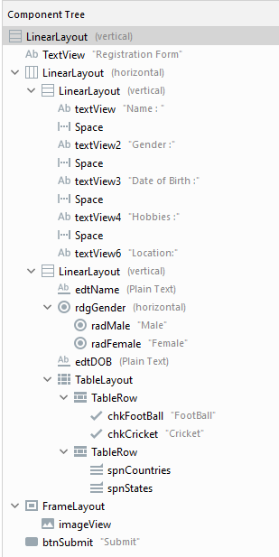

fun onSubmitClick(view: View?) {  
 val chkCricket = findViewById<CheckBox>(R.id.*chkCricket*)  
 val chkFootball = findViewById<CheckBox>(R.id.*chkFootBall*)  
 val radMale = findViewById<RadioButton>(R.id.*radMale*)  
 val radFemale = findViewById<RadioButton>(R.id.*radFemale*)  
 val edtName = findViewById<EditText>(R.id.*edtName*)  
 val edtDOB = findViewById<EditText>(R.id.*edtDOB*)  
 var strHobbies = ""  
 var strSalutation = ""  
 if (chkCricket.*isChecked*) strHobbies = "Cricket\n"  
 if (chkFootball.*isChecked*) strHobbies = "Football\n"  
 if (radMale.*isChecked*) strSalutation = "Mr."

if (radFemale.*isChecked*) strSalutation = "Ms."  
 Toast.makeText(  
 this, "Thank you for registration"+ strSalutation+edtName.*text*+"\nYour Date of Birth is"+edtDOB.*text*+  
 "\nYour Hobbies are"+strHobbies, Toast.*LENGTH_LONG*).show()  
 }  
}

Do the following practicals :- Practical 1A (Hello world application), 1B (Broadcast Receivers), 3A (activity Lifecycle), 6 (Sending data to another activity), Practical 8, 11, 12, 13, 14, 17,18