Computer Vision Journal
Name: Umayer Shaikh
SAP ID: 53021250026
Class: MSC. IT Part 1
Professor: Ms. Neha Vora

INDEX
Sr No. | Topic | Date | Sign
1. | Image Transformations using OpenCV  - Translation  - Rotation  - Scaling  - Shearing (Skewing)  - Affine Transformation  - Perspective Transformation
2. | Image Stitching
3. | Camera Calibration & Distortion Correction
4. | Object Detection and Recognition using OpenCV and Deep Learning

Practical 1
Aim:
To perform various transformations on an image such as translation, rotation, scaling, shearing, affine transformation, and perspective transformation using Python OpenCV.

Theory:
Geometric transformations change the position, orientation, size, or shape of an image by modifying pixel coordinates. OpenCV uses transformation matrices to perform these operations.
a. Translation
Shifts the image in X and Y directions without changing its shape or size
It moves every pixel by a certain amount in the X and Y directions.
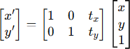

- tx: shift along X
- tyt_yty: shift along Y

b. Rotation
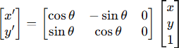
Rotates the image around a point (usually the center) by an angle θ\ theta θ.

  - θ positive → anticlockwise
  - θ\ theta θ negative → clockwise

c. Scaling
Enlarges or shrinks the image while keeping the shape proportional¹².
- sx > 1 → zoom in
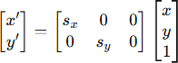
- sx < 1s_x < 1sx < 1 shrink

d. Shearing (Skewing)
Slants the image by shifting pixels proportional to their coordinates¹⁶.
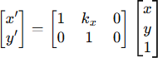
- X-Shear: Shifts horizontally depending on y.

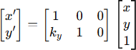
- Y-Shear: Shifts vertically depending on x.

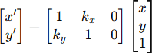
- General Shear: Shifts in both directions

e. Affine Transformation
A transformation that can include rotation, translation, scaling, and shearing
- Key Property: It preserves parallel lines but may change angles
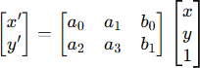
- Requirement: Requires 3 corresponding points to compute the matrix

f. Perspective Transformation (Projective)
Changes the viewpoint to give a 3D perspective effect
- Key Property: Straight lines remain straight, but parallel lines may converge
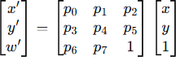
- Requirement: Requires 4 corresponding points to compute the matrix

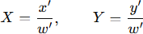
- Final pixel coordinates:

Code:
import cv2
import numpy as np
import matplotlib.pyplot as plt
# Load the image
image = cv2.imread('f8_tributo.jpg')
# Get image dimensions
height, width = image.shape[:2]
# Display original image
plt.figure(figsize=(6, 6))
plt.imshow(cv2.cvtColor(image, cv2.COLOR_BGR2RGB))
plt.title('original image')
plt.axis('off')
plt.show()

Output:

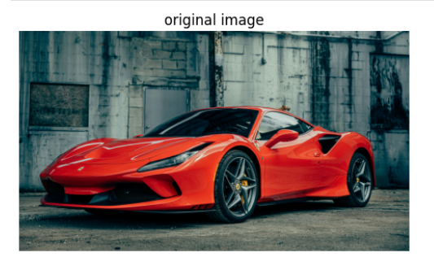

Code:
# Define the translation matrix
tx, ty = 250, 170
translation_matrix = np.float32([[1, 0, tx], [0, 1, ty]])
translated_image = cv2.warpAffine(image, translation_matrix, (width, height))
plt.figure(figsize=(6,6))
plt.imshow(cv2.cvtColor(translated_image, cv2.COLOR_BGR2RGB))
plt.title('Translated Image')
plt.axis('off')
plt.show()

Output:
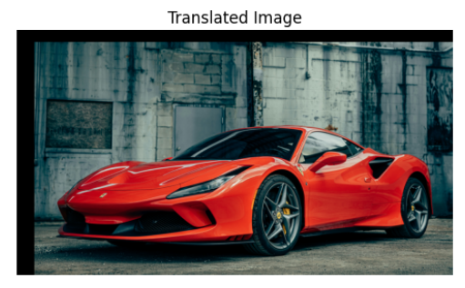

Code:
rotation_matrix = cv2.getRotationMatrix2D((width/2, height/2), 60, 1)
rotated_image = cv2.warpAffine(image, rotation_matrix, (width, height))

plt.figure(figsize=(6,6))
plt.imshow(cv2.cvtColor(rotated_image, cv2.COLOR_BGR2RGB))
plt.title('Rotated Image')
plt.axis('off')
plt.show()

Output:
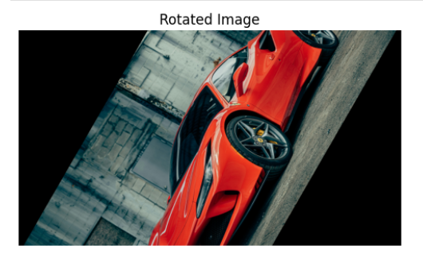
Code:
scaling_matrix = np.float32([[0.8, 0, 0], [0, 0.8, 0]])
scaled_image = cv2.warpAffine(image, scaling_matrix, (int(width*0.5), int(height*0.5)))
plt.figure(figsize=(6,6))
plt.imshow(cv2.cvtColor(scaled_image, cv2.COLOR_BGR2RGB))
plt.title('Scaled Image')
plt.axis('off')
plt.show()

Output:
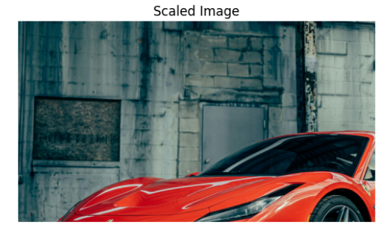

Code:
original_points = np.float32([[50,50], [200,50], [100,250]])
transformed_points = np.float32([[10,100], [200,50], [100,250]])
affine_matrix = cv2.getAffineTransform(original_points, transformed_points)
affine_transformed_image = cv2.warpAffine(image, affine_matrix, (width, height))
plt.figure(figsize = (4,10))
plt.imshow(cv2.cvtColor(affine_transformed_image, cv2.COLOR_BGR2RGB))
plt.title("Affine Transformed Image")
plt.axis("off")
plt.show()
Output:
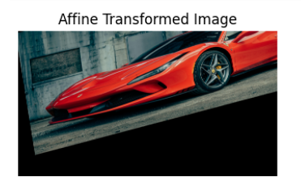
Code:
original_points = np.float32([[56,65], [368,52], [28,387], [389, 390]])
transformed_points = np.float32([[0,0], [50,0], [50,100], [50, 50]])
perspective_matrix = cv2.getPerspectiveTransform(original_points, transformed_points)
perspective_transformed_image = cv2.warpPerspective(image, perspective_matrix, (width, height))
plt.figure(figsize = (4,10))
plt.imshow(cv2.cvtColor(perspective_transformed_image, cv2.COLOR_BGR2RGB))
plt.title("Perspective Transformed Image")
plt.axis("off")
plt.show()

Output:
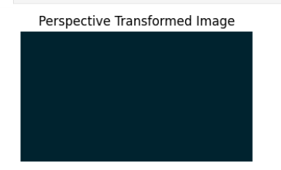

Practical 2
Aim:
To implement image stitching using OpenCV to combine two or more overlapping images into a single, seamless panoramic image by performing feature detection, matching, and perspective warping.

Theory:
Image stitching is the process of combining multiple photographic images with overlapping fields of view to produce a high-resolution panorama.² It involves several key computer vision stages:
1. Feature Detection and Description
The first step is to find "interest points" (corners or edges) that are unique in both images.
2. Feature Matching
Once features are found, the computer looks for pairs of points that look the same in both images. This is typically done using a Brute-Force Matcher or FLANN (Fast Library for Approximate Nearest Neighbors).
3. Homography Estimation
A Homography Matrix (H) is a 3 X 3 matrix that maps the points from one image's perspective to another. To filter out "bad" matches (outliers), the RANSAC (Random Sample Consensus) algorithm is used to find the most mathematically consistent transformation.
4. Image Warping and Blending
The final step is to "warp" one image using the Homography matrix so it aligns perfectly with the first image.
- Warping: Uses cv2.warpPerspective().
- Blending: Adjusts the brightness/edges where the two images meet to hide the "seam" and make it look like one continuous photo.

Code:
import cv2
import numpy as np
import matplotlib.pyplot as plt
# --- LOAD IMAGES ---
# Load right image (image to be warped) and convert to grayscale
img_right_color = cv2.imread('Part2.png')
if img_right_color is None:
raise FileNotFoundError("Error: /content/sample_data/right11.png not found. Please ensure the file exists.")
img1 = cv2.cvtColor(img_right_color, cv2.COLOR_BGR2GRAY) # Convert to grayscale for SIFT
# Load left image (base image) and convert to grayscale
img_left_color = cv2.imread('Part1.png')
if img_left_color is None:
raise FileNotFoundError("Error: /content/sample_data/left11.png not found. Please ensure the file exists.")
img2 = cv2.cvtColor(img_left_color, cv2.COLOR_BGR2GRAY) # Convert to grayscale for SIFT
# --- FEATURE DETECTION ---
# SIFT detects keypoints and computes descriptors that represent texture patterns
# Initialize SIFT detector
sift = cv2.SIFT_create()
# Compute keypoints and descriptors for both images
kp1, des1 = sift.detectAndCompute(img1, None) # For right image
kp2, des2 = sift.detectAndCompute(img2, None) # For left image
# --- FEATURE MATCHING ---
# Using BFMatcher (Brute Force Matcher) with L2 distance measurement for SIFT
bf = cv2.BFMatcher(cv2.NORM_L2, crossCheck=False)
# KNN Match: For every descriptor from img1, find two best matches in img2
matches = bf.knnMatch(des1, des2, k=2)
# --- RATIO TEST ---
# Lowe's Ratio Test removes poor matches
good = []
for m, n in matches:
if m.distance < 0.75 * n.distance:
good.append(m)
# At least 4 matches are needed for homography
if len(good) > 4:
# --- POINT EXTRACTION ---
# Extract matching points from both images
src_pts = np.float32([kp1[m.queryIdx].pt for m in good]).reshape(-1, 1, 2)
dst_pts = np.float32([kp2[m.trainIdx].pt for m in good]).reshape(-1, 1, 2)
# Find Homography matrix
# method = cv2.RANSAC -> rejects outlier matches
# ransacReprojThreshold = max allowed distance (in pixels)
H, status = cv2.findHomography(src_pts, dst_pts, cv2.RANSAC, 5.0)
# --- IMAGE WARPING ---
# Calculate output_size based on dimensions of both original color images
# Output width = sum of widths of both images; height stays same as left image
output_size = (img_left_color.shape[1] + img_right_color.shape[1], img_left_color.shape[0])
# Warp the right image onto the coordinate system of the left image
dst = cv2.warpPerspective(img_right_color, H, output_size)
# Convert warped image to RGB for displaying using matplotlib
dst_rgb = cv2.cvtColor(dst, cv2.COLOR_BGR2RGB)
# --- SHOW WARPED IMAGE ---
plt.subplot(122)
plt.imshow(dst_rgb)
plt.title('Warped Image')
plt.show()
# --- STITCHING ---
# Place left image on the stitched canvas
# This replaces the left portion of the warped image with the Left image
dst[0:img_left_color.shape[0], 0:img_left_color.shape[1]] = img_left_color
# Convert the final stitched image to RGB for display
combined_rgb = cv2.cvtColor(dst, cv2.COLOR_BGR2RGB)
# Save the stitched image in BGR format (OpenCV default)
cv2.imwrite('output.jpg', dst)
# Display the final stitched image
plt.imshow(combined_rgb)
plt.title('Stitched Image')
plt.show()
else:
raise AssertionError(f"Not enough matches found - {len(good)}/4")

Output:
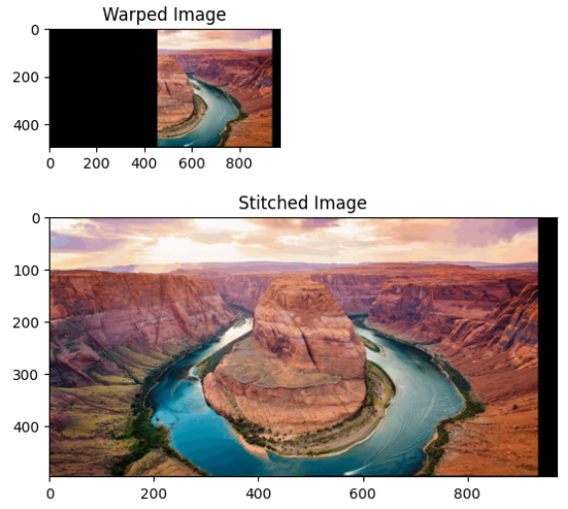
Practical 3
Aim:
To estimate the intrinsic and extrinsic parameters of a camera using a chessboard pattern and to use these parameters to correct lens distortion in captured images.

Theory:
Cameras don't capture perfectly "flat" images; lenses (especially cheap or wide-angle ones) introduce distortions. Calibration is the process of mathematically modeling the camera's lens to fix these errors.
1. Why use a Chessboard?
A chessboard is a "calibration rig." Because it consists of flat, alternating black and white squares, its geometric properties are known.
- The computer knows that the lines should be perfectly straight and the corners should be equidistant.
- By seeing how these lines "bend" in a photo, the computer can calculate exactly how the lens is distorting the world.
2. Types of Distortion
- Radial Distortion: This makes straight lines look curved. It is most visible at the edges of the image (e.g., Barrel Distortion where lines bulge outward).
- Tangential Distortion: This occurs when the lens is not perfectly parallel to the imaging sensor, making some parts of the image look closer than they actually are.
3. Key Parameters Calculated
- Intrinsic Parameters (K): These are internal to the camera. They include the Focal Length (fx, fy) and the Optical Center (cx, cy).
- Extrinsic Parameters: These describe the camera's position in the 3D world (Rotation and Translation).
- Distortion Coefficients (k1, k2, p1, p2, k3): The specific numbers used to "un-stretch" the pixels.

4. The Process
- Find Corners: cv2.findChessboardCorners() locates the internal corners.
- Refine Corners: cv2.cornerSubPix() improves accuracy to a fraction of a pixel.
- Calibrate: cv2.calibrateCamera() solves the math to find the Intrinsic and Distortion matrices.
- Undistort: cv2.undistort() applies the math to a new image to make the curved lines straight.

Code:
import numpy as np
import cv2
import glob
import matplotlib.pyplot as plt
# --- Step 1: Termination Criteria ---
# Define criteria for corner refinement (sub-pixel accuracy)
criteria = (cv2.TERM_CRITERIA_EPS + cv2.TERM_CRITERIA_MAX_ITER, 30, 0.001)
# --- Updated Step 2: Prepare Object Points ---
# The OpenCV sample images have 10x7 squares, which means 9x6 internal corners
objp = np.zeros((6 * 9, 3), np.float32)
objp[:, :2] = np.mgrid[0:9, 0:6].T.reshape(-1, 2)
# Arrays to store points from all calibration images
objpoints = [] # 3D points in real world space
imgpoints = [] # 2D points in image plane

# --- Step 3: List of Calibration Images ---
# Ensure these image files exist in your working directory
calibration_images = [
'left01.jpg',
'left02.jpg',
'left03.jpg',
'left04.jpg',
'left05.jpg',
'left06.jpg',
'left07.jpg',
'left09.jpg',
'left10.jpg',
'left11.jpg',
'left12.jpg',
'left13.jpg',
'left14.jpg'
]
# --- Updated Step 4: Detect Chessboard Corners ---
for fname in calibration_images:
img = cv2.imread(fname)
if img is None: continue
gray = cv2.cvtColor(img, cv2.COLOR_BGR2GRAY)

# CHANGE (7, 5) TO (9, 6) HERE
ret, corners = cv2.findChessboardCorners(gray, (9, 6), None)
if ret == True:
objpoints.append(objp)
corners2 = cv2.cornerSubPix(gray, corners, (11, 11), (-1, -1), criteria)
imgpoints.append(corners2)
# --- Step 5: Calibrate the Camera ---
# Using all pairs of 3D and 2D points to calculate camera parameters
ret, mtx, dist, rvecs, tvecs = cv2.calibrateCamera(objpoints, imgpoints, gray.shape[::-1], None, None)
print("Camera Matrix (mtx):\n", mtx)
print("\nDistortion Coefficients (dist):\n", dist)
# --- Step 6: Undistort an Image ---
# Read one image to apply undistortion
img = cv2.imread(calibration_images[0])
h, w = img.shape[:2]
# Compute new optimal camera matrix to reduce black edges
newcameramtx, roi = cv2.getOptimalNewCameraMatrix(mtx, dist, (w, h), 1, (w, h))
# Undistort the image
dst = cv2.undistort(img, mtx, dist, None, newcameramtx)
# --- Step 7: Crop the Result ---
# x, y, w, h from roi removes black borders from undistortion
x, y, w, h = roi
dst = dst[y:y+h, x:x+w]
# --- Step 8: Display Results ---
fig, ax = plt.subplots(1, 2, figsize=(10, 5))
# Original image (distorted)
ax[0].imshow(cv2.cvtColor(img, cv2.COLOR_BGR2RGB))
ax[0].set_title('Original Image')
ax[0].axis('off')
# Undistorted image (corrected)
ax[1].imshow(cv2.cvtColor(dst, cv2.COLOR_BGR2RGB))
ax[1].set_title('Undistorted Image')
ax[1].axis('off')
plt.show()

Output:
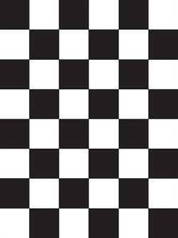

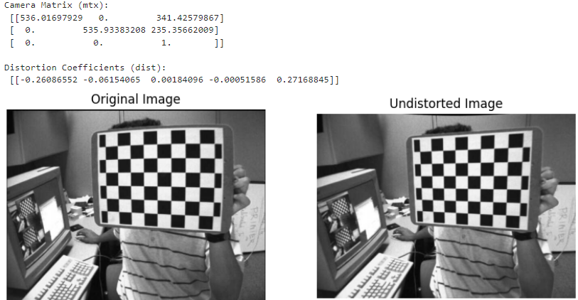

Practical 4
Aim:
To perform the following computer vision tasks using OpenCV and Deep Learning:
1. Face Detection
2. Object Detection
3. Pedestrian Detection
4. Face Recognition

Theory:
Computer Vision is a rapidly evolving field that enables machines to interpret and make decisions based on visual data. It involves multiple sub-tasks such as detection, classification, and recognition, used in real-world applications like autonomous vehicles, security systems, and robotics.
a. Face Detection
Face detection identifies and locates human faces in digital images or videos.
Techniques:
• Haar Cascades: Uses machine learning to detect features like eyes, nose, and mouth.
• HOG (Histogram of Oriented Gradients): Describes local shape information by capturing
gradient orientation.
Applications: Security systems, social media tagging, human-computer interaction.
b. Object Detection
Object detection identifies multiple objects within an image or video and marks their locations using bounding boxes.
Techniques:
• YOLO (You Only Look Once): Real-time object detection using a single neural network.
• SSD (Single Shot Multibox Detector): Detects multiple objects in one forward pass.
Applications: Autonomous vehicles, robotics, retail analytics.
c. Pedestrian Detection
Pedestrian detection focuses on identifying human figures in images or video streams.
Techniques:
• HOG + SVM: Traditional approach combining feature extraction and classification.
• CNNs (Deep Learning): Modern methods for accurate real-time detection.
Applications: Autonomous driving, surveillance, and smart city systems.
d. Face Recognition
Face recognition identifies or verifies a person’s identity using facial features.
Techniques:
• DeepFace, FaceNet: Deep learning models mapping faces into a feature space for
comparison.
• Dlib, OpenCV, TensorFlow: Libraries and frameworks for model training and recognition.
Applications: Access control, mobile authentication, and personalization.

Common Tools and Libraries
Library | Description
Open CV | Image/ Video processing library
Dlib | Facial recognition and machine learning toolkit
TensorFlow/ PyTorch | Deep learning frameworks
Matplotlib | Visualization and plotting

PART 4A:
Face Detection
Algorithm:
1. Load Haar Cascade face detection model.
2. Capture a frame from the webcam.
3. Convert the frame to grayscale.
4. Detect faces using detectMultiScale().
5. Draw rectangles around detected faces.
6. Display the output using Matplotlib.
7. Release the camera resource

Code:
import cv2
import matplotlib.pyplot as plt
# 1. Load the Pre-trained Classifier
face_cascade = cv2.CascadeClassifier(cv2.data.haarcascades + 'haarcascade_frontalface_default.xml')

# 2. Access the Camera
cap = cv2.VideoCapture(0)

# Check if the webcam is actually accessible
if not cap.isOpened():
print("Error: Could not open webcam. Check if another app is using it.")
else:
# --- FIX 1: Camera Warm-up ---
# We read a few frames to let the camera sensor adjust its brightness/exposure
for _ in range(10):
cap.read()

# 3. Capture a Single Frame
ret, frame = cap.read()

if ret:
# 4. Process the Captured Frame
gray = cv2.cvtColor(frame, cv2.COLOR_BGR2GRAY)

# Detect Faces
faces = face_cascade.detectMultiScale(
gray,
scaleFactor=1.1,
minNeighbors=5,
minSize=(30, 30)
)

# 5. Draw Bounding Boxes
for (x, y, w, h) in faces:
cv2.rectangle(frame, (x, y), (x + w, y + h), (0, 255, 0), 2)

# 6. Display the Result
# Convert BGR (OpenCV default) to RGB (Matplotlib default)
img_rgb = cv2.cvtColor(frame, cv2.COLOR_BGR2RGB)

plt.figure(figsize=(10, 6)) # Make the display window larger
plt.imshow(img_rgb)
plt.title(f'Detected Faces: {len(faces)}')
plt.axis('off')
plt.show()

print('Number of faces detected:', len(faces))
else:
print("Error: Failed to capture image.")

# 7. Release the Camera Resource
cap.release()

print("Umayer Shaikh")

Output:
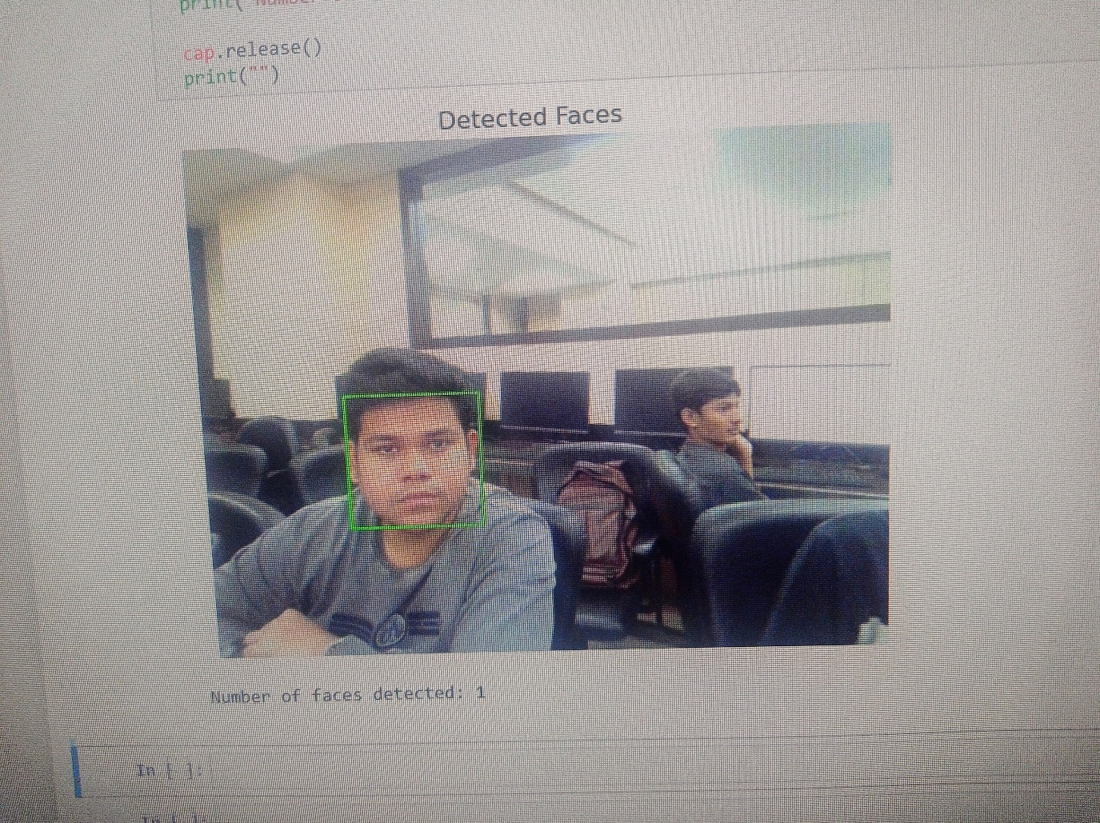

PART 4B:
Object Detection
Algorithm:
1. Load YOLO configuration, weights, and class names.
2. Read the input image.
3. Convert it into a blob and feed into the YOLO network.
4. Extract detections from the output layers.
5. Draw bounding boxes around detected objects.
6. Display the output using Matplotlib.

Code:
import cv2
import numpy as np
import matplotlib.pyplot as plt
import argparse
import os
# 1. Setup Arguments (Ensure files exist!)
args = argparse.Namespace(
image = "dog.jpg", # Replace with your image name
config = "yolov3.cfg",
weights = "yolov3.weights",
classes = "yolov3.txt"
)
# Check if files exist to prevent cryptic errors
for f in [args.config, args.weights, args.classes]:
if not os.path.isfile(f):
print(f"Error: {f} not found! Please download it.")
# 2. Load Class Labels
with open(args.classes, 'r') as f:
classes = [line.strip() for line in f.readlines()]

COLORS = np.random.uniform(0, 255, size=(len(classes), 3))
# 3. Load YOLO Model
net = cv2.dnn.readNet(args.weights, args.config)
# 4. Read and Process Image
image = cv2.imread(args.image)
if image is None:
print("Error: Image not found.")
else:
Height, Width = image.shape[:2]

# Pre-process for YOLO (416x416)
blob = cv2.dnn.blobFromImage(image, 1/255.0, (416, 416), (0,0,0), True, crop=False)
net.setInput(blob)

# Get Output Layers
layer_names = net.getLayerNames()
output_layers = [layer_names[i - 1] for i in net.getUnconnectedOutLayers()]

# Run Forward Pass
outs = net.forward(output_layers)

# 5. Parse Detections
class_ids, confidences, boxes = [], [], []

for out in outs:
for detection in out:
scores = detection[5:]
class_id = np.argmax(scores)
confidence = scores[class_id]

if confidence > 0.5:
# Scale coordinates back to original image size
center_x = int(detection[0] * Width)
center_y = int(detection[1] * Height)
w = int(detection[2] * Width)
h = int(detection[3] * Height)
# FIX: Must be integers for OpenCV drawing functions
x = int(center_x - w / 2)
y = int(center_y - h / 2)
boxes.append([x, y, w, h])
confidences.append(float(confidence))
class_ids.append(class_id)
# 6. Non-Maximum Suppression
indices = cv2.dnn.NMSBoxes(boxes, confidences, 0.5, 0.4)
# 7. Draw Results
if len(indices) > 0:
for i in indices.flatten(): # .flatten() handles different CV2 versions
x, y, w, h = boxes[i]
label = str(classes[class_ids[i]])
color = COLORS[class_ids[i]]
cv2.rectangle(image, (x, y), (x + w, y + h), color, 2)
cv2.putText(image, f"{label} {confidences[i]:.2f}", (x, y - 10),
cv2.FONT_HERSHEY_SIMPLEX, 0.5, color, 2)
# 8. Display with Matplotlib
plt.figure(figsize=(10,10))
plt.imshow(cv2.cvtColor(image, cv2.COLOR_BGR2RGB))
plt.axis('off')
plt.show()
print("Execution Finished")

Output:
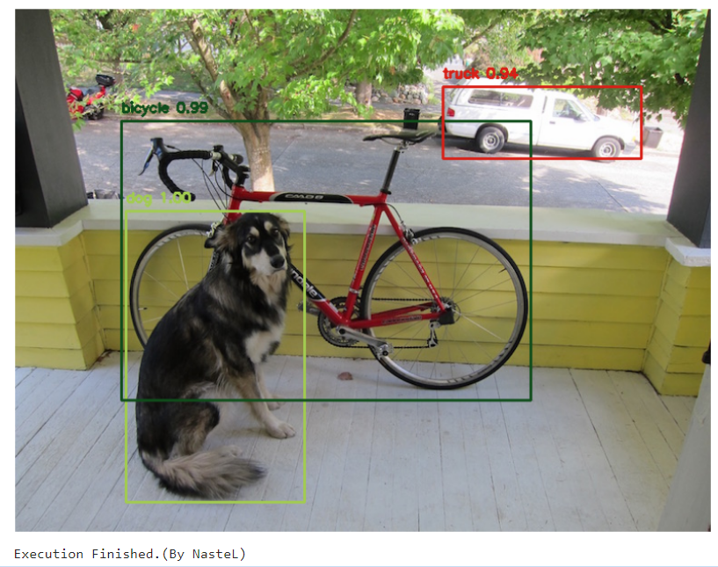

PART C:
Pedestrian Detection
Algorithm:
1. Load the pre-trained pedestrian detection cascade model.
2. Read a video file.
3. Convert each frame to grayscale.
4. Detect pedestrians using detectMultiScale().
5. Draw rectangles around detected pedestrians.
6. Display output frames sequentially.

Code:
# -------------------------------------------------
# Program : Pedestrian Detection using Haar Cascade Classifier
# -------------------------------------------------
# ---------- 1. Import Required Libraries ----------
import cv2 # OpenCV for video processing and object
detection
import matplotlib.pyplot as plt # To display each processed frame as an image
# ---------- 2. Load Pre-trained Haar Cascade Model ----------
# OpenCV includes pre-trained XML files for detecting full human bodies.
# 'haarcascade_fullbody.xml' detects pedestrians (standing or walking).
pedestrian_cascade = cv2.CascadeClassifier(
cv2.data.haarcascades + 'haarcascade_fullbody.xml'
)
# ---------- 3. Load the Input Video ----------
# You can use any video that has people walking.
# The video may contain traffic, street footage, etc.
video_path = 'traffic.mp4'
# cv2.VideoCapture() opens the video file for frame-by-frame reading.
cap = cv2.VideoCapture(video_path)
# ---------- 4. Check if Video Opened Successfully ----------
if not cap.isOpened(): # Returns False if video not found or
unreadable
print('Error: Unable to open the video')
exit()
# ---------- 5. Read Frames Continuously ----------
# The loop will continue reading frames until the video ends.
while True:
ret, frame = cap.read() # ret=True if a frame was read
successfully
if not ret: # When ret=False, video has ended
break
# ---------- 6. Convert Frame to Grayscale ----------
# Haar Cascades work on pixel intensity changes (edges),
# not on color, so grayscale simplifies computation.
gray_frame = cv2.cvtColor(frame, cv2.COLOR_BGR2GRAY)
# ---------- 7. Detect Pedestrians ----------
# detectMultiScale() scans the frame for full-body patterns.
# Parameters:
# 1. gray_frame : Input grayscale image.
# 2. scaleFactor=1.1: Specifies how much the image size is reduced at
each scale.
# Smaller → more detailed, slower; larger → faster,
less accurate.
# 3. minNeighbors=8 : Higher value reduces false positives.
# 4. minSize=(20,20): Ignores objects smaller than 20×20 pixels.
pedestrians = pedestrian_cascade.detectMultiScale(
gray_frame,
scaleFactor=1.1,
minNeighbors=8,
minSize=(20, 20)
)
# ---------- 8. Draw Bounding Boxes ----------
# The method returns rectangles (x, y, w, h) for each detected person.
# We draw green boxes for all pedestrians found.
for (x, y, w, h) in pedestrians:
cv2.rectangle(frame, (x, y), (x + w, y + h), (0, 255, 0), 2)
# You can also display confidence text if the model provides it.
# For Haar cascades, confidence is not returned, only positions.
# ---------- 9. Display Each Processed Frame ----------
# Convert color from BGR (OpenCV default) to RGB for displaying via
Matplotlib.
plt.imshow(cv2.cvtColor(frame, cv2.COLOR_BGR2RGB))
plt.title("Pedestrian Detection")
plt.axis('off') # Hide axis for cleaner view
plt.show() # Show one processed frame at a time
# ---------- 10. Release the Video Resource ----------
cap.release() # Frees the video capture object
# ---------- 11. End Message ----------
print("Program Executed Successfully – ")

Output:
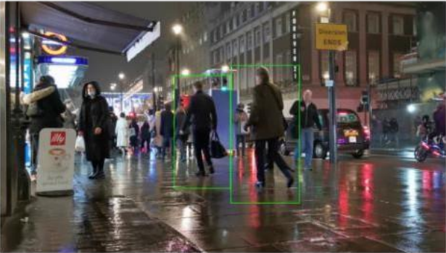

PART D:
Face Recognition
Algorithm:
1. Load the known face image and encode it.
2. Load the unknown image to identify faces.
3. Detect all face locations in the unknown image.
4. Compare each face with the known encoding.
5. Draw rectangles around detected faces and label them as “Known” or “Unknown.

Code:
import face_recognition
import matplotlib.pyplot as plt
from matplotlib.patches import Rectangle
import os
# --- 1. SET FILENAMES ---
# Make sure these files are in the same folder as this script
known_file = "umayer.jpeg"
unknown_file = "unknown.jpeg"
def run_face_recognition():
# Check if files exist to avoid "File Not Found" errors
if not os.path.exists(known_file) or not os.path.exists(unknown_file):
print(f"Error: Could not find {known_file} or {unknown_file} in the current folder.")
return
# --- 2. ENCODE KNOWN FACE ---
# Load the image of the person we want to recognize
print(f"Loading known face from {known_file}...")
known_img = face_recognition.load_image_file(known_file)
# Get the 128-d facial fingerprint (encoding)
known_encodings = face_recognition.face_encodings(known_img)
if len(known_encodings) == 0:
print(f"Error: No face found in {known_file}. Try a clearer photo.")
return
known_face_encoding = known_encodings[0]
# --- 3. PROCESS UNKNOWN IMAGE ---
print(f"Analyzing {unknown_file} for matches...")
unknown_img = face_recognition.load_image_file(unknown_file)
# Find all face locations and their fingerprints in the target image
face_locations = face_recognition.face_locations(unknown_img)
face_encodings = face_recognition.face_encodings(unknown_img, face_locations)
# Prepare the plot for visualization
fig, ax = plt.subplots(figsize=(12, 9))
ax.imshow(unknown_img)
# --- 4. COMPARE & DRAW ---
for (top, right, bottom, left), face_enc in zip(face_locations, face_encodings):
# Compare current face with umayer's encoding
# Tolerance: Lower = Strict (0.4), Higher = Loose (0.7). Default is 0.6.
matches = face_recognition.compare_faces([known_face_encoding], face_enc, tolerance=0.5)
name = "Known - umayer" if matches[0] else "Unknown"
color = 'green' if matches[0] else 'red'
# Draw the bounding box
rect = Rectangle((left, top), right - left, bottom - top,
fill=False, color=color, linewidth=3)
ax.add_patch(rect)
# Add a label background and text
ax.text(left, top - 15, name, color='white', fontsize=12, fontweight='bold',
bbox=dict(facecolor=color, alpha=0.8, edgecolor='none', pad=2))
plt.axis('off')
plt.title("Face Recognition Results", fontsize=16)
plt.show()
print("Program Executed Successfully")
if __name__ == "__main__":
run_face_recognition()

Output:
