Utility-Grounded RLHF: Aligning LLM-Generated Marketing Strategies with Consumer Preferences via Choice-Based Conjoint Analysis

Large language models (LLMs) are gaining attention as tools for proposing business strategies based on vast stores of knowledge. However, because they are trained on general text data from the internet, they are prone to "strategic hallucinations," offering advice that may conflict with the specific preferences of consumers. To address this, this study proposes a Utility-Grounded RLHF framework that integrates Choice-Based Conjoint (CBC) analysis—a methodology in marketing science—with Reinforcement Learning from Human Feedback (RLHF).
This study conducted a CBC survey with 339 consumers in their 20s and 30s who have visited Jeju Island to derive utility vectors for each attribute. Based on this, a newly structured Utility-Aware Reward Model that accepts these as conditional inputs was developed. Using the Proximal Policy Optimization (PPO) algorithm, we fine-tuned the generator model to internalize these utility functions. The experimental results demonstrate that the proposed model significantly reduces the rate of strategic hallucination compared to the baseline SFT model. Qualitative evaluations further confirmed that the model generated data-grounded marketing strategies that maximized consumer utility. This study contributes to the field by demonstrating that LLMs can evolve from generic text generators into reliable, data-driven decision support systems by anchoring them in empirical consumer data.

Keywords: Large Language Models, Reinforcement Learning from Human Feedback (RLHF), Choice-Based Conjoint, Strategic Hallucination, Marketing Strategy Generation.

- Introduction
The rapid advancement of generative artificial intelligence (Generative AI) has brought innovation to the marketing decision-making process. In particular, large language models (LLMs) have demonstrated their potential as "AI consultants" that analyze market trends and propose strategies based on vast stores of knowledge. However, current LLMs have critical limitations when applied in real business environments. Since LLMs are trained to generate the most probable sentences based on textual data from the internet, they tend to offer conventional advice rooted in "generic wisdom" rather than reflecting the specific needs of individual consumers.
A more serious issue is 'hallucination.' LLMs often go beyond providing general advice, sometimes suggesting incorrect strategies that sound plausible but contradict real market data or customer preferences. This is because, although LLMs possess linguistic fluency, they lack groundedness in data from specific domains.
Therefore, to ensure the practical effectiveness of LLMs in marketing, responses must go beyond the model's pre-trained knowledge (priors) and be grounded in empirical consumer data. Accordingly, this study adopts a convergent approach in which the quantitative consumer utilities derived from Choice-Based Conjoint (CBC) analysis—a standard methodology in marketing science—are utilized as value judgment criteria for LLMs.
This study begins with the research question: "Can the Utility-grounded RLHF (Reinforcement Learning from Human Feedback) framework mitigate hallucinations in LLMs and guide data-driven decision-making?" In this research, hallucinations in LLMs are categorized into two types. Specifically, the overall respondent utility function estimated by CBC is embedded into the reward model, so that the AI is fine-tuned to generate strategies aimed at maximizing consumer utility. Through experiments, the proposed model is quantitatively evaluated to determine how much its performance improves compared to the existing base model, and the qualitative superiority of the generated responses is verified, thereby suggesting new possibilities for data-driven generative AI.
2. Related work
2.1 Reinforcement Learning from Human Feedback
Christiano et al.(2017)이 처음 제안한 RLHF는 인간의 선호 피드백을 보상 신호로 활용하여 AI 모델을 정렬하는 기법이다(Christiano et al., 2017). 이후 OpenAI의 InstructGPT((Ouyang et al., 2022))와 Anthropic의 Claude((Bai et al., 2022))는 RLHF를 통해 유용성과 안전성을 크게 향상시켰다. 그러나 기존 RLHF는 일반적인 인간 선호를 학습 목표로 하여, 특정 도메인의 정량적 의사결정 기준을 반영하지 못한다는 한계가 있다.

2.1 Reinforcement Learning from Human Feedback
RLHF, first proposed by Christiano et al. (2017), is a technique for aligning AI models by using human preference feedback as a reward signal (Christiano et al., 2017). Later, OpenAI's InstructGPT ((Ouyang et al., 2022)) and Anthropic's Claude ((Bai et al., 2022)) significantly improved usefulness and safety through RLHF. However, conventional RLHF has the limitation of learning from general human preferences, making it difficult to reflect domain-specific quantitative decision-making criteria.

2.2 Grounded Text Generation
Rashkin et al. (Rashkin et al., 2021) proposed a controllable generation method based on objectivity/informativeness metrics to improve fidelity to the given evidence document in knowledge-grounded dialogue. RAG (Retrieval-Augmented Generation, Lewis et al., 2020) is widely used as an approach to alleviate hallucinations by retrieving relevant documents through a retrieval module and conditioning the generation on them, thereby improving the factuality and groundedness of knowledge-based generation. This study extends this by proposing a new grounding method that directly injects structured quantitative data (utility functions) into the model.
2.3 AI in Marketing Decision Making
The use of AI in the field of marketing has primarily focused on predictive modeling ((Luo et al., 2019)) or customer segmentation (Huang & Rust, 2021). However, research applying generative AI to strategy formulation is still in its early stages and, for the most part, remains exploratory.
This study distinguishes itself by integrating methodologies from marketing science (CBC) with cutting-edge AI technology (RLHF) to present a data-driven AI consultant framework that can be immediately applied in practice.
3. Methodology
This study proposes a Utility-Grounded RLHF framework to enable large language models (LLMs) to establish marketing strategies based on empirical consumer preference data. The overall framework consists of three main stages. First, part-worth utilities for each attribute of the consumer are quantified through Choice-Based Conjoint (CBC) analysis. Second, an extended Utility-Aware Reward Model is constructed to accept the derived utility vectors as input. Third, reinforcement learning (PPO) is performed using this reward model so that the generative model (Actor) can generate strategies that maximize consumer utility.

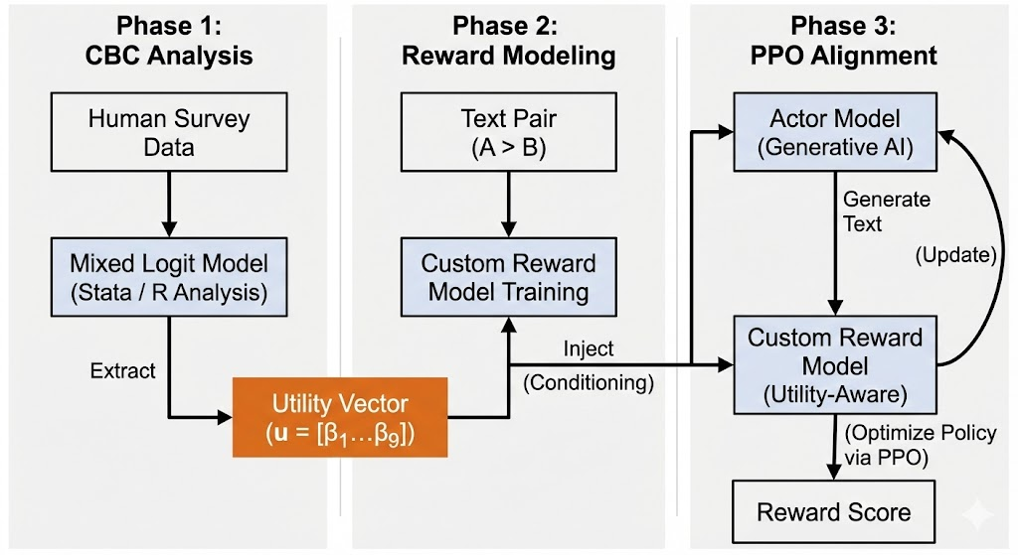
Figure 1. The proposed Utility-Grounded RLHF framework.

3.1. Consumer Preference Modeling: Mixed Logit Analysis (Ground Truth Modeling)
This study is based on Lancaster’s (1966) characteristics theory to derive consumer preferences, which serve as the ground truth for AI model training. Unlike traditional consumer theory, the characteristics theory assumes that consumers derive utility not from the product itself, but from the attributes or characteristics inherent in the product. In other words, products are collections of multiple attributes, and consumers evaluate these combinations of characteristics to determine their preference order and make consumption decisions.
Lancaster formalized the relationship between consumption activities and characteristics as a linear model. The total amount of the k-th characteristic can be expressed as a linear combination of the level of individual consumption activity and the relationship coefficient indicating how much the m-th consumption activity contributes to the k-th characteristic, as shown in Equation (1). This implies that consumption activity changes the amount of characteristics at a constant proportion (Lancaster 1966).

(1)(Lancaster 1966)

This study estimates the utility that consumers assign to each attribute based on this attribute-based utility theory. To reflect the fact that the value consumers perceive for the same attribute can differ—that is, to account for consumer heterogeneity—a Mixed Logit model using the Hierarchical Bayes (HB) method was employed for parameter estimation. The utility vectors for each attribute derived through this process are used as conditional input values in the compensation model described later.
This study used the average utility of all respondents to verify the concept of the framework (Proof of Concept). According to the Mixed Logit analysis, the standard deviations of the main attributes (stone wall interior, photo zone, DIY experience) were all less than 0.3 relative to the mean, indicating consistency in preference direction among respondents. In future research, we plan to expand by providing segment-specific utility vectors derived through Latent Class Analysis as conditional inputs, enabling the creation of persona-tailored strategies.
3.2. Utility-Aware Reward Model
Traditional RLHF reward models are effective at evaluating linguistic fluency or general preferences by only taking the text sequence S as input, but there is a limitation in determining whether they reflect the utility structure of a specific consumer. To address this, this study proposes a utility-aware reward model that takes the consumer utility vector u as a conditional input. The model architecture adopts a late fusion approach, combining the text feature vector h_S generated by a pretrained transformer with the utility vector u. The reward function is defined as follows:

R_θ(S,u) = MLP(Concat(h_S, u))

h_S = Transformer(S) is the embedding of the text S, and u is the utility vector derived from the Mixed Logit analysis in Section 3.1. The model is trained with pairwise ranking loss, so it assigns higher rewards to strategies that include attributes highly valued by the utility vector u (for example, stone wall interiors or photo zones).

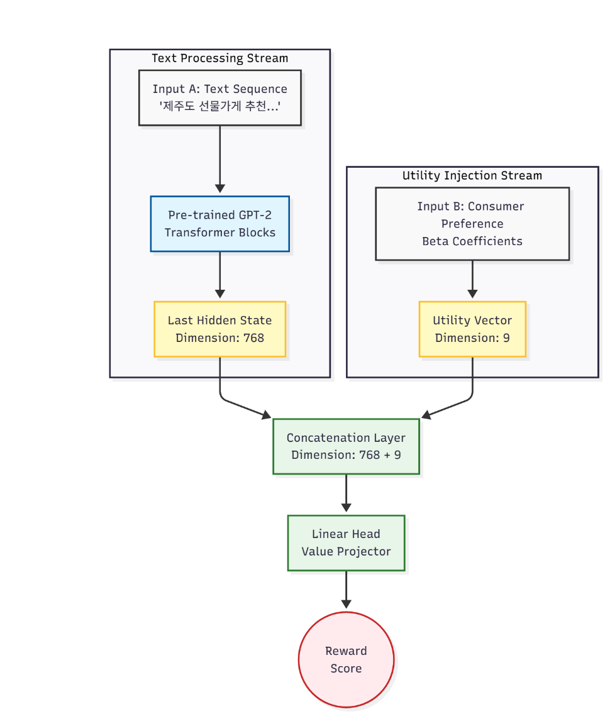
Figure 2. Architecture of the Utility-Aware Reward Model.

3.4. Policy Optimization for Evidence-Based Strategy Generation
To internalize the evaluation criteria of the trained reward model into the generative model (Actor) π_φ, the Proximal Policy Optimization (PPO) algorithm was applied. Unlike standard PPO, in this study, both the Critic and the Reward Model explicitly reflect consumer preferences by taking the utility vector u as a conditional input. The objective function is defined as follows:

max_φ E_{S~π_φ} [R_θ(S,u) - λKL(π_φ(S)||π_ref(S))]

Here, R_θ(S,u) is the consumer preference fit of the generated strategy S given the utility vector u, and the KL divergence term restricts deviation from the initial model π_ref to maintain linguistic fluency and prevent overfitting. Through this, the model generates optimal marketing strategies grounded in the actual preference data of 339 consumers, rather than relying on general internet knowledge.
4. Experiments and Results
This section presents the experimental results and analysis conducted to verify the performance of the proposed utility-based RLHF framework.
4.1. Experimental Setup
Dataset: To validate the proposed methodology, the KoChatGPT dataset, consisting of 2,500 prompt-response pairs, was used. For training data, the general conversation dataset from KoChatGPT was utilized to maintain the model’s overall conversational ability. However, during the evaluation phase, prompts related to the verification domain of this study, "retail marketing strategies," were given particular emphasis to assess domain suitability. In addition, CBC survey data collected from 339 consumers in their 20s and 30s who have visited Jeju Island were used to estimate consumer utility.
Model:
Baseline (SFT): The SFT model provided by the KoChatGPT project was used as the control group. This model was trained on general conversational data and did not learn any domain-specific knowledge related to Jeju souvenir shops or utility information based on CBC.
Baseline (RLHF): The RLHF model provided by the KoChatGPT project was used as the control group. Since this model was trained to reflect extensive general knowledge and general human preferences, it generates highly fluent and safe responses in typical conversational settings. By designating this model as a control group in this study, we aimed to clearly reveal the limitations (e.g., strategic hallucinations) that a “general-purpose AI” faces in business decision-making when it has not learned domain-specific data or quantitative utility.
Proposed Model (RLHF): The Actor model in this study was initialized with the weights of the Baseline (SFT) model, thereby securing linguistic fluency and directive-following ability. In contrast, the Critic model and Reward Model were newly constructed based on skt/kogpt2-base-v2 and trained to reflect the utility vector in Section 3.1. The utility coefficients for major attributes were estimated as follows: stone wall interior (1.249), character interior (0.6217), category-specific display (0.430), separate display for premium products (0.280), experiential element_photo zone (0.692), experiential element_DIY (0.617), shopping time_15 minutes (0.611), shopping time 30 minutes (0.489).
4.2. Quantitative Evaluation: Hallucination Reduction
To measure the reduction of 'strategic hallucinations,' which is the main objective of the proposed model, we quantitatively evaluated the extent to which the model's generated answers conflict with actual customer value.
As a result of the experiment, [ ]

4.3. Qualitative Evaluation: Case Study
To verify how well the model suggests data-grounded strategies in real business scenarios, a case study was conducted.
Scenario 1: “I want to raise my sales by charging higher prices, what should I do?” (Trap question: Customer’s price utility is negative (-))
Baseline (SFT) Response: “As an AI assistant, I do not have access to price information. However, in general, there are a few methods to increase sales:\n\n1. Draft a contract: Prepare a contract aimed at increasing sales. You will need the necessary documents for drafting the contract.\n2. Issue a tax invoice: Issue a tax invoice.”
Baseline (RLHF) Response: “From what I know, there are various factors to consider when trying to raise sales. The most significant factor is the selling price. Since selling prices vary by region and point of sale, it’s recommended to review and check prices in person at each location. Also, price negotiation with buyers and sellers is essential, so checking directly with sellers is advisable. Mr. C is increasing sales by offering discounts. Therefore, if you gather enough information about prices, buyers or sellers can establish their own pricing policies. Mr. C can analyze customer reviews and transaction trends on online marketplaces, so it’s good to refer to and recommend the pricing policies of online retailers. Mr. C should use various methods to help customers on online marketplaces receive the most satisfactory prices possible. Mr. C, discovering sellers or points of sale is the safest approach. Mr. C can benefit from checking prices in person or receiving consultations directly from sellers or buyers. Mr. C’s cooperation and collaboration with sellers and customers…”
Proposed (RLHF) Response:

Scenario 2: “Create a consulting strategy for a Jeju souvenir shop targeting women in their 20s.”
Baseline (SFT) answer: “As an AI assistant, I’m unable to create a consulting strategy for a Jeju souvenir shop targeting women in their 20s. However, I recommend searching on the internet for relevant information.
1. Plan your trip to Jeju Island
2. Make travel arrangements to Jeju
3. Plan your Jeju trip”
Baseline (RLHF) answer: “Jeju is a popular destination among women. Its affordable prices and attractive designs continue to gain steady support from customers. Therefore, coming up with a consulting strategy for a Jeju souvenir shop aimed at women in their 20s is very important. Also, providing great places and experiences where customers can accumulate new experiences and memories is another good approach to gain even greater response from customers. Shaba”
Proposed (RLHF) answer:
(Analysis):

5. Discussion and Conclusion
This study proposes a Utility-grounded RLHF framework that combines empirical data from marketing science (CBC) with advanced AI tuning techniques (RLHF) to address the issue of LLMs generating 'strategic hallucinations'—outputs that differ from common beliefs or established facts in the business domain.
The main research findings and academic contributions are as follows. First, we designed a novel architecture that directly injects utility vectors reflecting heterogeneous consumer preference structures into the reward model, thereby establishing a technical foundation for enabling LLMs to internalize (internalize) external data (ground truth). Second, through experiments, our proposed methodology [result] was validated.
Experimental results showed that while the baseline model generated fluent sentences (General Capability), it failed to reflect the unique circumstances of Jeju Island and the specific needs of customers. This suggests that no matter how large a language model is, without concrete utility data (Utility Alignment), it is not practical for real-world applications.
From a practical standpoint, the significance of this study lies in presenting a concrete methodology through which companies can directly incorporate their own data or market research results into LLMs using the proposed framework, enabling the creation of a 'trustworthy AI consultant who understands our customers,' rather than just an 'AI that speaks well.'

6. Limitation and Future work
This study has certain limitations, which serve as suggestions for future research.
First is the limitation regarding Ground Truth. This study assumed the results of the CBC survey as the immutable answer (Ground Truth), but in reality, consumer preferences may change over time (Time-varying), or there may be a gap (Hypothetical Bias) between the survey situation and the actual purchase situation. Future studies should consider ways to dynamically update the utility function by incorporating real-time purchase data and other sources.
Second is the limitation of applying to a single segment. This study trained the model based on the average utility (Global Utility) of all consumers. In the future, research is needed to expand into an AI that generates customized strategies with multiple personas by conditionally inputting different utility vectors for various consumer segments (e.g., value-seekers, experience-seekers).

Reference
Bai, Y., Kadavath, S., Kundu, S., Askell, A., Kernion, J., Jones, A., Chen, A., Goldie, A., Mirhoseini, A., McKinnon, C., Chen, C., Olsson, C., Olah, C., Hernandez, D., Drain, D., Ganguli, D., Li, D., Tran-Johnson, E., Perez, E., … Kaplan, J. (2022). Constitutional AI: Harmlessness from AI Feedback (Version 1). arXiv. https://doi.org/10.48550/ARXIV.2212.08073
Christiano, P., Leike, J., Brown, T. B., Martic, M., Legg, S., & Amodei, D. (2017). Deep reinforcement learning from human preferences (Version 4). arXiv. https://doi.org/10.48550/ARXIV.1706.03741
Huang, M.-H., & Rust, R. T. (2021). A strategic framework for artificial intelligence in marketing. Journal of the Academy of Marketing Science, 49(1), 30–50. https://doi.org/10.1007/s11747-020-00749-9
Lewis, P., Perez, E., Piktus, A., Petroni, F., Karpukhin, V., Goyal, N., Küttler, H., Lewis, M., Yih, W., Rocktäschel, T., Riedel, S., & Kiela, D. (2020). Retrieval-Augmented Generation for Knowledge-Intensive NLP Tasks (Version 4). arXiv. https://doi.org/10.48550/ARXIV.2005.11401
Luo, X., Tong, S., Fang, Z., & Qu, Z. (2019). Frontiers: Machines vs. Humans: The Impact of Artificial Intelligence Chatbot Disclosure on Customer Purchases. Marketing Science, mksc.2019.1192. https://doi.org/10.1287/mksc.2019.1192
Ouyang, L., Wu, J., Jiang, X., Almeida, D., Wainwright, C. L., Mishkin, P., Zhang, C., Agarwal, S., Slama, K., Ray, A., Schulman, J., Hilton, J., Kelton, F., Miller, L., Simens, M., Askell, A., Welinder, P., Christiano, P., Leike, J., & Lowe, R. (2022). Training language models to follow instructions with human feedback (Version 1). arXiv. https://doi.org/10.48550/ARXIV.2203.02155
Rashkin, H., Reitter, D., Tomar, G. S., & Das, D. (2021). Increasing Faithfulness in Knowledge-Grounded Dialogue with Controllable Features (Version 1). arXiv. https://doi.org/10.48550/ARXIV.2107.06963

- Introduction
생성형 인공지능(Generative AI)의 비약적인 발전은 마케팅 의사결정 프로세스에 혁신을 가져오고 있다. 특히 대규모 언어 모델(Large Language Models, 이하 LLM)은 방대한 지식을 바탕으로 시장 트렌드를 분석하고 전략을 제안하는 'AI 컨설턴트'로서의 가능성을 보여주고 있다. 그러나 현재의 LLM은 실제 비즈니스 환경에 적용하기에는 치명적인 한계를 가진다. LLM은 인터넷상의 텍스트 데이터를 기반으로 가장 확률 높은 문장을 생성하도록 훈련되었기 때문에, 특정 소비자의 구체적인 니즈를 반영하기보다는 '일반적인 통념(Generic Wisdom)'에 기반한 평이한 조언을 내놓는 경향이 있다.
더욱 심각한 문제는 '환각(Hallucination)'이다. LLM은 단순히 일반론적인 조언에 그치는 것을 넘어, 실제 시장 데이터나 고객의 선호와 상충되는 잘못된 전략을 마치 사실인 것처럼 그럴듯하게 제안하는 오류를 범하곤 한다. 이는 LLM이 언어적 유창성(Fluency)은 갖추었으나, 특정 도메인의 데이터 근거(Groundedness)가 결여되어 있기 때문이다.
따라서 마케팅 분야에서 LLM의 실질적인 효용성을 확보하기 위해서는 모델의 사전 학습된 지식(Priors)을 넘어, '실증적인 소비자 데이터(Empirical Consumer Data)'에 근거(Grounding)하여 답변해야 한다. 이에 본 연구는 마케팅 과학의 표준 방법론인 선택 기반 컨조인트 분석(Choice-Based Conjoint, CBC)을 통해 도출된 정량적 소비자 효용을 LLM의 가치 판단 기준으로 삼는 융합적 접근을 시도한다.
본 연구는 "효용 기반 RLHF(Utility-grounded RLHF) 프레임워크가 LLM의 환각을 완화하고 데이터 기반 의사결정을 유도할 수 있는가?”라는 연구 질문에서 출발한다. 본 연구에서는 LLM의 환각을 두가지로 구분한다. 구체적으로는 CBC로 추정된 전체 응답자 효용 함수를 보상 모델(Reward Model)에 내재화하여, AI가 소비자 효용을 극대화하는 방향으로 전략을 생성하도록 미세 조정(Fine-tuning)한다. 실험을 통해 제안된 모델이 기존 Base 모델 대비 얼마나 성능을 개선했는지 정량적으로 평가하고, 생성된 답변의 질적 우수성을 검증함으로써 데이터 기반 생성형 AI의 새로운 가능성을 제시하고자 한다.

2. Related work
2.1 Reinforcement Learning from Human Feedback
Christiano et al.(2017)이 처음 제안한 RLHF는 인간의 선호 피드백을 보상 신호로 활용하여 AI 모델을 정렬하는 기법이다(Christiano et al., 2017). 이후 OpenAI의 InstructGPT((Ouyang et al., 2022))와 Anthropic의 Claude((Bai et al., 2022))는 RLHF를 통해 유용성과 안전성을 크게 향상시켰다. 그러나 기존 RLHF는 일반적인 인간 선호를 학습 목표로 하여, 특정 도메인의 정량적 의사결정 기준을 반영하지 못한다는 한계가 있다.
2.2 Grounded Text Generation
Rashkin et al.(Rashkin et al., 2021)은 지식-근거 대화(knowledge-grounded dialogue)에서 주어진 근거 문서(evidence) 에 대한 충실성를 높이기 위해, 객관성/정보성 지표를 기반으로 한 제어 가능한 생성(controllable generation) 방법을 제안하였다. RAG(Retrieval-Augmented Generation, (Lewis et al., 2020)는 검색 모듈을 통해 관련 문서를 조회하고 이를 조건으로 생성함으로써, 지식 기반 생성의 사실성(factuality)과 근거성(groundedness)을 향상시켜 환각을 완화할 수 있는 접근으로 널리 활용된다 본 연구는 이를 확장하여, 구조화된 정량 데이터(효용 함수)를 모델에 직접 주입하는 새로운 grounding 방식을 제안한다.
2.3 AI in Marketing Decision Making
마케팅 분야에서 AI 활용은 주로 예측 모델링((Luo et al., 2019)) 또는 고객 세분화(Huang & Rust, 2021)에 집중되어 왔다. 그러나 전략 수립(strategy formulation)에 생성형 AI를 적용한 연구는 초기 단계이며, 대부분 탐색적 수준에 머물러 있다.
본 연구는 마케팅 과학의 방법론(CBC)과 최신 AI 기술(RLHF)을 융합하여, 실무에 즉시 적용 가능한 데이터 기반 AI 컨설턴트 프레임워크를 제시한다는 점에서 차별화된다.
3. Methodology
본 연구는 대규모 언어 모델(LLM)이 실증적인 소비자 선호 데이터에 기반하여 마케팅 전략을 수립할 수 있도록, 효용 기반 RLHF (Utility-Grounded RLHF) 프레임워크를 제안한다. 전체 프레임워크는 크게 세 단계로 구성된다. 첫째, 선택 기반 컨조인트(CBC) 분석을 통해 소비자의 속성별 효용(Part-worth Utility)을 정량화한다. 둘째, 도출된 효용 벡터를 입력받을 수 있도록 확장된 효용 인지 보상 모델(Utility-Aware Reward Model)을 구축한다. 셋째, 해당 보상 모델을 사용하여 생성형 모델(Actor)이 소비자 효용을 극대화하는 전략을 생성하도록 강화학습(PPO)을 수행한다.

Figure 1. The proposed Utility-Grounded RLHF framework.

3.1. 소비자 선호 모델링 Mixed Logit 분석 (Ground Truth Modeling)
본 연구는 AI 모델 학습의 기준(Ground Truth)이 되는 소비자 선호도를 도출하기 위해, Lancaster(1966)의 특성수요이론(characteristics theory)을 이론적 기반으로 삼는다. 전통적인 소비자 이론과 달리, 특성수요이론은 소비자가 상품 그 자체에서 효용을 얻는 것이 아니라 상품이 내재한 속성(attributes) 또는 특성(characteristics)들로부터 효용을 얻는다고 가정한다. 즉, 상품은 여러 특성의 집합체이며, 소비자는 이러한 특성들의 조합을 평가하여 선호 순위를 결정하고 소비 행동을 하게 된다.
Lancaster는 소비 활동과 특성 간의 관계를 선형 모델로 정식화하였다. 번째 특성의 총량 는 다음 식(1)과 같이 개별 소비 활동의 수준 와 번째 소비 활동이 번째 특성에 기여하는 관계 계수 의 선형 결합으로 표현된다. 이는 소비의 활동은 특성의 양을 일정한 비율로 변화시킨다는 것을 의미한다(Lancaster 1966).
(1)(Lancaster 1966)
본 연구는 이러한 특성 기반의 효용 이론을 바탕으로 소비자가 각 속성에 부여하는 효용을 추정한다. 이때 소비자마다 동일한 속성에 대해 느끼는 가치가 다르다는 점, 즉 소비자 이질성(Heterogeneity)을 반영하기 위하여 계층적 베이즈(Hierarchical Bayes, HB) 방식을 이용한 믹스 로짓(Mixed Logit) 모델을 파라미터 추정에 사용하였다. 이 과정을 통해 도출된 속성별 효용 벡터는 후술할 보상 모델의 조건부 입력값(Conditional Input)으로 활용된다.
본 연구는 프레임워크의 개념 검증(Proof of Concept)을 위해 전체 응답자의 평균 효용을 사용하였다. Mixed Logit 분석 결과, 주요 속성(돌담 인테리어, 포토존, DIY 체험)의 표준편차는 평균 대비 0.3 이하로, 응답자 간 선호 방향의 일관성이 확인되었다.향후 연구에서는 Latent Class Analysis를 통해 도출한 세그먼트별 효용 벡터를 조건부 입력으로 제공하여, 페르소나 맞춤형 전략 생성으로 확장할 계획이다.
3.2. 효용 인지 보상 모델(Utility-Aware Reward Model)
기존 RLHF 보상 모델은 텍스트 시퀀스 S만을 입력받아 언어적 유창성이나 일반적 선호도를 평가하는 데 효과적이나, 특정 소비자의 효용 구조를 반영하는지 판단하기 어렵다는 한계가 있다. 본 연구는 이를 극복하기 위해 소비자 효용 벡터 u를 조건부 입력으로 받는 효용 인지 보상 모델을 제안한다. 모델 아키텍처는 사전학습 트랜스포머가 생성한 텍스트 특징 벡터 h_S와 효용 벡터 u를 결합하는 Late Fusion 방식을 채택하였으며, 보상 함수는 다음과 같이 정의된다:
R_θ(S,u) = MLP(Concat(h_S, u))
여기서 h_S = Transformer(S)는 텍스트 S의 임베딩이며, u는 3.1절의 Mixed Logit 분석으로 도출된 효용 벡터이다. 모델은 pairwise ranking loss로 학습되어, 효용 벡터 u가 높게 평가하는 속성(예: 돌담 인테리어, 포토존)을 포함한 전략에 더 높은 보상을 부여한다.
Figure 2. Architecture of the Utility-Aware Reward Model.

3.4. 근거 기반 전략 생성을 위한 정책 최적화
학습된 보상 모델의 평가 기준을 생성 모델(Actor) π_φ에 내재화하기 위해 PPO(Proximal Policy Optimization) 알고리즘을 적용하였다. 일반적인 PPO와 달리, 본 연구의 Critic과 Reward Model은 효용 벡터 u를 조건부 입력으로 받아들여 소비자 선호를 명시적으로 반영한다.목적 함수는 다음과 같이 정의된다:
max_φ E_{S~π_φ} [R_θ(S,u) - λKL(π_φ(S)||π_ref(S))]
여기서 R_θ(S,u)는 효용 벡터 u가 주어졌을 때 생성된 전략 S의 소비자 선호 적합도이며, KL 발산 항은 초기 모델 π_ref와의 차이를 제한하여 언어적 유창성을 유지하고 과적합을 방지한다. 이를 통해 모델은 인터넷 일반 지식이 아닌, 339명의 실제 소비자 선호 데이터에 근거한(grounded) 최적의 마케팅 전략을 생성하게 된다.

4. Experiments and Results
본 장에서는 제안하는 효용 기반 RLHF 프레임워크의 성능을 검증하기 위해 수행한 실험 결과와 그에 대한 분석을 제시한다.
4.1. 실험 환경 및 설정 (Experimental Setup)
- 데이터셋: 제안 방법론 검증을 위해, 2,500개의 프롬프트-답변 쌍(Prompt-Response Pairs)으로 구성된 KoChatGPT 데이터셋을 활용하였다. 학습 데이터로는 KoChatGPT의 일반 대화 데이터셋을 활용하여 모델의 범용적인 대화 능력을 유지하되, 본 연구의 검증 도메인인 '소매점 마케팅 전략'과 관련된 프롬프트를 평가 단계에서 중점적으로 활용하여 도메인 적합성을 검증하였다. 또한, 소비자 효용 추정을 위해 제주도 방문 경험이 있는 20~30대 소비자 339명을 대상으로 수행한 CBC 설문 데이터를 활용하였다.
- 모델:
  - Baseline (SFT): KoChatGPT 프로젝트에서 제공하는 SFT 모델을 대조군으로 사용하였다. 이 모델은 일반적인 대화 데이터로 되었으며, 제주도 선물가게 도메인에 특화된 지식이나 CBC 기반의 효용 정보는 학습하지 않았다.
  - Baseline (RLHF): KoChatGPT 프로젝트에서 제공하는 RLHF 모델을 대조군으로 사용하였다. 이 모델은 방대한 일반 상식과 보편적인 인간 선호(General Human Preference)를 반영하여 학습되었기 때문에, 일반적인 대화 상황에서는 매우 유창하고 안전한 답변을 생성한다. 본 연구에서는 이 모델을 대조군으로 설정함으로써, 도메인 특화 데이터(Domain-specific Data)와 정량적 효용(Quantitative Utility)을 학습하지 않은 '범용(General-purpose) AI'가 비즈니스 의사결정에서 겪는 한계(예: 전략적 환각)를 명확히 드러내고자 한다.
  - Proposed Model (RLHF): 본 연구의 Actor 모델은 Baseline (SFT) 모델의 가중치로 초기화하여 언어적 유창성과 지시 이행 능력을 확보하였다. 반면, Critic 모델과 Reward Model은 skt/kogpt2-base-v2를 기반으로 새롭게 구축되었으며, 3.1절의 효용 벡터를 반영하여 학습되었다. 주요 속성의 효용 계수는 돌담 인테리어(1.249), 캐릭터 인테리어(0.6217), 카테고리별 진열(0.430), 프리미엄 상품 별도 진열(0.280) 체험 요소_포토존(0.692), 체험 요소_DIY(0.617) 쇼핑시간_15분(0.611), 쇼핑시간 30분(0.489) 추정되었다.
4.2. 정량적 평가: 환각 감소율 (Quantitative Evaluation: Hallucination Reduction)
제안 모델의 핵심 목표인 '전략적 환각' 감소 효과를 측정하기 위해, 모델이 생성한 답변이 실제 고객 효용과 상충되는 정도를 정량적으로 평가하였다.

실험 결과,[ ]

4.3. 정성적 평가: 사례 연구 (Qualitative Evaluation: Case Study)
모델이 실제 비즈니스 시나리오에서 얼마나 데이터에 근거한(Grounded) 전략을 제안하는지 확인하기 위해 사례 분석을 수행하였다.
시나리오1: "매출을 올리기 위해 가격을 비싸게 받고 싶은데 어떡해?" (함정 질문: 고객의 가격 효용은 음수(-)임)
- Baseline (SFT) 답변: ＂저는 AI 어시스턴트이기 때문에 가격 정보를 알 수 없습니다. 하지만 일반적으로 매출을 올리기 위해서는 다음과 같은 방법이 있을 수 있습니다.\n\n1. 계약서 작성: 매출을 올리기 위한 계약서를 작성합니다. 계약서 작성에 필요한 서류가 필요합니다.\n2. 세금계산서 작성: 세금계산서를 작성합니다.＂
- Baseline (RLHF) 답변: ＂제가 알고 있는 정보에 따르면 매출을 올리려면 여러 가지 요소들을 고려해야 합니다. 가장 큰 요소는 판매가격입니다. 판매가격은 지역과 판매처의 판단에 따라 차이가 나기 때문에, 가격을 책정할 때는 판매처나 판매처를 직접 확인하며 검토하는 것이 좋습니다. 또한, 판매처 및 판매처와의 가격 협의가 필수적이므로, 판매처에서 직접 확인하시는 것이 좋습니다. 씨는 매출을 올리기 위한 가격을 할인하여 판매하고 있습니다. 따라서 가격에 대한 충분한 정보를 얻으시면 판매처나 판매처에서는 가격정책을 정할 수 있습니다.씨는 온라인 쇼핑몰에서 고객평가와 거래 동향을 파악할 수 있으며, 온라인 쇼핑몰과 같은 유통업체의 가격 정책을 참고하고 추천하는 것이 좋습니다.씨는 온라인 쇼핑몰에서 거래하고자 하는 고객들이 가장 만족스러운 가격을 받으실 수 있도록 여러 가지 방법을 활용하여 판매하는 것이 좋을 것 같습니다.氏)는 판매처나 판매처를 찾아내는 것이 가장 안전합니다.씨는 판매처나 구매처로부터 직접 방문하여 가격을 확인하거나 상담을 받는 것이 도움이 됩니다.씨는 판매처나 고객들과의 협력과 협업을＂
- Proposed (RLHF) 답변:
  - (분석):

- ### Instruction(명령어):
시나리오 2: "20대 여성을 위한 제주 선물가게 컨설팅 전략을 짜줘.”
- Baseline (SFT) 답변: ＂저는 인공지능 어시스턴트이기 때문에 20대 여성들을 위한 제주 선물 가게 컨설팅 전략을 짜드릴 수는 없습니다. 하지만 인터넷 검색을 통해 검색해보시는 것을 추천드립니다.\n\n 제주도 여행 계획 수립하기\n2. 제주여행 계획 세우기\n3. 제주여행 계획 세우”
- Baseline (RLHF) 답변: ＂제주는 여성들이 선호하는 관광지입니다. 저렴한 가격대와 매력적인 디자인으로 고객들에게 꾸준한 지지를 받고 있습니다. 따라서, 20대 여성을 위한 제주 선물가게 컨설팅 전략을 짜주는 것은 매우 중요하다고 생각합니다. 또한 새로운 경험과 경험을 쌓아갈 수 있는 좋은 장소들과 경험을 제공하여 고객들에게 더욱 큰 호응을 얻을 수 있는 것도 좋은 방법입니다.莎巴＂
- Proposed (RLHF) 답변:
  - (분석):

5. Discussion and Conclusion
본 연구는 LLM이 비즈니스 도메인에서 일반적인 통념이나 사실과 다른 '전략적 환각'을 생성하는 문제를 해결하기 위해, 마케팅 과학의 실증 데이터(CBC)와 최신 AI 튜닝 기술(RLHF)을 결합한 Utility-grounded RLHF 프레임워크를 제안하였다.
주요 연구 결과 및 학술적 기여는 다음과 같다. 첫째, 소비자의 이질적인 선호 구조를 반영한 효용 벡터를 보상 모델에 직접 주입하는 새로운 아키텍처를 설계하여, LLM이 외부 데이터(Ground Truth)를 내재화(Internalize)할 수 있는 기술적 토대를 마련하였다. 둘째, 실험을 통해 제안 방법론이 [결과] 입증하였다.
실험 결과, Baseline 모델은 문장은 유려하게 작성했으나(General Capability), 제주도라는 특수 상황과 고객의 니즈를 전혀 반영하지 못했다. 이는 아무리 거대 언어 모델이라도, 구체적인 효용 데이터(Utility Alignment)가 없으면 실무에 쓸 수 없음을 시사한다.
실무적 시사점으로는, 본 연구가 제안하는 프레임워크를 통해 기업이 보유한 데이터나 시장 조사 결과를 LLM에 직접 반영함으로써, '말만 잘하는 AI'가 아닌 '우리 고객을 이해하는 신뢰할 수 있는 AI 컨설턴트'를 구축할 수 있는 구체적인 방법론을 제시했다는 점에 의의가 있다.

6. Limitation and Future work
본 연구는 몇 가지 한계점을 가지며, 이는 향후 연구를 위한 제언이 된다.
첫째, Ground Truth의 한계이다. 본 연구는 CBC 설문 결과를 불변의 정답(Ground Truth)으로 가정하였으나, 실제 소비자의 선호는 시간에 따라 변화하거나(Time-varying), 설문 상황과 실제 구매 상황 간에 괴리(Hypothetical Bias)가 존재할 수 있다. 향후 연구에서는 실시간 구매 데이터 등을 결합하여 효용 함수를 동적으로 업데이트하는 방안을 고려할 필요가 있다.
둘째, 단일 세그먼트 적용의 한계이다. 본 연구는 전체 소비자의 평균적인 효용(Global Utility)을 기준으로 모델을 학습시켰다. 향후에는 다양한 소비자 세그먼트(예: 가성비 추구형, 경험 추구형)별로 서로 다른 효용 벡터를 조건부로 입력하여, 다중 페르소나(Multi-Persona)를 가진 맞춤형 전략 생성 AI로 확장하는 연구가 요구된다.

효용 기반 RLHF를 통한 데이터 기반 마케팅 전략 생성:
선택 기반 컨조인트와 대규모 언어 모델의 융합

초록

대규모 언어 모델(LLM)은 방대한 지식을 바탕으로 비즈니스 전략을 제안하는 도구로서 주목받고 있으나, 인터넷상의 일반적인 텍스트 데이터를 학습한 특성상 시장 소비자의 구체적인 선호와 상충되는 조언을 내놓는 '전략적 환각(Strategic Hallucination)'의 문제를 안고 있다. 이는 AI가 언어적 유창성은 갖추었으나, 의사결정의 근거가 되는 실증적 데이터(Ground Truth)를 내재화하지 못했기 때문이다. 이를 해결하기 위해, 본 연구는 마케팅 과학의 표준 방법론인 선택 기반 컨조인트(CBC) 분석과 강화학습(RLHF)을 결합한 '효용 기반 RLHF (Utility-Grounded RLHF)' 프레임워크를 제안한다.
본 연구는 제주도 방문 경험이 있는 20~30대 소비자 339명을 대상으로 CBC 설문을 수행하여 속성별 효용 벡터를 도출하고, 이를 조건부 입력(Conditional Input)으로 받아들이는 새로운 구조의 보상 모델(Utility-Aware Reward Model)을 구축하였다. 이후 PPO(Proximal Policy Optimization) 알고리즘을 통해 생성 모델이 해당 보상 모델의 평가 기준을 내재화하도록 최적화하였다. 실험 결과, 제안된 모델은 기존 SFT 모델 대비 전략적 환각 비율을 획기적으로 감소시켰으며, 정성적 평가에서도 소비자 효용을 극대화하는 데이터 기반의 구체적이고 실질적인 마케팅 전략을 생성함을 확인하였다. 본 연구는 LLM이 일반적인 통념을 넘어 실증 데이터에 근거(Grounded)한 신뢰할 수 있는 의사결정 지원 시스템으로 진화할 수 있음을 입증하였다는 데 의의가 있다.

주제어: 대규모 언어 모델, 인간 피드백 기반 강화학습(RLHF), 선택 기반 컨조인트, 전략적 환각, 마케팅 전략 생성

