District Summary



School Summary

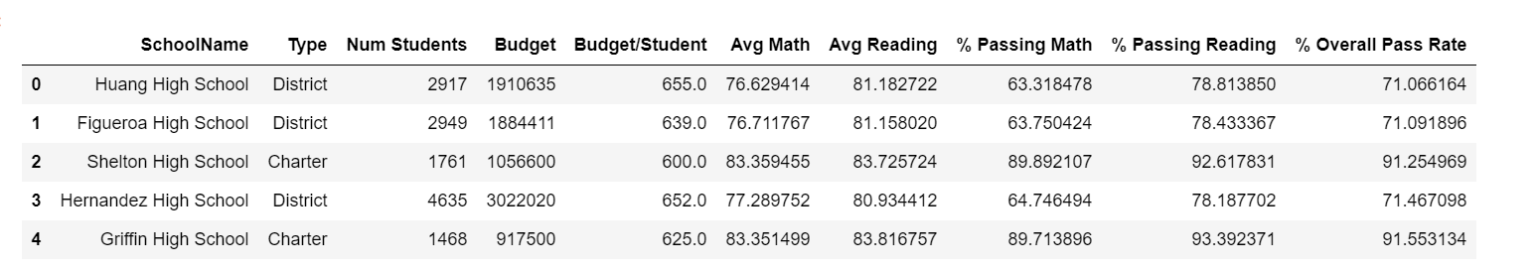

Top Performing Schools (By Passing Rate)

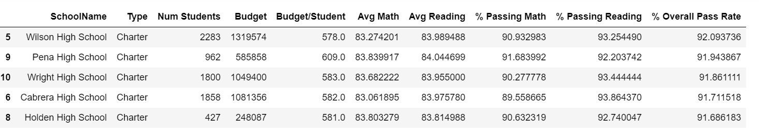

Bottom Performing Schools (By Passing Rate)

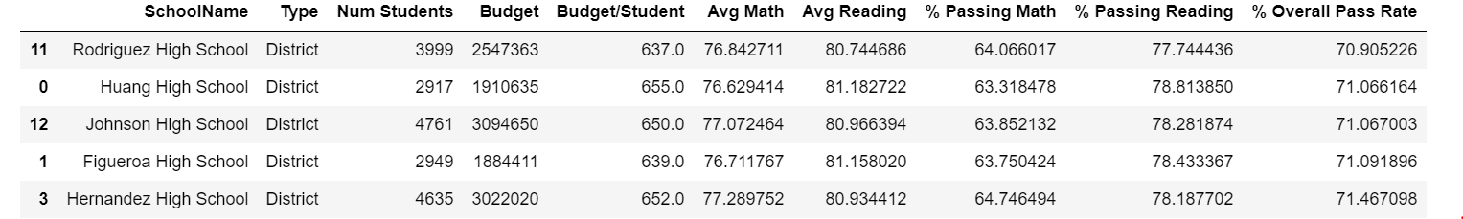

Math Scores by Grade

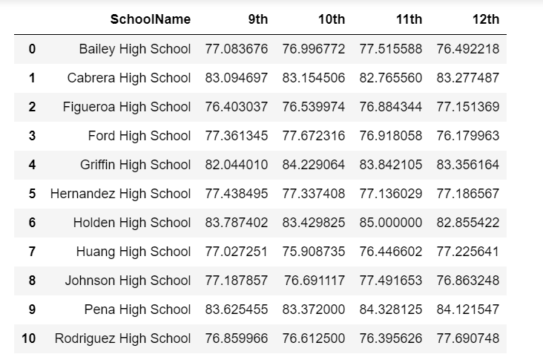

Reading Scores by Grade

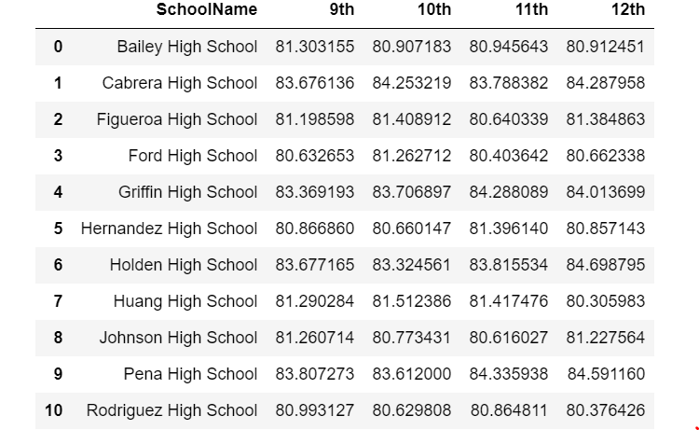

Scores by School Spending

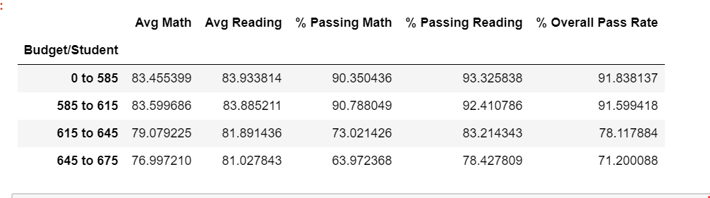

Scores by School Size

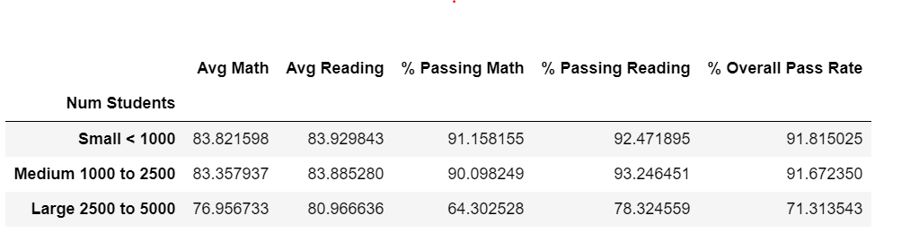

Score by School Type

