**Project Report: Travel Blog Website**

## Overview

The Travel Blog project is implemented as a web application for sharing travel experiences, displaying pictures, and authentication and contacting a user. This project is built using HTML CSS and JavaScript to make an aesthetic and user-friendly interface design.

**Project Structure**

1. **HTML Pages**:
   * **index.html**: Serves as the first impression of the blog containing general information and links to various areas of the blog.
   * **about.html**: Provides information on what the blog is all about, and who is involved in creating it.
   * **blog.html**: Contains the articles and blog posts relevant to the travel industry.
   * **contact.html**: Contains a facility to allow users to input their messages or questions.
   * **gallery.html**: There is a gallery of travel photographs.
   * **login.html & signup.html**: Allow users to have a unique experience by providing an authentication mechanism.
2. **Assets**:
   * Incorporates images and other artistic features relevant to traveling.
3. **CSS**:
   * **style.css**: Refers to factors such as the structure, font type and size, color, etc, of the website.
4. **JavaScript**:
   * **auth.js**: Is responsible for users and their login and signup.
   * **blog.js**: Oversees all the interactivity that concerns the blog.
   * **contact.js**: Manages contact form submissions.
   * **gallery.js**: Gives capabilities to perform on the image gallery.

## Testing Approach

**1. Functional Testing**

Each feature was tested to ensure it operates as intended:

* **Homepage**:
  + All the links on the website, directing to other web pages, were checked for their functionality and the authenticator mark.
  + Checked for responsive design.
* **Authentication**:
  + Checked for validity and invalidity of login and signup forms.
  + Ensured that the error messages of wrong credential entries were properly placed.
* **Contact Form**:
  + Ensure the fields wherein the form validation should be checked for the requirement of specific fields.
  + Talked about confirmed successful submission and received confirmation messages.
* **Gallery**:
  + Ensured smooth loading of images.
  + Verified functionality of any interactive elements like image enlargement or carousel effects.
* **Blog Page**:
  + Verified that all articles and links were loaded correctly.

**2. Compatibility Testing**

Browser compatibility was checked with popular browsers such as Google Chrome, Mozilla Firefox, and Safari among others, across different gadgets ranging from desktops, tablets, and mobile devices.

**3. Usability Testing**

It involved the assessment of possible users to determine the level of understanding regarding the navigation, the ability of the users to use the models, and the general usability of the two models.

## Debugging Approach

1. **Identifying Issues**:
   * Used the browser developer tools to find mistakes by checking the console tab.
   * Closely observed the networks for all the resources to check if they loaded all correctly.
2. **Common Issues Resolved**:
   * **CSS**:
     + Problems that solidify alignment and responsiveness problems are more predominant on small screen resolution.
     + To prevent the conflicts of styles that led to laying out in a haphazard manner we resolved them.
   * **JavaScript**:
     + Fixed critical auth issues to provide safe user login and signup options.
     + Corrected event listener problems of the gallery.
     + Fixed form validity concerns with the contact form script.
3. **Testing Iterations**:
   * Retest done after every bug has been fixed to test if the fix did not bring in new ones.
   * Used Lighthouse to perform tests such as performance audits.

**Key Features**

* **User Authentication**:
  + Enables people to sign up and sign in to get content that is relevant to their interests.
* **Interactive Gallery**:
  + A blog that involves traveling and it’s illustrated with images that can be interacted with.
* **Responsive Design**:
  + Reacts to the size of the devices you are using.
* **Contact Form**:
  + It offers a proper method whereby a user can express his or her views to the blog team.
* **Blog Posts**:
  + Shows articles with formatted structure for several layouts.

## Conclusion

The Travel Blog project can effectively contribute to the development of the given topic by offering both the form and content of the platform. After testing and debugging procedures, there is a guarantee that the view will be fully adaptive for various devices and browsers. Features such as authentication and interactive galleries assure a successful and practical integration of the technology.

Further improvements could include:

* Implementation of another backend system for real-time content-driven applications.
* Enhanced user communication capabilities like when one can openly post a comment on a blog or when one can bookmark images in a gallery.

This project shows how to develop a web application from scratch and test it for effectiveness, as well as the quality of the end product.

**Screenshot of Desktop Screen. (Browser).**

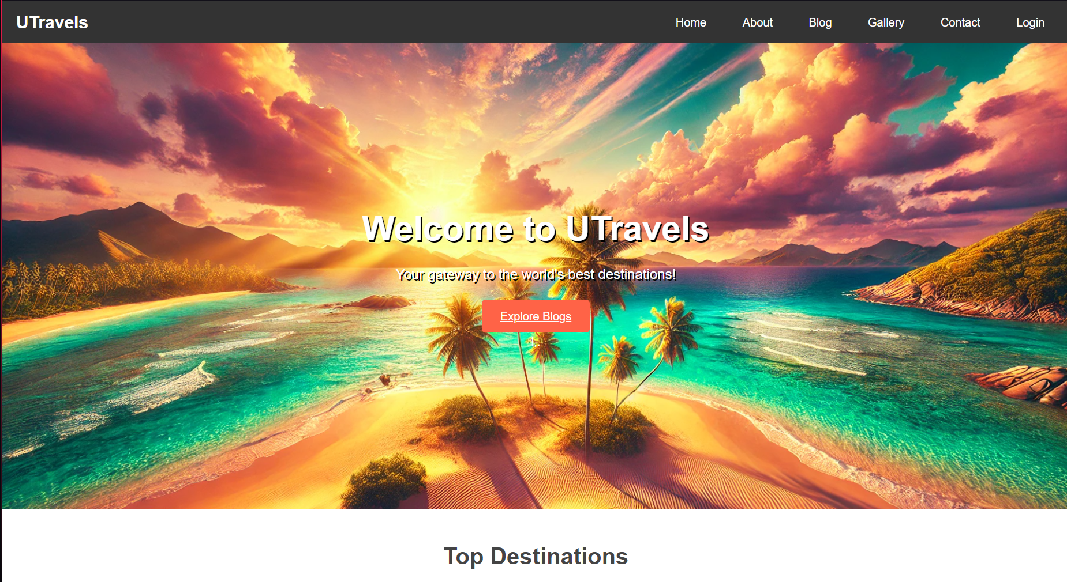

**Screenshot of Mobile Screen (Browser) Responsive Design.**

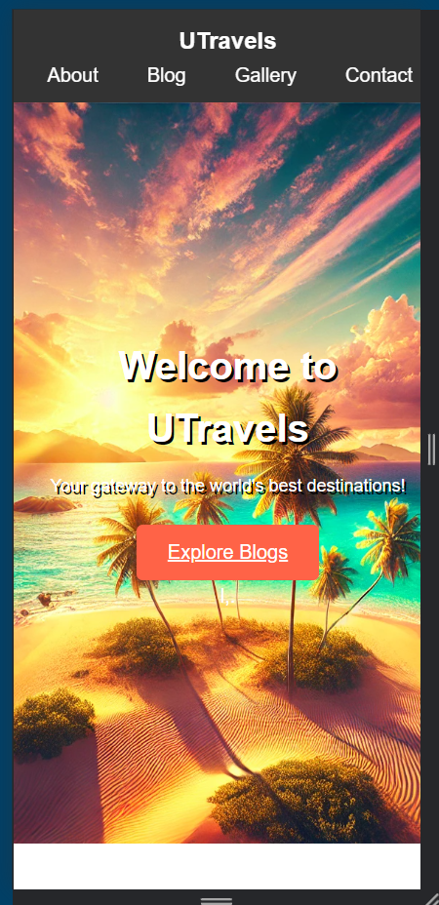

References:  
  
- **OpenAi for Image generation used on Website**