**ABSTRACT**

In automated pollution detection system, we are going to implement a technology that sends a message to vehicle owner that please change your car engine oil its polluting more within limited time and as well as to GOVT. POLLUTION CONTROL AUTHORITY with vehicle and owner detail so authority can put some penalties if they do not change engine oil after given limited time.

Steps of implementation are following Firstly; we will do Teflon coating on car silencer. Secondly; We will put black smoke detector sensor head just near to silence so it can detect black smoke. Thirdly; After sensor detects black smoke it sends signal to GSM module. Fourthly; GSM module will send message to OWNER and as well as AUTHORITY.

**INTRODUCTION**

The rapid development in urban India has resulted in a tremendous increase in the number of motor vehicles. In some cities this has doubled in the last decade. Rapid urbanization and growth of motor vehicles impose a serious effect on human life and the environment in recent years. Motor vehicles are a significant source of urban air pollution and are increasingly important contributors of anthropogenic carbon dioxide and other greenhouse gases. Transport sector contributes a major sector, contributing 90% of total emissions. Air pollution is a serious environmental health threat to humans. Adverse effects range from nausea, difficulty in breathing and skin irritations, birth defects, immune-suppression and cancer. All these situations indicate that air pollution becoming a major problem in Indian context and there is an essential need to build up healthy environment and increase the level of research around the world. The present study is a review of an increase in vehicular pollution in India and its effect on human due to increasing road transport.

**Block Diagram**

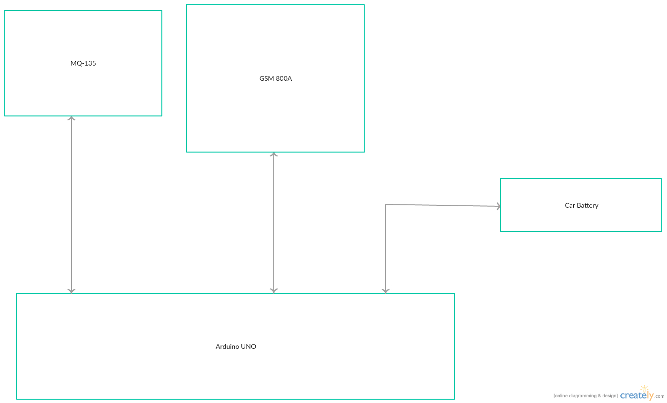

Figure 1. Block Diagram of Automated Pollution Detection Sensor

**SYSTEM ANALYSIS**

Data flow diagram

MQ-135 Sensor Idle state

Send signal 0 to Arduino

Send signal 1 to Arduino

MQ-135 checks for pollution

Car Starts

NO YES

If signal

Arduino receives Signal

0

1

GSM module send message to USER AND RTO

Sends Signal to GSM 800A to send message

**REQUIREMENT SPECIFICATION**

1. Software Requirements

Operating System: Window 98 and above

Software: Arduino Uno

The ATmega328 on the Arduino Uno comes pre burned with a boot loader that allows you to upload new code to it without the use of an external hardware programmer. It communicates using the original STK500 protocol (reference, C header files).

You can also bypass the boot loader and program the microcontroller through the ICSP (InCircuit Serial Programming) header.

The ATmega16U2 (or 8U2 in the rev1 and rev2 boards) firmware source code is available. The ATmega16U2/8U2 is loaded with a DFU boot loader, which can be activated by

* On Rev1 boards connecting the solder jumper on the back of the board (near the map of Italy) and then resetting the 8U2.
* On Rev2 or later boards there is a resistor that pulling the 8U2/16U2 HWB line to ground, making it easier to put into DFU mode.

1. Hardware Requirements

The hardware components used in the railway gate automation system are:

1. Arduino UNO MICRO-CONTROLLER
2. MQ-135 AIR POLLUTION SENSOR
3. GSM 800A
4. **Arduino UNO**

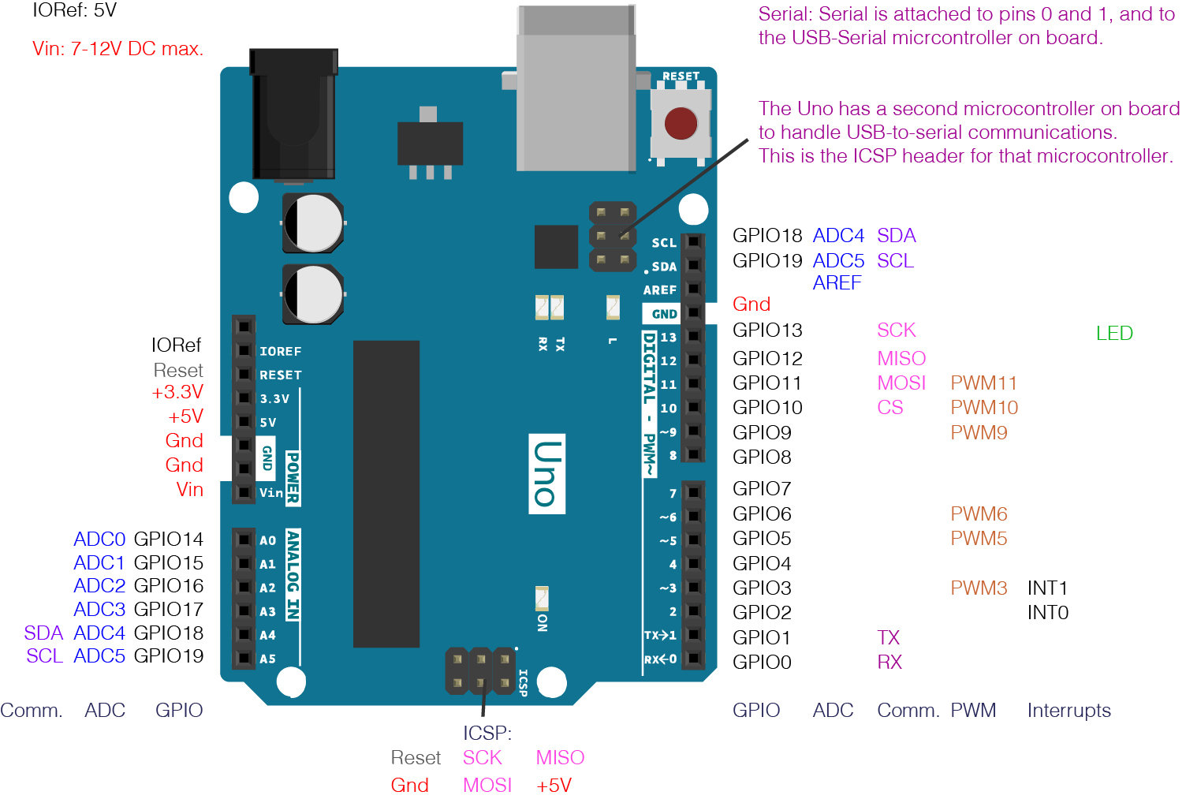

Figure 2. Pin Diagram of ARDUINO UNO

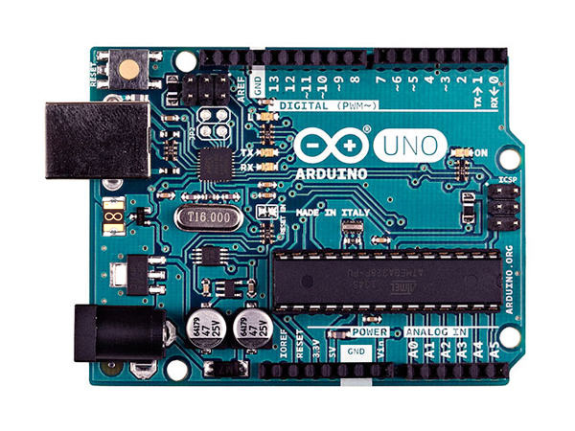

Figure 3. ARDUINO UNO

Arduino UNO is an open source tool which is readily available. The main advantage of using this controller is that it is very easy to implement as it follows the object oriented programming paradigm for the implementation of the code. Any special functionality can be easily shared are interfaced by importing the required library files. It has 14 digital pins and 6 analogue pins which can be used to input or output the data. This controller remains as the heart of our system as monitors the complete working of our model. Our system uses the analogue pins for input from the MQ-135 sensor and the digital pins to output the signals and the commands to the GSM MODULE. And the IDE for this controller is open source software.

1. **MQ-135 Sensor**

Figure 4. MQ-135 sensor Figure 5. Pin Diagram MQ-135 sensor

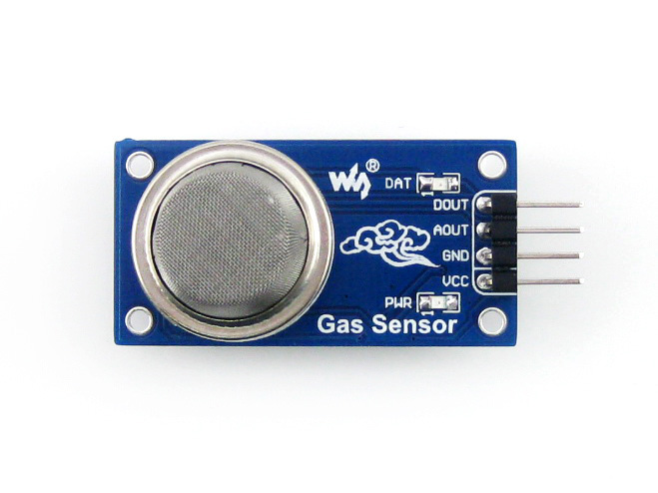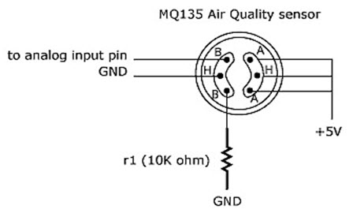

The MQ series of gas sensors utilizes a small heater inside with an electro chemical sensor these sensors are sensitive to a range of gasses are used at room temperature. MQ135 alcohol sensor is a Sno2 with a lower conductivity of clean air.

The MQ135 gas sensor has high sensitivity in ammonia, sulfide, benze steam, smoke and in other harm full gas. It is low cost and suitable for different applications. There are different types of alcohol sensors like MQ-2, MQ-3, MQ-4, MQ-5, MQ-6, etc.

1. **GSM 800 A**

GSM: Global System for Mobile communication

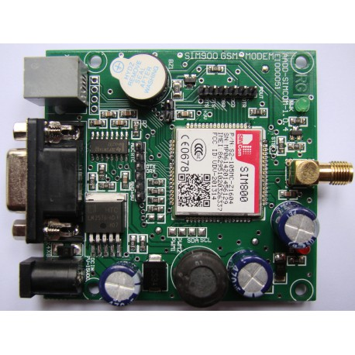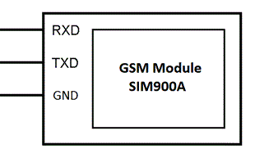

GSM is a standard developed by the European Telecommunications Standards Institute (ETSI) to describe the protocols for second-generation (2G) digital cellular networks used by mobile phones.

GSM digitizes and compresses data, then sends it down a channel with two other streams of user data, each in its own time slot. It operates at either the 900 MHz or 1800 MHz frequency band.

**LITERATURE REVIEW**

**AUTOMATED SYSTEM FOR AIR POLLUTION DETECTION AND CONTROL IN VEHICLES**

In [1] The air gets polluted by the emission of significant amount of gases. The main cause is increase in population. When the population increases the usage of vehicles which emits the gases also increases. This causes the air pollute in high level. When there is a lot of emission by the vehicle, it leads to death, diseases and more problems to humans. Thus the vehicles should be maintained in a controlled way.

This project helps in detecting if the pollution is increased or not. A pollution control circuit is used in controlling the pollutants in the vehicle. Many sensors like smoke sensor, temperature sensor, GSM, GPS kind of devices. All these sensors are combined and connected to a controller. Here ARM7 processor is used and a controller board is made where all the devices are combined and work accordingly. When the vehicle attains certain threshold level the vehicle engine gets switched off automatically and a SMS is sent to the user and sent to predefined number stored in the memory through the GSM module. The GPS module also helps in locating the vehicle.

PROJECT OVERVIEW:

Firstly, the power supply is switched on. The sensors are initialized. Then the GPS module is initialized. Then the GSM module is initialized. The motor then gets switched on. If the sensors are exposed to gases, then the smoke sensor gets excited. Else, the control goes to the motor. If the sensor output is greater than the set point the control goes to the microcontroller. Else checking if the sensors are exposed to gases. If the motor does not get switched on then the power supply is switched on. The microcontroller has three outputs.

* It triggers the alarm and also displays in the LCD.
* GPS will allow the nearest service station and sends the vehicle location through GSM to predefined number.
* Fuel supply to the engine gets off
* Motor is switched off.

Thus the pollution level is displayed in the LCD and when it exceeds the set point it gives a buzzer indication. Thus the system can be used highly. The carbon percentage in the smoke which is released by the vehicle is detected with the help of smoke detectors because of the combustion of fuel. The maximum percentage of the carbon content which is present in the smoke is checked and carbon is being detected which is passed on to the microcontroller.

The temperature sensor which is used here helps in sensing the temperature in the vehicle. The percentage of the carbon and the temperature is checked by the controller. The threshold level is checked and it triggers the system. The pollution control office gets the SMS through the GSM and finally the engine comes to Fault state.

The block diagram is represented here. Semiconductor sensor MQ-2 is used to detect the smoke whose range is 300ppm to 10000ppm. LM35 temperature sensor monitors the engine temperature and prevents it from getting over heated.

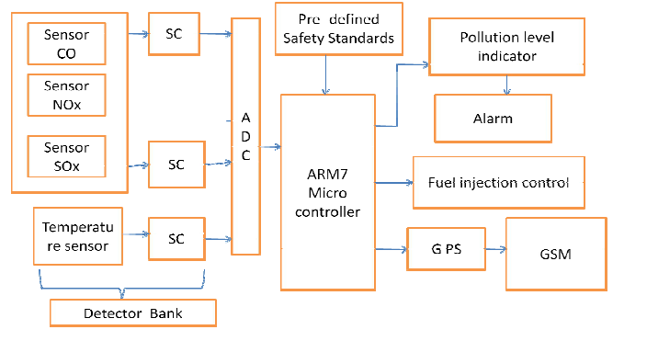

The microcontroller does mainly three functions namely:

* Comparison
* Timer
* Triggering

Two inputs are taken. The first one is from the smoke sensor and the other is the pre-defined threshold value specified by the government. The timer circuit is being triggered and an alarm is being set such that the driver of the vehicle will get informed when the smoke sensor output is more than the threshold value. The sensor used here is semiconductor sensor MQ-2 and the range is 300ppm to 10000ppm. ARM 7 microprocessor is being connected to CO sensor. This has low conductivity in the cleaning environment.

The conductivity is increased when the sensor is exposed to pollutants. This disables the motor. The circuit is connected to the GSM module and an automatic SMS is generated. Global system for mobile technology is used to establish cellular connection (SIM900).

It is used for transmitting the mobile voice and data services and sends message to the predefined mobile number.

**AN INTELLIGENT AIR POLLUTANT VECHICLE TRACKER SYSTEM USING GAS SENSOR AND GPS**

In [2], The usage of vehicles has increased more in the current generation. It has its own effects where it can be taken positively and negatively. On the positive side it is said that it is more useful for the people who work in companies. On the negative side it is said that it pollutes the air which causes pollution. The pollution central board of India has fixed some standardized values in which the main problem occurs such that it should not go beyond the values. Due to the improper maintenance of vehicles, incomplete combustion of fuel is supplied to the engine. The emission from the vehicles cannot be completely avoided but it can be reduced.

This paper aims at using those semi-conductor sensors at the emission outlets of vehicles which detects the level of pollutants and also indicates this level with a meter. The vehicle will stop at a certain period of time when buzz is indicated that the limit has been breached due to increase level of emission. An extra time will be given for the driver to park the vehicle nearby. At this time, the GPS is helpful in locating the nearest service stations.

After the timer is out, the fuel in the engine is reduced and is given to the nearby mechanic or service stations. The microcontroller is the main system which is monitored and controlled for synchronisation and execution. Thus this project helps in reducing the pollution and will also benefit the society. Air pollutants which are inhaled cause serious issues to the living beings affects mostly the respiratory system. These pollutants are also present in the soil, plants, water and also present in the sea level which affects the living beings.

The block diagram is given below:

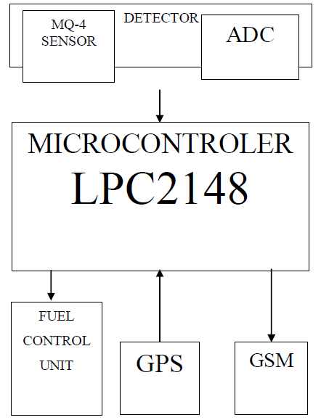

The block diagram mainly consists of the following elements:

1. Detector

2. Microcontroller

3. Fuel Control unit

4. Global Positioning System (GPS)

5. Global system for mobile communication(GSM)

First, the detector will detect the smoke level. Then the microcontroller LPC2148 receives the values. Then an alarming message will be displayed that the vehicle is going to stop after 2KM. The GPS will track the GPS values and it will be sent to the RTO only when after the vehicle has stopped.

The flowchart of the system is given here:

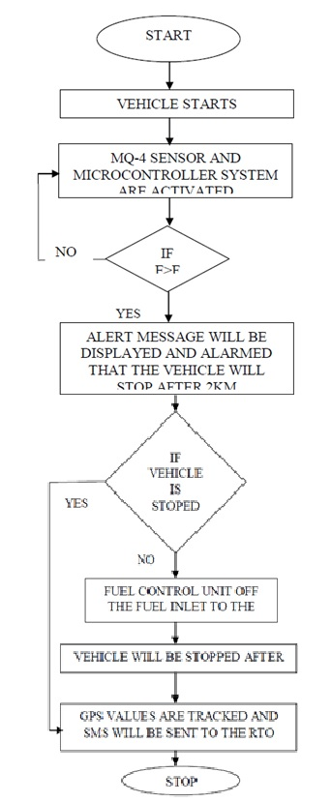

Two main things are followed here:

The first reason is that this system will be

Concept of detecting the level of Pollution and indicating it to the driver.

Several environmental problems are faced since there is increase in level of pollution.

There will be a huge population, who do not take the pollution from their vehicles seriously, which has already resulted in several environmental problems such Ozone layer depletion and so on. So, this system will be highly beneficial is curbing this problem.

The second reason is that this system will be

One of the greatest improvements in technology to keep the Environment free from vehicular emission and bring it to a halt if the Pollution level is more than the Standards mentioned by the Government. The fact that this system is just an add-on, as it does not change the configuration of the engine by any means, will make it easier to employ this system in the existing vehicles. The same concept can also be extended to industries.

**HUMAN SAFETY AND AIR POLLUTION DETECTION IN VEHICLES**

In [3], There are lot of vehicles increasing in the industries where the population is also increasing. Vehicles are needed to save time but it does not mean to pollute the air or kill people with harmful emissions. When the threshold level is crossed it becomes the problem. There is an automated control system for pollution detection in vehicle. Sensor system sensors in the system detect the level of pollution which is controlled by the emission of hazards.

If the level of pollution goes beyond the threshold level the vehicle will stop by the indication of the buzz and few minutes are given for the driver to park the vehicle nearby. During the time the GPS will start locating the vehicle. Vehicle should stop after the particular time otherwise it should be given to the service station. Thus Microcontroller controls everything.

The green house effects are caused by the greenhouse gases due to the air pollution. The oxides of carbon which are emitted can be sensed by the semiconductor gases. This affects the human health and lungs. Soil, water, plant also contains these gases.

Sensors like MQ7 and alcohol sensor identifies the concentration of CO gas and alcohol. The sensor sends the input to the microcontroller when the concentration value is more than the referred value. Thus the microcontroller displays the result on the LCD and also passes the trigger pulse to motor to stop the injection of fuel.

The block diagram is given below:

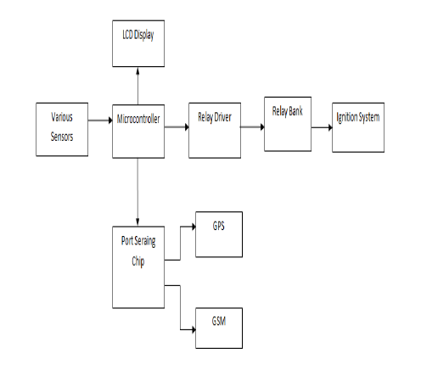

The features are:

* High performance RISC CPU
* Power-On Reset (POR)
* Power-Up Timer (PWRT)
* Programmable code protection
* Power saving SLEEP mode

MQ co sensor:

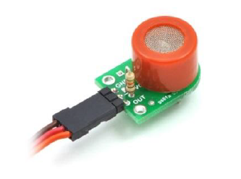

GSM modem connection:

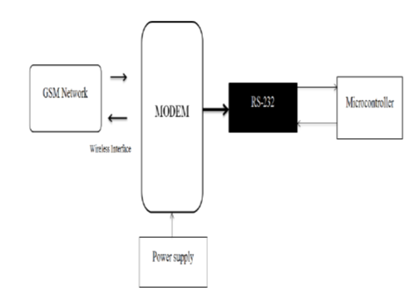

Thus the concept of detecting high level of pollution and providing the indication to the driver is given in this paper. When there is increase in population and in vehicle this proposed system will be useful.

**CONCLUSION**

The concept of detecting the level of Pollution and indicating it to the driver is implemented. There is an increase in the level of Pollution over the last couple of decades, leading to several Environmental problems. There will be a huge population, who do not take care of the pollution from their vehicles seriously, which has already resulted in several environmental problems such as Ozone layer depletion and so on. Hence this system will be highly beneficial in curbing this problem.

**REFERENCES**

1. Anita Kulkarni, Ravi Teja, “Automated System for Air Pollution Detection and Control in Vehicles”, International Journal of Advanced Research in Electrical, Electronics and Instrumentation Engineering, Vol. 3, Issue 9, September 2014 , ISSN (Print) : 2320 – 3765 ISSN (Online): 2278 – 8875.
2. M. RANGA REDDY, S. SARATH CHANDR, “AN INTELLIGENT AIR POLLUTANT VECHICLE TRACKER SYSTEM USING GAS SENSOR AND GPS”, International Journal of Computer Science information and Engineering., Technologies ISSN 2277-4408 || 01102014-049, IJCSIET-ISSUE4-VOLUME3-SERIES2.
3. Nishigandha Athare, Prof. P. R. Badadapure, “HUMAN SAFETY AND AIR POLLUTION DETECTION IN VEHICLES”, International Journal of Technical Research and Applications e-ISSN: 2320-8163, www.ijtra.com Volume 3, Issue 6 (November-December, 2015), PP. 176-179.