Lab10-Session2-YUKUI YE-READMEFILE

All tasks have been done.

Task1:

Source code : sc_example.c

Userlevel syscall: task1.c

Result :

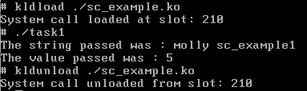

Task2:

Source code: sc_refcount.c

Userlevel syscall: task2.c

Result:

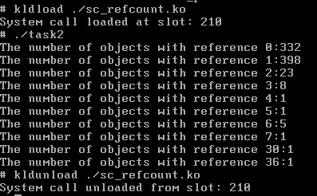

Task3:

Source code : sc_procinfor.c

Userlevel syscall: task3.c