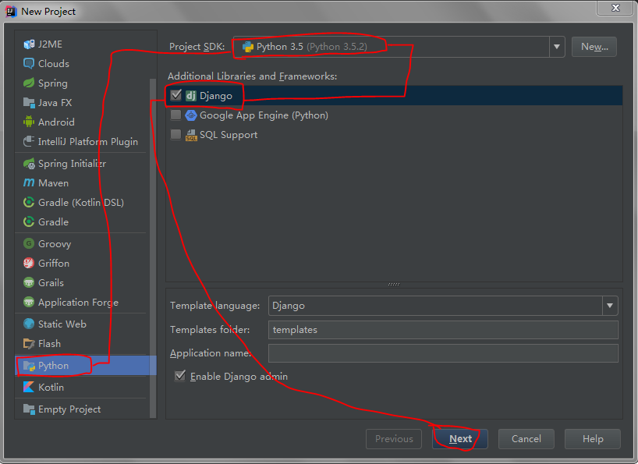

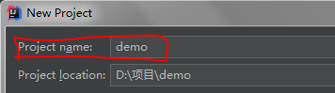

1.在Terminal中执行

python manage.py startapp cmdb

这样就创建了一个叫做cmdb的APP，django自动生成“cmdb”文件夹

2.修改setting.py文件中

例：

2.1.DATABASES

**'default'**: {  
 **'ENGINE'**: **'django.db.backends.mysql'**,  
 **'NAME'**: **'hhdjangotest'**,  
 **'USER'**: **'root'**,  
 **'PASSWORD'**: **'huanghai1995'**,  
 **'HOST'**:**'localhost'**,  
 **'PORT'**:**'3306'**,  
 **'CHARSET'**: **'utf-8'**,  
}

2.2.INSTALLED_APPS

**'cmdb'**,

2.3.MIDDLEWARE

注释掉 **'django.middleware.csrf.CsrfViewMiddleware'**,

2.4.静态文件使用

STATICFILES_DIRS = (  
 os.path.join(BASE_DIR, **'static'**),  
)

添加到下方

STATIC_URL = **'/static/'**

同时新建static目录

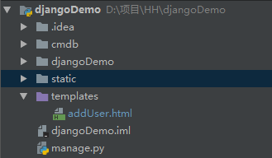

3.在templates文件夹中加index.html

例：

<!DOCTYPE **html**>  
<**html lang="en"**>  
<**head**>  
 <**meta charset="UTF-8"**>  
 <**title**>测试</**title**>  
</**head**>  
<**body**>  
<**h1**>用户输入</**h1**>  
<**form action="/index/test/" method="post"**>  
 <**input type="text" name="username"**/>  
 <**input type="password" name="password"**/>  
 <**input type="submit" value="提交"**/>  
</**form**>  
<**hr** />  
<**h1**>用户展示</**h1**>  
<**table border="1"**>  
 <**thead**>  
 <**th**>用户名</**th**>  
 <**th**>密码</**th**>  
 </**thead**>  
 <**tbody**>  
 {% **for each in data** %}  
 <**tr**>  
 <**td**>{{ **each**.**user** }}</**td**>  
 <**td**>{{ **each**.**pswd** }}</**td**>  
 </**tr**>  
 {% **endfor** %}  
 </**tbody**>  
</**table**>  
</**body**>  
</**html**>

4.修改models.py

例：

**class** UserInfo(models.Model):  
 user = models.CharField(max_length=32)  
 pswd = models.CharField(max_length=32)

5.修改urls.py中urlpatterns

例：

path(**r'index/test/'**,views.index),  
path(**r'rt_html/'**,views.rt_html),  
path(**r'rt_json/'**,views.rt_json)

6.修改views.py

例：

**def** index(request):  
 *# return render(request, 'index.html', )  
 # return HttpResponse('Hello world!')* user_list = []  
 **if** request.method == **'POST'**:  
 username = request.POST.get(**'username'**,**None**)  
 password = request.POST.get(**'password'**,**None**)  
 user_list.append({**'user'**: username, **'pswd'**: password})  
 models.UserInfo.objects.create(user=username,pswd=password)  
 user_list = models.UserInfo.objects.all()  
 **return** render(request, **'index.html'**, {**'data'**: user_list})  
  
**def** rt_html(request): *# 返回静态页面* **return** render(request, **'index.html'**, )  
  
**def** rt_json(request): *# 返回json* test = {**'name'**:**'晃晃'**,**'age'**:21}  
 **return** HttpResponse(json.dumps(test), content_type=**"application/json"**)

1. 新建数据库

先新建数据库，再进入manage.py所在目录，执行

python manage.py makemigrations

python manage.py migrate