**### download & install rclone**

curl -O https://downloads.rclone.org/rclone-current-linux-amd64.zip

rclone config

**### recuperare nome bucket**

oc get ob obc-openshift-logging-loki-bucket-odf -o yaml | grep bucketName

**### recuperare valori access_key_id e access_key_secret**

kubectl-view-secret logging-loki-odf -n openshift-logging access_key_id

kubectl-view-secret logging-loki-odf -n openshift-logging access_key_secret

root@grpi-ocp-kv00:~$ kubectl-view-secret ac-quay-datastore AWS_ACCESS_KEY_ID

ecoPeHYEEuJwzU7rUSoE

root@grpi-ocp-kv00:~$ kubectl-view-secret ac-quay-datastore AWS_SECRET_ACCESS_KEY

H8i5MZQk/kWdlAD5vNPJyfjaIejNoHvUYXvaTliR

**### recuperare URL S3**

oc get route s3 -n openshift-storage

oppure 🡪

#### oc get secret acm-hub-backup -n openshift-storage -o jsonpath='{.data.AWS_ACCESS_KEY_ID}' | base64 --decode   
#### oc get secret acm-hub-backup -n openshift-storage -o jsonpath='{.data.AWS_SECRET_ACCESS_KEY}' | base64 --decode  
#### oc get obc acm-hub-backup -o yaml -n openshift-storage | grep "bucketName" | awk '{print $2}'  
#### oc get route -n openshift-storage | grep "s3-openshift" | awk '{print $2}'

**### scelte menu interattivo**

n, 4 ,4 ,1,, invio x 4

ATTENZIONE!!! La parte in **rosso è il nome scelto in fase di config rclone**

**ES:**

**### cancella file più vecchi di 10 giorni (dry-run)[application]**

rclone delete **odf**:loki-bucket-odf-160a998c-7bbd-41bc-8fb6-903022e648c0/application --no-check-certificate --min-age 10d --progress --dry-run

...

2024/04/19 17:18:33 NOTICE: f3f9154f37b67ca0/18ebcd10c46:18ebcd30369:f58c7f86: Skipped delete as --dry-run is set (size 1.829Mi)

2024/04/19 17:18:33 NOTICE: f3f9154f37b67ca0/18ebcd3014a:18ebcd47a5c:30b3a41e: Skipped delete as --dry-run is set (size 1.830Mi)

2024/04/19 17:18:33 NOTICE: f3f9154f37b67ca0/18ebcd3014e:18ebcd47a5c:d51658e7: Skipped delete as --dry-run is set (size 1.830Mi)

Transferred: 0 B / 0 B, -, 0 B/s, ETA -

Checks: 72181 / 72181, 100%

Deleted: 72181 (files), 0 (dirs)

Elapsed time: 9m56.6s

**### cancella file più vecchi di 10 giorni (dry-run)[infrastructure]**

rclone delete **odf**:loki-bucket-odf-160a998c-7bbd-41bc-8fb6-903022e648c0/infrastructure --no-check-certificate --min-age 10d --progress --dry-run

...

2024/04/19 17:18:59 NOTICE: ff45214ef94670c0/18eaef9c740:18eaef9c742:e507d3bb: Skipped delete as --dry-run is set (size 4.212Ki)

2024/04/19 17:18:59 NOTICE: ffde65227b0ca9ff/18eafd83822:18eafd85387:c11fc03: Skipped delete as --dry-run is set (size 2.733Ki)

2024/04/19 17:18:59 NOTICE: ffee21ba6379afd0/18eaf1b3644:18eaf1b3645:9f135816: Skipped delete as --dry-run is set (size 1.747Ki)

Transferred: 0 B / 0 B, -, 0 B/s, ETA -

Checks: 100465 / 100465, 100%

Deleted: 100465 (files), 0 (dirs)

Elapsed time: 13m22.5s

**### check file e directory**

rclone delete **odf**:loki-bucket-odf-160a998c-7bbd-41bc-8fb6-903022e648c0/infrastructure --no-check-certificate --min-age 10d --progress --dry-run

2024/04/19 18:16:09 NOTICE: 10afefb7aa2832e5/18ec2fc9549:18ec37786ad:edcf913b: Skipped delete as --dry-run is set (size 30.403Ki)

prendo la prima riga

**### check per i file**

rclone lsl **odf**-coll:loki-bucket-odf-d5c96b00-57b8-4ef0-8222-71a5e2c4d3f6/infrastructure/13370128163c2cce --no-check-certificate

**### check per le directory**

rclone lsd **odf**:loki-bucket-odf-160a998c-7bbd-41bc-8fb6-903022e648c0 --no-check-certificate

**### check spazio**

rclone size **odf**:loki-bucket-odf-160a998c-7bbd-41bc-8fb6-903022e648c0/infrastructure --no-check-certificate

rclone size **odf**:loki-bucket-odf-160a998c-7bbd-41bc-8fb6-903022e648c0/application --no-check-certificate

**### Console**

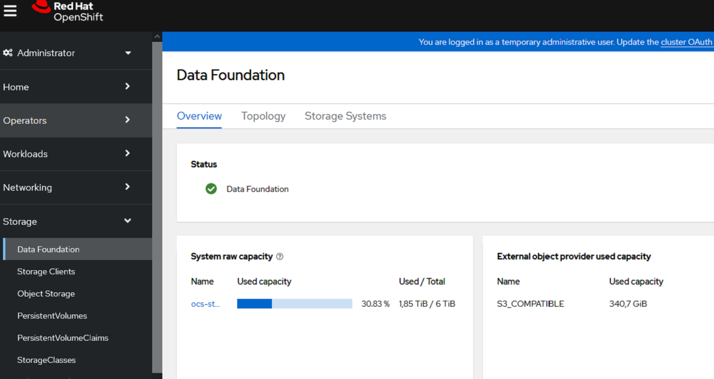

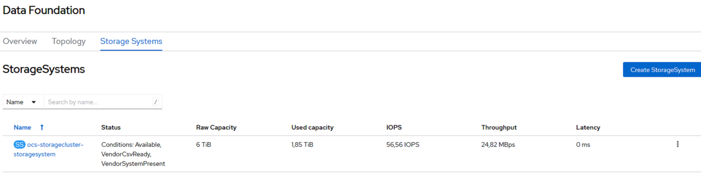

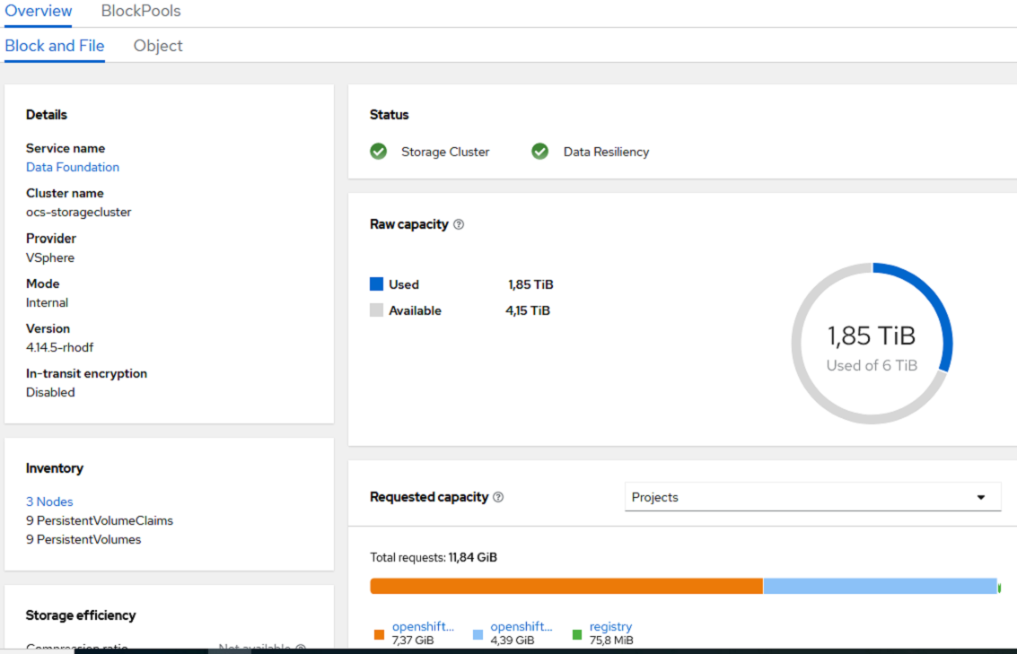

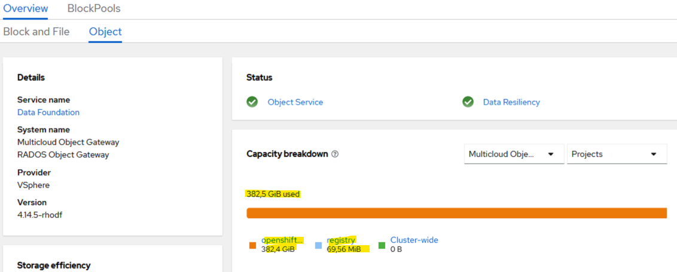

**Delete Stale Data**

Data cannot be deleted in this state of the cluster because any kind of write operation(s) to the cluster is not allowed in FULL state. To be able to delete any stale data, the ODF cluster needs to taken out of the FULL state first.

* Execute the following command to increase the FULL threshold (e.g. from the default 85% to 88%)

$ oc rsh -n openshift-storage $(oc get pods -n openshift-storage -o name -l app=rook-ceph-operator) ceph osd set-full-ratio 0.88 -c /var/lib/rook/openshift-storage/openshift-storage.config

* As soon as the cluster is out from FULL state, delete as much unnecessary / stale data as possible.
* Once the data is deleted and the ODF cluster is out of FULL state, revert the FULL threshold to default.

$ oc rsh -n openshift-storage $(oc get pods -n openshift-storage -o name -l app=rook-ceph-operator) ceph osd set-full-ratio 0.85 -c /var/lib/rook/openshift-storage/openshift-storage.config

**Esempio COLLAUDO 🡪**

Execute the following command to increase the FULL threshold (e.g. from the default 85% to 88%)

oc rsh -n openshift-storage $(oc get pods -n openshift-storage -o name -l app=rook-ceph-operator) ceph osd set-full-ratio 0.88 -c /var/lib/rook/openshift-storage/openshift-storage.config

rclone delete odf-collaudo:loki-bucket-odf-d5c96b00-57b8-4ef0-8222-71a5e2c4d3f6/infrastructure --no-check-certificate --min-age 5d –progress

rclone delete odf-collaudo:loki-bucket-odf-d5c96b00-57b8-4ef0-8222-71a5e2c4d3f6/application --no-check-certificate --min-age 5d –progress

As soon as the cluster is out from FULL state, delete as much unnecessary / stale data as possible.

Once the data is deleted and the ODF cluster is out of FULL state, revert the FULL threshold to default.

oc rsh -n openshift-storage $(oc get pods -n openshift-storage -o name -l app=rook-ceph-operator) ceph osd set-full-ratio 0.85 -c /var/lib/rook/openshift-storage/openshift-storage.config