**OPENSHIFT – POC QUAY User and Repository Management**

Contents

PROPOSTA TEMPLATE QUAY 1

Overview MODELLO 2

1. Creare un namespace un cluster Openshift target: 3

2. Login a Quay dell’ambiente target con un utenza amministrativa : 3

3. Creazione nuova Organization su Quay : 3

4. Sincronizzazione degli utenti (Team Member) da LDAP utilizzando il Group DN appropriato per il progetto: 3

5. Creazione Robot Account per attività DevOps : 4

[per i dettagli, vedere capitolo “Overview MODELLO”] 4

6. Creazione secret Robot Account e relativo ImagePullSecret da referenziare nei deployment del progetto: 5

7. Login a Quay con utenza amministrativa: 6

8. Test image pull : 6

9. Push Immagine e creazione Repository “on push” : 6

10. Verifica creazione repository su QUAY con Security Scan “Active” : 6

ANNEX : 8

**PROPOSTA TEMPLATE QUAY**

Il documento ha lo scopo di illustrare gli step, qui eseguiti in ambiente di Collaudo, sia per quanto riguarda Openshift che per quanto riguarda Quay, necessari alla gestione di utenti e repository privati sul registry Quay.

## 

## **Overview MODELLO**

[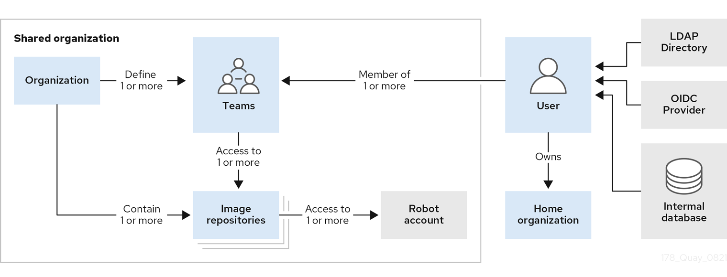](https://access.redhat.com/webassets/avalon/d/Red_Hat_Quay-3.11-Use_Red_Hat_Quay-en-US/images/b52482ede5f5b394740cba6808136d4f/178_Quay_architecture_0821_tenancy_model.png)

* **Organizations** provide a way of sharing repositories under a common namespace that does not belong to a single user. Instead, these repositories belong to several users in a shared setting, such as a company.
* **Teams** provide a way for an Organization to delegate permissions. Permissions can be set at the global level (for example, across all repositories), or on specific repositories. They can also be set for specific sets, or groups, of users.
* **Users** can log in to a registry through the web UI or a by using a client, such as Podman or Docker, using their respective login commands, for example, $ podman login. Each user automatically gets a user namespace, for example, <quay-server.example.com>/<user>/<username>, or quay.io/<username>.
* **Superusers** have enhanced access and privileges through the **Super User Admin Panel** in the user interface. Superuser API calls are also available, which are not visible or accessible to normal users.
* **Robot accounts** provide automated access to repositories for non-human users like pipeline tools. Robot accounts are similar to OpenShift Container Platform **Service Accounts**. Permissions can be granted to a robot account in a repository by adding that account like you would another user or team.

1. **Creare un namespace un cluster Openshift target:**

1. **Login a Quay dell’ambiente target con un’utenza amministrativa:**

1. **Creazione nuova Organization su Quay :**

1. **Sincronizzazione degli utenti (Team Member) da LDAP utilizzando il Group DN appropriato per il progetto:**

1. **Creazione** **Robot Account per attività DevOps :**

**[per i dettagli, vedere capitolo “Overview MODELLO”]**

1. **Creazione secret Robot Account e relativo ImagePullSecret da referenziare nei deployment del progetto:**



1. **Login a Quay con utenza amministrativa:**



1. **Test image pull :**

1. **Push Immagine e creazione Repository “on push” :**

1. **Verifica creazione repository su QUAY con Security Scan “Active” :**

1. **Set grant opportune per il Robot Account creato :**

1. **Creazione deployment a partire da un’immagine di Quay interno per simulare un deploy via pipeline :**



1. **Verifica che i pod partano correttamente :**



# **ANNEX :**

*** Activate Scan ***



*** Add insecure registry ***

oc edit image.config.openshift.io/cluster

Rif : <https://docs.projectquay.io/use_quay.html>

<https://access.redhat.com/documentation/en-us/red_hat_quay/3.11>

<https://access.redhat.com/documentation/en-us/red_hat_quay/3.11/html/use_red_hat_quay/index>