课程设计报告

课程名称： Python语言基础
指导教师： 曹洪军，马强
实 验 室： 信息馆202
专业班级： 计算机软件二班
姓 名： 张三丰
学 号： 20164081XXX

计算机科学系
电气与信息学院

基于Django的学生管理系统（平台）

说明文档

开发环境
数据库：SQLite
前台界面：Html5+CSS3+javascript
后台：python3.5+Django2.2.13

部署说明
系统启动步骤
1. 安装Django2.2.13
2. 命令行进入项目根目录
3. 执行命令 python3 manage.py runserver 8000
4. 用浏览器打开http://127.0.0.1/8000

测试账号
1. 学生：xs02 密码：02
2. 老师：ls01 密码：01

主要功能包括
- 学生/教师登录
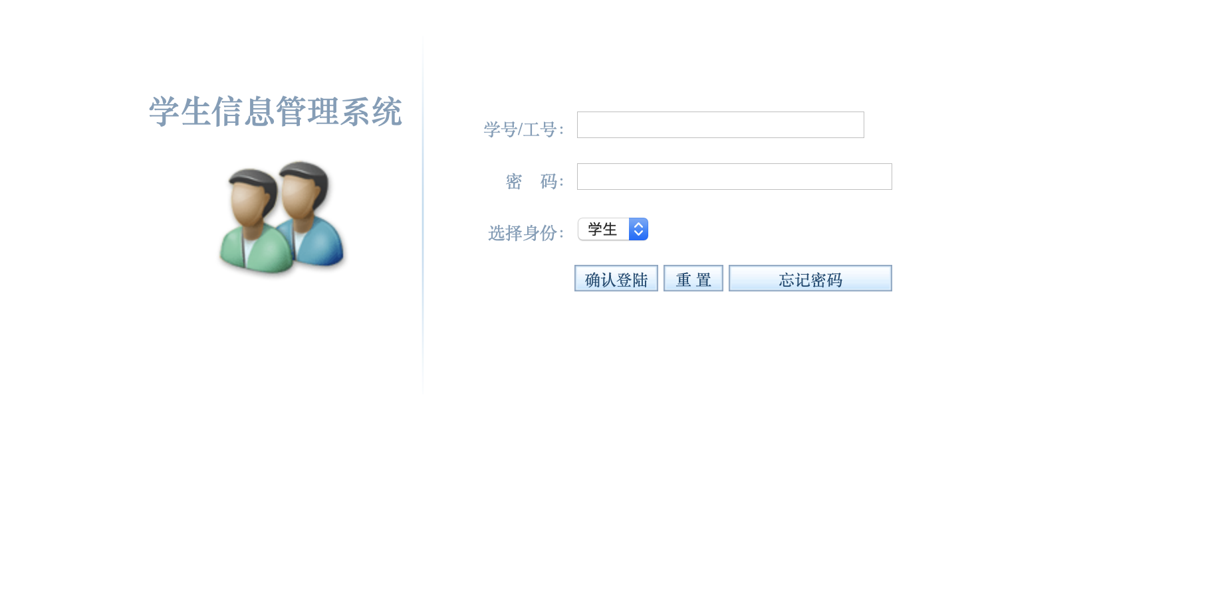
学生登录成功后可以查看修改自己的详细信息、老师登录后可以增删改查所有学生的信息。

- 学生查看自己的信息
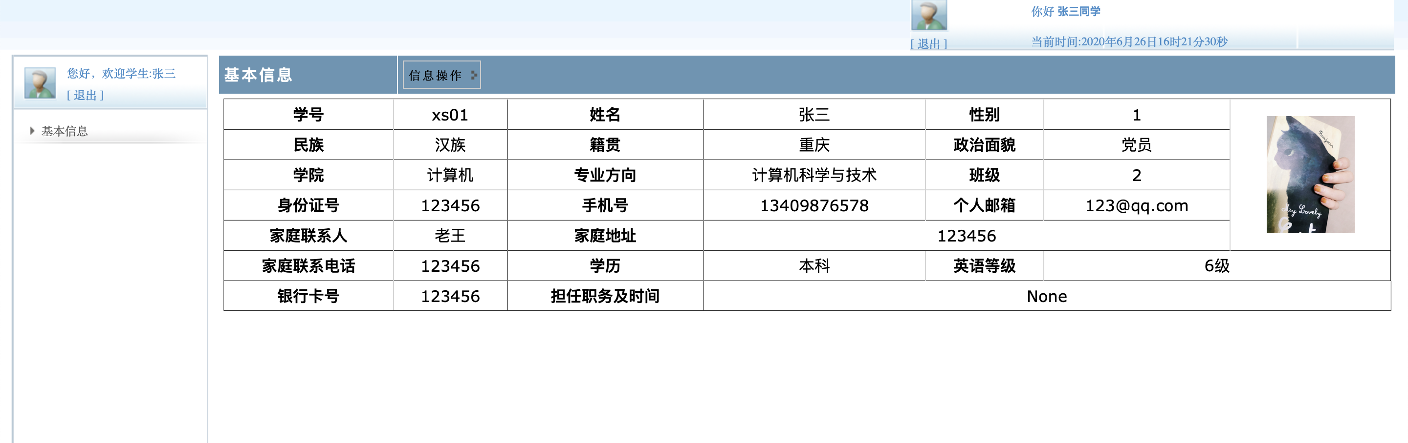

- 学生修改自己的常用信息
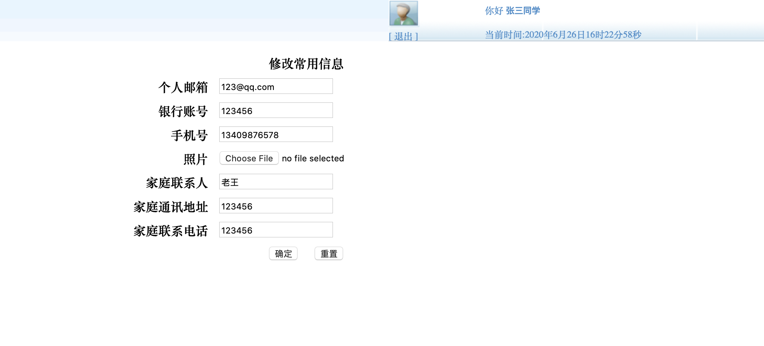

- 教师查看学生表所有信息并以表格形式显示到页面
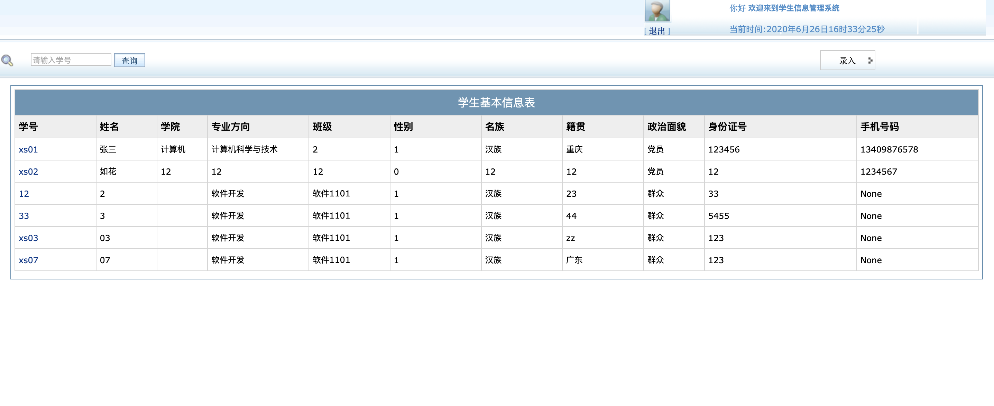

- 向学生表插入记录
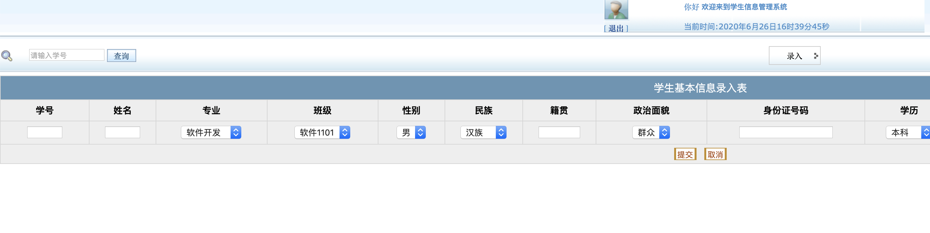

- 修改指定id（学号）的学生信息
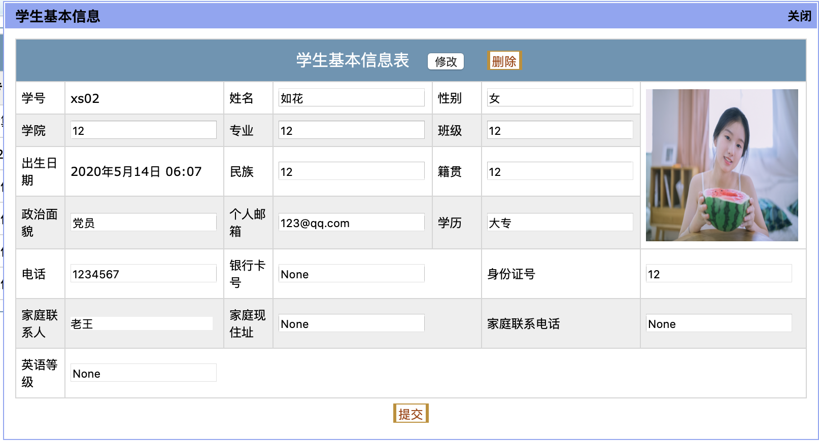

- 删除指定id（学号）的学生信息
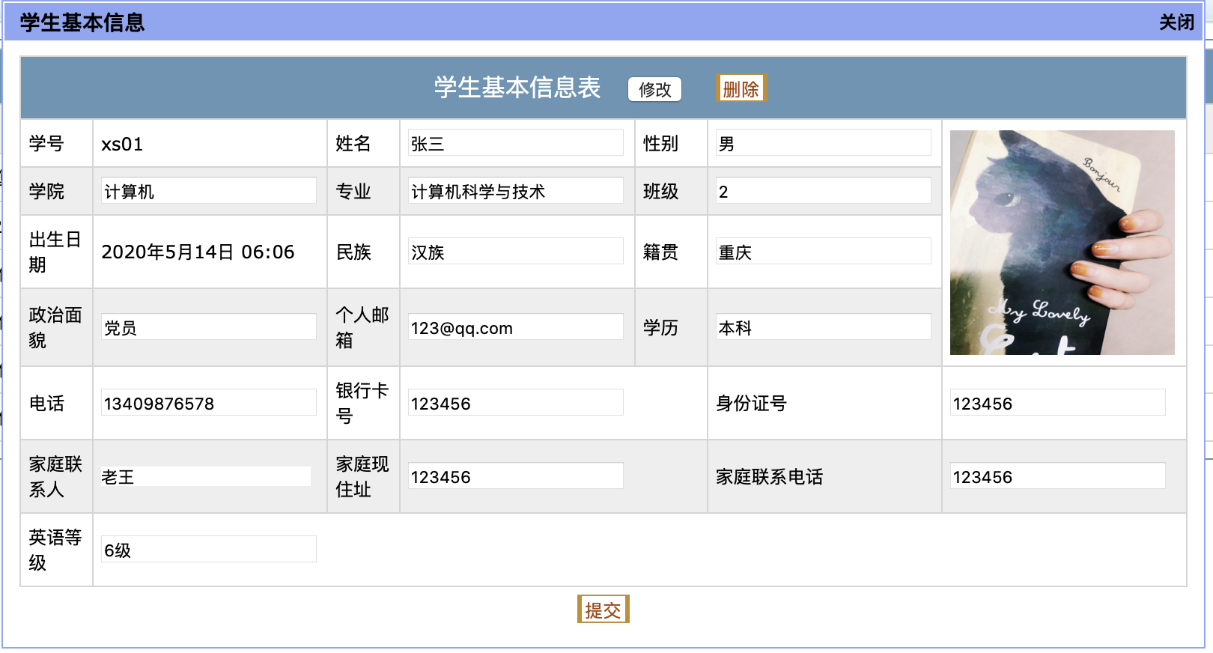

代码介绍
- Models

学生信息表模型，定义了学生信息表的字段，包括学号、姓名、性别、出生日期等信息。
class StuBasicInfo(models.Model):
studentNo = models.ForeignKey(to=StuInfo, on_delete=models.CASCADE, related_name="stu_stu",verbose_name='学号')
studentName = models.CharField(max_length=18, verbose_name='姓名')
birthday=models.DateTimeField(verbose_name='出生日期')
ClassNo = models.ForeignKey(to=ClassInfo, on_delete=models.CASCADE, verbose_name='班级编号',related_name='cla')
ClassName=models.CharField(max_length=30,verbose_name='班级')
major=models.CharField(max_length=30,verbose_name='专业方向')
college=models.CharField(max_length=30,verbose_name='学院')
sex=models.IntegerField(verbose_name='性别')
nation=models.CharField(max_length=30,verbose_name='名族')
hometown=models.CharField(max_length=84,verbose_name='籍贯')
political=models.CharField(max_length=24,verbose_name='政治面貌')
idcard=models.CharField(max_length=18,verbose_name='身份证号')
telephone=models.CharField(max_length=11,blank=True, null=True,verbose_name='手机号')
email = models.CharField(max_length=50, blank=True, null=True, verbose_name='个人邮箱')
emailOnly = models.IntegerField(verbose_name='邮箱绑定',default=0)
family = models.CharField(max_length=30, blank=True, null=True,verbose_name='家庭联系人')
address = models.CharField(max_length=60, blank=True, null=True,verbose_name='家庭地址')
fphone = models.CharField(max_length=18, blank=True, null=True,verbose_name='家庭联系电话')
photo = models.FileField(upload_to="media/",blank=True, null=True, verbose_name='照片')
eduBackground = models.CharField(max_length=12, blank=True, null=True,verbose_name='学历')
englishlevel = models.CharField(max_length=12, blank=True, null=True,verbose_name='英语等级')
bankcard = models.CharField(max_length=25, blank=True, null=True, verbose_name='银行卡号')
class Meta:
verbose_name = '学生基本信息表'
verbose_name_plural = '学生基本信息表'
def __str__(self):
return self.studentName

- Views
- 查看学生表所有信息
class StudentBaseView(View):
def get(self, request):
username = request.session['username']
role = request.session['role']
if role==1:
try:
Stuinfo = StuBasicInfo.objects.get(studentNo=username)
except Exception as e:
Stuinfo = []
return render(request, 'main/files/Student/std_BasicInfo.html', {'Stuinfo': Stuinfo})
else:
try:
classinfo=ClassInfo.objects.get(teacherNo=username)
Stuinfo_list=classinfo.cla.all()
except Exception as e:
Stuinfo = []
return render(request, 'main/files/teacher/class_basicInfo.html',
{"Stuinfo_list": Stuinfo_list, "classinfo": classinfo})

- 向学生表插入记录
class StudentAdd(View):
def post(self,request):
data= json.loads(request.POST.get("datats"))
for obj in data:
ct=ClassInfo.objects.first()
try:
sf=StuInfo.objects.get(studentNo=obj[0])
except:
sf=StuInfo()
sf.studentNo=obj[0]
sf.save()
sno = obj[0]
sname = obj[1]
profession = obj[2]
classname = obj[3]
sex = obj[4]
nation = obj[5]
birthPlace = obj[6]
political = obj[7]
IDCard = obj[8]
schooling = obj[9]
cete = obj[10]
job = obj[11]
bandCard = obj[12]
stuinfo = StuBasicInfo()
stuinfo.studentNo=sf
stuinfo.ClassNo=ct
stuinfo.studentName=sname
stuinfo.major=profession
stuinfo.ClassName=classname
stuinfo.sex=sex
stuinfo.nation=nation
stuinfo.hometown=birthPlace
stuinfo.political=political
stuinfo.idcard=IDCard
stuinfo.eduBackground=schooling
stuinfo.englishlevel=cete
stuinfo.bankcard=bandCard
stuinfo.remarks=job
stuinfo.birthday=datetime.datetime.now()
stuinfo.save()
return HttpResponse('{"status":"success","msg": "11！"}', content_type='application/json')

- 修改指定id（学号）的学生信息
def post(self,request):
data=QueryDict(request.POST.get("data"))
sno=data.get("studentNo")
Stuinfo = StuBasicInfo.objects.filter(studentNo=sno).first()
political = data.get("political")
eduBackground = data.get("eduBackground")
telephone = data.get("telephone")
bankcard = data.get("bankcard")
family = data.get("family")
address = data.get("address")
englishlevel = data.get("englishlevel")
fmaily_phone = data.get('family_phone')
id_card = data.get('id_card')
email = data.get('email')
hometown = data.get('hometown')
nation = data.get('nation')
college = data.get('college')
major = data.get('major')
class_name = data.get('class_name')
sex = data.get('sex')
student_name = data.get('student_name')
Stuinfo.political = political
Stuinfo.eduBackground = eduBackground
Stuinfo.telephone = telephone
Stuinfo.family = family
Stuinfo.address = address
Stuinfo.bankcard = bankcard
Stuinfo.englishlevel=englishlevel
Stuinfo.fphone = fmaily_phone
Stuinfo.idcard = id_card
Stuinfo.email = email
Stuinfo.hometown = hometown
Stuinfo.nation = nation
Stuinfo.college = college
Stuinfo.major = major
Stuinfo.ClassName = class_name
Stuinfo.sex = 1 if sex == "男" else 0
Stuinfo.studentName = student_name
Stuinfo.save()
return HttpResponse('{"status":"success","msg": "修改成功！"}', content_type='application/json')

- 删除指定id（学号的）学生信息
def post(self,request):
data=QueryDict(request.POST.get("data"))
sno=data.get("studentNo")
Stuinfo = StuBasicInfo.objects.filter(studentNo=sno).first()
is_delete = request.POST.get("is_delete", False)
if is_delete:
Stuinfo.delete()
return HttpResponse('{"status":"success","msg": "删除成功！"}', content_type='application/json')

- Templates
- 显示所有学生信息class_basicInfo.html, 部分代码示例如下
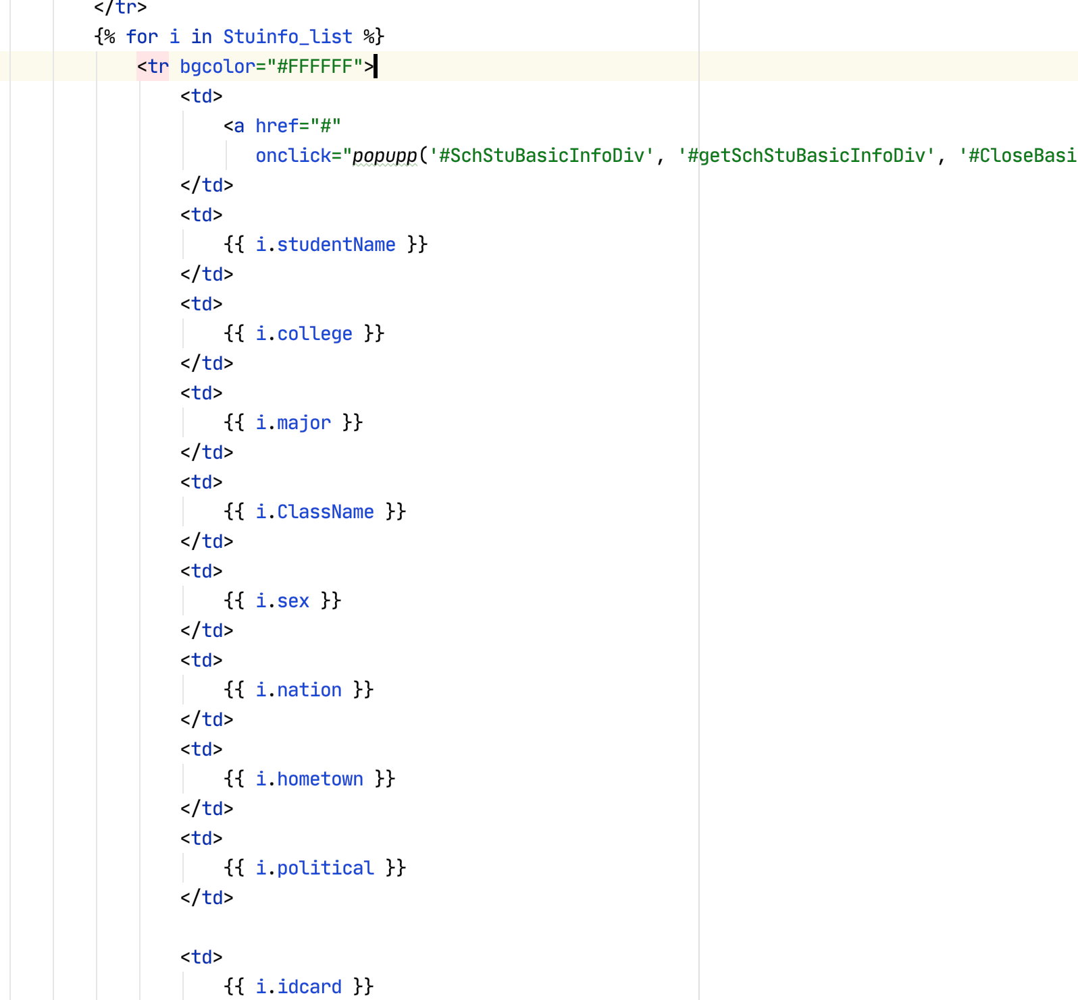

- 添加学生记录class_advanceInfo.html
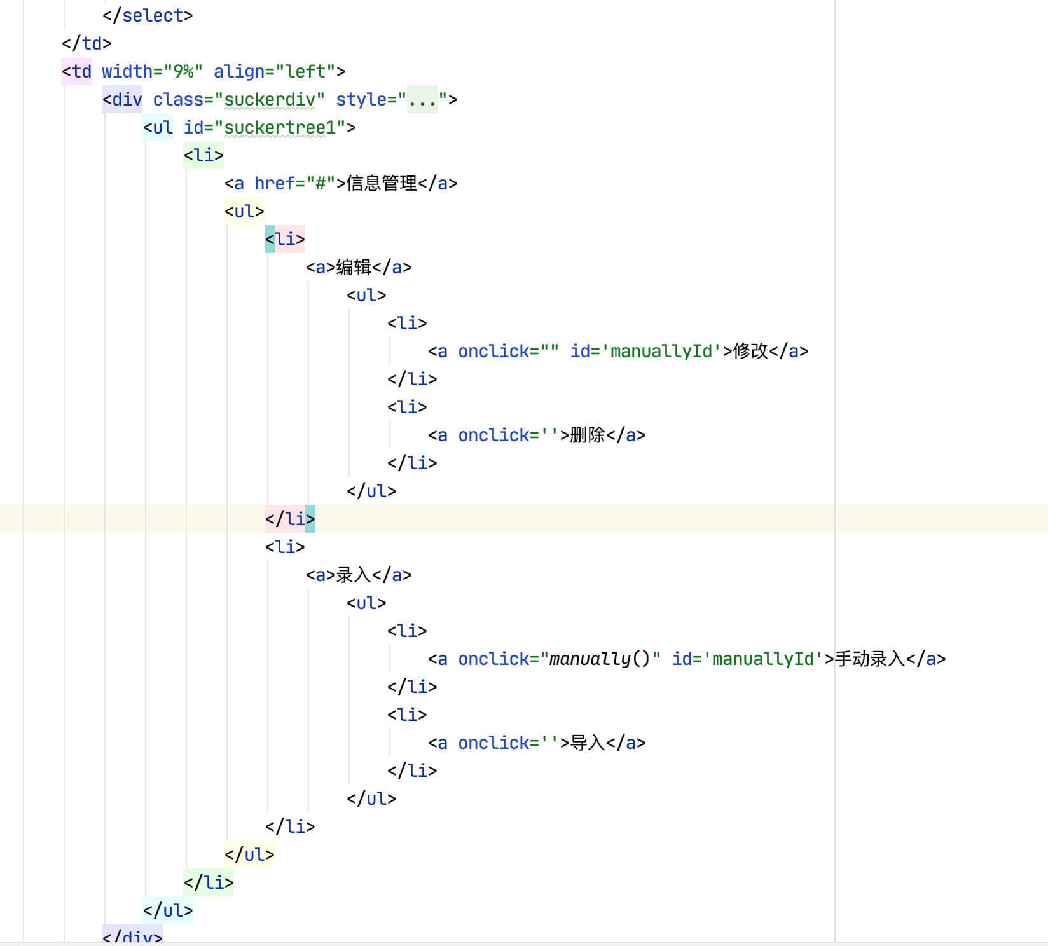

- 修改指定id（学号）学生信息detail.html
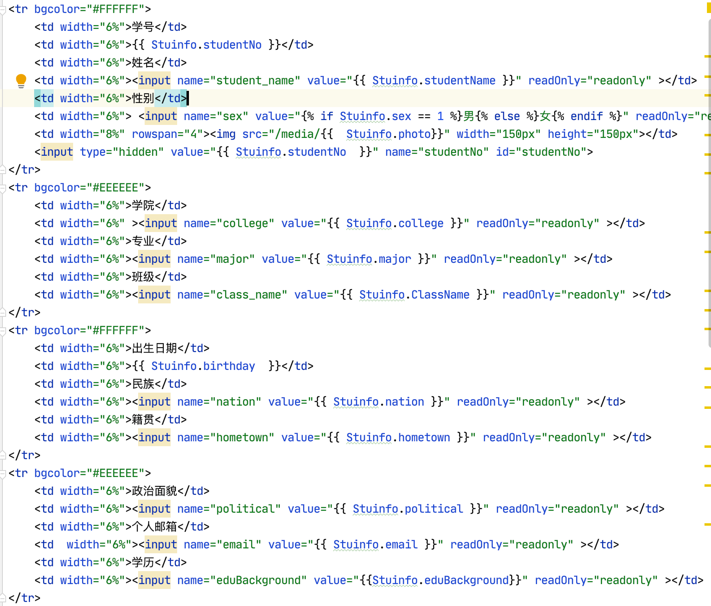

- 删除指定id（学号）的学生信息class_basicInfo.html
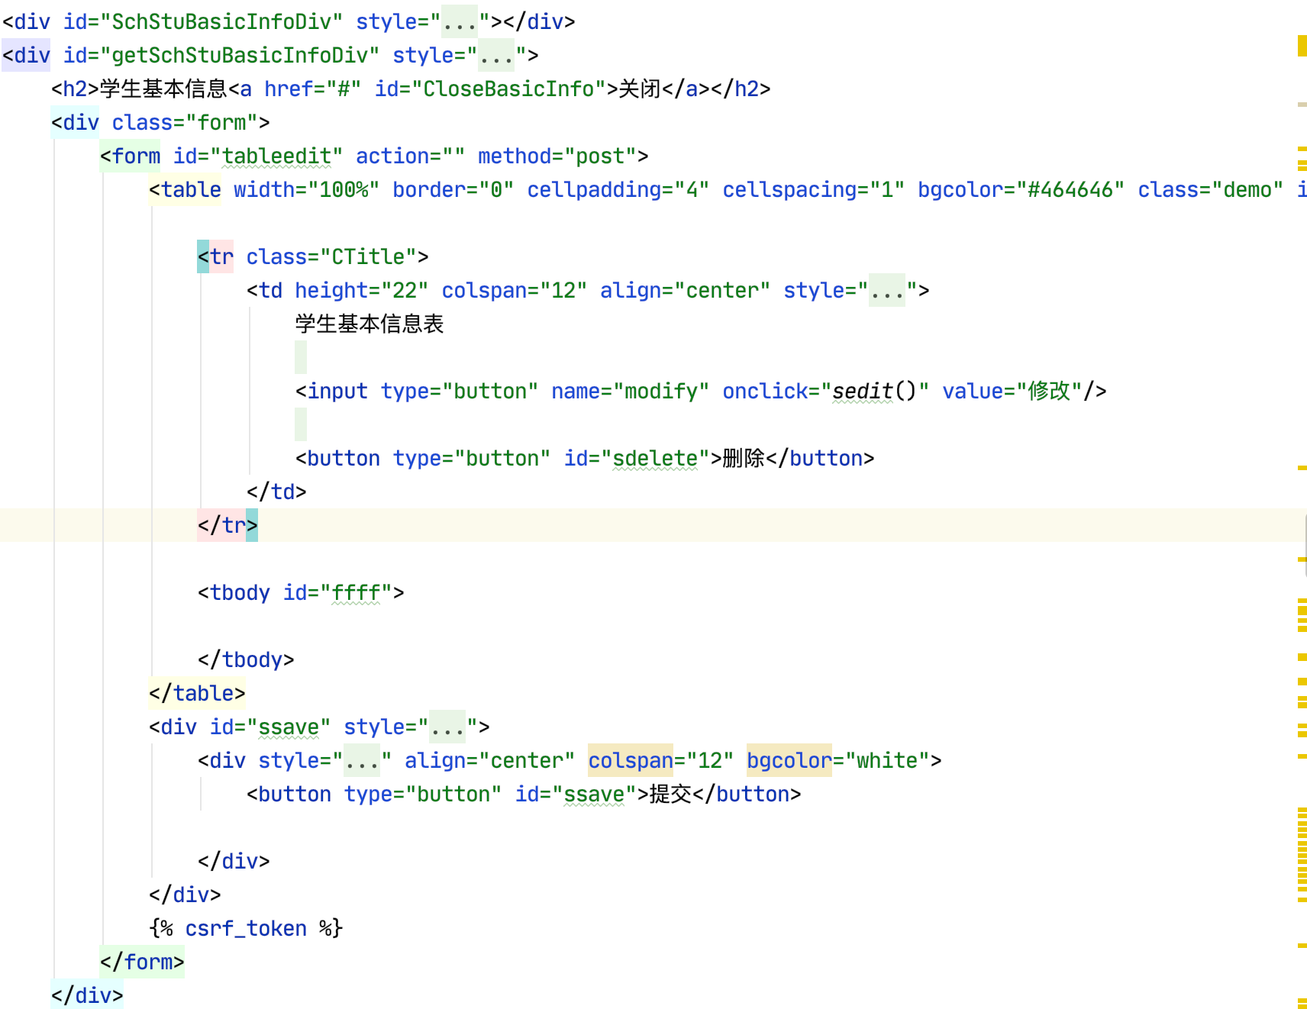

在school.js定义了删除按钮响应函数

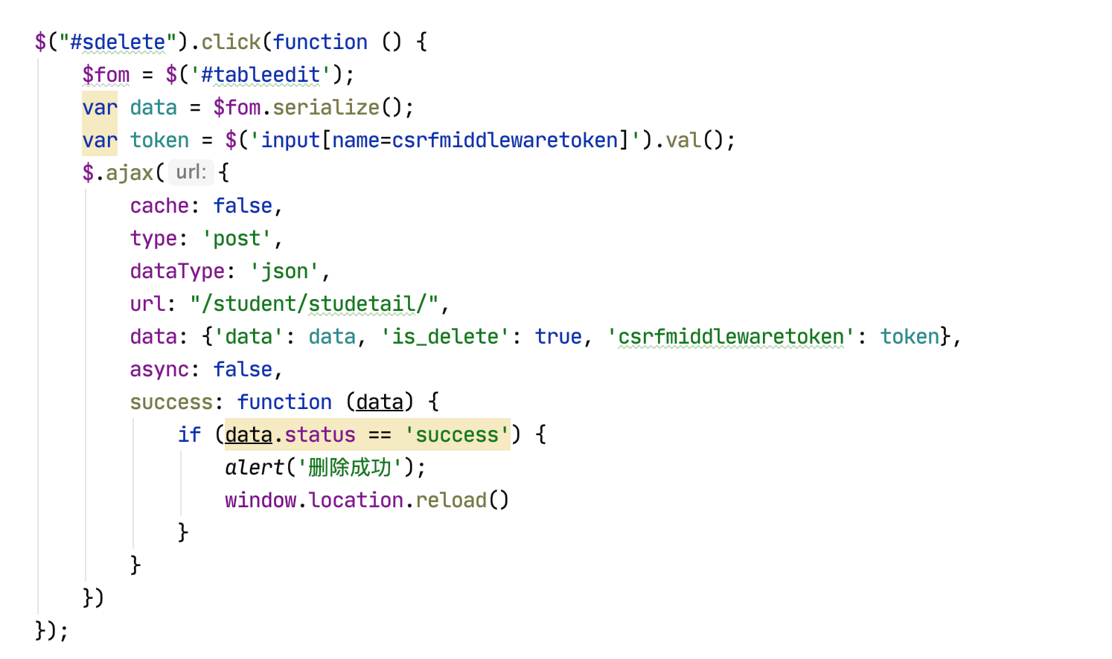

数据库设置
使用Django自带的SQLite3数据库
