BÁO CÁO THỰC HÀNH LAB 1  
OBJECT ORIENTED PROGRAMMING

Name: Đinh Việt Quang – Student ID: 20215235

The Very First Java Programs

**2.2.1 Write, compile the first Java application:**

**2.2.2 Write, compile the first dialog Java program.**

**2.2.3 Write, compile the first input dialog Java application**

**2.2.4 Write, compile, and run the following example:**

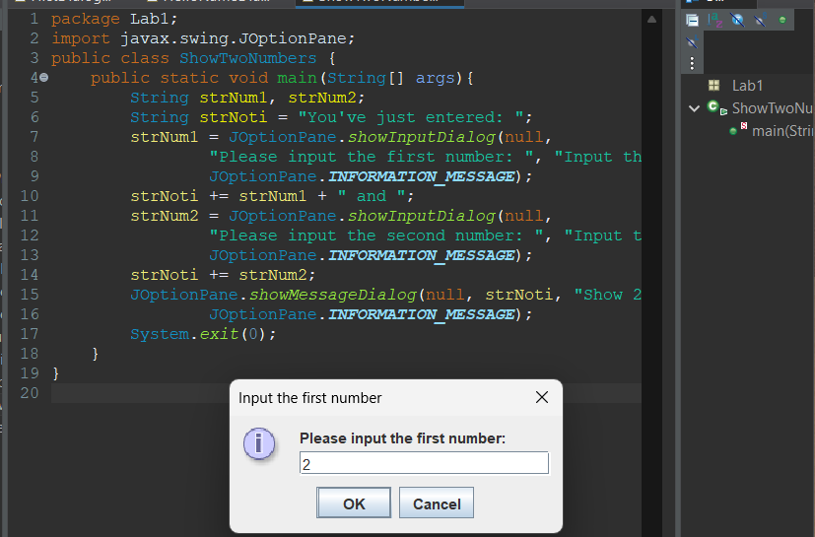

**2.2.5 Write a program to calculate sum, difference, product, and quotient of 2 double numbers which are entered by users.**

**Notes**

* To convert from String to double, you can use

**double num1 = Double.parseDouble(strNum1)**

* Check the divisor of the division

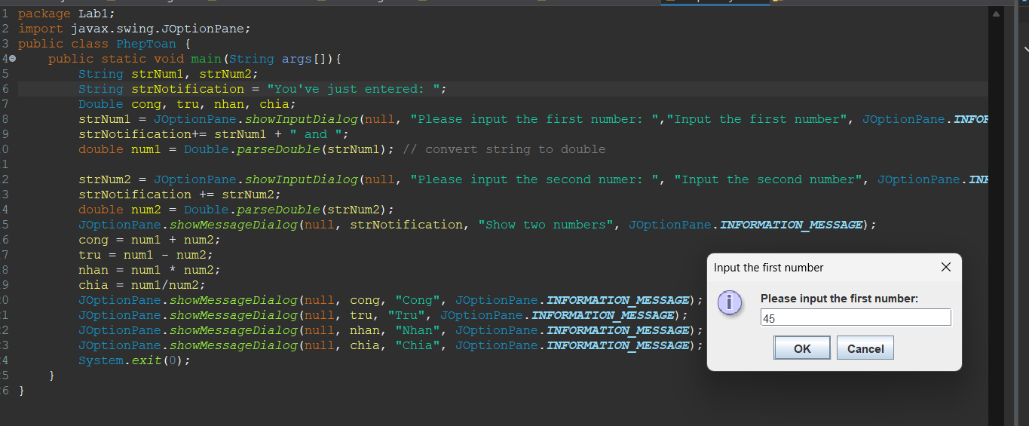

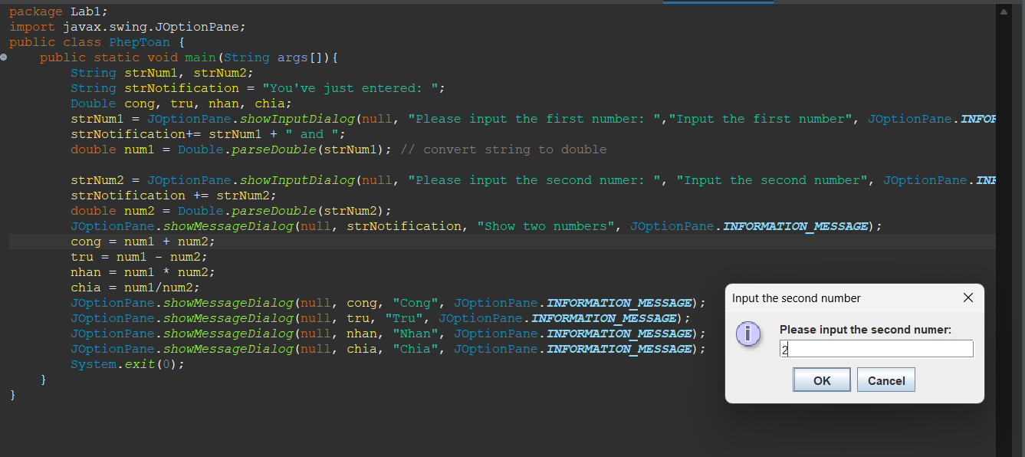

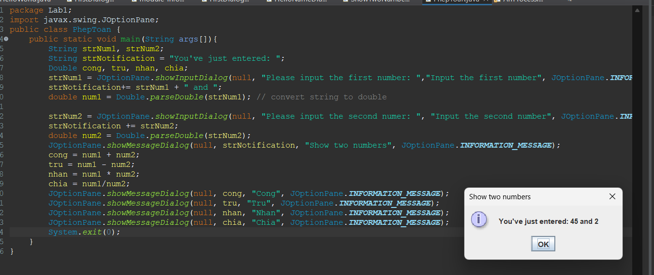

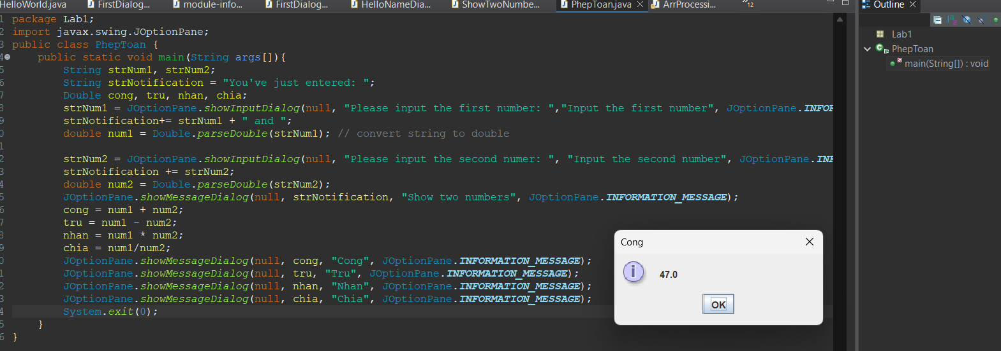

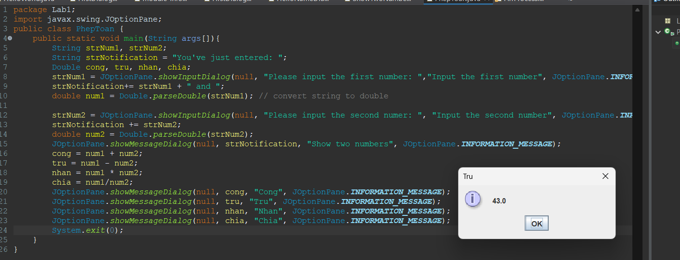

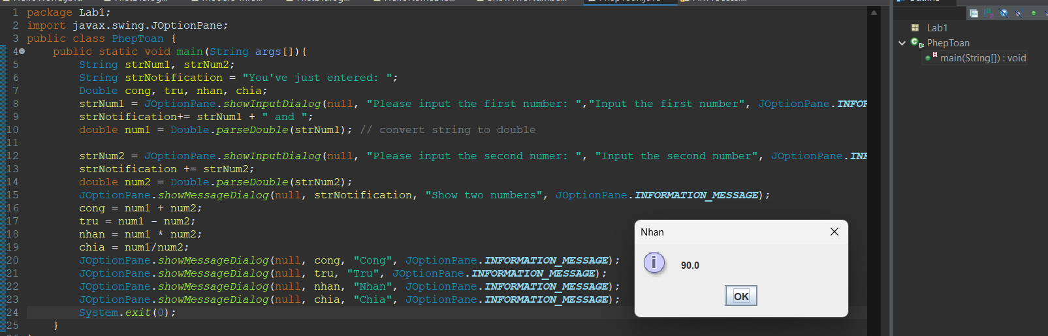

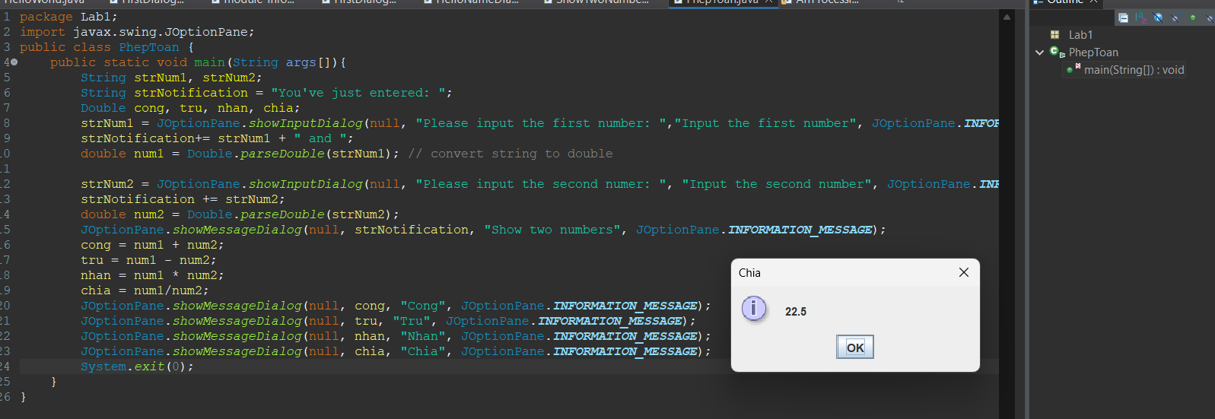

**2.2.6. Write a program to solve:**

**- The first-degree equation (linear equation) with one variable:**

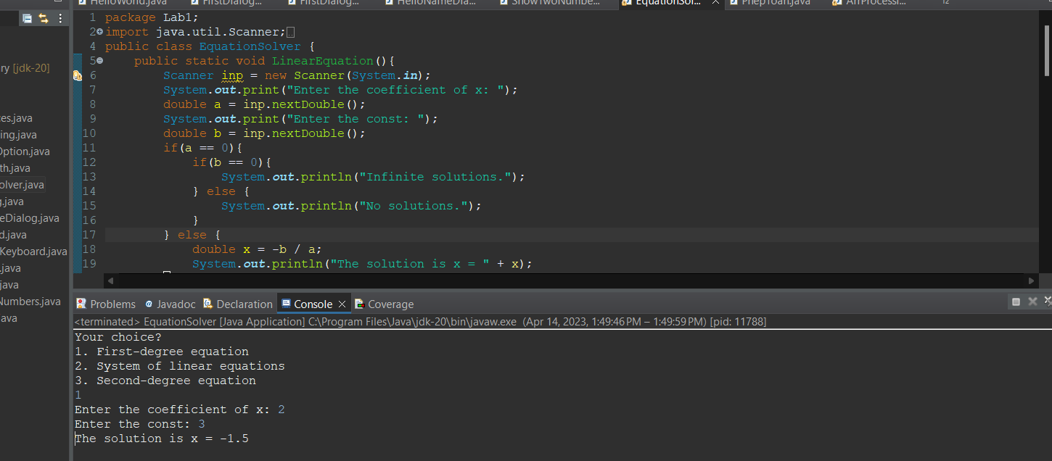

**- The system of first-degree equations (linear system) with two variables:**

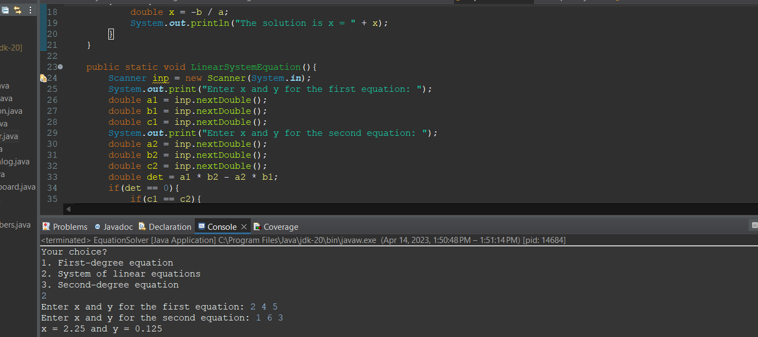

**- The second-degree equation with one variable:**

**6.1 Write, compile and run the ChoosingOption program:**

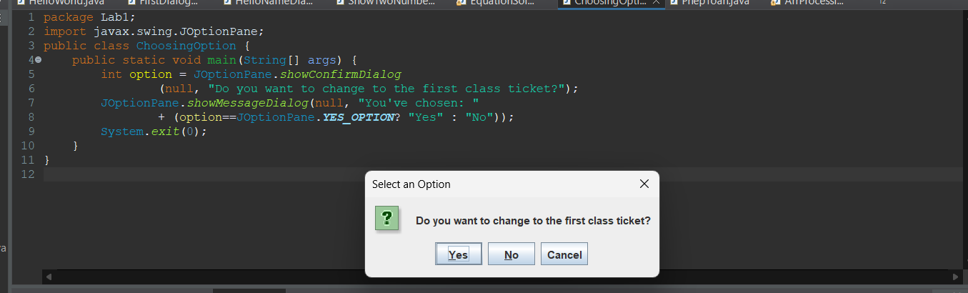

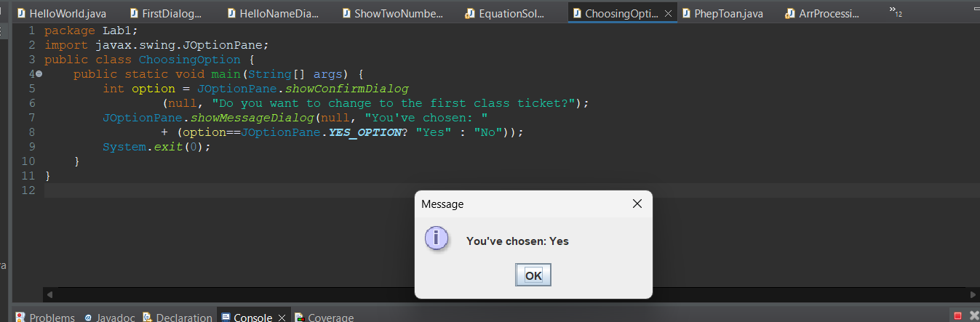

**6.2 Write a program for input/output from keyboard**

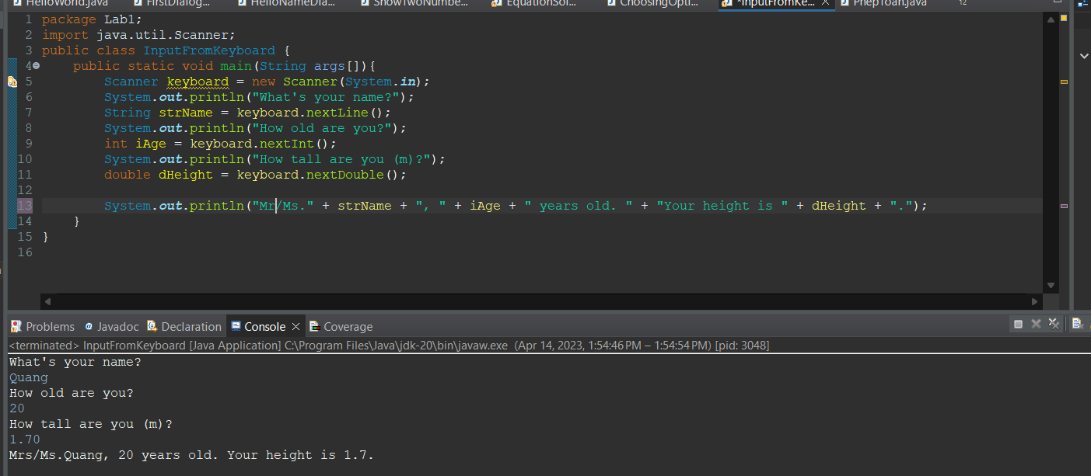

**6.3 Write a program to display a triangle with a height of n stars (*), n is entered by users.**

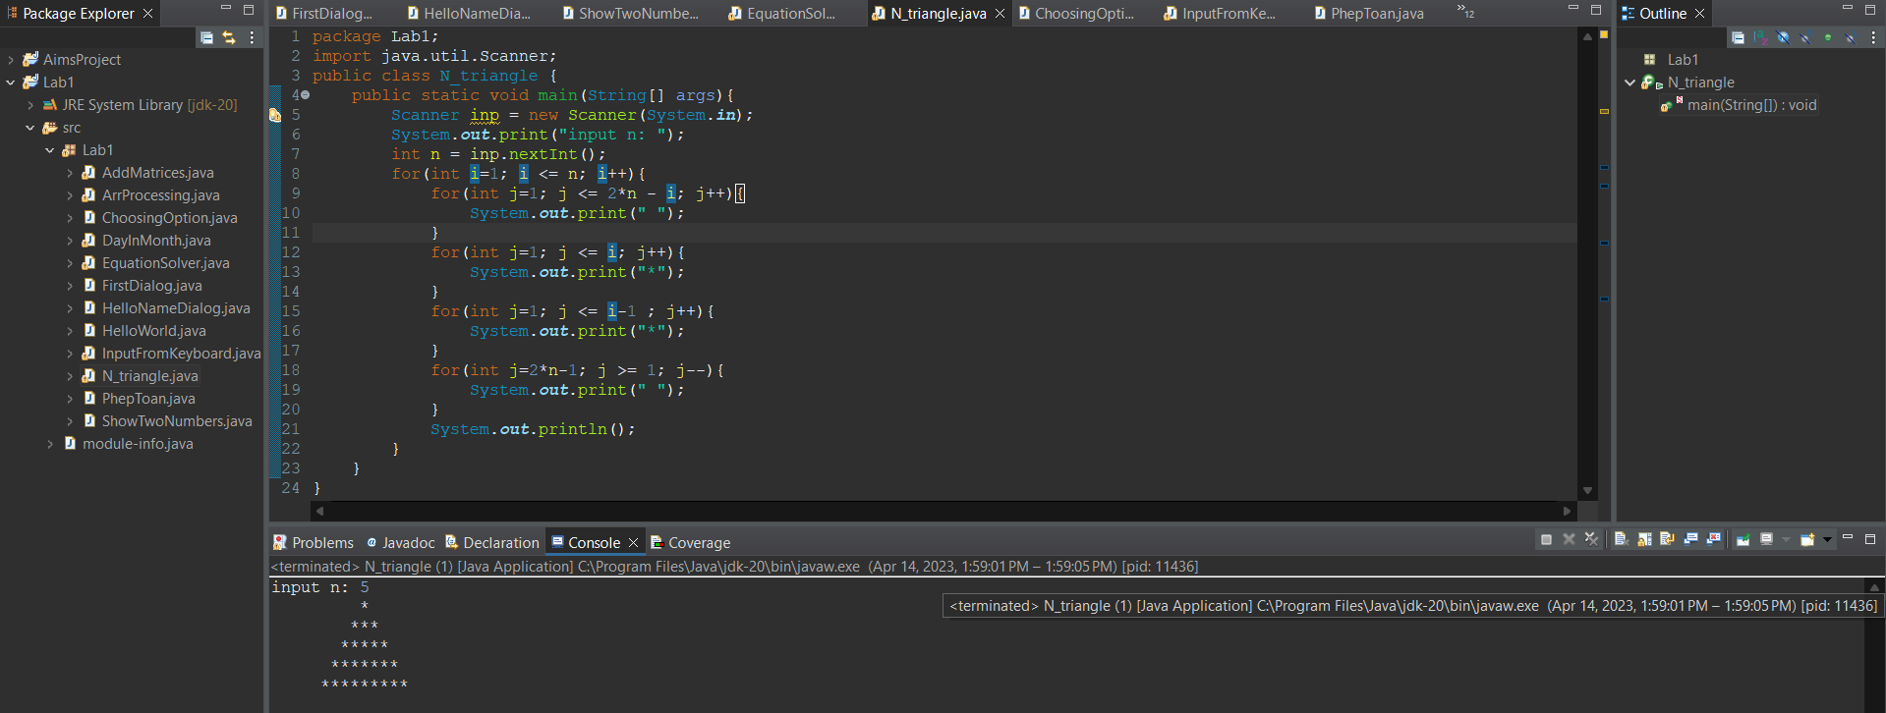

**6.4 Write a program to display the number of days of a month, which is entered by users**

**(both month and year). If it is an invalid month/year, ask the user to enter again.**

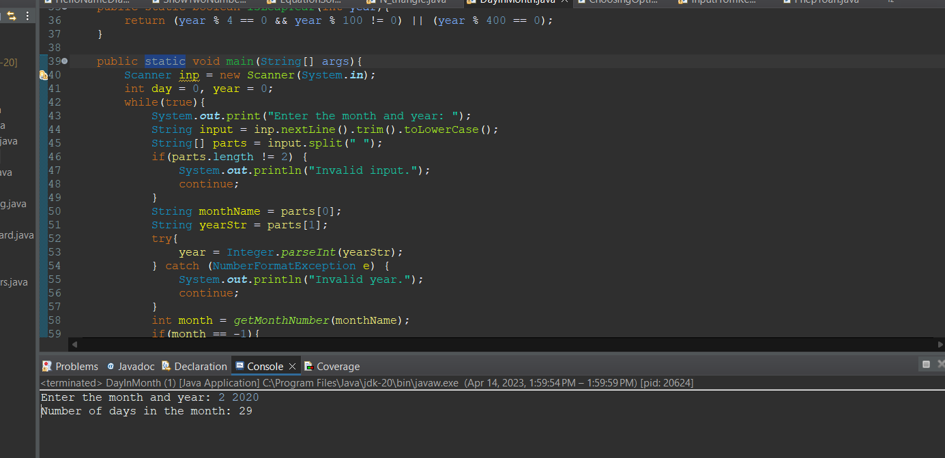

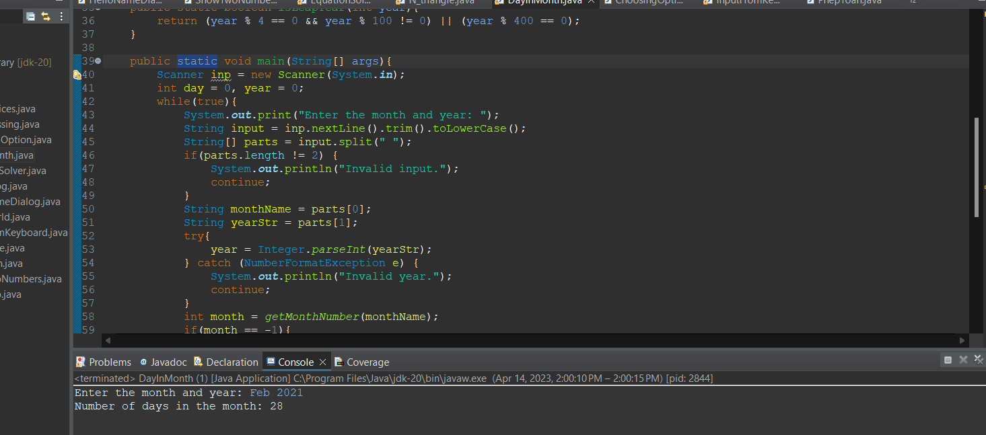

Invalid scenario:

**6.5 Write a Java program to sort a numeric array, and calculate the sum and average value of array elements.**

**6.6 Write a Java program to add two matrices of the same size.**



