Inequality in Administrative Democracy: Methods and Evidence from Financial Rulemaking

Studies in inequality in American democracy typically focus upon the legislative process, largely sidestepping administrative policymaking, where rules have the effect of law and where vast amounts of money and mobilization are involved. We develop a linked suite of measurements for wealth, participation and influence in rulemaking, and draw upon an original database of over 300,000 comments submitted to U.S. agencies under the Dodd-Frank Act, we document several patterns: (a) commenting is disproportionately concentrated among wealthier nonprofits but not wealthier for-profits, (b) wealthier organizations generally advance more sophisticated comments (though the disparities emerge differently for nonprofits and for-profits), and (c) comment influence is increasing in the wealth of the commenting organization. While finance is but one case study, its policies affect tens of millions of Americans and trillions of their assets. The results suggest that inequality in the legislative process is reinforced, if not magnified, in administrative government.

# Introduction

Studies of political inequality have revealed profound and durable patterns of disproportionate influence of wealthier citizens on lawmaking processes, which Gilens (2012) calls the influence of affluence. Critical work in American politics by Bartels (2008), Baumgartner et al. (2009), Hacker and Pierson (2010), Gilens (2012), Skocpol (2004), and Schlozman, Verba, and Brady (2012), among others, documents ties between economic and political inequality. Relatedly, Piketty (2014) and others in economics and the social sciences have demonstrated rising capital-based wealth inequality over the twentieth century, especially in the United States (e.g., Saez and Zucman 2020).

In contrast to the wealth of literature on inequality in lawmaking, however, research on inequality in administrative democracy is sparse, especially when one considers the bureaucracy’s most powerful policy tool: rulemaking J. W. Yackee and Yackee (2006). Research suggests that firms spend hundreds of millions lobbying after a bill has passed, both in the legislature and in the agencies entrusted to implement the legislation (You 2017; Libgober and Carpenter 2020). Legislators who receive more corporate Political Action Committee (PAC) money from companies are much more likely to lobby federal agencies on behalf of those companies (Powell, Judge-Lord, and Grimmer 2022). These rules are meaningful to the public, as well as to the courts. Through the writing of rules, agencies convert congressional intent into enforci policies with real human and economic effects. Given the scale and importance of bureaucratic policymaking and the large volume of data on business and interest group participation, rulemaking presents opportunities to study inequalities in policy influence (D. Carpenter et al. 2020).

*When policymaking occurs in the administrative realm, do inequalities in the legislative process persist or morph? Are they magnified or reduced?* We present a suite of measurement and analysis tools that permit identification of organizational commenting, measurement of commenter wealth and comment sophistication, and links between wealth, sophistication and influence. In this expansive study of financial rulemaking, we draw upon a database of over 300,000 comments submitted to U.S. agencies tasked with implementing the Dodd-Frank Wall Street Reform and Consumer Protection Act of 2010 (hereafter Dodd-Frank). Our data cover over eight hundred regulatory actions[1] such as proposed and final rules on 239 discrete rulemakings. The Dodd-Frank Act has the advantage of spurring historically abundant and significant rulemaking activity and, correspondingly, significant mobilization of interests to shape those rules. Beyond its provision of granular data, however, financial policymaking offers another reason for studying inequality - finance is perhaps an unparalleled site of interaction between economic inequality and unequal democracy.

As an indicator of the stakes of these developments, consider how media reporting in 2017 illustrated the political priorities of those at the very upper end of the income and power scale in the United States. During that year, major newspapers documented high-level gatherings between CEOs and officials at the Trump White House. For our purposes, what’s interesting about these meetings is that the existing inequality literature would likely have predicted America’s wealthiest business leaders and allocators of capital would direct their lobbying at Congress or at the president in the hope of indirectly influencing congressional lawmaking. Instead, the business leaders and their lobbyists were, targeting the Dodd-Frank rules being written by federal agencies (LaCapra and Miedema 2013).

The idea that inequality has affected financial policymaking is far from new. Reports of CEO meetings and financial lobbying on regulatory policy issues raise important yet unanswered questions: how can we know what various interests are asking for in regulation; how can we get a handle on whether they are getting what they ask for; and how can we measure what regulation is worth to them? And, perhaps most importantly, what do answers to these questions tell us about political inequality?

We provide both tools to address these questions these questions and, in an analysis of financial rulemaking, some answers for a significant policy domain. Our empirical tools can be applied to any policy domain (and any agency) for which rulemaking data in notice-and-comment format exist. While our data focus squarely on financial regulation—and the interests involved with its promulgation, this research has considerable breadth. For instance, it spans the rulemaking of **INSERT NUMBER HERE** federal agencies, including independent agencies such as the U.S. Securities and Exchange Commission (SEC) and Consumer Financial Protection Bureau (CFPB), and executive branch units such as the Department of the Treasury. Overall, the data represent the most comprehensive effort to date to understand the role of inequality during financial rulemaking.

Measuring the wealth of participants in rulemaking is difficult, in part because the kinds of surveys available to Bartels (2008) and Gilens and Page (2014) are not available for participants in rulemaking data.  
This study has several limitiations. First, our analyses of wealth are limited to organizations, leaving aside many individual commenters. We find that wealthier organizations are more likely to comment (a pattern restricted to the nonprofit sphere); that conditioned on commenting, wealthier organizations offer more sophisticated comments (as detected in language); and that wealthier organizations’ comments appear to move rules more (as measured by novel text reuse algorithms (see, S. D. Rashin 2020)).

Second, as with the inequality literature pioneered by Bartels and Gilens and others, we are not in a position to comment on the substantive merit or welfare effects of these patterns. On some issues, legislators and administrators may listen to wealthier Americans and organizations because their wealth is correlated with the expertise or value of their information (McCarty 2017; Libgober 2020). Yet, in other cases, the disparities we document may reflect patterns where unequal levels of access to power lead to policies that favor wealthier constituents, organizations, and businesses. Our tools and the findings they yield should be combined with observations drawn from the legislative policymaking process to provide a fuller—and more accurate picture—of how political inequality manifests across decision-making in America’s key political institutions.

The code used to document participation (commenting), measure commenter wealth and comment sophistication, and link these to comment influence will be applicable to other agencies. Because the text of legislative lobbying requests is rarely visible in full, moreover, [2] our tools and data permit measurement and examination of textual influence not yet available in studies of legislative lobbying.[3]

# Theory

## Prior Research

The past two decades have witnessed an outpouring of social science research on inequality in the United States and other nations, with a focus on national-level policymaking. While several scholars concentrated on the structural and technological determinants of inequality (e.g., Goldin and Katz 2009; Piketty 2014), others examined the political realm itself as a place where economic inequality shapes political outcomes, which plausibly generates further economic and social inequality.

In *Unequal Democracy*, Bartels (2008) established an important empirical case for political inequality by showing, among other findings, that legislative voting patterns in the U.S. Senate disproportionately reflect the preferences of those individuals at the highest levels of the income distribution. Hacker and Pierson (2010) described a “winner-take-all politics” by which wealthier Americans improved and secured their economic prospects under both liberal and conservative political leadership while the prospects of middle- and working-class Americans stagnated. In *Affluence and Influence*, Gilens (2012) further systematized these findings on political inequality using an innovative combination of survey data and legislative voting records. A range of work following from these studies that support and refines these empirical patterns (see, e.g., Baumgartner et al. 2009; Winters and Page 2009; Kelly and Enns 2010; Schlozman, Verba, and Brady 2012; Page, Bartels, and Seawright 2013; Gilens and Page 2014; Witko et al., n.d.). These studies mark critical innovations in our understanding, not only of inequality but also of U.S. political processes themselves.

Because important policy decisions are made in administrative agencies, however, our collective empirical portrait of political inequality in America remains sorely incomplete. Put differently, policymaking does not stop in Congress. Many critical choices are made in the executive and administrative branches, in part because the legislature delegates policymaking authority to agencies (Epstein and O’Halloran 1999; Huber and Shipan 2002; S. F. Haeder and Yackee 2020), and, in part, because some agencies have acquired sufficient legitimacy and expertise as to gain deference in program initiation, interpretation and policy proposals (D. P. Carpenter 2001; D. Carpenter 2010). Beyond this, it is well known that moneyed interests spend considerable resources in attempts to influence administrative and executive decision-making (S. Haeder and Yackee 2015; You 2017). These dynamics are often studied under the concept of regulatory capture (D. Carpenter and Moss 2013), yet few regulatory capture projects speak to questions of political inequality, and likewise, few studies of political inequality address issues of capture.

This is a major omission, particularly within the financial regulation space. Specifically, because financial policymaking affects the aggregation, accumulation, and disposition of wealth and income so directly, its plausible role in increasing inequality is large. Numerous experts in financial policymaking have discussed the idea that political inequality affects financial policymaking. For example, as the 2008 financial crisis unfolded, Johnson and Kwak (2010) and Kwak (2013) pinpointed industry influence in financial regulation, including during the Obama Administration, as one of the main culprits of both the crisis and what they saw as the American government’s problematic response to it. In their view, the very necessity of regulators spending time with banks, combined with the status, sophistication, and resource differentials between bankers and their regulators, resulted in a convergence of the regulator’s frames, assumptions, vocabularies, and methods towards those of the regulated industry. A different literature examines financial firms’ lobbying behavior. For instance, Igan, Mishra, and Tressel (2011) find correlations between lobbying behavior and pre- and post- financial crisis loan activity.

Other critical research sheds light on the revolving-door dynamics often present within financial regulation. This occurs when federal financial agencies hire those from the regulated sector, and/or those who work at these agencies leave to work in banks and non-bank financial firms (Lucca, Seru, and Trebbi 2014; “The Revolving Door and the SEC’s Enforcement Outcomes: Initial Evidence from Civil Litigation,” n.d.; Cornaggia, Cornaggia, and Xia 2016). Many scholars have examined the development of coalitions between financial and non-financial interests (see e.g., K. Young 2012; K. Young and Pagliari 2017; K. L. Young, Marple, and Heilman 2017; James, Pagliari, and Young 2021); for example, using network analysis techniques, K. Young, Marple, and Heilman (2017) focused on past and current employment ties between select business firms and the SEC and found that greater direct and indirect ties increase the likelihood of the firm engagement with SEC policy decision-making.

What this literature currently lacks, however, are measures of financial industry influence during one of the most important venues for political lobbying—agency rulemaking. Rulemaking is a critical—but understudied—part of the American political process. While Congress routinely passes statutes, their implementation almost always requires federal agencies, staffed primarily by civil servants, to devise legally binding standards and procedures (i.e., rules) that make the legislation practically effective. This kind of agency policymaking is pervasive; in 2018, for example, agencies finalized over 3,300 rules.

The Administrative Procedure Act of 1946 (APA) governs the rulemaking process. Among other provisions, the APA requires federal agencies to solicit public comments on their draft policy proposals (called Notice of Proposed Rulemakings, or proposed rules) and to consider any comments before issuing the agency’s legally binding rule (called Final Rules). Agency officials may or may not make changes to the proposed rule text based on the public comments—leaving open the possibility that the commenting process creates an avenue for unequal influence. Given the potential impact of agency-issued regulations, those individuals, firms, and other organizations most affected often attempt to influence regulatory policy content.

Unequal levels of power and access to the government may be especially acute in financial regulation, where Congress tends to rely upon government agencies to develop key regulatory concepts and instruments, and in doing so, to carry out legislative intent. In fact, many of the most important deregulatory decisions of the past three decades in finance were made in administrative agencies, such as reductions in regulatory capital requirements and the deregulation of mortgage and other consumer loans (Engel and McCoy 2011). Even while ostensibly re-regulating the financial sector, Dodd-Frank handed considerable authority to federal financial agencies (D. P. Carpenter and Krause 2012; D. Carpenter and Moss 2013). For instance, the law contains over 300 provisions authorizing agency rulemaking, and each provision could result in multiple rules (Copeland 2010). Each rule yields a fresh opportunity for the financial industry (and others) to lobby the government agency for policy change.

The traditional literature from bureaucratic politics has often shied away from both questions of inequality of influence during rulemaking and questions of financial policymaking. An older literature by McCubbins, Noll, and Weingast (1987) through Balla (1998) examined rulemaking as an important venue of policymaking, often debating whether legislative institutions (i.e., Congress) could use the APA to control administrative agencies. Other high-profile research focused on the legislature’s delegation decision while largely leaving unanswered how administrative agencies respond to new grants of policymaking authority in practice (Epstein and O’Halloran 1999; Volden 2002; Huber and Shipan 2002). Still, other work focused on the politics of agency decision-making in the areas of enforcement or permitting decisions but not rulemaking (e.g., Wood and Waterman 1994).

These patterns shifted when scholars began placing increased attention on the role of public comments during rulemaking and attempted to correlate the requests made in comments with regulatory policy change (J. W. Yackee and Yackee 2006; S. W. Yackee 2006, 2012, 2015, 2019; McKay and Yackee 2007; Nelson and Yackee 2012; Golden 1998; West 2004). This focus led to advancements in our understanding of political inequality during the agency rulemaking process, but without a specific concentration on financial regulation.

When we focus on the small subset of existing financial rulemaking studies, we uncover a more mixed portrait of the policy impact, if any, of inequality. As a result, these studies—which tend to focus on one rule or one agency—raise important questions for future scholarship. Ban and You (2019), for instance, studied lobbying and agency rulemaking on a sample of SEC rules after Dodd-Frank. They conclude that the “amount of resources” that an organization can devote to lobbying appeared to influence the likelihood that the SEC would cite the name of the organization in its Final Rule (p. 282). However, in contrast, S. D. Rashin (2020), who examined over 47,000 public comments to hundreds of recent SEC rules, found that organizational resources do not appear to be correlated with the commenter’s efficacy in securing policy changes. Instead, he demonstrated that other factors, including the amount of data provided in the comment, were more closely related to regulatory modification.

Similarly, Krawiec (2013) studied public participation patterns early in the rulemaking process in section 619 of Dodd-Frank—commonly known as the Volcker Rule. She found that comments from financial institutions and industry were often detailed, complex, and lengthy during the pre-proposal stage, while other commenters—who generally favored stricter regulation—often signed on to form comments or provided feedback that lacked the type of specificity and detail agencies needed to change policy. Yet, Ziegler and Woolley (2016) reached a different conclusion. When focusing on macroprudential supervision and derivatives trading rules, they were more optimistic that non-industry group participation was actionable—and potentially influential—on Dodd-Frank regulatory content. Specifically, Ziegler and Woolley concluded that small advocacy groups tended to prevent industry domination in the financial regulation space.

Gordon and Rosenthal (2020) demonstrated that a diverse coalition of actors could come together to counter the role of larger and more established regulated entities—in their case, in the area of credit risk retention regulation in the post-Dodd-Frank environment. As a result, their work, like Ziegler and Woolley’s, suggested a more complicated explanation than traditional regulatory capture accounts. In doing so, it aligned with Nixon, Howard, and DeWitt (2002) older analysis of SEC rule changes, which did not suggest a severe bias toward what they called “privileged” interests. That said, other research points to the difficulty of diverse and non-industry coalitions coming together. K. Young and Pagliari (2017), for instance, found that such coalitions may not form with great frequency in the financial sector; their research demonstrated that the voices outside the affected firms were less likely to mobilize, especially when the regulation is technically complex.

In sum, the existing literature yields mixed results on the question of political inequality and thereby leaves open critical questions about the plausible effects of firm behavior upon regulatory policymaking in the financial regulation space.

## Hypotheses

Overall, our theoretical intuitions lead us to anticipate that among both for-profit and nonprofit organizations, wealthier entities will comment more often, with greater sophistication and with greater influence. These intuitions yield several hypotheses:

**H1. Differential Participation** We theorize that larger and wealthier financial sector interests will participate in financial rulemaking more frequently than consumer protection, labor, public interest, and smaller financial groups. Differential levels of participation may be a result of legal and technical complexity of rulemaking processes, which create financial barriers to participation. This is important because unequal levels of participation could lead to unequal influence. Regardless of whether some organizations are more influential than others *when they participate*, differential commenting behavior alone could lead some organizations to be more influential than others, simply by showing up. Specific, testable assertions include:

*H1* Overall, organizations that comment on more rules will be wealthier than organizations that comment on fewer rules.

*H1.1* Nonprofits with more assets will comment more frequently than nonprofits with fewer assets.

*H1.2* Among nonprofits that participate in financial rulemaking, nonprofits with more assets will comment on more proposed rules.

*H1.3* Firms with more assets will comment more frequently than firms with fewer assets.

*H1.4* Among firms that participate in financial rulemaking, firms with more assets will comment on more proposed rules.

### Differential Sophistication and Mobilization of Expertise

Theories about mechanisms of lobbying influence suggest that wealthier organizations are better able to deploy sophisticated legal arguments and technical information (Wagner, Barnes, and Peters 2011). We thus expect wealthier entities will utilize greater expertise and sophistication in their comments. Large financial firms will marshal legal and technical expertise disproportionately to write complex and sophisticated comments to rules in which they are interested. We expect them to be more highly sophisticated, reflecting greater legal expertise, and more technically supported. Large financial firms may also marshal different mixtures of lobbyists and legal experts in their comments, drawing upon ties to lobbying firms and to other financial institutions.

Our second hypothesis poses testable assertions about the strategies of commenting upon which different organizations rely:

*H2.* Organizations with more resources will use more technical and legal language when commenting on proposed rules.

### Differential Commenting Influence

Our third hypothesis extends existing research to the financial regulation arena. One expectation from J. W. Yackee and Yackee (2006) and related work is that industry comments, in general, will move rules more than non-industry comments. Yet because any industry, not least the financial industry, is composed of companies smaller and larger, as well as wealthier and poorer, we seek to understand whether larger and wealthier firms have more commenting influence than do smaller firms. In general, we anticipate that wealthier organizations are more influential.

*H.3*: More influential comments tend to come from wealthier organizations.

*H3.1*: The comments that suggest language identical to language added to the final rule will more often come from organizations that are wealthier compared to the organizations that submitted comments that are less aligned with the changes made to rules.

### The Dividends of Sophistication

Finally, we link the second and third hypothesis to make testable claims about legal and technical sophistication as a mechanism of influence. We theorize that organizations with more resources are more influential *because* they have the capacity to produce more sophisticated comments and that more sophisticated comments are more influential.

*H4*. The language suggested by comments with more legal and technical language will be more likely to appear in text added between draft and final rules.

Together, these hypothesis are designed to test for two major kinds of potential bias in modern U.S. policymaking: that the wealthy are better able to participate, and even when less wealthy groups participate, the wealthy are more influential. Additionally, they test a major theorized mechanism of lobbying influence: the ability of the wealthy to mobilize lawyers and experts to make sophisticated and thus influential arguments on their behalf.

# Empirical Tools and Data

To assess the extent of inequality in rulemaking implementing the Dodd-Frank Act, we assembled data from the Federal Register, Regulations.gov, Wharton Research Data Services (WRDS), the Internal Revenue Service (IRS), the Consumer Financial Protection Bureau (CFPB), Commodity Futures Trading Commission (CFTC), Federal Reserve (FRS), National Credit Union Administration (NCUA), and the Securities and Exchange Commission (SEC). **CHECK THIS LIST WHEN WE’RE DONE**. The expansive data collection effort includes data on comment texts and metadata, Dodd-Frank metadata, agency metadata, and data on for-profit and non-profit organizations. We define our sampling frame as rules promulgated under the Dodd-Frank Act, as defined by the law firm Davis Polk LLP, which maintained a regulatory tracker for such actions. We used Davis Polk’s tracker as it was the most complete source of regulatory actions under the Dodd-Frank Act. This tracker was scraped throughout 2017 and early 2018 while we collected other data about these rules, most importantly tracking down the web location of dockets and their rule texts. Our final set of rules covers the set of Dodd-Frank rules after enactment on July 20, 2010, and before July 8, 2018.

## Rules

Rulemaking involves a series of related regulatory actions. Figure shows policy the number of actions that key agencies took to implement the Dodd-Frank Act from 2009 to 2018. These actions include advance notices of proposed rulemaking (ANPRMs), proposed rules (NPRMs), interim rules, final rules, and others. Multiple of each kind of action may appear in some rulemakings, but none necessarily appears in any rulemaking. The range of possible action sequences creates semantic challenges for social scientists. Defining operationally how many rules were made or in the making by financial regulators sometimes requires complex choices. In our study, we define a “rulemaking” (or “rule”) as a set of regulatory actions that are connected via shared Regulation Identifier Number (RIN).[4] Using this definition, we found that between 2010 and July 8, 2018, there were 239 rulemakings by 21 regulators involving 802 regulatory actions. Some agencies, like the Department of Veterans Affairs, were not involved in more than a small number of rules. When they were, they usually engaged in a collaborative fashion with other agencies. Therefore, for the purposes of collecting data on comments, we focused our attention on the primary financial regulators: the Federal Reserve, the Consumer Financial Protection Bureau, the Securities and Exchange Commission, the Commodity Futures Trading Commission, the Federal Deposit Insurance Corporation, and the Office of the Comptroller of the Currency, and the National Credit Union Administration **TODO: CHECK THIS LIST AFTER JACOB UPDATES THE MATCHED DATA FROM MASTER.SQL**.  
For each Dodd-Frank rulemaking that reached the stage of a proposed or final rule, we collected draft and final policies from the Federal Register.

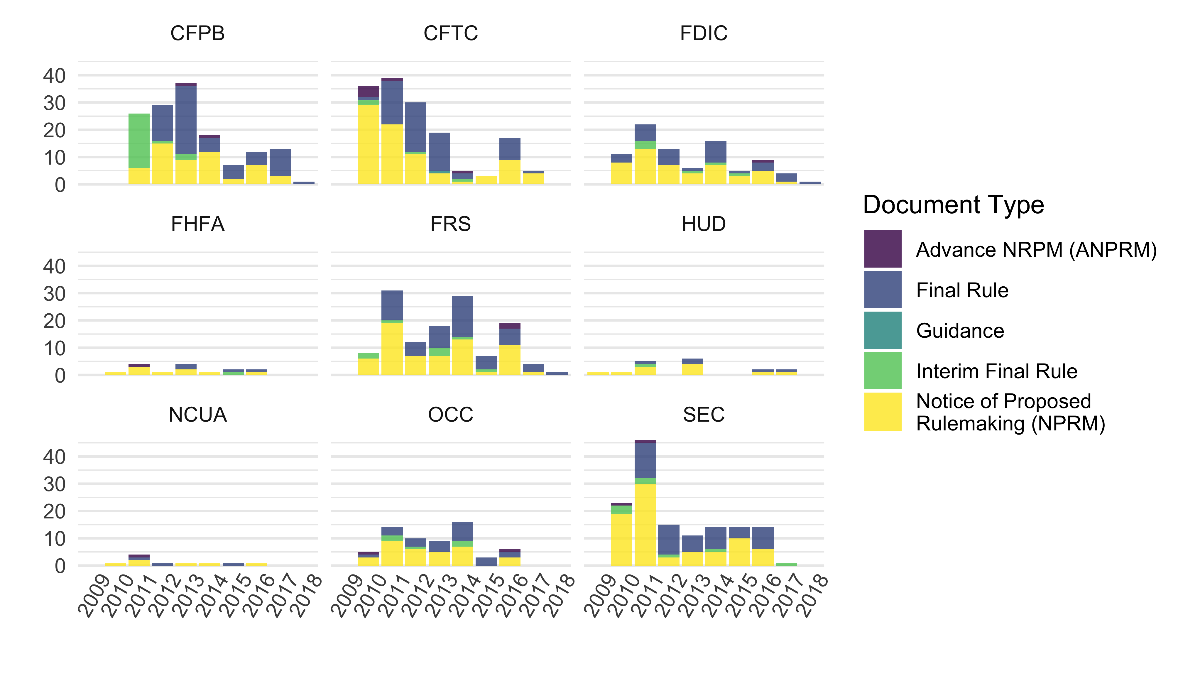

Dodd-Frank Act Implimenting Actions by Agency, Including the Consumer Financial Protection Bureau (CFPB), Commodity Futures Trading Commission (CFTC), Federal Reserve (FRS), National Credit Union Administration (NCUA), and Securities and Exchange Commission (SEC)

## Comments

The authors and research assistants scraped all available public comments from each financial regulator’s website or regulations.gov for all Dodd-Frank rules. In doing so, we collected key metadata include the name of the individual and organization submitting comments and the date of their submission. We used the open-source software tesseract to OCR comments that were not machine-readable on the Open Science Grid computing cluster. Comments are posted on agency websites and regulations.gov as either open text boxes or attachments. We collected collected **NUMBER** open text responses and **NUMBER** comments. Comments are not distributed uniformly across rules or agencies; for example, our sample included **NUMBER** comments from the CFPB and **SMALLER NUMBER** from **SMALLEST AGENCY**.

We then collected data about the relative resources of potential participants in rulemaking and matched these data to organizations that submitted comments. Given the varied types of organizations that participate in rulemaking (including small nonprofits and large corporations), no single database contains data on the resources available to all types of participants. However, we were able to systematically collect data on organizational resources for particular types of organizations.

Following Libgober (2019), we collect information on public companies listed on U.S. exchanges during this time period and gather commonly reported financial data, for example, market capitalization from the Federal Deposit Insurance Corporation (FDIC). The primary source for these data are various databases from Wharton Research Data Service, especially their Compustat and bank regulatory datasets. From the Compustat data, we selected a key measure of corporate size: the firm’s total assets, which represents a company’s reported assets and liabilities. For bank and bank-like entities that report to the Federal Financial Institutions Examinations Council (FFIEC), we also collected a measure of their total assets under management from call reports on ncua.gov (see Appendix for data sources).

To capture the resources of nonprofit organizations that do and do not engage in financial rulemaking, we download all Internal Revenue Service (IRS) reports from nonprofits from 2012. We also collect data on Political Action Committee (PAC) donations and lobbying expenses from companies profiled by the Center for Responsive Politics using the Center’s bulk data files and calculate average PAC contributions per year for each organization.

Finally, we use a probabilistic matching algorithm to match comments to organizations in these databases as the names which organizations use to submit comments and the names by which they appear in datasets like Compustat are often different. To do this, we identified comments that were likely from an organization, excluding those that were likely from an individual or public pressure campaign (“mass comments”). Each of the remaining comments was then linked to the organization with the best matching name (or no organization, where the matching algorithm did not identify any high-probability match in any of the datasets discussed above). The vast majority of comments that we did not match to an organization were submitted by individuals and thus beyond the scope of this study.

Our main dataset includes all comments that matched to either an FDIC-insured bank, a bank or bank-like entity that reports to the FFIEC, an organization that reports to the SEC (i.e. a publicly traded company), additional companies that appear in the Compustat database, and or an IRS compliant nonprofit organization. To some degree, these categories may overlap. For example, some, but not all, banks are publicly traded. At the same time, each data source delimits a category of related entities that plausibly constitutes a sampling frame for making relevant comparisons.

This new dataset includes financial data on over 6,378 distinct organizations that submitted 27,601 unique comments on the Dodd-Frank rules in our database.

## Types of Organizations

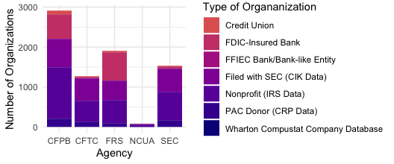

Number of Organizations by Type and Agency to which they Commented, Including the Consumer Financial Protection Bureau (CFPB), Commodity Futures Trading Commission (CFTC), Federal Reserve (FRS), National Credit Union Administration (NCUA), and Securities and Exchange Commission (SEC)

Each database contains qualitatively different types of organizations; we can compare patterns of commenting within each type and across types. The remainder of this section describes the distribution of these data, which are not equally distributed across agencies, rules, and commenter types. Figure shows the number of unique commenting organizations matched to each database by the agency or agencies to which they submitted comments. Across all agencies except for the Federal Reserve (FRS), the majority of commenting organizations are nonprofits. The next most common federally-insured (FDIC) banks. Organizations that report to the SEC (CIK) and donors to PACs were less common.

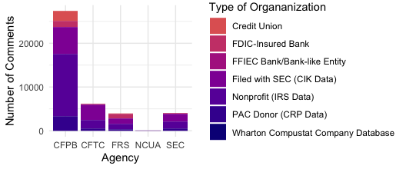

Number of Comments by Authoring Organization Type and Agency, Including the Consumer Financial Protection Bureau (CFPB), Commodity Futures Trading Commission (CFTC), Federal Reserve (FRS), National Credit Union Administration (NCUA), and Securities and Exchange Commission (SEC)

Figure shows the number of comments submitted to each agency by an organization matched to each database described above.

## Measuring Comment Sophistication and Influence

We measure comment sophistication by counting the financial and legal terms in each comment. We argue that, on average, more sophisticated commenters will use more legal and finance terms in their arguments.[5] For finance terms we use the [Oxford Dictionary of Finance and Banking](https://www.oxfordreference.com/view/10.1093/acref/9780199664931.001.0001/acref-9780199664931). For law, we use the [Merriam Webster law dictionary](https://www.merriam-webster.com/browse/legal/). [6] As there are terms with both financial and legal meaning (e.g., consideration, immunization, underwrite, etc…) and we do not want to double count overlapping terms, we calculate the sophistication of each comment by summing the legal and financial terms and then subtracting the subset of those that appear in both dictionaries [7]

We assess influence by measuring the overlap in language between comments and final rules excluding the text of the proposed rule.[8] We argue that organizations whose language is cited more often are more influential than organizations whose language is cited less often. To construct the measure we first link proposed rules to final rules by their RINs and docket numbers - internal agency identifiers that uniquely identify rulemaking sequences - where RINs are not available. We tokenize each rule and comment in groups of ten words and take the total number of words in the overlap as the measure of comment influence on a final rule. For rules with more than one proposed rule, we match comments to proposed rules by publication date; that is, if a comment comes after the publication of a second proposed rule it is assumed to be on the second proposed rule. For rules with multiple final rules, we take the sum of the rules influence on both final rules. When an organization submits a comment with multiple attachments, we include only the highest scoring document as the primary comment.[9]

# Results

We test our hypotheses about wealth and access to the policy process using two broad sets of comparisons. First, we compare organizations that did and did not comment on Dodd-Frank rules. Because our data included data on a full population of similar organizations that could submit comments (e.g., all FDIC-insured banks and all tax-exempt nonprofits), only some of which submitted comments, we are able to compare commenters to similar organizations that did comment (e.g., FDIC-insured banks that did and did not comment). Second, we assess our hypotheses within the population of organizations that did comment. These analyses give us even more certainty that we are comparing similar organizations with similar interests—all commented on at least one Dodd-Frank rule, but some commented more frequently, with more sophisticated language, and addressed comments to more agencies than others. Moreover, phrases from the texts of some comments are much more likely to be added to final rules than others. We explore whether each of these types of variation is related to wealth.

We find that organizations, banks, nonprofits, and credit unions, that comment on proposed rules have much greater assets on average than similar organizations that did not comment. The median credit union that comments has three times the assets of the median credit union that does not. The median nonprofit that comments has six times the assets of the median nonprofit that does not. And the median bank has 40% more assets than the median bank that does not. Banks that comment are also much more likely to be profit-driven Commercial Banks than Savings Associations.

Among publicly-traded firms, wealth (measured by market capitalization) is strongly correlated with efficacy. Market capitalization is also highly correlated with using technical terms, which are associated with efficacy, and causal mediation analysis suggests that much of the effect of market cap on efficacy is a result of the use of technical and legal terms.

## Variation Across Commenters and Non-Commenters

First, we compare levels of resources among commenting organizations and similar organizations that did not comment.

### Commenting organizations are wealthier than non-commenters

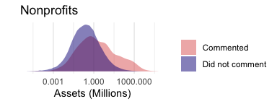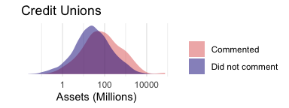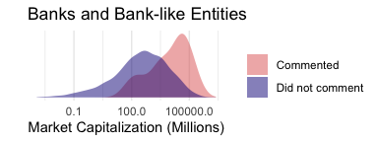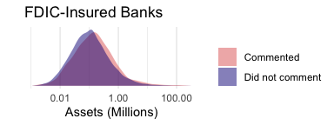

Figure shows the distribution (on a log scale) of organizations’ financial resources for commenting organizations that matched in our comment database compared to other, similar organizations.

#### Nonprofits

The top left panel in Figure shows that nonprofits that comment on proposed financial regulations tend to be significantly better-resourced than we would expect from a random sample of nonprofits. The average nonprofit that did not comment has about $7.5 million in assets, whereas the average nonprofit that did comment has $74.1 million in assets. The average assets of commenting nonprofits was ten times larger than nonprofits that did not participate. This supports the *Differential Participation* Hypothesis (H1), specifically H1.1.

#### Credit Unions

Similarly, the top right panel in Figure shows that credit unions that comment on proposed financial regulations also tend to be significantly better-resourced than we would expect from a random sample of credit unions. The average nonprofit that did not comment has about $19.5 million in assets, whereas the average credit union that did comment has $108.6 million in assets. The average commenting credit union is five times larger than the average credit union that did not comment. This also supports the *Differential Participation* Hypothesis (H1), specifically H1.1.

#### Publicly-traded firms

The bottom left panel in Figure shows the same distributions for banks and bank-like entities that file with the Securities and Exchange Commission. The banks that comment on proposed financial regulations are better-resourced than we would expect from a random sample of these organizations. Specifically, they have more capital, as measured by the the total value of their stock.

#### Banks

In contrast, the bottom right panel in Figure shows that, on average, large (FDIC-insured) banks that comment on proposed financial regulations are not significantly better-resourced, on average, than we would expect from a random sample of large banks. The x-axis shows assets in the (in thousands of dollars). At first glance, this does not support the *Differential Participation* Hypothesis (H1), specifically H1.3. However, when we look within categories of banks, we see that it is the wealthier banks in each class are more likely to participate. The top-left panel of Figure shows that Commercial banks that comment are wealther than those that did not comment. The top-right panel of Figure shows that Savings Banks banks that comment are wealthier than those that did not comment. The modal savings bank that commented has nearly twice the assets of the modal savings bank that did not comment. The bottom-left panel of Figure shows that state banks banks that comment are wealthier than those that did not comment. The average assets of state banks that commented were three times the average assets of the state banks that did not comment. While savings associations are less likely to comment than more profit-oriented banks (see Figure ), the bottom-right panel of Figure shows that when savings associations do comment, it tends to be the wealthier ones.

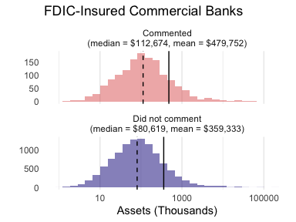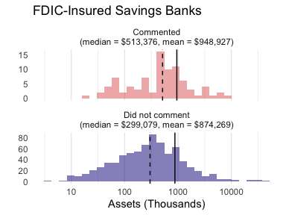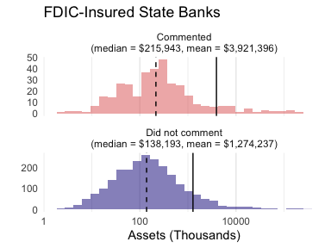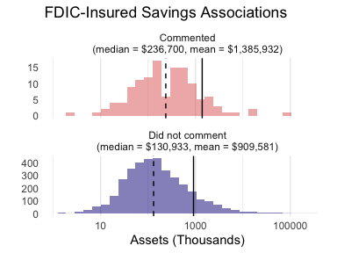

Moreover, when we assess the odds of commenting among different types of FDIC banks, we find find that Commercial Banks, State Banks, and Savings Banks are much more likely to comment than Saving Associations. Commercial banks are often large multinational corporations managed by a board selected by shareholders. In contrast Savings Associations are chartered with the narrow purpose of providing affordable residential mortgages. While both types of banks may hold large volumes of assets, Banks and Savings Associations serve different clients. Figure shows that banks that serve corporations and wealthier clients were disproportionately represented in Dodd-Frank rulemaking, and that savings associations were less represented, even controlling for differences in assets. Likewise, assets remains a significant predictor of whether an organization comments, even controling for differences in the type of institution. This supports the *Differential Participation* Hypothesis (H1), specifically H1.3.

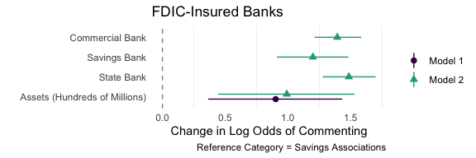

Log Odds of Participating in Dodd-Frank Rulemaking by Type of FDIC-Insured Bank

### Wealthier organizations are more likely to participate

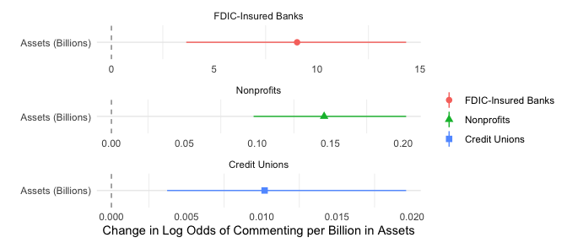

Log Odds of Participating in Dodd-Frank Rulemaking by Assets

Figure shows the results of three logit models predicting the log odds of commenting on a Dodd-Frank rules by assets for FDIC-Insured banks, credit unions, and nonprofits. Aligned with descriptive results above, wealthier organizations of all three types are more likely to comment. Of these three types of organizations, the marginal effect of assets on the log odds of commenting is largest for banks.

### Organizations that make larger campaign donations are more likely to comment

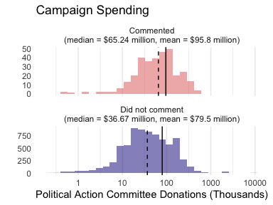

Campaign Spending of Organizations that Did and Did Not Comment

Figure shows that organizations profiled by the Center for Responsive Politics (generally, those that donate to Political Action Committees) that comment on Dodd-Frank rules are better-resourced than we would expect from a random sample of political donor organizations. This aligns with the *Differential Participation* Hypothesis (H1), specifically H1.3. The average campaign spending per 2-year cycle was $80 thousand for donors organizations that did not comment, and the average for a donor organization that did comment on a Dodd-Frank rule was $96 thousand.

The main takeaway from this analysis is that resources are correlated with the commenting behavior of nonprofits. That is, wealthy nonprofits are represented more than less wealthy nonprofits. In general, companies with high market capitalization are represented better than companies with lower market capitalization. Additionally, campaign donations are correlated with commenting on Dodd-Frank rules.

## Variation Within Commenting Organizations

### Repeat players in commenting are substantially wealthier

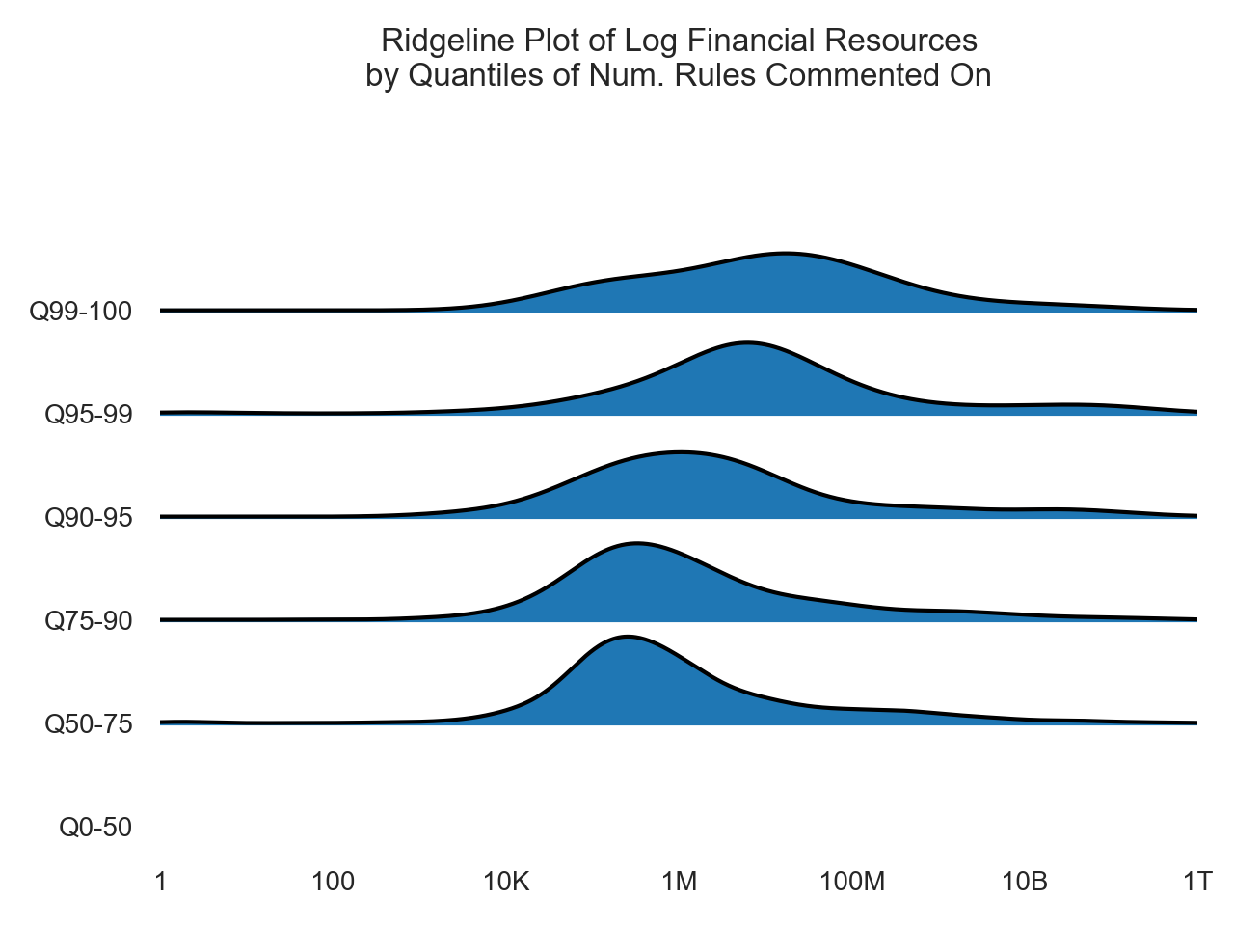

Frequent and infrequent commenters (By Percentile of the Number of Dockets on which the Organization Commented) by Resources (Log Scale)

Figure shows that organizations that comment on more rulemaking dockets tend to be wealthier.[10] More specifically, it shows that organizations that comment infrequently are more likely to have less financial resources (less than a million dollars in assets). In contrast, the top five percent of the most frequent commenters tend to have well over ten million dollars in assets. Organizations in the top percentile of most frequent commenters have assets closer to 100 million dollars on average. A substantial share of organizations that are in the top ten percent of most frequent commenters have over $10 billion in assets, while only a tiny share bottom fifty percent of commenters have that level of wealth. In line with Hypothesis 2.5, frequent commenters tend to be wealthy organizations.

### Wealthier companies are more sophisticated at lobbying

Wealthier organizations generally advance more sophisticated comments. Figure shows that comments from wealthier organizations tend to include more more legal citations (the left column of plots) and technical language (the right columns of plots). Specifically, it shows that FDIC-insured banks with more assets use more legal and banking terms.

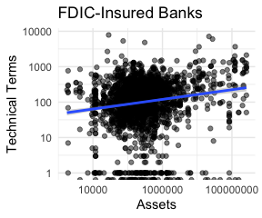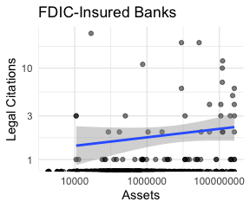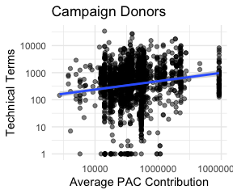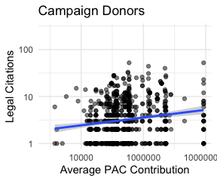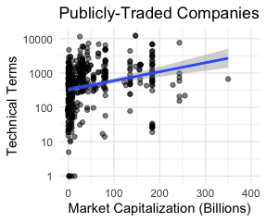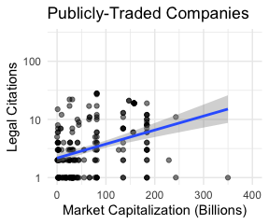

Similarly, Figure shows that a company’s comment uses four additional terms, on average, for every additional billion dollars in market capitalization. Both of these patterns align with the *Mobilization of Expertise* Hypothesis (H2) that better resourced companies will utilize greater technical and legal expertise.

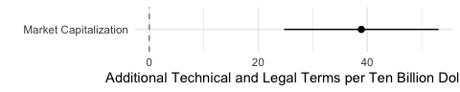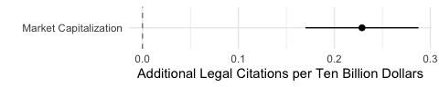

### Wealthier commenters are more influential

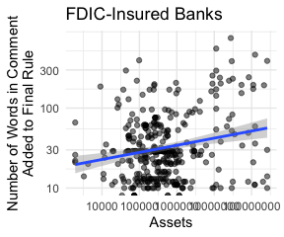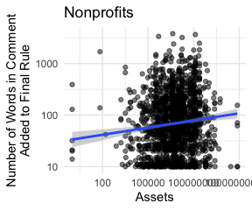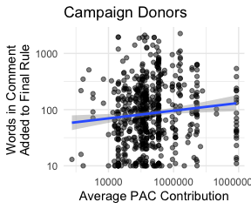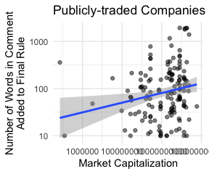

Our measure of comment influence increases with the wealth of the commenting organization. Figure shows the number of words that appear in 10-word phrases in both a comment and the final rule but were not present in the draft rule. This measure captures the extent to which text added to final policy documents contains exact phrases used or suggested by a particular commenter. While this does not necessarily represent a causal relationship (for example, both the commenter and regulator may have copied the phrase from a third source), it shows the alignment of specific comments and policy changes. Ten-word phrases are long enough that they rarely co-occur by chance and are thus a well-validated measure of textual similarity (Wilkerson, Smith, and Stramp 2015; Casas, Denny, and Wilkerson 2019; Judge-Lord 2017; S. Rashin 2018). The strong positive correlation between an organization’s wealth and its comment’s similarity to text added to the final rule aligns with the *Differential Commenting Influence* Hypothesis (H3).

### More sophisticated comments are more influential

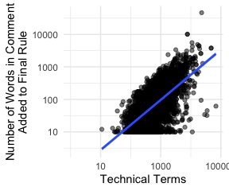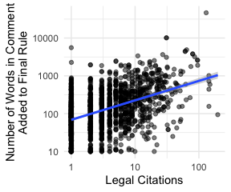

To investigate our proposed mechanism for unequal influence, we assess the relationship between legal and technical sophistication and policy influence. We find that legal citations and technical terms are highly correlated with efficacy. Figure shows that comments that use more sophisticated legal and technical language are more likely to contain phrases that were added to the final rule. This aligns with the *Dividends of Sophistication* Hypothesis (H4). We measure the sophistication of comments in two ways and observe similar results. The top panel of Figure shows a positive correlation between the number of legal and banking terms and the amount of text a comment shares with the final rule. To capture sophistication with respect to the use of finance and banking jargon, we use the Oxford Dictionary of Finance and Banking, which includes 5260 finance and banking terms. To capture sophistication with respect to legal jargon, we use the Merriam-Webster law dictionary, which includes 10,172 legal terms.

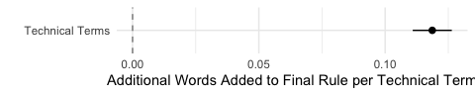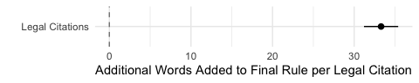

Figure shows estimates of comment efficacy from a regression model where the predictor is the number of technical terms or legal citations. Each additional legal citation in a comment is associated with 34 additional words added to the final rule from phrases in the comment proposed rule.

To be clear, these relationships do not necessarily imply a causal relationship between sophistication and policy influence. The processes that lead commenters to include particular phrases in comments may be endogenous to policy outcomes. For example, because comments are explicitly responding to proposed policy texts, they often reference phrases and ideas that are already under consideration.

In dealing with endogeneity, one methodological choice merits elaboration: we chose to exclude text from the proposed rule when measuring influence but not when measuring sophistication. This choice rests on the underlying concepts we are attempting to measure. In measuring text reuse, we aim to capture ideas that are not yet in the policy. Thus, text copied from the agency’s proposal must be excluded. Indeed text that appears in both the draft and final rule is precisely what did *not* change. If a commenter attached a marked-up version of the proposed rule, we aim to exclude all but their suggested changes.

In contrast, in measuring sophistication, we aim to assess the extent to which the commenter is utilizing expertise to engage in legal and technical policy debates. Here, when attaching a marked-up version of the proposed rule does capture the underlying concept of sophistication. Thus, our counts of legal and banking terms and bluebook citations do not exclude the text of the draft rule. Even if they are the agency’s own terms and citations, engaging with the agency’s texts indicates sophistication. For example, the comment with by the most bluebook/legal terms from an FDIC-insured bank contained a 4-page comment and 112 pages of attachments, 105 pages of which were the full proposed rule. These 105 pages were excluded from our measure of text reuse but included in the count of legal and banking terms.

### The Efficacy of Wealthy Companies is Explained by Their Legal and Technical Sophistication

To investigate whether the use of legal and technical language explains the correlation between corporate wealth (e.g., market capitalization) and policy changing as commenters suggest, we conduct mediation analysis. Efficacy is the dependent variable, market capitaliztion is the predictor, and the number of legal citations and techanical terms is the proposed mediator.

We find that the bulk of the relationship between wealth and efficacy can be attributed to the use of technical and legal citations. Market capitalization is highly correlated with using technical terms, which are associated with efficacy. Causal mediation analysis suggests that much of the effect of market capitalization on efficacy is a result of the use of technical and legal terms. In a model with legal citations as the mediator (Figure ), the Average Conditional Marginal Effect is nearly identical to the Total Effect of market capitalization on efficacy. In a model with technical terms as the mediator (Figure ), the Average Conditional Marginal Effect is a large share (69.4%) of the Total Effect of market capitalization on efficacy.

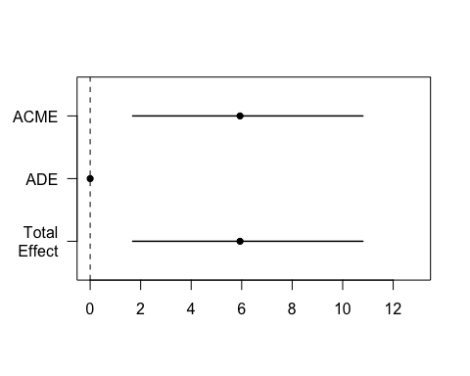

Legal Citations as a Proposed Mediator Between Wealth and Efficacy

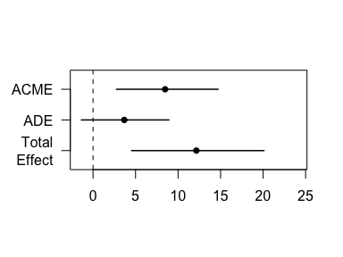

Technical Language as a Proposed Mediator Between Wealth and Efficacy

# Conclusion

By combining multiple methods and sources of data, this paper offers a new and systematic perspective on inequality in bureaucratic policymaking. Our systematic approach, covering all rules across multiple agencies implementing the same landmark piece of legislation (the Dodd-Frank Act) and rich data on multiple kinds of participants, allows unique comparisons within and across agencies and types of organizations. This new dataset allows us to assess the relative level of access and influence that different types of organizations enjoy across policymaking institutions.

We have shown that commenting is disproportionately concentrated among wealthier organizations. Many organizations do not have the baseline level of resources to engage in sophisticated lobbying. Our finding that wealthier companies generally advance more sophisticated comments suggests that wealth is correlated with exactly the kind of lobbying behavior that past studies have found to be most influential. Sophisticated and technical lobbying strategies are effective. Indeed this has been a common explanation for why businesses enjoy unique levels of access and influence in agency rulemaking (J. W. Yackee and Yackee 2006). Our results lend support to this theory. Where previous studies generally assume that businesses are wealthier, we show not only that businesses are wealthier, but that within and across types of organizations—including businesses—organizations with more engage in more sophisticated and technical lobbying efforts.

Finally, we have shown that corporate wealth is also positively correlated with the best available quantitative measures of commenter influence. Given previous research and our analysis into commenter sophistication, this finding may not be surprising, but the magnitude of these relationships have implications for future research and policy reforms.

# Appendix

Do we prefer this to the density plots?

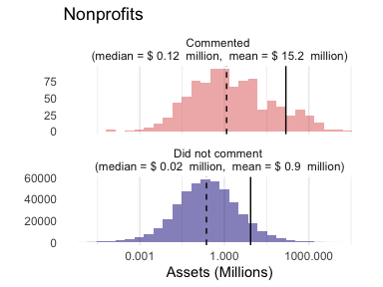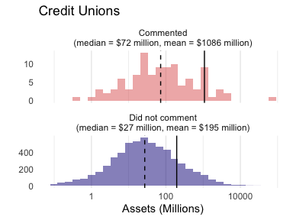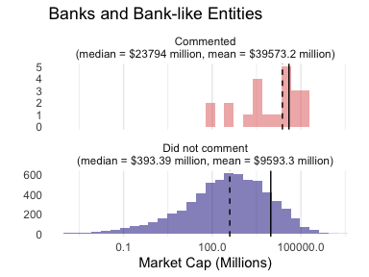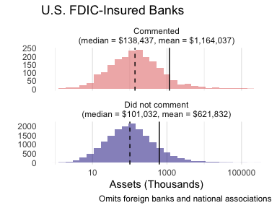

# Refrences

Balla, Steven. 1998. “Administrative Procedures and Political Control of the Bureaucracy.” *American Political Science Review* 92 (3, 03): 663–73.

Ban, Pamela, and Hye Young You. 2019. “Presence and Influence in Lobbying: Evidence from Dodd-Frank.” *Business and Politics* 21 (2): 267–95. <https://doi.org/10.1017/bap.2018.27>.

Bartels, Larry M. 2008. *Unequal Democracy: The Political Economy of the New Gilded Age*. STU - Student edition. Princeton University Press. <http://www.jstor.org/stable/j.ctt7t9ks>.

Baumgartner, Frank, Jeffrey Berry, Marie Hojnacki, David Kimball, and Beth Leech. 2009. *Lobbying and Policy Changes: Who Wins, Who Loses, and Why*. University of Chicago Press.

Blackhawk, Maggie, Daniel Carpenter, Tobias Resch, and Benjamin Schneer. 2021. “Congressional Representation by Petition: Assessing the Voices of the Voteless in a Comprehensive New Database, 1789–1949.” *Legislative Studies Quarterly* 46 (3): 817–49.

Carpenter, Daniel. 2010. *Reputation and Power: Organizational Image and Pharmaceutical Regulation at the FDA*. Princeton University Press.

Carpenter, Daniel P. 2001. *The Forging of Bureaucratic Autonomy: Reputations, Networks, and Policy Innovation in Executive Agencies, 1862-1928*. Princeton University Press.

Carpenter, Daniel P., and George A Krause. 2012. “Reputation and public administration.” *Public Administration Review* 72 (1): 26–32.

Carpenter, Daniel, Devin Judge-Lord, Brian Libgober, and Steven Rashin. 2020. “Data and Methods for Analyzing Special Interest Influence in Rulemaking.” *Interest Groups & Advocacy* 9. <https://doi.org/10.1057/s41309-020-00094-w>.

Carpenter, Daniel, and David Moss. 2013. *Preventing Regulatory Capture: Special Interest Influence and How to Limit it*. Cambridge University Press.

Casas, Andreu, Matthew J Denny, and John Wilkerson. 2019. “More Effective Than We Thought: Accounting for Legislative Hitchhikers Reveals a More Inclusive and Productive Lawmaking Process” 64: 5–18.

Copeland, Curtis W. 2010. “Rulemaking Requirements and Authorities in the Dodd-Frank Wall Street Reform and Consumer Protection Act.” Congressional Research Service; CRS. <http://www.llsdc.org/assets/DoddFrankdocs/crs-r41472.pdf>.

Cornaggia, Jess, Kimberly J. Cornaggia, and Han Xia. 2016. “Revolving Doors on Wall Street.” *Journal of Financial Economics* 120 (2): 400–419. <https://EconPapers.repec.org/RePEc:eee:jfinec:v:120:y:2016:i:2:p:400-419>.

Engel, Kathleen C., and Patricia A. McCoy. 2011. *The Subprime Virus Reckless Credit, Regulatory Failure, and Next Steps*. Oxford University Press.

Epstein, David, and Sharyn O’Halloran. 1999. *Delegating powers: a transaction cost politics approach to policy making under separate powers*. Cambridge University Press. <https://books.google.com/books/about/Delegating{_}Powers.html?id=kczTG{_}ftaC8C>.

Gilens, Martin. 2012. *Affluence & Influence: Economic Inequality and Political Power in America*. Princeton University Press.

Gilens, Martin, and Benjamin I. Page. 2014. “Testing Theories of American Politics: Elites, Interest Groups, and Average Citizens.” *Perspectives on Politics* 12 (03): 564–81. <https://doi.org/10.1017/S1537592714001595>.

Golden, Marissa. 1998. “Interest Groups in the Rule-Making process: Who Participates? Whose Voices Get Heard?” *Journal of Public Administration Research and Theory* 8 (2): 245–70.

Goldin, Claudia, and Lawrence F. Katz. 2009. “The Future of Inequality.” *Milken Institute Review* Q3.

Gordon, Sanford C., and Howard Rosenthal. 2020. “Cross-Ideological Coordination by Private Interests: Evidence from Mortgage Market Regulation Under Dodd-Frank.” *Business and Politics* 22 (2): 383–411. <https://doi.org/10.1017/bap.2019.17>.

Hacker, Jacob, and Paul Pierson. 2010. *Winner Take All Politics*. Simon; Schuster.

Haeder, Simon F., and Susan Webb Yackee. 2020. “Policies That Bind? The Use of Guidance Documents by Federal Agencies.” *Journal of Health and Human Services Administration* 43: 87–100.

Haeder, Simon, and Susan Webb Yackee. 2015. “Influence and the Administrative Process: Lobbying the U.S. President’s Office of Management and Budget.” *American Political Science Review* 109 (3): 507–22. <https://doi.org/10.1017/S0003055415000246>.

Huber, John D., and Charles R. Shipan. 2002. *Deliberate discretion : the institutional foundations of bureaucratic autonomy*. Cambridge University Press. <http://www.cambridge.org/ca/academic/subjects/politics-international-relations/comparative-politics/deliberate-discretion-institutional-foundations-bureaucratic-autonomy?format=PB{\&}isbn=9780521520706{\#}oLj9BJk19UIhQhSW.97>.

Igan, Deniz, Prachi Mishra, and Thierry Tressel. 2011. “A Fistful of Dollars: Lobbying and the Financial Crisis.” *NBER Macroeconomics Annual* 26.

James, Scott, Stefano Pagliari, and Kevin L. Young. 2021. “The Internationalization of European Financial Networks: A Quantitative Text Analysis of EU Consultation Responses.” *Review of International Political Economy* 28 (4): 898–925. <https://doi.org/10.1080/09692290.2020.1779781>.

Johnson, Simon, and James Kwak. 2010. *13 Banker*. Pantheon Books.

Judge-Lord, Devin. 2017. “Measuring Change and Influence in Budget Texts.” In. The Society for Political Methodology Annual Conference.

Kelly, Nathan J., and Peter K. Enns. 2010. “Inequality and the Dynamics of Public Opinion: The Self-Reinforcing Link Between Economic Inequality and Mass Preferences.” *American Journal of Political Science* 54 (4): 855–70. https://doi.org/<https://doi.org/10.1111/j.1540-5907.2010.00472.x>.

Kerwin, Cornelius M., and Scott R. Furlong. 2018. *Rulemaking: How Government Agencies Write Law and Make Policy*. 5th ed. Washington, DC: CQ Press.

Krawiec, Kimberly D. 2013. “Don’t ‘Screw Joe the Plummer’: The Sausage-Making of Financial Reform.” *Arizona Law Review* 55: 53–103.

Kwak, James. 2013. “Cultural Capture and the Financial Crisis.” In *Preventing Regulatory Capture*, edited by Dan Carpenter and David Moss.

LaCapra, Lauren Tara, and Douwe Miedema. 2013. “INSIGHT-Resigned to Reform, Wall St Tries a Different Tack in DC.” *Reuters*, July. <https://www.reuters.com/article/dodd-frank-lobbying/insight-resigned-to-reform-wall-st-tries-a-different-tack-in-dc-idINL1N0FP16620130721>.

Libgober, Brian. 2019. “Meetings, Comments, and the Distributive Politics of Rulemaking.” *Quarterly Journal of Political Science*.

———. 2020. “Strategic Proposals, Endogenous Comments, and Bias in Rulemaking.” *Journal of Politics*.

Libgober, Brian, and Dan Carpenter. 2020. “What’s at Stake in Rulemaking? Financial Market Evidence for Banks’ Influence on Administrative Agencies.” <{https://libgober.files.wordpress.com/2018/09/libgober-and-carpenter-unblinded-what-at-stake-in-rulemaking.pdf}>.

Lucca, David, Amit Seru, and Francesco Trebbi. 2014. “The Revolving Door and Worker Flows in Banking Regulation.” *NBER Working Paper*. <https://doi.org/10.3386/w20241>.

McCarty, Nolan. 2017. “The Regulation and Self-Regulation of a Complex Industry.” <https://doi.org/10.1086/692474>.

McCubbins, Mathew D., Roger G. Noll, and Barry R. Weingast. 1987. “Administrative Procedures as Instruments of Political Control.” *Journal of Law, Economics, & Organization* 3 (2): 243–77. <https://doi.org/10.1093>.

McKay, Amy, and Susan Webb Yackee. 2007. “Interest Group Competition on Federal Agency Rules.” *American Politics Research* 35: 336.

Nelson, David, and Susan Webb Yackee. 2012. “Lobbying Coalitions and Government Policy Change: An Analysis of Federal Agency.” *The Journal of Politics* 74 (2): 339–53. <https://doi.org/10.1017/s0022381611001599>.

Nixon, David, Robert M. Howard, and Jeff DeWitt. 2002. “With Friends Like These: Rule-Making Comment Submissions to the Securities and Exchange Commission.” *Journal of Public Administration Research and Theory* 12: 59–76.

Page, Benjamin I., Larry M. Bartels, and Jason Seawright. 2013. “Democracy and the Policy Preferences of Wealthy Americans.” *Perspectives on Politics* 11 (1): 51–73. <https://doi.org/10.1017/S153759271200360X>.

Piketty, Thomas. 2014. *Capital in the Twenty-First Century*. Harvard University Press. <https://doi.org/doi:10.4159/9780674369542>.

Potter, Rachel Augustine. 2019. *Bending the Rules*. The University of Chicago Press.

Powell, Eleanor Neff, Devin Judge-Lord, and Justin Grimmer. 2022. “Legislator Advocacy on Behalf of Constituents and Corporate Donors: A Case Study of the Federal Energy Regulatory Commission.” In *Accountability and Public Policy: Voters and Governance in the Contemporary United States*, edited by Brandice Canes-Wrone, Gregory Huber, Sanford Gordon, and Charles M. Cameron. Cambridge University Press. <https://judgelord.github.io/research/ferc/>.

Rashin, Steven. 2018. “‘Private Influence over the Policymaking Process’.” In. Southern Political Science Association Annual Conference.

Rashin, Steven Daniel. 2020. “Essays on Private Influence on the Policymaking Process.” New York University.

Saez, Emmanuel, and Gabriel Zucman. 2020. “The rise of income and wealth inequality in America: Evidence from distributional macroeconomic accounts.” *Journal of Economic Perspectives* 34 (4): 3–26. <https://doi.org/10.1257/JEP.34.4.3>.

Schlozman, Kay Lehman, Sidney. Verba, and Henry E. Brady. 2012. *The Unheavenly Chorus: Unequal Political Voice and the Broken Promise of American Democracy*. Princeton University Press.

Skocpol, Theda. 2004. “Voice and Inequality: The Transformation of American Civic Democracy.” *Perspectives on Politics* 2 (1): 3–20. <https://doi.org/10.1017/S1537592704000593>.

“The Revolving Door and the SEC’s Enforcement Outcomes: Initial Evidence from Civil Litigation.” n.d. *Journal of Accounting and Economics 60(2):65-96*. <https://doi.org/10.1016/j.jacceco.2015.07.010>.

Volden, Craig. 2002. “A Formal Model of the Politics of Delegation in a Separation of Powers System.” *American Journal of Political Science* 46 (1): 111–33. <https://doi.org/10.2307/3088417>.

Wagner, Wendy, Katherine Barnes, and Lisa Peters. 2011. “Rulemaking in the Shade: An Empirical Study of EPA’s Air Toxic Emissions Standards.” *Adminstrative Law Review* 63 (1): 99–158.

West, William. 2004. “Formal Procedures, Informal Processes, Accountability, and Responsiveness in Bureaucratic Policy Making: An Institutional Policy Analysis.” *Public Administration Review* 64 (1): 66–80. <https://doi.org/10.1111/j.1540-6210.2004.00347.x>.

Wilkerson, John, David Smith, and Nicholas Stramp. 2015. “Tracing the Flow of Policy Ideas in Legislatures: A Text Reuse Approach.” *American Journal of Political Science* 59 (4): 943–56. <https://doi.org/10.1111/ajps.12175>.

Winters, Jeffrey A., and Benjamin I. Page. 2009. “Oligarchy in the United States?” *Perspectives on Politics* 7 (4): 731–51.

Witko, Christopher, Jana Morgan, Nathan J. Kelly, and Peter K. Enns. n.d. *Hijacking the Agenda: Economic Power and Political Influence*. Russel Sage Foundation.

Wood, B. Dan, and Richard W Waterman. 1994. *Bureaucratic Dynamics*. Boulder, CO: Westview Press.

Yackee, Jason Webb, and Susan Webb Yackee. 2006. “A Bias Towards Business? Assessing Interest Group Influence on the U.S. Bureaucracy.” *The Journal of Politics* 68 (1): 128–39. <https://doi.org/10.2307/3449611>.

Yackee, Susan Webb. 2006. “Sweet-Talking the Fourth Branch: The Influence of Interest Group Comments on Federal Agency Rulemaking.” *Journal of Public Administration Research and Theory* 16 (1): 103–24. <https://doi.org/10.1093/jopart/mui042>.

———. 2012. “The Politics of Ex Parte Lobbying: Pre-Proposal Agenda Building and Blocking during Agency Rulemaking.” *Journal of Public Administration Research and Theory* 22 (2): 373–93. <https://doi.org/10.1093/jopart/mur061>.

———. 2015. “Participant Voice in the Bureaucratic Policymaking Process.” *Journal of Public Administration Research and Theory* 25 (2): 427–49. <https://doi.org/10.1093/jopart/muu007>.

———. 2019. “The Politics of Rulemaking in the United States.” *Annual Review of Political Science* 22 (1): 37–55. <https://doi.org/10.1146/annurev-polisci-050817-092302>.

You, Hye Young. 2017. “Ex Post Lobbying.” *The Journal of Politics* 79 (4): 1162–76. <https://doi.org/10.1086/692473>.

Young, Kevin. 2012. “Transnational Regulatory Capture? An Empirical Examination of the Transnational Lobbying of the Basel Committee on Banking Supervision.” *Review of International Political Economy* 19: 663–88.

Young, Kevin L, Tim Marple, and James Heilman. 2017. “Beyond the Revolving Door: Advocacy Behavior and Social Distance to Financial Regulators.” *Business and Politics* 19 (2): 327–64.

Young, Kevin, Tim Marple, and James Heilman. 2017. “Beyond the Revolving Door: Advocacy Behavior and Social Distance to Financial Regulators.” *Business and Politics* 19 (2): 327–64. <https://doi.org/10.1017/bap.2017.10>.

Young, Kevin, and Stefano Pagliari. 2017. “Capital United? Business Unity in Regulatory Politics and the Special Place of Finance.” *Regulation & Governance* 1.

Ziegler, J. Nicholas, and John T. Woolley. 2016. “After Dodd-Frank: Ideas and the Post-Enactment Politics of Financial Reform in the United States.” *Politics & Society* 44 (2): 249–80. <https://doi.org/10.1177/0032329216638061>.

1. We define a regulatory action as the publication of a proposed or final rule by one agency. For accounting purposes, we consider a joint rule issued by the SEC and the Federal Reserve as two regulatory actions.
2. But see Blackhawk et al. (2021)
3. While our tools are generalizable across policy domains and agencies, we use “tools” rather than methods as we are not presenting new statistical estimators or estimation routines.
4. RINs are assigned by OIRA to (almost) all actions by each agency and are usually preserved through rulemaking. We consider two RINs to be “directly connected” if there is a regulatory action (i.e., a document like a proposed rule) where those RINs appear together. Two RINs are “indirectly connected” or more simply “connected” if there is a way to start from one RIN and go from direct connection to direct connection and eventually arrive at the other RIN.
5. Note that we’re making no assumptions on how well an organization uses these terms. A commenter using ten terms incorrectly will have the same score as a commenter using the same terms in the correct context.
6. While Black’s is a more common law dictionary, a complete version is not available online.
7. For example, a comment may have 20 banking terms and 15 legal terms. If 5 of these are in both dictionaries, then the comment should have 30 banking and finance terms instead of 35.
8. We exclude the text of the proposed rule so that if someone cited the proposed rule they would not score highly on an influence measure. Formally, we do this by tokenizing the proposed and final rules by sentence and keeping only full sentences in the final rule that were not in the proposed rule.
9. We do this as organizations that submit multiple attachments often have one primary comment and a bunch of supporting material. We are only interested in the effect of the comment, not the supporting material.
10. Note that this does not necessarily imply that wealthier organizations submit more comments. Many wealthy organizations only submit one comment on a docket, where other organizations may submit many comments on the same rule. For example, Axcess Financial (a payday lending company) and Advance Financial (a credit union) both mobilized over 1000 comments from their stores on the Consumer Financial Protection Bureau’s Payday Loan Rule. These are not the wealthiest organizations.