**Java Database Connectivity**

JDBC API is Java API that can access any kind of tabular data,especially stored in a relational database.

JDBC stands for Java Database Connectivity ,which is a Java API for database-independent connectivity between the java programming and wide range of databases.

**JDBC Usage**

1. Making a Connection to database
2. Creating SQL or MySQL statements
3. Executing SQL or MySQL queries
4. Viewing and modifying the resulting records.

**Applications of JDBC**

1. Java applications
2. Java applets
3. Java servlets
4. Java server pages
5. Enterprise Java Beans

**JDBC Architecture**

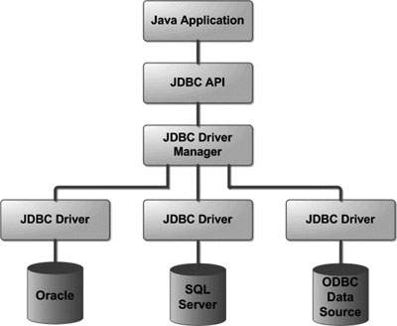

Common JDBC components:

**Driver Manager** This class manages a list of database drivers.Matches connection requests from the java application with proper database driver.

**Driver** This interface handles the communications with database servers.

You will interact directly with driver objects.

**Connection** This interface with all methods for contacting a database.This connection object represents communication with database through connection object only.

**Statement** This interface used to create and submit SQL statements.

**Result Set** This interface used to hold data retrieved from database.