Loyalty Program Information System

Requirements

The Royal and Loyal (R&L) company handles loyalty programs for companies that offer their customers various kinds of bonuses (E.g., bonus points, air miles, reduced rates, a larger car for the rate of a smaller one in a Car Rental company, extra or better service on an Airline etc.). Anything a company is willing to offer can be a service rendered in a loyalty program.

The central class in the UML model, below, is LoyaltyProgram. A system that administers a single loyalty program will contain only one object of this class. A company that offers its customers a membership in a loyalty program is called a ProgramPartner. More than one company can enter into the same loyalty program. In such a case, customers who enter the loyalty program can profit from services rendered by any of the participating companies.

Every customer of every program partner can enter the loyalty program by filling in a form and obtaining a membership card. The objects of class Customer represent people who have entered the program. The membership card, represented by the class CustomerCard, is issued to one person. Card use is not checked, so the card could be used as a family or business card. Most loyalty programs allow customers to save bonus points. Each individual program partner decides when and how many bonus points are allotted for a certain purchase. Saved bonus points can be used to “buy” specific services from one of the program partners. To account for the bonus points that are saved by the customer, every membership can be associated with a LoyaltyAccount.

Various transactions on this account are possible. For example, the loyalty program “Silver and Gold” has four program partners: a supermarket, a chain of petrol stations, a car rental service and an airline:

- At the supermarket a customer earns 5 bonus points for each $1 spent above $10: bonus points can be redeemed for items buyable only with bonus points
- The petrol stations offer a discount of 5% on every bill
- The Car Rental company offers 20 bonus points for every $50 spent
- Customers can save bonus points for free flights with the Airline. For every normal flight the airline offers, one bonus point for each 15 miles of flight.

The petrol stations offer discounts to members, but neither offer nor accept bonus points and therefore do not render transactions on the LoyaltyAccount.

In this scenario, there are two types of transactions. First, there are transactions in which the customer obtains bonus points. These are Earning transactions. Second, there are transactions where the customer consumes bonus points. These are Burning transactions.

Customers in the Silver and Gold program who make extensive use of membership are rewarded by a higher level of service: the gold card.

They are also offered additional services:

- Every two months the supermarket offers ‘Gold Card’ customers a completely free item worth about $10 for which not even bonus points are needed
- The petrol stations offer a 10% discount on every purchase
- The Car Rental company offers a larger car for the same price
- The Airline offers a business class trip for the price of an economy class ticket

Customers must meet at least one of the following conditions to get a Gold Card:

- Three sequential years of membership with average annual spending of $2000
- One year of membership with spending of $6000

To administer different levels of service, the class ServiceLevel is introduced in the model. A service level is defined by the loyalty program and used for each membership.

R&L advertises the program and its conditions. It manages all customer data and transactions on the loyalty accounts. For this purpose, program partners must inform R&L of all transactions on loyalty program membership cards. Each year, R&L sends new membership cards to all customers. When appropriate R&L upgrades a membership to a Gold Card. In this case, R&L sends out the new card with a list of additional services and invalidates the old membership card. A customer can withdraw from the program by submitting a withdrawal form to R&L. Any remaining bonus points are cancelled and the card is invalidated. R&L can invalidate a membership when the customer has not used the membership card for a certain period. For the Silver and Gold program this period is one year.

Class Diagram
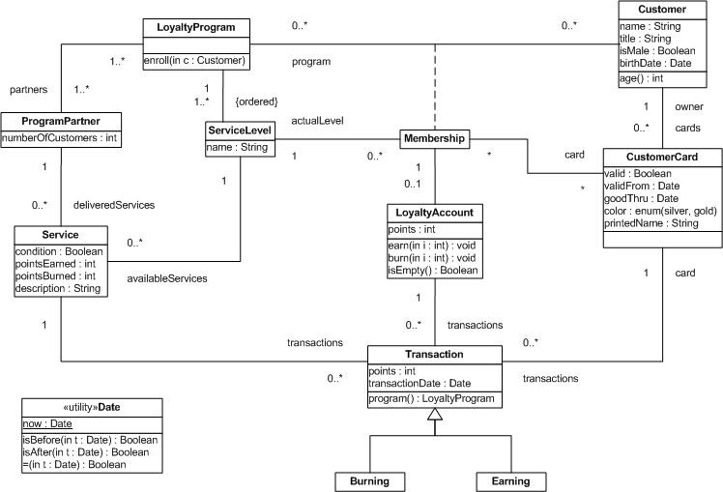

Questions

Write the following constraints in OCL, in each case making the context clear:

- Customers must have a minimum age of 18 years
context Customer inv: self.age() >= 18

- The CustomerCard’s validFrom date must be earlier than the goodThru date
context CustomerCard inv: self.validFromdate < self.goodThrudate

- A card issued for membership must be for a customer mentioned in the membership
context CustomerCard inv:
pre: CustomerCard.membership.program->exists(Customer)

- The number of service levels is exactly two
context LoyaltyPrograms inv:
self->serviceLevel->collect(serviceLevel).size() =2
context <which> inv: self->collect(<name>)->size() = 2
context <which2> inv: self->collect(x)->size() = 2

- The printed name on the customer card must be a title followed by the registered name of the customer
context CustomerCard inv: self.printedName = self.owner.title + self.owner.name

- The number of valid cards for each customer must be equal to the number of programs in which they participate
context Customer inv: self->collect(program).size() = self->collect(cards).size()

- When a LoyaltyProgram does not earn or burn points then its members do not have LoyaltyAccounts
context LoyaltyProgram inv:
(if self.servicelevel.available Service..pointsEarned = 0 and
self.servicelevel.available Service..pointsBurned = 0
then
else
Customer.membership.LoyaltyProgram
Customer.membership.LoyaltyAccount.does not exists

- The number of customers of a ProgramPartner is the number who participate in one or more loyalty programs offered by this ProgramPartner
context ProgramPartner inv:
self.numberOfCustomers = self->collect(partner).membership->collect(customer).size()

- The first ServiceLevel is silver
context ServiceLevel inv: self=>collect(name).first() = 'silver'

- The upper limit of points that can be burned for each ProgramPartner is 10,000
LoyaltyAccount.burn(i)
context ProgramPartner:
ProgramPartner.deliveredServices.Service.pointsBurned <= 10000

Express what the following OCL expressions mean in English.

- context Customer
inv: title = (if isMale = true
then ‘Mr.’
else ‘Ms.’
endif)

Define a constraint on class Customer, it is invariant (does not change) that defines the Customer.title attribute depending upon the Customer.isMale attribute. The title must be 'Mr.' when isMale attribute is true, and title must be 'Ms.' when isMale attribute is false.

- context Transaction
inv: self.program( ) = customerCard.membership.program

Define an invariant constraint on the Transaction class. The value of the Transaction.program() method must match the value of the Customer.membership.(Loyalty)program

- context Membership
inv: LoyaltyProgram.serviceLevel-> includes(actualLevel)

Define an invariant constraint on the Membership (class/relation) that declares the LoyaltyProgram.serviceLevel must include the Membership.actualLevel attribute (existence of the actualLevel in the serviceLevel.

- context LoyaltyProgram
inv: serviceLevel->includesAll(membership.actualLevel)

Define and invariant constraint on the LoyaltyProgram class that asserts that the serviceLevel contains all of the attributes defined by the LoyaltyProgram membership relation named actualLevel defines for the program.

- context LoyaltyAccount
inv: transaction->collect(points)->
exists (p:Integer | p > 500)

- context LoyaltyAccount
inv: points>0 implies transaction->exists (points>0)

Define an invariant constraint on LoyaltyAccount clas that the attribute LoyaltyAccount.points is >0 (positive, greater than zero) means that there exists at least one Transaction class element (related by transactions relation) which also has points >0 (positive, greater than zero).
Likely you could further refine this constraint to claim that the sum of all LoyaltyAccount->collect(transactions)->sum() == LoyaltyAccount.points

- context ProgramPartner
inv: self.service.transaction-> select(oclType=Burning)->collect(points)->sum()
<= self.service.transaction->select(oclType=Earning) ->collect(points)->sum()

Write pre- and post- conditions for:
- The isEmpty() operation of LoyaltyAccount

context LoyaltyAccount inv:
pre: self.isEmpty()
I got nothing here...

- The enroll() operation of LoyaltyProgram. Postconditions include that there is now one more customer than before and that the new customer’s loyalty account has no points and no transactions

context LoyaltyProgram::enroll(c)
pre:
Customer.membership.program->exists() == false

post:
LoyaltyProgram.membership->collect(customer)->size() @post =
LoyaltyProgram.membership->collect(customer)->size() @pre

post:
LoyaltyProgram.membership.LoyaltyAccount(c).points = 0
post:
LoyaltyProgram.membership.LoyaltyAccount(c)->collect(transactions)->size() = 0

- The program() query on Transaction

context Transaction::program():
pre: LoyaltyProgram->exists()

- The burn() operation on LoyaltyAccount

context LoyaltyAccount.transactions.burn():
pre: LoyaltyAccount.points > 0

- The age() operation on Customer assuming participants must be adults below retirement age, which is 65.

context Customer::age(.transactions.burn():
pre: self.exists() == true
pre: ( (Date.now() - self.birthDate ) < 65 )
pre: ( (Date.now() - self.birthDate ) >= 18 )
post: self.age()@post > 18 and self.age() < 65

