Singtel BCC Delivery Manager — HR 初筛面试准备
Oct 16, 2026 · @wilson zhang

速览
结论：这是 BCC（Billing, Customer & Charging）squad 的发布与变更把关岗，不是项目群负责人。HR 初筛最可能卡你的是资历落差、薪资区间和电信领域三点；岗位核心能力你都有直接证据。
岗位本质：对 BCC 的 Major 和 Ad-hoc release 负单点责任——每周、每月汇总需求与测试状态定发布范围，盯 SIT、UAT、PET、PPT，备齐 TCR 文档，参加 Pre-CAB 和 CAB，负责环境就绪、cutover 和 rollback。JD 写明不负责跨领域的端到端项目群交付（JD）。
HR 这一轮看什么：公开面经里，Singtel 经理岗面试常聊岗位匹配、加入动机和近远期规划（Glassdoor）；初筛还会核对简历匹配、薪资、通知期和动机（Hyring）。
三个风险，按严重度排
- 资历落差：JD 要 5–10 年；你 18+ 年、VP2，带两条平台线共 25 人，还有投资和供应商决策权。HR 会担心落差感、待不久、薪资对不上（见 Q8）。
- 薪资区间：本岗区间很可能低于你现在的 VP2 水平，这是能否推进的分歧点（见 Q2 的公开数据）。
- 电信领域：没做过 telco BSS 或 billing；桥接点是支付交易准确性与 cut-off 窗口、信用卡与贷款催收、customer-360 平台、VV 支付子系统对账（见 Q9）。
你的硬牌：ISO 20022 迁移用分阶段共存，2025 年 5 月、8 月两次 MX-rich 上线，早于 SWIFT 11 月截止；2026 年 8 月退出共存，无服务中断。每次发布过 SIT/UAT sign-off 和变更控制；团队自管生产支持，处理 P1–P3；你主持四家 IT 服务供应商的治理。
概率怎么读：被问概率按新加坡大企业 HR 初筛常见题型、本 JD 的信号和你的简历特点估计，是经验判断，不是统计数据；不给整体匹配度或通过率。下图按概率排序，颜色表示你现在能否直接答好。
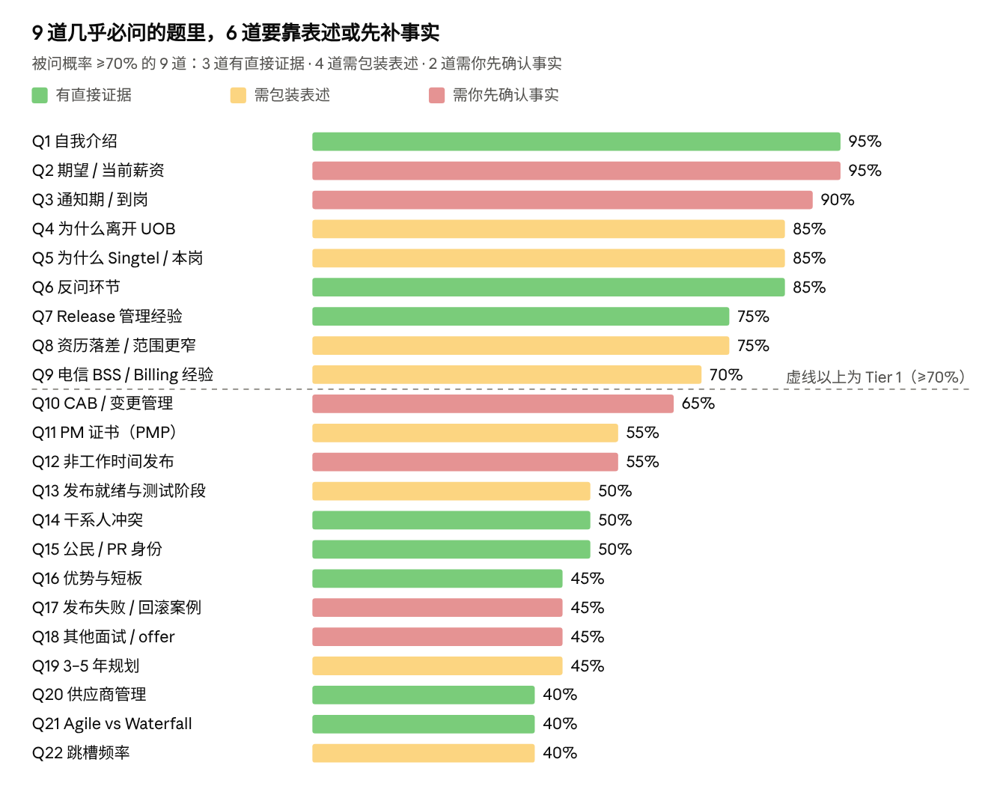
经验估计，非统计 · Q1–Q22（被问概率 ≥40%）
红色题取决于你还没定的数字或事实，周二前先处理；绿色题练流畅度即可。

JD × 你的证据
按 JD 拆出的 11 个发布环节里，原有 6 个直接证据、2 个可迁移；原待确认的 3 个中，CAB 和 TCR（你亲自用 CRQ 准备变更单）10-19 已确认为直接证据，PPT 仍是缺口。流程图之外的要求见下表，编号对应你的 03_Achievement_Library。
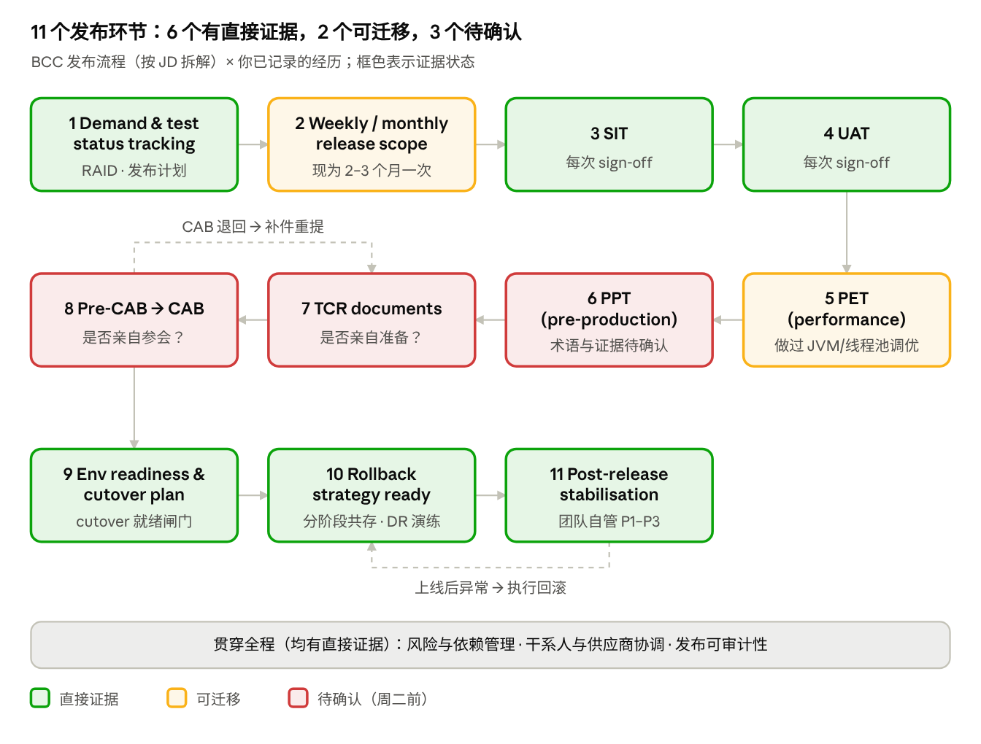
BCC 发布流程 × 证据状态 · 11 个环节，2 个回路
红框三项已于 10-19 确认：CAB 和 TCR 有直接证据，Q10 用 A 版；没有正式 PET 和预生产演练，Q13 照实说。图中颜色是确认前的状态，以文字为准。
JD 要求 | 你的证据 | 状态
5–10 年 IT 交付或发布管理，矩阵型企业 | 18+ 年；UOB VP2 / Technical Delivery Manager 4 年，Group Technology & Operations | 直接（超额，即资历落差信号）
跨多系统、多团队、多干系人的端到端交付 | ISO 20022 迁移涉及网银和分行渠道、参考数据、下游系统、供应商和第三方银行系统（PA-01） | 直接
Major 与 Ad-hoc 发布，业务关键平台 | Major：2025 年 5 月、8 月 MX-rich 上线，之后每 2–3 个月一次升级；Ad-hoc：P1/P2 事故后紧急分析、修复并走紧急变更（10-19 确认） | 直接
风险与依赖管理（集成、下游影响） | RAID；渠道、参考数据、供应商交付等依赖（PA-01） | 直接
Waterfall 与 Agile 务实结合 | customer-360 平台用 Waterfall 治理；ISO 20022 项目 Agile 交付加变更控制；GBD 混合模式，从零搭 Scrum（PA-05、PA-01、PA-10） | 直接
Excel、PowerPoint、Word、Visio、MS Project、Agile 工具 | Jira、Confluence、MS Project；给高层的汇报材料；Visio 未记录 | 直接（Visio 待确认）
沟通、影响与谈判 | 向高层和指导委员会汇报；主持供应商治理；排期冲突时先谈 MVP 范围 | 直接
跨职能、多元文化团队 | 25 人在岸加离岸；5 年以上离岸团队管理；与印度、泰国、印尼团队跨时区协作（10-17 确认，非汇报关系） | 直接
发布执行与排障时冷静、结构化 | P1–P3：升级、沟通、RCA、事后报告；亲自主持 DR / failover 演练（X-06、PA-02） | 直接
IT、CS 或工程类本科 | 应用数学学士；计算机科学与技术硕士 | 直接
PM 认证或同等实践经验 | PMP 在考，不能说已持证；以同等实践经验满足 | 需包装
BCC 领域（Billing、Customer、Charging） | 无电信经验；可桥接支付交易、信用卡与贷款催收、customer-360、VV 支付子系统对账 | 需包装（真实缺口）
与 Network、Operations、Infrastructure 协调 | Operations、Infrastructure 是你的常规干系人（PA-02）；电信网络团队没有经验 | 需包装

Tier 1：几乎必问（≥70%）
这 9 道题几乎必问；Q1、Q2、Q4、Q8 决定 HR 是否往下推，先练到能脱稿。英文答案只用已确认或已记录的事实，标"属实再用"的句子按你的实际情况取舍。

#Q1 · Tell me about yourself（95% · 有直接证据）
考察点：两分钟内讲清你是谁、为什么和这个岗位相关。
参考答案（约 75 秒）：I have 18 years of work experience across internet technology, fintech, and banking.
I started my career as a Java engineer and gradually moved into architect, project manager. I joined UOB in 2022 and lead two app teams which are from 4 tech vendors.
My main responsibility is the end-to-end delivery of mission-critical payment projects. This includes delivery planning, technical design, CI/CD pipeline, SIT + UAT sign-off, risk management, prod rollout, incident handling.
I’m now looking to bring the technical judgement and delivery leadership into another large-scale, business-critical platform env.

避坑：不说 CTO 或 Chief Architect，你没有这两个正式头衔；不报 UOB 交易量、客户名等内部数字。

Q2 · What's your current and expected salary?（95% · 需你先确认）
考察点：预算能否对上、你是否灵活。这是本岗最可能的分歧点。
公开数据（自报或估算，只看量级）
- 新加坡 Delivery Manager 月 base 约 S$7K–11K，平均约 S$9K，另有平均约 S$1K/月浮动（Glassdoor）。
- 银行同类岗更高：DBS Delivery Manager 月总包约 S$10K–16K，中位数约 S$14K（同一页面）。
- 按职位发布估算，Singtel 平均月薪最高一档是 Service Delivery Director，约 S$13,461（Indeed）。
- 有 Singtel 经理岗候选人在 2025 年 5 月的面经里直言薪资区间偏低（Glassdoor 面经）。
推断：本岗区间大概率在 Delivery Manager 量级，可能低于你现在 VP2 的总包。
参考答案："Before I give a number, may I ask the budgeted range for this role? My expectation is around [your range] a month, but I look at the total package — base, bonus and benefits — and I'm open to a sensible discussion if the role is the right fit."
被追问当前薪资："My current base is [X] a month, plus an annual performance bonus." 如实给结构，入职时对方可能要工资单核对。
避坑：先问区间，别先报点值；周二前定好底线，若明显高于区间上沿，这一轮就说清；别说"薪资不重要"。

Q3 · What's your notice period?（90% · 已确认）
参考答案："My notice period is one month. I'd use it for a proper handover, so I could start about a month after accepting an offer."
要点：通知期 1 个月（10-19 确认），比多数在职候选人短，是加分项；HR 问最早入职日，按 offer 签署日加 1 个月报。

#Q4 · Why are you leaving UOB? Why now?（85% · 需包装）
考察点：动机是否正面，会不会很快再走。
参考答案（你的定稿，10-19）：
I've gained valuable experience at UOB over the past 4 years, especially in delivering complex technical payment projects.
During this time, I've strengthened both my project delivery skills and payment tech business, particularly when working with business-critical systems and multiple stakeholders.
Now, the CBPR+ is coming to the end. New projects will be next year.
And I'm looking to broaden my industry experience while continuing to apply my technical and project management background, take on new business challenges.

避坑：不评价 UOB、上级或团队；不把薪资、晋升或疲惫当主因。

#Q5 · Why Singtel? Why this role?（85% · 需包装）
考察点：是否了解 Singtel 和 BCC，还是海投。
参考答案：
There are 3 reasons.
- First, the role. It’s very close to what I do every day at UOB. I own releases for a business-critical platform: scope, SIT and UAT sign-off, change requests and CAB, cutover, and production support. So I can add value from day one.
- Second, BCC. Billing and charging is where the money flows in a telco, just like payments in a bank. It touches every customer, every month. If something goes wrong, it hits revenue and customer trust straight away. That’s the kind of system I’ve looked after for the past four years.
- Third, Singtel itself. It’s Singapore’s largest telco, and with Singtel28 there’s a lot of change coming, like simpler products and more AI. I expect a lot of that change will land in billing. So BCC will need strong release control for years, and that’s a place where I can stay and build.
The telco side is new to me, and I’m ready to learn it. But running safe releases works the same way..

要点
- Singtel28 是 2024 年 5 月推出的增长计划，两条主线是提升业务表现和资本管理；原文写明要简化产品、用 AI 改善客户体验（Singtel28 新闻稿）。
- "产品变化最终落到计费"是推断，口头当作你的观点说。
避坑：别展开5G、数据中心、NCS 等与 BCC 无关的话题。

#Q6 · Do you have any questions for me?（85% · 有直接证据）
必问 3 个（按顺序）
- “Is this a new role, or a replacement?”
  - 目的：判断岗位背景。如果是新增岗位，通常说明 BCC 的发布量或改造力度在加大（可能和 Singtel28 有关），用人主管那一轮你可以重点讲发布量和治理。如果是补缺，可以顺着问前任为什么离开，了解岗位难点。
  - 结合你的背景：HR 可以答，又不敏感。这个答案决定你下一轮用 ISO 20022 的哪个角度讲。
- “Who does this role report to, and how does it work with the BCC squad leads and vendors?”
  - 目的：确认汇报线，以及是不是纯 IC 岗位。
  - 结合你的背景：你现在是 VP2、带 25 人，最需要先弄清楚这个落差有多大。HR 一提到 vendor，你可以顺势补一句你主持 4 家 vendor 的治理，把带过团队变成跨团队协调的优势。
- “What would success look like in the first six months?”
  - 目的：拿到岗位的考核标准，用人主管那一轮可以对着讲。
  - 结合你的背景：问的是"进来后怎么做好"，不是"什么时候能升"，等于在表态你想长期做，正好对冲 HR 对跳槽的顾虑。

- ---Q7 · Tell me about the major and ad-hoc releases you've managed.（75% · 有直接证据）
考察点：是否真管过业务关键平台的发布全流程。
参考答案（STAR，约 90 秒）："At UOB I own release planning and production rollout for our cross-border payment initiation platform. The biggest example is the ISO 20022 migration. The platform was live, payments had to land inside cut-off windows, and we depended on channels, reference data, downstream systems and vendors, against a fixed SWIFT deadline. I chose a phased, blue-green style coexistence rather than a big-bang cutover, with cutover-readiness gates, RAID tracking and steering-committee reporting. Every release needed SIT and UAT sign-off and went through change control. We went live in May and August 2025, ahead of the November deadline, retired coexistence in August 2026 with no service interruption, and have shipped an upgrade every two to three months since."
Ad-hoc 补一句（10-19 已确认）："Alongside scheduled releases, I handle urgent fixes after P1 and P2 incidents. I start with the production logs and the database to confirm whether the issue is in our system. If it is, or if it's not clear, I bring in the architect and the other stakeholders to find the root cause and agree the fix, and the fix goes out as an urgent change."
要点：你的节奏是 2–3 个月一次，BCC 按周、按月定范围。被问时答：节奏不同，每次过的闸门是同一套。
避坑：不用 "10+ payment domains"，这条已停用。

Q8 · You're a VP leading 25 engineers. Why a narrower role with no direct reports?（75% · 需包装）
考察点：落差感、稳定性、薪资能否对上。
参考答案：
For me, it's less about the title or the size of the team, and more about the role and the value I can bring.
Over the years, I've built experience in tech delivery, project management teams. I believe these skills are also valuable in a role where I need to coordinate different teams and vendors without having direct reporting authority.
What interests me about this opportunity is the chance to apply my experience to another business-critical platform, learn the telecom business, and contribute to the team over the long term.
I'm looking for the right place to build and contribute, not just my next job title.

要点：先承认落差，再给理由；和 Q2 的薪资灵活度口径一致。
避坑：别说"想轻松一点"；别暗示"先进来再往上走"。

Q9 · Do you have telco, BSS or billing experience?（70% · 需包装，真实缺口）
考察点：领域门槛多高、你学得多快。
参考答案："Not in telco. But the core problems are familiar. In payments, every transaction must be accurate, traceable and inside cut-off windows, and billing runs need the same discipline. I own the technology for post-disbursement collections across credit-card and unsecured-loan portfolios, which is close to receivables and collections in a BSS stack. I've led a customer-360 platform team, and earlier I delivered a payment subsystem with transaction, management and reconciliation modules. Release discipline itself is domain-agnostic. I'd use my first 30 to 60 days to learn BCC's flows: billing cycles, rating and charging, and downstream impacts."
要点：先承认，再给三座桥（交易准确与 cut-off、催收、对账），最后给学习计划。新加坡电信 BSS 岗位的公开描述把 billing、charging、receivables、collections 放在同一范围（Billigence 职位）。
避坑：别说 billing 和 payments 一样，说"问题相似"。

Tier 2：较可能问到（40–69%）
这 13 道题里，Q10 和 Q17 已于 10-19 确认；还剩 Q12（非工作时间上线）和 Q18（是否在面别家）要按你的实际情况答。

Q10 · Have you worked with CAB and change management?（65% · 有直接证据）
考察点：JD 关键词核对，TCR、Pre-CAB、CAB。
已确认（10-19）：你为每次变更亲自准备 CR（行内以 CRQ 单提交），并亲自在 CAB 会上讲解。用 A 版，B 版作废。
参考答案 A（用这版）："Yes. For each production change I prepare the change request myself, as a CRQ in our change-management system. It covers the scope, test evidence including SIT and UAT sign-off, the implementation and rollback plan, and the impact assessment. Then I present it at the CAB meeting. In a MAS-regulated bank, auditability is non-negotiable, so the evidence trail is part of the release, not an afterthought."
参考答案 B（作废，保留备查）："In my current setup, squad leads raise the change requests, and I review and approve the package — scope, test evidence, rollback plan and impact — before it goes to CAB."
避坑：HM 轮可能追问 CAB 细节，比如一次被退回或附条件通过的变更、CRQ 里回滚计划写到什么程度。只讲你真遇到过的。

Q11 · Do you have PMP or another PM certification?（55% · 需包装）
参考答案："I'm currently working towards PMP. The JD also accepts equivalent practical experience, and that's my strength: I've owned delivery of a multi-year, regulated payments migration end to end. I've also completed formal SRE training."
要点：考试日期还没定（10-19）。不主动报时间；被问就如实说还没约考，重点落在同等实践经验上；绝不说 "PMP certified"。

Q12 · Releases often run after hours or at weekends. Is that OK?（55% · 需你先确认）
参考答案（属实再用）："Yes. In payments, production changes are scheduled outside cut-off windows, so off-hours cutovers and on-call support are already part of my routine."
要点：cut-off 窗口有记录；"非工作时间上线是常态"要你确认属实。BCC 的发布窗口可以放进反问。

-----Q13 · How do you make sure a release is ready?（50% · 需包装）
参考答案：
- Scope readiness：发布范围、版本和依赖已经确认，没有未受控的临时变更。
- Quality readiness：SIT、UAT、回归测试，以及安全测试已经完成，关键缺陷已关闭。
- Technical readiness：环境、部署包、配置、数据库脚本和 CI/CD pipeline 已验证。
- Operational readiness：cutover runbook、负责人、时间窗口、监控和上线后支持已经安排。
- Risk readiness：已知风险、上下游依赖、回滚触发条件和 rollback plan 清晰可执行。
- Governance readiness：业务、技术、运营及 Change/CAB 等必要审批已经到位。
要点
- 已确认（10-19）：ISO 20022 项目没有正式 PET 和预生产演练，测试方式是模拟报文发送和回执的成功、失败场景。被问就照实说："We didn't have a formal performance-test phase or a pre-production rehearsal. We simulated sending messages and receiving both success and failure responses, to test each path end to end." 不要把它说成 PET 或 PPT。
- PPT 各公司含义不同（pre-production test 或 production parallel test）；HR 轮不必展开，HM 轮可以反问 BCC 的定义。

Q14 · Tell me about a stakeholder conflict over release scope or priority.（50% · 有直接证据）
参考答案（STAR）："With two platform lines, release schedules sometimes collide. When that happened, I didn't escalate first. I sat down with the requirement owners, project leads and tech leads, agreed the MVP scope for each change, confirmed the real dependencies, and then set a sequence that both sides accepted. That way the priority call was owned by the people affected, not imposed through escalation."
要点：这是你已确认的做法；能补一个具体结果（例如两边都按期上线）更有说服力。

Q15 · Are you a Singapore Citizen or PR?（50% · 有直接证据）
参考答案："I'm a Singapore Permanent Resident."

Q16 · What are your key strengths, and one weakness?（45% · 有直接证据）
参考答案："Three strengths. I land high-risk changes safely: our ISO 20022 cutover went live with no service interruption. I'm technical enough to read the risk in a change and talk credibly with engineers and vendors, because I still review code and design daily. And I stay calm in incidents: my teams own production support, so P1s are part of my job. One weakness: telco billing is new to me, so in my first months I'll lean on the BCC squad leads and put real time into learning the domain."
避坑：别拿"太追求完美"这类套话当弱点；领域缺口是真实的，也和 Q9 口径一致。

Q17 · Tell me about a release that went wrong.（45% · 有直接证据）
考察点：出事时是否冷静，有没有先止损、再查根因、最后根治的纪律。你的案例是生产事故，不是发布失败；HR 问 release 时先过渡一句："The closest example I have is a production incident."
参考答案（你的案例，10-19）："Sure. One example was a production incident where a payment was stuck in 'pending in process'. First, we checked the production logs in Splunk and the payment records in Oracle to trace the transaction flow. We found that the payment had been initiated successfully and sent to the downstream application, but our payment hub had not received the response. So we contacted the downstream team and confirmed that the payment had actually been processed successfully. The response message was blocked in the messaging channel back to our hub, so our system still showed the payment as pending. For immediate containment, the downstream team manually cleared the blocked messages and the affected payments were recovered. Then, as the permanent fix, [we / the channel team] optimised the messaging channel service so the same blocking couldn't happen again. The key lesson for me: first contain the business impact, then find the real root cause, and finally make a permanent fix to prevent recurrence."
要点：相对你的原稿只改了三处：CEW 换成 our payment hub（内部系统名不对外）；止损一句补上主语 the downstream team；永久修复一句缺主语，按实际填 we 或 the channel team。
追问准备：HM 轮会问你本人做了什么，比如谁通知了业务、多久更新一次、有没有补监控告警或 RCA 报告。只说你真做过的。被问回滚就如实说，这个案例不涉及回滚。

Q18 · Are you interviewing elsewhere?（45% · 需你先确认）
参考答案（属实再用）："Yes, I'm speaking with a few organisations at different stages. This role is high on my list because [reason]. I'll keep you posted if my timeline changes."
避坑：不报公司名；不虚构 offer 施压。

Q19 · Where do you see yourself in three to five years?（45% · 需包装）
参考答案："I want to be the person Singtel trusts with its most critical changes. First by making BCC releases predictable and auditable, then by improving the release process itself, for example automating readiness checks and quality gates. If that grows into broader delivery leadership over time, great, but my focus is to do this role very well first."
要点：同时回应"会不会很快想升职走人"。

Q20 · How do you manage vendors?（40% · 有直接证据）
参考答案："At UOB I chair governance for four IT service vendors: periodic budget reviews, year-end performance reviews and accountability meetings with their teams. I hold decision or joint-decision authority on vendor selection and on SOW and licence negotiation, and I govern their SLAs."
避坑：不说供应商名字。

Q21 · Agile or Waterfall?（40% · 有直接证据）
参考答案："Both, pragmatically. Our customer-360 platform runs under waterfall governance. The ISO 20022 programme used agile delivery inside the squads, with change control and fixed release gates. At Golden Bridge I set up Scrum from scratch inside a hybrid model: waterfall for scope and budget, sprints for the build. In a release-driven environment like BCC, squads can run agile while the release train keeps fixed governance checkpoints."

Q22 · You've changed jobs several times. Why?（40% · 需包装）
参考答案："My early career was at large internet companies: Renren, Sohu and Baidu. From 2016 to 2022 I chose start-up and scale-up roles leading technology, and those have shorter cycles by nature. My own start-up closed after fundraising fell through, and at another company the CEO moved the technical team to China while I stayed in Singapore for family reasons. Since 2022 I've been at UOB for four years, and I'm looking for a long-term home again."
要点：GBD 离开原因已确认（10-19）：父母身体不好，需要照顾。这和答案里的 family reasons、Q25 的 2022 年空档是同一件事，三处说法要一致；面试只说 family reasons，不展开健康细节。简历上自创公司（2017.10–2019.9）和 VV（2019.4 起）重叠约半年，被问就说："When I joined VV in April 2019, my start-up was already largely dormant, and VV was my primary role."
避坑：不提 Baidu 那段的离职原因。

Tier 3：可能顺带问到（<40%）
低概率题各准备一句即可；答错代价最高的是空档期和兼职顾问两题。

Q23 · Which delivery tools do you use?（30% · 有直接证据）
参考答案："I use Jira and Confluence daily, MS Project for programme plans, and PowerPoint for steering-committee and senior-management reporting."
要点：Visio 档案未记录，用过就加上；Excel 照实说。Miro 在 VV、GBD、UOB 都用过，可以一并提（用途还没确认，只说用过）。

Q24 · Are you OK with the work location and arrangement?（30% · 需你先确认）
要点：HR 初筛常会确认工作地点与模式（Hyring）。按你的实际偏好答，有硬约束就在这一轮说清。

Q25 · I see gaps in 2015 and 2022.（20% · 有直接证据）
参考答案："In 2015 I took a little over a year to study and develop myself before returning to work. In 2022 I took three months to care for a family member before joining UOB."
避坑：一句带过，不展开；LeMail/Letv 的时间点尚未确认（FU-2），简历没写就不主动提。

Q26 · Have you worked with network or infrastructure teams?（20% · 需包装）
参考答案：
- At the bank I work with infrastructure and operations teams on deployments and DR drills.
- In internet companies, I led tech and infra team for website env built.

反问 HR
挑 2–3 个问，优先问能帮你判断级别、薪资区间和工作强度的问题；第 2、5 题留到用人主管那一轮也适用。
- "What does success look like for this role in the first six months?"
- "How is the BCC release calendar structured — how many major and ad-hoc releases a month, and how many application teams and vendors are involved?"
- "Who does this role report to, and how does it work with the BCC squad leads?"
- "What is the job grade, and the budgeted range for the role?"（Q2 没谈清时问）
- "Is there an on-call or after-hours rota for releases?"
- "What are the next steps and the timeline?"

周二前必须确认
下面 10 项决定哪些答案能直接说。10-19 已确认 9 项，只剩投递简历版本这一项。
- ☒ CAB：你在 UOB 是否亲自准备变更单（CR/TCR）、是否亲自参加 CAB（决定 Q10 用 A 还是 B） → 亲自准备 CRQ 并在 CAB 上讲解，Q10 用 A
- ☒ Ad-hoc release：是否处理过 P1/P2 之后的紧急变更（Q7 补充句） → 处理过，Q7 已补
- ☒ 性能测试与预生产：ISO 20022 项目是否有正式的性能测试或预生产演练（Q13） → 没有正式 PET 和预生产演练，只做报文成功/失败模拟，Q13 已改
- ☒ 一个真实的发布事故或回滚案例（Q17） → 支付卡在 pending 的生产事故，Q17 已写入
- ☒ 薪资：底线、期望区间、是否透露当前薪资（Q2）
- ☒ 通知期：合同写几个月，最早入职日期（Q3） → 1 个月，Q3 已改
- ☒ 离开 UOB 的真实原因，"项目已收尾"是否是其中之一（Q4） → 用你的定稿，不再提"项目收尾"
- ☒ GBD 2022 年 7 月离开的原因（Q22） → 家庭原因（照顾父母），Q22 已改
- ☒ PMP 考试日期，若已排期（Q11） → 未定，Q11 不报日期
- ☐ 投给 Singtel 的是哪一版简历：HR 照简历提问，旧版本可能含已停用的表述（见下表）
旧版本表述的应对
本地素材库 10-18 核对结果：六个 V5 素材库都还带着下表的旧表述，10-16 的 TPM_Bank 模板已清理干净，只是职称写成 "Technical Development"。你投的如果是 V5 派生的版本，这张表要逐行准备。
旧表述 | 出现在 | 状态 | 被问时这样说
"Prior CTO" / "former CTO / Chief Architect" | 4 个 V5 素材库（含 TPM_Bank） | 已停用：没有正式 CTO 头衔 | "My formal titles were VP of Technical Department at AI Park and Head of Technical Centre at VV Technology, both head-of-technology roles."（职称写法见下一行）
职称写法：Department / Centre，还是 Development | V5 素材库写 Department / Centre；10-16 模板写 Development | 冲突未决（CF-16）：你 10-17 说的是 Department / Centre，原始文件依据待确认 | 按投给 Singtel 的那版简历说，并和雇佣信一致；同一场面试别混用两种写法
"10+ interconnected payment domains" | 全部 6 个 V5 | 已停用：来源不明 | 改说团队和范围："a 15-engineer team on the payment-initiation hub, integrating channels, reference data and downstream systems."
"100+ person technology organisation" | 全部 6 个 V5 | 依据待确认（B1）：你说过 VV 约 140 人是总编制，直接下属最多 15–20 人 | 讲清总编制和直接下属："About 140 people in total at VV, with 15 to 20 direct reports at most."；别说 built 或 hired
"10M DAU" | 全部 6 个 V5 | 暂停：口径未定义（FU-1） | 不报数字，说 "high-traffic consumer platforms"，口径定了再用
"200+ regions"、"1,000+ lots"、"multi-million daily transactions" | 全部 6 个 V5 | 不能用：200+ 是设计覆盖还是实际用户待确认（B5）；1,000+ 可能是你离职后的公司数字；multi-million 来源不明 | 不报数字：KYC 说 "designed for multi-country coverage"，AI Park 说 "pilots in three cities"
"AI-assisted delivery-risk forecasting" | 4 个 V5（含 TPM_Bank） | 暂停：没有方法和结果记录 | 不主动提；被问前先回忆真实情况，说不清就承认没有可量化的结果
VV 的 "GenAI customer chatbot"（RAG、function calling） | 全部 6 个 V5 | 暂停：2019–20 年谈不上 LLM function calling，2022 年旧简历也没有 | 不主动提；被问就只讲当时实际做的（具体做了什么还没确认）

来源
- Singtel — Delivery Manager JD（2026-10-13 发布）
- Launching Singtel28: a new growth plan（Singtel 新闻稿，TelecomTV 转载，2024-05-23）
- Glassdoor — Singtel Manager 面经
- Hyring — Singtel Interview Process (2026)
- Glassdoor — 新加坡 Delivery Manager 薪资
- Indeed — Singtel 薪资
- Billigence — Solution Designer, Telco（新加坡，已下架）
- 你的资料：本地素材库 C:\Users\surface\resumes（10-18 核对）中 master\v2.0-draft 的 02 v3.1、03 v4.1、05 v1.0、technical-skills-inventory v2.3、fact-check-and-open-questions v2.3（10-17 TEKsystems 回填后），六个 V5 素材库，templates\wilson-2026_TPM_Bank_template.docx；初稿用的是项目同步版（02 v3.0、03 v4.0），比本地旧一版；10-19 你确认的 CAB、紧急变更、测试方式、事故案例、通知期、离职原因和 PMP 状态

