实验七：Spring基本使用

毕业答辩，zhangsan是liang老师的学生。使用Spring管理这两个对象，客户端输出学生的姓名和这个学生的导师的姓名。
Spring的配置文件
<?xml version="1.0" encoding="UTF-8"?>
<beans xmlns="http://www.springframework.org/schema/beans"
xmlns:xsi="http://www.w3.org/2001/XMLSchema-instance" xmlns:p="http://www.springframework.org/schema/p"
xsi:schemaLocation="http://www.springframework.org/schema/beans http://www.springframework.org/schema/beans/spring-beans-4.1.xsd http://www.springframework.org/schema/tx http://www.springframework.org/schema/tx/spring-tx.xsd"
xmlns:tx="http://www.springframework.org/schema/tx">

<bean id="liangzaoqing" class="cn.edu.scau.cmi.longting.spring.domain.Teacher">
<property name="id" value="001"></property>
<property name="name" value="梁早清"></property>
<property name="gender" value="男"></property>
</bean>

<bean id="zhangsan" class="cn.edu.scau.cmi.longting.spring.domain.Student">
<property name="id" value="201727020"></property>
<property name="name" value="张三"></property>
<property name="gender" value="男"></property>
<property name="tutor" ref="liangzaoqing"></property>
</bean>
</beans>

客户端获取zhangsan对象的核心方法
public static void main(String[] args){
ApplicationContext applicationContext = getApplicationContext();
Student student = (Student) applicationContext.getBean("zhangsan");
System.out.println(student.getName()+" 的毕业指导老师是："+student.getTutor().getName());
}

private static ApplicationContext getApplicationContext() {
//单例获取ac
ApplicationContext ac = ApplicationContextUtil.getApplicationContext();
return ac;
}

实现效果
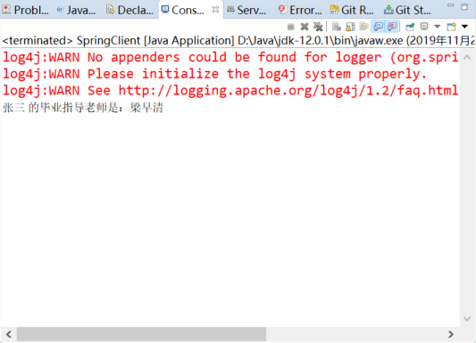

在第六个实验的基础上（Hibernate+DAO），DAO对象使用Spring管理。其他要求按照默认要求。
Spring配置文件
<?xml version="1.0" encoding="UTF-8"?>
<beans xmlns="http://www.springframework.org/schema/beans"
xmlns:xsi="http://www.w3.org/2001/XMLSchema-instance" xmlns:p="http://www.springframework.org/schema/p"
xsi:schemaLocation="http://www.springframework.org/schema/beans http://www.springframework.org/schema/beans/spring-beans-4.1.xsd http://www.springframework.org/schema/tx http://www.springframework.org/schema/tx/spring-tx.xsd"
xmlns:tx="http://www.springframework.org/schema/tx">

<bean id="teacherDao" class="cn.edu.scau.cmi.longting.hibernate.dao.TeacherDao">

</bean>

<bean id="studentDao" class="cn.edu.scau.cmi.longting.hibernate.dao.StudentDao">

</bean>
</beans>

DAO的获取核心代码
ApplicationContext ac = ApplicationContextUtil.getApplicationContext();
studentDao = (StudentDao) ac.getBean("studentDao");
teacherDao = (TeacherDao) ac.getBean("teacherDao");

实现效果
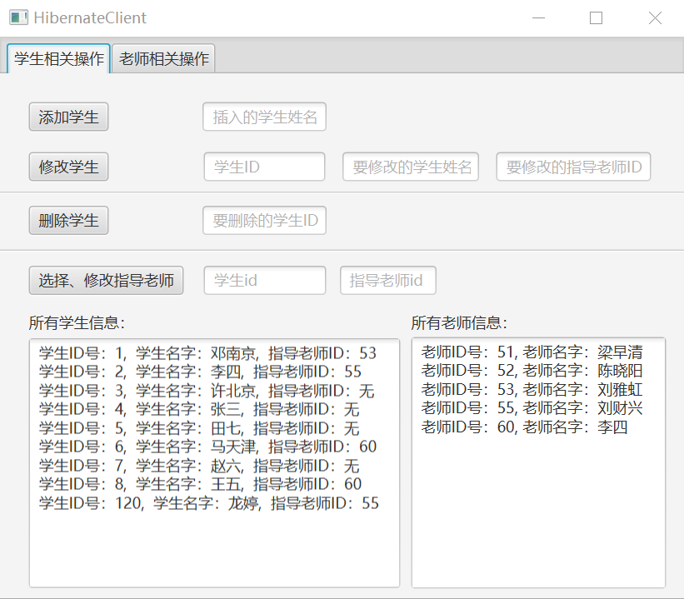
（因为和实验六相同需求，只是改了一下StudentDao加载方式，所以多余的测试见上一个实验，这里仅做展示。）

