实验一实验报告

1 UML设计图
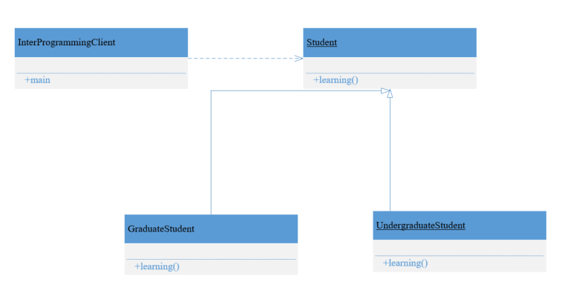

2 核心代码
package cn.edu.scau.cmi.longting.client;

import cn.edu.scau.cmi.longting.interProgramming.GraduateStudent;
import cn.edu.scau.cmi.longting.interProgramming.Student;
import cn.edu.scau.cmi.longting.interProgramming.UndergraduateStudent;

public class InterProgrammingClient {

public static void main(String[] args) {
Student graduateStudent = new GraduateStudent();
graduateStudent.learning();

Student undergraduateStudent = new UndergraduateStudent();
undergraduateStudent.learning();
}
}

3 运行效果
