实验三：工厂模式

(1) 简单工厂方法
肉厂(MeatFactory)可以生产猪肉(Pork)，牛肉(Beef)，鸡肉(Chicken)等肉类(Meat)，使用简单工厂方法实现肉类的生产。
在界面上选择某一种肉类，在输出框中显示获得的对象的行为。

UML图
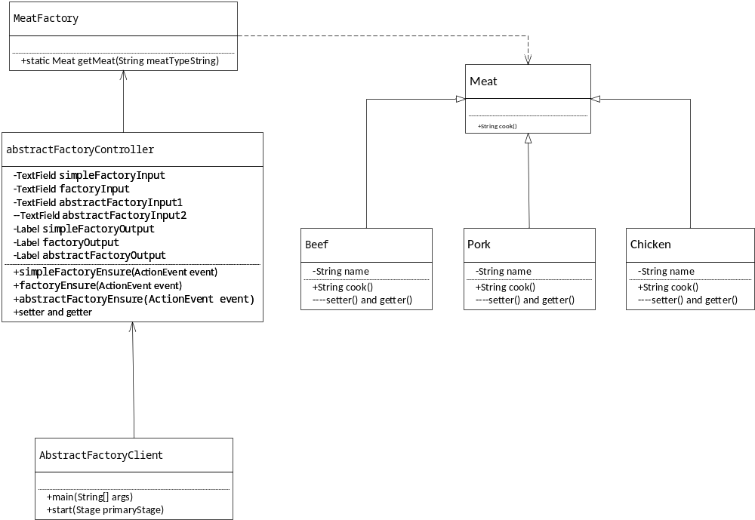

核心代码
public class MeatFactory {
public static Meat getMeat(String meatTypeString) {
Meat meat = null;
switch (meatTypeString) {
case "beef":
meat = new Beef();break;
case "pork":
meat = new Pork();break;
case "chicken":
meat = new Chicken();break;
}
return meat;
}
}
public abstract class Meat {
public abstract String cook();
}
public class Chicken extends Meat{
private String name;
@Override
public String cook() {
return "chicken is marvelous!!!";
}
}

1.3 实验效果
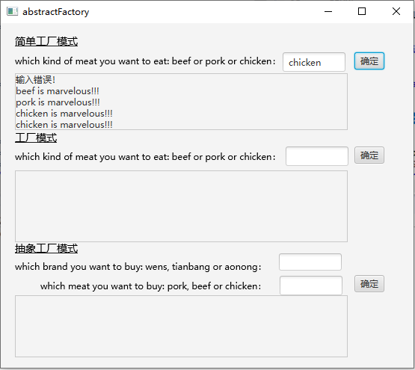

(2) 工厂模式
不同类型的肉厂生产不同的肉类，PorkMeatFactory生产猪肉，BeefMeatFactory生产牛肉，ChickenMeatFactory生产鸡肉。使用工厂模式实现这一功能。

2.1 UML图
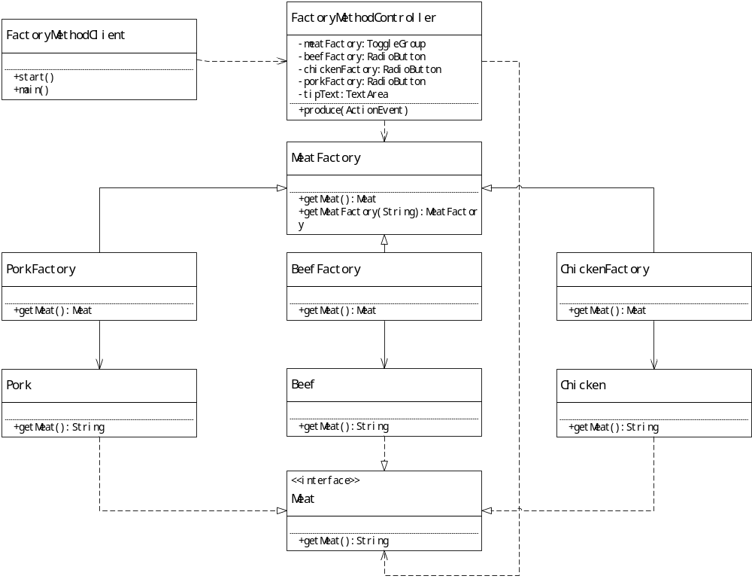

2.2 代码
public interface MeatFactory {
Meat getMeat();
}
public class PorkMeatFactory implements MeatFactory {
@Override
public Meat getMeat() {
return new Pork();
}
}

public class FactoryClient {
public static void main(String[] args) {
System.out.println("Please select which kind of meat you want to eat: beef or pork or chicken???");
Scanner scanner = new Scanner(System.in);
String meatString = scanner.next();
MeatFactory meatFactory = null;
switch (meatString) {
case "beef":
meatFactory = new BeefMeatFactory();
break;
case "pork":
meatFactory = new PorkMeatFactory();
break;
case "chicken":
meatFactory = new ChickenMeatFactory();
break;
default:
System.out.println("sorry, your input is not correct!");
break;
}
if(meatFactory != null) {
Meat meat = meatFactory.getMeat();
System.out.println(meat.cook());;
}
}
}

2.3 效果
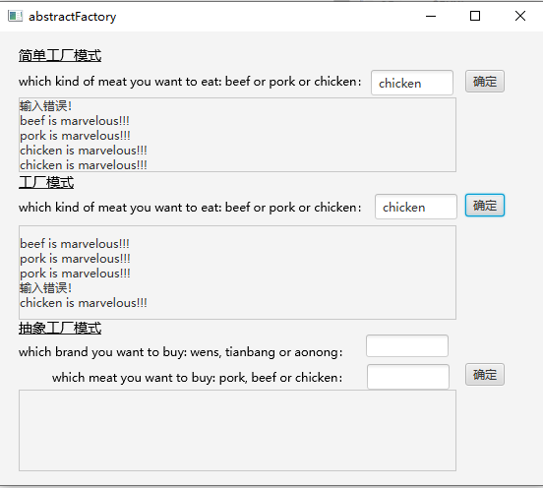

(3) 抽象工厂模式
温氏(Wens)集团、天邦(Tianbang)股份、傲农(Aonong)生物是我国三家大型的养殖企业，可以养猪，养牛，养鸡。利用抽象工厂模式实现用户购买不同品牌(Brand)的不同肉类(Meat)产品。

3.1 UML图
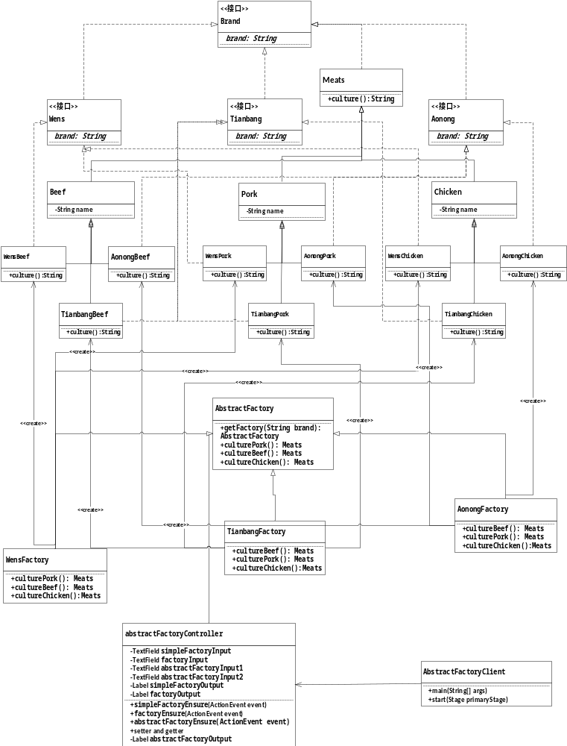

3.2 代码
public interface Wens extends Brand {
public String NAME="Wens";
}

public abstract class Pork extends Meat{
String TYPE="pork";
}

public class WensPork extends Pork implements Wens{

@Override
public String getMeat() {
return (super.TYPE+" has benn produced by "+Wens.NAME);
}
}

public class WensFactory extends AbstractFactory {
@Override
public Meat getBeef() {
return new WensBeef();
}
@Override
public Meat getChicken() {
return new WensChicken();
}
@Override
public Meat getPork() {
return new WensPork();
}
}

public abstract class AbstractFactory {
public static AbstractFactory getFactory(String brand) {
switch (brand) {
case "Wens":
return new WensFactory();
case "Aonong":
return new AonongFactory();
case "Tianbang":
return new TianbangFactory();
}
return null;
}
public abstract Meat getBeef();
public abstract Meat getChicken();
public abstract Meat getPork();
}

3.3 效果
